Demo of publishing to Learn process

Sample content materials:

* Sample Learning Path work items: <https://microsoftdigitallearning.visualstudio.com/Courseware/_queries/query/443d6003-68d5-4ce3-968e-30ea52cd4850/>
* Sample Learning Path git repo:

<https://microsoftdigitallearning.visualstudio.com/DefaultCollection/Courseware/_git/LP_DEMO_it-is-a-sample-course>

Publishing to Learn for preview steps:

1. Open following URL in Web browser:

<https://microsoftdigitallearning.visualstudio.com/DefaultCollection/Courseware/_git/LP_DEMO_it-is-a-sample-course>

1. Expand the top-level folders: *0_Build* and *Modules*, as show in following screenshot.

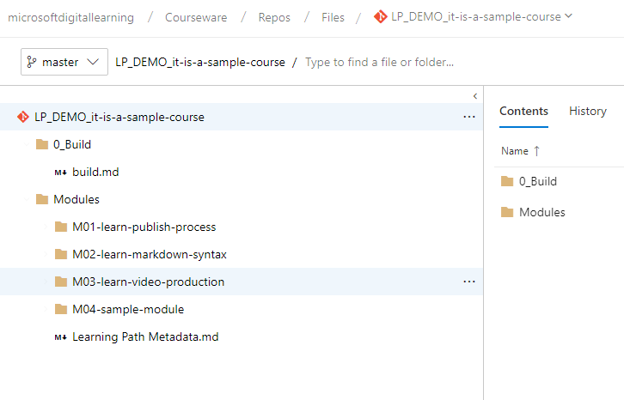

1. Make edits to one of the markdown files, for example, adding a timestamp at the end *of 1-introduction.md*.

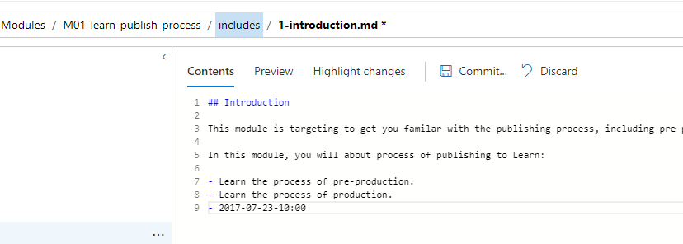

1. Select the **Commit** to submit the changes.
2. Go to **0_Build** folder, select *build.md* to open that file.
3. Ensure the **Preview** tab is selected.

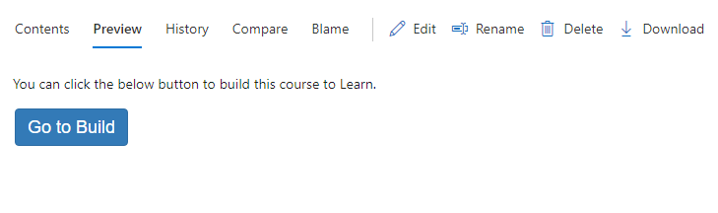

1. Select the **Go to Build**.
2. In the **WWL Learn Assembly** page, review the *module titles*, module *work items* and target *folder names*.

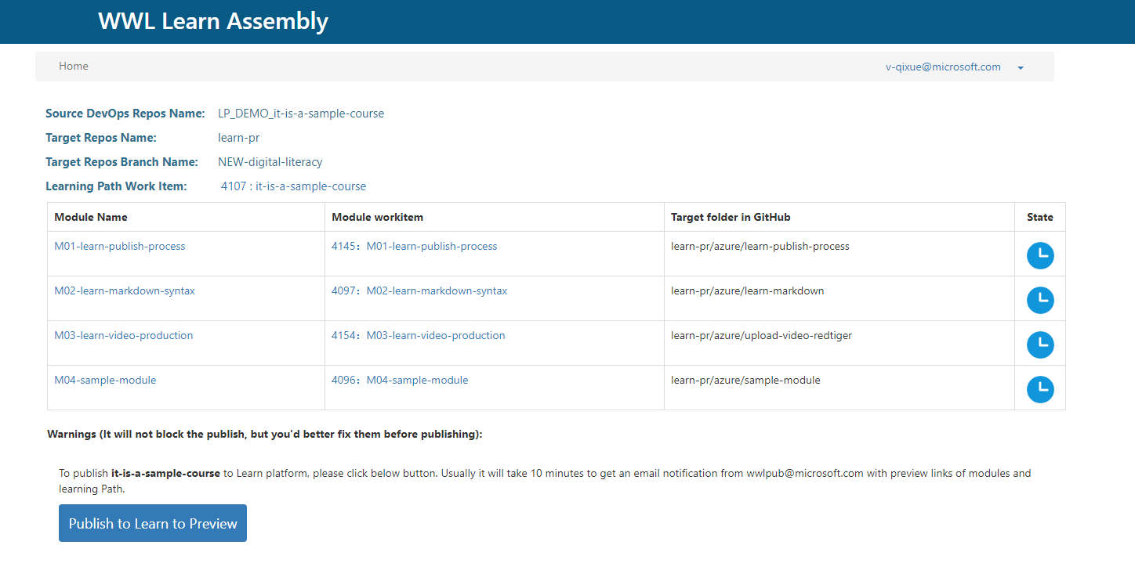

1. Select the **Publish to Learn to Preview**.
2. All publishing steps are complete from the git repository side, check your email box 15 minutes later to get the build result email.

