|  |  |
| --- | --- |
|  | **FAKULTI TEKNOLOGI MAKLUMAT DAN KOMUNIKASI**  **UNIVERSITI TEKNIKAL MALAYSIA MELAKA** |
| **ASSIGNMENT 1 (10%)**  **FINAL PROJECT PROPOSAL**  **BITM 2113 WEB APPLICATION DEVELOPMENT** | |

|  |  |
| --- | --- |
| **Student ID Number** | **Full Name** |
|  |  |
|  |  |
|  |  |
|  |  |

|  |  |
| --- | --- |
| **Website’s Title** |  |
| **Lecturer** | **MR SHAHRIL BIN PARUMO** |

|  |  |
| --- | --- |
| **Due date : 03 March 2017** | **Date Submitted :** |

**Comments:**

|  |
| --- |
| **MARK : /100** |

|  |  |
| --- | --- |
| **Criteria** | **Marks** |
| Evaluated websites |  |
| Explanation on the prototype |  |
| The similarity of the prototype |  |
| Tidiness and file arrangement in the folder |  |
| Efforts and punctuality |  |
| **Total** |  |

# **Introduction**

Online banking system is one of the most important online system that needed by the society nowadays. Money need to be stored and guard well in order to secure the individual’s asset. That’s why online banking system were the choice of our team had chosen to hone the skill to work on. This system is an electronic payment system that enables it’s customer of a bank to conduct a range of financial transactions through the specific financial institution. It possibly is based on E-Banking idea which means simplify all the works and mess that human do in a real physical bank by using electronic banking system that you can work on at any places with internet network service.

Our idea is about creating an online banking system name Sasa Online Banking System. It is a system allows administrators and valid customers to access the functionalities provided in this banking system. The services included balanced enquiry which show the balanced details of a particular account, registration modules which admin able to add new customers into this banking system and assign corresponding username and other details. Besides, this banking system allows customer to update their own profiles of their account and funds transfer action also permitted for those who registered under this online banking system. Next, is that mini statements function is one of the highlights in our banking system because this module allows customers to view and check out on their transaction history and details which were very important and convenient for those who lazy to had transaction activity check at the bank counter.

1. **Review of Current System**

Nowadays technology is growing fast and always adds new dimensions to our daily life. The online banking system has now become an alternative that allow users to manage their financial affair such as checking account balances and transaction of money between the account in same bank or different bank. The online banking system of CIMB and Hong Leong bank are going to discuss in this proposal.

The online banking system of CIMB is CIMB Clicks. The CIMB click is available in both website and mobile application. The theme used in the website and mobile application is red color. The basic services provided are My Account, transfer fund, bill payment and online application forms. For first time user, the user will have to register an account. The user can register their account through the CIMB click website, the demonstration of registration is provided in the website. The registration is simple as the user only need to follow 3 steps: 1. Authenticate the account by entering the ATM/Debit/Credit Card Number and pin number and the activation code will be sent to user’s mobile phone. After this the user will need to create the user ID, password, secure word and other details. Users are able to login after the registration is complete by using the user ID and check the secure password before enter the password. Besides that, user also needs to update their account information by providing the Security Question in order to boost the security and non-repudiation of account.

Furthermore, CIMB click also provide quick access to account information of user to view balances upon login. In addition, CIMB click have combine the fund transfer between accounts and 3rd party account within CIMB under the same page. Transfer to other banks is also combined. For the user who would like to change their password they need to enter the Transaction Authorization code (TAC) to verify their identity. The design of the website is complex and not user friendly. The information is not properly organized and this will lead to confusion. Besides, this also burdens the beginner user as they need some time to learn the features in websites since the features are many.

Hong Leong bank Berhad is one of the company listed on Bursa Malaysia and also a member of the Hong Leong Group. At the beginning, Hong Leong bank was incorporated as Kwong Lee Mortage and Remittance Company in 1905 and later as Kwong Lee Bank Limited in 1934, the oldest local financial intuition in Malaysia. Kwang Lee Bank Limited was later known as MUI Bank before being acquired by Hong Leong Group and the Hong Leong bank berhad was created. In order to provide a quick and simple manage of personal financial affair, Hong Leong Bank Connect was born. Hong Leong Connect is a digital banking services offered by Hong Leong Bank Vietnam (HLBVN) to its customers. Similarly, Hong Leong Connect also offer their services in both website and application.

For the first time user, they require at least one active account in Hong Leong Bank and have the registered mobile phone number and email address. Next, user need to register online or launch the mobile banking application to complete the registration. There two registration mode found on the registration which are register by using ATM/Debit Card or using account. Each mode is requires to fill up the details of account or debit card. After this, the TAC verification is required before proceed. The TAC code will be sent through the registered mobile phone number. Next the credentials create the username and passcode for future login to Hong Leong Connect and confirm the registration.

After the registration is successful, users are now able to login to the Hong Leong connect using the registered username and password. Password is allow to change based on the user. Hong Leong Connect also allow user to transfer money between accounts in same bank and different banks by select the option of pay and transact from the menu and a TAC code will be required to do the transactions. In addition, several securities are ensured by providing the important reference for the recipient. The users also able to view their current account summary on overview and also select My statement to display the statement of account. Furthermore, users also able to set the email address to allow the statements to be emailed to user monthly.

However, the online Banking and mobile banking application do not offer the same type service. For example, the functions of payment express and contactless payment are not supported in online banking. The services offer by Hong Leong Connect are operate 24/7 hour but some services are unstable during daily maintenance period like Loan account transaction history are not available.

1. **System Design**
   1. **Login**



* 1. **Customer**



* 1. **Admin**



* 1. **Balance Enquiry**

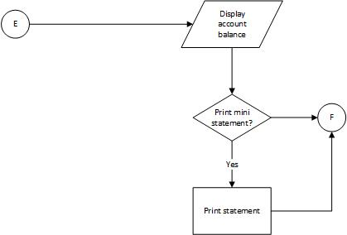

* 1. **Change Password**



* 1. **Fund Transfer**

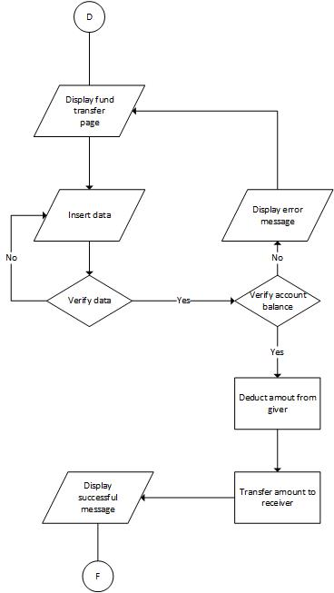

1. **Database Design**
   1. **Entity Relationship Diagram**

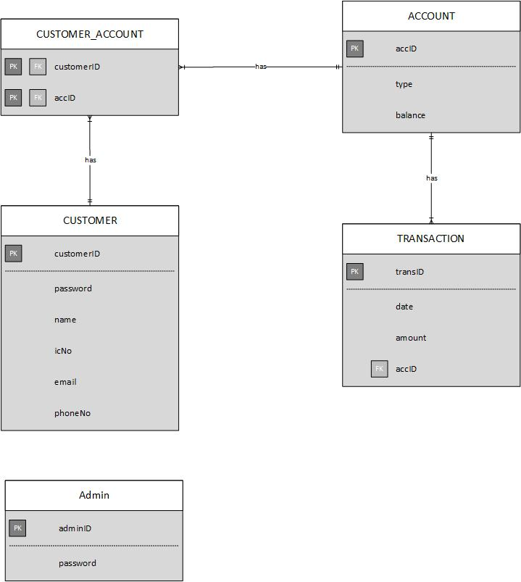

* 1. **Data Dictionary**



1. **Interface Sketches**