From Official Statistics to Sound: Testing Each Link of Moodscape, a Data-to-Music System for South Korean Places
[Participant Name]^{1*}
¹[School Name], [City], Republic of Korea
Abstract Maps convey differences between places only visually. We built Moodscape, a web prototype that turns official regional statistics into music, and tested each link from data to sound. Nine official indicators for 17 Korean provinces give an activity score and a visitor-pleasantness score; rules turn them into tempo, mode and style for 75 places; 20 tracks were generated with Suno and measured with librosa. The regional ranking was sensitive to its weights (median ρ = 0.87), and region explained only 12.2% of landmark-score variance. The requested mode was detected in 5/10 and 7/10 tracks, and all five minor-key requests came back major. The requested tempo was among the three strongest rhythmic peaks in 7/10 and 9/10 clips (about 1.5 expected by chance), yet one clip measured at 95.3 BPM was tapped at 48 BPM by a listener and reached 96 BPM only after time-axis correction. Listener, field and accessibility studies are prepared but not yet run.

Key Words : Generative music, ISO 12913, Sonification, Soundscape, Validation

1. Research Motivation
Maps show how places differ through color and labels, so a person who cannot see the screen does not learn which regions are busy and which are quiet. Sound can carry some of the same information, and sonified maps for users with visual impairment have precedent [6]. Turning data into sound raises a second problem, however. Soundscape research defines a soundscape as the acoustic environment as perceived by people in context [1] and measures it on two perceptual axes, Pleasantness and Eventfulness [2–4]. Oberman et al. collected 443 questionnaires at 28 points in protected natural areas and showed that perceived sound-source dominance and psychoacoustic measures predicted perception better than sound pressure level alone [5]. A single computed “mood” number therefore cannot be assumed to match what a place sounds like or what a listener hears.
This project starts from both problems. We need a tool that expresses a place’s character as music from official statistics, and because that tool is a chain (data → score → musical specification → generated audio → perception) in which every link can fail on its own, each link has to be tested separately.
2. Objectives and Research Questions
The objectives are (1) to build Moodscape, a reproducible web prototype that turns official regional statistics into musical specifications for South Korean places; (2) to test each link of the chain as its own research question (RQ), to find out which links are strong and which are weak; and (3) to derive concrete improvements from the results.
• RQ1. How do official statistics become a regional activity score, and is the ranking stable when the weights change?
• RQ2. How do regional values become landmark scores?
• RQ3. How does a score become a tempo, mode and style specification, and which rule decides each choice?
• RQ4. Does generated audio carry the specification, and what changes that?
• RQ5. How do the AI components (Gemini style prediction, request format) change the specification?
• RQ6–RQ8. Listener perception, perception in real places, and accessibility for blind users (protocols ready; no data).
3. Methodology
3.1 System design: from data to sound
The idea is to map a region’s activity onto tempo and pitch, and visitor satisfaction onto major or minor mode. Fig. 1 shows the implemented chain and the research question that tests each link. The web app uses static HTML/JavaScript and a D3 map, and for 17 provinces and 75 landmarks shows a score, the musical specification, photos, an explanation and generated audio [17][18].
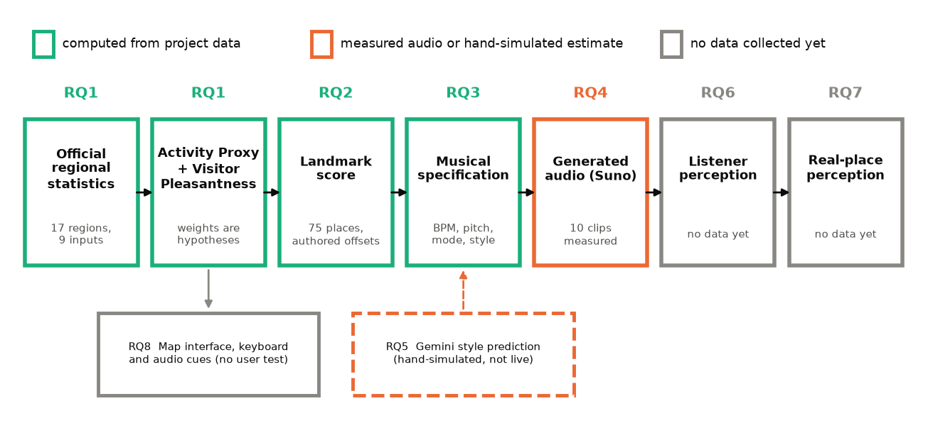
Fig. 1. The chain tested in this study. Each box is one link, labelled with the research question that tests it. Green: computed from project data; orange: measured on generated audio or hand-simulated; gray: no data collected yet.
Data and scores (RQ1, RQ2). Nine official inputs are used for 17 regions: 2025 population and density (Statistics Korea [7]); 2024 domestic tourism trips and four visitor-survey measures (overall satisfaction, recommendation, revisit intention, crowding satisfaction; National Travel Survey [8]); and 2023 noise and vibration complaints and regulated noise-emitting facilities (Ministry of Environment [9]). All values were transcribed by hand with a link to their source; nothing was scraped. Five activity components (density, trips per resident, complaints and facilities per 100,000 residents, crowding pressure = 100 − crowding satisfaction) are log1p-transformed, min–max scaled across the 17 regions and combined:
Activity Proxy = 100 × (0.35 density + 0.30 tourism + 0.15 complaints + 0.10 facilities + 0.10 crowding)
Visitor Pleasantness = 0.40 overall + 0.25 recommendation + 0.20 revisit + 0.15 crowding satisfaction
The weights are stated design hypotheses, not fitted coefficients, and the Activity Proxy is not an ISO 12913 Eventfulness coordinate; a field study to compare it with perception (RQ7) is designed separately. A landmark score is the region’s Activity Proxy plus an offset set by the researcher, clipped to [0, 1], and the app labels it “illustrative”.
Musical specification (RQ3). Tempo is round(42 + 110 × score) BPM, giving 42–138 BPM across the 75 landmarks; pitch is round(12 × score) semitones above A4 (440 Hz). Mode is decided by three rules in order: minor for solemn places (memorial, cemetery, observatory, cave); major for traditional, natural or administrative places (hanok, temple, palace, park, beach, government); otherwise major if the region’s Visitor Pleasantness is at or above the median of the 17 regions (77.72) and minor if below. Genre and mood words are chosen by place category and score band and joined with a scene sentence, a mode sentence, the tempo, instrumentation and a vocal directive into one generation request. Audio is generated with Suno model V4_5 through sunoapi.org. Gemini (gemini-3.5-flash-lite) can suggest genre, instruments and mood from a photo, but tempo, mode, root note and vocals are passed in as fixed values it cannot change. For non-visual use, every region is a keyboard stop with a screen-reader label, focus plays the score as pitch with east–west position as stereo pan, and arrow keys move to the nearest region.
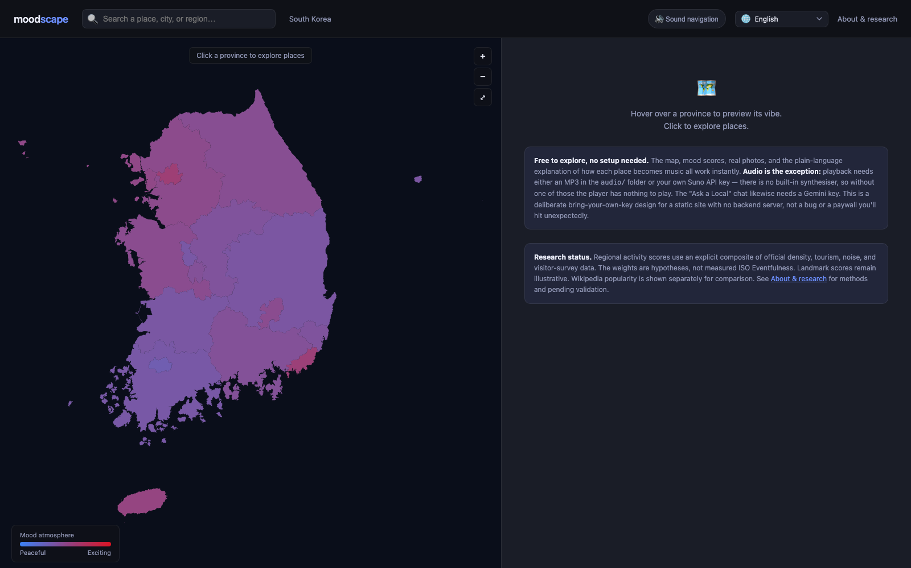
Fig. 2. Start screen of the web app (current development branch). Region color is the activity score (blue calm, red active); choosing a region opens each landmark’s score, musical specification, photos and generated audio. The panel states that audio needs an MP3 or the user’s own Suno key and that the score weights are hypotheses.
3.2 Verification design
Each link has an evidence class: computed (from project data and code), measured (generated audio analyzed by software), hand-simulated (a researcher followed a function’s instructions by hand; not live model output), or pending (no data). All statistics are recomputed by the repository’s analysis scripts with seed 20260920 [17].
• RQ1 weight sensitivity. Spearman correlation of each component with the score; agreement after dropping one component; and 10,000 weight vectors drawn from a Dirichlet distribution centered on the stated weights (concentration 20) and 10,000 from a flat Dirichlet. The order of the two regions with published soundscape values (Seoul [10] and Daejeon) was compared.
• RQ2 variance partition. η² and ICC(1) of the 75 landmark scores grouped by region; association of a log English-Wikipedia readership index (Sep 2025–Aug 2026) [11] with the score by permutation test.
• RQ4 audio measurement. Ten landmarks at rank quantiles of the 75 scores (Gangnam included as a minor-key case) were generated twice: round 1 with the original text and a single free-text request, round 2 with the revised text and Suno’s custom request shape. Audio was analyzed with librosa 1.0.0 [12]. Key is the major or minor key whose Krumhansl–Kessler profile [13] correlates best with the chroma vector; that correlation is reported as the key-fit score (not a probability). Tempo was assessed both as the single global estimate and as whether the request (±5%) is among the three strongest tempogram peaks; the chance level comes from 20,000 shuffles of the requests among clips. Rates carry Clopper–Pearson intervals [14]; 2×2 contrasts use Fisher’s exact test.
• Variables. Independent: request wording (position and phrasing of the mode sentence), request shape (single text vs custom), genre words. Dependent: detected mode and tempo. Controlled: model version (V4_5), analysis procedure and version. Because the generator is stochastic, a single success was never counted as an improvement.
• Human pulse check. For one Sejong clip, one informal listener who did not know the target tapped the main pulse of anonymous 25-second files. This is an engineering diagnostic with n = 1, not the listener experiment (RQ6).
4. Results
4.1 RQ1: a plausible regional order that is sensitive to the weights
The Activity Proxy ranged from 32.9 to 61.3; Seoul, Busan and Jeju scored highest and Gwangju lowest. Visitor Pleasantness occupied a narrow band (75.0–81.7). The effective influence of the components did not follow the stated weights (Table 1): tourism, weighted 0.30, had almost no rank association with the score (ρ = -0.07), while dropping density reduced agreement with the full ranking to ρ = 0.23. Under perturbation near the stated weights the median agreement was ρ = 0.87, but the 5th percentile was 0.34 and only 41.8% of draws kept ρ ≥ 0.9 (Fig. 2). The two regions with published values were in the same order as the model (Seoul 61.3, 1st; Daejeon 44.6, 10th; published Eventfulness 78 and 45), but two points can expose a contradiction, not validate a model.
Table 1. Stated weight and actual influence of each Activity Proxy component (17 regions). ρ (component): Spearman correlation of the scaled component with the score; ρ (drop): agreement of the ranking recomputed without that component.
Component | Weight | ρ (component) | ρ (drop)
Population density | 0.35 | 0.45 | 0.23
Tourism trips per resident | 0.30 | -0.07 | 0.60
Complaints per 100,000 | 0.15 | 0.68 | 0.85
Facilities per 100,000 | 0.10 | -0.20 | 0.91
Crowding pressure | 0.10 | 0.65 | 0.94

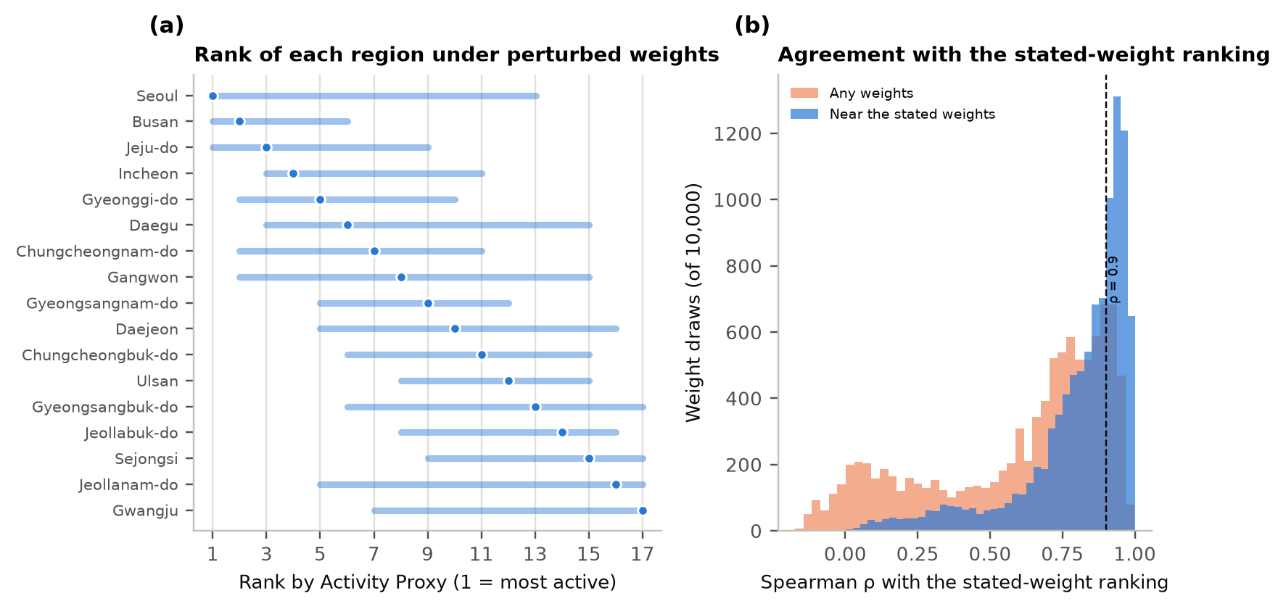
Fig. 3. Sensitivity of the Activity Proxy to its weights. (a) Rank under the stated weights (dot) and 95% range across 10,000 perturbed weight vectors (bar). (b) Distribution of Spearman ρ between perturbed and stated rankings; blue: near the stated weights, orange: arbitrary weights; dashed line ρ = 0.9.
4.2 RQ2: landmark sound comes mostly from authored offsets
Region explained 12.2% of landmark-score variance (η²), and ICC(1) was indistinguishable from zero; landmark offsets (SD 0.21) varied far more than regional scores (SD 0.08). Place-level sound therefore reflects the researcher’s judgment more than official statistics, which the app discloses. The Wikipedia readership index was weakly related to the landmark score across 58 landmarks (ρ = 0.25, permutation p = 0.062), not distinguishable from zero at the 5% level; it measures online attention, not footfall or noise, and never changes the music.
4.3 RQ3: Visitor Pleasantness decides the mode for less than half of the places
Category rules decided the mode for 40 of 75 landmarks (53.3%); the Pleasantness rule decided 35 (46.7%) (Table 2), and 21 landmarks request minor. Because the 17 Pleasantness values lie within 6.7 points and 6 regions sit within one point of the median, small survey differences become a categorical major/minor difference; and because the value is regional, every default-rule place in a region (e.g. Hongdae, Gangnam, N Seoul Tower) shares one decision.
Table 2. Which rule decides the requested mode (current code, 75 landmarks). Rules are applied in this order.
Deciding rule | Major | Minor | Places
Solemn (memorial, cemetery, observatory, cave, …) | 0 | 6 | 6
Traditional/nature (hanok, temple, palace, park, beach, government, …) | 34 | 0 | 34
Regional Visitor Pleasantness (vs median of 17 regions) | 20 | 15 | 35
Total | 54 | 21 | 75

4.4 RQ4: generated audio follows the request only in part
In round 1 the requested mode was detected in 5 of 10 tracks (95% interval 19–81%): 5/7 major and 0/3 minor requests. Round 2 reached 7/10 (35–93%), but minor requests were again 0/2 (Table 3, Fig. 3). The round-2 gain includes Sejong changing to a major request after a factual correction, and clips 05, 06 and 08 flipped without any change in request, consistent with random variation, so the gain cannot be attributed to the rewording. The Gangnam miss (A♯ major) had a key-fit score of 0.92, so the detector was not undecided.
Table 3. Requests and measurements for the ten landmarks. Measured BPM is librosa’s single estimate; ✓ requested mode detected, ✗ other mode. Sejong (07) requested minor in round 1 and major in round 2.
Clip | Landmark | Score | Req. BPM | R1 BPM | R2 BPM | Mode asked | R1 key | R2 key
01 | Gyeongbokgung Palace | 0 | 42 | 122 | 131 | major | D♯ major ✓ | A major ✓
02 | Hanbat Arboretum | 19 | 62 | 125 | 125 | major | D♯ major ✓ | B major ✓
03 | Naganeupseong Folk Village | 24 | 68 | 131 | 131 | major | G major ✓ | C major ✓
04 | Korean Folk Village | 30 | 75 | 152 | 75 | major | D♯ major ✓ | C♯ major ✓
05 | Oeam Folk Village | 35 | 81 | 161 | 161 | major | B minor ✗ | C♯ major ✓
06 | Gunsan Modern History Street | 41 | 88 | 44 | 60 | major | C major ✓ | B minor ✗
07 | Government Complex Sejong | 48 | 95 | 128 | 95 | minor→major | D♯ major ✗ | D♯ major ✓
08 | Kia AutoLand Gwangju | 59 | 107 | 144 | 144 | major | G minor ✗ | B major ✓
09 | Gangnam | 66 | 115 | 115 | 117 | minor | A♯ major ✗ | G♯ major ✗
10 | Hyundai Motor Asan Plant | 87 | 138 | 137 | 137 | minor | D major ✗ | D major ✗

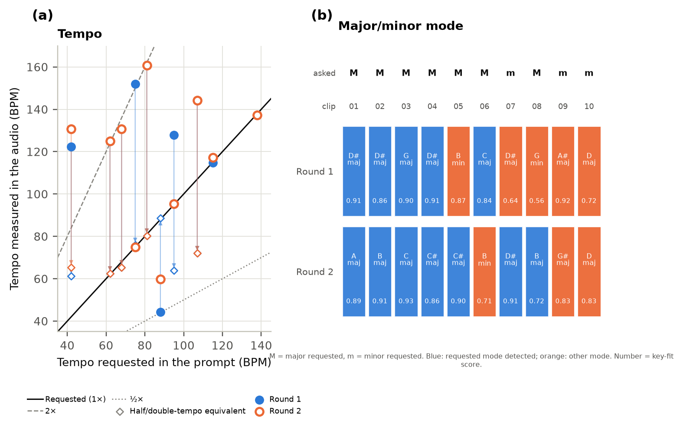
Fig. 4. Generated audio against the specification. (a) Requested vs measured tempo, round 1 (filled) and round 2 (open); solid line exact agreement, dashed and dotted lines double and half tempo; diamonds are the half- or double-tempo reading of the same number (the audio is unchanged). (b) Detected key and key-fit score per clip; blue requested mode, orange other mode.
Judged by the single estimate, tempo was barely followed: the rank correlation between requested and measured tempo was ρ = 0.07 (round 1) and 0.08 (round 2), and nine of ten round-1 estimates fell between 114 and 161 BPM. Yet the requested tempo was among the three strongest tempogram peaks in 7/10 and 9/10 clips, against about 1.5 and 1.6 expected by chance (permutation p < 0.0001 in both rounds). The requested pulse is usually present, but often not the strongest metrical level. The slowest request, 42 BPM, never appeared among the top peaks in five generations.
4.5 The pulse a person heard: the Sejong 95 BPM case
The round-2 Sejong clip requested 95 BPM and the automatic estimate was 95.3 BPM, so it looked like a success. One informal listener who did not know the target tapped its main pulse at 48 BPM (Table 4). A regeneration that strictly required a 95 BPM quarter-note pulse was also tapped at 48 BPM, and the source with an exact 95 BPM kick and rim overlaid at 47 BPM, the added pulse being absorbed as a subdivision of the slow beat. Finally the time axis was compressed 2.021× with pitch preserved, from the human measurement of 47 BPM to the 95 BPM target, and the conflicting hi-hat was replaced by one hit per quarter note; the new anonymous file was tapped at 96 BPM (1.1% error; criterion ±5% set before the test) [20][21].
Table 4. Perceptual-tempo diagnosis and correction for the Sejong clip. Automatic values are librosa estimates; human values are blind taps by the same single listener. The last row is post-processed audio, not a raw generation.
Stage | Target | Automatic BPM | Human tap | Decision
Round-2 Suno source | 95 | 95.3 | 48 | Fail
Regenerated with strict 95 BPM request | 95 | 95.3 | 48 | Fail
Source + 95 BPM kick and rim | 95 | 95.3 | 47 | Fail
47→95 time-axis correction + hi-hat replacement | 95 | 95.3 | 96 | Pass (1.1%)

This is a sequential engineering diagnostic at one place with one listener (n = 1); it does not estimate an effect size or success rate. It does show that an automatic BPM match does not guarantee the pulse a person perceives, and that where exact tempo carries meaning, deterministic post-processing rather than the generator should be responsible for tempo.
4.6 What changes the mode: genre words
The two places that kept failing to come back minor, Gangnam and the Asan plant, were generated further (Fig. 4). For Gangnam, none of the five generations that kept the original genre words (“lo-fi hip-hop, city-pop”) was minor, regardless of wording, request shape or an explicit root; one of two was minor without genre words, and three of three when the genre was swapped to “dark synth-pop, moody downtempo” [22]. The same swap gave 0/3 for Asan. Pooling all 21 minor requests, 9 (42.9%) came back minor, and no single factor was distinguishable from chance at this sample size (custom 8/15 vs single-text 1/6, Fisher p = 0.178). Gangnam’s 3/3 vs 1/7 (p = 0.033) is one of several uncorrected exploratory comparisons. The requested root note was matched in only one of three Gangnam minor tracks.
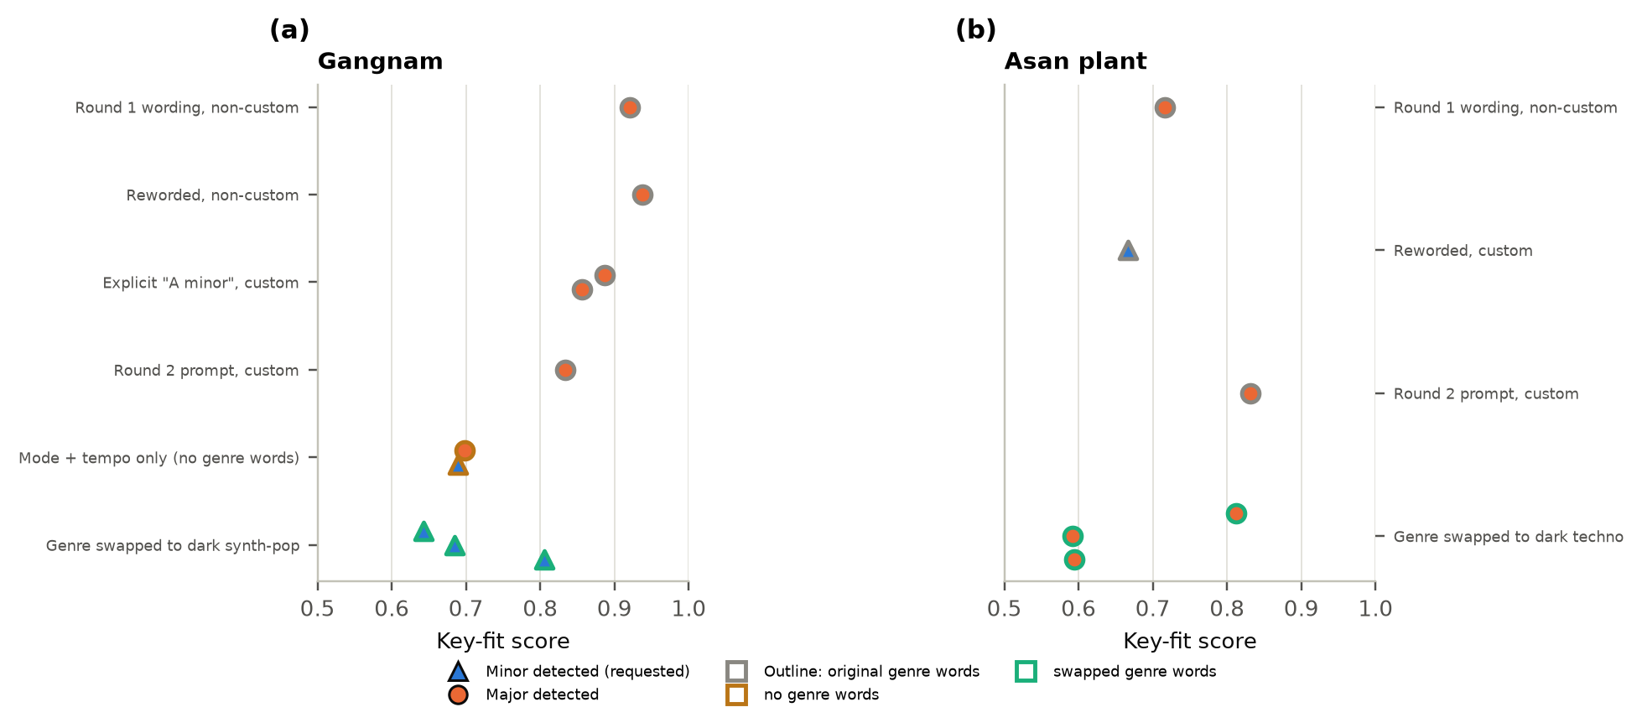
Fig. 5. Every generation for the two minor-key places. Triangles: minor detected (as requested); circles: major detected. Outline: gray original genre words, brown no genre words, green swapped genre words. (a) Gangnam (b) Asan plant.
4.7 RQ5–RQ8
The Gemini style predictor is implemented and its request format and model identifier were checked, but no output from a key-backed run is recorded in the repository. The comparison of rule-based mode with photo-based prediction is therefore a hand simulation (a researcher applied the function’s instructions to the real photos and text): four of five places agreed, and only Hongdae differed. For the listener experiment (RQ6) a preregistered protocol, a blinded rating form and an analysis script (Spearman ρ, permutation test, pairwise ordering accuracy, ICC [15], Lin’s concordance [16]) are ready, but no participant data exist. The field study (RQ7) has a 47-column observation template and a Korean questionnaire, and accessibility (RQ8) has implemented features and technical checks only, with no evaluation by blind users.
5. Feedback-driven Improvements
Results and feedback were turned directly into fixes (Table 5). The clearest gains came from repairing the project’s own rules and data rather than from rewording the request to a third-party model.
Table 5. Problems found through testing and feedback, and the fixes.
Problem found | Fix | Outcome
Keyword collision (“complex”) gave the Sejong government complex a semiconductor-plant style | New institutional category | Style corrected; later generations at 95.3 BPM
Missing fact: Sejong is a planned city with many young families (user feedback) | Government added to major rule; description updated | D♯ major, key-fit 0.94
Bright words (“warm, mellow”) next to a minor request | Remove bright words when minor | Necessary, not sufficient (Gangnam failed)
Mode word buried at the end of a long adjective list | Mode as an early sentence; root as “around” | Root still not controlled
Automatic BPM match differed from the human pulse | Time-axis correction + hi-hat replacement | One listener tapped 96 BPM (1.1%)
Key passed through a public relay; AI prompt ignored; unfinished audio returned | Direct calls; use the prompt shown; wait for completion | Checked with a mocked network

6. Conclusions, Limitations and Future Plans
Moodscape makes the chain from official statistics to sound traceable end to end, and its first four links were tested by computation and measurement. The regional order is plausible but weight-sensitive; landmark scores are mostly the researcher’s judgment; the mode rule is coarse and regional; and the generator did not honor minor-key requests (0/5 across the two rounds) or guarantee the pulse a person perceives. In the Sejong case, deterministic time-axis correction brought the perceived pulse to the target. These results matter for interpreting any listener study: if the audio does not carry the requested tempo and mode, a weak listener result cannot separate a failure of perception from a failure of generation.
Limitations. Twenty tracks plus about twenty follow-ups from one provider and model version; follow-up comparisons were not preregistered and changed several things at once; the only human check is one listener tapping one clip, and all other modes and tempos are automatic detections; weights are not fitted and landmark scores are not measured; the inputs for Seoul and Daejeon sit outside the 15-region source file and still need provenance reconciliation; no Gemini output is recorded.
Future plans. In order of value per effort: (1) several listeners tap every clip blind and a trained musician identifies the mode; (2) generate each request several times before claiming any change works; (3) test the genre-word hypothesis at more places; (4) freeze one clip set and run the listener experiment with 15–24 adults; (5) run a field pilot at 6–10 sites in two time windows; (6) check Gemini with a live key; (7) evaluate the interface with blind and low-vision users when possible; (8) calibrate the hypothesised weights with field data. Where tempo carries meaning, we propose using generated audio as harmonic and timbral material and enforcing tempo with deterministic correction.
Data availability and use of AI tools. All inputs, analysis scripts and generated audio are public in the project repository [17–22]; generated audio remains subject to the provider’s terms and photographs keep their own licenses. The system uses Gemini and Suno as components. The analysis scripts and parts of this manuscript were prepared with the assistance of Claude (Anthropic) under the researcher’s direction; every number was recomputed from repository data, and the researcher is responsible for the content.
References
[1] International Organization for Standardization, ISO 12913-1:2014 Acoustics — Soundscape — Part 1: Definition and conceptual framework, ISO, 2014.
[2] International Organization for Standardization, ISO/TS 12913-2:2018 Acoustics — Soundscape — Part 2: Data collection and reporting requirements, ISO, 2018.
[3] International Organization for Standardization, ISO/TS 12913-3:2019 Acoustics — Soundscape — Part 3: Data analysis, ISO, 2019.
[4] Östen Axelsson, Mats E. Nilsson, Birgitta Berglund, A principal components model of soundscape perception, The Journal of the Acoustical Society of America, 128, 5, 2836–2846, 2010. doi:10.1121/1.3493436
[5] Tin Oberman, Arianna Latini, Francesco Aletta, Giacomo Gozzi, Jian Kang, Simone Torresin, Human sounds and associated tonality disrupting perceived soundscapes in protected natural areas, Scientific Reports, 15, 1, 28759, 2025. doi:10.1038/s41598-025-08524-y
[6] Haixia Zhao, Catherine Plaisant, Ben Shneiderman, Jonathan Lazar, Data sonification for users with visual impairment: a case study with georeferenced data, ACM Transactions on Computer-Human Interaction, 15, 1, 1–28, 2008. doi:10.1145/1352782.1352786
[7] Statistics Korea, e-National Indicators: Population density, Statistics Korea, 2025, https://www.index.go.kr/unity/potal/eNara/sub/showStblGams3.do?freq=Y&idx_cd=1007&period=N&stts_cd=100701, accessed Sep 2026.
[8] Korea Tourism Organization, 2024 National Travel Survey (tables 19-2-1, 19-14-1, 20-2-1, 21-2-1), Korea Tourism Data Lab, 2025, https://datalab.visitkorea.or.kr/site/portal/ex/bbs/View.do?bcIdx=309282&cbIdx=1127, accessed Sep 2026.
[9] Ministry of Environment (Korea), 2023 noise and vibration complaints and regulated emission facilities, Ministry of Environment, 2024, https://me.go.kr, accessed Sep 2026.
[10] Joo Young Hong, Jin Yong Jeon, Comparing associations among sound sources, human behaviors, and soundscapes on central business and commercial streets in Seoul, Korea, Building and Environment, 186, 107327, 2020. doi:10.1016/j.buildenv.2020.107327
[11] Wikimedia Foundation, Analytics API: page views, Wikimedia Foundation, 2026, https://doc.wikimedia.org/generated-data-platform/aqs/analytics-api/reference/page-views.html, accessed Sep 2026.
[12] Brian McFee, Colin Raffel, Dawen Liang, Daniel Ellis, Matt McVicar, Eric Battenberg, Oriol Nieto, librosa: Audio and Music Signal Analysis in Python, Proceedings of the 14th Python in Science Conference, 18–24, 2015. doi:10.25080/Majora-7b98e3ed-003
[13] Carol L. Krumhansl, Edward J. Kessler, Tracing the dynamic changes in perceived tonal organization in a spatial representation of musical keys, Psychological Review, 89, 4, 334–368, 1982. doi:10.1037/0033-295X.89.4.334
[14] C. J. Clopper, E. S. Pearson, The use of confidence or fiducial limits illustrated in the case of the binomial, Biometrika, 26, 4, 404–413, 1934. doi:10.1093/biomet/26.4.404
[15] Patrick E. Shrout, Joseph L. Fleiss, Intraclass correlations: Uses in assessing rater reliability, Psychological Bulletin, 86, 2, 420–428, 1979. doi:10.1037/0033-2909.86.2.420
[16] Lawrence I-Kuei Lin, A concordance correlation coefficient to evaluate reproducibility, Biometrics, 45, 1, 255–268, 1989. doi:10.2307/2532051
[17] Moodscape project, Source code, data and analysis scripts, GitHub, 2026, https://github.com/clairenah19/sound-moodscape/tree/ksef2027-submission/, accessed Nov 2026.
[18] Moodscape project, Web demo, GitHub Pages, 2026, https://clairenah19.github.io/sound-moodscape/, accessed Nov 2026.
[19] Moodscape project, Generated audio (round 1 clip01–10, round 2 v2_clip01–10, follow-ups), GitHub, 2026, https://github.com/clairenah19/sound-moodscape/tree/ksef2027-submission/research/listener_clips, accessed Nov 2026.
[20] Moodscape project, Sejong clip before tempo correction (tapped at 48 BPM), GitHub, 2026, https://github.com/clairenah19/sound-moodscape/blob/ksef2027-submission/research/listener_clips/clip07_sejong_perceived95_candidate2.mp3, accessed Nov 2026.
[21] Moodscape project, Sejong clip after tempo correction, 25-s listening file (tapped at 96 BPM), GitHub, 2026, https://github.com/clairenah19/sound-moodscape/blob/ksef2027-submission/research/listener_clips/clip07_hihat_fixed_blind_test.wav, accessed Nov 2026.
[22] Moodscape project, Gangnam genre-swap generations, 3 runs (minor 3/3), GitHub, 2026, https://github.com/clairenah19/sound-moodscape/blob/ksef2027-submission/research/listener_clips/clip09_genre_swap_test.mp3, accessed Nov 2026.

