

NAME: OBUONG CLAIRE ANYANGO
ADM NO : BSCCS/2024/52885
COURSE : BACHELOR OF SCIENCE IN COMPUTER SCIENCE
UNIT CODE: BIT3208
UNIT NAME: ADVANCED WEB DESIGN AND DEVELOPMENT
LECTURER NAME : NYORO MICHAEL
ACADEMIC YEAR: YEAR 3

PROJECT TITLE: VOTER REGISTRATION SYSTEM
SELECTED TECHNOLOGIES
• PHP + MySQL
• HTML
• CSS
• JavaScript
• XAMPP
• GitHub
• Canva

GIT HUB LINK
https://github.com/claireobuong/VRS_Project

Week 1: Local Environment Setup

1.1 Installation and Testing of Local Development Environment

Figure 1: Installation of XAMPP

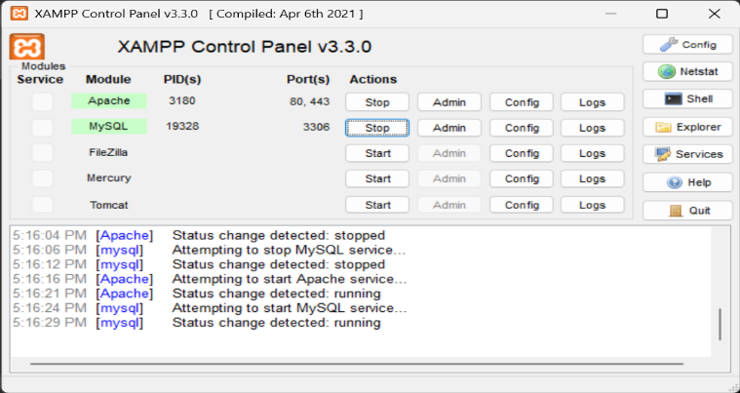
Figure 2: Apache and MySQL Running

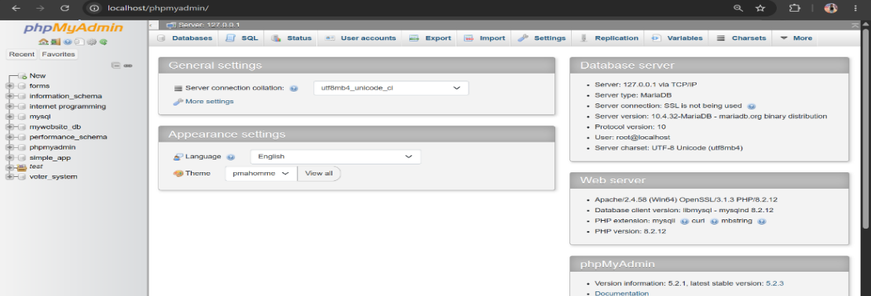
Figure 3: Localhost Test Page

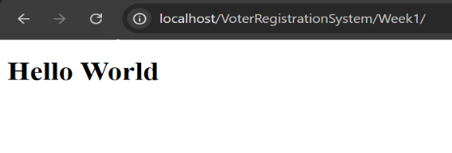
Figure 4: Hello World Test

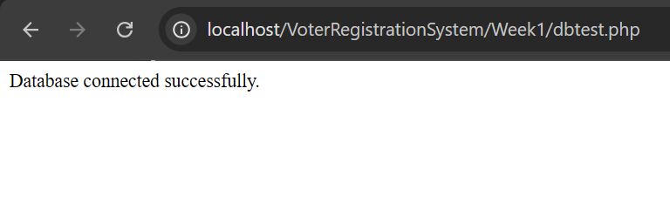
Figure 5: Database Connection Test

1.2 Reflection
This week I learned the basics of web development and project planning. I created the initial structure of the system and designed the user interface. The activities helped me understand the importance of organizing files and building a strong foundation for future development.

Week 2: Wireframes and GUI Design

2.1 User Interface Planning and System Design

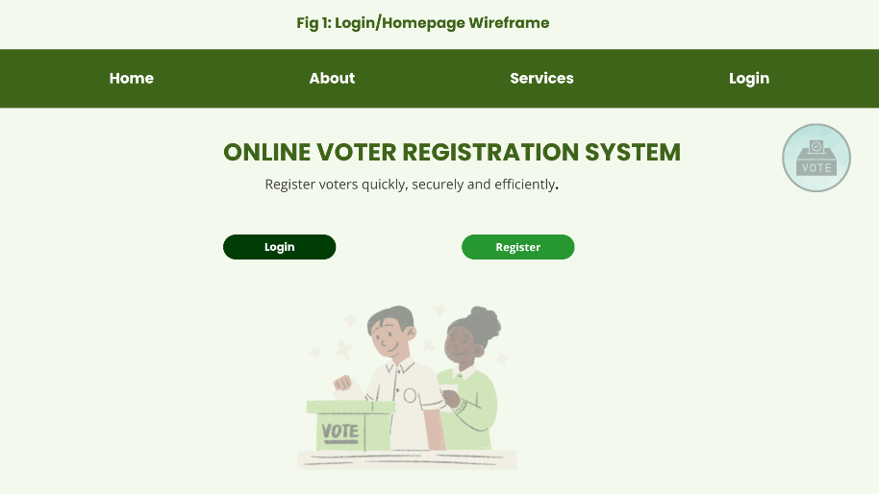
Figure 6: Login/Homepage Wireframe

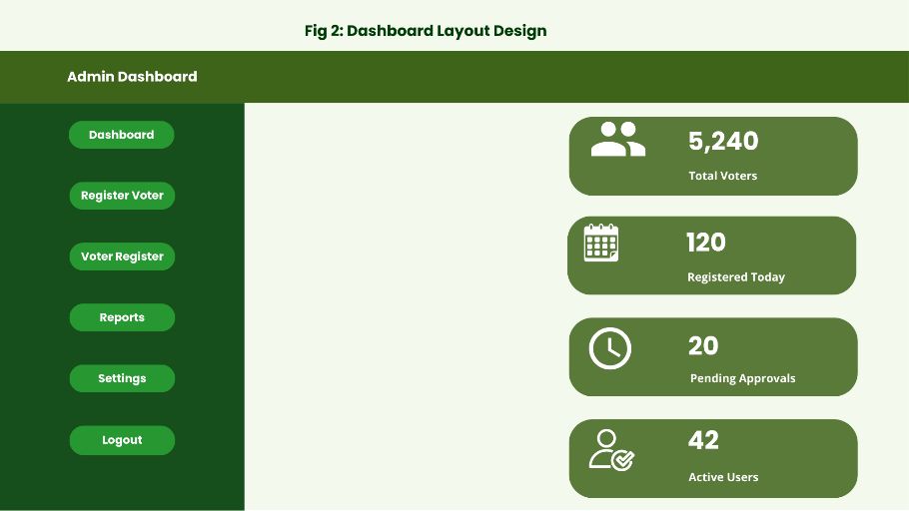
Figure 7: Dashboard Layout Design

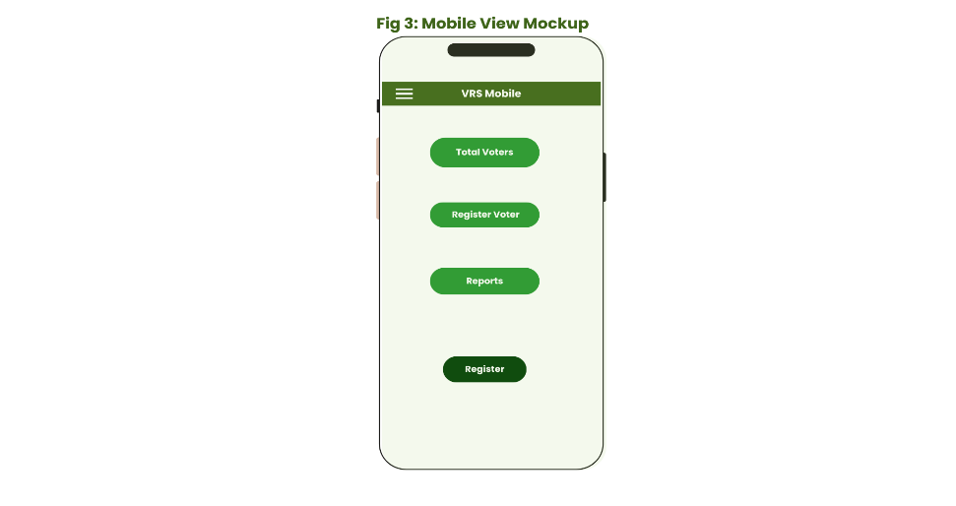
Figure 8: Mobile View Mockup

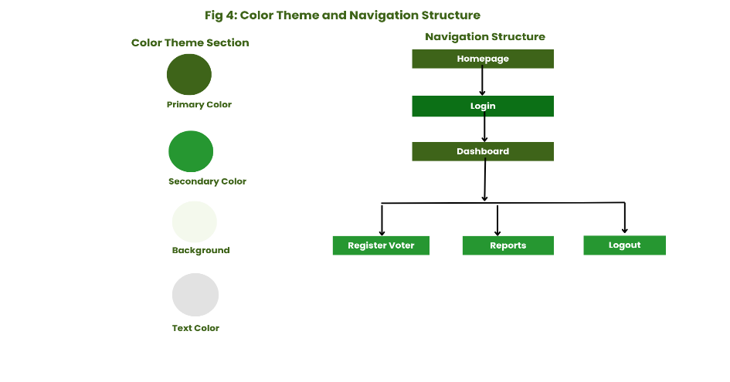
Figure 9: Color Theme and Navigation Structure

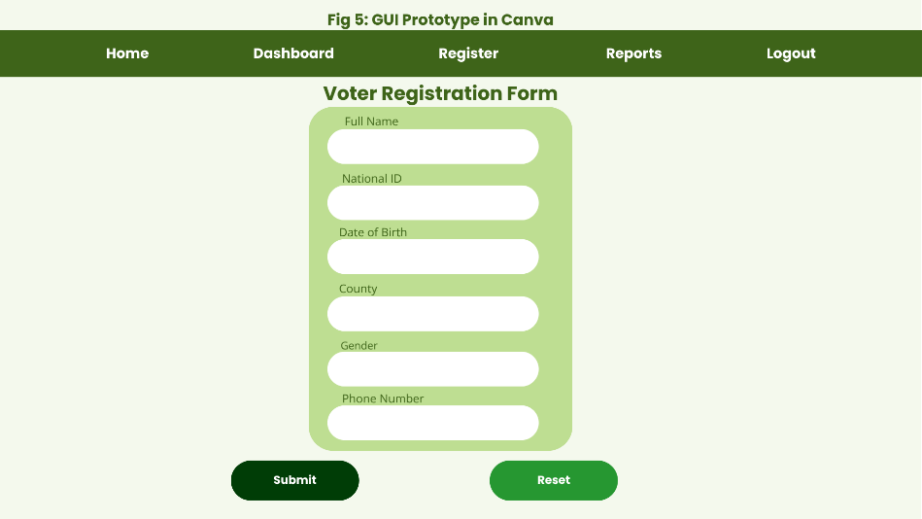
Figure 10: GUI Prototype in Canva

2.2 Project theme
Online Voter Registration System

2.3 Choosen technologies
• PHP
• MySQL
• HTML
• CSS
• JavaScript
• XAMPP
• GitHub
• Canva

2.4 Project Proposal Summary
I designed the Online Voter Registration System to simplify voter registration and management processes through a digital platform. The system allows administrators to register voters, manage records and generate reports efficiently.

2.5 Reflection
The system design was selected to provide a clean and user-friendly interface for voter management. Green and white colors were used to create a professional government-style appearance similar to official registration systems. The navigation structure was planned to reduce user clicks and improve accessibility by placing important modules within easy reach. Mobile responsiveness was also considered to ensure usability on smaller devices. The intended users of the system include election administrators and registration officers who require an organized and efficient platform for managing voter information and reports.

Week 3: Javascripts and PHP basics

3.1 Frontend Interection and Backend Foundations

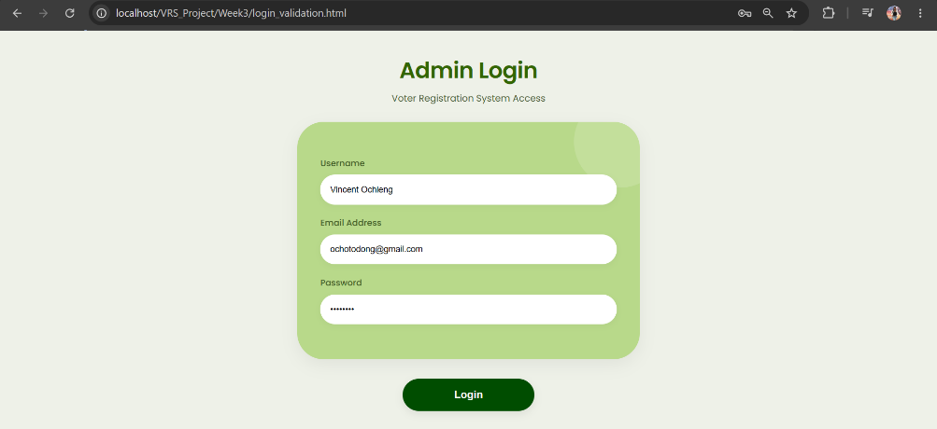
Figure 11: JavaScript Form Validation

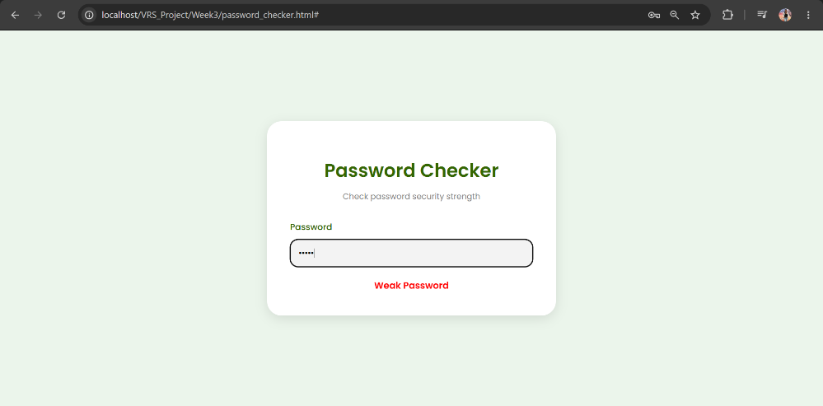
Figure 12: Password Strength Checker
The password I used was 1234 and it was identified as a weak password.
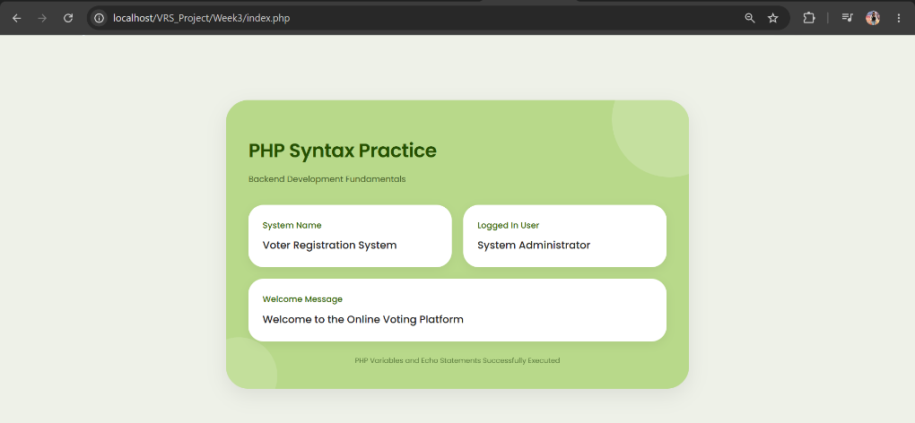
Figure 13: PHP Syntax Practice
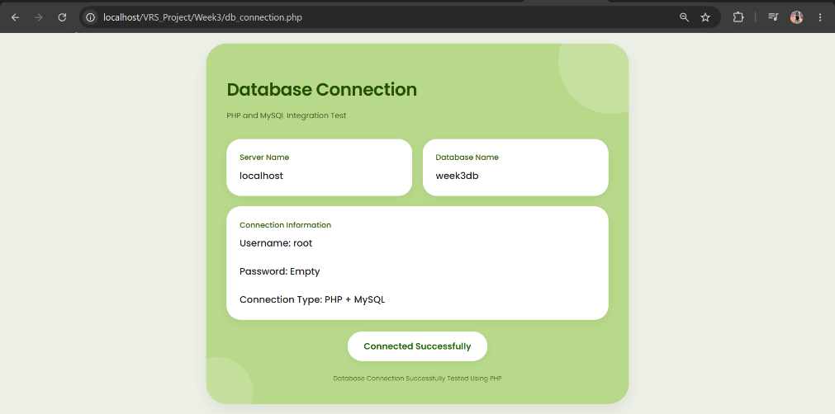
Figure 14: Database Connection Script

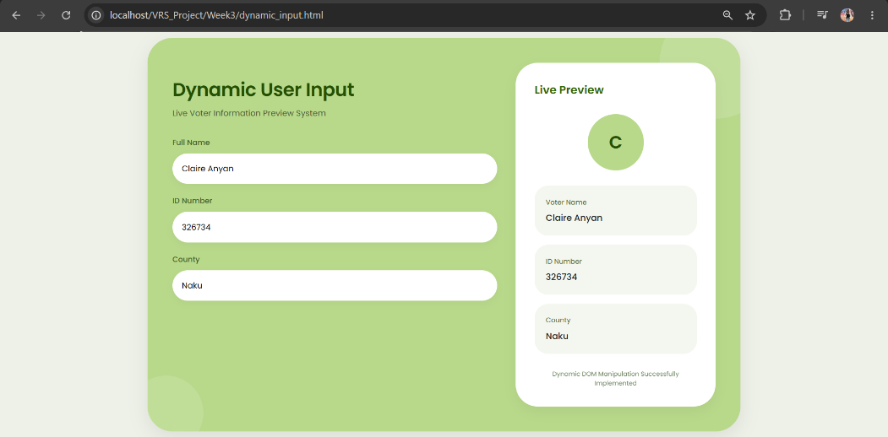
Figure 15: Dynamic User Input Handling

3.2 Reflection
The system used JavaScript for validation and dynamic user interaction. PHP was used for backend scripting and database connection testing. Validation helps prevent empty or incorrect user input. The database connection allows communication between the system and MySQL database. Technologies used include HTML, CSS, JavaScript, PHP, MySQL, XAMPP, and VS Code.

Week 4: Backend Processing and User Authentication

4.1 Server-Side Components and Backend Development Foundations

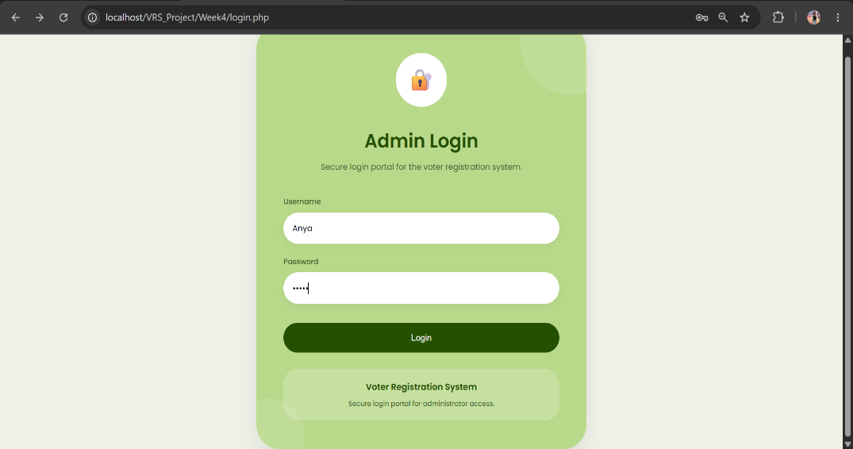
Figure 16: Admin Login Page

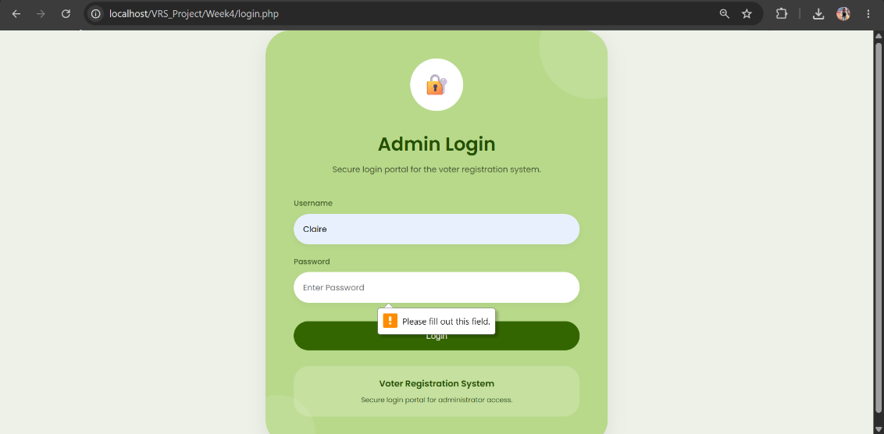
Figure 17: Form Validation System

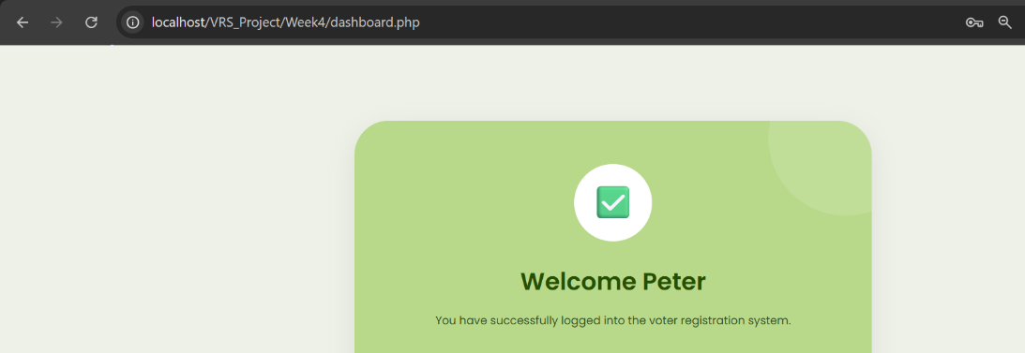
Figure 18: PHP Processing Page

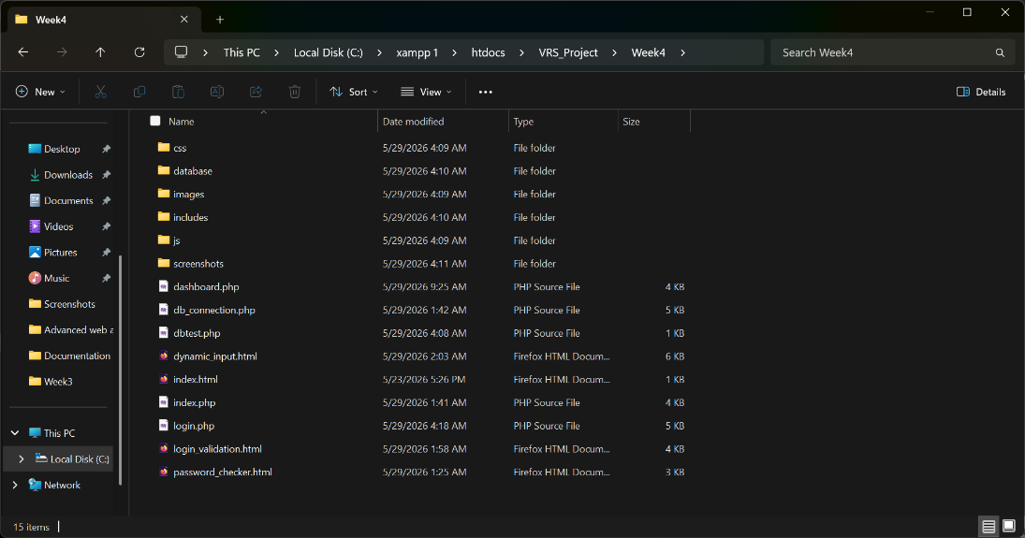
Figure 19: Backend Folder Structure

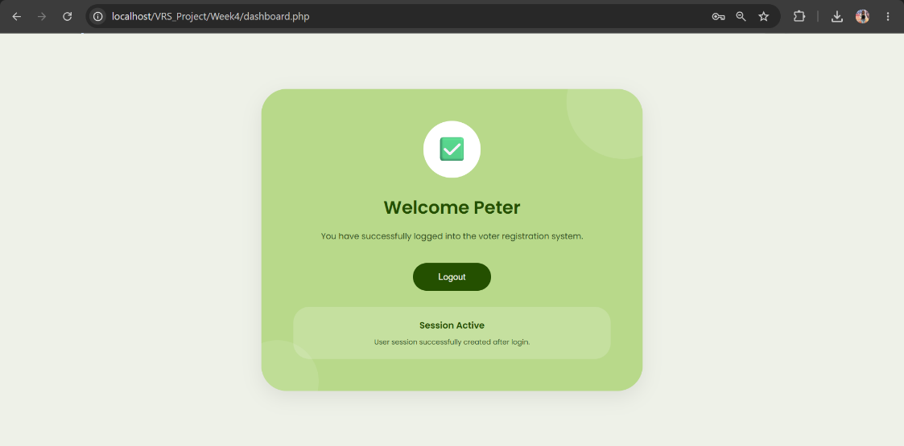
Figure 20: Session Welcome Page

4.2 Reflection
This week I learned how frontend and backend components work together in a web application. I created HTML forms and used PHP to process user input and handle login requests. I also learned the basics of sessions and how they help manage user access after logging in. Organizing project files into folders improved the structure of my system and made development easier. These activities helped me understand the flow of data between users and the server.

Week 5: Database Components and CRUD Operations

5.1 Building Database-Driven Web Applications

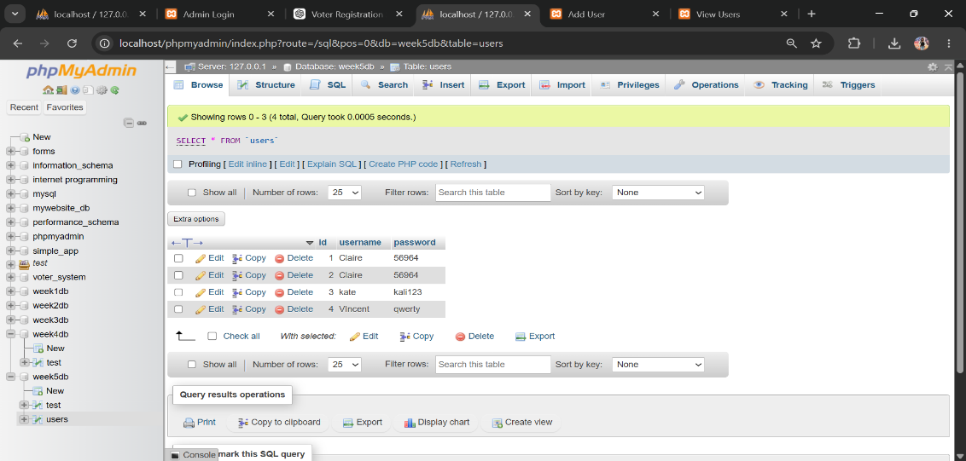
Figure 21: Users Table Creation
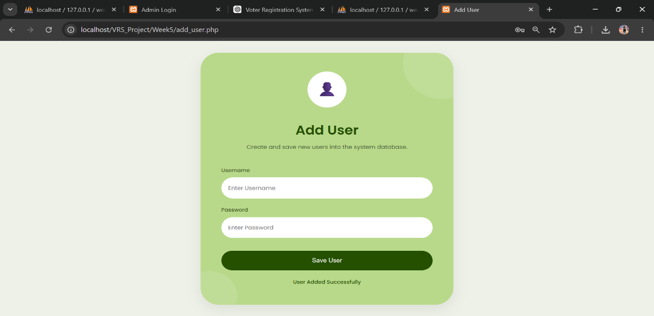
Figure 22: User Record Insertion
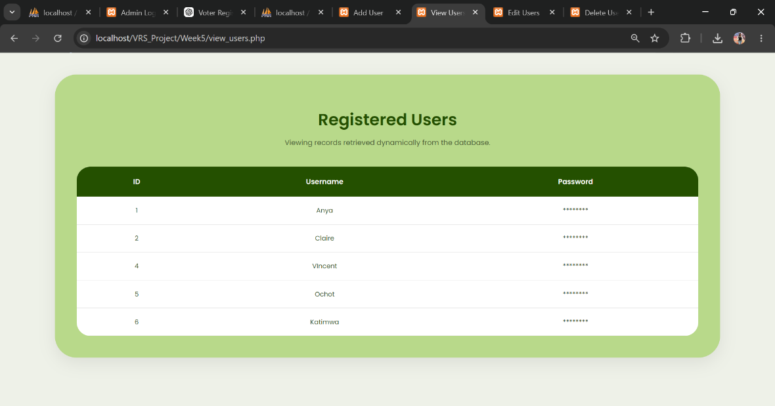
Figure 23: Displaying Database Records

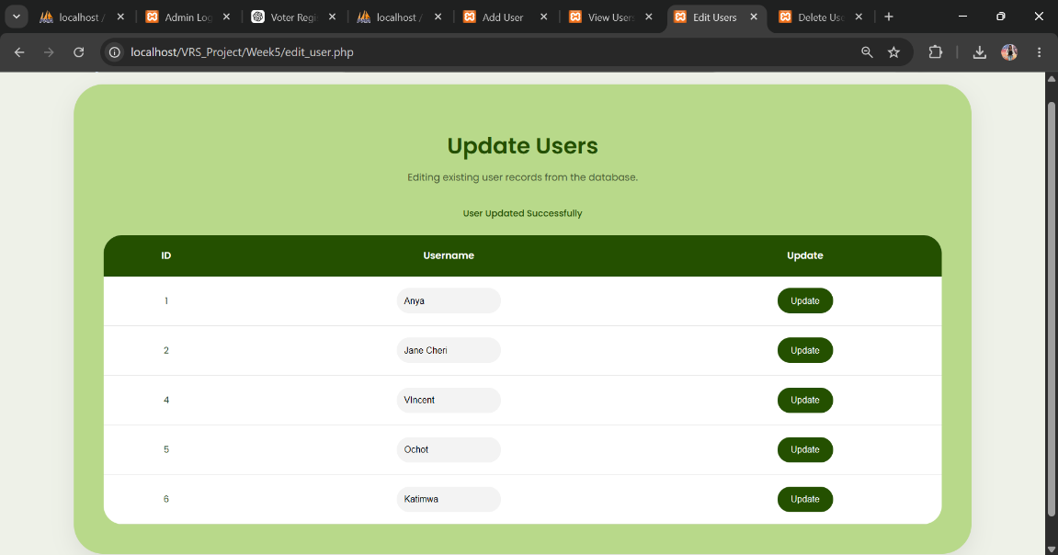
Figure 24: Updating User Records

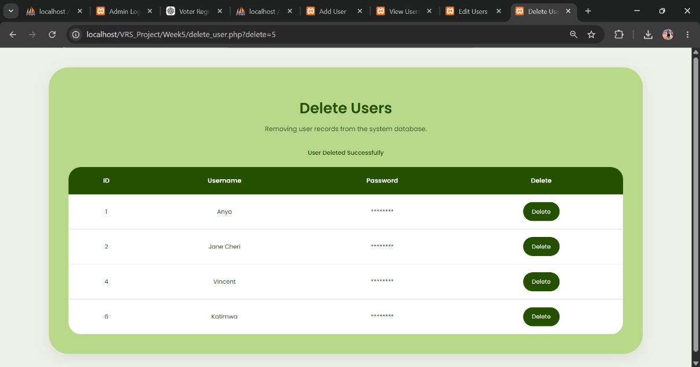
Figure 25: Deleting User Records

5.2 Reflection
This week I learned the importance of databases in web development and how they store and manage information. I created a database and table, then practiced CRUD operations by adding, viewing, updating, and deleting records. I also connected PHP to MySQL to display dynamic data from the database. These practical activities helped me understand how backend systems interact with databases and how data-driven web applications are built.

