

NAME: OBUONG CLAIRE ANYANGO
ADM NO : BSCCS/2024/52885
COURSE : BACHELOR OF SCIENCE IN COMPUTER SCIENCE
UNIT CODE: BIT4138
UNIT NAME: ADVANCED CRYPTOGRAPHY
LECTURER NAME : NYORO MICHAEL
ACADEMIC YEAR: YEAR 3

PROJECT TITLE: Secure File Encryption System
SELECTED TECHNOLOGIES:
Python
VS Code
Python Cryptography Library
OpenSSL
GitHub
GITHUB LINK
https://github.com/claireobuong/advanced-cryptography

Table of Contents
Week 1 6
Installation and Configuration of Cryptography Development Environment 6
1.2 Student Reflection 7
Week 2 8
3.1 Implementation of Classical Encryption Algorithms 8
3.2 Student Reflection 9
Week 3 10
Implementation of Stream Cipher Systems and Random Sequence Analysis 10
10
10
10
11
4.5 Reflection 11
Week 4 12
Advanced Encryption Standard (AES) and Block Cipher Operations 12
5.5 Reflection 13
Week 5 14
Implementation of RSA Encryption and Key Management 14
6.5 Summary 15
7. Creative task 16

Week 1

Installation and Configuration of Cryptography Development Environment
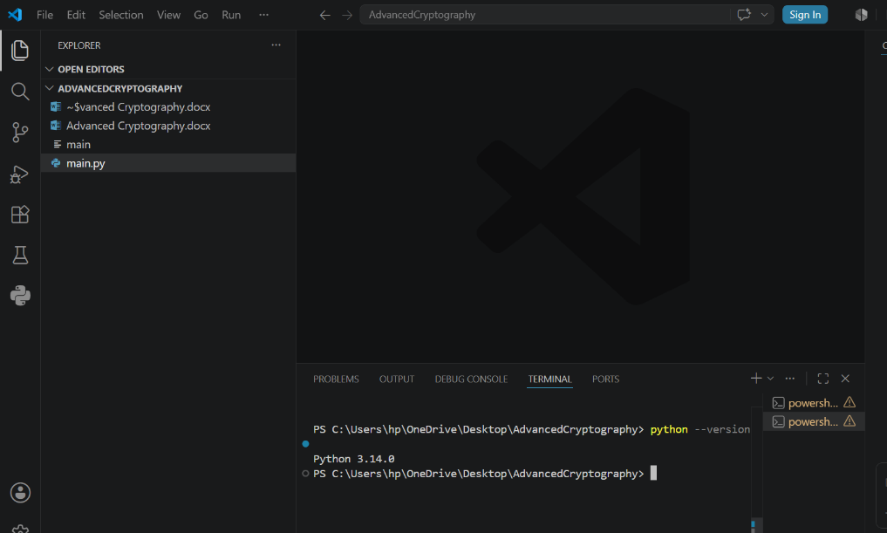
Figure 1: Confirms successful installation of Python and VS Code, providing the development environment required for implementing and testing cryptographic algorithms.

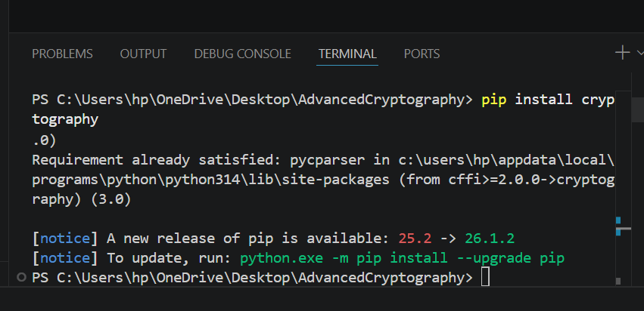
Figure 2: Verifies successful installation of the Python Cryptography library, enabling secure encryption and decryption operations within the project.

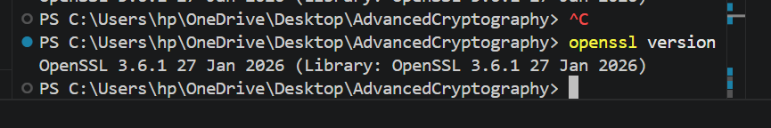
Figure 3: Confirms proper installation and configuration of OpenSSL, a widely used toolkit for generating cryptographic keys and certificates.
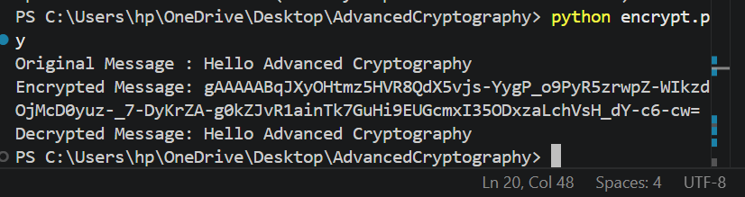
Figure 4: Demonstrates successful execution of a local encryption script, validating the functionality of symmetric encryption and decryption operations.

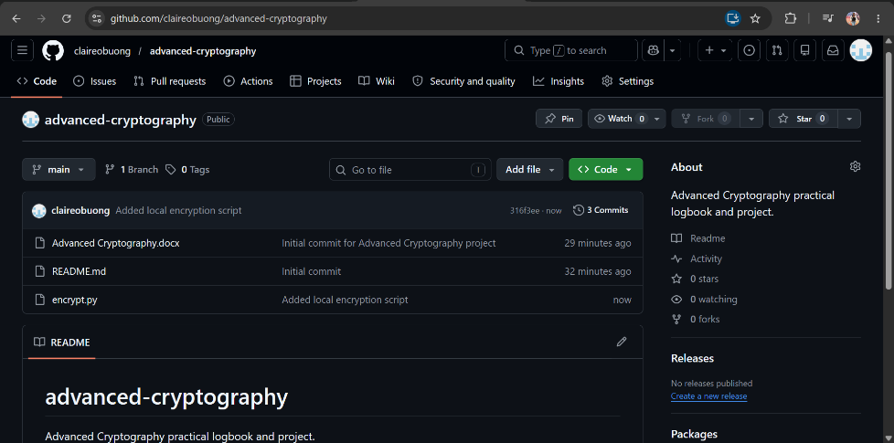
Figure 5: Illustrates initialization of the GitHub repository and version control setup, supporting secure code management and project tracking.

1.2 Student Reflection
This week's activities helped me understand the setup required for practical cryptography development. I configured essential security tools, tested encryption scripts, and learned the importance of OpenSSL and version control in secure software development.

Week 2

3.1 Implementation of Classical Encryption Algorithms
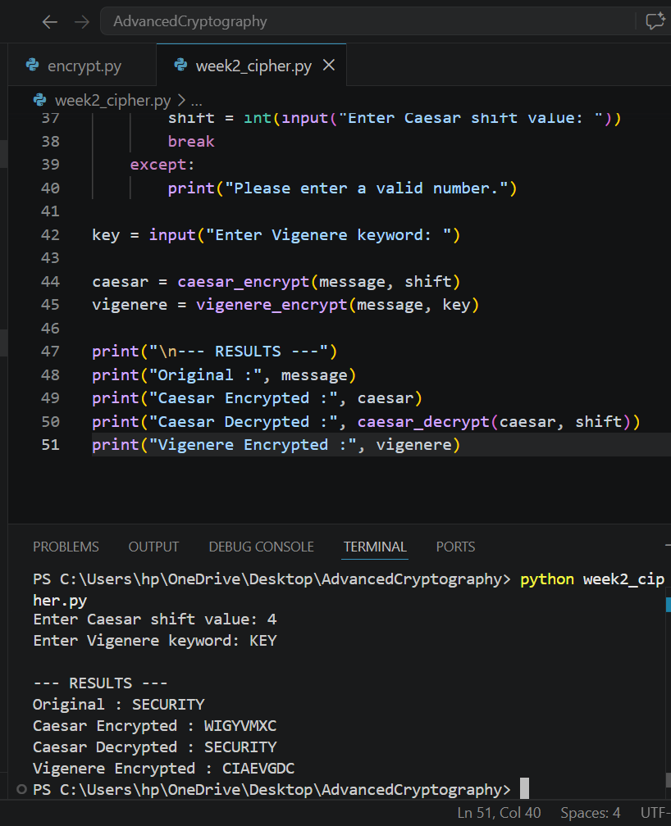
Figure 6: Demonstrates the implementation of the Caesar Cipher algorithm, where each character is shifted by a user-defined key to produce encrypted output.
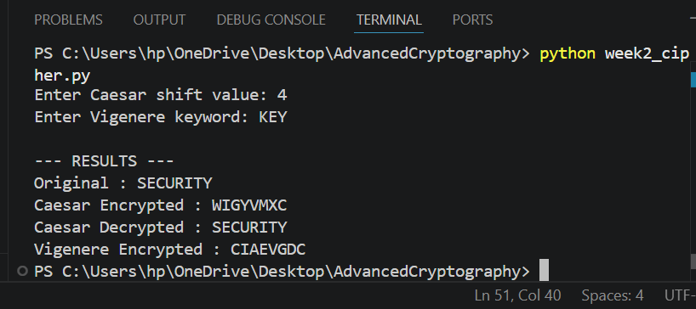
Figure 7: Illustrates the Vigenère Cipher encryption process, where a keyword is used to generate multiple substitution alphabets, improving security over simple shift ciphers.

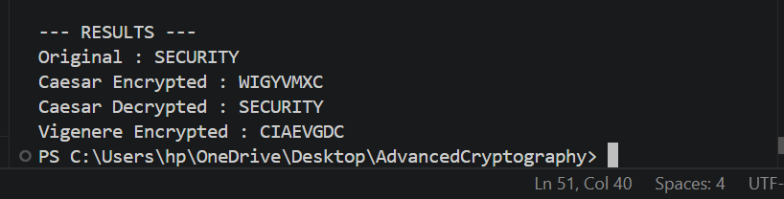
Figure 8: Confirms the successful encryption and decryption of plaintext, demonstrating that the original message can be accurately recovered using the correct key.

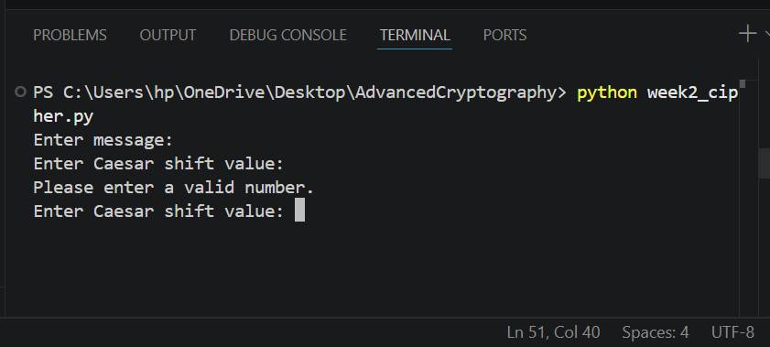
Figure 9: Demonstrates the user input interface, allowing dynamic entry of plaintext and encryption keys while validating numerical input for the Caesar Cipher.

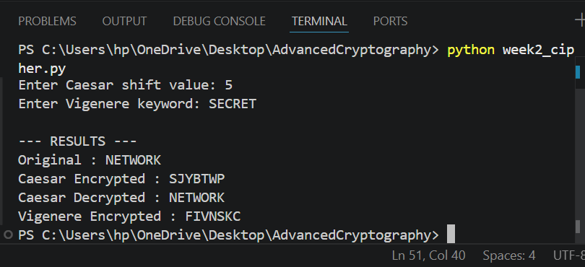
Figure 10: Presents the testing results obtained using different plaintext messages and encryption keys, verifying the correctness and consistency of the implemented algorithms.

3.2 Student Reflection
This week's activities demonstrated how classical encryption algorithms transform plaintext into ciphertext using secret keys. Implementing Caesar and Vigenère ciphers improved my understanding of encryption workflows, key management and the security weaknesses of simple substitution techniques.

Week 3

Implementation of Stream Cipher Systems and Random Sequence Analysis

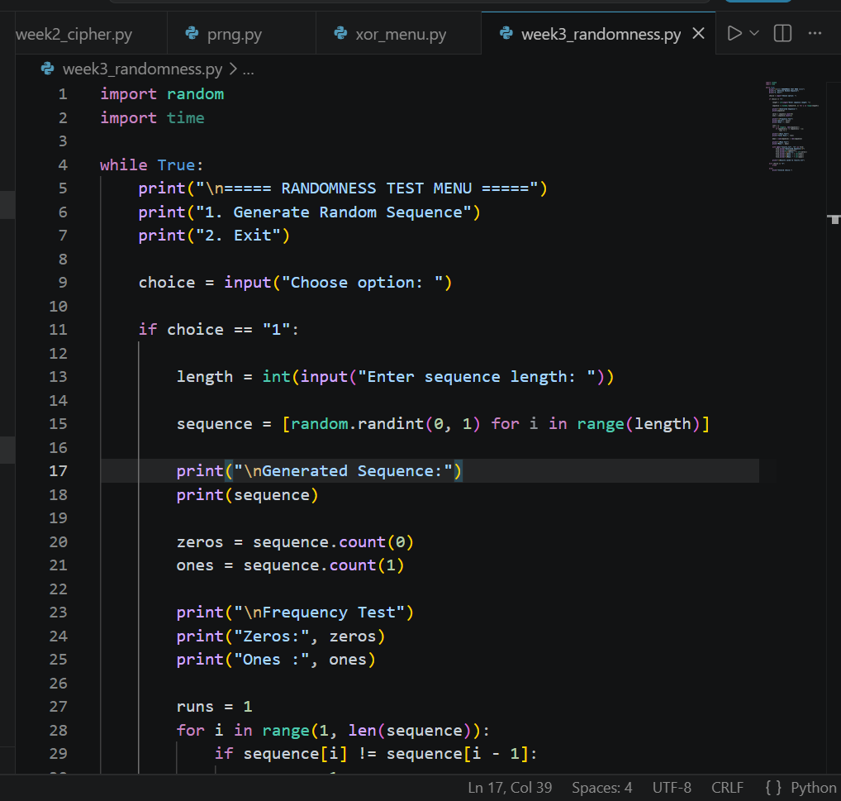
Figure 11: Implementation of a pseudorandom sequence generator for stream cipher security analysis.

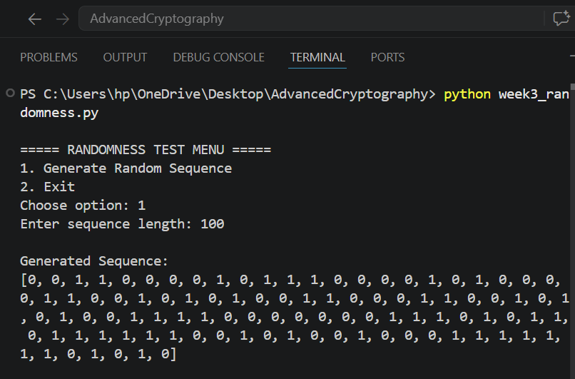
Figure 12: Generated pseudorandom binary sequence used for randomness analysis.

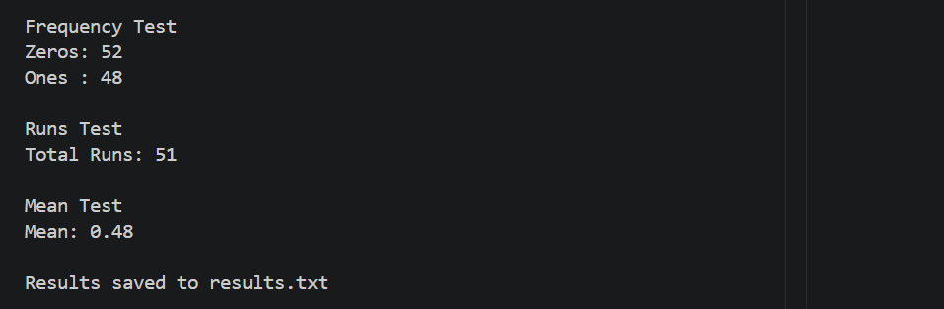
Figure 13: Statistical testing results showing frequency, runs, and mean analysis of the generated binary sequence.

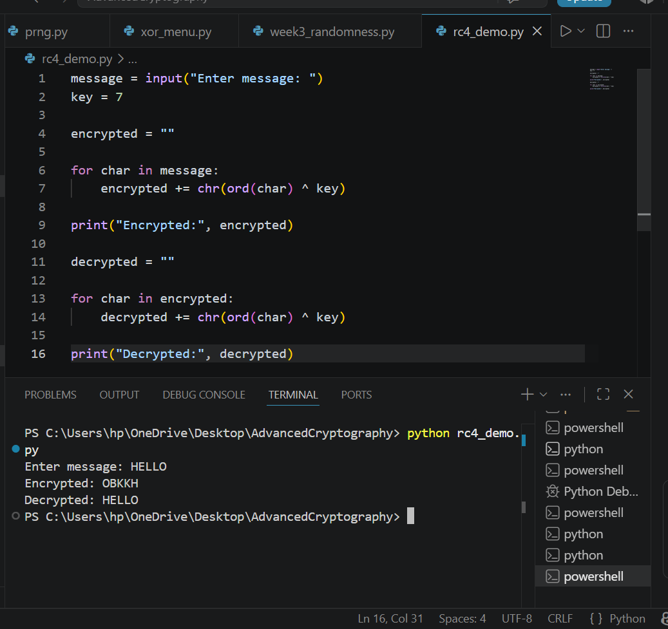
Figure 14: RC4-style stream cipher simulation demonstrating XOR-based encryption and decryption.

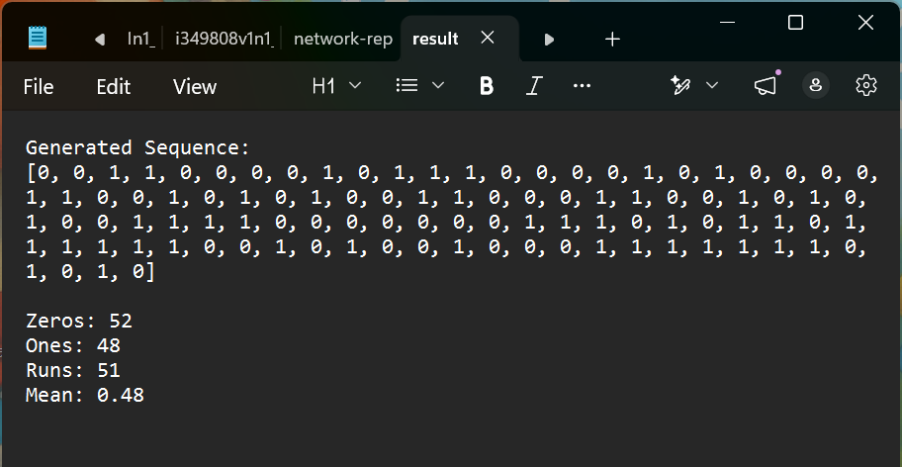
Figure 15: Encryption and randomness testing results successfully generated and stored for later analysis.

4.5 Reflection
This week's activities demonstrated the importance of randomness in stream cipher security. Implementing pseudorandom sequence generation and statistical testing improved my understanding of how randomness affects encryption strength and how weak generators can introduce cryptographic vulnerabilities.

Week 4

Advanced Encryption Standard (AES) and Block Cipher Operations
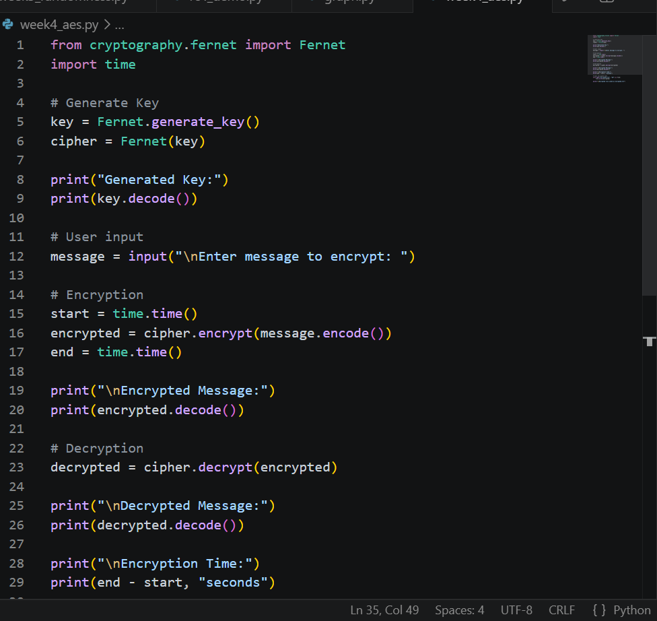
Figure 16: Python implementation of an AES-based encryption script using the Cryptography library.

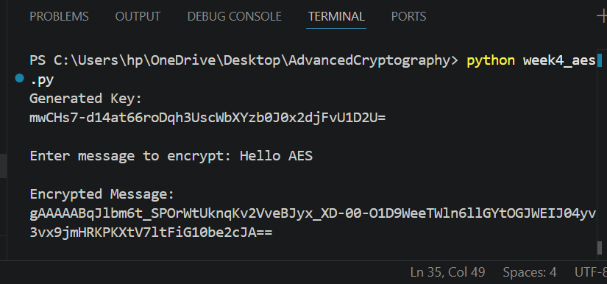
Figure 17: Automatic generation of a symmetric encryption key used for AES operations.

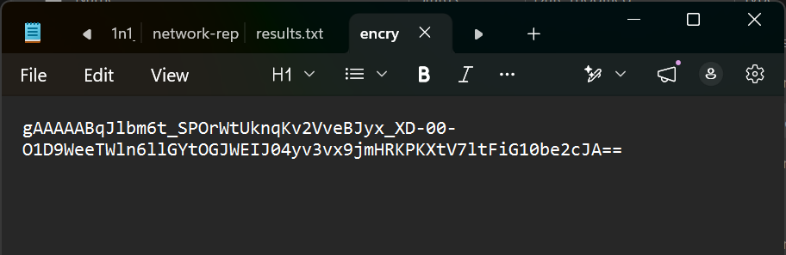
Figure 18: Encrypted output successfully stored in a file for secure data protection.

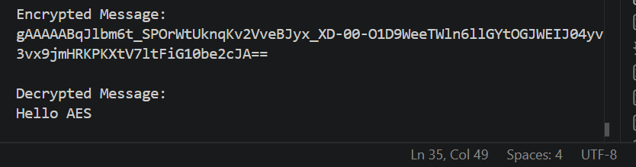
Figure 19: Successful decryption process demonstrating recovery of the original plaintext using the correct encryption key.

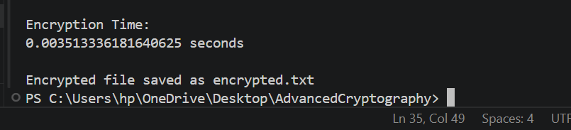
Figure 20: AES encryption performance measurement showing the execution time required for the encryption process.

5.5 Reflection
This week introduced AES encryption and secure key management. Implementing encryption and decryption operations improved my understanding of symmetric cryptography, secure file protection, and the importance of safeguarding encryption keys during communication.

Week 5

Implementation of RSA Encryption and Key Management
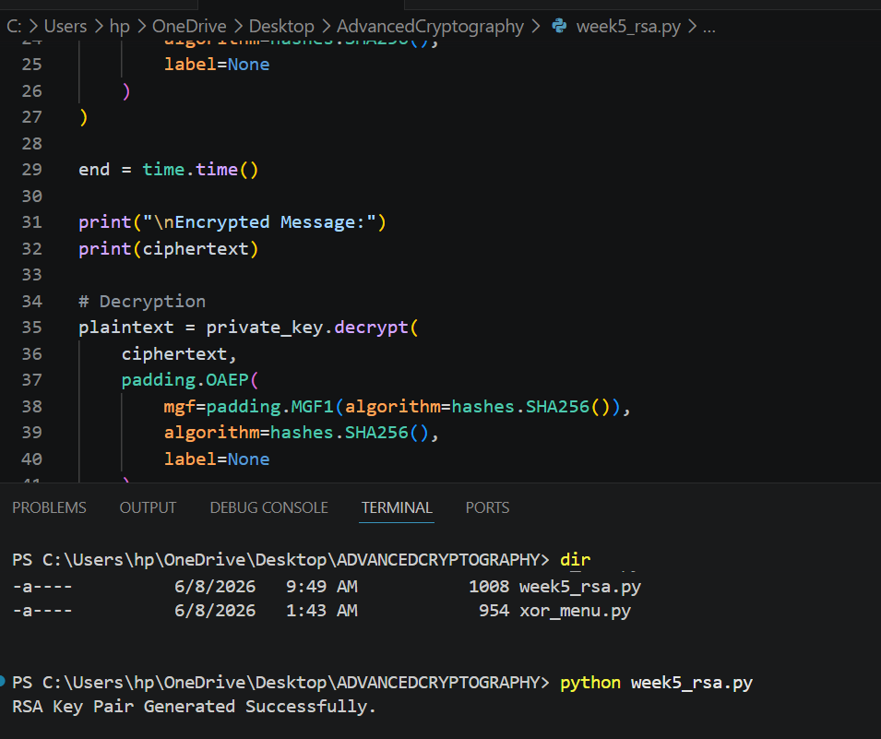
Figure 21: Successful generation of RSA public and private key pairs for secure communication.

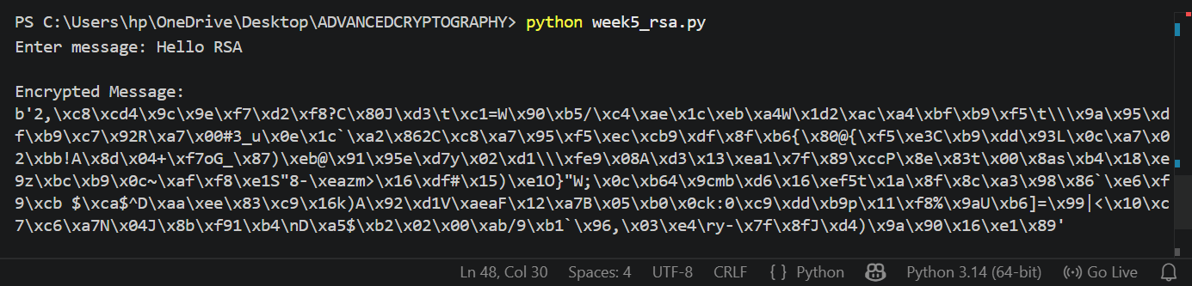
Figure 22: Encryption of plaintext using the RSA public key.
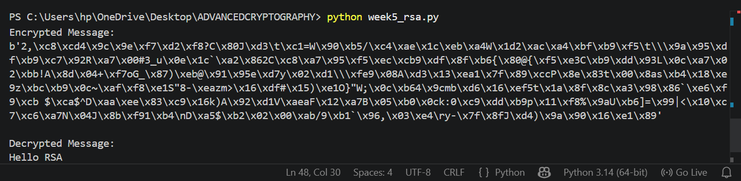
Figure 23: Successful decryption of ciphertext using the RSA private key.


Figure 24: RSA secure message transmission demonstrating protection of data during communication.

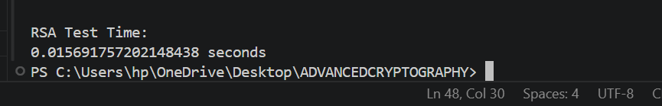
Figure 25: RSA encryption and decryption successfully tested and validated through execution time measurement.

6.5 Summary
RSA encryption and block cipher concepts were implemented through practical simulations and a GUI cryptography toolkit. The project demonstrated key generation, secure communication, avalanche effect analysis, and SHA-256 hashing, reinforcing both asymmetric encryption and modern security principles.

7. Creative task
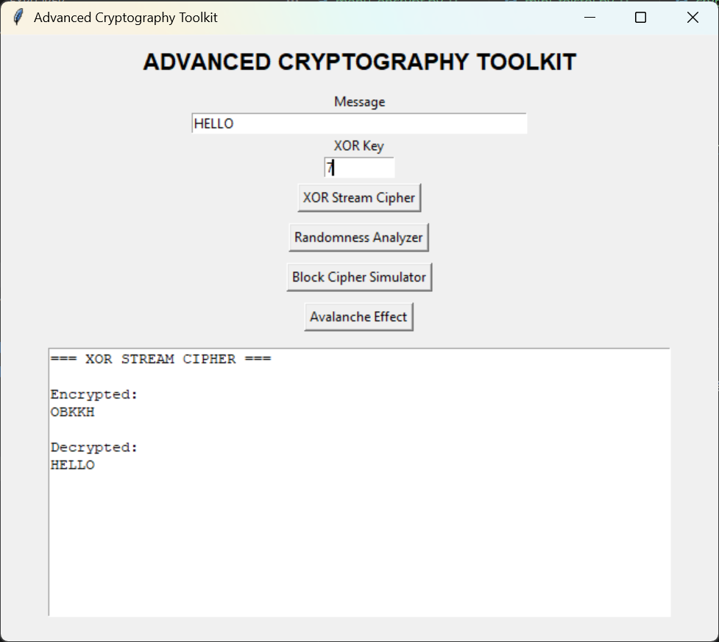
Figure 26: GUI-based XOR stream cipher demonstrating secure encryption and successful decryption using a shared key.

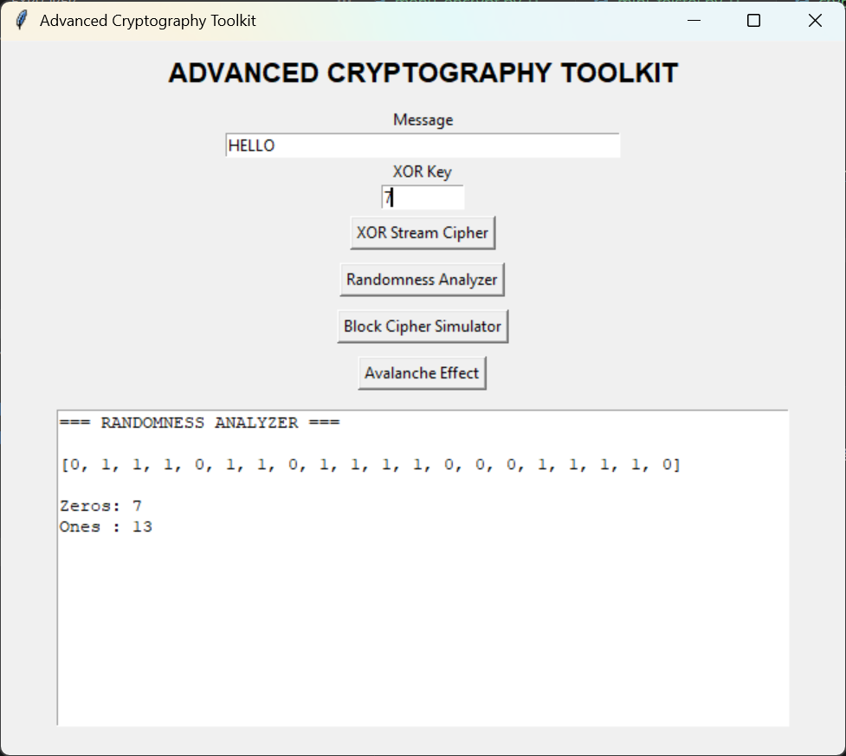
Figure 27: Randomness analyzer generating binary sequences and evaluating frequency distribution.
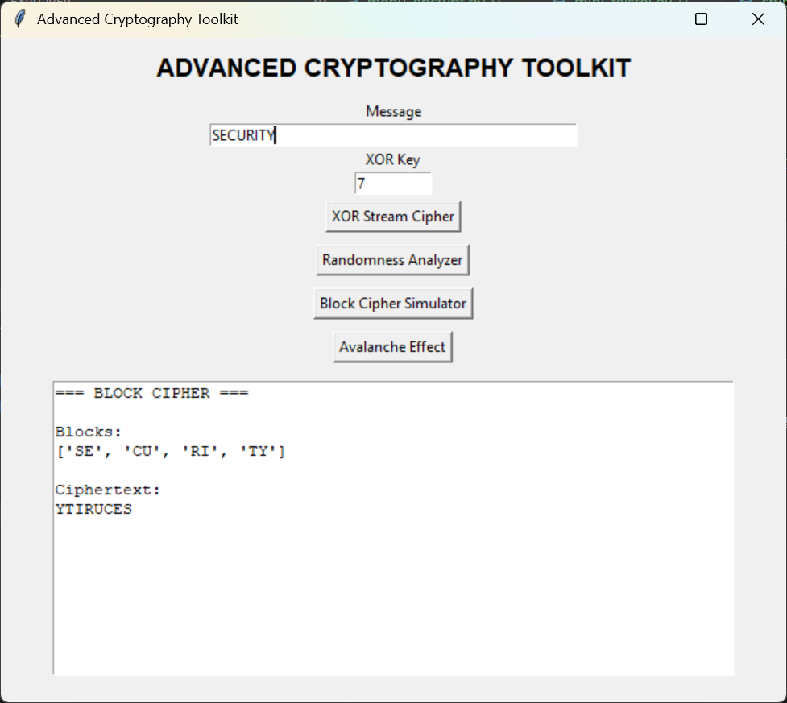
Figure 28: Block cipher simulator implementing block division, substitution, and permutation operations.
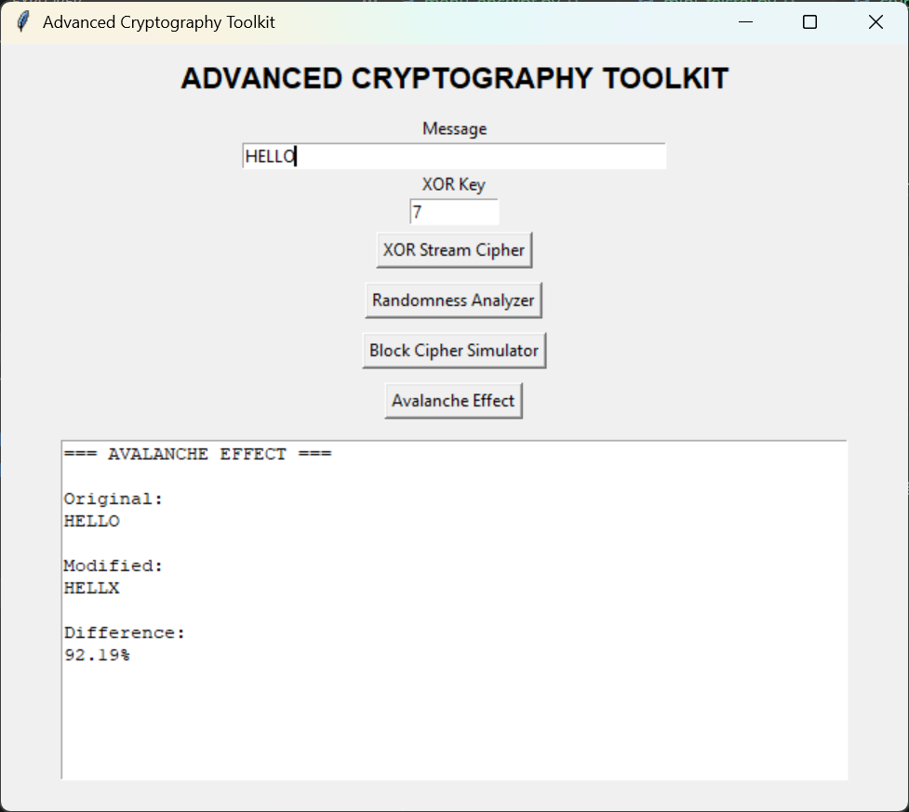
Figure 29: Avalanche effect demonstration showing how a small plaintext change produces significant cryptographic differences
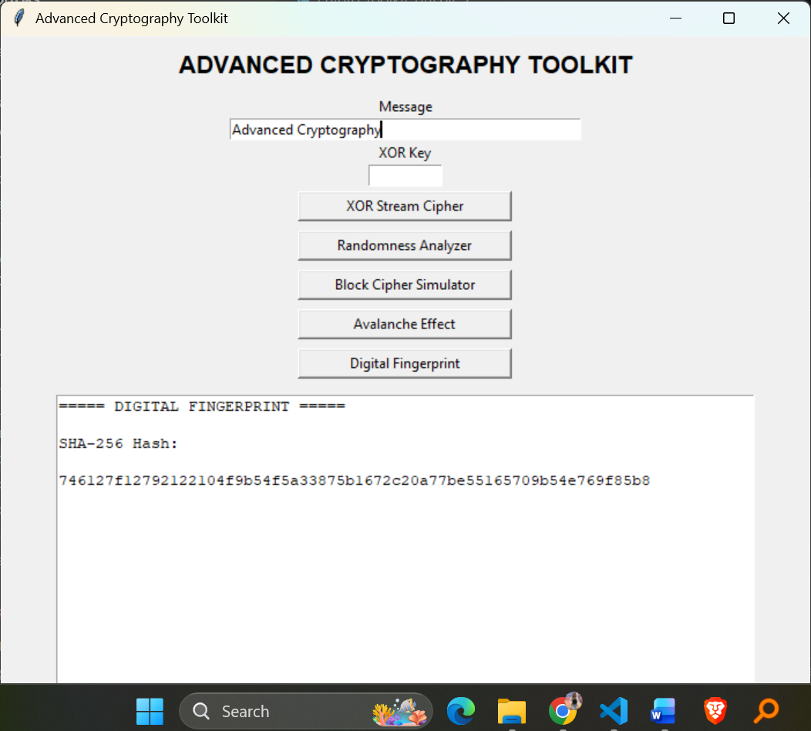
Figure 30: Digital fingerprint generator using SHA-256 hashing for message integrity verification.

