

NAME: OBUONG CLAIRE ANYANGO
ADM NO : BSCCS/2024/52885
COURSE : BACHELOR OF SCIENCE IN COMPUTER SCIENCE
UNIT CODE: BIT3208
UNIT NAME: ADVANCED WEB DESIGN AND DEVELOPMENT
LECTURER NAME : NYORO MICHAEL
ACADEMIC YEAR: YEAR 3

PROJECT TITLE: VOTER REGISTRATION SYSTEM
SELECTED TECHNOLOGIES
• PHP + MySQL
• HTML
• CSS
• JavaScript
• XAMPP
• GitHub
• Canva

GIT HUB LINK
https://github.com/claireobuong/VRS_Project

Week 1: Local Environment Setup

1.0 Installation and Testing of Local Development Environment

Figure 1: Installation of XAMPP

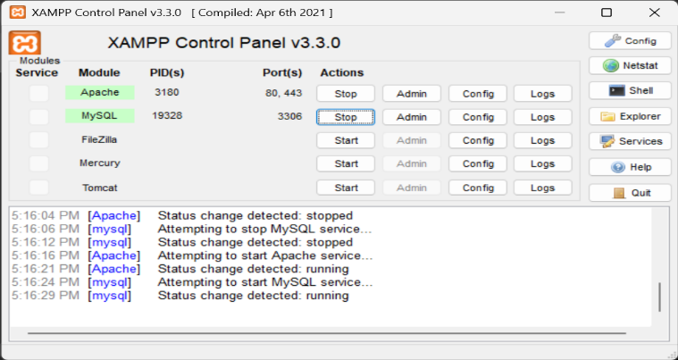
Figure 2: Apache and MySQL Running

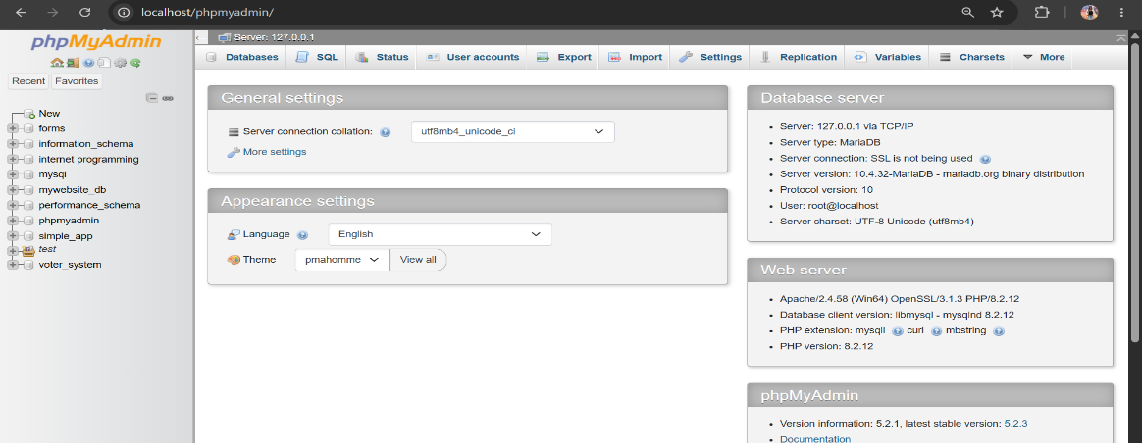
Figure 3: Localhost Test Page

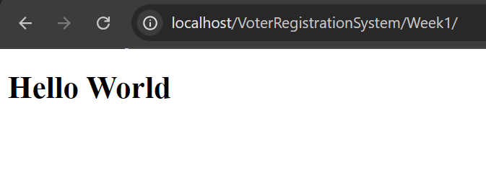
Figure 4: Hello World Test

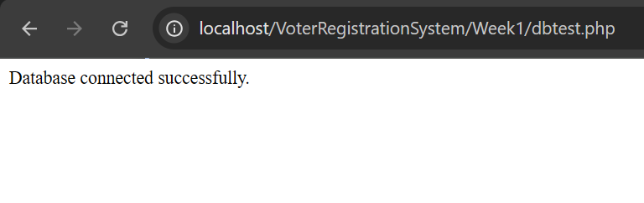
Figure 5: Database Connection Test

Week 2: Wireframes and GUI Design

2.0 User Interface Planning and System Design

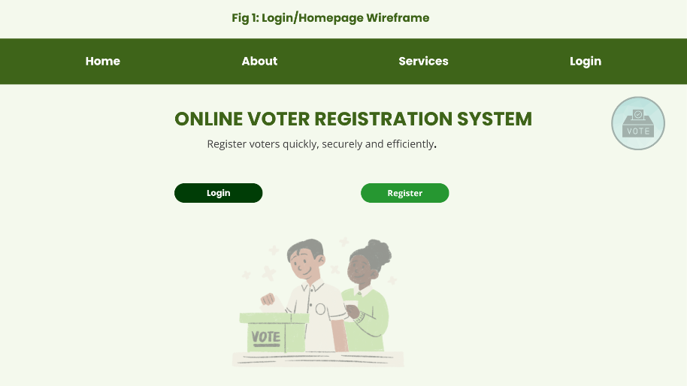
Figure 1: Login/Homepage Wireframe

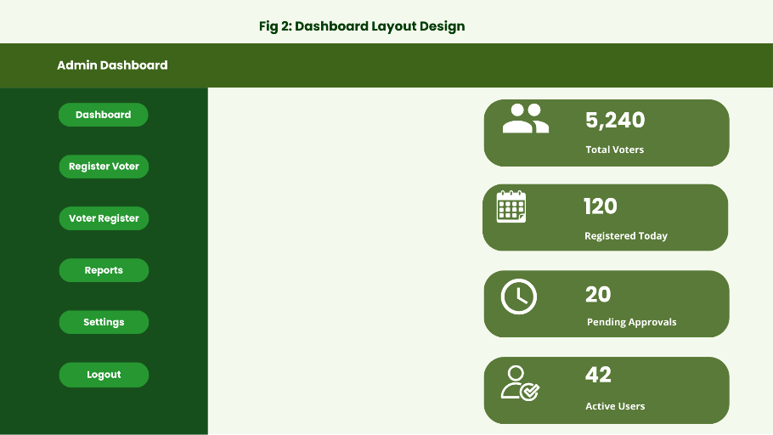
Figure 2: Dashboard Layout Design

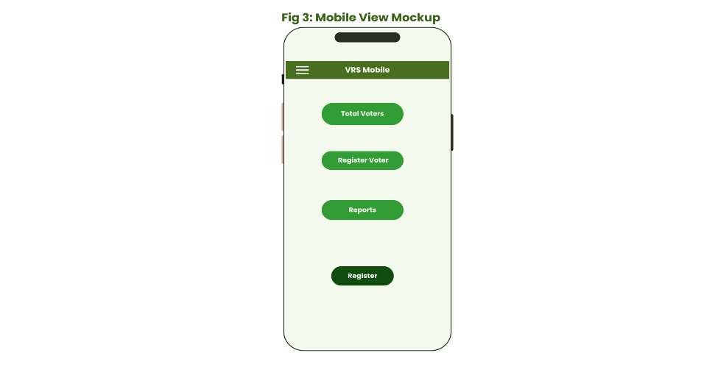
Figure 3: Mobile View Mockup

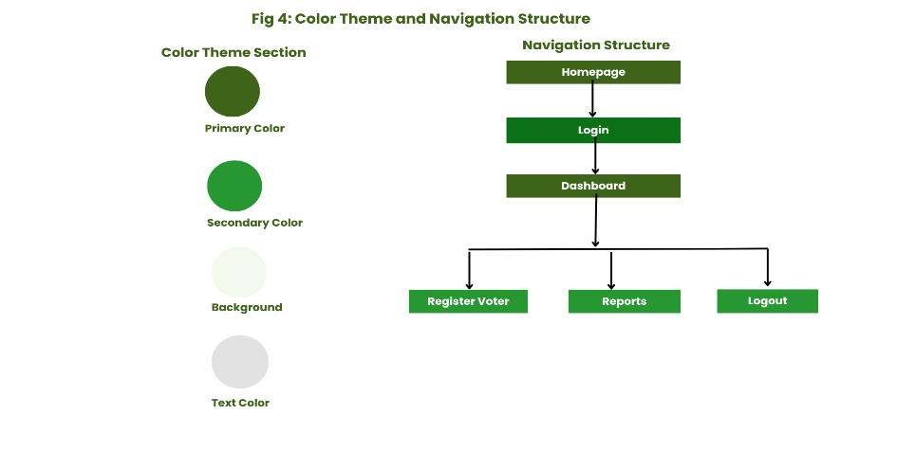
Figure 4: Color Theme and Navigation Structure

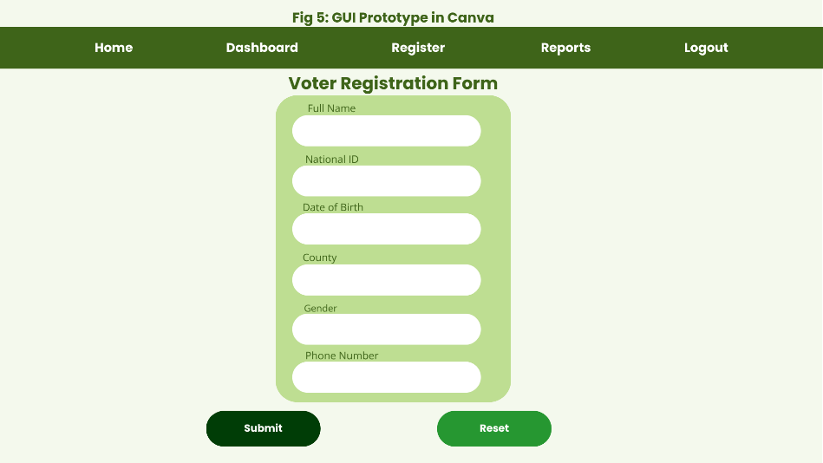
Figure 5: GUI Prototype in Canva

2.1 Project theme
Online Voter Registration System

2.2 Choosen technologies
• PHP
• MySQL
• HTML
• CSS
• JavaScript
• XAMPP
• GitHub
• Canva

2.3 Project Proposal Summary
I designed the Online Voter Registration System to simplify voter registration and management processes through a digital platform. The system allows administrators to register voters, manage records and generate reports efficiently.
My project uses PHP and MySQL for backend development and Canva for UI/UX planning and system prototyping.

