**CompSci 316 - Project Report**

Meng Yuan, Shuai Yuan, Chengen Xie, Shangru Huang

**Open Project Description**

By Fall 2014, there are totally 6,417 undergraduate students at Duke with 10% international students. Besides, there are 8,379 graduate students and 24% of them are foreign students. Therefore, Duke totally has about 2,653 international students. Unlike native students, studying abroad is never an easy thing for international students. All the difficulties start from arrival – how to get to the apartment/campus from airport. Duke Chinese Student and Scholar Association (DCSSA) has a long history for providing free airport ride for incoming Chinese students. But so far all the volunteer-student match is manual work. Every summer, DCSSA needs to organize a special team to handle hundreds of requests from incoming students and assign them to available volunteers, which is inefficient, tedious and error-prone.

Therefore, a fully automated volunteer-student matching system would be necessary and benecifial. Our group is intended to design a web-based airport-pickup application, which can largely simplify the process of volunteers and new students matching. Furthermore, we hope this tool can be further extended to help more students.

**Data Sources**

After contacting with DCSSA, we can have access to previous new students and volunteers’ information (They are stored in some Google Docs), which can be used to populate our database.

Data Samples:

New students: goo.gl/gZhb92

Volunteers: goo.gl/T2ysBp

**Implementation Details & Assumptions**

* To register with the Web site, a user must provide name, email and status (newstudnet or volunteer), extra information includes major, age, gender, hobby, etc.
* Each volunteer is capable of driving different cars indicated by car plate referencing plate_number in Car.
* Each volunteer need to provide availabilities (available time period),
* Each newstudent should provide arrival time, flight number (referencing flight number in table Flight), number of people, number of total luggages.

**E/R Diagram (UPDATED)**

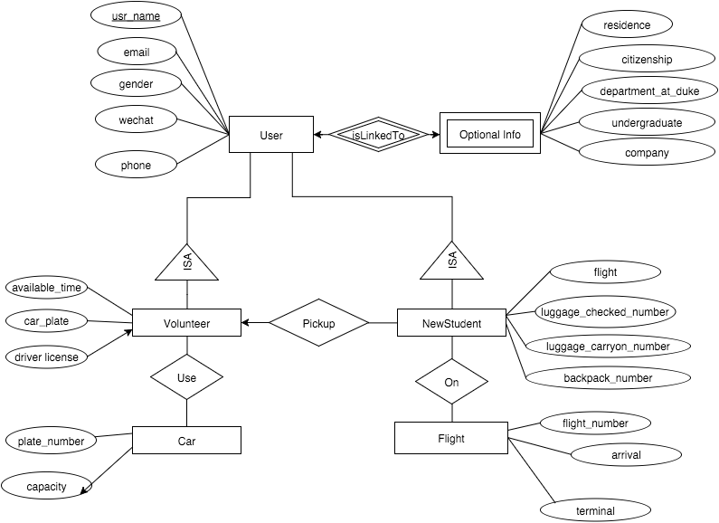

**System Architecture & Platform**

In our project we are planning to use Django as the framework of our web application. Django is a open-souce framework written in Python. Comparing to other existing frameworks, Django is lightweight, fast and scalable. Therefore, it would be our optimal choice for a agile prototyping project approach.

One of the distinguishing feature of Django is the model-view-controller architectural pattern.

It also come with many bundled applications that we might need in our project including authentication system and GIS applications frameworks (for example, building a GIS visualization measuring the distance of free ride provider and the RDU airport.)

As for the backend database, Django is compatible with multiple existing SQL database including PostgreSQL, MySQL, SQLite and Oracle. Initially we are planning to use SQLite for our database. Other possible choices might include Postgresql and MySQL.

By default, the configuration of Django uses SQLite. If we want to use the PostgreSQL, install the appropriate database binding, and change the some keys(including ENGINE - Either and NAME) in the database 'default' item to match the database connection settings.

For the User Interface part, once our models are defined, Django can create a professional interface called administrative interface automatically, which is a Web site that allows authenticated users manipulate objects.

A beautiful URL scheme is critical to a Web application. For designing URLs for our web app, we can use the Python module called URLconf, which provides a simple mapping between URL patterns and Python callback functions.

**Related Work/Systems**

**Wingz** is a mobile app that lets travelers book prescheduled rides to and from the airport. It is a platform that provides a means to enable persons who seek rides to certain destinations ("Riders") to connect with persons available to drive to those destinations ("Drivers"). There are some similarities between this application and our web service. We think it can give us some inspiration about connecting flight information with user requests and volunteers’ available time. But it also has some limitations. Since it does not has extra information about undergraduate school, place of birth… it cannot give much help for our recommendation functions.

**Feedback**

Instructor: You might want to consider some sort of social login so that users don't have to remember another username/password pair for your site.

Response: Since Facebook and Google services are blocked in China, implementation of the social login with QQ/Wechat/Weibo interfaces can be an optional choice.

Instructor: You also need some sort of assignment resolution and feedback procedure.

Response: So far our thought is letting volunteers choose new students, which means any registered volunteer can see the entire list of unpaired incoming students. The web application can also push recommendations to volunteers based on the common grounds between them, like flight arrival time and volunteer's available time, Department/Program at Duke, place of birth... Once a volunteer-and-new-student pair is chosen by a registered volunteer, confirmation emails containing more detailed information will be sent to both email addresses. If some students are still not chosen and his/her flight will arrive soon, it will also trigger an alarm mechanism, which can send mass emails to all the volunteers to see if anyone can spare some time.

**References**

1. <https://duke.qualtrics.com/jfe/form/SV_dbtFkV1ohJUe8ex>
2. <https://docs.djangoproject.com/>
3. <https://wingz.me/>