Finapp
Design Document
Finance Dashboard Cash-Flow Engine & Wealth Simulator
━━━━━━━━━━━━━━━━━━━━
Course | Software Engineering I
Team | Team 1
Team Members | Ali Canturk, Braden Elsworth, Jason Mele, Lucas Polo, Quinn Johnson, Sean Bassi
Version | 0.1 Draft
Date | September 30, 2026
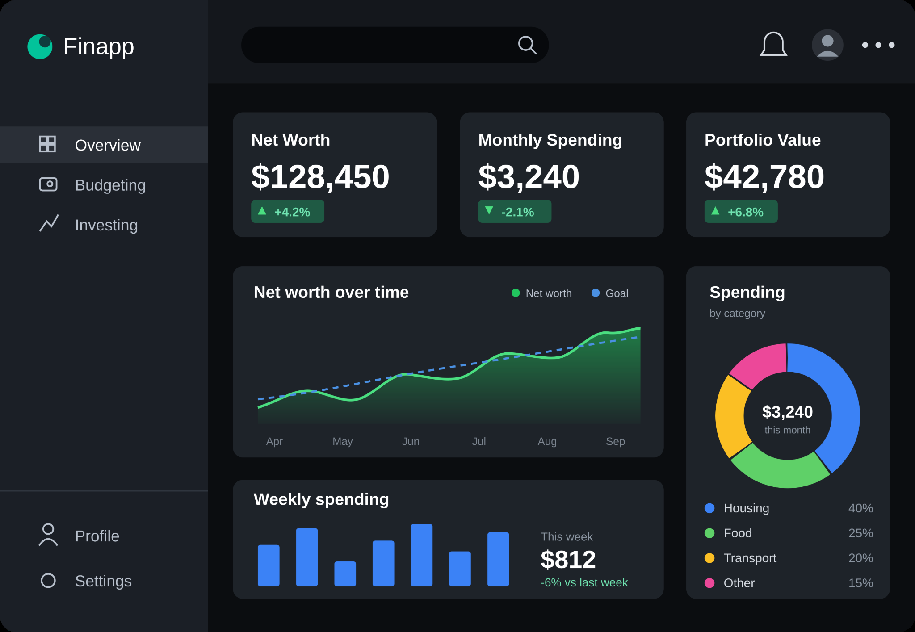
Cover figure: Finapp overview dashboard mockup provided by the team.
Drafted from Sprint 0 materials, the class design-document outline, user stories, and team screenshots.

Document Control
Version | Date | Description | Owner
v0.1 | 09/30/2026 | Initial design document draft created for Team 1 from Sprint 0 report, project screenshots, and user-story workbook. | Team 1

Source Materials Used
- DesignDocOverview.pptx: class outline for sections such as purpose, scope, solution design, technical architecture, configuration, roles, and references.
- SprintReviewStatusReport.pdf: Team 1 Sprint 0 project overview, architecture, core functionality, user story categories, and Definition of Done.
- UserStoryDeliverable.xlsx: current product backlog and acceptance-criteria draft.
- Team screenshots: dashboard mockup, core ingestion strategy, and discussion around manual input vs. paid bank connectors.

Table of Contents
- 1. Purpose
- 2. Scope
- 3. Exclusions, Assumptions, and Limitations
- 4. Solution Design Overview
- 5. Technical Architecture
- 6. Hardware, Hosting, and Physical Layout
- 7. Configuration Specification
- 8. Solution Design Specification
- 9. Data and Information Design
- 10. Module Descriptions
- 11. Interfaces and External Integration Points
- 12. Coding Standards
- 13. Roles and Responsibilities
- 14. Terms and Definitions
- 15. Supporting References
- 16. Appendix A - Screenshots and Figures

1. Purpose
This document describes the proposed design for Finapp, a web-based budgeting and investing application. The purpose is to give Team 1 a shared technical blueprint for how the product will be built, how the major components communicate, what data the system needs, and which design decisions affect Sprint 1 and later implementation.
The document supports the user stories and Definition of Done created during Sprint 0. It is intended for developers, testers, the Product Owner role, and the instructor/stakeholder reviewing the project architecture.
Design intent
Finapp should help users see where their money goes, track assets and liabilities, understand cash flow, monitor investments, and run what-if financial projections without needing paid bank-connection services.

2. Scope
Finapp is in scope as a class-project MVP focused on manual financial modeling, dashboard visualization, and backend services. The system includes three primary user-facing areas: overview, budgeting, and investing.

2.1 In-Scope Features
- Overview dashboard that shows net worth, monthly spending, portfolio value, charts, and recent financial status.
- Manual financial node entry for income, accounts, assets, liabilities, expenses, and investment accounts.
- Budgeting support for recurring and one-off income and expenses, including daily, weekly, monthly, and yearly views.
- Investing support for stock/bond tracking, selected watchlist items, historical market data, goals, and diversification information.
- Net worth calculation using assets minus liabilities, with income and expenses treated separately as cash-flow data.
- Demo archetypes for quick testing and presentations without real bank data.
- Optional CSV/JSON import for batch loading financial nodes.
- Monte Carlo simulation and AI-generated financial suggestions through a separate Python service.

2.2 User Interfaces
Screen | Purpose
Overview | Main dashboard with net worth, monthly spending, portfolio value, spending chart, and trends.
Budgeting | Inputs and views for income, expenses, categories, recurring items, and cash-flow warnings.
Investing | Stock/bond tracking, investment goals, diversification, and market/news information.
Profile/Settings | Basic personalization such as display name, theme, and profile information if time permits.
Figure 1. Finapp overview dashboard mockup used as the main visual reference for the user interface.

3. Exclusions, Assumptions, and Limitations

3.1 Exclusions
- Plaid or live bank-account linking is excluded from the MVP because it introduces paid credentials, OAuth complexity, bank-token security, and audit requirements.
- The application will not execute trades, transfer money, or connect directly to brokerage accounts.
- The system will not provide professional financial, tax, or legal advice.
- Production-grade identity management, SSO, and password hashing may be deferred if the team does not have enough time.
- Real estate and vehicle values will be manual inputs for the MVP; automatic appraisal APIs are optional future enhancements.

3.2 Assumptions
- Users are willing to manually enter financial data for the class-project MVP.
- Demo archetypes can stand in for real bank data during testing and presentation.
- External market data can be fetched through free or limited-use sources such as yfinance/Yahoo Finance or a free-tier API.
- Claude or another AI service may have usage costs, so AI calls should be limited and optional.
- The app will run locally with Docker containers during development and presentation.

3.3 Limitations
- Market data from free sources may be delayed, rate-limited, or less reliable than paid financial-data APIs.
- Manually entered asset values may become stale unless users update them or an optional estimation API is added later.
- Simulation results are estimates and depend on user inputs, assumptions, and historical market data.

4. Solution Design Overview
Traditional budgeting tools often show static spending categories, while investing tools are usually separate. Finapp combines budgeting, net worth, and investing into a single dashboard. The design uses a financial-node model: users add income streams, accounts, assets, liabilities, investments, and expenses as structured data. The application then displays those nodes through dashboard cards, charts, and financial calculations.
The primary business problem is reducing friction for a user who wants a simple picture of their financial position without switching between multiple apps. The technical problem is to model that information clearly while avoiding paid bank-aggregation APIs. The solution is manual input, demo archetypes, and optional CSV/JSON import.
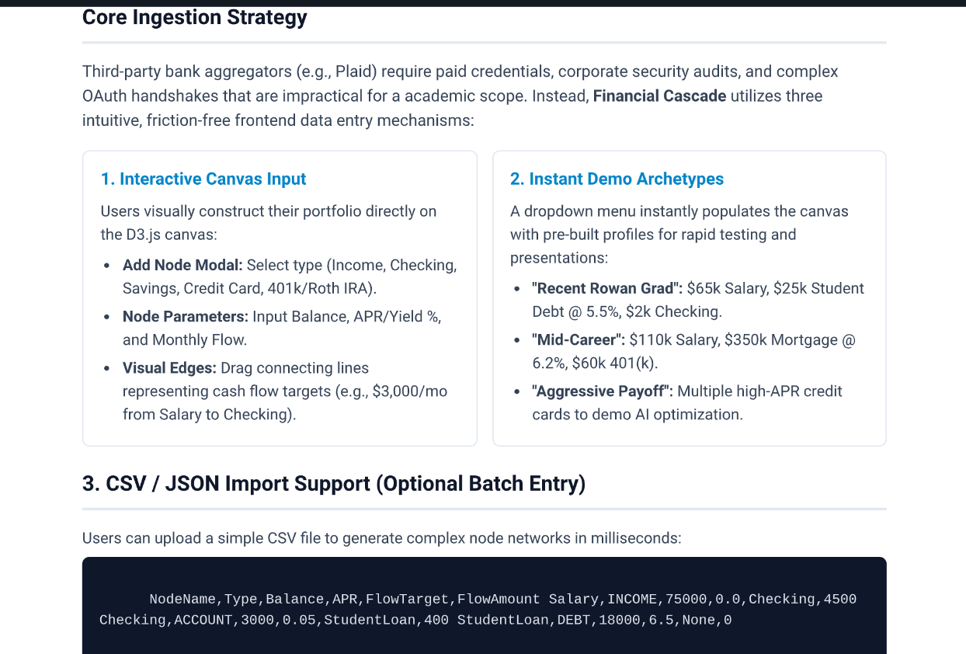
Figure 2. Core ingestion strategy screenshot: manual canvas input, demo archetypes, and optional CSV/JSON import instead of paid bank aggregators.

4.1 Key Design Decisions
Decision | Reason
Manual input over Plaid | Keeps the project free, reduces security risk, and avoids paid credentials/OAuth complexity.
Node-based financial model | Allows different financial objects to be represented consistently and displayed as a visual cash-flow graph.
Java as backend hub | Centralizes REST endpoints, database access, and communication with the Python analytics service.
Python for analytics | Keeps market-data fetching, Monte Carlo simulation, and AI/Claude integration separated from Java CRUD/business logic.
Assets minus liabilities for net worth | Corrects the Sprint 0 net-worth discussion: income and expenses are cash-flow data, not direct net-worth values.

5. Technical Architecture
Finapp uses a multi-service architecture. The browser frontend communicates with a Java Spring Boot backend over HTTP/REST. Java reads and writes financial data through PostgreSQL and delegates analytics-heavy work to the Python service. The Python service uses market data and AI APIs when needed.
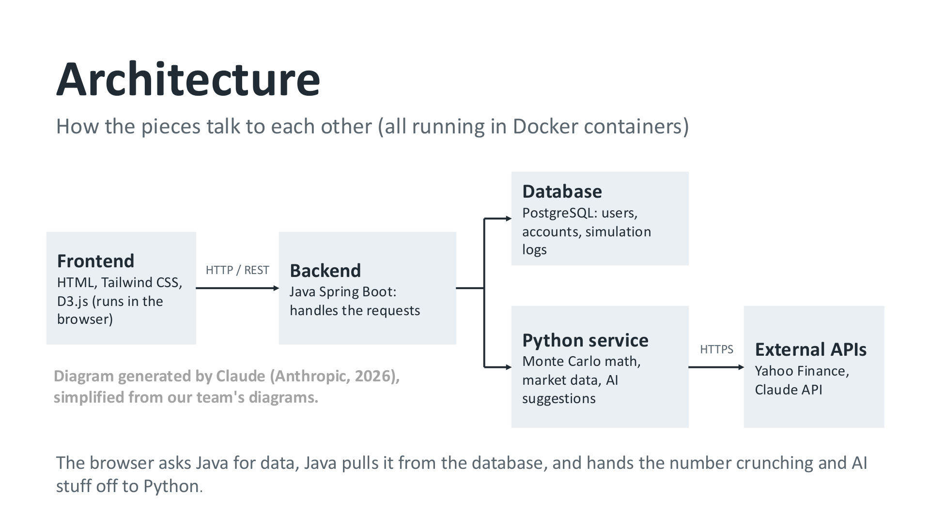
Figure 3. Sprint 0 architecture diagram: frontend to Java backend, PostgreSQL, Python service, and external APIs.

5.1 Component View
Component | Technology | Responsibility
Frontend | HTML, Tailwind CSS, JavaScript, D3.js | Runs in the browser; renders dashboard, forms, charts, and financial graph/canvas.
Java Backend | Spring Boot, Spring Data JPA, REST controllers | Handles requests, DTOs, validation, business rules, and database access.
Database | PostgreSQL | Stores users, financial profiles, nodes, edges, stock holdings, simulation logs, and preferences.
Python Service | FastAPI, NumPy, Pandas, yfinance, Claude SDK | Fetches market data, calculates simulations, and generates AI suggestions.
External APIs | Yahoo Finance/yfinance, Claude API, optional free-tier market APIs | Provides market data and AI-generated recommendations.

5.2 Request Flow
- User interacts with the browser dashboard, budgeting screen, or investing screen.
- Frontend sends an HTTP/REST request to the Java Spring Boot backend.
- Java validates the request, applies business rules, and reads/writes PostgreSQL data.
- If analytics or AI is required, Java calls the Python FastAPI service.
- Python fetches market data or runs simulations, then returns structured JSON to Java.
- Java returns an API response to the frontend, and the UI updates charts/cards/canvas elements.

6. Hardware, Hosting, and Physical Layout
No dedicated physical production hardware is required for the class-project MVP. The system is expected to run locally during development and presentation using Docker Desktop or individual developer machines.
Item | Specification | Location/Use
Developer Workstations | Windows/macOS/Linux laptops or desktops | Run IntelliJ/VS Code, Git, Docker Desktop, Java, Python, and local services.
Application Containers | Docker containers | Host the Java backend, Python service, and PostgreSQL during local testing.
Browser Client | Any modern browser | Displays the Finapp user interface and calls Java REST APIs.
Future Hosting | Cloud VM or container platform | Possible deployment target if required later; not needed for Sprint 1.

7. Configuration Specification

7.1 Local Runtime Configuration
Service | Technology | Default Port | Purpose
Java Service | Spring Boot | 8080 | Runs REST API and business logic.
Python Service | FastAPI/Uvicorn | 5000 | Runs analytics, market data, Monte Carlo, and AI calls.
Database | PostgreSQL | 5432 | Stores persistent application data.
Frontend | Static HTML/CSS/JS or served assets | Browser/8080 | Can be served by Java or run as static frontend in early phases.

7.2 Environment Variables
Variable | Description
POSTGRES_DB | Database name, such as finance_db.
POSTGRES_USER / POSTGRES_PASSWORD | Database credentials used by Spring Boot.
PYTHON_SERVICE_URL | Base URL Java uses to call the Python service.
ANTHROPIC_API_KEY | Optional key for Claude API calls; should not be committed to Git.
MARKET_DATA_PROVIDER | Optional flag for yfinance, Alpha Vantage, or other market source.
Security note
No API keys, passwords, bank tokens, or secrets should be committed to GitHub. Use .env files locally and keep them out of version control.

8. Solution Design Specification
The solution is organized around user stories and backend modules. The first usable increment should focus on manual financial data entry, saved nodes/edges, dashboard calculations, and a small number of must-have user stories.

8.1 High-Level Functional Requirements
- User can add, edit, delete, and view financial assets.
- User can add, edit, delete, and view recurring or one-off income streams.
- User can add, edit, delete, and view recurring or one-off expenses.
- User can see current net worth calculated as total assets minus total liabilities.
- User can track selected stocks and see current/historical prices when market-data integration is available.
- User can run or view financial simulations when the Python service is available.

8.2 Priority User Story Summary
ID | Theme | User Story Goal | Priority
1 | Investing | Access current stock prices | Must have
2 | Investing | Track specific stocks | Must have
3 | Financial Management | Track and manage the value of different assets | Must have
4 | Financial Management | Have my currently invested stocks automatically update my net worth | Should have
5 | Financial Management | Track and manage various income streams | Must have
6 | Financial Management | Track and manage various expenses | Must have
9 | Financial Management | See my current net worth | Must have
21 | Security | Have a secure website | Must have
24 | AI | Have AI analyze my financial information and give suggestions | Should have
25 | Simulation | Run simulations with my financial information | Should have
31 | Simulation | Run simulations in a reasonable amount of time | Should have
Recommended refinement: update the ID 9 net-worth acceptance criteria to use assets minus liabilities and keep income/expenses as cash-flow inputs. This aligns with the instructor feedback from the Sprint 0 review.

9. Solution Data, Information View, and Data Requirements

9.1 Conceptual Data Model
Entity | Description | Example Fields
User | Represents a registered user or demo account. | id, username/displayName, email, createdAt
FinancialProfile | Groups a user's financial graph, assumptions, and preferences. | id, userId, name, defaultCurrency, createdAt
FinancialNode | Represents an income stream, account, asset, debt, expense, or investment. | id, profileId, nodeType, name, currentValue/balance, APR/yield, monthlyFlow
NodeEdge | Represents a cash-flow route between nodes. | id, sourceNodeId, targetNodeId, percentageFlow, fixedAmountFlow
StockHolding | Specialized investment data for stocks/ETFs that require market-price updates. | id, profileId, ticker, sharesOwned, latestPrice, dividendYield
SimulationResult | Stores Monte Carlo or what-if simulation results. | id, profileId, inputs, percentileCurves, createdAt

9.2 Net Worth and Cash Flow Rules
Net worth rule
Net worth = total current asset value - total outstanding liabilities. Income and expenses are not directly added into net worth; they are used to calculate cash flow and future projections.
Data Category | Rule
Assets | Checking, savings, brokerage, 401(k), Roth IRA, house value, vehicle value, stock holdings, bonds, crypto (optional).
Liabilities | Credit-card balances, student loans, car loans, mortgages, other debts.
Cash Flow | Monthly income minus monthly expenses. Used for warnings, budgeting, and simulation contributions.
Stock Holding Value | sharesOwned x latestPrice. Dividends are treated as a separate income stream or investment income field.
Home/Vehicle Value | Manual current value in MVP; optional free/limited API estimation can be added later.

9.3 Data Sensitivity
- Financial amounts are sensitive and should not be exposed in logs.
- No SSNs or bank login credentials should be collected for the MVP.
- If authentication is implemented, passwords should be hashed and never stored in plaintext.
- API keys for AI or market data must be stored in environment variables, not source code.

10. Module Descriptions
Module | Description | Primary Owner/Layer
Dashboard Module | Shows cards and charts for net worth, monthly spending, portfolio value, spending categories, and trend lines. | Frontend + Java
Graph/Node Module | Creates, stores, retrieves, and updates financial nodes and cash-flow edges. | Java + PostgreSQL
Budgeting Module | Stores income and expense streams; calculates cash flow and overspending warnings. | Java + PostgreSQL
Investing Module | Tracks selected stocks, holdings, goals, diversification, and market/news data. | Java + Python
Simulation Module | Runs Monte Carlo or scenario analysis and stores simulation history. | Python + Java
AI Suggestion Module | Reads profile/graph data and returns structured recommendations. | Python + Claude API
CSV/JSON Import Module | Optional batch import to quickly create financial graph nodes. | Frontend + Java

10.1 Sprint 1 Recommended Java Backend Focus
For the Java/Spring backend team, the easiest useful Sprint 1 work is to support income and expense data. This aligns with the user stories and gives the frontend and dashboard meaningful values to display.
- Create endpoints/service methods for adding and retrieving income nodes.
- Create endpoints/service methods for adding and retrieving expense nodes.
- Add a simple cash-flow calculation: monthly income - monthly expenses.
- Add an overspending warning rule if monthly expenses exceed monthly income.

11. Interfaces and External Integration Points

11.1 Planned Internal API Endpoints
Method | Endpoint | Purpose
GET | /api/v1/graph | Return the user/profile financial graph.
POST | /api/v1/graph | Save or update financial nodes and edges.
GET | /api/v1/users/{userId}/graph | Return a specific user graph once user-scoped endpoints are finalized.
POST | /api/v1/nodes | Create a financial node such as income, expense, account, asset, debt, or investment.
PUT | /api/v1/nodes/{nodeId} | Update a node value, name, category, APR/yield, or monthly flow.
POST | /api/v1/simulations/run/{profileId} | Run a simulation through the Python service.
GET | /api/market-data?ticker={symbol} | Return market data such as CAGR/volatility or latest price from Python.

11.2 External APIs
API/Integration | Use
Yahoo Finance / yfinance | Stock/ETF historical and current market data; good for educational use but not guaranteed as production data source.
Claude API | AI chatbot/suggestion engine; usage should be limited because API calls can cost money.
Alpha Vantage or similar free-tier APIs | Optional alternative for market data if request limits are acceptable.
Real-estate valuation APIs | Optional future enhancement; MVP should use manual home values to avoid paid API dependency.

12. Coding Standards

12.1 Git Workflow
- Use feature branches rather than committing directly to main.
- Use descriptive branch names such as feature/US-5-income or feature/US-6-expenses.
- Open pull requests for review before merging into the shared branch.
- Keep commits small and focused so code review is manageable.
- Update documentation and tests when behavior changes.

12.2 Java/Spring Standards
- Use a layered structure: controller -> service -> repository -> entity/database.
- Expose DTOs rather than raw entity objects when returning JSON to the frontend.
- Validate user input before saving to the database.
- Return clear API responses and appropriate HTTP status codes.
- Write unit tests for financial calculations and service-layer logic.

12.3 Definition of Done Alignment
DoD Item | Meaning for Finapp
Acceptance criteria | Each story must meet its defined conditions of satisfaction.
Complete code | Implementation follows team standards and is rigorously tested.
Unit tests | Tests are defined and complete where applicable.
Documentation | New features and code are documented when necessary.
Code review/merge | Relevant code is reviewed and integrated/merged successfully.
Product Owner acceptance | Feature is accepted by the Product Owner role.

13. Roles and Responsibilities

13.1 Development Roles
Role | Responsibilities
Java/Spring Backend Developer 1 | Java architecture, REST controllers, JPA mapping, integration with database and Python service.
Java/Spring Backend Developer 2 | Income/expense backend features, cash-flow calculations, overspending warning logic, tests, and support for DTO/service code.
Python Developer | Market data, Monte Carlo simulation, AI integration, FastAPI endpoints.
SQL/Database Specialist | PostgreSQL schema, seed data, relationships, and database initialization.
Frontend/D3 Developer | Interactive dashboard, node/canvas visuals, graph rendering, chart behavior.
UI/Documentation/Presentation Support | Slides, user stories, DoD, UI mockups, design documentation, and sprint reporting.

13.2 System User Roles
Role | System Responsibility
User | Adds financial data, views dashboard, tracks income/expenses/assets/liabilities, runs simulations, and reviews suggestions.
Product Owner / Stakeholder | Reviews user stories, acceptance criteria, sprint review results, and whether features meet project goals.
Developer | Builds frontend, backend, database, analytics, and integrations.
Tester/Reviewer | Verifies acceptance criteria, tests, bugs, and Definition of Done items.

14. Terms and Definitions
Term | Definition
Asset | Something the user owns that has value, such as cash, investments, a vehicle, or a house.
Liability | Money the user owes, such as credit-card debt, loans, or mortgage balance.
Net Worth | Total current asset value minus total outstanding liabilities.
Cash Flow | Income minus expenses over a period of time, usually monthly.
Financial Node | A graph object representing an account, income stream, expense, asset, debt, or investment.
Node Edge | A connection showing how money flows from one node to another.
Monte Carlo Simulation | A simulation method that runs many random possible outcomes to estimate a range of future financial results.
PBI | Product Backlog Item; a unit of work such as a user story.
DoD | Definition of Done; shared requirements that every completed backlog item must satisfy.

15. Supporting References
- Team 1 Sprint 0 presentation/status report.
- Team 1 UserStoryDeliverable.xlsx.
- DesignDocOverview.pptx class outline for design-document sections.
- Team screenshots and UI/UX mockups provided in the project discussion.
- Claude-generated mockup and architecture assets credited in Sprint 0 materials.

16. Appendix A - Screenshots and Figures

A.1 Dashboard Mockup
Appendix Figure A1. Dashboard mockup showing overview, budgeting, investing, profile, and settings navigation.

A.2 Architecture Slide
Appendix Figure A2. Architecture slide from Sprint 0 showing browser, Java backend, PostgreSQL, Python service, and external APIs.

A.3 Core Ingestion Strategy
Appendix Figure A3. Team screenshot explaining manual canvas input, demo archetypes, and CSV/JSON import support.

