FinApp
System Design Document v2.1
Finance Dashboard Cash-Flow Engine & Wealth Simulator
――――――――――――――――――――――――――――――――――――――――
Course: Software Engineering I
Team: Team 1
Members: Ali Canturk, Braden Elsworth, Jason Mele, Lucas Polo, Quinn Johnson, Sean Bassi
Version: 2.1.0
Date: October 2026
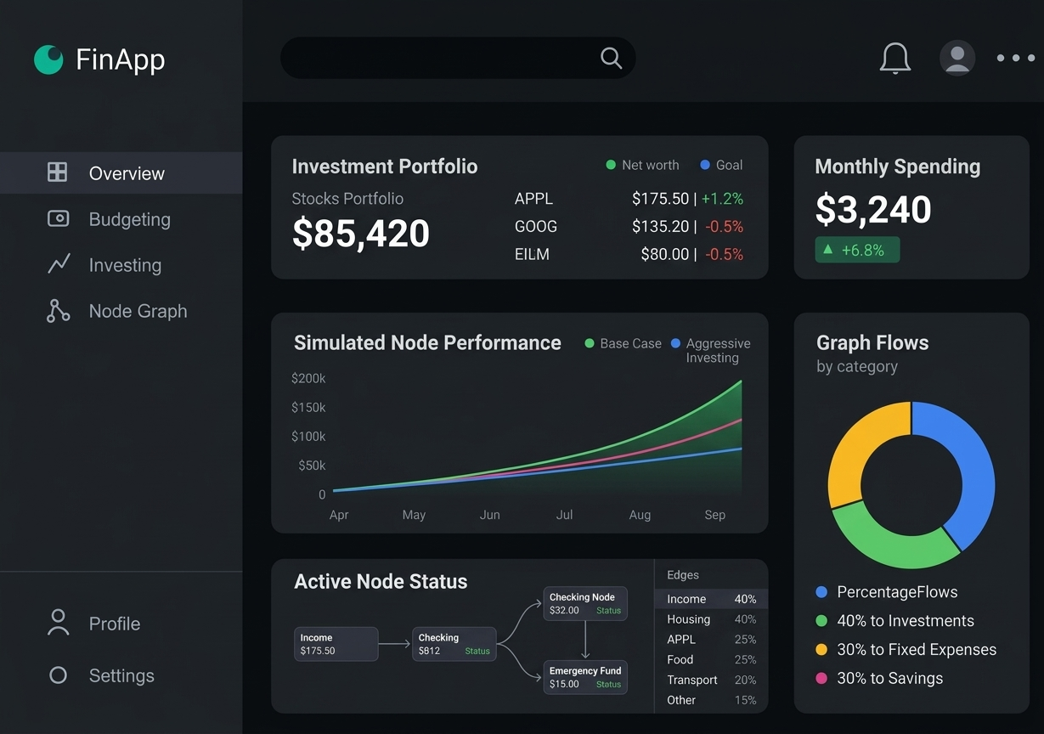
Figure 0. FinApp Overview Dashboard featuring node status dynamics, portfolio tracking, and interactive graph flows.
Document Control
Version | Date | Description | Owner
v0.1 | 09/30/2026 | Initial design document draft created from Sprint 0 materials and backlog. | Team 1
v1.0 | 10/01/2026 | Added ERD, communication flow, Docker layout, Java class structure, and simulation sequences. | Team 1
v2.0 | 10/02/2026 | Pivot to Graph-Based Node Architecture, dynamic edges, and stock holdings; removed static net worth calculation. | Team 1
v2.1 | 10/03/2026 | Production design layout: inline diagrams throughout text, cover page, executive glossary, and complete appendices. | Team 1

Source Materials Used
- DesignDocOverview.pptx: Academic course outline for section structure.
- SprintReviewStatusReport.pdf: Sprint 0 project overview, architecture, core features, and Definition of Done.
- UserStoryDeliverable.xlsx: Product backlog and acceptance criteria.
- Technical UML Diagrams: ERD model, communication sequence, deployment view, Java class diagram, and simulation flow.

Table of Contents
1. Purpose
2. Scope
3. Exclusions, Assumptions, and Limitations
4. Solution Design Overview
5. Technical Architecture
6. Hardware, Hosting, and Physical Layout
7. Configuration Specification
8. Solution Design Specification
9. Data and Information Design
10. Module Descriptions
11. Interfaces and External Integration Points
12. Coding Standards and Definition of Done
13. Roles and Responsibilities
14. Terms and Definitions (Glossary)
15. Supporting References
16. Appendix A - Screenshots and Visual Assets
17. Appendix B - Full Architectural UML Diagrams

1. Purpose
This document provides the production software design for FinApp, a web-based financial modeling, wealth simulation, and portfolio management application. The system models personal financial structures as an interactive Directed Acyclic Graph (DAG) of Financial Nodes and Cash-Flow Edges.
The system enables users to visualize capital routing, model stock portfolios, simulate cash-flow changes, and run stochastic Monte Carlo wealth forecasts enriched by natural language AI suggestions without requiring paid bank-aggregation APIs.

2. Scope

2.1 In-Scope Features
- Interactive Graph Canvas: Visual canvas using D3.js to render nodes (Income, Accounts, Liabilities, Investments) connected by percentage or fixed monthly flow edges.
- Investment Portfolio Tracking: Live price lookups and yield updates for tracked tickers (e.g., AAPL, GOOG) via market data sources.
- Cash-Flow Simulation Engine: Multi-scenario cash-flow engine powered by Python FastAPI to run Monte Carlo probability distributions (P10, P50, P90).
- AI Financial Advisory: Automated advice generated via Claude API based on graph state payloads.
- Friction-Free Ingestion: Flexible data input via visual canvas, pre-configured demo archetypes, or batch JSON/CSV uploads.

2.2 Core User Interfaces
Screen | Primary Purpose
Overview | Main dashboard with stock portfolio values, active node status, monthly spending, and graph flow distributions.
Node Graph Canvas | D3.js interactive workspace to add/edit financial nodes, connect edges, and model cash allocation routes.
Budgeting & Flows | Categorized cash-flow tables, recurring transfer configurations, and overspending warning metrics.
Investing & Simulation | Real-time stock watchlist, dividend yield tracking, and Monte Carlo probability percentile curves.

3. Exclusions, Assumptions, and Limitations

3.1 Exclusions
- Live Bank Credentials (Plaid): Omitted to avoid paid API credentials, OAuth complexity, and security audits.
- Direct Brokerage Trading: FinApp models and simulates portfolios but does not execute financial transactions.
- Certified Financial Advice: Outputs are for educational simulation purposes only.

3.2 Assumptions & Limitations
- Users enter initial account balances and flow allocations manually or via demo archetypes.
- External financial market endpoints (e.g., yfinance) are free-tier and subject to rate limits.
- The software stack runs in Docker containers during development and local testing.

4. Solution Design Overview
FinApp replaces traditional static spreadsheets with a dynamic graph model. Every income source, checking account, investment account, debt, and expense is represented as a node, while cash movements are represented as directed edges.
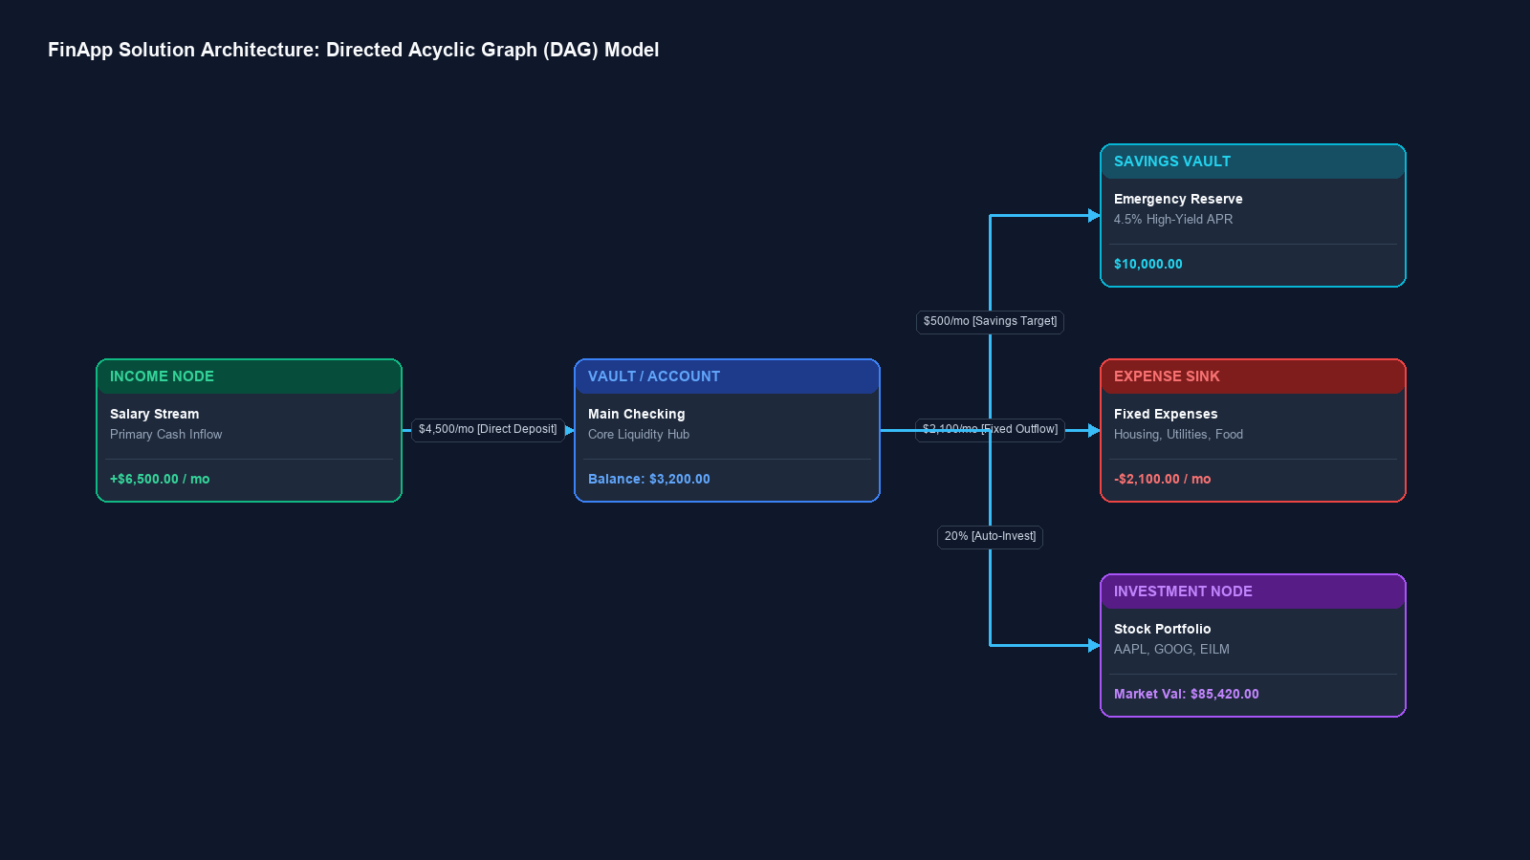
Figure 1. FinApp Dashboard layout displaying investment portfolios, simulated node trajectories, active graph statuses, and allocation percentages.

5. Technical Architecture
FinApp uses a containerized multi-service architecture. The browser-based single-page application interacts with a Java Spring Boot core backend via HTTP/REST endpoints. The Spring Boot server manages persistence in PostgreSQL and delegates mathematical analytics and AI requests to a Python FastAPI microservice.
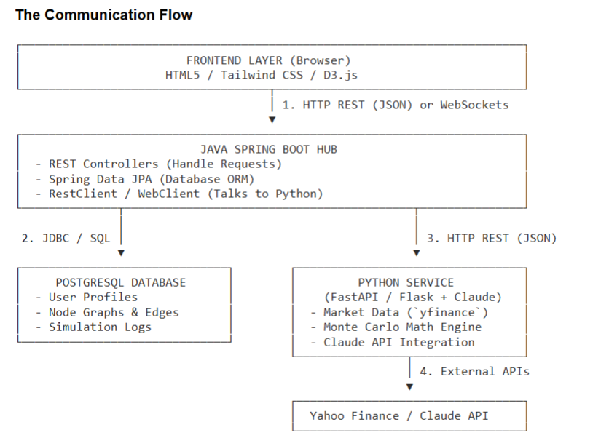
Figure 2. End-to-end communication sequence across frontend, Java Spring Boot hub, PostgreSQL database, Python service, and external APIs.

6. Hardware, Hosting, and Physical Layout
The application is containerized using Docker Compose, isolating each service on a shared internal bridge network (finapp-net).
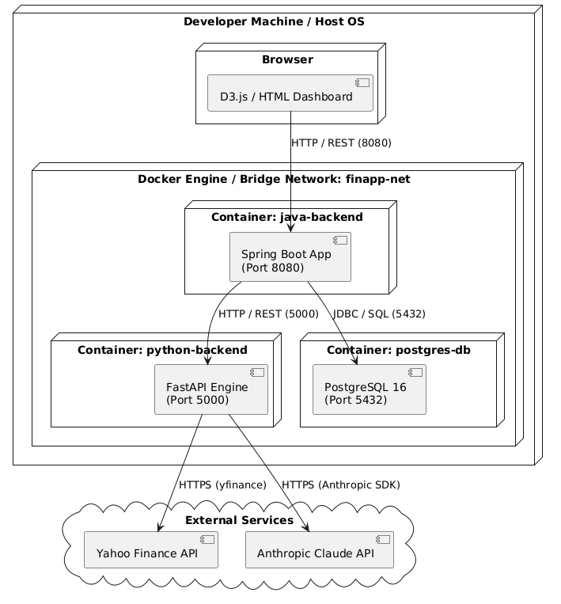
Figure 3. Physical deployment diagram showing Docker container topology on the host machine.
Container Name | Runtime Environment | Exposed Port | Internal Function
java-backend | OpenJDK 17 / Spring Boot | 8080 | REST API Gateway, business logic, ORM persistence.
python-backend | Python 3.11 / FastAPI | 5000 | Monte Carlo simulations, price scraping, AI prompts.
postgres-db | PostgreSQL 16 Alpine | 5432 | Relational storage for users, graphs, and simulation snapshots.

7. Configuration Specification
Runtime environment properties are passed via containerized environment files (.env):
# Database Credentials
POSTGRES_DB=finance_db
POSTGRES_USER=finapp_admin
POSTGRES_PASSWORD=SecurePassword123!
# Service Intercommunication
PYTHON_SERVICE_URL=http://python-backend:5000
SPRING_PROFILES_ACTIVE=dev
# External API Integrations
ANTHROPIC_API_KEY=sk-ant-api03-...
MARKET_DATA_PROVIDER=yfinance

8. Solution Design Specification
The ingestion engine provides three complementary ways to populate node graphs, removing the need for paid bank aggregators.
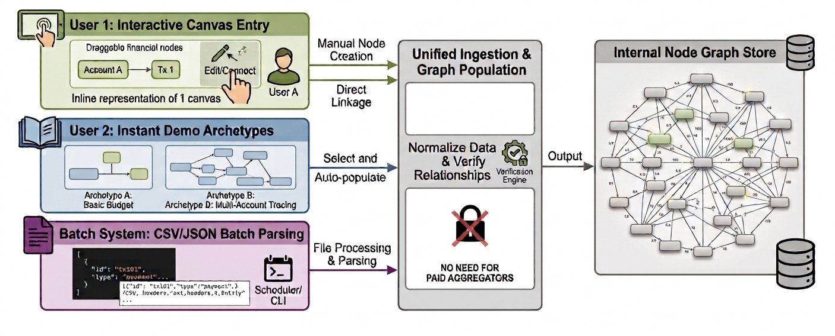
Figure 4. Ingestion strategy highlighting interactive canvas entry, instant demo archetypes, and CSV/JSON batch parsing.

9. Data and Information Design
The relational database schema is designed around node-edge graph structures using PostgreSQL.
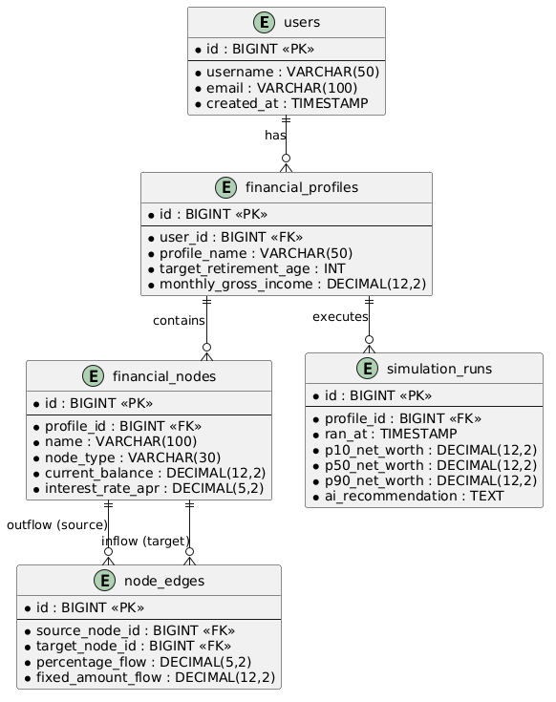
Figure 5. Entity-Relationship Diagram (ERD) defining relationships between users, financial profiles, financial nodes, node edges, and simulation runs.

10. Module Descriptions

10.1 Java Backend Architecture
The Java Spring Boot subsystem uses a layered architecture to separate entities, JPA repositories, service layers, and REST controllers.
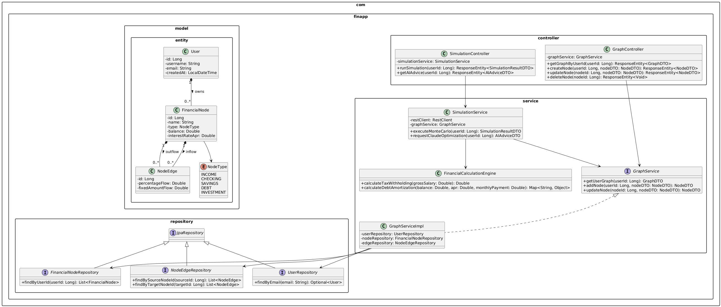
Figure 6. Class diagram for the Java Spring Boot backend service showing controller, service, repository, and entity layers.

10.2 Simulation Execution Flow
When a user runs a scenario simulation, execution flows asynchronously across both backend microservices.
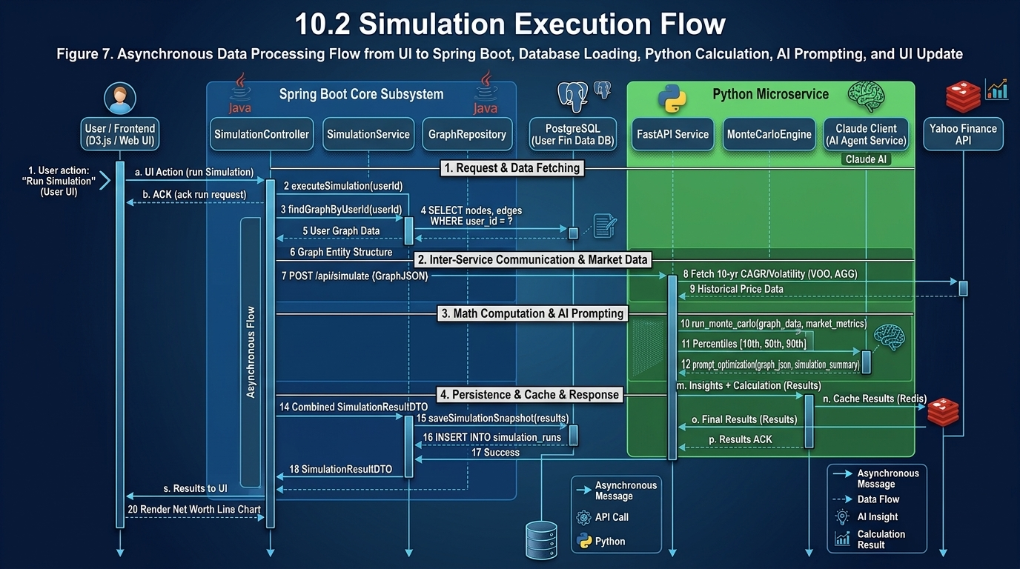
Figure 7. Sequence diagram showing data processing flow from UI action to Spring Boot, database loading, Python calculation, AI prompting, and UI update.

11. Interfaces and External Integration Points
Planned primary internal REST endpoints for graph management:
GET /api/v1/graph
Description: Retrieves full financial graph (nodes and edges) for current user.
POST /api/v1/graph
Description: Atomically saves/updates nodes and edges.
POST /api/v1/simulations/run/{userId}
Description: Initiates Monte Carlo calculation and AI advice request.

12. Coding Standards and Definition of Done
1. User Story Acceptance: All acceptance criteria defined in the user story are met and verified.
2. Code Quality & Standards: Code follows team guidelines, includes inline comments/JavaDocs for complex algorithms, and passes static analysis.
3. Automated Testing: Unit tests pass locally and in the CI build pipeline.
4. Documentation: Public APIs, DTO schemas, and environment setups are fully documented.
5. Git & Peer Review: Feature branch is rebased onto main, code passes peer review with at least 1 approval, and changes are merged via Pull Request.
6. Product Owner Acceptance: Feature demonstration is accepted by the Product Owner role.

13. Roles and Responsibilities
Role | Assigned Member(s) | Primary Responsibilities
Backend & Integration | Lucas Polo, Ali Canturk | Java Spring Boot REST Controllers, JPA mappings, service layer, DTO serialization, API integration.
Database & Persistence | Braden Elsworth | PostgreSQL schema design, foreign key constraints, migration scripts, and repository optimizations.
Python & Simulation | Quinn Johnson, Sean Bassi | FastAPI setup, Monte Carlo algorithm development, yfinance integration, Claude SDK prompts.
Frontend & UI Canvas | Jason Mele | React/D3.js graph visualizer, dashboard components,

14. Terms and Definitions (Glossary)
Financial Node: A discrete account entity within the graph (e.g., salary stream, checking account, credit card, stock portfolio).
Node Edge: A directed connection defining capital transfer between two nodes, configured as a fixed dollar amount or percentage flow.
DAG (Directed Acyclic Graph): A graph structure that flows in one direction without circular loops, ensuring predictable cash-flow processing.
Monte Carlo Simulation: A statistical technique that runs thousands of randomized trials to model probability distributions of future portfolio returns.
DTO (Data Transfer Object): Lightweight object used to serialize JSON payloads between the frontend, Java backend, and Python services.

15. Supporting References
- Spring Boot Documentation & JPA Guidelines.
- FastAPI Microservice Architecture Framework.
- D3.js Force-Directed Graph Layout Engine.
- Anthropic Claude API Structured Output Prompting Guides.

16. Appendix A - Screenshots and Visual Assets
Appendix Figure A1. Primary UI Dashboard mock-up showing node status panels and stock portfolio widgets.

17. Appendix B - Full Architectural UML Diagrams
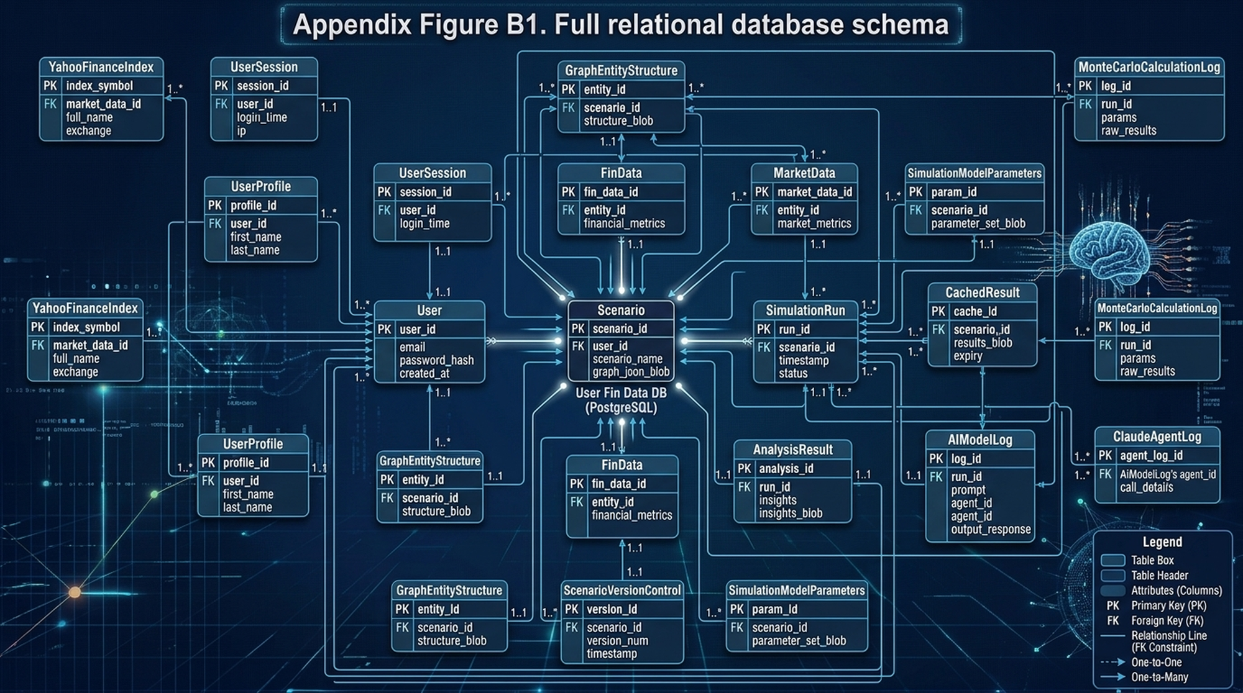
Appendix Figure B1. Partially Full relational database schema to current requirements.
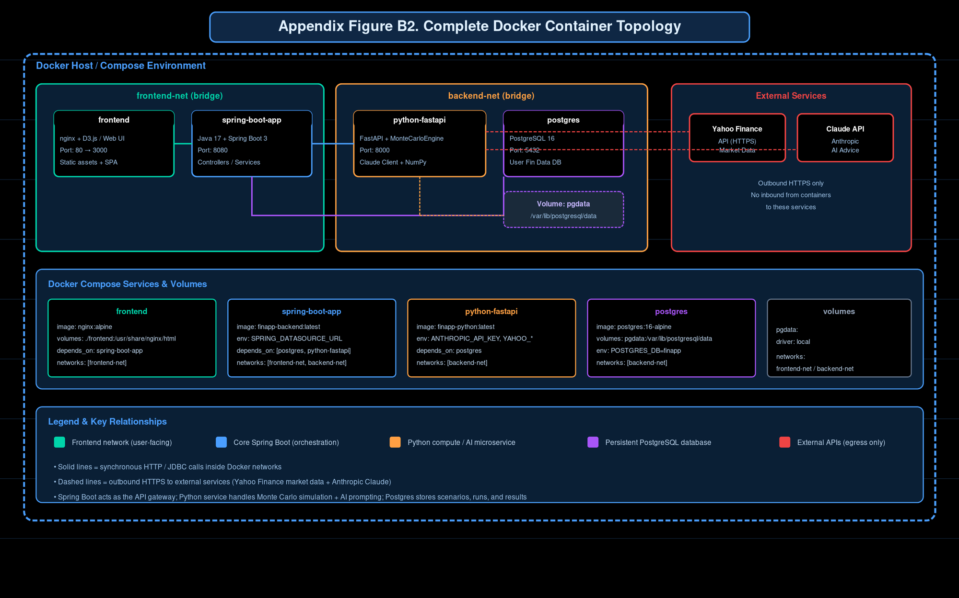
Appendix Figure B2. Partially Complete Docker container topology.
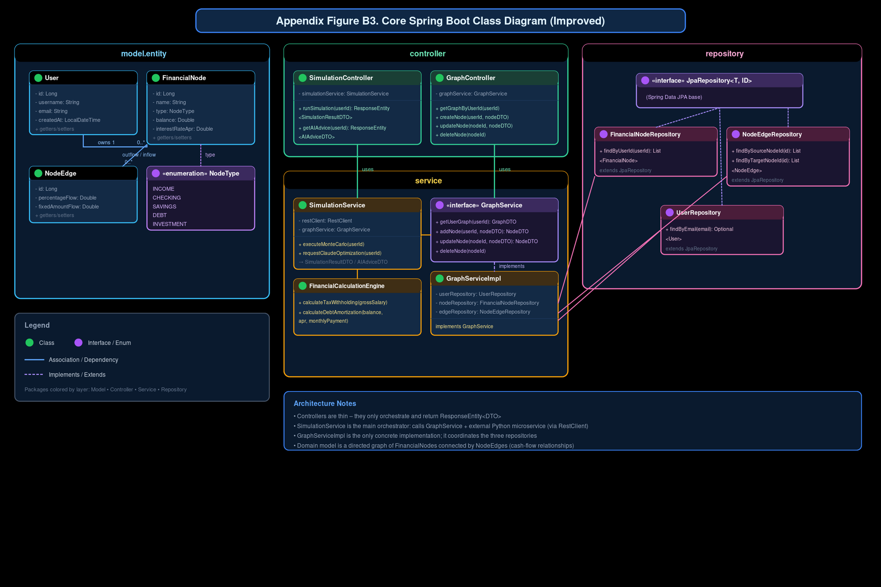
Appendix Figure B3. Initial Object-oriented class diagram for the core Spring Boot application.
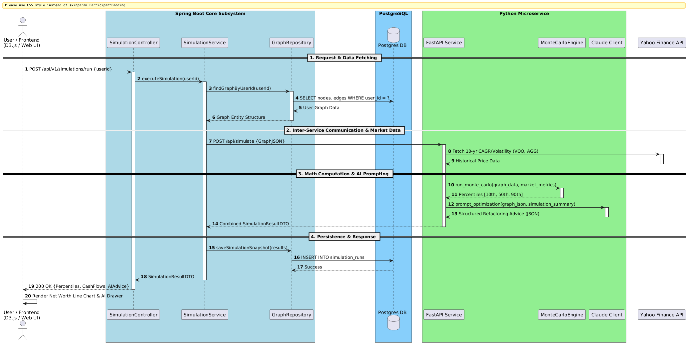
Appendix Figure B4. Detailed architecture.

