Catapult Initial Report
Project Goal:
Design and build a catapult that stores mechanical energy to launch a baseball.

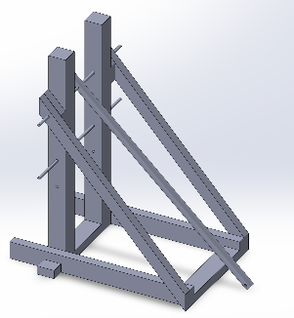
Materials List:
- 2 x ½” by 36” metal all-thread rod
- 2 x 3/8’’ by 4’’ bolts
- 4 x 2’ by 4’ by 8’ wood
- 1 x 4’ by 4’ by 8’ wood
- 3/8’’ flared nut
- 7/16” washers
- 5/16” uss flat washers
- ½-13” hex nuts
- 5/16-18 x 7” carriage bolts
- Various drills, saws, and screws
Project Design and Description:
We used SolidWorks 2023 to build this design.
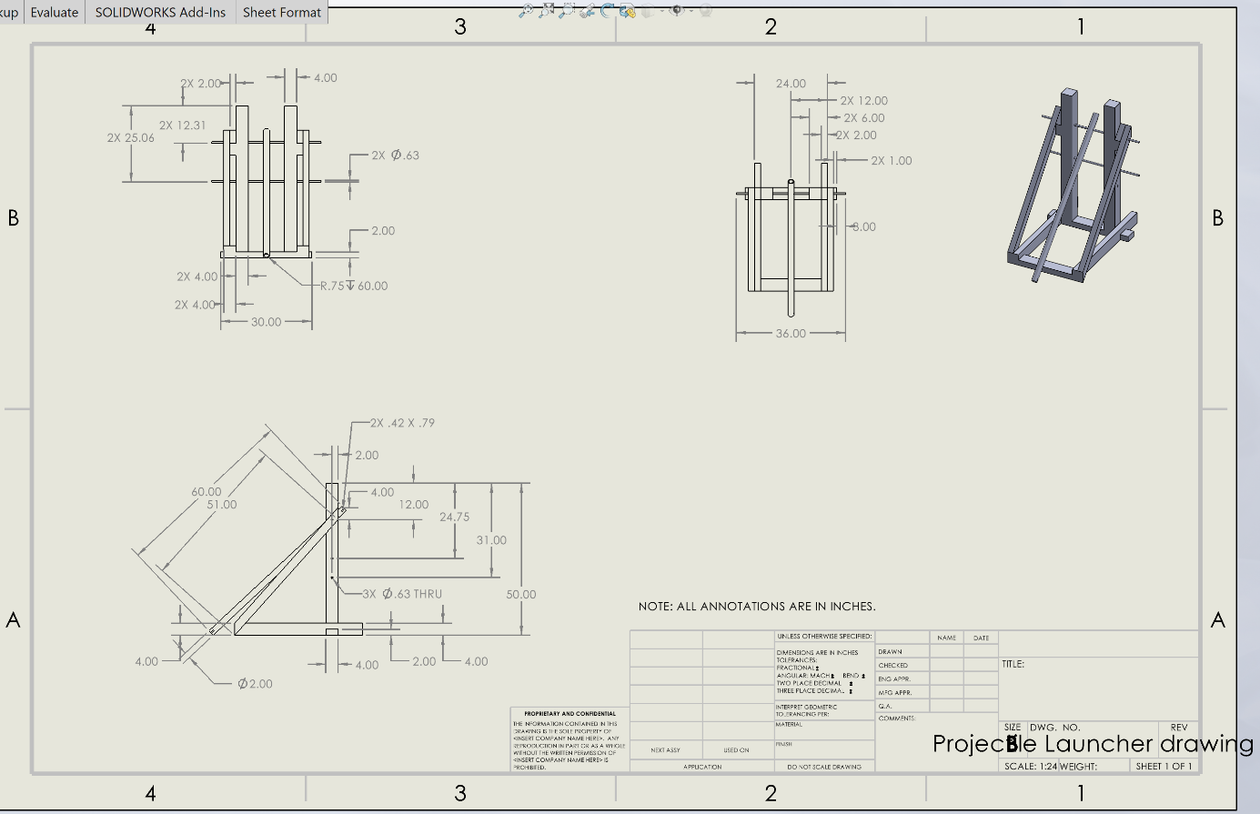
Attached to the bottom of the launcher (the circular pipe) is a pouch for the baseball. Also attached to the bottom of the launcher is a latch. The launching arm is on an axis (the first metal rod from the top), so undoing the latch will cause the launch of the baseball. On the other end of the arm, there is a hole for rubber bands to be put under tension when stretched to the second bar from the top. These rubber bands are what causes the catapult to be put under a tension force, making the catapult work. This is how our catapult converts potential energy into kinetic energy.

Historical Background:
The inspiration for the design for the catapult came from the Trebuchet and the Onager with some added modifications on the torsion. The Trebuchet was first used in 4th century B.C. China, known as a massive siege weapon, later inherited in Europe during the medieval period. Its original design was used during sieges to launch heavy stones into enemy walls and was considered a large a giants catapult or a stave sling. The catapult was also used to launch other items such as corpses and dead animals, in hopes of spreading disease inside the castle’s walls. The first medieval design of the Trebuchet, known as the traction trebuchet, required people to supply power to the catapult arm; however, it later evolved into the counterweight trebuchet. The counterweight trebuchet or the counterpoise trebuchet, used counterweight with a long wooden beam by offsetting the beam and attaching the counterweight to the short end. The projectile is placed on the longer end of the beam in a sling. When the arm of the catapult is released, the counterweight pulls the longer end of the beam up and launches the projectile out of the sling. The sling allowed the trebuchet to be aimed by adjusting its angle rather than relocating the entire trebuchet.
The Onager was another significant medieval war catapult built with high efficiency and the capabilities to launch projectiles weighing up to 275 pounds. Used during siege by the Roman military, accurately launching projectiles with power, destroying enemy fortifications, and disrupting troops. The Onager used a torsion design with a sling, like the trebuchet, in an efficient yet powerful design that was a key to many Roman victories.

Citations:
History, Simple. “The Trebuchet.” YouTube, YouTube, 28 Dec. 2017, www.youtube.com/watch?v=i_6LeWzNx_c.
Ginjomantas. “Onager Catapult: Ancient Siege Engine Secrets.” The Roman Empire, 7 Feb. 2024, roman-empire.net/army/onager/.

