Final Report: Projectile Launcher

Experimental Results
The actual range of the catapult was calculated using the experiment results shown in the table below.
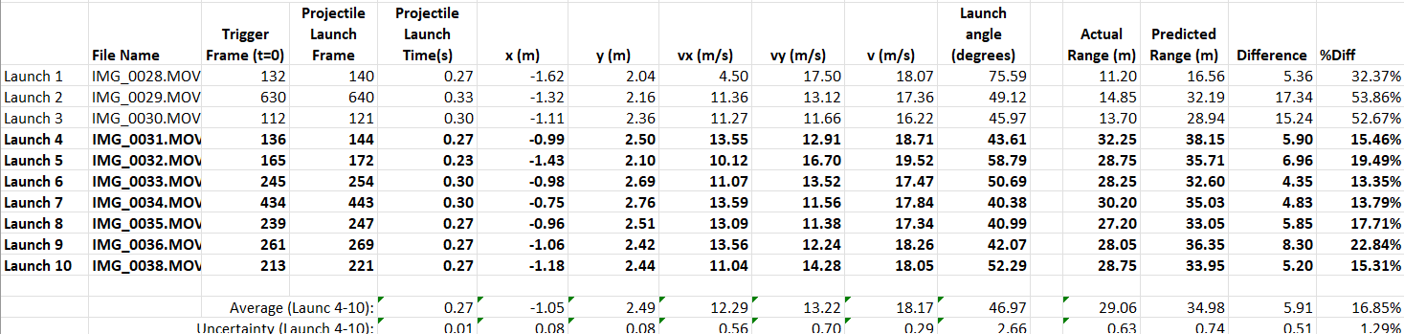
The kinetic energy (KE) of the catapult can be calculated using, $KE=\frac{1}{2}mv^{2}$, and the values from the results shown above. The average mass of a baseball is 142 grams, and the average initial velocity is 18.17 meters per second.
$KE=\frac{1}{2}mv^{2}=\frac{1}{2}\left(0.142kg\right){\left(18.17\frac{m}{s}\right)}^{2}=23.44 J=0.02344 kJ$
The potential energy (PE) of the projectile before launch can be estimated by using the spring constant (k) of the five rubber bands and the actual horizontal distance (x) that the ball travelled. To get the spring constant of the rubber bands, we used a cart and a track that can measure the force needed to stretch the rubber band to various distances. After testing various distances using the cart and a single rubber band, we used a best fit line to figure out the slope that gave us our estimated spring constant (k). The graph is shown below.
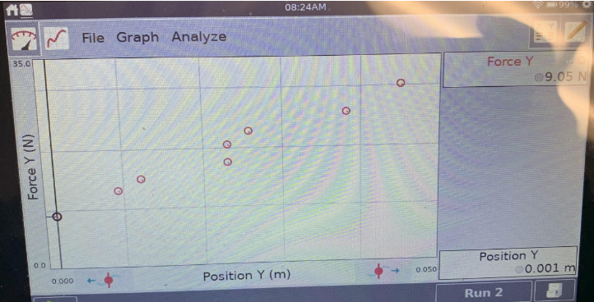
$$y=mx+b m=469.39 b=8.7923N$$
$PE= \frac{1}{2}\left(5kx^{2}\right)= \frac{1}{2}\left(5\left(469.39N\right)\right){\left(29.06m\right)}^{2}=990.98 kJ$ (for 5 rubber bands)

The mechanical efficiency of the catapult was relatively high. By looking at the %Diff column from the graph (column that compares predicted range with actual range), we find the mechanical efficiency of the catapult. If the percentage difference is high, then the mechanical efficiency is low and vis versa. The average percent difference was 16.85%, making it a pretty efficient catapult.

Discussion of Results
The theoretical and actual range results varied. With a difference average of 5.91m, there were factors that played into the actual range of the baseball other than what we calculated. For example, air resistance, wind, rain, and human error collecting data are just some of the many factors that may play into the difference between theoretical and actual ranges.

From calculating the kinetic and potential energy, we find that the kinetic energy is equal to $0.02344 kJ$ and the potential energy is equal to $990.98 kJ$. These numbers do not agree experimentally. Errors in our calculations may cause this discrepancy, causing these two numbers to be very far apart.

Many of the sources of error and uncertainty were the result of the sling and the ball leaving the pouch. In the first launch, the hook was not bent enough, and the ball left the pouch at a high launch angle consequently leading to a shorter distance travelled. After adjusting the hook where the ring glides off, the launches were consistent with the predicted range. The release of the ring and the position of the sling initially on the guide platform were the parts that contributed to the most uncertainty. With the strings of the sling tangled, the launcher released the ball backwards and the ring when caught was ripped from the sling.

The design was a big success. We found inspiration online, then built the base as close as possible. When it came to the launcher itself, we had an idea in mind of what we wanted it to be, and then successfully brought it to life. While being a success, the launcher could have been improved by a stronger launching pole. When launching under high tension, there was always worry that the pole might break. So, if there were requirements of a much longer distance, the only thing I would attempt to change is the strength of the launching pole.

