Z80 Simulator

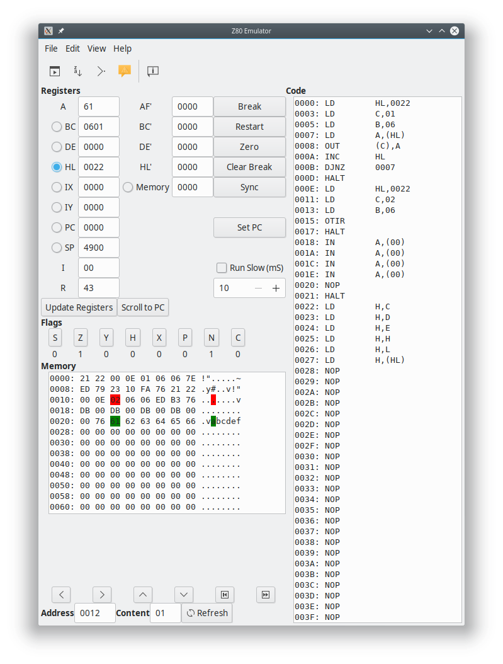
This is the main window which appears when z80sim is called. It has five main areas:

- The menu bar.
- The tool bar.
- The code text area.
- The memory dump area.
- Flags.

All the elements on the main window have tooltips for guidance.

The menu bar
Has four entries:

File
- New project – doesn’t do much at the moment except to set the project name to ‘untitled.z80sim’.
- Open Project… - opens a pre-saved project.
- Save Project – saves the project under the current project filename.
- Save Project As… - allows a new project filename to be specified for the project save.
- Load Z80 code… - load a new assembled Z80 binary into RAM. Clears all breakpoints and resets all the registers and flags.
- Quit – err… quits the simulator.

Edit
This menu doesn’t do anything at the moment and may be removed later.

View
Toggles the windows for sub sections which are
- Log – shows the simulator log window which displays useful information such as loading statistics for Z80 binaries, notifications of IN ports needing input and so on. Note that the log window may come up automatically if attention needs to be paid to certain situations.
- IOPorts – shows the IOPorts window which controls all IN/OUT opcodes.
- Breakpoints – shows a window for managing existing breakpoints.

Help
Just contains the “About...” entry.

The tool bar
Has five entries:

Run
Starts the program from the PC at a rate specified in the “run slow” selection if turned on. Stops when it encounters a breakpoint which has been triggered pass times, or a HALT instruction.

Trace

Step

Dump vars (for development)

Show opcodes

