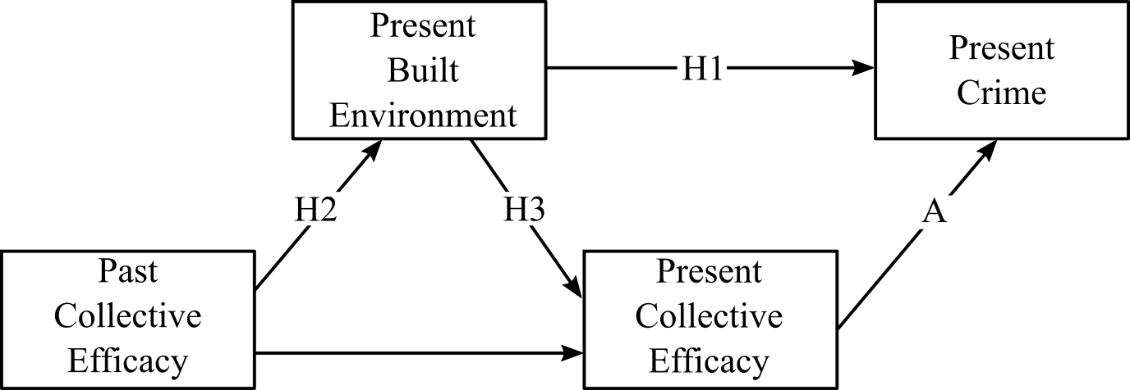

FIGURE  Theoretical model of collective efficacy, the built environment, and crime. Tested hypotheses represented as paths H1, H2, and H3

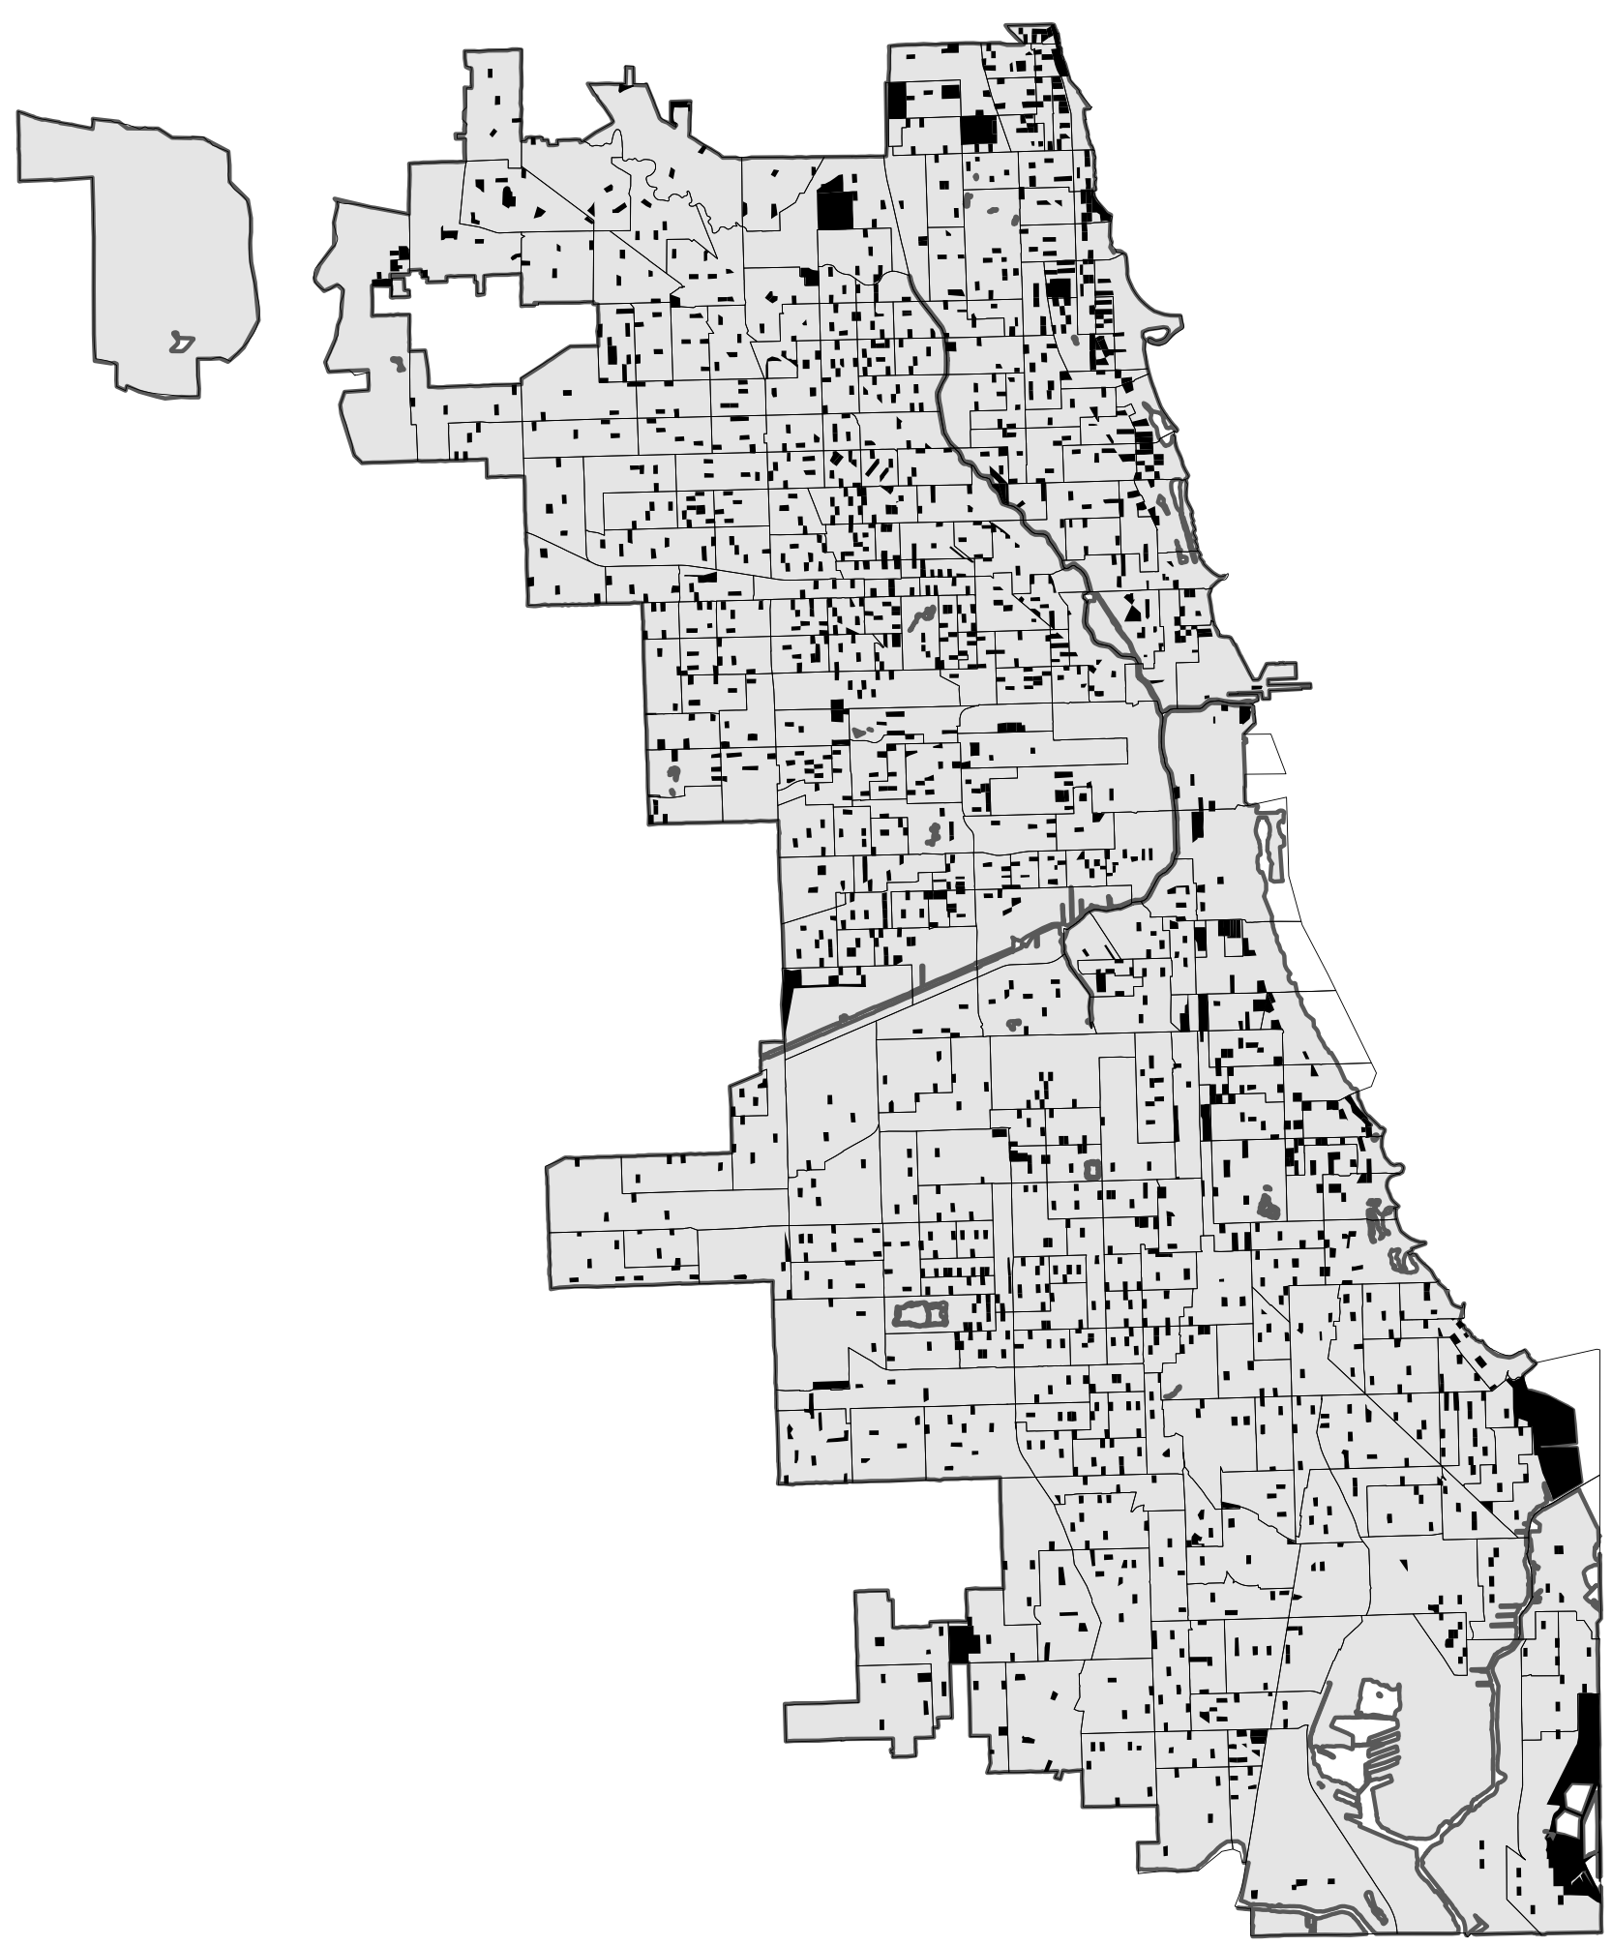

FIGURE  Map of census blocks sampled in 2001-2003 Chicago Community Adult Health Study. Sampled blocks are filled black shapes. Neighborhood clusters are outlines

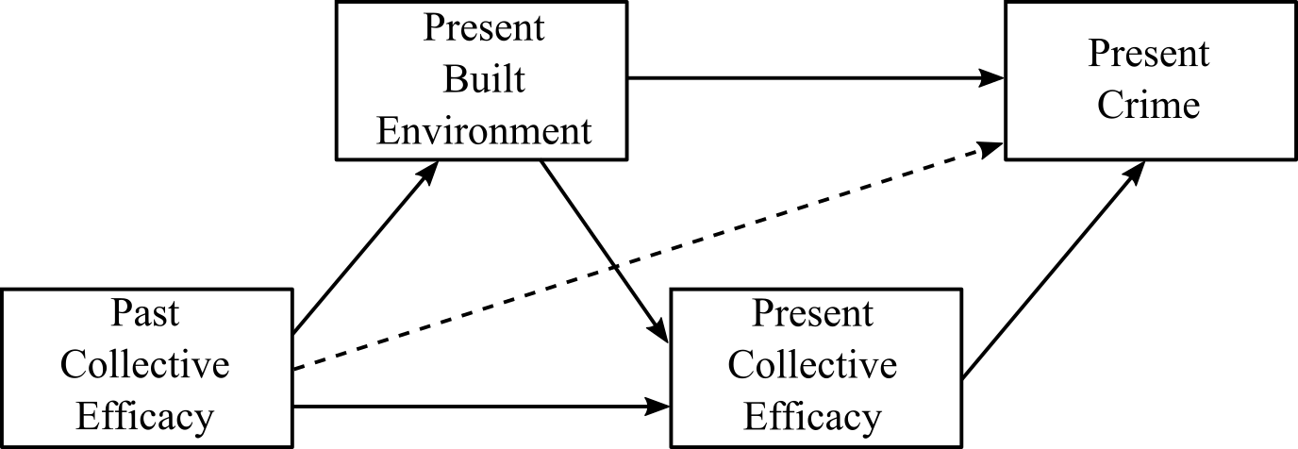

FIGURE  Longitudinal structural model. Dashed arrow represents tested independence restriction (d-separation)

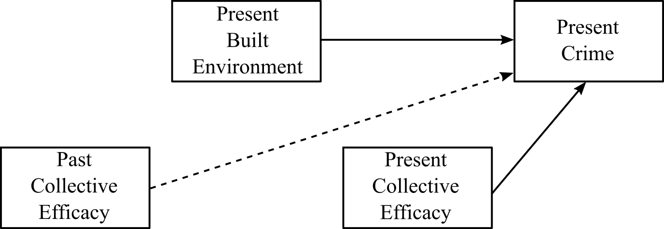

FIGURE  Simplified depiction of crime models. Solid arrows are modeled direct effects. The dashed arrow represents unmodeled (restricted) paths

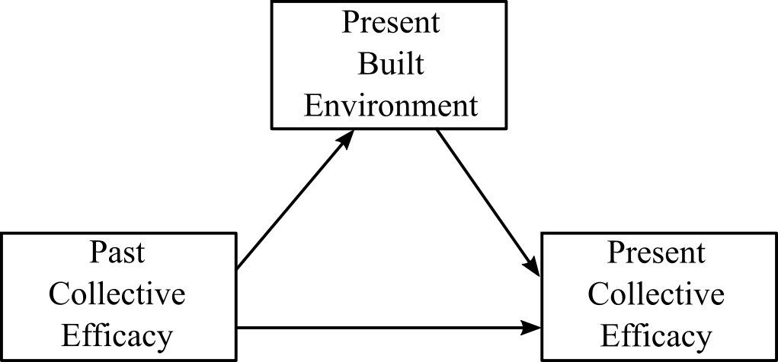

FIGURE  Models of the built environment and present collective efficacy

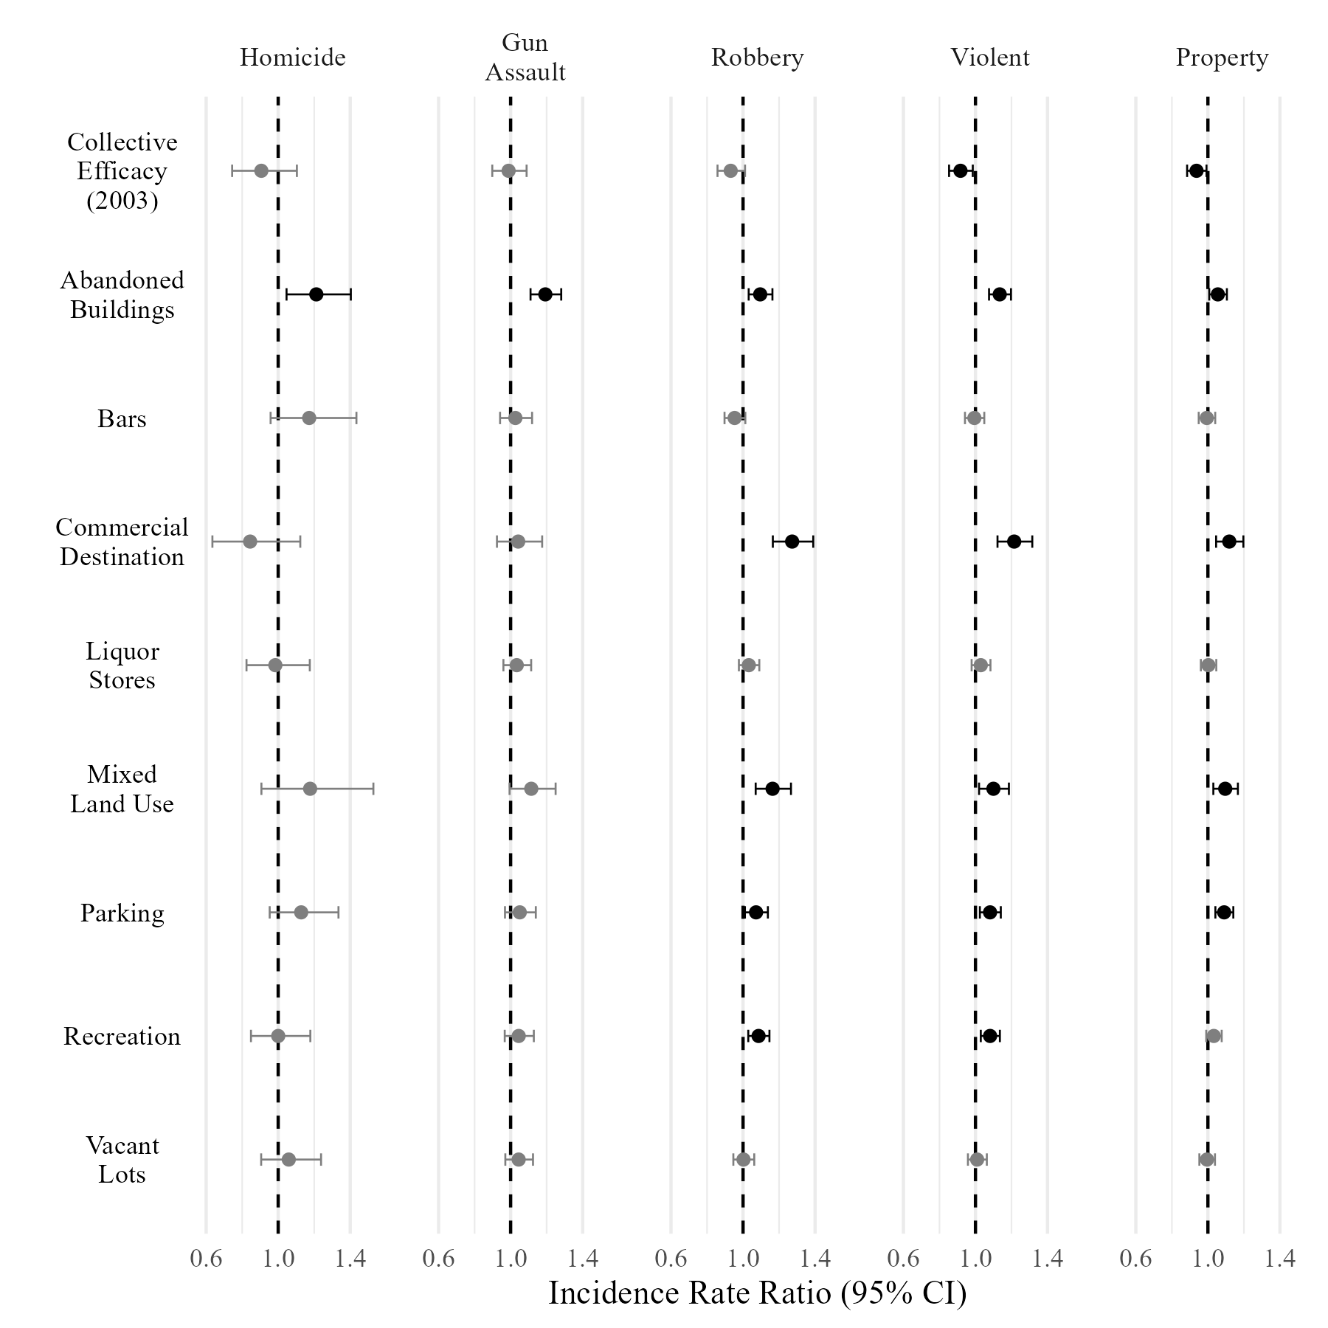

FIGURE  Estimated incidence rate ratios and 95% confidence intervals for selected predictors of five crime types. Predictors are standardized, outcomes are log-counts. Estimates significant at p < .05 are in black