Title
Subtitle
Author

Heading 1
This is a block quote
This is the first paragraph of a section. Lorem ipsum yo.
This is body text while this is an in-line fig ref: Figure 1.
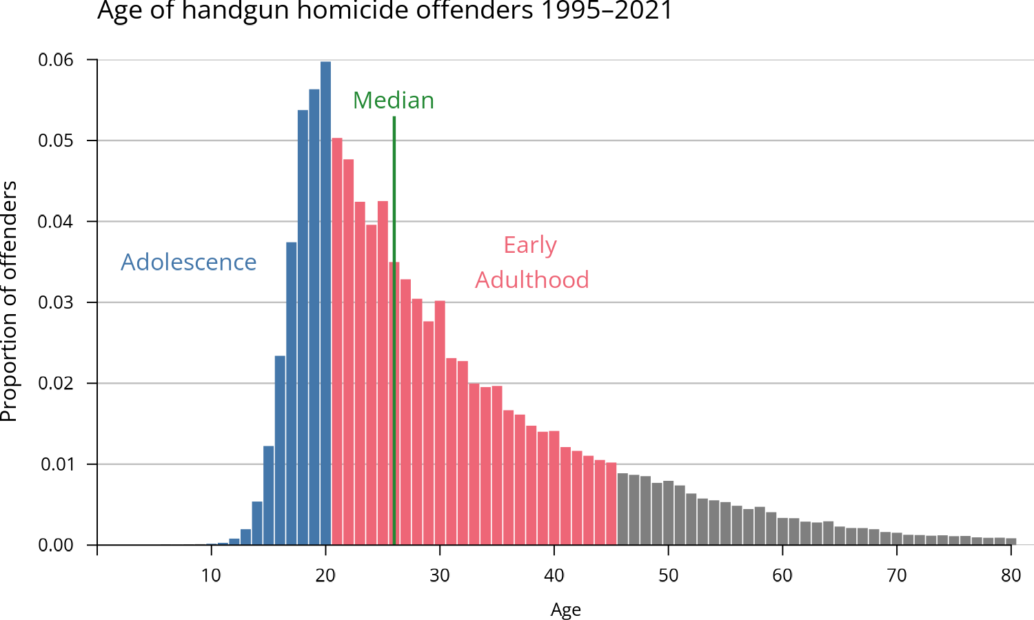
Figure 1: Look a caption!

Heading 2
First para text again, but so I can add a footnote
Refs:
Anderson-Bergman, C. (2017). icenReg : Regression Models for Interval Censored Data in R. Journal of Statistical Software, 81(12). https://doi.org/10.18637/jss.v081.i12
Beardslee, J., Mulvey, E., Schubert, C., Allison, P., Infante, A., & Pardini, D. (2018). Gun- and Non-GunRelated Violence Exposure and Risk for Subsequent Gun Carrying Among Male Juvenile Offenders. Journal of the American Academy of Child & Adolescent Psychiatry, 57(4), 274–279. https://doi.org/10.1016/j.jaac.2018.01.012
Bingenheimer, J. B., Brennan, R. T., & Earls, F. J. (2005). Firearm Violence Exposure and Serious Violent Behavior. Science, 308(5726), 1323–1326. https://doi.org/10.1126/science.1110096
Blumstein, A. (1995a). Youth violence, guns, and the illicit-drug industry. The Journal of Criminal Law and Criminology (1973-), 86(1), 10. https://doi.org/10.2307/1143998
Blumstein, A. (1995b). Youth violence, guns, and the illicit-drug industry. The Journal of Criminal Law and Criminology (1973-), 86(1), 10. https://doi.org/10.2307/1143998
Braga, A. A., Griffiths, E., Sheppard, K., & Douglas, S. (2021). Firearm Instrumentality: Do Guns Make Violent Situations More Lethal? Annual Review of Criminology, 4(1), 147–164. https://doi.org/10.1146/annurev-criminol-061020-021528
Carlson, J. D. (2012). ’I Don’t Dial 911’: American Gun Politics and the Problem of Policing. British Journal of Criminology, 52(6), 1113–1132. https://doi.org/10.1093/bjc/azs039
Comer, B. P., & Connolly, E. J. (2023). Exposure to gun violence and handgun carrying from adolescence to adulthood. Social Science & Medicine, 328, 115984. https://doi.org/10.1016/j.socscimed.2023.115984
Cook, P. J., & Ludwig, J. (1997). Guns in america: National survey on private ownership and use of firearms.
Cook, P. J., Ludwig, J., Venkatesh, S., & Braga, A. A. (2007). Underground gun markets. The Economic Journal, 117(524), F588–F618. https://doi.org/10.1111/j.1468-0297.2007.02098.x
Cook, P. J., Parker, S. T., & Pollack, H. A. (2015). Sources of guns to dangerous people: What we learn by asking them. Preventive Medicine, 79, 28–36. https://doi.org/10.1016/j.ypmed.2015.04.021
Curry, G. D., & Decker, S. H. (1998). Confronting gangs: Crime and community. Roxbury Pub. Co.
Hsu, C.-H., Taylor, J. M. G., Murray, S., & Commenges, D. (2007). Multiple imputation for interval censored data with auxiliary variables. Statistics in Medicine, 26(4), 769–781. https://doi.org/10.1002/sim.2581
Kaplan, J. (2023). Jacob Kaplan’s Concatenated Files: Uniform Crime Reporting (UCR) Program Data: Supplementary Homicide Reports (SHR), 1976-2021. https://doi.org/10.3886/E100699V12
Kellermann, A. L., Rivara, F. P., Somes, G., Reay, D. T., Francisco, J., Banton, J. G., Prodzinski, J., Fligner, C., & Hackman, B. B. (1992). Suicide in the home in relation to gun ownership. New England Journal of Medicine, 327(7), 467–472. https://doi.org/10.1056/NEJM199208133270705
Kirk, D. S., & Papachristos, A. V. (2011). Cultural Mechanisms and the Persistence of Neighborhood Violence. American Journal of Sociology, 116(4), 1190–1233. https://doi.org/10.1086/655754
Kosmidis, I., Kenne Pagui, E. C., & Sartori, N. (2020). Mean and median bias reduction in generalized linear models. Statistics and Computing, 30(1), 43–59. https://doi.org/10.1007/s11222-019-09860-6
Kravitz-Wirtz, N., Aubel, A., Schleimer, J., Pallin, R., & Wintemute, G. (2021). Public Concern About Violence, Firearms, and the COVID-19 Pandemic in California. JAMA Network Open, 4(1), e2033484. https://doi.org/10.1001/jamanetworkopen.2020.33484
Lanfear, C. C., Bucci, R., Kirk, D. S., & Sampson, R. J. (2023). Inequalities in exposure to firearm violence by race, sex, and birth cohort from childhood to age 40 years, 1995-2021. JAMA Network Open, 6(5), e2312465. https://doi.org/10.1001/jamanetworkopen.2023.12465
Lang, B. J., & Lang, M. (2021). Pandemics, Protests, and Firearms. American Journal of Health Economics, 7(2), 131–163. https://doi.org/10.1086/713035
Levine, P., & McKnight, R. (2020). Three million more guns. https://policycommons.net/artifacts/4139054/three-million-more-guns/4947646/
Lizotte, A. J., Krohn, M. D., Howell, J. C., Tobin, K., & Howard, G. J. (2000). FACTORS INFLUENCING GUN CARRYING AMONG YOUNG URBAN MALES OVER THE ADOLESCENT-YOUNG ADULT LIFE COURSE*. Criminology, 38(3), 811–834. https://doi.org/10.1111/j.1745-9125.2000.tb00907.x
Luckenbill, D. F. (1977). Criminal homicide as a situated transaction. Social Problems, 25(2), 176–186. https://doi.org/10.2307/800293
Miller, M., Zhang, W., & Azrael, D. (2022). Firearm purchasing during the COVID-19 pandemic: Results from the 2021 National Firearms Survey. Annals of Internal Medicine, 175(2), 219–225. https://doi.org/10.7326/M21-3423
Molnar, B. E., Miller, M. J., Azrael, D., & Buka, S. L. (2004). Neighborhood Predictors of Concealed Firearm Carrying Among Children and Adolescents: Results From the Project on Human Development in Chicago Neighborhoods. Archives of Pediatrics & Adolescent Medicine, 158(7), 657. https://doi.org/10.1001/archpedi.158.7.657
Moore, M. H. (1980). The Police and Weapons Offenses. The ANNALS of the American Academy of Political and Social Science, 452(1), 22–32. https://doi.org/10.1177/000271628045200103
NICS firearm checks: Month/year. (n.d.). https://www.fbi.gov/file-repository/nics_firearm_checks_-_month_year.pdf/view
Oliphant, S. N., Mouch, C. A., Rowhani-Rahbar, A., Hargarten, S., Jay, J., Hemenway, D., Zimmerman, M., Carter, P. M., & FACTS Consortium, for the. (2019). A scoping review of patterns, motives, and risk and protective factors for adolescent firearm carriage. Journal of Behavioral Medicine, 42(4), 763–810. https://doi.org/10.1007/s10865-019-00048-x
Parker, K., Horowitz, J. M., Igielnik, R., Oliphant, J. B., & Brown, A. (2017). America’s complex relationship with guns. https://policycommons.net/artifacts/617827/americas-complex-relationship-with-guns/1598689/
Reny, T. T., & Newman, B. J. (2021). The Opinion-Mobilizing Effect of Social Protest against Police Violence: Evidence from the 2020 George Floyd Protests. American Political Science Review, 115(4), 1499–1507. https://doi.org/10.1017/S0003055421000460
Rosenfeld, R., Boxerman, B., & Lopez, E. (2023). Pandemic, social unrest, and crime in US cities: Year-end 2022 update.
Rubin, D. B. (1987). Multiple Imputation for Nonresponse in Surveys (1st ed.). Wiley. https://doi.org/10.1002/9780470316696
Sampson, R. J., & Bartusch, D. J. (1998). Legal cynicism and (subcultural?) tolerance of deviance: The neighborhood context of racial differences. Law & Society Review, 32(4), 777–804. https://doi.org/10.2307/827739
Sampson, R. J., Kirk, D. S., & Bucci, R. (2022). Cohort Profile: Project on Human Development in Chicago Neighborhoods and Its Additions (PHDCN+). Journal of Developmental and Life-Course Criminology, 8(3), 516–532. https://doi.org/10.1007/s40865-022-00203-0
Schaeffer, K. (2023). Key facts about americans and guns. https://www.pewresearch.org/short-reads/2023/09/13/key-facts-about-americans-and-guns/
Shapira, H., Jensen, K., & Lin, K.-H. (2018). Trends and Patterns of Concealed Handgun License Applications: A Multistate Analysis. Social Currents, 5(1), 3–14. https://doi.org/10.1177/2329496517725334
Sheley, J. F., & Wright, J. D. (1993). Gun acquisition and possession in selected juvenile samples. https://www.ojp.gov/library/publications/gun-acquisition-and-possession-selected-juvenile-samples
Sherman, L. W. (2000). Gun carrying and homicide prevention. JAMA, 283(9), 1193. https://doi.org/10.1001/jama.283.9.1193
Sherman, L. W., & Rogan, D. P. (1995). Effects of gun seizures on gun violence: “Hot spots” patrol in Kansas city. Justice Quarterly, 12(4), 673–693. https://doi.org/10.1080/07418829500096241
Spano, R., & Bolland, J. M. (2011). Is the Nexus of Gang Membership, Exposure to Violence, and Violent Behavior a Key Determinant of First Time Gun Carrying for Urban Minority Youth? Justice Quarterly, 28(6), 838–862. https://doi.org/10.1080/07418825.2010.547868
Stroebe, W., Leander, N. P., & Kruglanski, A. W. (2017). Is It a Dangerous World Out There? The Motivational Bases of American Gun Ownership. Personality and Social Psychology Bulletin, 43(8), 1071–1085. https://doi.org/10.1177/0146167217703952
Studdert, D. M., Zhang, Y., Swanson, S. A., Prince, L., Rodden, J. A., Holsinger, E. E., Spittal, M. J., Wintemute, G. J., & Miller, M. (2020). Handgun Ownership and Suicide in California. New England Journal of Medicine, 382(23), 2220–2229. https://doi.org/10.1056/NEJMsa1916744
Teplin, L. A., Meyerson, N. S., Jakubowski, J. A., Aaby, D. A., Zheng, N., Abram, K. M., & Welty, L. J. (2021). Association of Firearm Access, Use, and Victimization During Adolescence With Firearm Perpetration During Adulthood in a 16-Year Longitudinal Study of Youth Involved in the Juvenile Justice System. JAMA Network Open, 4(2), e2034208. https://doi.org/10.1001/jamanetworkopen.2020.34208
Turnbull, B. W. (1976). The Empirical Distribution Function with Arbitrarily Grouped, Censored and Truncated Data. Journal of the Royal Statistical Society: Series B (Methodological), 38(3), 290–295. https://doi.org/10.1111/j.2517-6161.1976.tb01597.x
Warner, T. D., & Thrash, C. R. (2020). A Matter of Degree? Fear, Anxiety, and Protective Gun Ownership in the United States. Social Science Quarterly, 101(1), 285–308. https://doi.org/10.1111/ssqu.12735
Wolfgang, M. E. (1958). Patterns in criminal homicide. University of Pennsylvania Press.
Yamane, D. (2022). Gun Culture 2.0: The Evolution and Contours of Defensive Gun Ownership in America. The ANNALS of the American Academy of Political and Social Science, 704(1), 20–43. https://doi.org/10.1177/00027162231156292

Blah blah blah

