Module 1 Assignment 1.3  
1/16/2024  
Clay Lankford  
  
WSC Error Code  
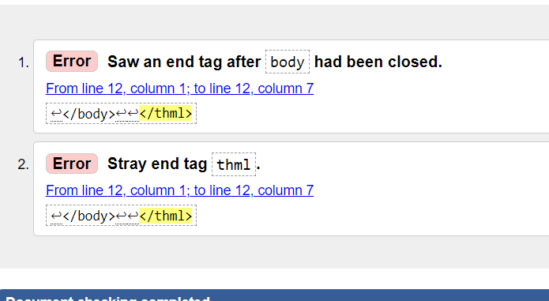  
Corrected  
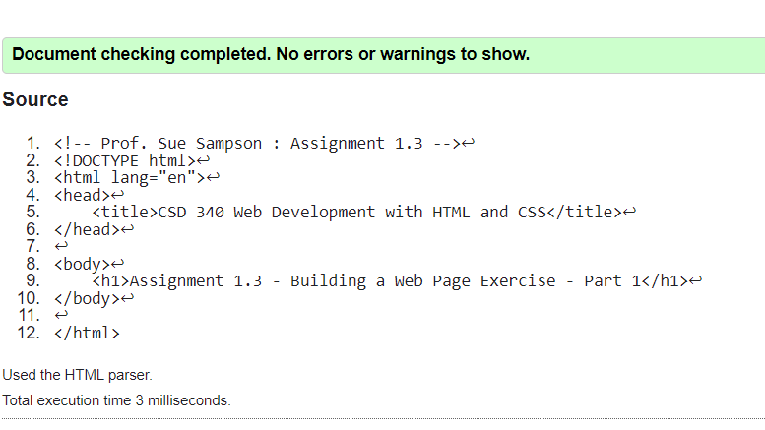  
Screenshot in browser

