# User testing

## Step 1: The Usability Test

User Feedback: Explain here in detail

1. Font is a little small
2. Too much noise/text
3. Big logo that takes up too much screen space

### Proposed Changes as a result of feedback

1. Font bigger
2. Less text
3. Smaller Logo

## Step 2: Revision

Explanation of changes made

1. Shrunk the text in the navigation bar
2. Decreased text length on the left column
3. Decreased logo size

Sketch with changes

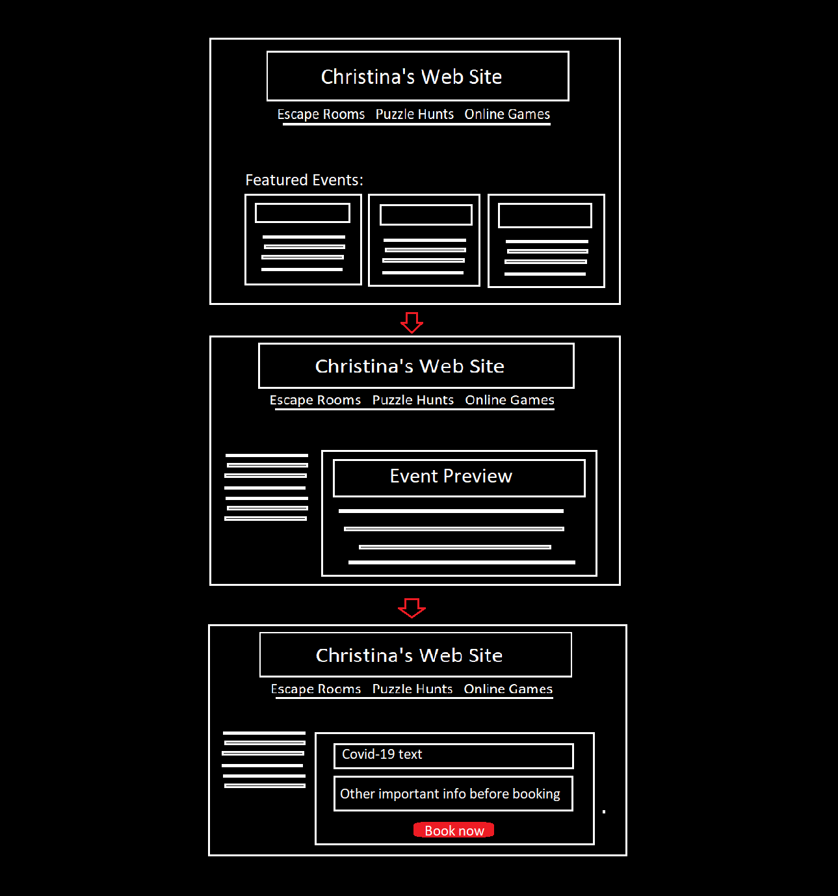

## Step 3: Second Usability Test

User Feedback: Explain here in detail

1. Logo still big
2. Unclear place to click for full event text
3. Doesn’t need extra text on left when picking event

Proposed Changes as a result of feedback

1. Shrink logo (again)
2. Read more button
3. Get rid of extra text

## Step 4: Revision

Explanation of changes made

1. Logo size has been reduced
2. Added a read more button to the event preview
3. Deleted extra text on the left to reduce noise

