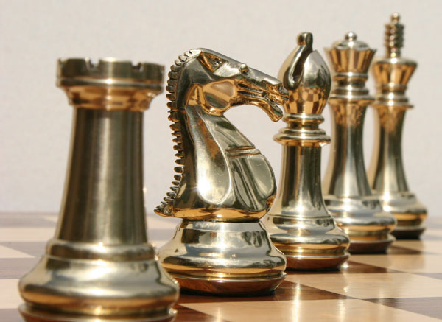

Chess XIV

**Software Specification**

Team 1

Hanchel Cheng

Quan Chau

Kevin Duong

Jamie Lee

Ryan Morrison

Andrew Trinh

University of California: Irvine

Table of Contents

Glossary 1

1: Software architecture overview 2

1.1 Main data types and structures 2

1.2 Major software components 4

1.3 Module interfaces 4

1.4 Overall program control flow 5

2: Installation 6

2.1 System Requirement 6

2.2 Setup and Configuration 6

2.3 Building, compilation, installation 6

3: Documentation of packages, modules, interfaces 7

3.1 Detailed description of data structures 7

3.2 Detailed description of functions and parameters 9

3.3 Detailed description of input and output formats 13

3.4 Detailed description of artificial intelligence for computer player 14

4: Development plan and timeline 15

4.1 Partitioning of tasks 15

4.2 Team member responsibilities 15

Back Matter 16

Copyright 16

Index 17

# Glossary

AI: Artificial Intelligence

GUI: Graphical User Interface

Model: The set of modules responsible for the rules and logic of program

Control: The set of modules responsible for program flow

View: The set of modules responsible for program display

# 1: Software architecture overview

## Main data types and structures

**ChessBoard**

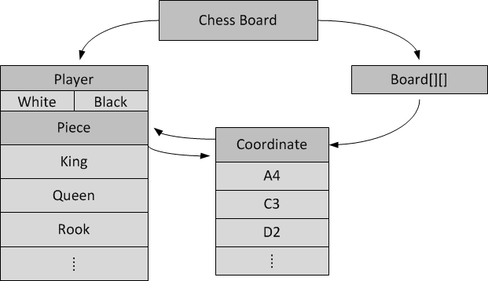

**ChessMoveList**

ChessMove

ChessPlayer

ChessCoordinate Start

ChessCoordinate End

ChessMoveNode

Next Node

Previous Node

ChessMove

ChessPlayer

ChessCoordinate Start

ChessCoordinate End

ChessMoveNode

Next Node

Previous Node

ChessMove

ChessPlayer

ChessCoordinate Start

ChessCoordinate End

ChessMoveNode

Next Node

Previous Node

ChessMoveList

First Move

Last Move

**ChessCoordinateList**

ChessCoor-dinate

ChessCoor-dinate Node

Next Node

Previous Node

ChessCoor-dinate

ChessCoor-dinate Node

Next Node

Previous Node

ChessCoor-dinate

ChessCoor-dinate Node

Next Node

Previous Node

ChessCoordinate-List

FirstNode

FirstNode

## Major software components

Whole program

View

Model

Control

ChessBoard

ChessPlayer

ChessPiece

ChessCoordinate

AI

## Module interfaces

**Model module:**

ChessBoard* Model_Init(void);

ChessBoard* Model_Move(ChessBoard*, ChessMove*);

ChessBoard* Model_Undo(ChessBoard*, ChessMove*);

int Model_CheckLegal(ChessBoard*, ChessMove*);

ChessMove* Model_GetBestMove(ChessBoard*, Player*);

ChessBoard* Model_CleanUp(void);

void SaveLog(ChessMoveList *, char *);

**View module:**

PlayerControlEnum AskPlayerControl(ChessPlayer *);

AIDifficultyLevel AskAIDifficultyLevel(void);

void DisplayChessBoard(ChessBoard *);

void HighlightCoordinates(ChessBoard *, ChessCoordinateList *);

Event * View_GetEvent(void);

Boolean AskSaveLog(char *);

**Control module:**

void Control_Initialize(void);

void Control_MainLoop(void);

void Control_CleanUp(void);

## 1.4 Overall program control flow

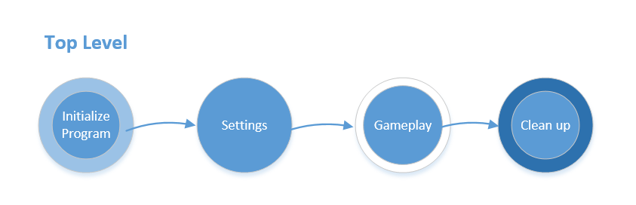

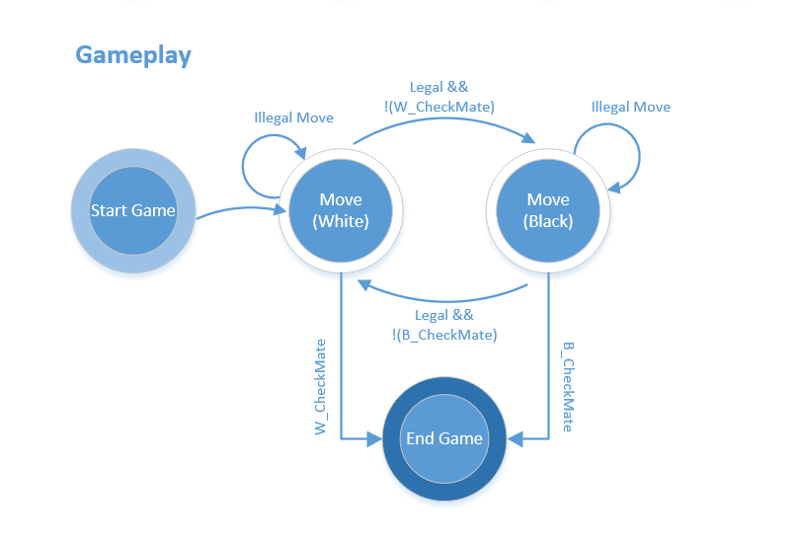

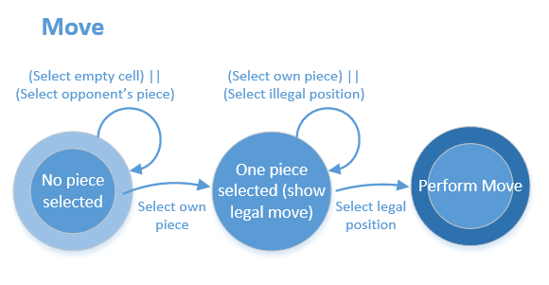

# 2: Installation

## 2.1 System Requirement

* + Hardware: PC Hardware (x86_64 server)
  + Operating system: Linux OS (RHEL-6-x86_64)
  + Dependent third party software:
    1. gcc
    2. GNU make
  + Dependent libraries:
    1. SDL for graphical user interface: SDL2, SDL2_img, SDL2_gfx, SDL2_ttf, SDL2_mixer
    2. Math library

## 2.2 Setup and Configuration

* SDL library installation: details are shown at http://libsdl.org

## 2.3 Building, compilation, installation

* The software comes in a tar.gz package. After downloading, extract the package by running:  
  tar –zxvf ChessXIV.tar.gz
* Change into the directory by running:  
  cd ChessXIV
* Compile the code by running:   
  make
* Run the program by running:  
  ./ChessXIV

# 3: Documentation of packages, modules, interfaces

## 3.1 Detailed description of data structures

**Structures related to Chess game play:**

typedef enum {Pawn, Rook, Knight, Bishop, Queen, King, None} ChessPieceTypeEnum;

typedef enum {Human, AI}         PlayerControlEnum;

typedef enum {White, Black}         PlayerColorEnum;

typedef enum {False, True}        Boolean;

typedef struct {

  ChessCoordinate * Board[CHESS_BOARD_MAX_ROW][CHESS_BOARD_MAX_COL];

  ChessPlayer * WhitePlayer, * BlackPlayer;

} ChessBoard;

*Description*: ChessBoard hold all player, piece and coordinates

struct ChessCoordinateStruct {

  unsigned char Rank, File;

  ChessPiece * Piece;

};

*Description:* ChessCoordinate hold the rank, file and the piece occupying that coordinate

struct ChessPlayerStruct{

        PlayerColorEnum         PlayerColor;

        AIDifficultyLevel        AIDifficulty;

        PlayerControlEnum        PlayerControl;

        /*list all the pieces that could belong to a player*/

        ChessPiece * Pawn[8];

        ChessPiece * Rook[2];

        ChessPiece * Knight[2];

        ChessPiece * Bishop[2];

        ChessPiece * Queen[1];

        ChessPiece * King[1];

};

*Description:* ChessPlayer holds player color, player control (AI or human) and all its pieces

struct ChessPieceStruct{

        ChessPieceTypeEnum         Type;

        unsigned char                Index;

        ChessPlayer *                Player;

        ChessCoordinate *        Coordinate;

        Boolean                        AliveFlag;

};

*Description:* ChessPiece holds the coordinate it stays, the index to distinguished with other pieces of same type, the player it belongs to and alive flag to let people know it’s alive

struct ChessMoveStruct{

        ChessPlayer * Player;

        ChessCoordinate * Start;

        ChessCoordinate * End;

};

*Description:* ChessMove holds the piece that moves and the start and end coordinates

struct ChessMoveListStruct{

        ChessMoveList * PrevMove;

        ChessMoveList * NextMove;

        ChessMove * Move;

}

*Desciption:* ChessMoveList is the double linked list of Chess Move, used to display move history or undo last move

struct ChessCoordinateListStruct{

        ChessCoordinateList * NextNode, * PrevNode;

        ChessCoordinate * Coordinate;

};

*Description:* ChessCoordinateList is the double linked list of Chess Coordinates, used by AI to compute next move or to pass a list of chess coordinates between modules

**Data structures to communicate between View and Control:**

typedef enum {SelectCoordinate, UndoMove} EventTypeEnum;

typedef struct {

        EventTypeEnum EventType;

        ChessCoordinate * Coordinate;

        ChessPlayer *        Player;

} Event;

*Description:* This structures allows information passing between View and Control

## 3.2 Detailed description of functions and parameters

**Model Module:**

ChessBoard* Model_Init(void);

Description: Initializes the model by creating a ChessBoard

ChessBoard* Model_Move(ChessBoard*, ChessMove*);

Description: Takes in the current board and a move and returns the board after the move is performed

ChessBoard* Model_Undo(ChessBoard*, ChessMove*);

Description: Gives the user the option to undo the previous move

int Model_CheckLegal(ChessBoard*, ChessMove*);

Description: Boolean function to check if the move entered is valid based on the current board and the piece at the position given

ChessMove* Model_GetBestMove(ChessBoard*, Player*);

Description: Gives the ‘best move’ as determined by the program. Can be used to generate the next move for the computer and also as a hint for the human player

ChessBoard* Model_CleanUp(void);

Description: Cleans the board

void SaveLog(ChessMoveList *, char *);

Description: Save the MoveList to a log file

**View Module:**

View(View.c, View.h):

PlayerControlEnum AskPlayerControl(ChessPlayer *);

Description: Ask the user for the control of White player and Black player. Return Human or AI

AIDifficultyLevel AskAIDifficultyLevel(void);

Description: If user selected AI, ask for AI difficulty level. Return one of three options: Easy, Medium or Difficult

void DisplayChessBoard(ChessBoard *);

Description: Take a chessboard structure and display it on the screen

void HighlightCoordinates(ChessBoard *, ChessCoordinateList *);

Description: Highlight Coordinate in Coordinate List on the board

Event * View_GetEvent(void);

Description: Wait for user to make an event and return the event handler

Boolean AskSaveLog(char *);

Description: Ask the user if he/she wants to save a log file. If yes then ask for file name

Render (render.c, render.h)

SDL_Texture *loadTexture(const char *fileName, SDL_Renderer *renderer);

Description: loads an image from the filename parameter into the renderer. Upon success, a texture is returned; returns NULL if the load fails.

void renderTexture(SDL_Texture *texture, SDL_Renderer *renderer, int x, int y, int w, int h);

Description: appends a texture to a destination rect at the coordinates x and y. This function is used when a specific width and height (scaling) for the texture is desired, which is indicated by the w and h parameters.

void renderTexture2(SDL_Texture *texture, SDL_Renderer *renderer, int x, int y);

Description: appends a texture to a destination rect at the coordinates x and y. This function is used when preservation of the size of the texture is desired; no scaling of the image in the texture.

SDL_Texture *renderText(const char *message, const char fontFile, SDL_Color color, int fontSize, SDL_Renderer *renderer);

Description: loads a .ttf font file, renders it in the specified color and size, and renders a message to a surface. Returns a texture on success, and returns NULL otherwise.

Display (display.c, display.h)

void drawMainMenu(SDL_Renderer *renderer);

Description: renders the main menu graphics assets; this includes background image and all menu text.

void drawOnePlayerMenu(SDL_Renderer *renderer);

Description: renders the graphics assets for the one-player options menu; this includes background image and all text.

void drawTwoPlayerMenu(SDL_Renderer *renderer);

Description: renders the graphics assets for the two-player options menu; this includes background image and all text.

void drawAdvancedMenu(SDL_Renderer *renderer);

Description: renders the graphics assets for the advanced options menu; this includes background image and all text.

void drawGameplayScreen(SDL_Renderer *renderer, int mode, int time);

Description: renders the graphics assets for the gameplay screen; this includes sub-menus, counters, and all text.

void drawChessboard(SDL_Renderer *renderer);

Description: uses SDL primitive rendering to draw and color the chessboard.

void drawPieces(SDL_Renderer *renderer);

Description: renders the chess piece images to a texture, and then renders them to the chessboard at starting position.

void drawError_p1_Options(SDL_Renderer *renderer);

Description: renders a background color and an error message in a floating window. This is invoked when the user selects play in a one-player option menu without selecting all relevant options.

void drawError_p2_Options(SDL_Renderer *renderer);

Description: renders a background color and an error message in a floating window. This is invoked when the user selects play in a two-player option menu without selecting all relevant options.

void drawError_kbd_Input(SDL_Renderer *renderer);

Description: renders a background color and an error message in a floating window. This is invoked when the user attempts non-standard notation or incomplete keyboard inputs.

void drawError_mouse_Input(SDL_Renderer *renderer);

Description: renders a background color and an error message in a floating window. This is invoked when the user attempts to move piece off the board with the mouse.

void drawError_IllegalMove(SDL_Renderer *renderer);

Description: renders a background color and an error message in a floating window. This is invoked when the user commits an illegal move.

void drawWarning_BlackInCheck(SDL_Renderer *renderer);

Description: renders a background color and an error message in a floating window. This is invoked when the black king is in check.

void drawWarning_WhiteInCheck(SDL_Renderer *renderer);

Description: renders a background color and an error message in a floating window. This is invoked when the white king is in check.

void drawMessage_time_BlackWins(SDL_Renderer *renderer);

Description: renders a background color and an error message in a floating window. This is invoked when the white timer runs out and black wins.

void drawMessage_time_WhiteWins(SDL_Renderer *renderer);

Description: renders a background color and an error message in a floating window. This is invoked when the black timer runs out and white wins.

void drawMessage_mate_BlackWins(SDL_Renderer *renderer);

Description: renders a background color and an error message in a floating window. This is invoked when white is checkmated.

void drawMessage_mate_WhiteWins(SDL_Renderer *renderer);

Description: renders a background color and an error message in a floating window. This is invoked when black is checkmated.

**Control module:**

void Control_Initialize(void);

Description: This function initializes Model and View and get things started.

void Control_MainLoop(void);

Description: Run the main program

Void Control_CleanUp(void);

Description: Close windows and free all used memory then quit

## 3.3 Detailed description of input and output formats

**Syntax/format of a move input by the user:**

Move input by user is recorded by the computer as mouse click on the GUI. A click on the board will be translated into a coordinate and the program will perform computational logic on it.

**Syntax/format of a move recorded in the log ﬁle:**

The log file will keep track of the moves in accordance to the algebraic notation. Example of what it would look like is on the wikia page: http://en.wikipedia.org/wiki/Algebraic_notation_%28chess%29

## 3.4 Detailed description of artificial intelligence for computer player

The artificial intelligence machine will consist of three different difficulties: beginner, intermediate, advanced.

The beginner difficulty’s aim is to familiarize the player with the basic operations of chess and nothing more. The beginner artificial intelligence setting will consist of selecting a move from LegalChessMoves[] using a random number generator. The random number generator will be using the time of day as a seed, so that the moves do not become repetitive.

The intermediate difficulty’s aim is to test the player’s ability to handle pressure. It will make its selection from LegalChessMoves[] by selecting the most aggressive move. The algorithm for the most aggressive move will be detailed below.

The advanced difficulty’s aim is to test the player’s deeper understanding of the game, and will be more similar with a human player. The advanced difficulty and the intermediate difficulty will be sharing an algorithm that will rate each move from LegalChessMoves[] based on aggressiveness and defensiveness. The algorithm for calculating the level of aggression and defense of each move will be utilizing an “InCheck” variable and “PieceValue” variable from the “ChessPiece” structure. The “PieceValues” for each piece are as follows:

Pawn: 1

Knight: 3

Bishop: 3

Rook: 5

Queen: 9

King: 1000000

The most aggressive move will be calculated based on the number of enemy pieces the move places “InCheck”, which will be multiplied to the piece values for each piece that is placed “InCheck”. The most defensive move will be calculated based on the number of friendly pieces the move places “!InCheck” and this will be multiplied with the piece values for the pieces that are being protected as well as factoring in the value of the piece that is protecting the pieces to avoid a queen protecting a pawn the whole game. The advanced difficulty will sum up the aggressiveness and defensiveness of each move and select the one that has the higher sum, as opposed to the intermediate difficulty which only checks for aggressiveness.

# 4: Development plan and timeline

## 4.1 Partitioning of tasks

The whole program will be divided into four main areas:

- Gameplay: All functionality of a chess program such as move, undo, checkmate, check

- AI: The intelligence behind the computer-generated moves

- GUI: The display of program for user

- Control and Integration: Program flow and integration between modules

## 4.2 Team member responsibilities

As discussed above, four areas will be responsible by the following team members:

* + - * Gameplay: Hanchel Cheng, Kevin Duong and Jamie Lee
      * AI: Andrew Trinh
      * GUI: Ryan Morrison
      * Control and Integration: Quan Chau

## 4.3 Timeline

By January 27:

* + - * Finish Command line output
      * Finish basic moves, excluding castling, transforming and en passant
      * King can not commit suicide
      * Support Undo

By February 3:

* + - * Finish GUI output
      * Finish castling, transforming and en passant
      * Finish AI
      * Support Move history record

# Back Matter

## Copyright

This software is licensed under GNU General Public License version 3. Details can be found on <http://www.gnu.org/licenses/gpl.html>

## Index

AI, 1, 15

artificial intelligence, 14

Control, 1

Control and Integration, 15

Control module, 4, 12

Dependent libraries, 6

Dependent third party software, 6

Gameplay, 15

GUI, 1, 15

Hardware, 6

Model, 1

Model module, 4

Model Module, 9

move input, 13

move recorded, 13

Operating system, 6

View, 1

View module, 4

View Module, 10