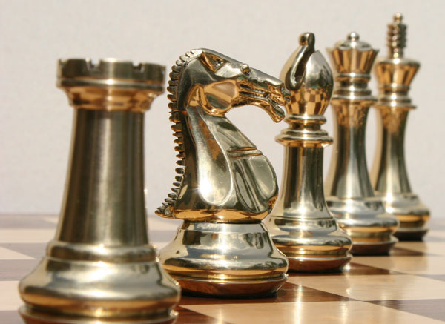

Chess XIV

Version 1.0

Team 1

Hanchel Chang

Quan Chau

Kevin Duong

Lloyd Estacio

Jamie Lee

Ryan Morrison

Andrew Trinh

University of California: Irvine

Table of Contents

Glossary 1

1: Computer Chess 2

1.1 Usage Scenario 2

Main Menu 2

Player vs Computer Option 3

Player vs Computer Board 4

1.2 Goals 5

1.3 Features 5

Display: 5

Gameplay: 5

2: Installation 6

2.1 System Requirement 6

2.2 Setup and Configuration 6

2.3 Building, compilation, installation 6

3: Chess Program Functions and Features 7

3.1 Choice of Difficulty 7

3.2 User Interface 7

3.3 Move history 7

3.4 Undo 7

3.5 Gameplay Mode 7

Back Matter 8

Copyright 8

Index 9

# Glossary

Chess Pieces

Bishop – Can move diagonally across the board

King – Can move one step in any direction at a time

Knight – Can jump two steps forward plus one step sideways from current position

Pawn – Can move forward towards the end of the board but captures diagonally. Initially can move two steps forward, otherwise only one at a time

Queen – Can move horizontally, vertically, and diagonally across the board

Rook – Can move horizontally and vertically across the board

Chess Terminology

Castling – Special move in which the king moves two spaces toward the rook on either side, and the rook is placed on the opposite side of the king. This can only be done if the king and rook have not yet been moved and there are no pieces in between the two

Check – When the king can be captured by at least one enemy piece. In such a case, either the king must move out of check, the enemy piece must be captured, or another piece must block the king

Checkmate – When the king is unable to get out of check. This ends the game of chess

En Passant – Special move in which a pawn can capture the opposing pawn in the subsequent move if the opposing pawn moves forward two square instead of one to avoid capture

# 1: Computer Chess

## Usage Scenario

### Main Menu

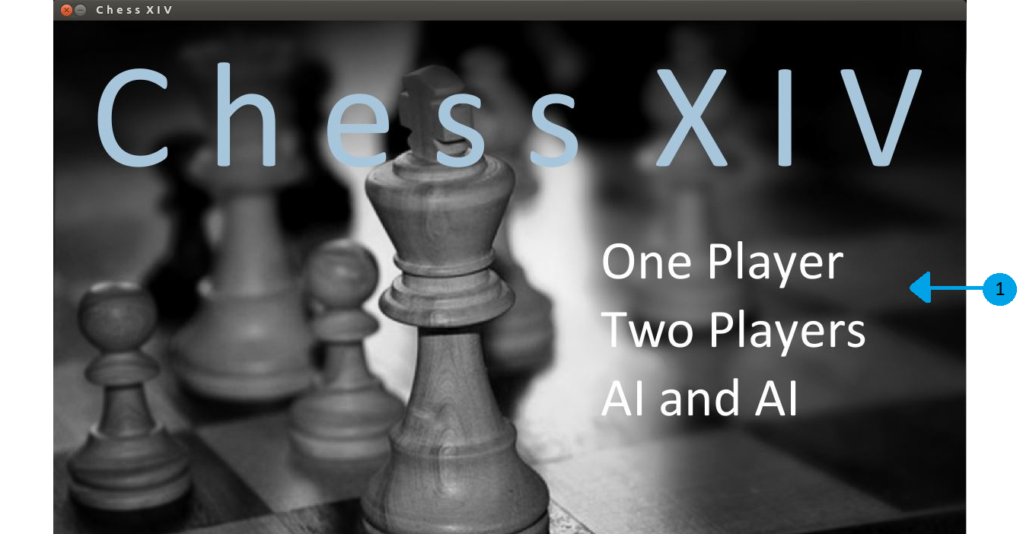

Main Menu for the chess game – gameplay mode is selected here via the mode selection list.

1. MODE SELECTION LIST – three options for gameplay are provided. Each option is highlighted and available for selection when the mouse is hovered over it; left-clicking a highlighted option selects it.
   1. One Player – human versus computer. See One Player Options Menu for more details.
   2. Two Players – human versus human.
   3. AI & AI – computer versus computer.

### Player vs Computer Option

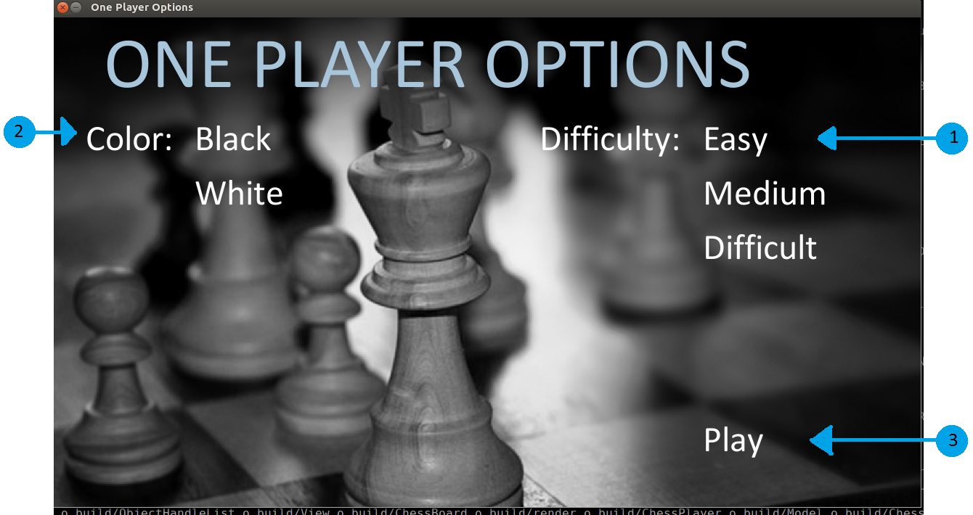

One Player Options Menu – all options for human versus computer game are selected here. Options are highlighted and available for selection when the mouse is hovered over them. Each of the four options must have a selection before the game commences; selecting “Play” before each option has a selection will result in an error screen. See Errors section for more details on error screens.

1. DIFFICULTY – left-click one of the three difficulty levels. This option determines the intelligence of the computer opponent. This option is available for One Player mode only.
   1. Easy – computer makes legal moves without any strategy. In this mode, expect the computer to make seemingly random moves.
   2. Moderate – computer makes legal moves, with strategy applied towards current turn. In this mode, expect the computer to make moves targeted towards capture of pieces.
   3. Challenging – computer makes legal moves, with strategy applied 3 moves ahead. In this mode, expect the computer to make moves according to analysis and prioritization.
2. COLOR – left-click one of the two color selections. This option is available for One Player game only.
   1. Black – the pieces for the human player are black and located at the top of the game board; the Player Window for black is located at the top left of the gameplay screen. Upon beginning the game, black moves second.
   2. White – the pieces for the human player are white and located at the bottom of the game board; the Player Window for white is located at the bottom right of the gameplay screen. Upon beginning the game, white moves first.
3. PLAY – left-click to proceed to gameplay. If the Difficulty, Timer, Input, and Color Options do not each have a selection, an error screen will appear. See Errors section for more details.

### Player vs Computer Board

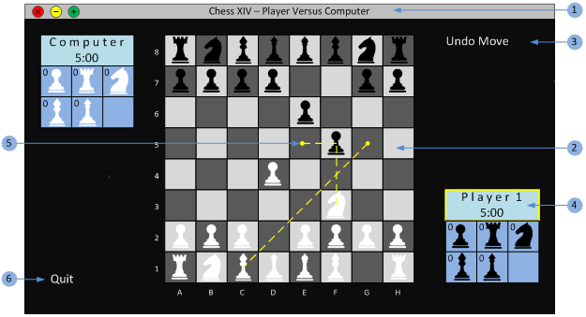

1. WINDOW TITLE –identifies the current location within the application. The screenshot above indicates a one-player game where the human is pitted against the computer.
2. CHESS BOARD – area where the game play occurs. Depending on Input option selected, pieces can be moved either with the mouse or by manually typing moves with the keyboard.
   1. Moving with mouse – hover mouse over the intended piece to move and left-click to hold the piece. While holding button down, move mouse to desired position and release button. Illegal moves will invoke an error pop-up and the piece will return to its original position.
   2. Moving with the keyboard – in the “Piece” input window, type in the desired piece to move by entering its coordinates i.e. F8; in the “Position” input window, type in the desired coordinate to move to and press return. Illegal moves will invoke an error pop-up and the piece will return to its original position. See #6 below for more information on the Piece and Position input windows.
3. PLAYER OPTIONS – additional in-play options available to the current player. These selections are highlighted and available for selection when the mouse is hovered over them.
   1. Undo Move – left-click to select. This option will undo the last move executed.
4. PLAYER WINDOW – sub-window that reports all pertinent data for the player indicated at the top of the window. The bottom right window is always for the player using white pieces, and the top left window is always for the player using black pieces. Below the indicated player is the player’s timer. Below the timer is the summary of captured pieces; each captured piece is represented by its respective icon and a number indicating how many of them have been captured.
5. QUIT – additional in-play options available to the current user. Hovering over either option with the mouse will highlight it, making the option available for selection.
   1. Quit – left-click to select. This option ends the current game and returns the user to the main menu.

## 1.2 Goals

The goal is to capture opponent’s King by forcing checkmate position.

## 1.3 Features

### Display:

* + Interactive graphical user interface
  + Choice of black or white
  + Highlight of last move
  + Highlight of legal moves

### Gameplay:

* + Timer
  + Three level of difficulties: easy, medium and hard
  + Move log
  + Undo option
  + Moves hints

# 2: Installation

## 2.1 System Requirement

* + Hardware: PC Hardware (x86_64 server)
  + Operating system: Linux OS (RHEL-6-x86_64)
  + Dependent third party software:
    1. gcc
    2. GNU make
  + Dependent libraries:
    1. SDL for graphical user interface: SDL2, SDL2_img, SDL2_gfx, SDL2_ttf, SDL2_mixer
    2. Math library

## 2.2 Setup and Configuration

* SDL library installation: details are shown at http://libsdl.org

## 2.3 Building, compilation, installation

* The software comes in a tar.gz package. After downloading, extract the package by running:  
  tar –zxvf ChessXIV.tar.gz
* Change into the directory by running:  
  cd ChessXIV

A)To compile the command line (ASCII) version of the program:

* Compile the code by running:

make clean  
make

* Run the program by running:  
  bin/ChessXIV

B) To compile the Graphical User Interface version of the program:

* Compile the code by running

setenv PKG_CONFIG_PATH $PWD/SDL2_Library/lib/pkgconfig

make clean

make GUI_ENABLE=y

* Run the program by running

bin/ChessXIV

# 3: Chess Program Functions and Features

## 3.1 Choice of Difficulty

Easy Mode: Random valid move

Medium Mode: Prioritize piece capture

Hard Mode: Prioritize scholar mate and prioritize piece capture value

## 3.2 User Interface

Come in different pages for option selection

Attractive and comprehensive display for an entertaining chess game

## 3.3 Move history

Show or store previous moves

## 3.4 Undo

Let the player undo a move

## 3.5 Gameplay Mode

Allow you to choose Player vs Computer, Player vs Player, Computer vs Computer or preset board

# Back Matter

## Copyright

This software is licensed under GNU General Public License version 3. Details can be found on <http://www.gnu.org/licenses/gpl.html>

## Index

Bishop, 3

Castling, 3

Check, 3

Checkmate, 3

CHESS BOARD, 10

COLOR, 6

DEMO, 9

Dependent libraries, 13

Dependent third party software, 13

DIFFICULTY, 5

En Passant, 3

Hardware, 13

INPUT, 6, 7

INPUT WINDOWS, 11

INTERACTIVE BOARD SETUP, 9

King, 3

Knight, 3

MAIN MENU, 6, 8

MODE SELECTION LIST, 4

MOVE HINT INDICATOR, 11

Operating system, 13

PAUSE and QUIT, 11

Pawn, 3

PLAY, 6, 8

PLAYER OPTIONS, 10

PLAYER WINDOW, 11

Queen, 3

Rook, 3

TIMER, 5, 7

WINDOW TITLE, 10