# Wild species intraspecific germination variability in water-limited alpine environments.

Abstract

## 1. Introduction

Mesoscale heterogeneity of alpine landscape; microclimatic conditions; species adaptations (similar to move along intro)

Snowmelt gradients and summer drought effects

Snow depth and snowmelt patterns strongly influence surface-level temperature, moisture and light, three key abiotic factors determining plant growth and reproduction in the corresponding communities (Winkler et al. 2018; Körner 2021).

Regeneration niche and Mediterranean germination syndrome

The majority of the empirical tests of niche theory focus on adults ignoring the important seed regeneration niche (Briceño et al 2015, Larson and Funk 2016).

Temperature and water, two major environmental drivers of the physiological process of seed germination (Bewley et al. 2013).

As these two environmental factors are essential for germination, the integration of heat accumulation units and soil water availability as hydrothermal time is considered a useful approach to describe germination progression over time of seed lots or populations under field conditions (Allen et al. 2000; Bradford 2002; Bewley et al. 2013). The use of hydro thermal time is based on the premise that seed germination rate is related to temperature (T) and water potential (.) around optimum conditions that are bound by lower and upper thresholds (Allen et al. 2000; Bradford 2002). Therefore, total germination and germination rate will occur as long as both conditions are met: 1) temperature is within the thresholds and 2) water potential is above the minimum. The longer the time these two conditions are met (i.e., hydrothermal time accumulation), the greater the germination.

Sensitivity to drought conditions depends on multiple factors and may be higher during germination and establishment (Fischer & Turner 1978).

Components of the life history of plants, such as seed size, are significantly associated with plant height, growth form and dispersal mode, and can also influence recruitment patterns (Leishman & Westoby 1994). Seed size has a high impact on capacity and time of germination, establishment and survival of seedlings during early stages of the life cycle, when plants are more susceptible (Baskin & Baskin 1998). In general, average germination time tends to be greater for larger-sized seeds (Norden et al. 2009), while small seeds absorb water faster than large seeds because of their larger surface-area-to-mass ratio (Kikuzawa &Koyoma 1999). For example, Kidson & Westoby (2000) argued that larger seeds are able to germinate better under drought, while Merino-Martín et al. (2017) reported that most light seeds had higher germination and emergence under dry conditions than heavier seeds. The authors recognize that more studies are required in order to understand whether the role of seed size in germination response under drought is general or species-specific (Gelviz-Gelvez, 2020)

Although germination response to climatic factors has been investigated for alpine/subalpine species at population and community levels (Cao et al., 2018; Cavieres & Arroyo, 2000; Giménez-Benavides, Escudero, & Pérez-García, 2005; Liu et al., 2011, 2018;Shimono & Kudo, 2005; Wagner & Simons, 2009).

Drought effects on germination are more commonly studied in water-limited systems (e.g. Cochrane et al., 2014). Other germination in alpine systems often focus on the impacts of warming (Fernández-Pascual 2021, Hoyle 2013, Mondoni 2012) BUT what about alpine + water limited???

In alpine regions, much of the increased precipitation falls as snow. But as increased temperature leads to earlier snowmelt, increased evapotranspiration, and increased run-off, this can paradoxically result in higher risks of early summer soil moisture deficit in the alpine in the future (Hanssen- Baeuer et al., 2017)

At the global scale, environments with stable climate are expected to select for and be dominated by taxa that produce relatively large, fast-germinating seeds, while relatively small seeds should be adaptive to and predominate in seasonal habitats (Rubio de Casas et al., 2017). Species with small seeds have high temporal variation in germination that spreads the risk of extinction, and large seeds produce large seedlings that perform better than small ones under stressful conditions (Kitajima & Fenner, 2000; Pake & Venable, 1996).

However, species vary considerably in response of seed germination to drought stress (Kos & Poschlod, 2008).

Water stress /PEG

Plants from drier habitats tend to produce larger seeds in order to provide more resources for handling drought stress during germination (Wellsteins et al., 2013).

Reduced water availability can result in delayed germination (Cochrane et al 2015, Vázquez-Ramírez and Venn 2021)

In alpine lichen heaths, communities occurring at the snow-poor end of the gradient, we expected seeds to be able to germinate at comparatively low soil water contents, due to the low water supply from the melting snowpack and the fast-drying skeletal soils (Onipchenko2004).

Low and spread out germination (Gya 2023) could be an indication of bet-hedging, a strategy well known for germination in habitats with high variability in climate (Evans and Dennehy, 2005). Bet hedging has been found to be a strategy that yields advantages during drought events (Evans and Dennehy, 2005, Lampei et al 2017).

Drought events can vary in duration, magnitude, and severity [19]. It is important to explore the stage specific drought adaptations of important plant species. In particular, variation in seed germination and dormancy in response to water deficit requires scrutiny (Bernau 2020). Drought resistance can be separated into several different strategies: dehydration avoidance,

dehydration tolerance, and dehydration escape [23]. For instance, maintaining seeds in

an un-germinated state during dry periods can allow them to escape dehydration, although

seed dormancy has many other adaptive dimensions (as reviewed in [24]).

A common methodology in most studies using hydrothermal time is the use of polyethylene glycol (PEG) to generate different water potentials as described by Michel (1983). PEG solutions have the advantages of maintaining relatively steady osmotic potentials equivalent to the desired water potentials as well as the simplicity with which a wide range of water potentials can be generated to determine germination thresholds (Bewley et al. 2013).

Requirements determined with PEG solutions might not be appropriate to describe field seed germination (Camacho 2021), so direct soil water potential measurements might be needed (Bullied et al. 2012). Soil textural properties could influence the response of the seed to water potential, and this could result in different germination behaviours (Camacho 2021). Comparing osmotic and matrix potentials using PEG solutions as well as soil matrices with different soil particle sizes, Hadas (1977) determined that water potential is important for seed germination as long as soil moisture content is not limiting, but as soon as water content or water diffusivity decrease, soil physical properties influencing water supply to the seed will play a more important role. The use of PEG solutions is a practical way to determine relative differences in water use between species, genotypes, or seed lots, but it is not an adequate system to determine accurate germination responses to water availability, which seems to be the aim of many studies. Potential for multiple species as a function of soil physical properties

Soil hydraulic conductivity thresholds identified in the present study, represent a useful parameter to be included in seed germination and seedling emergence studies, because it provides a clear limit to germination (Camacho 2021).

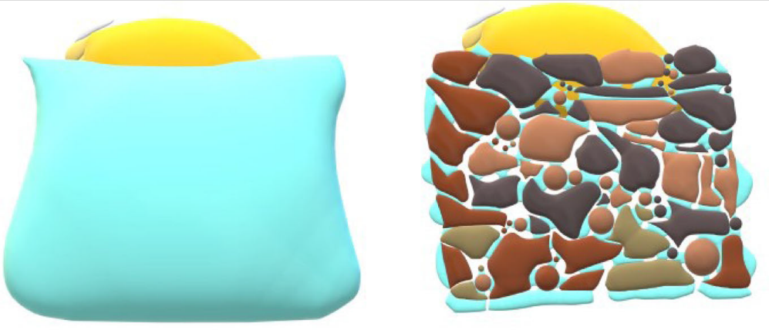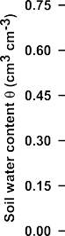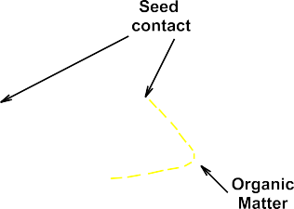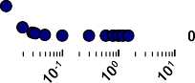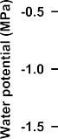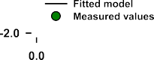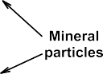

Fig 6 from Camacho 2021.

Intraspecific germination variability to water stress

Variation in seed germination of a species under different environmental conditions can increase long-term reproduction of plant populations by temporally spreading risk and thus maximizing their fitness (Philippi & Seger, 1989; Simons, 2011; Venable, 2007).

Intraspecific variation in germination responses to abiotic gradients has received less attention (Gya et al., 2023).

Populations within species may vary in their germination responses along environmental variables as a consequence of local adaptations (Grassein et al., 2014; Kawecki & Ebert, 2004), for instance, by optimizing germination timing and rate to population-specific environmental conditions (Baskin & Baskin, 2014; Giménez-Benavides et al., 2007; Meineri et al., 2013; Satyanti et al., 2019). The selective pressures operating on such local adaptations may generally be expected to be high in alpine ecosystems due to harsh environmental conditions, topographically complex landscapes, and high microclimate variability (Scherrer & Körner, 2011). This environmental variability within the alpine habitats leads to high but spatiotemporally variable seedling mortality rates (Graae et al., 2018; Scherrer & Körner, 2011), which further suggests selection for locally adapted seed regeneration responses in alpine species (Giménez-Benavides et al., 2007; Kim & Donohue, 2013; Mondoni et al., 2009). While such local adaptions may increase the total range of conditions under which the species as a whole can survive, each locally adapted population tolerates a narrower range of conditions and can be vulnerable to climate change, especially if dispersal is low (Atkins & Travis, 2010; Valladares et al., 2014). Local adaptations could therefore confer a higher vulnerability to climate change of each population than inferred from the species-wide geographic distribution and climatic range (Atkins & Travis, 2010; Diamond & Martin, 2020; Peterson et al., 2018, 2019).

General goal:

Study intraspecific germination adaptation to water stress in Mediterranean high mountain grasslands.

Novelty:

Germination in water-limited alpine environments is understudied.

Variability in intraspecific responses to water stress in wild species.

Research questions:

1. Will seeds from warmer/drier subpopulations germinate better under higher water stress levels? Intraspecific adaptation to realized niche from adult plants, transgenerational effects into the regeneration niche?
2. Will the ripening stage (fresh vs. after-ripening) modify their response to water stress? Physiological responses to explore bet-hedging strategies?

Queríamos ser muy finos y ver si la respuesta a estrés hídrico variaba de acuerdo a la subpoblación (con distintos GDD), se cumple en el momento más próximo posible a la dispersión (tiene funcionalidad ecológica) al tratarse de una especie oromediterranea podría existir cierto grado de fter ripening y para hacer lo modelso de hidrotime necesitamos semillas que no ten dormición, por ese motivo probamos 1 semana después de recorgela y a los 45 dias. Se genera una segunda pregunta que hay que responder primero. (1) Existe After ripening?

Hypothesis:

1. Seeds from warmer/drier subpopulations will germinate better and faster at higher levels of water stress.
2. Fresh seeds will have higher variability of germination responses and will germinate worse.

Approach/General methods

We conducted a growth chamber experiment to investigate subpopulation-level variation of germination to water availability.

Seed collection of 1 specialist/strict alpine species, *Dianthus langeanus*, from Mediterranean high mountain grasslands. Seed collection the 7th-8th of August 2023, from 18 different collection sites (considered as subpopulations). Collections sites where previously iButtons were buried for 11 months (from 12/7/2021 to 29/05/2022) and we have temperatures registered every 4 hours. Additionally, we have hourly temperature and water potential data from 7 plots (A00, B00, B07, C00, C18, D00, D12).

Fresh seeds germination trial: (A00, B00, B03, B07, B17, B19, C00, C06, C19, D00, D19, D12). Seeds from 12 subpopulations were subjected to 7 water stress treatments (h2O, -0.2, -0.4, -0.6, -0.8, -1, -1.2 MPa, following standard typical with PEG 6000). 4 Petri dish 90mm diameter with 25 seeds for each WP treatment (100 seeds x treatment). Seeds sowed in two layers of germination paper. Added 5ml of PEG solutions and sealed Petri dishes with parafilm to avoid evaporation of the solution.

After-ripening germination trial: (A00, A02, A11, B03, B19, C00, C18, C19, C20, D00, D11, D19) Seeds from 12 subpopulations were subjected to 7 water stress treatments (h2O, -0.2, -0.4, -0.6, -0.8, -1, -1.2 MPa, following standard typical with PEG 6000). 4 Petri dish 90mm diameter with 25 seeds for each WP treatment (100 seeds x treatment, number were adapted in subpopulations with lower seeds). Seeds sowed in two layers of germination paper. Added 5ml of PEG solutions and sealed Petri dishes with parafilm to avoid evaporation of the solution.

6 populations were subjected to both fresh and after-ripening sowing (A00, B03, C00, C19, D00, D19)

## 2. Methods

### 2.1. Study area

This study was conducted in the alpine grasslands above 2000 m a.s.l from the southern slope of the Cantabrian Mountains, a mountain range running E-W in northern Spain, and within the Valles de Omaña and Luna Biosphere Reserve (coordinates?). The climate in the study system is typically Mediterranean, characterized by a 2-month dry period in summer (average annual precipitation of 1050 mm, mostly accumulated in spring and autumn). The growing season stretches from March to October with a mean annual soil temperature of 8ºC ADD days with water stress in the growing season and mean of days with snow (high variations according to orientation of slope). Grazing impact is also restricted to wild populations of Cantabrian chamois. The sampling sites are located above acidic bedrock (pH 3.8 – 4.8, own non-published data). Local community richness ranges from 20 to 30 species dominated mostly by *Poaceae* and *Cyperaceae*, but they are also rich in Hemicryptophytes and Chamaephytes.

We established a systematic sampling across 4 summits with a central representative plot where we buried, at 5 cm deep, a Microlog SP3 datalogger, which hourly records temperature and water potential values (Microlog SP3 ref). The recording period for the Microlog SP3 went from XXXX to XXXX (xxx days). We then established 20 additional plots, 5 in each cardinal direction separated by 10 m (cross design) where we buried, also at 5 cm deep, iButtons dataloggers (Thermochron, iButton, Newbury, UK; accuracy: +/- 0.5 ºC from -10 ºC to +65 ºC, resolution: 0.5 ºC, records every 4 hours). The recording period for the iButtons went from 12/7/2021 to 29/05/2022 (xx days). Each summit *D. langeanus* is considered a different subpopulation of Dianthus langeanus, with several plots sampled within subpopulation.

Figura 1. Mapa zona de estudio con las cruces de los plots recolectados, imagen de Dianthus langeanus y de los sensores enterrados.

### 2.2. Soil Bioclimatic Indices (from Picos paper)

We used the microclimatic soil data of our dataloggers to calculate soil bioclimatic indices. For comparison, we homogenized the data between the two types of dataloggers: (1) Microlog SP3 (Temperature + water potential hourly data) in 6 plots and iButtons temperature data at four-hour intervals for the 12 resting plots, keeping the same XXX calendar days (but from different years if we include the extremes WP loggers buried one year later). In total, we obtained XX data points. We calculated bioclimatic indices based on WorldClim standard variables (Fick & Hijmans 2017), together with other relevant variables on alpine microtopography. Following the paper by (Picos Paper) the selected variables were: (1) bio1 = annual mean temperature; (2) bio2 = mean diurnal range, i.e. the mean of the monthly differences between maximum and minimum temperatures; (3) bio7 = temperature annual range; i.e. the difference between the maximum temperature of the warmest month and the minimum temperature of the coldest month; (4) snow = the number of days of snow cover, when the soil temperature is around 0 ºC, calculated for the period in which the maximum temperature was < 0.5 ºC and the minimum temperature was > -0.5 ºC; (5) FDD = freezing degree days, i.e. the sum of daily mean temperatures for days in which the mean temperature was below 0 ºC (Choler 2018); and (6) GDD = growing degree days, i.e. the sum of daily mean temperatures for days in which the soil mean temperature at five cm deep was above 5 ºC (Körner 2021). For FDD, we transformed the values from negative to positive, so higher values represent more freezing. To identify the main gradients of microclimatic variability, we conducted a principal component analysis (PCA) includign all bioclimatic indices.

### 2.3. Seed collection

The study focuses on *Dianthus langeanus*, a wild species endemic to dry grasslands in high Mediterranean mountains, highly abundant in our study area and with high seed production. We collected mature seeds directly from the mother plants from at least 20 randomly selected individuals following standard protocols for sampling seeds of wild populations (ENSCONET, 2009) within a 2m radius from the datalogger location, at the time of natural dispersal (August 7-8th, 2023). To enable equal conditions among seeds, we manually clean and air-dried at room conditions (22ºC and 35%RH) before germination experiments. In total, we sampled 18 plots (subpopulations), and we measured fresh seed mass by weighting 5 replicates of 50 seeds from each subpopulation. In some cases, with less than 50 seeds left after sowing, we annotated the number of seeds and the weight to have a proxy of mass per individual seed.

### To our knowledge there are no drought germination studies on our study species, therefore by testing across such a large gradient of water potentials, we aimed to identify the species minimum water potential for germination (from Gya 2023). 2.4. Germination experiments

To test the seed germination responses to water stress we performed two four-level full factorial experiments (12 subpopulations x 7 WP treatments x 4 replicates x 25 seeds), using fresh seeds (10 days after collection) and after ripened seeds (45 days after collection).

We sowed four replicates of 25 seeds from each subpopulation in a Petri dish (90 mm Ø) with two layers of filter paper (Filtros Anoia S.A. paper for germination assays, Ref.518G085). We added with 5 ml of either distilled water or a polyethylene glycol 6000 solution (PEG) prepared according to Michel & Kaufmann (1973) and based on Vilella et al 1991 tables. The solutions aimed to reach osmotic potentials of −0.2, −0.4, −0.6, −0.8, −1 and −1.2 MPa at 20 ºC (100 seeds per treatment except in -1 and -1.2 MPa treatments with only 2 replicates of 25 seeds each). Previous pilot study showed zero germination at -1.4 and -1.6 MPa, thus we excluded those concentrations from the final experiment. We sealed Petri dishes with parafilm to avoid evaporation of the solution, keeping the filter paper moist and thus maintaining relatively constant water potential throughout the experiment.

Seeds were incubated at constant 20°C with a daily photoperiod (12-12h) in Aralab incubators (Aralab climatic chamber Fitoclima S600 PL, equipped with 4 led modules 11W 350mA, using Fitolog 9000 software version 9308, Aralab Pharmaceutical Stability software). Conditions simulate late summer conditions in the field, when germination has been previously showed to happen (paper move-along?).

### We monitored germination (radicle emergence > 1.5mm) for 28 days, daily until the cumulative germination curve flattened (day 21) and then we checked germination every two or three days until the end of the experiment. We removed germinated seeds during the scorings and once the experiments were finished, we cut non-germinated seeds (Ooi et al., 2004; FAO, 2014), under the binocular loupe and classified them as viable, dead or empty. Seeds with firm and white embryos were considered viable i.e., potentially germinable (Baskin and Baskin 2014). The subsequent analysis took into account germinated and viable seeds. 2.5. Data Analysis

### All analyses were done in R software (R core Team 2022), using seedR package (Fernández-Pascual and González-Rodríguez, 2020) and GerminaR package (Lozano-Isla et al., 2019). visualization was done with ggplot2 package (Wickham, 2016)

Use GLMM with multinomial2 family

Germination (final/t50/rate/synchrony) ~ maturity_level*WP_treatment*Bioclimatic_indices*seed mass (several?).

## 3. Results (preliminary)

### 3.1. Populations realized niche

|  |  |  |  |  |  |  |  |  |
| --- | --- | --- | --- | --- | --- | --- | --- | --- |
| Site | ID | bio1 | bio2 | bio7 | Snw | FDD | GDD | Mean seed mass |
| Rabinalto | A00 | 6.67 | 6.35 | 32.87 | 108 | 184.94 | 4410.08 | 1.098 |
| Rabinalto | A02 | 7.88 | 6.14 | 28.23 | 19 | 0.00 | 2190.85 | 1.144 |
| Rabinalto | A11 | 7.73 | 7.89 | 33.18 | 28 | 4.50 | 2190.29 | 0.949 |
| Cañada | B00 | 18.77 | 16.34 | 18.18 | 0 | 0.00 | 1013.40 | 0.949 |
| Cañada | B03 | 8.54 | 8.68 | 29.85 | 0 | 11.08 | 2380.34 | 1.025 |
| Cañada | B07 | 7.38 | 10.17 | 40.32 | 23 | 12.75 | 2078.20 | 1.2 |
| Cañada | B17 | 6.50 | 4.52 | 26.19 | 41 | 8.50 | 1833.33 | 1.2 |
| Cañada | B19 | 6.51 | 6.27 | 28.31 | 14 | 1.58 | 1775.83 | 0.776 |
| Cañada | B20 | 6.75 | 7.00 | 28.37 | 33 | 0.00 | 1860.21 | 1.603 |
| Solana | C00 | 10.22 | 10.71 | 34.49 | 30 | 30.86 | 3766.36 | 1.119 |
| Solana | C06 | 6.84 | 5.27 | 23.90 | 15 | 3.75 | 1951.94 | 1.908 |
| Solana | C18 | 6.39 | 6.68 | 28.95 | 20 | 7.00 | 1896.90 | 0.81 |
| Solana | C19 | 5.51 | 4.51 | 22.69 | 8 | 8.42 | 1595.75 | 0.995 |
| Solana | C20 | 6.47 | 7.51 | 27.95 | 16 | 6.25 | 1869.46 | 0.765 |
| Penauta | D00 | 8.92 | 8.11 | 30.38 | 51 | 58.26 | 3883.65 | 1.112 |
| Penouta | D11 | 6.60 | 5.31 | 25.56 | 31 | 12.17 | 1975.60 | 0.853 |
| Penouta | D12 | 7.98 | 7.56 | 31.26 | 6 | 4.17 | 2341.53 | 1.036 |
| Penouta | D19 | 4.83 | 2.69 | 16.90 | 56 | 5.00 | 1375.27 | 1.074 |

### 3.2. Immediate sowing

Table with full germination summary “immediate_germsummary.csv” for all plots

Individual plots for each dianthus subpopulation in results/Dianthus ID graph/immediate

Combined cumulation germination plot

Germination percentage dropped sharply below -0.2MPa water potential. Low water availability also led to delayed germination (confirming results by Gya 2023)

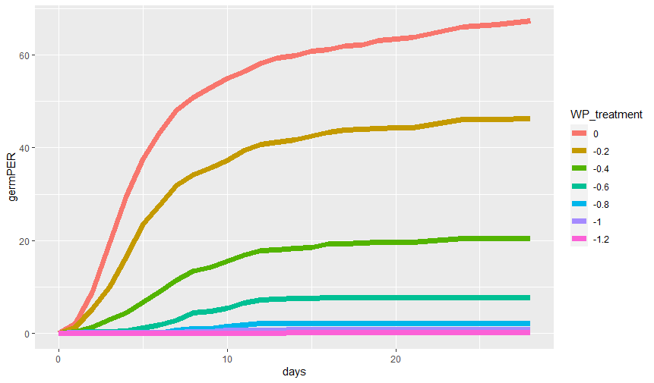

Table with full base water potential summary “immediate_bwpsummary.csv” for all plots

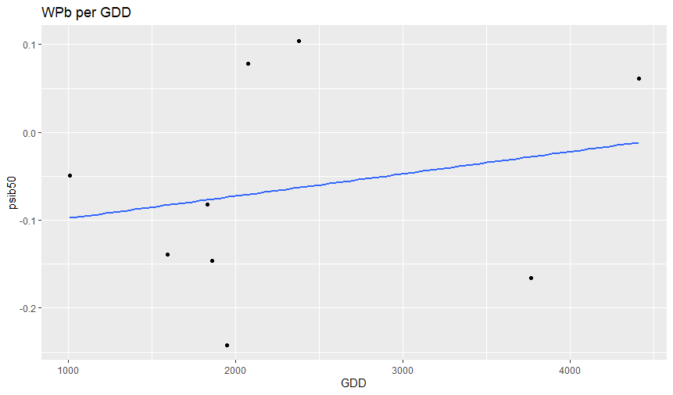

Combine total germination, mean germination rate and synchrony (calculated with GerminaR) to check possible correlation with the response according to bioclimatic indices. No patterns visually detected but bioclimatic values need to be updated and homogenised.

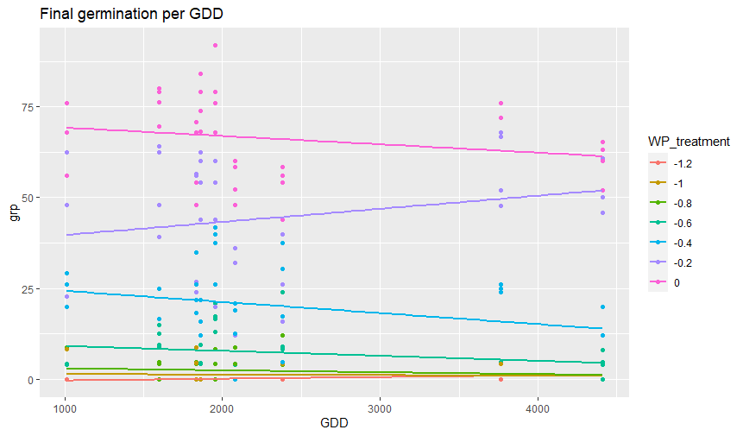

### 4. Discussion

Rosback et al., 2022 found that:

“Germination temperature and water potential had significant and positive main effects: overall, germination was higher at higher temperatures and at comparatively higher water potentials. The different communities (lichen heath, grassland, meadow, snowbed) did not differ in their response to water potential. This finding suggests that snowbed species might not depend entirely on habitat specific ample meltwater supply during germination and can tolerate short-term summer droughts common in years with low precipitation. In its turn, the overall positive effects of low osmotic potentials on the germination of the focal species confirms the evidence that seedling establishment in terrestrial habitats with seasonal climates, including arctic and alpine environments (Bell and Bliss 1980; Oberbauer and Miller 1982; Tudela-Isanta et al. 2018b), is water-limited (Orsenigo et al. 2015; Walder and Erschbamer 2015). From the ecological point of view, it implies that alpine seed germination is triggered by comparatively high soil moisture levels (e.g. after a snowmelt or summer rainfalls), a key adaptation to avoid seedling emergence on commonly desiccated surfaces of summer alpine soils (Körner 2021) known to be one of the main reasons for seedling mortality in alpine regions (Welling and Laine 2000; Forbis 2003). High soil moisture is necessary for germination and seedling establishment because small seeds do not contain sufficient carbohydrate reserves for rapid production of deep roots in a drying environment (Oberbauer and Miller 1982).

Gya et al., 2023 (test for local adaptations to drought, 10 different water potentials, in germination and seedling in two alpine forbs with contrasting habitats (generalist vs snowbed). Main findings: drought led to lower germination percentage and slower germination. Seeds from the driest populations had higher germination percentage and shorter time to germination than seeds from the wettest populations, suggesting local adaptation to drought. We found evidence that germination and seedling traits may show adaptation to drought even in populations from wet habitats. Our results also indicate that alpine generalists might be more adapted to drought and show more local adaptations in drought responses than snowbed specialists. In one species, seed mass was also important because populations with lighter seeds reached higher germination percentages but had slower germination rates compared to heavier-seeded populations. While in the other species seeds from populations with higher seed mass germinated at higher percentages and faster rates. (mixed evidence)

Low moisture availability leads to partial or complete inhibition of physiological processes which may slow down the germination processes or hinder seeds from germinating (Baskin and Baskin 2014, Sumner and Venn 2021)

A sharp decrease in germination percentage between -0.57 and -0.7 Mpa. -0.7Mpa is described by Evans and Etherington (1990) as continuous water stress, representative of an intermediate dry environment before rainfall, or according to Young and Nobel (1986), corresponding to approximately 600 mm of rainfall.

As plants respond predominantly to soil water availability rather than precipitation events themselves, drought responses may be driven by different factors (Gya 2023).

Bernau 2020found evidence of local adaptation to both ecozone and source cultivation system in germination characteristics of diverse chile peppers. Overall, survival time analysis revealed delayed germination at the 20% concentration of PEG. Based on germination curves, we found that the seeds of landraces that were collected from drier ecozones tended to have slower and less complete germination, especially under osmotic. accessions with the most similar genetic backgrounds and cultivation histories also showed faster and more complete germination when originating from wetter environments.

Camacho 2021 Aimed to compare seed germination in PEG (lab) and soil with six water potential (simulating field conditions). They found that total germination for all species significantly differed between soil and PEG under the same water potentials. Germination rate was more directly related to water potential than total germination. As a conclusion: caution must be used when considering results obtained using PEG solutions to infer germination behaviour under field conditions. Our results suggest that Kh (soil hydraulic conductivity) is the driving force of maximumgermination potential by regulating water flow towards the seed, while water potential might play a more important role for the ability of the seed to absorb water that is in direct contact with the seed coat. As shown here, different soil textures have different Kh thresholds below which water flow to the seed is impeded and germination collapses. The use of K thresholds can be an important tool to describe vegetation dynamics in response to climate change including geographic distribution,seasonality and desertification.

Gelviz-Gelvez 2020. Found that Germination decreased as water potential was reduced; almost no seeds germinated at -0.8 MPa. The least sensitive species was Eysenhardtia polystachya, whose germination reached 35 % at -0.6 MPa. A positive relationship was found between seed size andgermination proportion under water stress. Contrary to expectation, germination was higher in the large-seeded species in all drought treatments, suggesting that large seeds may have a greater capacity to retain water in dry environments.

For the control, seed size did not affect germination; however, under drought conditions, germination proportion increased with seed size and this effect became more pronounced with increased drought condition, as demonstrated by an increase in both the slope and significance of the relationships. Overall, seed germination was driven much more strongly by water potential treatment than by seed size, with these two factors explaining 29 and 7 % of the total variance respectively. Our results do not support the hypothesis that small seeded species germinate more than large-seeded species under drought conditions, as found by Merino-Martín et al. (2017). Our results showed under drought conditions, large seeded species exhibited higher germination (E. polystachya and M. pringlei), in contrasts with small-seeded species. The rationale behind the proposed hypothesis was that under natural conditions, small seeds with a high surface area-to-volume ratio may imbibe water more quickly than large seeds with a lower ratio, particularly when periods of available soil moisture are short. However, when water potential is constantly low, higher dehydration of the seed tissues is expected in seeds with a higher surface-area-to volume ratio, which could explain our results under conditions of constant dryness.

Yi 2019 (desert species): they found that germination decreased with water stress, but germination % (in 4 treatments and 5 WP) was not significantly correlated with seed mass or seed area. Our results suggest that the species-specific germination responses to environmental conditions are important in structuring the desert steppe community and have implications for predicting community structure under climate change. Thus, the predicted warmer and dryer climate will favor germination of drought-tolerant species. We found great variation in the response of seed germination to environmental conditions both within and between species. Most research has concluded that large seeds buffer seedling growth from some of the negative effects of drought stress (Leishman et al., 2000), and experimental evidence for the advantage of large seeds for establishment under low soil moisture conditions has been reported (Leishman & Westoby, 1994). However, the relationships between germination under drought stress and seed size might differ among ecosystems. Therefore, determining the relationship between seed germination and seed size is important for predicting future community structures from this important seed trait

Orsenigo 2015

GBIF.org (24 November 2023) GBIF Occurrence Download https://doi.org/10.15468/dl.d2zyk2

## 5. References

R Core Team (2022). R: A language and environment for statistical computing. R Foundation for Statistical Computing, Vienna, Austria. URL <https://www.R-project.org/>.

Fernández-Pascual Eduardo and González-Rodríguez Gil (2020). seedr: Hydro and Thermal Time Seed Germination Models in R. R package version 0.3.0. https://CRAN.R-project.org/package=seedr

Lozano-Isla, F, Benites-Alfaro, OE, Pompelli, MF. (2019). GerminaR: An R package for germination analysis with the interactive web application “GerminaQuant for R.” Ecological Research, 34(2), 339-346. URL https://doi.org/10.1111/1440-1703.1275.

Wickham, H. 2016. Ggplot2: elegant Graphics for Data Analysis. Springer-Verlag New York. URL https:// ggplot2.tidyverse.org