Prospective Title: Alpine germination syndromes to test in Southwestern Europe

Prospective author list
Espinosa del Alba, C.¹, Fernández-Pascual, E.¹, Götzenberger, L². & Jiménez-Alfaro, B¹.
Affiliations
1. Biodiversity Research Institute (IMIB), University of Oviedo-CSIC-Principality of Asturias, 33600 Mieres, Spain.
2. Czech Academy of Sciences, Institute of Botany, Czech Republic
Correspondence author:
Clara Espinosa Del Alba. Email: espinosaclara@uniovi.es
ORCIDs
Clara Espinosa Del Alba. https://orcid.org/0000-0001-8634-5808
Eduardo Fernández-Pascual. https://orcid.org/0000-0002-4743-9577
Lars Götzenberger. https://orcid.org/0000-0003-3040-2900
Borja Jiménez-Alfaro. https://orcid.org/0000-0001-6601-9597
Abstract (300 words)

Key words: Germination syndromes, Germination niche, Alpine regeneration,

Introduction
Alpine regeneration
Germination syndromes

2. Material and Methods

2.1 Study area
The study focuses on alpine grassland communities between 1900 and 2500 m a.s.l. in the Cantabrian Mountains (NW Spain). In this southwestern Europe mountain range (Figure 1), the Eurosiberian and Mediterranean regions meet, facilitating the coexistence of floras from both origins (Jiménez-Alfaro et al., 2021). We included two study systems one from each region: (1) acidic grasslands in the Valles de Omaña and Luna Biosphere Reserve from the Mediterranean region and (2) calcareous grasslands in Picos de Europa National Park from Eurosiberian region (more details in table 1). Poaceae and Cyperaceae families mostly dominate local grassland communities, and Hemicryptophytes and Chamaephytes are the most common lifeforms. Herbivory is limited to wild chamois (Rupicapra rupicapra) in both systems.

2.3 Species selection and seed sampling
During August-September 2022, we visited the sampling sites at peak reproductive season and sampled ripe seeds or fruits (hereafter ‘seeds’ for simplicity), directly from the mother plant, from all species present in a central representative plot (3 m radius). Sampling took place within a 50 m radius of the central plot of each sampling site from at least 20 – 50 randomly chosen individuals. Following standard protocols for sampling seeds of wild populations, the goal was to collect 400 seeds from each target species, maximizing intraspecific genetic diversity (ENSCONET, 2009). In the temperate system, we obtained seeds from 33 species while in the Mediterranean system we obtained enough seeds from 24 species. Only Thymus praecox was collected in both systems. After cleaning, seed lots (species x sampling site, N = 57) remained in room conditions (22 ºC and 35% RH) until November. Then we subjected all seed lots to a 5-month long (November – March) cold-stratification pretreatment at constant 0 degrees Celsius and darkness. The pretreatment goal was to mimic natural snow conditions registered in the area (Espinosa del Alba et al. 2024) and ensure dormancy breaking.

2.4 Germination treatments
Four germination treatments were designed to study the responses to three main drivers of the germination niche. (1) “control” treatment consisted of alternating temperatures and 12h photoperiod, (2) “darkness” treatment with alternating temperatures and constant darkness, (3) “water stress” treatment simulating -0.6 MPa and 12h photoperiod and (4) “constant temperatures” treatment without temperature variation and 12h photoperiod (More details in table 2 and supplementary xxx). We checked germination weekly, removing germinated seeds from the Petri dishes (radicle > 1.5 mm long), for 6 weeks. At the end of the experiment, we cut open non-germinated seeds under a binocular stereoscope to visually assess if they were empty, infected, or seemed normal. We considered seeds with white and firm embryos viable, i.e. potentially germinable (Baskin and Baskin, 2014), and removed empty or infected seeds from germination calculations. The final raw dataset (Supporting information Table S1) consisted of the raw scoring data for 56 species (57 seed lots) representing 21 plant families. A total of 18,371 viable seeds were used in the experiment. For further analysis, we removed species with zero germination (n=11, 4 and 7 species from Mediterranean and Temperate systems respectively) or with less than 25 % of viable seeds (n=1, Salix breviserrata), assuming we were not able to break dormancy or the seed quality during collection was not optimal.

Pretreatment (cold stratification)
Each seed lot was sowed in 16 Petri dishes (90 mm Ø) with 25 seeds each (reduced to 20 seeds/petri for 2 species with fewer seeds available, Avenella flexuosa and Helictochloa marginata) on agar 1% (10 gr agar in 1L of distilled water) and cover with two layers of aluminium foil. Petri dishes were sealed with parafilm to maintain the moisture content, avoiding water stress throughout the cold stratification period.

Germination treatments details
Preceding germination research by Espinosa del Alba et al. (2024) found that a similar set of species had two differential optimal germination temperatures: some with cold preference while other preferred warm temperatures. Consequently, we subdivided the species into two temperature regimes and programmed in four different climatic chambers i.e. there were two constant (10 ºC vs 17 ºC) and two alternating temperature regimes (15 - 5 ºC vs 22 – 12 ºC). Germination treatments were programmed in three Aralab incubators (Aralab climatic chamber Fitoclima S600 PL, equipped with 4 led modules 11W 350mA) configured using Fitolog 9000 software (version 9308, Aralab Pharmaceutical Stability software) and one incubation chamber (BOS, details Edu?). Once the pretreatment ended, non-germinated seeds were transferred to new 90 mm Ø Petri dishes with two layers of filter paper (Filtros Anoia S.A. paper for germination assays, Ref.518G085) and sealed with parafilm. Firstly, we transferred the seeds for Darkness treatment, added 6ml of distilled water and immediately cover them with two layers aluminium foil. Next, we transferred the seeds for the Water stress treatment, where instead of distilled water we added 6ml of a polyethylene solution (PEG 6000) to simulate a -0.6 Mpa of water potential. As PEG solutions depend on experimental temperatures, two PEG solutions were prepared according to Michel & Kaufmann (1973) and Villela et al. (1991) to reach desired osmotic potentials at 10 ºC and 17ºC depending on species optimal germination temperatures. Lastly, the rest of the seeds were divided between control and constant temperature treatments and added 6ml of distilled water. We checked germination right after cold stratification pretreatment and one species (Teesdalia conferta) germinated to 100% thus could not be included in the study.

Details of plant functional traits measurements
Leaves were collected early in the day in the field, kept in sealed plastic bags with moist paper until further processing in the laboratory. Fresh weight was measured (Mettler Toledo, New classic SG – Model ML1052E/01, precision 0.1 mg), removing any visible droplets of water, then leaves were scanned with Epson Canon scanner (REF) at 600 dpi and finally leaves were put in the oven at 70ºC for 72h to lastly measure dry weight. Leaves images where analysed using WinDIAS software v3.3 (Delta-T Devices, WinDias Leaf Image Analysis System version 3.3).
For the Mediterranean system one species (Jasione laevis was missing leaf traits, thus the species was also removed from analysis), all species from the temperate system had the full dataset of traits.

3. Results

3.1. Germination responses to main drivers
During cold stratification (pre-treatment), there was an average of 25% of seed germination in species from the Mediterranean system, while less than 10% seeds germinated in the temperate system (see Figure 2). The highest mean germination proportion was registered in the constant temperature treatment (0.41) followed by control (0.37), darkness (0.27) and lastly water stress (0.12). Germination analysis (MCMC-GLMM), performed separately for each system, showed consistent responses to germination drivers (details in Supplementary Table S2). Germination does not significantly differs between control (with alternating temperatures) and constant temperatures. However, there is a significant decrease of germination under water stress (-0.6 MPa) (posterior mean = -2.03 and -3.42 for Mediterranean and Temperate respectively, both pMCMC<0.001). Also lower germination was recorded in darkness, more pronounced in the Mediterranean (posterior mean = -1.41, pMCMC <0.001) than in the temperate system (posterior mean = -1.02, pMCMC <0.05) see Figure 2. Individual species responses to each treatment in Supplementary Figure S1.
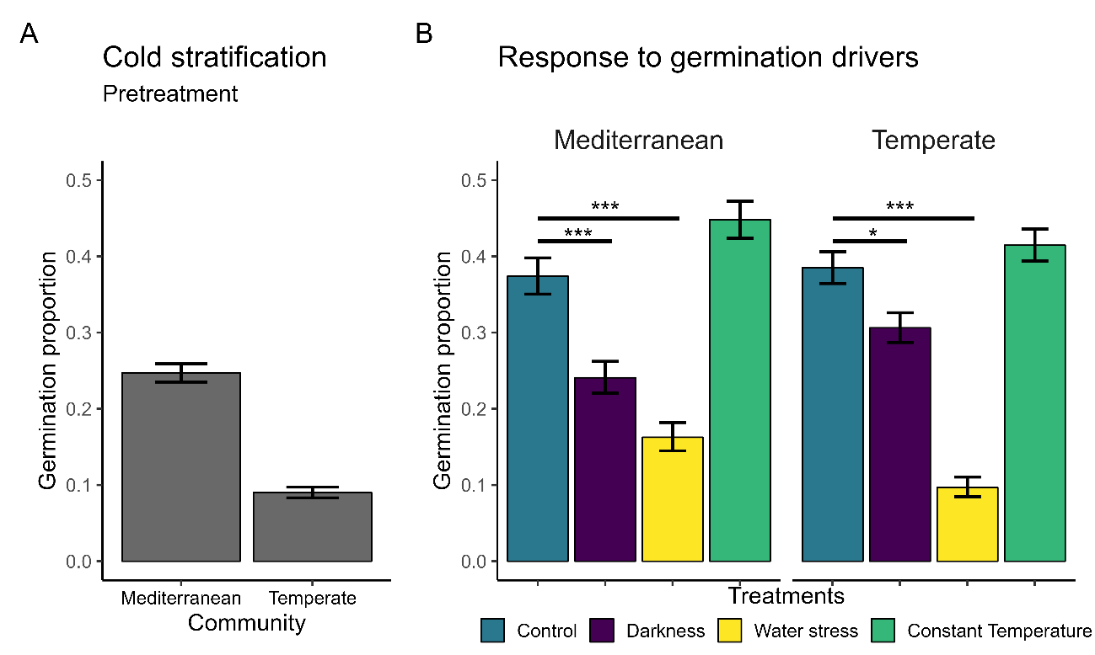
Figure 2. (A) Germination during cold stratification pretreatment. (B) Germination responses to the four experimental germination treatments studied. Bars represent the mean germination observed per each treatment (in different colors) in each system. Significance is represented by *** = p.value < 0.001 and * = p.value < 0.05. Error bars represent binomial confidence intervals calculated using binom.confint function (binom package (Dorai-Raj, 2022).

4. Discussion

4.1. Main germination patterns
Both systems responded consistently to the main germination drivers studied. Corroborating our hypothesis, the significant lower germination in darkness is in concordance with the “Alpine Germination Syndrome” (Fernández-Pascual et al 2021, Schwienbacher et al., 2011) and Mediterranean mountain specialist germination (Cruz-Tejada et al, 2024). As expected, water stress negatively affected germination corroborating what has been found for crop species (Bernau et al., 2020) and wild species from alpine habitats (for example Gya et al., 2023, Espinosa del Alba et al 2025 FE?), suggesting that under future climate warming and increasing drought germination will be negatively impacted. Surprisingly, both systems showed a trend of higher germination under constant temperatures, likely because seeds experienced longer time under “higher” temperatures than with the alternating temperatures and benefits germination (Picciau et al 2018).

