Article type: Original Research Article
Prospective Title: The alpine germination syndrome is regulated by water availability in temperate and mediterranean habitats
Prospective author list:
Espinosa del Alba, Clara^{1,2*}, Fernández-Pascual, Eduardo^{1,2}, Götzenberger, Lars³ & Jiménez-Alfaro, Borja^{1,2}.
Affiliations
1. Biodiversity Research Institute (IMIB), University of Oviedo-CSIC-Principality of Asturias, 33600 Mieres, Spain.
2. Department of Organismal and Systems Biology, University of Oviedo, Oviedo, Asturias, 33071, Spain.
3. Czech Academy of Sciences, Institute of Botany, Czech Republic.
Correspondence author:
Clara Espinosa del Alba. Email: clara.esdal@hotmail.es
ORCIDs
Clara Espinosa Del Alba. https://orcid.org/0000-0001-8634-5808
Eduardo Fernández-Pascual. https://orcid.org/0000-0002-4743-9577
Lars Götzenberger. https://orcid.org/0000-0003-3040-2900
Borja Jiménez-Alfaro. https://orcid.org/0000-0001-6601-9597

Abstract (max 300 words)
- Background and Aims: Alpine plants experience harsh environmental conditions that restrict growth and regeneration. Transitional areas between Eurosiberian and Mediterranean regions are more likely to exhibit changes due to global warming. Adaptation to future climates may occur through a modification of their reproductive phenological cycle or reproductive performance; therefore, understanding the environmental cues that drive alpine germination is essential for predicting future impacts. Recent research has emphasised the previously overlooked potential limiting effect of water stress in regeneration, but we still lack a more comprehensive point of view.
- Methods: We examined two seasonal and two microsite germination drivers in 57 alpine grassland species from Mediterranean and temperate alpine habitats from northwestern Spain. We subjected fresh seeds to a 5-month period of conditions mimicking snow-like conditions (0.5ºC and darkness). Subsequently, and for 6 weeks, we tested the effects of water stress, darkness, and constant temperatures on final germination proportion.
- Key Results: Both habitats reacted similarly to water stress, darkness, and constant temperatures. Water limitation and lack of light both hindered germination, while constant temperatures enhanced it. However, the response to snow-like conditions varied between habitats, with Mediterranean species showing higher germination rates than temperate species. We found large interspecific variation related to chorology and habitat specialisation.
- Conclusions: The results presented in this study suggest that under future climate warming scenarios with reduced snow cover and increasing water stress, the germination of alpine plant communities will be heavily impacted, with strict alpine species from Eurosiberian origin being less adapted to warmer, drier environments. These findings support the suggestion that seed germination traits, and particularly the response to water availability, play an essential role in understanding the ecology of alpine vegetation and their response to climate change.
Keywords (3-12): Germination syndromes, Germination niche, Alpine regeneration, Snow cover, Water stress, Water availability, Germination cues, Seed germination, Constant temperatures, Darkness

Introduction (approx. 1450 words)
Alpine areas are experiencing warmer temperatures (Nogués Bravo et al., 2008) and a redistribution of monthly rainfall (Sillmann et al., 2013). These changes are leading to a reduction of snowpack duration (Mote et al., 2005; López-Moreno, Goyette and Beniston, 2009; Morán-Tejeda et al., 2013), altered frequencies of freeze-thaw cycles (Groffman et al., 2001; Venäläinen et al., 2001) and an increase frequency of severe droughts (Beniston et al., 2007) and freezing events (Inouye, 2008; Wheeler et al., 2014). This has been linked to changes in species composition in mountain summits (Schöb et al., 2009; Gottfried et al., 2012; Pauli et al., 2012; Steinbauer et al., 2018), like upward shifts of thermophilous, more generalist species (García-Romero et al., 2010; Jiménez-Alfaro, Gavilán, et al., 2014). Warming effects have been evaluated via several experimental approaches like open top chambers (Marion et al., 1997) or resurveys (e.g. Jiménez-Alfaro, Gavilán, et al. 2014), but less attention has been given to the regeneration niche (Briceño, Hoyle and Nicotra, 2015).
The regeneration niche is defined as “the requirements for a high chance of success in the replacement of one mature individual by a new mature individual of the next generation” (Grubb, 1977). One of the first post-zygotic stages of regeneration is germination, an irreversible phase that sets the conditions and environment in which subsequent developmental stages will have to thrive or perish (Donohue et al., 2010). The general global alpine germination syndrome (Fernández-Pascual et al., 2021) is characterised by a requirement of long periods of cold-wet stratification and warm temperatures to relieve physiological dormancy (Shimono and Kudo, 2005; Schwienbacher et al., 2011; Margreiter et al., 2020) and positive responses to light and alternating temperatures (Fernández-Pascual et al., 2021). Nevertheless, the large microtopographic diversity, the short and highly variable growing season, and the taxonomic differences (Körner, 2021) have resulted in a variety of germination responses (Baskin and Baskin, 2014). There are many examples of alpine species departing from the general germination syndrome previously described (Schwienbacher et al., 2011; Hoyle et al., 2015; Orsenigo et al., 2015; Rosbakh et al., 2022; Espinosa del Alba, Fernández-Pascual and Jiménez-Alfaro, 2024). For example, a Mediterranean alpine germination syndrome in high-elevation areas with Mediterranean influence has been described, where species are ready to germinate shortly after dispersal, due to physiological dormancy release by dry after-ripening in late summer (Giménez-Benavides, Escudero and Pérez-García, 2005; Baskin and Baskin, 2014; Picciau et al., 2019). Under the current climate warming, adaptation might take place due to a modification of their reproductive phenological cycle (Walck et al., 2011; Mondoni et al., 2012), like earlier flowering (Nicotra et al., 2015; Kudo, 2020) or germination (Milbau et al., 2009; Espinosa del Alba, Fernández-Pascual and Jiménez-Alfaro, 2024), but also as a result of variations in their reproductive performance (Lluent et al., 2013; Notarnicola et al., 2022). While most literature has evaluated the effect of warming on germination (Mondoni et al., 2012; Hoyle et al., 2013; Fernández-Pascual et al., 2021), very few have inferred related effects like reduced duration of winter (i.e., cold stratification) or increased drought (Vázquez-Ramirez and Venn, 2021; Mondoni, Jiménez-Alfaro and Cavieres, 2022; Gya et al., 2023), especially in temperate alpine floras. While warmer temperatures seem to increase germination (Fernández-Pascual, Jiménez-Alfaro and Díaz, 2013; Bernareggi et al., 2016; Vázquez-Ramirez and Venn, 2021), water stress has a consistent negative effect on germination (Walck et al., 2011; Baskin and Baskin, 2014; Orsenigo et al., 2015; Vázquez-Ramirez and Venn, 2021; Gya et al., 2023). Thus, the overall effects of alpine warming on regeneration will mostly depend on water availability (Mondoni, Jiménez-Alfaro and Cavieres, 2022). Concordantly, recent research has highlighted the crucial role of water stress (Mondoni, Jiménez-Alfaro and Cavieres, 2022; Gya et al., 2023; Espinosa del Alba et al., 2025), especially in lower latitudes (Engler et al., 2011). It would be especially informative to analyse the relative importance of germination as a response to drought in alpine areas with Mediterranean influence (Fernández-Pascual et al., 2017), which are known to have a more severe and lengthy drought in summer (Joffre and Rambal, 2001) and whose oromediterraneous flora might be more adapted to regenerate under these circumstances (Giménez-Benavides, Escudero and Iriondo, 2007; Giménez-Benavides et al., 2018).
To maximise recruitment during the appropriate time and place, germination in alpine areas is triggered by a set of specific environmental cues (Donohue et al., 2010; Baskin and Baskin, 2014; Carta et al., 2022). These cues are related to stational, local habitat and microsite conditions (Baskin and Baskin, 2014; Fernández-Pascual et al., 2021; Carta et al., 2022) to ensure suitability for germination, avoiding freezing or early frost spells in spring and water stress in summer (Giménez-Benavides et al., 2018; Gremer et al., 2020; Fernández-Pascual et al., 2021). One of the main seasonal cues is related to snow precipitation and snowmelt timing (Walker et al., 1999; Körner, 2021) because of its direct impacts on water availability and indirect impacts on soil temperature (Decker et al., 2003). Experiencing a period of cold-wet stratification (winter season) usually increases germination percentages (Cavieres and Arroyo, 2000; Giménez-Benavides, Escudero and Pérez-García, 2005; Shimono and Kudo, 2005; Bernareggi et al., 2016; Fernández-Pascual et al., 2017) but not always (Baskin, Zackrisson and Baskin, 2002; Fernández-Pascual et al., 2017). Cold stratification is usually selected close to 4ºC, optimal for dormancy-breaking in many species (Ellis, 2006), but does not mimic real under-snow conditions (0-0.5 ºC and darkness) (Shimono and Kudo, 2005; Milbau et al., 2009). Interestingly, some alpine plants can germinate during cold stratification treatments and under snow-like conditions (Schwienbacher et al., 2011; Hoyle et al., 2015; Cavieres and Sierra-Almeida, 2018; Fernández-Pascual et al., 2021). This can allow seeds to germinate protected from freezing temperatures, take advantage of early water availability and extend the growing season (Briceño, Hoyle and Nicotra, 2015). The water amount required for germination is much less than what is needed to sustain subsequent seedling and plant growth (Ellis, 2006). Thus, germination water requirements must be related to the soil water content required to sustain further growth (Evans and Etherington, 1990). Both general alpine germination syndromes described in the literature temperate alpine and mediterranean alpine (Giménez-Benavides, Escudero and Pérez-García, 2005; Fernández-Pascual et al., 2021) might be regionally adapted to avoid drought. In temperate alpine habitats, the requirement for cold stratification prevents precocious germination under autumn conditions, where optimum conditions are not likely to persist (Cavieres and Arroyo, 2000). Thus, germination is postponed until a more favourable period after snowmelt in spring or summer (Cavieres and Arroyo, 2000; Walder and Erschbamer, 2015). Mediterranean alpine species, probably due to the lower snow cover/depth and the higher temperatures experienced, germination is synchronised with autumn rainfall (Giménez-Benavides, Escudero and Pérez-García, 2005; Baskin and Baskin, 2014; Picciau et al., 2019), shortly after dispersal, maximising the length of the growing season before the onset of summer drought (Doussi and Thanos, 2002). Other germination cues like the response to diurnal alternating temperatures (Thompson, Grime and Mason, 1977) and the need for light or darkness (Carta et al., 2017) can indicate to seeds whether they are buried deep in the soil, in rock crevices, allowing for a fine-scale detection of germination micro-niches and safe sites (Jumpponen et al., 1999; Liu et al., 2013). Local studies and recent meta-analyses have found alpine species to prefer germinating in light (Mondoni et al., 2009; Fernández-Pascual et al., 2021; Cruz-Tejada et al., 2024), while other alpine species seem to prefer germination in darkness (Schwienbacher et al., 2011). The diurnally alternating temperature can promote radicle growth by reducing the ratio of abscisic acid and gibberellin (Huarte and Benech-Arnold, 2010) and thus relieve dormancy and stimulate germination (Fenner and Thompson, 2005; Fernández-Pascual, Seal and Pritchard, 2015). Again, the literature reports variable results, both positive (Fernández-Pascual et al., 2021; Cruz-Tejada et al., 2024) or non-significant responses to alternating temperatures (Liu et al., 2013). Thus, although there are general germination patterns described, the responses to environmental cues seem to be species-specific (Drescher and Thomas, 2013; Drescher, 2014).
This study focuses on analysing germination responses to the main drivers expected in alpine areas, comparing two habitats with different macroclimates (Mediterranean and temperate) within the same regional scale. Firstly, we asked if the germination responses to cold stratification (mimicking under-snow climatic conditions) could be comparable between habitats. We hypothesised higher germination during cold stratification in the alpine temperate habitat, due to their general requirement of cold stratification and adaptation to snowy areas. Secondly, we asked how alpine species would germinate under moderate water stress. We hypothesised that the species from the Mediterranean alpine habitat would be able to germinate better than the ones from the temperate habitat due to a higher selective pressure to thrive under higher water stress. Thirdly, we asked if both habitats would respond similarly to the microsite germination cues (dark and constant temperatures). Since both habitats represent similar functional ecosystems (open mountain grasslands), we expect similar germination responses.

2. Materials and Methods (1640 words)

2.1 Study area
We investigated alpine grasslands between 1900 and 2500 m a.s.l. in the Cantabrian Mountains, extending east-west in northwestern Spain. This area serves as a transitional biogeographical zone between Eurosiberian and Mediterranean regions in Europe, allowing for the coexistence of temperate and Mediterranean floras (García-Gutiérrez et al., 2018; Jiménez-Alfaro et al., 2021). Our analysis focused on two habitats: (1) temperate alpine calcareous grasslands from Picos de Europa National Park (43.194856º N, -4.828414º E), and (2) Mediterranean alpine acidic grasslands from Valles de Omaña and Luna Biosphere Reserve (42.891956º N, -6.102928º E). The temperate alpine habitat high-diversity grasslands and swards (Jiménez-Alfaro, Alonso Felpete, et al., 2014) dominated by Carex sempervirens and a soil pH ranging from 6.5 to 6.8 (own data). The growing season, defined as the period with daily mean temperatures above 5ºC (at 5cm deep, Körner (2021)), lasts from mid-May to early October, with an average soil temperature of 11.4 ºC. Yearly, snow cover ranges from 57.2 to 211 days (calculated as the number of days in which the maximum temperatures were < 0.5 ºC and the minimum temperature was > -0.5 ºC, Zhang et al. (2005)) and mean daily water stress, during the growing season, ranges from -0.15 to -0.45 MPa depending on microsite conditions (soil data recorded from 2016 to 2024, own data). Conversely, the Mediterranean alpine habitat features lower plant diversity dominated by endemics Luzula caespitosa and Festuca summilusitana, with acidic bedrock and pH ranging from 3.8 to 4.8 (own data). The growing season runs from mid-April to early November, with an average soil temperature of 12.2ºC. Yearly, snow cover ranges from 13 to 116 days and mean daily water stress, during the growing season, ranges from -0.32 to -0.52 MPa (soil data collected from 2021 to 2024, not shown). Both alpine habitats are dominated by the Poaceae and Cyperaceae families, mainly consisting of Hemicryptophytes and Chamaephytes. Grazing impacts are limited to wild populations of Cantabrian chamois (Rupicapra pyrenaica parva).

2.2 Species selection and seed sampling
During August-September 2021 and 2022, we visited four sampling sites per habitat at peak reproductive season. We collected ripe seeds or fruits (hereafter ‘seeds’ for simplicity) directly from the mother plants of all species in a central representative plot of each habitat. Sampling took place within a 50 m radius of the central plot at each site, involving at least 20 to 50 randomly chosen individuals. Following standard protocols for sampling seeds of wild populations, the goal was to collect 400 seeds from each species to maximize intraspecific genetic diversity (ENSCONET, 2009). Field permits were necessary for seed sampling in Picos de Europa National Park (granted expedition number: CO/09/203/2021). In the temperate alpine habitat, we gathered sufficient seeds from 34 species, and 24 species in the Mediterranean alpine habitat. Only Thymus praecox (Ronniger) Holub was collected in both habitats. After cleaning, the seed lots (n=57) were kept in room conditions (22 ºC and 35% RH) for less than three months, then moved to hermetic pots with silica gel, in a refrigerator at 5ºC and darkness until the beginning of the experiment in November 2022. Each seed lot was sown in 16 Petri dishes (90 mm Ø) containing 25 seeds each (reduced to 20 seeds per Petri dish for two species: Avenella flexuosa (L.) Drejer and Helictochloa marginata (Lowe) Romero Zarco), using 1% agar, sealed with parafilm to maintain moisture and covered with two layers of aluminium foil. The goal of cold-wet stratification was to mimic natural snow conditions (0.5ºC and darkness, Milbau et al. (2009)) recorded in the area (5.5 months, Espinosa del Alba, Fernández-Pascual and Jiménez-Alfaro (2024)), similar to other alpine regions worldwide (as noted in Cavieres and Arroyo (2000) and (García-Fernández et al. (2015)), and to ensure the breaking of dormancy (Schwienbacher et al., 2011).

2.3 Germination treatments
Once the cold stratification ended, non-germinated seeds were transferred to new 90 mm Ø Petri dishes with two layers of filter paper (Filtros Anoia S.A. paper for germination assays, Ref.518G085) to subject the seeds to the specific germination treatments. (1) “Control” treatment consisted of alternating temperatures, 12h photoperiod and water available, (2) “Darkness” treatment with alternating temperatures, constant darkness and water available, (3) “Constant temperatures” treatment with constant temperatures, 12h photoperiod and water available and lastly (4) “Water stress” treatment, with alternating temperatures, 12h photoperiod and with polyethene glycol (PEG) solution to simulate -0.6 MPa. The specific amount of water stress was based on reported water-stress “thresholds” from other alpine areas (Orsenigo et al., 2015; Tudela-Isanta et al., 2018; Gya et al., 2023; Espinosa del Alba et al., 2025) and slightly above the mean water stress values registered in the area during the growing season (own data).
Preceding germination research by Espinosa del Alba, Fernández-Pascual and Jiménez-Alfaro, (2024) found that a similar set of species had two differential phenologies and optimal germination temperatures, and it is preferable to fully cover the potential germination niches of alpine species Margreiter et al. (2020). Consequently, we subdivided the species into two temperature regimes, and programmed it in four different climatic chambers, i.e., there were two alternating (15 - 5ºC vs 22 – 12ºC) and two constant temperature regimes (10ºC vs 17ºC). Firstly, for Darkness treatment, we transferred the seeds, added 6 ml of distilled water, and immediately covered them with two layers of aluminium foil. Next, for the Water stress treatment, instead of distilled water, we added 6 ml of a PEG solution (PEG 6000) to simulate a -0.6 MPa of water potential. As PEG solutions depend on experimental temperatures, two solutions were prepared according to Michel and Kaufmann (1973) and Villela, Doni Filho and Sequeira (1991) to reach desired osmotic potentials at mean temperatures in alternating temperature regimes. Lastly, seeds were divided between the Control and Constant temperature treatments, with 6 ml of distilled water. Germination treatments were programmed in three Aralab incubators (Aralab climatic chamber Fitoclima S600 PL, equipped with 4 LED modules 11w 350mA) configured using Fitolog 9000 software (version 9308, Aralab Pharmaceutical Stability software) and one incubation chamber (Grow-S 360, Ing. Climas, Barcelona, Spain). We checked germination weekly, removing germinated seeds from the Petri dishes (radicle > 1.5 mm long), for 6 weeks. At the end of the experiment, we cut open non-germinated seeds under a binocular stereoscope to visually assess if they were empty, infected, or seemed normal.
We considered seeds with white and firm embryos viable, and removed empty or infected seeds from germination calculations (Baskin and Baskin, 2014). The final raw dataset (Supporting information Table S1) consisted of the raw scoring data for 56 species (57 seed lots) representing 21 plant families. A total of 18,694 viable seeds were used in the experiment. For all analyses, we removed species with zero germination across all treatments (n=7), assuming we could not break dormancy or the seed quality during collection was not optimal. To study germination drivers, we removed those species that only germinated during cold stratification (n=2) and those with >50% germination during cold stratification (n=10), assuming those species can germinate under snow and their germination ecology is thus not limited by the germination cues experienced later in the season at microsite level. To test the effect of water stress, we additionally removed 6 species that did not germinate either in the Control or under Water stress.

2.4 Statistical analysis
All analyses and figures were done with R statistical software (Team and R Core Team, 2024) and graphs using ggplot2 (Wickham, 2016), ggpubr (Kassambara, 2023) and patchwork (Pedersen, 2023).
We analysed the germination data by fitting Markov Chain Monte Carlo generalized linear mixed models (MCMCglmm) with Bayesian estimation using the R package MCMCGLMM (Hadfield, 2010), using multinomial2 family. For all models, phylogeny was included as a random factor using a reconstructed tree for the 57 species, created with the V.PHYLOMAKER R package (Jin and Qian, 2019) using phylosignal and phylobase R packages ((Keck et al., 2016; R Hackathon et al., 2020). We used weakly informative priors, with parameter-expanded priors for the random effects. Each model was run for 1,000,000 iterations, with an initial burn of 100,000 and a thinning interval of 100. From the resulting posterior distributions, we calculated mean parameter estimates and 95% credible intervals (CI). To assess the significance of the models, we use the posterior mean from posterior probabilities and the credible intervals (CI). The posterior mean is an analogue of model effect sizes, and when the CI values do not overlap with 0, there is a significant effect of the explanatory variable.
For our first question, we analysed the germination responses to cold stratification (n=50) to test if there were differences between temperate and Mediterranean alpine habitats (germination in cold stratification ~ Habitat). For our next questions, we wanted to test the responses to germination drivers, thus we excluded species that only germinated during cold stratification, and those species with more than 50% germination in cold stratification. To test the effect of water stress, we also excluded those species with no germination either in the Control or Water stress treatments (n=33). First, we tested the differences between Control and Water stress germination (germination ~ treatment). Second, we measured the percentage of decreased germination in Water stress compared to Control, e.g., a specific species has germinated 80% in Control and 20% in Water Stress, the percentual germination decrease is equal to 75% ((1-(20/80)) *100). Then, we tested the differences in the percentual germination decrease between alpine Habitats with an Exponential/Gaussian MCMC-GLMM (germination reduction ~ Habitats). To tackle our third question about germination cues at the microsite level (n=39), we preliminarily tested if the different optimal temperatures had an effect on germination, but they were not significant and thus not included in further tests. We compared germination between treatments (light control vs dark and alternating vs constant temperatures) (germination ~ treatment); and, within each germination treatment, we tested germination differences between Habitats (germination ~ habitat).

3. Results (760 words with captions)

3.1. Responses to cold stratification
During cold stratification, germination ranged from 0 (e.g., Armeria cantabrica Boiss. & Reut. ex Willk) to 100% (e.g., Teesdalia conferta O.Appel (Lag.)); with 10 species (out of 50) germinating >50% (3 from the temperate alpine and 7 from the Mediterranean alpine), see Figure 1A. There was an average of 25% germination in species from the Mediterranean alpine habitat, while less than 10% of seeds germinated in the temperate alpine habitat. Habitat comparison detected significant differences (post. mean = -3.56, CI = [-6.22|-0.9]), with higher germination in the Mediterranean; see Figure 1B. The response of cold stratification across habitats was significantly modulated by phylogeny (post. mean = 0.94, CI: [0.88|1]), although phylogeny does not appear to have a significant effect explaining the variation of the model (post. mean = 28.16, CI: [0|58]).
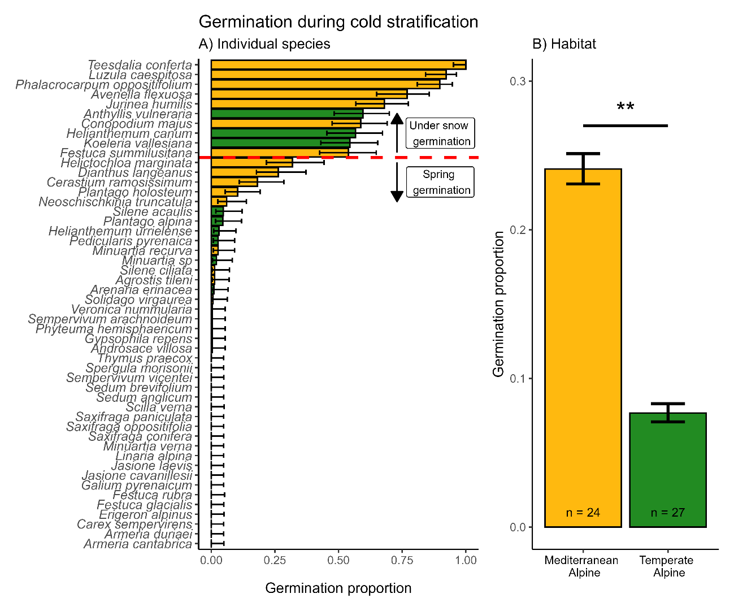
Figure 1. Germination during cold stratification. A) Accumulated germination during cold stratification across species (n = 50) colour by Habitat. B) Differences across habitats, n = number of species in each Habitat. Bars represent the mean germination proportion during cold stratification, and the error bar represents the binomial confidence intervals; significance derives from multinomial MCMCGLMM models, ** = p-value<0.01.

3.2. Responses to water stress
Water stress exhibited a significantly negative effect on overall germination, from 0.5 germination proportion in control to 0.16 in water stress (post. mean = -3.32, CI= [-3.71|-2.94]), see Figure 2A. Species in both habitats experienced a reduction of germination in water stress; although the mean percentual decrease was slightly higher in the temperate alpine habitat, (mean germination reduction of 63.6% and 76% in Mediterranean and temperate alpine, respectively) the differences were not significant (post. mean = 9, CI= [-9.62|28.3]); see Figure 2B. The percentage of decreased germination ranged from 100%, meaning that they did not germinate at all under water stress (e.g., Sedum brevifolium DC.) to 1%, meaning they were practically not affected by the water stress applied (-0.6 MPa) (e.g., Plantago holosteum Scop.); see Figure 2C for species individual responses. The germination response to water stress does not appear to be modulated by phylogeny and does not significantly explain variation within either of the models (see model details in supplementary Table S3).
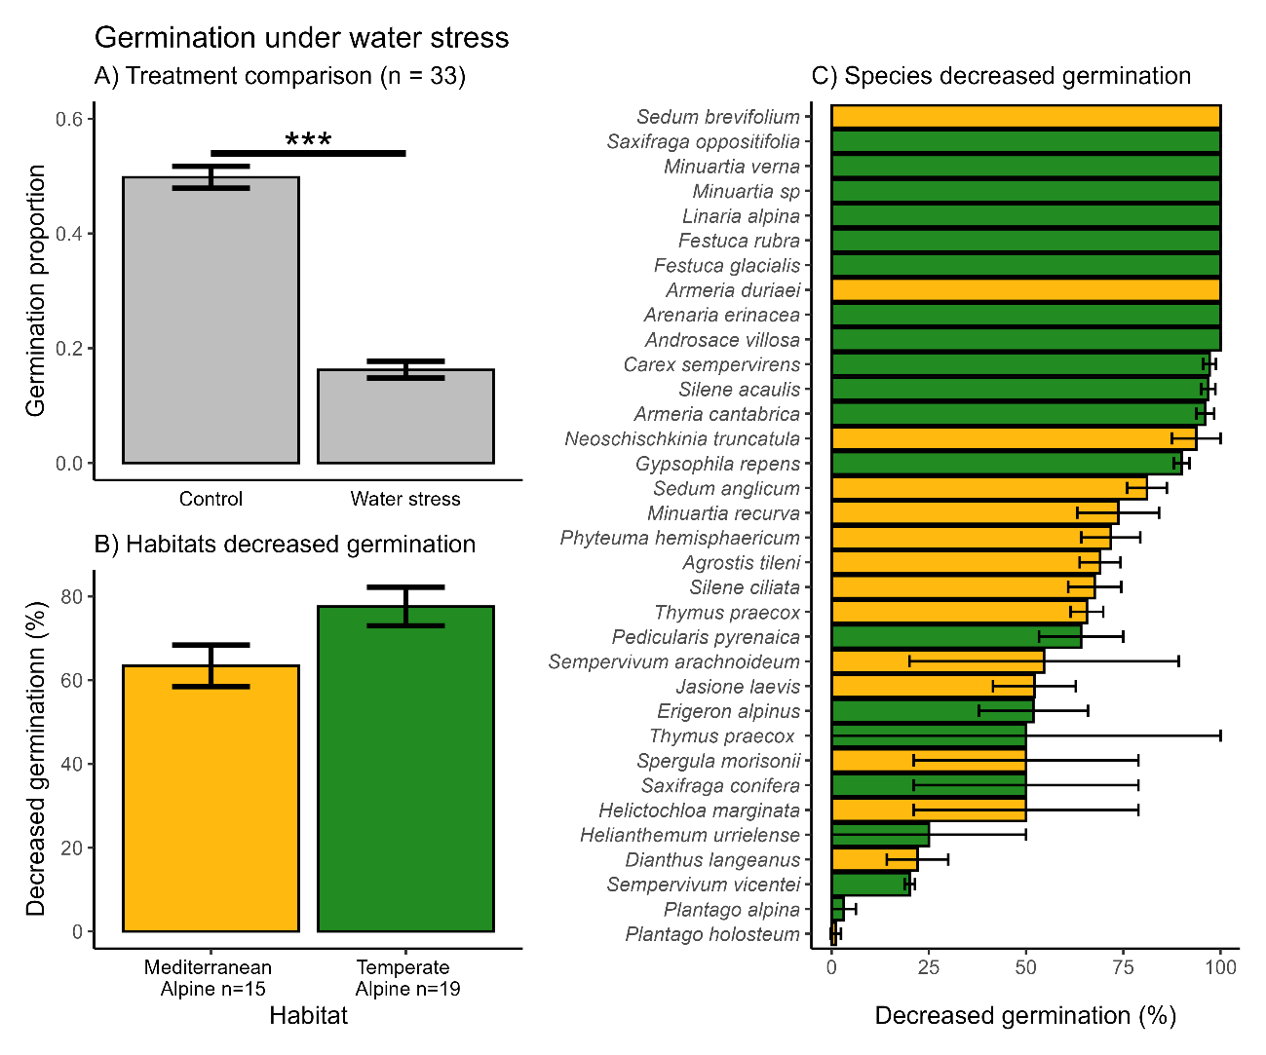
Figure 2. Germination responses under water stress. A) Control treatment with alternating temperatures (22-12ºC or 15-5ºC), 12 hours of light and constant water availability, Water Stress treatment with alternating temperatures (22-12ºC or 15-5ºC), 12 hours of light and PEG solution to mimic -0.6 MPa. Bars represent the mean germination observed per treatment, and error bars represent binomial confidence intervals. Significances from multinomial MCMC-GLMM models *** = p-value<0.001. B) Decreased germination is calculated as the percentual reduction of germination in water stress compared to control treatment. Bars represent the mean germination reduction under water stress in each Habitat, and error bars represent the Standard error of the mean. C) Decreased germination in each species, Bars represent the mean germination reduction under water stress in each Habitat, and error bars represent the Standard error of the mean. Colour represents the Habitat of the species.

3.3. Responses to germination cues
The highest mean germination proportion was recorded in the constant temperature treatment (0.47), followed by control (0.42) and darkness (0.36). Germination was significantly higher in Constant temperatures (post. mean = 0.42, CI= [0.1|0.72]) and significantly lower in Darkness (post. mean = -0.52, CI= [-0.84|-0.21]) compared to Control germination; see Figure 3A. When comparing both alpine habitats, we did not observe significant differences in germination within either of the treatments, although the Mediterranean habitat showed slightly higher germination under all treatments; see Figure 3B (model details in Supplementary Table S3). Phylogeny does not significantly explain variation in any of the models, but the differential germination response to darkness across habitats was significantly modulated by phylogeny (post. mean = 0.86, CI: [0.29|1]). Individual species germination responses to each treatment are available in Supplementary Figure S1 and Supplementary Table S2.
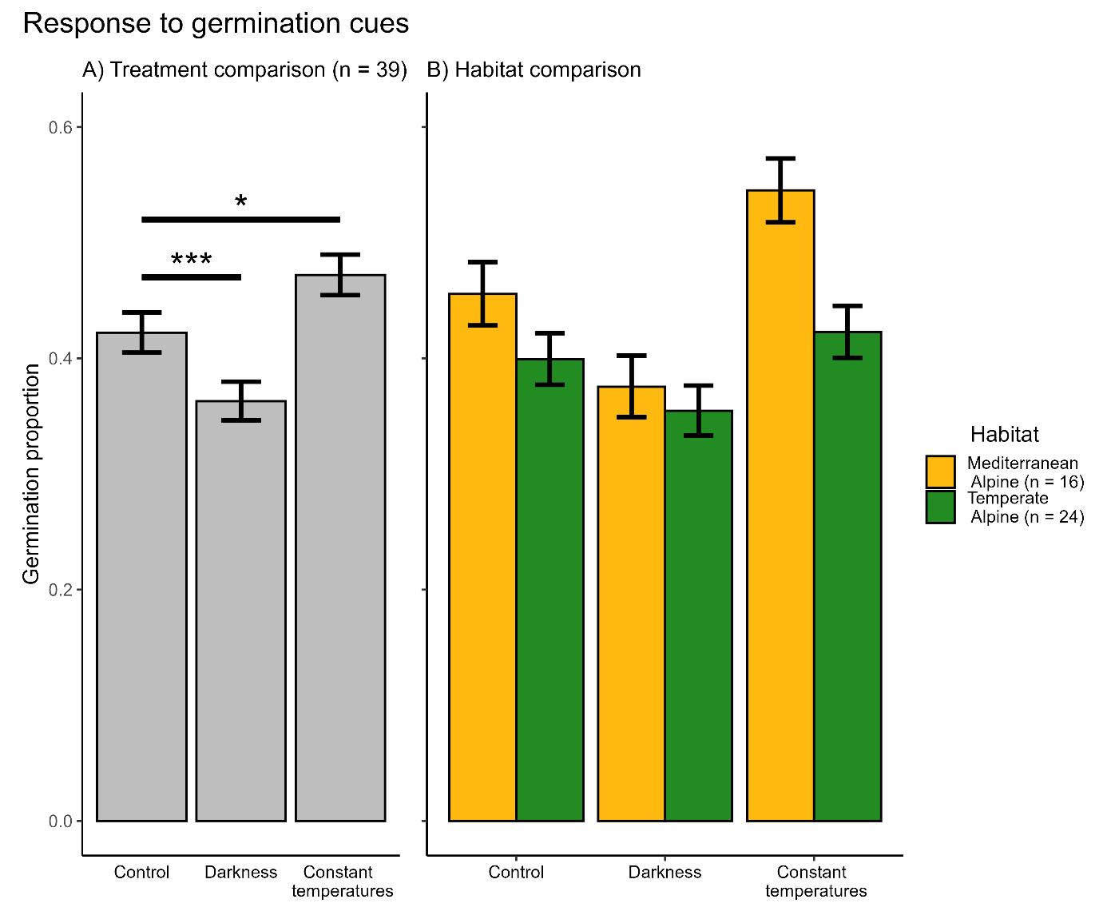
Figure 3. Germination responses to the three germination treatments studied. Control treatment with alternating temperatures (22-12ºC or 15-5ºC) and 12 hours of light; Darkness treatment with alternating temperatures (22-12ºC or 15-5ºC) and 0 hours of light and Constant temperatures treatment with constant temperatures (17ºC or 10ºC) and 12 hours of light. A) Bars represent the mean germination observed per treatment, error bars represent binomial confidence intervals, significances from multinomial MCMC-GLMM models, * = p-value < 0.05 and *** = p-value < 0.005. B) Bars represent the mean germination observed per treatment in each Habitat, and error bars represent binomial confidence intervals; n represents the number of species in each alpine habitat included in this analysis.

4. Discussion (1900 words)

4.1. Response to cold stratification
We tested germination responses to real under-snow conditions (0.5ºC and darkness) for five months and found that species from the Mediterranean habitat germinated higher than species from the temperate habitat. This confirms a lower physiological dormancy from the Mediterranean alpine species (Gimenez-Benavides et al. 2005) pool and appears in line with the Mediterranean germination syndrome, with species being able to germinate in darkness and lower temperatures (Thanos et al., 1991; Doussi and Thanos, 2002; Carta et al., 2017). It is important to note that the three species from the temperate habitat with >50% germination (Anthyllis vulneraria L., Helianthemum canum (L.) Hornem and Koeleria vallesiana (Honckeny) Gaud.) are adapted to the drier and less snowy places in Picos de Europa (Jiménez-Alfaro, Alonso Felpete, et al., 2014), thus they are adapted to more Mediterranean-like conditions. The only study comparing cold stratification (0ºC and darkness at 0,3,5 months) between alpine habitats is from Tudela-Isanta et al. (2017). They found higher germination in species from the calcareous habitat compared to those from the siliceous (although differences were not significant after 5 months of cold stratification), which interestingly, although it appears to be opposite to the patterns we report, the alpine siliceous habitats in their study system are actually wetter than the calcareous ones. Thus, it seems to be a consistent result of floras adapted to drier environments, being able to germinate better under snow. Moreover, from the top ten species with higher cold stratification germination, eight are considered generalist species, expanding from subalpine grasslands. Subalpine species are known to germinate better under snow (Fernández-Pascual et al., 2017) or at colder temperatures (Baskin and Baskin, 2014), so our results are in line with previously reported, although the germination we reported is generally lower than at 3-5ºC (Fernández-Pascual et al., 2017). Interestingly, some of these species seem to be restricted to germinate only under snow or at very low temperatures, either due to dormancy restrictions or underdeveloped embryos. For example, Luzula caespitosa (Juncaceae), an endemic northwestern Iberian grassland specialist thriving in snowy patches and northern slopes, has only been able to germinate during cold stratification and the results are in line with those observed in a germination phenology experiment (Espinosa del Alba, Fernández-Pascual and Jiménez-Alfaro, 2024). Another example, Teesdalia conferta (Brassicaceae), have shown consistent results with 100% germination during cold stratification in previous studies (Fernández-Pascual et al., 2017), while Conopodium majus (Apiaceae), also only germinated during cold stratification, is known to have an underdeveloped embryo which can only grow at lower temperatures between 0-5ºC (Blandino et al., 2018). Conopodium also shows an epicotyl dormancy (Baskin and Baskin, 2014) or a slow continuous seedling development after radicle emergence as alternative strategies to avoid cold damage (Vandelook and Van Assche, 2008; Carta et al., 2014). Under future climate scenarios with a reduction of snow cover (Mote et al., 2005; López-Moreno, Goyette and Beniston, 2009), the results of the present study suggest these species might be at a higher risk of decreased regeneration by seeds. Thus, variations in snow cover could change plant community structure by changing seed germination patterns (Anniwaer et al., 2020) and could have a stronger effect on seed germination than passive warming (Drescher, 2014). Nevertheless, according to our and other literature results, the responses will be very species specific (Drescher, 2014; Fernández-Pascual et al., 2017), thus, more research is needed to investigate the impacts of variations in snow cover (Briceño, Hoyle and Nicotra, 2015; Anniwaer et al., 2020) and cold tolerance (Ladwig et al., 2024) on seed germination, especially studies in the field with natural conditions have barely explored the response of a handful of species (Baskin, Zackrisson and Baskin, 2002; Graae et al., 2009).

4.2. Response to water stress
As expected, water stress negatively affected germination, corroborating previous studies from alpine habitats (Orsenigo et al., 2015; Gya et al., 2023; Espinosa del Alba et al., 2025). Low moisture availability leads to partial or complete inhibition of physiological processes, which may hinder seeds from germinating (Baskin and Baskin, 2014). Interestingly, species from the Mediterranean habitat germinated slightly better at -0.6 MPa than species from our temperate habitat and other alpine regions (Walder and Erschbamer, 2015). Although not significant these differences seem opposite to the results presented by Tudela-Isanta et al. (2018) where species from siliceous habitats were shown to have lower capacity to germinate under drought, but again more than the bedrock type the patterns observed are consistent if we shift the focus to the water holding capacity of the soils, species living in wetter soils responded more negatively to germination under water stress. The contrasting results might indicate that the combination of bedrock and climate is driving general germination patterns. We also found a large interspecific variability already been highlighted for alpine species in general and is dependent on species-specific requirements (Orsenigo et al., 2015; Walder and Erschbamer, 2015; Fernández-Pascual et al., 2017; Espinosa del Alba, Fernández-Pascual and Jiménez-Alfaro, 2024). A possible explanation for the interspecific variability could be the variable environmental conditions of the mother plants during seed production and the maternal effects per se (Graae et al., 2009; Giménez-Benavides and Milla, 2013). In our results, strict alpine species like Minuartia verna (L.) Hiern, Festuca glacialis K. Richt. (Miégev. ex Hack.) or Carex sempervirens Vill. showed higher decreased germination under water stress than other subalpine species or more generalist species (e.g. Plantago holosteum Scop.). Subalpine or generalist species occur in sites with early snowmelt and are subjected to higher summer drought, which might make them more adapted to drought. Here, we did not focus on intraspecific variations, although there is evidence of adaptation to drought in germination responses (Giménez-Benavides, Escudero and Iriondo, 2007; Cochrane et al., 2014; Torres-Martínez et al., 2017; Espinosa del Alba et al., 2025). Reduced water availability can also result in delayed germination (Cochrane et al., 2015; Vázquez-Ramirez and Venn, 2021), which could be indicative of strategies to postpone germination to a time with more favourable moisture conditions, but at a cost of a shorter growing season, which might limit winter survival (Mondoni et al., 2012). More studies are needed and pressing under current climatic scenarios to understand how much germination will be negatively affected by drought (Gya et al., 2023).

4.3. Response to germination cues
Both habitats responded consistently to the germination microsite cues studied. The significantly lower germination in darkness we observed is in concordance with the general alpine germination syndrome (Shimono and Kudo, 2005; Mondoni et al., 2009; Wagner and Simons, 2009; Wu, Du and Shi, 2013; Fernández-Pascual et al., 2021) and Mediterranean mountain specialist germination (Giménez-Benavides, Escudero and Pérez-García, 2005; Picciau et al., 2019; Cruz-Tejada et al., 2024). Surprisingly, both systems showed a trend of higher germination under constant temperatures, opposite to the general reported results (Fernández-Pascual et al., 2021), likely because seeds experienced longer time under “higher” temperatures than with the alternating temperatures and benefited germination (Picciau et al., 2019), while the lower limit might be outside the germination temperature range (i.e., below the Tb) rather than an effect of constancy per se (Jiménez-Alfaro et al., 2018). Our results contrast with Liu et al. (2013), who found no response to temperature fluctuations for species of the Qinghai-Tibet Plateau. Alternating temperatures and light are conditions that mimic the environment in the upper soil and certain microsites during the snow-free season (Mondoni et al., 2012; Körner, 2021) and also a detection mechanism that prevents seeds from germinating too deep in the soil (Saatkamp et al., 2011), thus acting as triggers of germination. Germination light requirement is considered to be one of the main factors that promote the formation of a persistent soil seed bank (Shimono and Kudo, 2005; Jaganathan, Dalrymple and Liu, 2015). The depth of seed burial is also crucial for seedling emergence; shallow depths might be beneficial for small seeds (Bond, Honig and Maze, 1999), which potentially lack the resources to survive until they reach the soil surface. On the other hand, deeper depths might be an advantageous strategy to avoid radicle emergence at the soil surface and decrease seedling mortality due to irregular and inconsistent water availability (Pons and Fenner, 2000; Doussi and Thanos, 2002; Carta et al., 2017).

Conclusions
The results presented in this study suggest that alpine germination of a large number of species will be heavily impacted due to changes in water availability derived from reduced snow cover and increasing water stress under current climate warming (Morán-Tejeda et al., 2013; Gobiet et al., 2014). Despite most species showing similar responses to the germination cues analysed in this study, when comparing both habitats, we detected slightly different patterns in their response to water availability. Alpine species from the Mediterranean habitat showed less dormancy and significantly higher germination under snow; this way, they take advantage of early-season water availability and start developing before the onset of summer drought (ref), and still, they also showed a trend of slightly better germination response to water stress. The species from the temperate alpine habitat are not so restricted by water stress during summer. Thus, fewer species took advantage of germination under snow and showed lower germination under water stress, likely due to the lack of adaptation to summer drought (ref). Our results suggest that alpine germination seems to be regionally adapted to avoid drought. The temperate alpine habitat has more species from a Eurosiberian origin, finding their southern distributional limits in the Mediterranean region (Stanisci et al., 2011; Gentili et al., 2015). These marginal populations, or “trailing edges”, usually survive in ‘cold’ refuges next to their limits of environmental tolerance, especially in Mediterranean mountains, with isolated peaks and limited surface of the highest bioclimatic belts (Gavilán et al., 2013; Jiménez-Alfaro, Gavilán, et al., 2014). These strict alpine species and, especially, snowbed specialists (Matteodo et al., 2016; Illa et al., 2022) are less adapted to warmer, drier environments, which in a warmer and drier future may benefit those subalpine species that are better competitors under those circumstances (Notarnicola et al., 2022). This supports the suggestion that seed germination traits play an essential role in understanding the ecology of alpine plant communities and their response to climate change (Briceño, Hoyle and Nicotra, 2015; Hoyle et al., 2015). More research is needed to further investigate specific effects of shortened snow cover protection and increasing water stress to be able to detect species' minimal requirements, indirectly favouring species less dormant (Verdú and Traveset, 2005; Mondoni et al., 2015) or with no stratification requirement (Sommerville, Martyn and Offord, 2013). This risk will be partly alleviated by the plasticity of physiological seed dormancy in response to the seed maturation temperature (Fernández-Pascual et al., 2013; Carta et al., 2015) or via maternal effects that facilitate acclimatisation to changing environments, and can reduce the stratification requirements of seeds produced in a warmer climate (Fernández-Pascual, Seal and Pritchard, 2015; Fernández-Pascual, Mattana and Pritchard, 2019). Thus, including intraspecific variation will also be key to understanding potential local adaptations or buffers (Gya et al., 2023; Espinosa del Alba et al., 2025). Research also needs to address several cofounding factors we have in this study, such as macroclimate and bedrock (Tudela-Isanta et al., 2017, 2018), although the results from both studies seem to indicate that is context-dependant on regional factors controlling water availability. The results presented here are based on laboratory experiments, and have limited transference to natural communities; therefore, increasing the field experimentation (Milbau et al., 2009; Müller, Cooper and Alsos, 2011) is needed to be able to more precisely predict future responses to climate warming.

Figure legends:
Figure 1. Germination during cold stratification. A) Accumulated germination during cold stratification across species (n = 50) colour by Habitat. B) Differences across habitats, n = number of species in each Habitat. Bars represent the mean germination proportion during cold stratification, and the error bar represents the binomial confidence intervals; significance derives from multinomial MCMCGLMM models, ** = p-value<0.01.
Figure 2. Germination responses under water stress. A) Control treatment with alternating temperatures (22-12ºC or 15-5ºC), 12 hours of light and constant water availability, Water Stress treatment with alternating temperatures (22-12ºC or 15-5ºC), 12 hours of light and PEG solution to mimic -0.6 MPa. Bars represent the mean germination observed per treatment, and error bars represent binomial confidence intervals. Significances from multinomial MCMC-GLMM models *** = p-value<0.001. B) Decreased germination is calculated as the percentual reduction of germination in water stress compared to control treatment. Bars represent the mean germination reduction under water stress in each Habitat, and error bars represent the Standard error of the mean. C) Decreased germination in each species, Bars represent the mean germination reduction under water stress in each Habitat, and error bars represent the Standard error of the mean. Colour represents the Habitat of the species.
Figure 3. Germination responses to the three germination treatments studied. Control treatment with alternating temperatures (22-12ºC or 15-5ºC) and 12 hours of light; Darkness treatment with alternating temperatures (22-12ºC or 15-5ºC) and 0 hours of light and Constant temperatures treatment with constant temperatures (17ºC or 10ºC) and 12 hours of light. A) Bars represent the mean germination observed per treatment, error bars represent binomial confidence intervals, significances from multinomial MCMC-GLMM models, * = p-value < 0.05 and *** = p-value < 0.005. B) Bars represent the mean germination observed per treatment in each Habitat, and error bars represent binomial confidence intervals; n represents the number of species in each alpine habitat included in this analysis.

Supplementary files
Figure S1. Species individual germination responses to the different germination treatments studies.
Table S1. Raw germination data
Table S2. Species summary mean germination per treatment
Table S3. MCMC germination model results

Data availability statement
Raw data and R script for analysis are available in GitHub; once the manuscript is accepted, the GitHub repository will be public and stored in Zenodo. (add later in reference list)

Competing interests
None declared

Author contributions CREDIT
Conceptualization: Eduardo Fernández-Pascual, Borja Jiménez-Alfaro/ EFP, BJA; Investigation: Clara Espinosa del Alba/CEA; Formal Analysis: Clara Espinosa del Alba, Eduardo Fernández-Pascual/CEA, EFP; Writing – original draft: Clara Espinosa del Alba/CEA; Writing – Review & Editing: all authors; Supervision: Borja Jiménez-Alfaro, Eduardo Fernández-Pascual, Lars Götzenberger/BJA, EFP, LG; Funding acquisition: Borja Jiménez-Alfaro/BJA.

Funding sources
This work was supported by Agencia Española de Investigación - Spanish Research Agency (grant number: AEI/10.13039/501100011033); Ayuntamiento de Gijón/Xixón (grant number: SV-23-GIJON-JBA) and Grant “Laboratorio de Vegetación y Biodiversidad” (grant number: IDE/2024/000720, Principality of Asturias-Sekuens-EU-FEDER).

Acknowledgements
We want to thank the Picos de Europa National for support in field sampling. This research is framed within the SEEDALP project (MCI-20-PID2019-108636GA-I00) funded by the Spanish Research Agency (AEI/10.13039/501100011033), and supported by Ayudas para Contratos Predoctorales para la Formación de Doctores del Ministerio de Ciencia e Innovación (FPI: MCI-21-PRE2020-092874); Ayuntamiento de Gijón/Xixón - Jardín Botánico Atlántico (SV-23-GIJON-JBA) and the grant “Laboratorio de Vegetación y Biodiversidad” (IDE/2024/000720, Principality of Asturias-Sekuens-EU-FEDER).

Literature cited
Anniwaer, A. et al. (2020) ‘Impacts of snow on seed germination are independent of seed traits and plant ecological characteristics in a temperate desert of Central Asia’, Journal of Arid Land, 12(5), pp. 775–790. doi: 10.1007/s40333-020-0059-9.
Baskin, C. C. and Baskin, J. M. (2014) Seeds. Ecology, Biogeography and Evolution of Dormancy and Germination. 2nd Editio, Seeds. 2nd Editio. San Diego, CA, USA: Academic Press. doi: 10.1016/B978-0-12-416677-6.00001-9.
Baskin, C. C., Zackrisson, O. and Baskin, J. M. (2002) ‘Role of warm stratification in promoting germination of seeds of Empetrum hermaphroditum (Empetracea), a circumboreal species with a stony endocarp’, American Journal of Botany, 89(3), pp. 486–493. doi: 10.3732/ajb.89.3.486.
Beniston, M. et al. (2007) ‘Future extreme events in European climate: An exploration of regional climate model projections’, Climatic Change, 81, pp. 71–95. doi: 10.1007/s10584-006-9226-z.
Bernareggi, G. et al. (2016) ‘Seed dormancy and germination changes of snowbed species under climate warming: The role of pre-And post-dispersal temperatures’, Annals of Botany, 118(3), pp. 529–539. doi: 10.1093/aob/mcw125.
Blandino, C. et al. (2018) ‘Seed ecology of the geophyte Conopodium majus (Apiaceae), indicator species of ancient woodland understories and oligotrophic meadows’, Plant Biology, 21(3), pp. 487–497. doi: 10.1111/plb.12872.
Bond, W. J., Honig, M. and Maze, K. E. (1999) ‘Seed size and seedling emergence: An allometric relationship and some ecological implications’, Oecologia, 120(1), pp. 132–136. doi: 10.1007/s004420050841.
Briceño, V. F., Hoyle, G. L. and Nicotra, A. B. (2015) ‘Seeds at risk: How will a changing alpine climate affect regeneration from seeds in alpine areas?’, Alpine Botany, 125(2), pp. 59–68. doi: 10.1007/s00035-015-0155-1.
Carta, A. et al. (2014) ‘Seed dormancy and germination in three Crocus ser. Verni species (Iridaceae): Implications for evolution of dormancy within the genus’, Plant Biology, 16(6), pp. 1065–1074. doi: 10.1111/plb.12168.
Carta, A. et al. (2015) ‘Local climate explains degree of seed dormancy in Hypericum elodes L. (Hypericaceae)’, Plant Biology, 18(Suppl. 1), pp. 76–82. doi: 10.1111/plb.12310.
Carta, A. et al. (2017) ‘Photoinhibition of seed germination : occurrence , ecology and phylogeny Photoinhibition of seed germination : occurrence , ecology and phylogeny’, Seed Science Research, 27, pp. 131–153. doi: 10.1017/S0960258517000137.
Carta, A. et al. (2022) ‘Climate shapes the seed germination niche of temperate flowering plants: A meta-analysis of European seed conservation data’, Annals of Botany, 129(7), pp. 775–786. doi: 10.1093/aob/mcac037.
Cavieres, L. A. and Arroyo, M. T. K. (2000) ‘Seed germination response to cold stratification period and thermal regime in Phacelia secunda (Hydrophyllaceae): Altitudinal variation in the mediterranean Andes of central Chile’, Plant Ecology, 149(1), pp. 1–8. doi: 10.1023/A:1009802806674.
Cavieres, L. A. and Sierra-Almeida, A. (2018) ‘Assessing the importance of cold-stratification for seed germination in alpine plant species of the High-Andes of central Chile’, Perspectives in Plant Ecology, Evolution and Systematics, 30, pp. 125–131. doi: 10.1016/j.ppees.2017.09.005.
Cochrane, J. A. et al. (2014) ‘Evidence of population variation in drought tolerance during seed germination in four Banksia (Proteaceae) species from Western Australia’, Australian Journal of Botany, 62(6), pp. 481–489. doi: 10.1071/BT14132.
Cochrane, J. A. et al. (2015) ‘Climate warming delays and decreases seedling emergence in a Mediterranean ecosystem’, Oikos, 124(2), pp. 150–160. doi: 10.1111/oik.01359.
Cruz-Tejada, D. M. et al. (2024) ‘Macroclimatic Convergence and Habitat Specialisation Shape the Mediterranean Seed Germination Syndrome’, Ecology and Evolution, 14(11), pp. 1–8. doi: 10.1002/ece3.70527.
Decker, K. L. M. et al. (2003) ‘Snow Removal and Ambient Air Temperature Effects of Forest Soil Temperatures in Northern Vermont’, Soil Science Society of America Journal, 67(5), pp. 1629–1629. doi: 10.2136/sssaj2003.1629.
Donohue, K. et al. (2010) ‘Germination, postgermination adaptation, and species ecological ranges’, Annual Review of Ecology, Evolution, and Systematics, 41, pp. 293–319. doi: 10.1146/annurev-ecolsys-102209-144715.
Doussi, M. A. and Thanos, C. A. (2002) ‘Ecophysiology of seed germination in Mediterranean geophytes. 1. Muscari spp’, Seed Science Research, 12(3), pp. 193–201. doi: 10.1079/ssr2002111.
Drescher, M. (2014) ‘Snow cover manipulations and passive warming affect post-winter seed germination: A case study of three cold-temperate tree species’, Climate Research, 60(3), pp. 175–186. doi: 10.3354/cr01237.
Drescher, M. and Thomas, S. C. (2013) ‘Snow cover manipulations alter survival of early life stages of cold-temperate tree species’, Oikos, 122(4), pp. 541–554. doi: 10.1111/j.1600-0706.2012.20642.x.
Ellis, R. (2006) The Encyclopedia of Seeds. Science technology and uses. 1st edn. Edited by M. Black, J. Bewley, and P. Halmer. Wallingford, CABI: CABI International. doi: 10.1093/aob/mcm225.
Engler, R. et al. (2011) ‘21st century climate change threatens mountain flora unequally across Europe’, Global Change Biology, 17(7), pp. 2330–2341. doi: 10.1111/j.1365-2486.2010.02393.x.
ENSCONET (2009) ENSCONET Seed Collecting Manual for Wild Species.
Espinosa del Alba, C. et al. (2025) ‘Functional intraspecific variation in the base water potential for seed germination along soil microclimatic gradients’, Functional Ecology, 39(3), pp. 897–911. doi: 10.1111/1365-2435.14754.
Espinosa del Alba, C., Fernández-Pascual, E. and Jiménez-Alfaro, B. (2024) ‘Microclimatic variation regulates seed germination phenology in alpine plant communities’, Journal of Ecology, (November), pp. 1–14. doi: 10.1111/1365-2745.14461.
Evans, C. E. and Etherington, J. R. (1990) ‘The effect of soil water potential on seedling growth of some British plants’, New Phytologist, 115, pp. 539–548. doi: 10.1111/j.1469-8137.1991.tb00998.x.
Fenner, M. and Thompson, K. (2005) ‘The ecology of seeds’, in Fenner, M. and Thompson, K. (eds) The ecology of seeds. Cambridge, UK: Cambridge: Cambridge Uniersity Press, pp. 110–135.
Fernández-Pascual, E. et al. (2013) ‘A local dormancy cline is related to the seed maturation environment, population genetic composition and climate’, Annals of Botany, 112(5), pp. 937–945. doi: 10.1093/aob/mct154.
Fernández-Pascual, E. et al. (2017) ‘Comparative seed germination traits in alpine and subalpine grasslands: higher elevations are associated with warmer germination temperatures’, Plant Biology, 19(1), pp. 32–40. doi: 10.1111/plb.12472.
Fernández-Pascual, E. et al. (2021) ‘The seed germination spectrum of alpine plants: a global meta-analysis’, New Phytologist, 229(6), pp. 3573–3586. doi: 10.1111/nph.17086.
Fernández-Pascual, E., Jiménez-Alfaro, B. and Díaz, T. E. (2013) ‘The temperature dimension of the seed germination niche in fen wetlands’, Plant Ecology, 214(4), pp. 489–499. doi: 10.1007/s11258-012-0165-7.
Fernández-Pascual, E., Mattana, E. and Pritchard, H. W. (2019) ‘Seeds of future past: climate change and the thermal memory of plant reproductive traits’, Biological Reviews, 94(2), pp. 439–456. doi: 10.1111/brv.12461.
Fernández-Pascual, E., Seal, C. E. and Pritchard, H. W. (2015) ‘Simulating the germination response to diurnally alternating temperatures under climate change scenarios: Comparative studies on Carex diandra seeds’, Annals of Botany, 115(2), pp. 201–209. doi: 10.1093/aob/mcu234.
García-Fernández, A. et al. (2015) ‘Effects of the duration of cold stratification on early life stages of the Mediterranean alpine plant Silene ciliata’, Plant Biology, 17(2), pp. 344–350. doi: 10.1111/plb.12226.
García-Gutiérrez, T. et al. (2018) ‘Functional diversity and ecological requirements of alpine vegetation types in a biogeographical transition zone’, Phytocoenologia, 48(1), pp. 77–89. doi: 10.1127/phyto/2017/0224.
García-Romero, A. et al. (2010) ‘Relationship between climate change and vegetation distribution in the Mediterranean mountains: Manzanares Head valley, Sierra De Guadarrama (Central Spain)’, Climatic Change, 100(3), pp. 645–666. doi: 10.1007/s10584-009-9727-7.
Gavilán, R. G. et al. (2013) ‘Mountain Biodiversity patterns in Southern Europe and North Africa’, Lazaroa, 34, pp. 7–10. doi: 10.5209/rev.
Gentili, R. et al. (2015) ‘From cold to warm-stage refugia for boreo-alpine plants in southern European and Mediterranean mountains: the last chance to survive or an opportunity for speciation?’, Biodiversity, 16(4), pp. 247–261. doi: 10.1080/14888386.2015.1116407.
Giménez-Benavides, L. et al. (2018) ‘How does climate change affect regeneration of Mediterranean high-mountain plants? An integration and synthesis of current knowledge’, Plant Biology, 20, pp. 50–62. doi: 10.1111/plb.12643.
Giménez-Benavides, L., Escudero, A. and Iriondo, J. M. (2007) ‘Local adaptation enhances seedling recruitment along an altitudinal gradient in a high mountain mediterranean plant’, Annals of Botany, 99(4), pp. 723–734. doi: 10.1093/aob/mcm007.
Giménez-Benavides, L., Escudero, A. and Pérez-García, F. (2005) ‘Seed germination of high mountain Mediterranean species: Altitudinal, interpopulation and interannual variability’, Ecological Research, 20(4), pp. 433–444. doi: 10.1007/s11284-005-0059-4.
Giménez-Benavides, L. and Milla, R. (2013) ‘Comparative germination ecology of two altitudinal vicariant Saxifraga species endemic to the north of Spain’, Plant Biology, 15(3), pp. 593–600. doi: 10.1111/j.1438-8677.2012.00663.x.
Gobiet, A. et al. (2014) ‘21st century climate change in the European Alps-A review’, Science of the Total Environment, 493, pp. 1138–1151. doi: 10.1016/j.scitotenv.2013.07.050.
Gottfried, M. et al. (2012) ‘Continent-wide response of mountain vegetation to climate change’, Nature Climate Change, 2(2), pp. 111–115. doi: 10.1038/nclimate1329.
Graae, B. J. et al. (2009) ‘The effect of an early-season short-term heat pulse on plant recruitment in the Arctic’, Polar Biology, 32(8), pp. 1117–1126. doi: 10.1007/s00300-009-0608-3.
Gremer, J. R. et al. (2020) ‘Variation in the seasonal germination niche across an elevational gradient: the role of germination cueing in current and future climates’, American Journal of Botany, 107(2), pp. 350–363. doi: 10.1002/ajb2.1425.
Groffman, P. M. et al. (2001) ‘Colder soils in a warmer world: A now manipulation study in a Northern hardwood forest ecosystem’, Biogeochemistry, 56(2), pp. 135–150. Available at: https://www.jstor.org/stable/1469925.
Grubb, P. J. (1977) ‘the Maintenance of Species-Richness in Plant Communities: the Importance of the Regeneration Niche’, Biological Reviews, 52(1), pp. 107–145. doi: 10.1111/j.1469-185x.1977.tb01347.x.
Gya, R. et al. (2023) ‘A test of local adaptation to drought in germination and seedling traits in populations of two alpine forbs across a 2000 mm/year precipitation gradient’, Ecology and Evolution, 13(2), pp. 1–19. doi: 10.1002/ece3.9772.
Hadfield, J. D. (2010) ‘MCMCglmm: MCMC Methods for Multi-Response GLMMs in R’, Journal of Statistical Software, 33(2), pp. 1–22. Available at: http://www.jstatsoft.org/.
Hoyle, G. L. et al. (2013) ‘Soil warming increases plant species richness but decreases germination from the alpine soil seed bank’, Global Change Biology, 19(5), pp. 1549–1561. doi: 10.1111/gcb.12135.
Hoyle, G. L. et al. (2015) ‘Seed germination strategies: An evolutionary trajectory independent of vegetative functional traits’, Frontiers in Plant Science, 6(OCTOBER), pp. 1–13. doi: 10.3389/fpls.2015.00731.
Huarte, H. R. and Benech-Arnold, R. L. (2010) ‘Hormonal nature of seed responses to fluctuating temperatures in Cynara cardunculus (L.)’, Seed Science Research, 20(1), pp. 39–45. doi: 10.1017/S0960258509990249.
Illa, E. et al. (2022) ‘Living on the edge: Plant diversity in the Iberian chionophilous vegetation’, Applied Vegetation Science, 25(4), pp. 1–13. doi: 10.1111/avsc.12701.
Inouye, D. W. (2008) ‘Effects of climate change on phenology, frost damage, and floral abundance of montane wildflowers’, Ecology, 89(2), pp. 353–362.
Jaganathan, G. K., Dalrymple, S. E. and Liu, B. (2015) ‘Towards an Understanding of Factors Controlling Seed Bank Composition and Longevity in the Alpine Environment’, Botanical Review, 81(1), pp. 70–103. doi: 10.1007/s12229-014-9150-2.
Jiménez-Alfaro, B., Alonso Felpete, J. I., et al. (2014) ‘Alpine plant communities in the Picos de Europa calcareous massif (Northern Spain)’, Lazaroa, 35(0). doi: 10.5209/rev_laza.2013.v34.n1.43646.
Jiménez-Alfaro, B., Gavilán, R. G., et al. (2014) ‘Decline of dry grassland specialists in Mediterranean high-mountain communities influenced by recent climate warming’, Journal of Vegetation Science, 25(6), pp. 1394–1404. doi: 10.1111/jvs.12198.
Jiménez-Alfaro, B. et al. (2018) ‘Germination ecology of winter annual grasses in Mediterranean climates: Applications for soil cover in olive groves’, Agriculture, Ecosystems and Environment, 262, pp. 29–35. doi: 10.1016/j.agee.2018.04.013.
Jiménez-Alfaro, B. et al. (2021) ‘Post-glacial determinants of regional species pools in alpine grasslands’, Global Ecology Biogeography, 30, pp. 1101–1115. doi: https://doi.org/10.1111/geb.13274.
Jin, Y. and Qian, H. (2019) ‘V.PhyloMaker: an R package that can generate very large phylogenies for vascular plants’, Ecography, 42(8), pp. 1353–1359. doi: 10.1111/ecog.04434.
Joffre, R. and Rambal, S. (2001) ‘Mediterranean Ecosystems’, Encyclopedia of Life Sciences. doi: 10.1038/npg.els.0003196.
Jumpponen, A. et al. (1999) ‘Characterization of “safe sites” for pioneers in primary succession on recently deglaciated terrain’, Journal of Ecology, 87, pp. 98–105. doi: 10.1046/j.1365-2745.1999.00328.x.
Kassambara, A. (2023) ‘ggpubr: “ggplot2” Based Publication Ready Plots’. Available at: https://rpkgs.datanovia.com/ggpubr/.
Keck, F. et al. (2016) ‘phylosignal: an R package to measure, test, and explore the phylogenetic signal’, Ecology and Evolution, 6(9), pp. 2774–2780. doi: 10.1002/ece3.2051.
Körner, C. (2021) Alpine Plant Life. 3rd edn. Edited by Springer Nature Switzerland AG 2021. Springer Cham. doi: 10.1007/978-3-030-59538-8.
Kudo, G. (2020) ‘Dynamics of flowering phenology of alpine plant communities in response to temperature and snowmelt time: Analysis of a nine-year phenological record collected by citizen volunteers’, Environmental and Experimental Botany, 170. doi: 10.1016/j.envexpbot.2019.103843.
Ladwig, L. M. et al. (2024) ‘Germination response to winter temperature changes with seed shape and length of temperature exposure’, Ecology, 105(8), pp. 1–15. doi: 10.1002/ecy.4361.
Liu, K. et al. (2013) ‘Effect of Diurnal Fluctuating versus Constant Temperatures on Germination of 445 Species from the Eastern Tibet Plateau’, PLoS ONE, 8(7), pp. 1–10. doi: 10.1371/journal.pone.0069364.
Lluent, A. et al. (2013) ‘Phenology and seed setting success of snowbed plant species in contrasting snowmelt regimes in the Central Pyrenees’, Flora, 208(3), pp. 220–231. doi: 10.1016/j.flora.2013.03.004.
López-Moreno, J. I., Goyette, S. and Beniston, M. (2009) ‘Impact of climate change on snowpack in the Pyrenees: Horizontal spatial variability and vertical gradients’, Journal of Hydrology, 374(3–4), pp. 384–396. doi: 10.1016/j.jhydrol.2009.06.049.
Margreiter, V. et al. (2020) ‘Pros and cons of using a standard protocol to test germination of alpine species’, Plant Ecology, 221(11), pp. 1045–1067. doi: 10.1007/s11258-020-01061-w.
Marion, G. M. et al. (1997) ‘Open-top designs for manipulating field temperature in high-latitude ecosystems’, Global Change Biology, 3(SUPPL. 1), pp. 20–32. doi: 10.1111/j.1365-2486.1997.gcb136.x.
Matteodo, M. et al. (2016) ‘Snowbeds are more affected than other subalpine–alpine plant communities by climate change in the Swiss Alps’, Ecology and Evolution, 6(19), pp. 6969–6982. doi: 10.1002/ece3.2354.
Michel, B. E. and Kaufmann, M. R. (1973) ‘The Osmotic Potential of Polyethylene Glycol 60001’, pp. 914–916.
Milbau, A. et al. (2009) ‘Effects of a warmer climate on seed germination in the subarctic’, Annals of Botany, 104(2), pp. 287–296. doi: 10.1093/aob/mcp117.
Mondoni, A. et al. (2009) ‘Germination requirements of the alpine endemic Silene elisabethae Jan: Effects of cold stratification, light and GA3’, Seed Science and Technology, 37(1), pp. 79–87. doi: 10.15258/sst.2009.37.1.10.
Mondoni, A. et al. (2012) ‘Climate warming could shift the timing of seed germination in alpine plants’, Annals of Botany, 110(1), pp. 155–164. doi: 10.1093/aob/mcs097.
Mondoni, A. et al. (2015) ‘Climate warming could increase recruitment success in glacier foreland plants’, Annals of Botany, 116(6), pp. 907–916. doi: 10.1093/aob/mcv101.
Mondoni, A., Jiménez-Alfaro, B. and Cavieres, L. A. (2022) ‘Effect of climate change on plant regeneration from seeds in the arctic and alpine biome’, in Plant Regeneration from Seeds. Academic Press.
Morán-Tejeda, E. et al. (2013) ‘Evolution and frequency (1970-2007) of combined temperature-precipitation modes in the Spanish mountains and sensitivity of snow cover’, Regional Environmental Change, 13(4), pp. 873–885. doi: 10.1007/s10113-012-0380-8.
Mote, P. W. et al. (2005) ‘Declining mountain snowpack in western north America’, Bulletin of the American Meteorological Society, 86(1), pp. 39–49. doi: 10.1175/BAMS-86-1-39.
Müller, E., Cooper, E. J. and Alsos, I. G. (2011) ‘Germinability of arctic plants is high in perceived optimal conditions but low in the field’, Botany, 89(5), pp. 337–348. doi: 10.1139/b11-022.
Nicotra, A. B. et al. (2015) ‘Adaptive plasticity and epigenetic variation in response to warming in an Alpine plant’, Ecology and Evolution, 5(3), pp. 634–647. doi: 10.1002/ece3.1329.
Nogués Bravo, D. et al. (2008) ‘Climate change in Mediterranean Mountains during the 21st Century’, Ambio, 37(4), pp. 280–285. Available at: https://www.jstor.org/stable/25547898.
Notarnicola, R. F. et al. (2022) ‘Effects of warming temperatures on germination responses and trade-offs between seed traits in an alpine plant’, Journal of Ecology, 111(1), pp. 62–76. doi: 10.1111/1365-2745.14014.
Orsenigo, S. et al. (2015) ‘Effects of autumn and spring heat waves on seed germination of high mountain plants’, PLoS ONE, 10(7), pp. 1–17. doi: 10.1371/journal.pone.0133626.
Pauli, H. et al. (2012) ‘Recent plant diversity changes on Europe’s mountain summits’, Science, 336(6079), pp. 353–355. doi: 10.1126/science.1219033.
Pedersen, T. L. (2023) ‘patchwork: The Composer of Plots’. Available at: https://cran.r-project.org/package=patchwork.
Picciau, R. et al. (2019) ‘Thermal thresholds for seed germination in Mediterranean species are higher in mountain compared with lowland areas’, Seed Science Research, 29(1), pp. 44–54. doi: 10.1017/S0960258518000399.
Pons, T. L. and Fenner, M. (2000) ‘Seed responses to light’, in Seeds: the ecology of regeneration in plant communities 2, pp. 237–260.
R Hackathon et al. (2020) ‘phylobase: Base Package for Phylogenetic Structures and Comparative Data’. Available at: https://cran.r-project.org/package=phylobase.
Rosbakh, S. et al. (2022) ‘Alpine plant communities differ in their seed germination requirements along a snowmelt gradient in the Caucasus’, Alpine Botany, 132(2), pp. 223–232. doi: 10.1007/s00035-022-00286-x.
Saatkamp, A. et al. (2011) ‘Germination traits explain soil seed persistence across species: The case of Mediterranean annual plants in cereal fields’, Annals of Botany, 107(3), pp. 415–426. doi: 10.1093/aob/mcq255.
Schöb, C. et al. (2009) ‘Small-scale plant species distribution in snowbeds and its sensitivity to climate change’, Plant Ecology, 200(1), pp. 91–104. doi: 10.1007/s11258-008-9435-9.
Schwienbacher, E. et al. (2011) ‘Seed dormancy in alpine species’, Flora: Morphology, Distribution, Functional Ecology of Plants, 206(10), pp. 845–856. doi: 10.1016/j.flora.2011.05.001.
Shimono, Y. and Kudo, G. (2005) ‘Comparisons of germination traits of alpine plants between fellfield and snowbed habitats’, Ecological Research, 20(2), pp. 189–197. doi: 10.1007/s11284-004-0031-8.
Sillmann, J. et al. (2013) ‘Climate extremes indices in the CMIP5 multimodel ensemble: Part 2. Future climate projections’, Journal of Geophysical Research Atmospheres, 118(6), pp. 2473–2493. doi: 10.1002/jgrd.50188.
Sommerville, K. D., Martyn, A. J. and Offord, C. A. (2013) ‘Can seed characteristics or species distribution be used to predict the stratification requirements of herbs in the Australian Alps?’, Botanical Journal of the Linnean Society, 172(2), pp. 187–204. doi: 10.1111/boj.12021.
Stanisci, A. et al. (2011) ‘Assessing the diversity pattern of cryophilous plant species in high elevation habitats’, Plant Ecology, 212(4), pp. 595–600. doi: 10.1007/s 11258-010-9849-z.
Steinbauer, M. J. et al. (2018) ‘Mountain Summits Is Linked To Warming’, Nature, 556, pp. 231–249. doi: 10.1038/s41586-018-0005-6.
Team, R. C. and R Core Team (2024) ‘R: A Language and Environment for Statistical Computing’. Vienna: R Foundation for Statistical computing. Available at: https://www.r-project.org/.
Thanos, C. A. et al. (1991) ‘Photoinhibition of seed germination in mediterranean maritime plants’, Annals of Botany, 68(5), pp. 469–475. doi: 10.1093/oxfordjournals.aob.a088280.
Thompson, K., Grime, J. P. and Mason, G. (1977) ‘Seed geermination in response to diurnal fluctuations of temperature’, Nature, 267, pp. 147–149.
Torres-Martínez, L. et al. (2017) ‘Spatiotemporal heterogeneity in precipitation patterns explain population-level germination strategies in an edaphic specialist’, Annals of Botany, 119(2), pp. 253–265. doi: 10.1093/aob/mcw161.
Tudela-Isanta, M. et al. (2017) ‘Habitat-related seed germination traits in alpine habitats’, Ecology and Evolution, 8(1), pp. 150–161. doi: 10.1002/ece3.3539.
Tudela-Isanta, M. et al. (2018) ‘The seed germination niche limits the distribution of some plant species in calcareous or siliceous alpine bedrocks’, Alpine Botany, 128(1), pp. 83–95. doi: 10.1007/s00035-018-0199-0.
Vandelook, F. and Van Assche, J. A. (2008) ‘Temperature requirements for seed germination and seedling development determine timing of seedling emergence of three monocotyledonous temperate forest spring geophytes’, Annals of Botany, 102(5), pp. 865–875. doi: 10.1093/aob/mcn165.
Vázquez-Ramirez, J. and Venn, S. E. (2021) ‘Seeds and Seedlings in a Changing World : A Systematic Review and Meta-Analysis from High altitude and High Latitude Ecosystems’, Plants, 10(768). doi: 10.3390/plants10040768.
Venäläinen, A. et al. (2001) ‘Impact of climate change on soil frost under snow cover in a forested landscape’, Climate Research, 17(1), pp. 63–72. doi: 10.3354/cr017063.
Verdú, M. and Traveset, A. (2005) ‘Early Emergence Enhances Plant Fitness: A Phylogenetically Controlled Meta-Analysis’, Ecological society of America, 86(6), pp. 2588–2593. Available at: https://www.jstor.org/stable/3450763.
Villela, F. A., Doni Filho, L. and Sequeira, E. L. (1991) ‘Tabela de potencial osmótico em função da concentração de polietileno glicol 6.000 e da temperatura’, Pesquisa Agropecuária Brasileira, 26(11/12), pp. 1957–1968.
Wagner, I. and Simons, A. M. (2009) ‘Divergence in Germination Traits among Arctic and Alpinepopulations of Koenigia islandica: Light Requirements’, Plant Ecology, 204(1), pp. 145–153. doi: 10.1007/sl 1258-009-9578-3.
Walck, J. L. et al. (2011) ‘Climate change and plant regeneration from seed’, Global Change Biology, 17(6), pp. 2145–2161. doi: 10.1111/j.1365-2486.2010.02368.x.
Walder, T. and Erschbamer, B. (2015) ‘Temperature and drought drive differences in germination responses between congeneric species along altitudinal gradients’, Plant Ecology, 216(9), pp. 1297–1309. doi: 10.1007/s11258-015-0509-1.
Walker, M. D. et al. (1999) ‘Long-term experimental manipulation of winter snow regime and summer temperature in arctic and alpine tundra’, Hydrological Processes, 13(14–15), pp. 2315–2330. doi: 10.1002/(SICI)1099-1085(199910)13:14/15<2315::AID-HYP888>3.0.CO;2-A.
Wheeler, J. A. et al. (2014) ‘Increased spring freezing vulnerability for alpine shrubs under early snowmelt’, Oecologia, 175(1), pp. 219–229. doi: 10.1007/s00442-013-2872-8.
Wickham, H. (2016) ‘ggplot2: Elegant Graphics for Data Analysis’. New York: Springer-Verlag.
Wu, G. L., Du, G. Z. and Shi, Z. H. (2013) ‘Germination strategies of 20 alpine species with varying seed mass and light availability’, Australian Journal of Botany, 61(5), pp. 404–411. doi: 10.1071/BT12119.
Zhang, Y. et al. (2005) ‘Soil temperature in Canada during the twentieth century: Complex responses to atmospheric climate change’, Journal of Geophysical Research D: Atmospheres, 110(3), pp. 1–15. doi: 10.1029/2004JD004910.

