Article type: Original Research Article
Prospective Title: Variation in alpine germination syndrome between Mediterranean and Temperate habitats
Prospective author list:
Espinosa del Alba, Clara^{1,2*}, Fernández-Pascual, Eduardo^{1,2}, Götzenberger, Lars^{3,4} & Jiménez-Alfaro, Borja^{1,2}.
Affiliations
1. Biodiversity Research Institute (IMIB), University of Oviedo-CSIC-Principality of Asturias, 33600 Mieres, Spain.
2. Department of Organismal and Systems Biology, University of Oviedo, Oviedo, Asturias, 33071, Spain.
3. Czech Academy of Sciences, Institute of Botany, Czech Republic.
4. Department of Botany, Faculty of Sciences, University of South Bohemia, Ceske Budejovice, 37 005, Czech Republic
Correspondence author:
Clara Espinosa del Alba. Email: espinosaclara@uniovi.es
ORCIDs
Clara Espinosa Del Alba. https://orcid.org/0000-0001-8634-5808
Eduardo Fernández-Pascual. https://orcid.org/0000-0002-4743-9577
Lars Götzenberger. https://orcid.org/0000-0003-3040-2900
Borja Jiménez-Alfaro. https://orcid.org/0000-0001-6601-9597
Author contributions CREDIT
Conceptualization: Eduardo Fernández-Pascual, Borja Jiménez-Alfaro; Formal Analysis and investigation: Clara Espinosa del Alba, Eduardo Fernández-Pascual; Writing – original draft preparation: Clara Espinosa del Alba; Writing – Review & Editing: all authors; Supervision: Borja Jiménez-Alfaro, Eduardo Fernández-Pascual, Lars Götzenberger; Funding acquisition: Borja Jiménez-Alfaro.
Abstract (max 250 words)
- Recently, alpine communities have shown changes in plant composition, potentially influenced by alterations in their reproductive performance. Therefore, understanding the environmental cues that stimulate germination is crucial for forecasting future impacts. The germination requirements of alpine plants are highly species-specific; however, literature has identified two general alpine germination syndromes (Temperate and Mediterranean). Primary differences are related to seed dormancy and responses to cold stratification; nonetheless, germination responses to specific environmental cues have not been directly compared.
- We examined four germination cues in 56 species from Mediterranean and temperate alpine grassland habitats. First, we subjected the seeds to five months of cold stratification, mimicking snow-like conditions, and recorded their germination. Subsequently, using the remaining non-germinated seeds, we tested the effects of water limitation, darkness, and constant temperatures on final germination proportions compared to control conditions.
- Seeds from species of both habitats reacted differently to cold stratification, with those from the Mediterranean habitat exhibiting significantly higher germination than those from the Temperate habitat. Species from both habitats responded similarly to the other treatments; lack of water and light both hindered germinations, while constant temperatures enhanced it.
- The results confirmed that the primary difference in germination between habitats is related to responses to cold stratification. Therefore, in scenarios with decreased snow cover, germination of alpine plants requiring long cold stratification will be negatively impacted. Moreover, the species-specific needs suggest future shifts in community composition, favouring species whose germination requires cold stratification while also being resistant to limited water availability.
Keywords (4-6): Germination syndromes, Alpine regeneration, Snow cover, Water limitation, Germination cues, Seed germination.

Introduction (1053 words)
Alpine plants (i.e. above the natural tree limit) are subjected to a very particular set of environmental conditions, such as high irradiation, strong winds, below-zero temperatures and snow cover (Körner, 2021). These factors limit the length of the growing season for plant development and regeneration (Körner, 2021). To maximise regeneration during the appropriate time and place, germination is driven by the interactive effects of specific environmental cues, mainly related to water availability and temperature (Donohue et al., 2010; Baskin and Baskin, 2014). These cues maximise germination success, avoiding freezing in winter, early frost spells in spring and water stress in summer (Giménez-Benavides et al., 2018; Fernández-Pascual et al., 2021). Under ongoing climate change, with warmer temperatures (Nogués Bravo et al., 2008) and a redistribution of monthly rainfall (Sillmann et al., 2013), alpine plants adaptation might take place due to a modification of their reproductive phenological cycle (Walck et al., 2011; Mondoni et al., 2012), like earlier flowering (Briceño, Hoyle and Nicotra, 2015) or germination (Milbau et al., 2009; Espinosa del Alba, Fernández-Pascual and Jiménez-Alfaro, 2024), but also as a result of variations in their reproductive performance (Notarnicola et al., 2022). Therefore, understanding the environmental cues that drive alpine germination is essential for predicting future impacts.
Temperate alpine floras tend to show a cold-adapted germination syndrome (Fernández-Pascual et al., 2021). It is characterised by a requirement for long periods of cold-wet stratification to relieve physiological dormancy (Shimono and Kudo, 2005; Schwienbacher et al., 2011; Margreiter et al., 2020), optimal germination at relatively warm temperatures, and increased germination under light (Mondoni et al., 2009) and alternating temperatures (Fernández-Pascual et al., 2021). The requirement for cold stratification prevents precocious germination under autumn conditions, where optimum conditions are not likely to persist (Cavieres and Arroyo, 2000). Thus, germination is postponed until a more favourable period after snowmelt, with higher water availability and once temperature requirements are met (Cavieres and Arroyo, 2000; Walder and Erschbamer, 2015). However, this germination delay might make them more susceptible to future drier conditions in alpine habitats. Nevertheless, the large microtopographic diversity and the short, highly variable growing season in alpine areas have resulted in a variety of species-specific germination responses (Baskin and Baskin, 2014; Körner, 2021). Accordingly, in the literature, there are many examples of alpine species departing from the general germination syndrome previously described (Schwienbacher et al., 2011; Orsenigo et al., 2015; Espinosa del Alba, Fernández-Pascual and Jiménez-Alfaro, 2024). A particular case has been described for high-elevation areas with Mediterranean climate influence (referred to as the Mediterranean alpine germination syndrome). There, most species are ready to germinate shortly after dispersal, due to physiological dormancy release by dry after-ripening in late summer, thus synchronised with autumn rainfall (Giménez-Benavides, Escudero and Pérez-García, 2005; Baskin and Baskin, 2014; Picciau et al., 2019), maximising the length of the growing season before the onset of summer drought (Doussi and Thanos, 2002). Species germination still show positive responses to warm temperatures, light and alternating temperatures (Cruz-Tejada et al., 2024). These two alpine germination syndromes (Giménez-Benavides, Escudero, and Pérez-García, 2005; Fernández-Pascual et al., 2021) appear to be regionally adapted to match the most favourable conditions for germination; however, they have never been directly compared, evaluating the same germination cues. It is essential to note that neither of these germination syndromes provides a general description of germination responses to water availability, as we still lack direct information about most alpine species (Vázquez-Ramirez and Venn, 2021; Mondoni, Jiménez-Alfaro,and Cavieres, 2022; Gya et al., 2023).
Water availability in alpine areas is highly related to snow cover and precipitation, and will likely be impacted by climate change: p.eg. experiencing reduced snow (Morán-Tejeda et al., 2013) or increased drought (Beniston et al., 2007). Snow cover has a direct impact on water availability and an indirect impact on soil temperature (Decker et al., 2003), thereby acting as an important cue for germination. Some alpine species can germinate under snow-like conditions (Schwienbacher et al., 2011; Cavieres and Sierra-Almeida, 2018; Fernández-Pascual et al., 2021), which can protect seed and seedlings from freezing temperatures while taking advantage of early water availability and extend the growing season (Briceño, Hoyle and Nicotra, 2015). While most germination studies use a cold-wet stratification period for breaking seed dormancy (usually temperatures selected close to 4ºC) and increase final germination proportions, very few mimic real under-snow conditions (0-0.5 ºC and darkness) (Shimono and Kudo, 2005; Milbau et al., 2009) and thus the knowledge available is limited. On the other hand, water limitation has a consistent negative effect on germination studies (Walck et al., 2011; Baskin and Baskin, 2014; Orsenigo et al., 2015; Vázquez-Ramirez and Venn, 2021). Considering that warmer temperatures seem to increase germination (Vázquez-Ramirez and Venn, 2021), the limiting effects of alpine warming on regeneration will mostly depend on water availability (Mondoni, Jiménez-Alfaro and Cavieres, 2022). To test the role of water availability, it would be especially informative to analyse the responses in alpine areas with both Mediterranean and temperate floras (Fernández-Pascual et al., 2017). In Mediterranean alpine habitats, known to have a more severe and lengthy drought in summer (Joffre and Rambal, 2001), the present flora might be more adapted to regenerate under low water availability (Giménez-Benavides et al., 2018) in comparison to species living in a temperate habitat, which experiences less summer drought.
The current study focuses on analysing germination cues related to water availability in alpine ecosystems, comparing species from two habitats with different climate influences (Mediterranean and temperate). Firstly, we compared germination responses to cold stratification (mimicking snow-like climatic conditions) between habitats. We expected lower germination during cold stratification in the alpine temperate habitat, due to their general requirement of warm temperatures after a period of cold stratification. Secondly, we tested germination responses to water limitation in both habitats. We hypothesised that species from the Mediterranean alpine habitat would be able to germinate better than those from the temperate habitat due to higher selective pressure to thrive under higher water limitation. Additionally, we analysed germination responses to darkness and constant temperatures to control for other known germination cues. We do not expect differences between habitats in the responses to those germination cues, as both habitats are open mountain grasslands with similar functional communities.

2. Materials and Methods (1477 words)

2.1 Study area (192)
We investigated alpine plants between 1900 and 2500 m a.s.l. in the Cantabrian Mountains, northwestern Spain. This area is a transitional biogeographical zone between Eurosiberian and Mediterranean regions in Europe, allowing for the coexistence of temperate and Mediterranean mountain floras (García-Gutiérrez et al., 2018; Jiménez-Alfaro et al., 2021). Our study focused on two habitats: (1) temperate alpine grasslands, and (2) Mediterranean alpine grasslands (specific study sites details in Table 1 and Figure 1). The temperate alpine habitat exhibits high-diversity grasslands and swards on calcareous bedrock (Jiménez-Alfaro et al., 2014) mainly dominated by Carex sempervirens. In the study region, temperate alpine habitats are restricted to higher altitudes and wetter areas in the northern slopes of the Cantabrian Mountains. Conversely, the Mediterranean alpine habitat occurs on acidic bedrock and features lower plant diversity dominated by endemics Luzula caespitosa and Festuca summilusitana. These habitats both experience a cold, wet winter, but only the Mediterranean habitat has a two-month summer drought (based on own climatic data). Both alpine habitats are dominated by the Poaceae and Cyperaceae families, mainly consisting of Hemicryptophytes and Chamaephytes. Grazing impacts are limited to wild populations of Cantabrian chamois (Rupicapra pyrenaica parva).
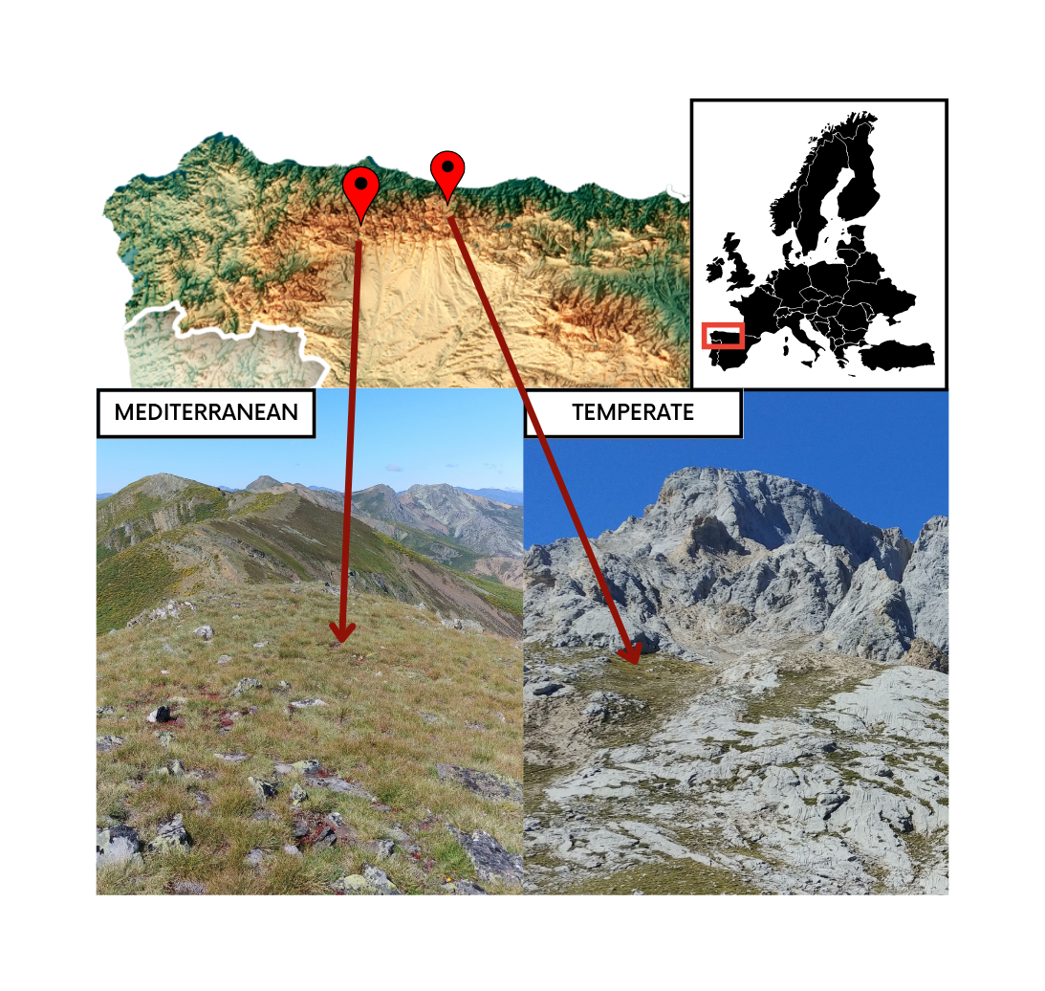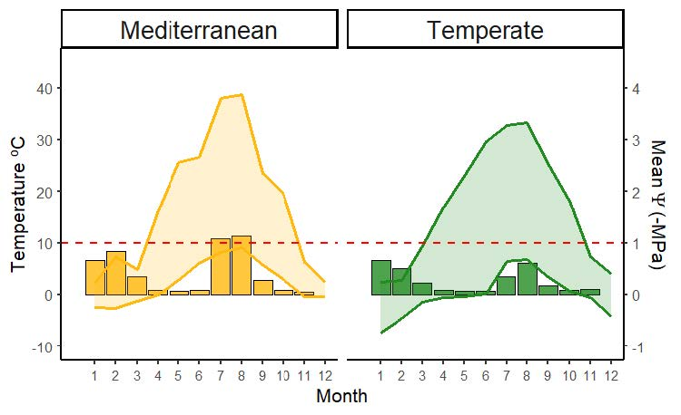
Or
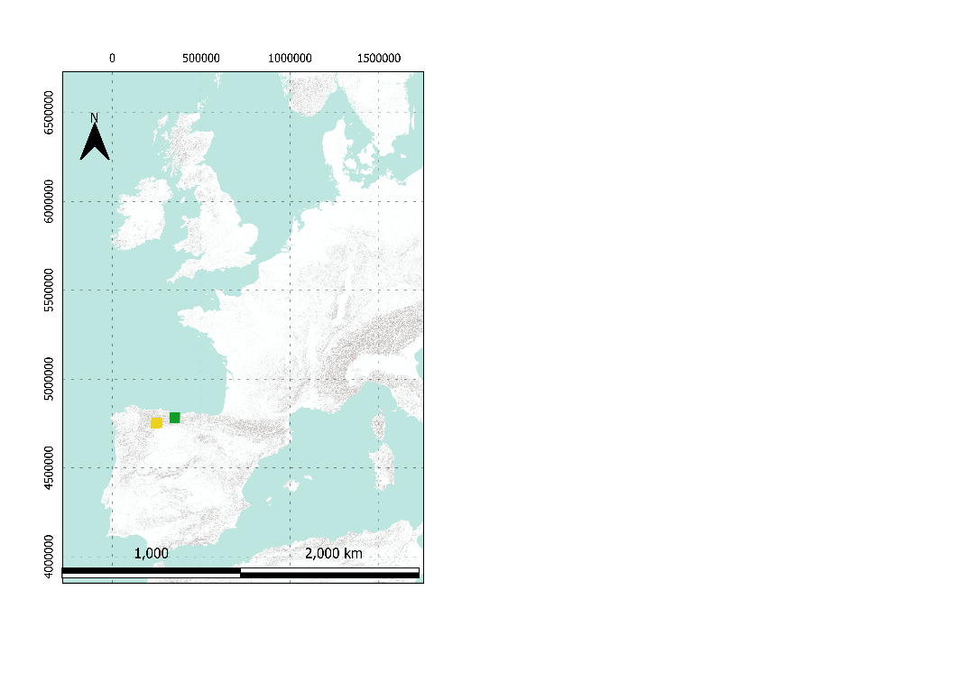


Fig1 Study area map and clima,
Table 1. Study sites specific details for both habitats. Growing season, defined as the period with daily mean temperatures above 5ºC (at 5cm deep, Körner, 2021). Snow cover calculated as the number of days in which the maximum temperatures were < 0.5 ºC and the minimum temperature was > -0.5 ºC, (Zhang et al., 2005). Temperate Alpine site soil data from to 2016 to 2024, at 5cm deep. Mediterranean Alpine site soil data from 2021 to 2024, at 5cm deep.
 | Mediterranean Alpine Habitat | Temperate Alpine Habitat
Location | Valles de Omaña y Luna Biosphere Reserve | Picos de Europa National Park
pH range (based on 40 samples) | 3.8 - 4.8 | 6.5 - 6.8
Growing season period | mid-April to early November | mid-May to early October
Daily mean water limitation during the growing season | -0.32 to -0.52 MPa | -0.15 to -0.45 MPa
Average soil temperature | 12.2ºC | 11.4 ºC
Annual snow cover | 13 to 116 days | 57.2 to 211 days

2.2 Species selection and seed sampling (208)
During August-September 2021 and 2022, we sampled the two study habitats at peak reproductive season. We collected ripe seeds or fruits (hereafter ‘seeds’ for simplicity) of all fruiting species directly from the mother plants, involving at least 20 to 50 randomly chosen individuals. Following standard protocols for sampling seeds of wild populations, the goal was to collect 400 seeds from each species to maximise intraspecific genetic diversity (ENSCONET, 2009). Field permits were necessary for seed sampling in Picos de Europa National Park (granted expedition number: CO/09/203/2021). We gathered sufficient seeds from 34 species in the temperate alpine habitat, and 24 species in the Mediterranean alpine habitat. Taxonomic nomenclature follows Euro+Med (Euro+Med, 2006). Only Thymus praecox was collected in both habitats, while the rest of the species were represented by one seed lot (n = 57). After cleaning, seed lots were kept in room conditions (22 ºC and 35% RH) for less than three months, then moved to hermetic pots with silica gel, in a refrigerator at 5ºC and darkness until the beginning of the experiment in November 2022. Seed collection year was included preliminary as a random factor in the model, but results remained consistent when excluded, thus we decided not to include it in the final models.

2.3 Germination treatments (644)
Each seed lot was sown in 16 Petri dishes (90 mm Ø) containing 25 seeds each (reduced to 20 seeds per Petri dish for two species: Avenella flexuosa and Helictochloa marginata, using 1% agar, sealed with parafilm to maintain moisture. The goal was to measure germination responses both during cold stratification and afterwards to other germination cues in non-dormant seeds; thus, all seed lots (n=57) were subjected to a 5-month long cold stratification period mimicking real under-snow like conditions (0.5ºC and darkness, Milbau et al., 2009).
Once cold stratification ended, the number of seeds that had germinated was recorded (radicle > 2 mm was used as the definition of germination), except for the Petri dishes going to the darkness treatment, which were covered with two layers of aluminium foil and immediately transferred to the growing chamber. Then, non-germinated seeds were transferred to new 90 mm Ø Petri dishes with two layers of filter paper (Filtros Anoia S.A. paper for germination assays, Ref.518G085) and 6 ml of distilled water, to subject the seeds to the control and constant temperatures treatments. Previous research (Espinosa del Alba, Fernández-Pascual and Jiménez-Alfaro, 2024) showed that the study species respond to two optimal germination temperatures. Consequently, we divided the species into these temperature regimes, programmed in four different growing chambers: some species went to a colder regime (15 – 5ºC alternating and 10ºC constant) and the other species to a warmer regime (22/12ºC alternating and 17ºC constant) (specific details available in GitHub, 2025). Optimal germination temperatures were included in preliminary models and had no effect on germination responses to the specific treatments, and we removed that factor from analysis. For the water limitation treatment, instead of distilled water, we added 6 ml of Polyethene glycol (PEG 6000) to simulate a water potential of -0.6 MPa. We used PEG, an inert water-binding polymer that creates a negative osmotic pressure, making it more difficult for seeds to absorb water. We chose a negative osmotic potential of -0.6 MPa (Megapascals) based on reported water-limitation “thresholds” from other alpine areas (Orsenigo et al., 2015; Tudela-Isanta et al., 2018; Gya et al., 2023; Espinosa del Alba et al., 2025) and slightly above the mean water osmotic potential values registered in the area during the growing season (own data). See Figure 1 for a schematic flowchart representing the seeds and germination steps applied, and Table 2 for detailed treatment conditions descriptions and their ecological significance. As PEG solutions depend on experimental temperatures, two solutions were prepared according to (Michel and Kaufmann, 1973) and (Villela, Doni Filho and Sequeira, 1991) to reach desired osmotic potentials at the mean temperatures in the two temperature regimes. Germination treatments were programmed in three Aralab growing chamber (Aralab climatic chamber Fitoclima S600 PL, equipped with 4 LED modules 11w 350mA) configured using Fitolog 9000 software (version 9308, Aralab Pharmaceutical Stability software) and one KBW growing chamber (KBW 400, Binder, Tuttlingen, Germany, specifically for the warm constant temperatures). We scored germination weekly for 6 weeks, removing germinated seeds from the Petri dishes (radicle > 2 mm long). To calculate darkness germination, from the final germination counted we subtracted the mean germination during cold stratification (measured in 12 petri dishes of each specific species). At the end of the experiment, we cut open non-germinated seeds under a binocular stereoscope to visually assess if they were empty, infected, or normal. We considered seeds with white and firm embryos viable and removed empty or infected seeds from germination calculations (Baskin and Baskin, 2014). The final dataset (Online Resource 2) consisted of the raw scoring data for 56 species (57 seed lots) representing 21 plant families. A total of 18,694 viable seeds were used in the experiment. For further analysis, we removed 7 species with zero germination across all treatments, assuming that we could not break dormancy or that the seed quality during collection was not optimal.
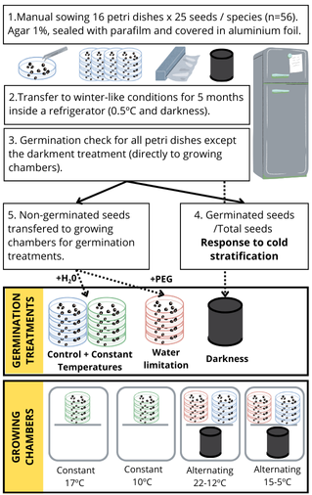
Fig 2 Schematic flowchart representing the seeds and germination steps applied in the study
Table 2. Description of germination experiments and their ecological significance
Treatment | Description | Ecological significance
Control | Alternating temperatures, 12h photoperiod and water available. | Mimic environment with theoretical optimal conditions for alpine species seed germination. Alternating temperatures, light and water available indicate safer germination microsites (Mondoni et al., 2012; Körner, 2021).
Darkness | Alternating temperatures, constant darkness and water available. | Mimic the environment of seeds buried deeper in the soil, where especially small seeds (Bond, Honig and Maze, 1999) might encounter problems to reach the soil surface, thus germination should be avoided (Saatkamp et al., 2011).
Constant temperatures | Constant temperatures, 12h light and water available. | Mimic the environment of seeds buried deeper in the soil, where there is small temperature variation, but higher moisture than on the surface.
Water limitation | Alternating temperatures, 12h light and PEG solution to simulate -0.6 MPa. | Mimic environment of seeds experiencing intermediate water limitation or drought, more likely if they are buried closed to the surface or on it.

2.4 Statistical analysis (439)
All analyses and figures were done with R statistical software (Team and R Core Team, 2024) and graphs using ggplot2 (Wickham, 2016) and patchwork (Pedersen, 2023).
We analysed the germination data by fitting Markov Chain Monte Carlo generalized linear mixed models (MCMCglmm) with Bayesian estimation using the R package MCMCGLMM (Hadfield, 2010), using multinomial2 family. For all models, phylogeny was included as a random factor using a reconstructed tree for the 57 species, created with the V.PHYLOMAKER R package (Jin and Qian, 2019) using phylosignal and phylobase R packages (Keck et al., 2016; R Hackathon et al., 2020). We used weakly informative priors, with parameter-expanded priors for the random effects. Each model was run for 1,000,000 iterations, with an initial burn of 100,000 and a thinning interval of 100. From the resulting posterior distributions, we calculated mean parameter estimates and 95% credible intervals (CI). To assess the significance of the models, we use the posterior mean from posterior probabilities and the credible intervals (CI). The posterior mean is an analogue of model effect sizes, and when the CI values do not overlap with 0, there is a significant effect of the explanatory variable.
For our first question, we analysed the germination responses to cold stratification (n=51 seed lots) to test if there were differences between temperate and Mediterranean alpine habitats (germination during cold stratification ~ Habitat). For our next questions, we excluded species with more than 50% germination in cold stratification (n=10 seed lots). To test the effect of water limitation, we also excluded those species with no germination either in the control or water limitation treatments (n=7 seed lots). First, we tested the differences between control and water limitation germination (germination ~ treatment). Second, we measured the percentage of decreased germination in water limitation compared to control, e.g., if a specific species has germinated 80% in control and 20% in water limitation, the percentual germination decrease is equal to 75%:
$\left(1-\frac{20}{80}\right)*100=75$
Then, we tested the differences in the percentual germination decrease between alpine Habitats with an Exponential MCMC-GLMM (germination reduction ~ Habitats). Finally, to control germination responses to fine-scale germination drivers (n=39), we preliminarily tested if the different optimal temperatures had an effect on germination, but they were not significant and thus not included in further tests. We compared germination between treatments (light control vs dark and alternating vs constant temperatures) (germination ~ treatment); and, within each germination treatment, we tested germination differences between Habitats (germination ~ habitat). Models assumptions were visually checked and fulfilled (we checked for patterns in the trace of the sampled output (time series) and density estimates of each explanatory variable (Hadfield, 2017).

3. Results (377 words without captions)

3.1. Germination during cold stratification (146)
During cold stratification, germination ranged from 0 (e.g., Armeria cantabrica) to 100% (e.g., Teesdalia conferta); with 10 species (out of 50) germinating >50% (3 from the temperate alpine and 7 from the Mediterranean alpine), see Figure 2A. Top-10 species with highest germination during cold stratification (“under snow germination” in Figure 2A) were removed from further analysis, the rest of species were kept assuming they will mostly germinate during spring and would therefore be exposed to the tested germination cues after cold stratification. There was an average of 0.24 (+/- 0.01) germination proportion in species from the Mediterranean alpine habitat, while less than 0.08 (+/- 0.006) of seeds germinated in the temperate alpine habitat. Habitat comparison detected significant differences (post. mean = -3.56, CI = [-6.22|-0.9]), with higher germination in the Mediterranean; see Figure 2B. The response of cold stratification across habitats was significantly modulated by phylogeny (post. mean = 0.95, CI: [0.88|1) (see model details in Online Resource 3).
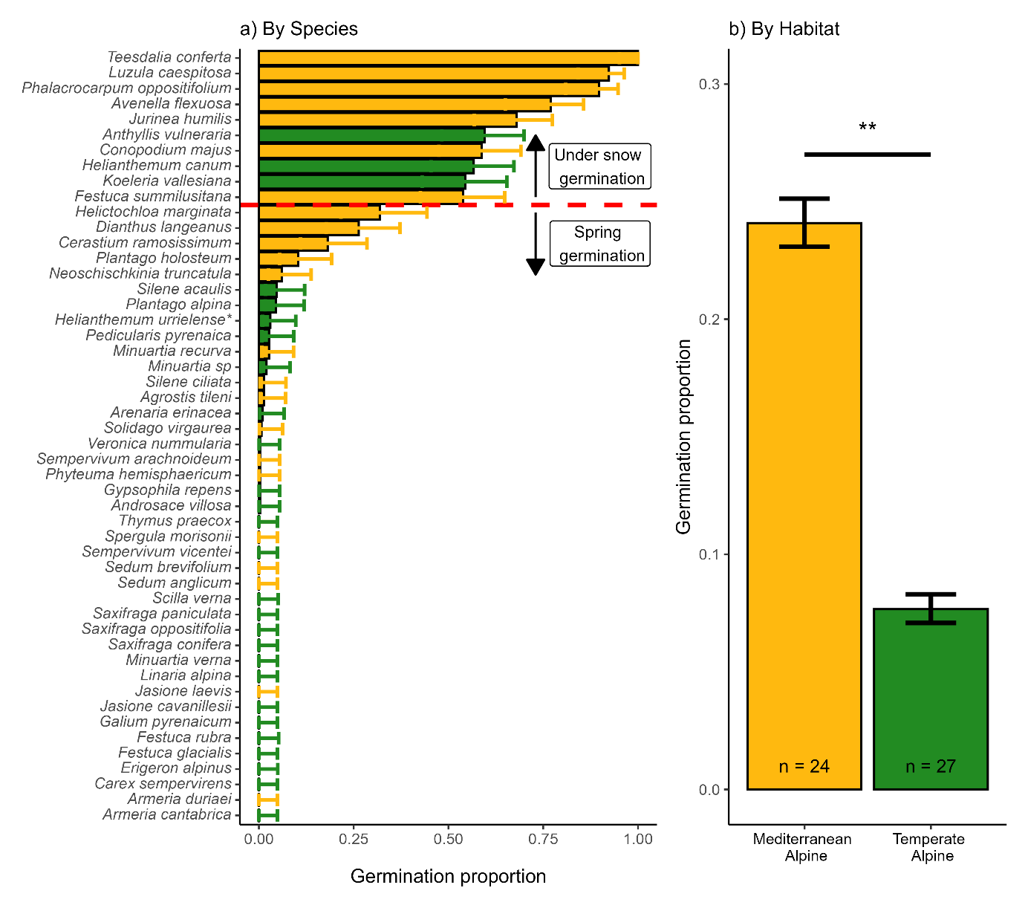
Fig 3 Germination during cold stratification. A) Accumulated germination during cold stratification across species (n = 50) coloured by Habitat. The red line marks the limit of species with >50% germination during cold stratification that will be removed from further analysis. B) Differences across habitats, n = number of species in each Habitat. Bars represent the mean germination proportion during cold stratification, and the error bar represents the binomial confidence intervals; significance derives from multinomial MCMCGLMM models, ** = p-value<0.01. Helianthemum urrielense* = Helianthemum apenninum subsp. urrielense.

3.2. Germination under water limitation (136)
Water limitation exhibited a significantly negative effect on overall germination proportion, from 0.5 (+/- 0.02) average germination in the control to 0.16 (+/- 0.01) in water limitation (post. mean = -3.32, CI= [-3.71|-2.94]), see Figure 3A. Although the mean percentual decrease was slightly higher in the temperate alpine habitat (mean germination reduction of 77.6% and 63.4% temperate alpine and Mediterranean, respectively) the differences were not significant (post. mean = -28.5, CI= [-145.3|100.8]); see Figure 3B. The percentage of decreased germination ranged from 100%, i.e., no germination at all under water limitation (e.g., Sedum brevifolium) to 1%, i.e., practically no effect of water limitation (-0.6 MPa) (e.g., Plantago holosteum); see Figure 3C for species individual responses. The germination response to water limitation does not appear to be modulated by phylogeny (see model details in Online Resource 3).
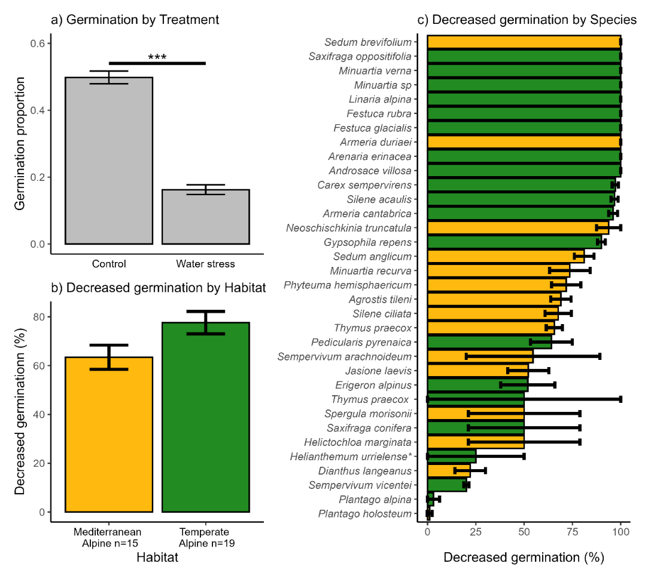
Fig 4 Germination responses under water limitation. A) Bars represent the mean germination observed per treatment, and error bars represent binomial confidence intervals. Significances from multinomial MCMC-GLMM models *** = p-value<0.001. B) Bars represent the mean germination reduction under water limitation in each Habitat, and error bars represent the Standard error of the mean. C) Decreased germination in each species, Bars represent the mean germination reduction under water limitation in each Habitat, and error bars represent the Standard error of the mean. Colour represents the Habitat of the species. Helianthemum urrielense* = Helianthemum apenninum subsp. urrielense.

3.3. Germination responses to dark and constant temperatures (130)
The highest mean germination proportion was recorded in the constant temperature treatment (0.47 +/- 0.02), followed by control (0.42 +/- 0.02) and darkness (0.36 +/- 0.02). Germination was significantly higher in constant temperatures (post. mean = 0.42, CI= [0.1|0.72]) and significantly lower in darkness (post. mean = -0.52, CI= [-0.84|-0.21]) compared to control; see Figure 4A. When comparing both alpine habitats, we did not observe significant differences in germination within either of the treatments, although the Mediterranean habitat showed slightly higher germination under all treatments; see Figure 4B (model details in Online Resource 3). The differential germination response to darkness across habitats was significantly modulated by phylogeny (post. mean = 0.86, CI: [0.29|1]). Individual species germination responses to each treatment are available in Online Resource 1 and Online Resource 4.
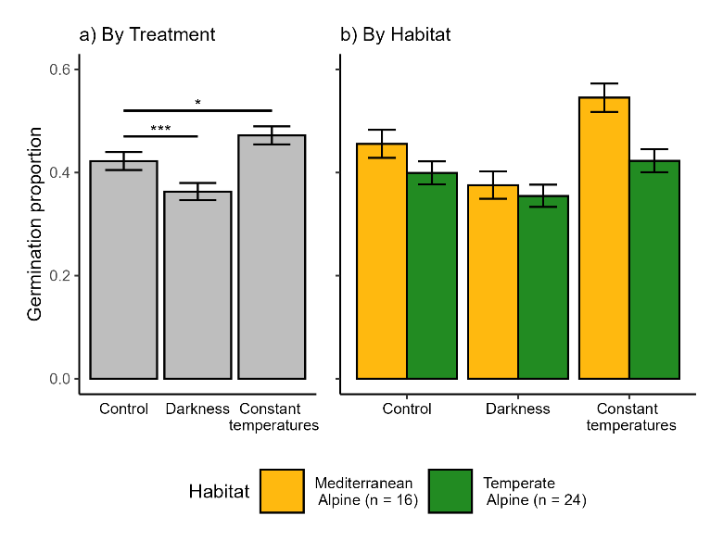
Fig 5 Germination responses to darkness and constant temperatures treatments. A) Bars represent the mean germination observed per treatment, error bars represent binomial confidence intervals, significances from multinomial MCMC-GLMM models, * = p-value < 0.05 and *** = p-value < 0.005. B) Bars represent the mean germination observed per treatment in each Habitat, and error bars represent binomial confidence intervals; n represents the number of species in each alpine habitat included in this analysis

4. Discussion (1086 words)
In this study, we focused on germination cues related to water availability in alpine ecosystems, comparing species from two habitats with different macroclimates, while controlling for other known germination cues (responses to darkness and constant temperatures). The main germination differences between habitats were related to the response to cold stratification, while both habitats' germination responses to water limitation, darkness and constant temperatures did not differ. Lack of water and light both hindered germination, while constant temperatures enhanced it.
As expected, we found higher germination during cold stratification in species from the Mediterranean habitat. This supports a lower physiological dormancy in the Mediterranean alpine species pool (Gimenez-Benavides et al. 2005) and also appears in line with the general Mediterranean germination syndrome, with species being able to germinate in darkness and at lower temperatures (Doussi and Thanos, 2002; Carta et al., 2017). These germination responses enable them to capitalise on early-season water availability and develop before the onset of summer drought. Note that the three species from the temperate habitat with >50% germination during stratification (Anthyllis vulneraria, Helianthemum canum and Koeleria vallesiana) are adapted to the drier and less snowy places in Picos de Europa National Park (Jiménez-Alfaro et al., 2014) thus, they are adapted to more Mediterranean-like conditions. The only study comparing cold stratification (0 °C and darkness at 0, 3, and 5 months) between alpine habitats found higher germination during cold stratification in species from the calcareous habitat (drier) compared to those from the siliceous habitat (wetter) (Tudela-Isanta et al., 2017). Thus, there appears to be a pattern where floras adapted to drier environments (such as the Mediterranean habitat in our study) germinate better under snow. Noteworthy to mention, among the top ten species with higher cold stratification germination, eight are generalist species that extend their distribution to subalpine grasslands. Subalpine species are known to germinate more effectively under snow (Fernández-Pascual et al., 2017) or at colder temperatures (Baskin and Baskin, 2014); therefore, our results align with those previously reported. Interestingly, some of our studied species (Luzula caespitosa (Juncaceae), Teesdalia conferta (Brassicaceae) or Conopodium majus (Apiaceae)) seem to be restricted to germinating only under snow or at low temperatures, corroborating previous research (Fernández-Pascual et al., 2017; Espinosa del Alba, Fernández-Pascual and Jiménez-Alfaro, 2024), either due to dormancy restrictions or underdeveloped embryos (Blandino et al., 2018).
Corroborating previous literature reports from alpine habitats, water limitation negatively affected germination in our study species (Orsenigo et al., 2015; Gya et al., 2023; Espinosa del Alba et al., 2025). Low moisture availability leads to partial or complete inhibition of physiological processes, which can hinder seeds from germinating (Baskin and Baskin, 2014). Against our initial expectation, we found no significant differences between alpine habitats. It is interesting to note that species from the Mediterranean habitat seem to exhibit more intermediate germination responses to water limitation (mostly between 25% and 75% decreases). In comparison, most species from our temperate habitat show a germination reduction of more than 90%, and only five species show a reduction of less than 50%. These results suggest that in the temperate habitat species pool, we found two opposing responses to drought (at -0.6 MPa): either very sensitive (most species) or non-sensitive species. Although there are no significant differences in habitat average responses, our results suggest that alpine communities from the temperate habitat are likely to face higher detrimental effects from future drier conditions, since many of the occurring species will not be able to regenerate via seed. Additionally, more strict alpine species, such as Minuartia verna, Festuca glacialis, Armeria duriaei, or Carex sempervirens, generally showed higher decreased germination under water limitation than other subalpine species or more generalist species (e.g., Plantago holosteum or Helictochloa marginata). These subalpine or generalist species, which migrate from lower habitats, usually occur in sites with early snowmelt and are subjected to higher summer drought. They might potentially be more adapted to germinate under these circumstances.
The significantly lower germination in darkness we observed is in concordance with the general alpine germination syndrome (Shimono and Kudo, 2005; Mondoni et al., 2009; Wu, Du and Shi, 2013; Fernández-Pascual et al., 2021) and Mediterranean mountain specialist germination (Giménez-Benavides, Escudero and Pérez-García, 2005; Picciau et al., 2019; Cruz-Tejada et al., 2024). Increased burial depth may be detrimental for small seeds with lower energy stored to survive the first few centimetres of soil (Saatkamp et al., 2011), which might be the case for most species in our study. Surprisingly, both systems exhibited a trend of higher germination under constant temperatures, which is opposite to the general reported patterns for alpine floras (Fernández-Pascual et al., 2021). While diurnally alternating temperatures can promote radicle growth by reducing the ratio of abscisic acid to gibberellin (Huarte and Benech-Arnold, 2010), thereby relieving dormancy and stimulating germination (Fenner and Thompson, 2005; Fernández-Pascual, Seal and Pritchard, 2015); the results we observed might be because our seeds in the constant treatment experienced a longer time under “warmer” temperatures than those in the alternating temperature treatments, and therefore accumulated more heat units towards germination (Picciau et al., 2019).
The results presented in this study suggest that alpine germination of a large number of species will be heavily impacted due to changes in water availability derived from reduced snow cover and increasing water limitation under current climate warming (Morán-Tejeda et al., 2013). The responses we observed indirectly favour less dormant species (Verdú and Traveset, 2005; Mondoni et al., 2015) or species with no stratification requirement (Sommerville, Martyn and Offord, 2013). As well as favouring those species with lower water requirements for germination. Some germination responses will be partly alleviated by the plasticity of physiological seed dormancy in response to the seed maturation temperature (Fernández-Pascual et al., 2013; Carta et al., 2015; Fernández-Pascual, Seal and Pritchard, 2015; Fernández-Pascual, Mattana and Pritchard, 2019) or via maternal effects that facilitate acclimatisation to changing environments. Nevertheless, due to the large interspecific variation of germination responses, reflecting species-specific requirements (Orsenigo et al., 2015; Walder and Erschbamer, 2015; Fernández-Pascual et al., 2017; Espinosa del Alba, Fernández-Pascual and Jiménez-Alfaro, 2024), future alpine communities might shift towards a more drought-resistant community. Thus, variations in snow cover can alter plant community structure by influencing seed germination patterns (Anniwaer et al., 2020) and may have a more substantial impact on seed germination than passive warming (Drescher, 2014). Expanding our knowledge about the specific effects of shortened snow cover protection (Briceño, Hoyle and Nicotra, 2015; Anniwaer et al., 2020) and increased water limitation on alpine species germination is needed to forecast future potential impacts.
Conclusion (148 words)
In our study, all germination drivers consistently affected germination except for cold stratification, which showed differences between habitats. Lack of water and light both hindered germination, while constant temperatures enhanced it. Nevertheless, the species-specific germination requirements suggest that in a warmer and drier scenario, species living in alpine habitats with less strict cold stratification and lower water availability requirements will germinate more effectively, facilitating a directional shift in alpine community composition. Our results support the suggestion that seed germination traits, especially responses to snow and water availability might play an essential role in understanding the regeneration ecology of alpine plant communities under climate change (Briceño, Hoyle and Nicotra, 2015). Nevertheless, these results are based on laboratory experiments, and how the findings transfer to natural communities is unclear; therefore, increasing the field experimentation (Milbau et al., 2009) is needed to predict responses in the field more precisely.
Anniwaer, A. et al. (2020) ‘Impacts of snow on seed germination are independent of seed traits and plant ecological characteristics in a temperate desert of Central Asia’, Journal of Arid Land, 12(5), pp. 775–790. Available at: https://doi.org/10.1007/s40333-020-0059-9.
Baskin, C.C. and Baskin, J.M. (2014) Seeds. Ecology, Biogeography and Evolution of Dormancy and Germination. 2nd Editio, Seeds. 2nd Editio. San Diego, CA, USA: Academic Press. Available at: https://doi.org/10.1016/B978-0-12-416677-6.00001-9.
Blandino, C. et al. (2018) ‘Seed ecology of the geophyte Conopodium majus (Apiaceae), indicator species of ancient woodland understories and oligotrophic meadows’, Plant Biology, 21(3), pp. 487–497. Available at: https://doi.org/10.1111/plb.12872.
Bond, W.J., Honig, M. and Maze, K.E. (1999) ‘Seed size and seedling emergence: An allometric relationship and some ecological implications’, Oecologia, 120(1), pp. 132–136. Available at: https://doi.org/10.1007/s004420050841.
Briceño, V.F., Hoyle, G.L. and Nicotra, A.B. (2015) ‘Seeds at risk: How will a changing alpine climate affect regeneration from seeds in alpine areas?’, Alpine Botany, 125(2), pp. 59–68. Available at: https://doi.org/10.1007/s00035-015-0155-1.
Carta, A. et al. (2015) ‘Local climate explains degree of seed dormancy in Hypericum elodes L. (Hypericaceae)’, Plant Biology, 18(Suppl. 1), pp. 76–82. Available at: https://doi.org/10.1111/plb.12310.
Carta, A. et al. (2017) ‘Photoinhibition of seed germination : occurrence , ecology and phylogeny Photoinhibition of seed germination : occurrence , ecology and phylogeny’, Seed Science Research, 27, pp. 131–153. Available at: https://doi.org/10.1017/S0960258517000137.
Cavieres, L.A. and Arroyo, M.T.K. (2000) ‘Seed germination response to cold stratification period and thermal regime in Phacelia secunda (Hydrophyllaceae): Altitudinal variation in the mediterranean Andes of central Chile’, Plant Ecology, 149(1), pp. 1–8. Available at: https://doi.org/10.1023/A:1009802806674.
Cavieres, L.A. and Sierra-Almeida, A. (2018) ‘Assessing the importance of cold-stratification for seed germination in alpine plant species of the High-Andes of central Chile’, Perspectives in Plant Ecology, Evolution and Systematics, 30, pp. 125–131. Available at: https://doi.org/10.1016/j.ppees.2017.09.005.
Cruz-Tejada, D.M. et al. (2024) ‘Macroclimatic Convergence and Habitat Specialisation Shape the Mediterranean Seed Germination Syndrome’, Ecology and Evolution, 14(11), pp. 1–8. Available at: https://doi.org/10.1002/ece3.70527.
Decker, K.L.M. et al. (2003) ‘Snow Removal and Ambient Air Temperature Effects of Forest Soil Temperatures in Northern Vermont’, Soil Science Society of America Journal, 67(5), pp. 1629–1629. Available at: https://doi.org/10.2136/sssaj2003.1629.
Donohue, K. et al. (2010) ‘Germination, postgermination adaptation, and species ecological ranges’, Annual Review of Ecology, Evolution, and Systematics, 41, pp. 293–319. Available at: https://doi.org/10.1146/annurev-ecolsys-102209-144715.
Doussi, M.A. and Thanos, C.A. (2002) ‘Ecophysiology of seed germination in Mediterranean geophytes. 1. Muscari spp’, Seed Science Research, 12(3), pp. 193–201. Available at: https://doi.org/10.1079/ssr2002111.
Drescher, M. (2014) ‘Snow cover manipulations and passive warming affect post-winter seed germination: A case study of three cold-temperate tree species’, Climate Research, 60(3), pp. 175–186. Available at: https://doi.org/10.3354/cr01237.
ENSCONET (2009) ENSCONET Seed Collecting Manual for Wild Species.
Espinosa del Alba, C. et al. (2025) ‘Functional intraspecific variation in the base water potential for seed germination along soil microclimatic gradients’, Functional Ecology, 39(3), pp. 897–911. Available at: https://doi.org/10.1111/1365-2435.14754.
Espinosa del Alba, C., Fernández-Pascual, E. and Jiménez-Alfaro, B. (2024) ‘Microclimatic variation regulates seed germination phenology in alpine plant communities’, Journal of Ecology, (November), pp. 1–14. Available at: https://doi.org/10.1111/1365-2745.14461.
Euro+Med (2006) Euro+Med PlantBase - the information resource for Euro-Mediterranean plant diversity.
Fenner, M. and Thompson, K. (2005) ‘The ecology of seeds’, in M. Fenner and K. Thompson (eds) The ecology of seeds. Cambridge, UK: Cambridge: Cambridge Uniersity Press, pp. 110–135.
Fernández-Pascual, E. et al. (2013) ‘A local dormancy cline is related to the seed maturation environment, population genetic composition and climate’, Annals of Botany, 112(5), pp. 937–945. Available at: https://doi.org/10.1093/aob/mct154.
Fernández-Pascual, E. et al. (2017) ‘Comparative seed germination traits in alpine and subalpine grasslands: higher elevations are associated with warmer germination temperatures’, Plant Biology, 19(1), pp. 32–40. Available at: https://doi.org/10.1111/plb.12472.
Fernández-Pascual, E. et al. (2021) ‘The seed germination spectrum of alpine plants: a global meta-analysis’, New Phytologist, 229(6), pp. 3573–3586. Available at: https://doi.org/10.1111/nph.17086.
Fernández-Pascual, E., Jiménez-Alfaro, B. and Díaz, T.E. (2013) ‘The temperature dimension of the seed germination niche in fen wetlands’, Plant Ecology, 214(4), pp. 489–499. Available at: https://doi.org/10.1007/s11258-012-0165-7.
Fernández-Pascual, E., Seal, C.E. and Pritchard, H.W. (2015) ‘Simulating the germination response to diurnally alternating temperatures under climate change scenarios: Comparative studies on Carex diandra seeds’, Annals of Botany, 115(2), pp. 201–209. Available at: https://doi.org/10.1093/aob/mcu234.
García-Gutiérrez, T. et al. (2018) ‘Functional diversity and ecological requirements of alpine vegetation types in a biogeographical transition zone’, Phytocoenologia, 48(1), pp. 77–89. Available at: https://doi.org/10.1127/phyto/2017/0224.
Giménez-Benavides, L. et al. (2018) ‘How does climate change affect regeneration of Mediterranean high-mountain plants? An integration and synthesis of current knowledge’, Plant Biology, 20, pp. 50–62. Available at: https://doi.org/10.1111/plb.12643.
Giménez-Benavides, L., Escudero, A. and Pérez-García, F. (2005) ‘Seed germination of high mountain Mediterranean species: Altitudinal, interpopulation and interannual variability’, Ecological Research, 20(4), pp. 433–444. Available at: https://doi.org/10.1007/s11284-005-0059-4.
Gya, R. et al. (2023) ‘A test of local adaptation to drought in germination and seedling traits in populations of two alpine forbs across a 2000 mm/year precipitation gradient’, Ecology and Evolution, 13(2), pp. 1–19. Available at: https://doi.org/10.1002/ece3.9772.
Hadfield, J. (2017) MCMCglmm Course Notes.
Hadfield, J.D. (2010) ‘MCMCglmm: MCMC Methods for Multi-Response GLMMs in R’, Journal of Statistical Software, 33(2), pp. 1–22.
Jiménez-Alfaro, B. et al. (2014) ‘Alpine plant communities in the Picos de Europa calcareous massif (Northern Spain)’, Lazaroa, 35(0). Available at: https://doi.org/10.5209/rev_laza.2013.v34.n1.43646.
Jiménez-Alfaro, B. et al. (2021) ‘Post-glacial determinants of regional species pools in alpine grasslands’, Global Ecology Biogeography, 30, pp. 1101–1115. Available at: https://doi.org/https://doi.org/10.1111/geb.13274.
Jin, Y. and Qian, H. (2019) ‘V.PhyloMaker: an R package that can generate very large phylogenies for vascular plants’, Ecography, 42(8), pp. 1353–1359. Available at: https://doi.org/10.1111/ecog.04434.
Joffre, R. and Rambal, S. (2001) ‘Mediterranean Ecosystems’, Encyclopedia of Life Sciences [Preprint]. Available at: https://doi.org/10.1038/npg.els.0003196.
Keck, F. et al. (2016) ‘phylosignal: an R package to measure, test, and explore the phylogenetic signal’, Ecology and Evolution, 6(9), pp. 2774–2780. Available at: https://doi.org/10.1002/ece3.2051.
Körner, C. (2021) Alpine Plant Life. 3rd edn. Edited by Springer Nature Switzerland AG 2021. Springer Cham. Available at: https://doi.org/10.1007/978-3-030-59538-8.
Margreiter, V. et al. (2020) ‘Pros and cons of using a standard protocol to test germination of alpine species’, Plant Ecology, 221(11), pp. 1045–1067. Available at: https://doi.org/10.1007/s11258-020-01061-w.
Michel, B.E. and Kaufmann, M.R. (1973) ‘The Osmotic Potential of Polyethylene Glycol 60001’, pp. 914–916.
Milbau, A. et al. (2009) ‘Effects of a warmer climate on seed germination in the subarctic’, Annals of Botany, 104(2), pp. 287–296. Available at: https://doi.org/10.1093/aob/mcp117.
Mondoni, A. et al. (2009) ‘Germination requirements of the alpine endemic Silene elisabethae Jan: Effects of cold stratification, light and GA3’, Seed Science and Technology, 37(1), pp. 79–87. Available at: https://doi.org/10.15258/sst.2009.37.1.10.
Mondoni, A. et al. (2012) ‘Climate warming could shift the timing of seed germination in alpine plants’, Annals of Botany, 110(1), pp. 155–164. Available at: https://doi.org/10.1093/aob/mcs097.
Mondoni, A. et al. (2015) ‘Climate warming could increase recruitment success in glacier foreland plants’, Annals of Botany, 116(6), pp. 907–916. Available at: https://doi.org/10.1093/aob/mcv101.
Mondoni, A., Jiménez-Alfaro, B. and Cavieres, L.A. (2022) ‘Effect of climate change on plant regeneration from seeds in the arctic and alpine biome’, in Plant Regeneration from Seeds. Academic Press.
Morán-Tejeda, E. et al. (2013) ‘Evolution and frequency (1970-2007) of combined temperature-precipitation modes in the Spanish mountains and sensitivity of snow cover’, Regional Environmental Change, 13(4), pp. 873–885. Available at: https://doi.org/10.1007/s10113-012-0380-8.
Nogués Bravo, D. et al. (2008) ‘Climate change in Mediterranean Mountains during the 21st Century’, Ambio, 37(4), pp. 280–285.
Notarnicola, R.F. et al. (2022) ‘Effects of warming temperatures on germination responses and trade-offs between seed traïts in an alpine plant’, Journal of Ecology, 111 (1), pp. 62-76. Available at: https://doi.org/10.1111/1365-2745.14014
Orsenigo, S. et al. (2015) ‘Effects of autumn and spring heat waves on seed germination of high mountain plants’, PLoS ONE, 10(7), pp. 1–17. Available at: https://doi.org/10.1371/journal.pone.0133626.
Pedersen, T.L. (2023) ‘patchwork: The Composer of Plots’.
Picciau, R. et al. (2019) ‘Thermal thresholds for seed germination in Mediterranean species are higher in mountain compared with lowland areas’, Seed Science Research, 29(1), pp. 44–54. Available at: https://doi.org/10.1017/S0960258518000399.
R Hackathon et al. (2020) ‘phylobase: Base Package for Phylogenetic Structures and Comparative Data’.
Saatkamp, A. et al. (2011) ‘Germination traits explain soil seed persistence across species: The case of Mediterranean annual plants in cereal fields’, Annals of Botany, 107(3), pp. 415–426. Available at: https://doi.org/10.1093/aob/mcq255.
Schwienbacher, E. et al. (2011) ‘Seed dormancy in alpine species’, Flora: Morphology, Distribution, Functional Ecology of Plants, 206(10), pp. 845–856. Available at: https://doi.org/10.1016/j.flora.2011.05.001.
Shimono, Y. and Kudo, G. (2005) ‘Comparisons of germination traits of alpine plants between fellfield and snowbed habitats’, Ecological Research, 20(2), pp. 189–197. Available at: https://doi.org/10.1007/s11284-004-0031-8
Sillmann, J., Kharin, V.V., Zwiers, F.W., et al. (2013) Climate Extremes Indices in the CMIP5 Multimodel Ensemble: Part 2. Future Climate Projections. Journal of Geophysical Research: Atmospheres, 118, 2473-2493.
https://doi.org/10.1002/jgrd.50188
Sommerville, K.D., Martyn, A.J. and Offord, C.A. (2013) ‘Can seed characteristics or species distribution be used to predict the stratification requirements of herbs in the Australian Alps?’, Botanical Journal of the Linnean Society, 172(2), pp. 187–204. Available at: https://doi.org/10.1111/boj.12021.
Team, R.C. and R Core Team (2024) ‘R: A Language and Environment for Statistical Computing’. Vienna: R Foundation for Statistical computing.
Tudela-Isanta, M. et al. (2017) ‘Habitat-related seed germination traits in alpine habitats’, Ecology and Evolution, 8(1), pp. 150–161. Available at: https://doi.org/10.1002/ece3.3539.
Tudela-Isanta, M. et al. (2018) ‘The seed germination niche limits the distribution of some plant species in calcareous or siliceous alpine bedrocks’, Alpine Botany, 128(1), pp. 83–95. Available at: https://doi.org/10.1007/s00035-018-0199-0.
Vázquez-Ramirez, J. and Venn, S.E. (2021) ‘Seeds and Seedlings in a Changing World : A Systematic Review and Meta-Analysis from High altitude and High Latitude Ecosystems’, Plants, 10(768). Available at: https://doi.org/10.3390/plants10040768.
Verdú, M. and Traveset, A. (2005) ‘Early Emergence Enhances Plant Fitness: A Phylogenetically Controlled Meta-Analysis’, Ecological society of America, 86(6), pp. 2588–2593.
Villela, F.A., Doni Filho, L. and Sequeira, E.L. (1991) ‘Tabela de potencial osmótico em função da concentração de polietileno glicol 6.000 e da temperatura’, Pesquisa Agropecuária Brasileira, 26(11/12), pp. 1957–1968.
Walck, J.L. et al. (2011) ‘Climate change and plant regeneration from seed’, Global Change Biology, 17(6), pp. 2145–2161. Available at: https://doi.org/10.1111/j.1365-2486.2010.02368.x.
Walder, T. and Erschbamer, B. (2015) ‘Temperature and drought drive differences in germination responses between congeneric species along altitudinal gradients’, Plant Ecology, 216(9), pp. 1297–1309. Available at: https://doi.org/10.1007/s11258-015-0509-1.
Wickham, H. (2016) ‘ggplot2: Elegant Graphics for Data Analysis’. New York: Springer-Verlag.
Zhang, Y. et al. (2005) ‘Soil temperature in Canada during the twentieth century: Complex responses to atmospheric climate change’, Journal of Geophysical Research D: Atmospheres, 110(3), pp. 1–15. Available at: https://doi.org/10.1029/2004JD004910.

Figure legends:
Fig 2 Schematic flowchart representing then seeds and germination steps applied in the study
Fig 3 Germination during cold stratification. a) Accumulated germination during cold stratification across species (n = 50) coloured by Habitat. The red line marks the limit of species with >50% germination during cold stratification that will be removed from further analysis. b) Differences across habitats, n = number of species in each Habitat. Bars represent the mean germination proportion during cold stratification, and the error bar represents the binomial confidence intervals; significance derives from multinomial MCMCGLMM models, ** = p-value<0.01. Helianthemum urrielense* = Helianthemum apenninum subsp. urrielense
Fig 4 Germination responses under water limitation. a) Bars represent the mean germination observed per treatment, and error bars represent binomial confidence intervals. Significances from multinomial MCMC-GLMM models *** = p-value<0.001. b) Bars represent the mean germination reduction under water limitation in each Habitat, and error bars represent the Standard error of the mean. c) Decreased germination in each species, Bars represent the mean germination reduction under water limitation in each Habitat, and error bars represent the Standard error of the mean. Colour represents the Habitat of the species. Helianthemum urrielense* = Helianthemum apenninum subsp. urrielense
Fig 5 Germination responses to darkness and constant temperatures treatments. a) Bars represent the mean germination observed per treatment, error bars represent binomial confidence intervals, significances from multinomial MCMC-GLMM models, * = p-value < 0.05 and *** = p-value < 0.005. b) Bars represent the mean germination observed per treatment in each Habitat, and error bars represent binomial confidence intervals; n represents the number of species in each alpine habitat included in this analysis

Online resources
Additional supporting information in the online version of this article (see „Supplementary Material”) contains the following:
Online Resource 1. Species individual germination responses to the different germination treatments studied.
Online Resource 2. Raw germination data
Online Resource 3. MCMC germination model results
Online Resource 4. Species summary mean germination per treatment

Data availability statement
Raw data and R script for analysis are available in GitHub; once the manuscript is accepted, the GitHub repository will be public and stored in Zenodo. (add later in reference list)

Statements and Declarations
The authors have no relevant financial or non-financial interests to disclose.

Funding sources
This work was supported by Agencia Estatal de Investigación (grant number: AEI/10.13039/501100011033); Ayuntamiento de Gijón/Xixón (grant number: SV-23-GIJON-JBA) and Grant “Laboratorio de Vegetación y Biodiversidad” (grant number: IDE/2024/000720, Principality of Asturias-Sekuens-EU-FEDER).

Acknowledgements
We want to thank the Picos de Europa National for support in field sampling. This research is framed within the SEEDALP project (MCI-20-PID2019-108636GA-I00) funded by the Agencia Estatal de Investigación (AEI/10.13039/501100011033), and supported by Ayudas para Contratos Predoctorales para la Formación de Doctores del Ministerio de Ciencia e Innovación (FPI: MCI-21-PRE2020-092874); Ayuntamiento de Gijón/Xixón - Jardín Botánico Atlántico (SV-23-GIJON-JBA) and the grant “Laboratorio de Vegetación y Biodiversidad” (IDE/2024/000720, Principality of Asturias-Sekuens-EU-FEDER). L.G. was supported by the long-term research development project number RVO67985939 of the Czech Academy of Sciences.

