Prospective title

**Effects of microniche on seed longevity: a case study on alpine species**

Goal

To study seed longevity patterns we used artificial ageing protocol from seed banking in 25 species (9 species with 2 populations). The aim of the dissertation is to verify the relationship between the microhabitat preference of the species and the resistance of their seeds to ageing

Question

Will SNC/realized niche/microhabitat preference modulate seed longevity in alpine species?

H: Species from different microhabitats will have differential longevity values

Main results

Seeds of colder/wetter environments (snowbed) are shorter-lived. Microhabitat preference and play a significant role as seed longevity drivers and contribute to explain the large variation of seed longevity found across alpine species. The phylogenetic signal is confirmed to be high, supporting previous results on the genetic dependence of seed resistance to ageing. This results also highlight that microhabitats seems colonised by closely related species

NOTES/RE DO some analysis

* Instead of categorical classification use GDD/FDD SNC
* Oil content is highly related to longevity (add and use oil data)
* Use seed mass as predictor

INTRODUCTION (from Giovanni dissertation)

Plant diversity can be preserved through *in situ* and *ex situ* methodologies,. *In situ* conservation refers to recovery and maintenance actions in order to maintain a population in the “natural surroundings”. *Ex situ* conservation, defined as “the conservation of components of biological diversity outside their natural habitats” (Braverman, 2014; Convention on Biological Diversity, 2002), like the seed banks (Smith et al., 2011), should not be underestimated since it provides “backup” biodiversity and is a source of knowledge. both methodologies are complementary. Plants are preserved in protected areas and parks (in situ conservation) or ex situ, in botanic gardens and seed banks to provide material for research, education and restoration (Walters & Pence, 2021).

Seeds have cryptobiosis, which allows the seeds to be stored in small spaces and inexpensively for a long time (Walters & Pence, 2021). Cryptobiosis is a process that starts when the embryo accumulates reserves, the water is substituted with dry matter to maintain cell structures and gains this characteristic of drying tolerance, acquired when the embryo accumulates reserves. In the cryptobiotic state plants stop all metabolic and physiological activities despite keeping the organism alive. This particular adaptation seems to derive from the first plants that colonised the land (Gaff & Oliver, 2013).

Seed storage procedures take advantage of cryptobiosis properties of the seeds and are now standardized: seeds are dried to equilibrium at 5-20°C and 10-25% RH, the stored at -18°C to -20°C in waterproof material. Low temperature storage is a relatively inexpensive method to maintain the genetic resources. In these conditions of low temperature and relative humidity germination decreases by 0.95% per year on average and when it reaches the 85% of its initial value regeneration is necessary, according to Food and Agriculture Organization (FAO) standards. Indications about the loss in viability could come from periodic germination tests or from models; the tests reduce the collection, but the models are not so accurate (Solberg et al., 2020). Oil and water content of the seeds differ between species and this determines the longevity (measured as the time the viability falls by 50%, the *p50*) of the seed, meaning the drop in viability is slower if seeds are dried and stored at low temperature and faster when seeds are kept at high RH and temperature (Solberg et al., 2020). Recalcitrant seeds however can be damaged by the low temperature storage, is associated with crystallization of triacylglycerols (TAG), causing the volume of oil bodies to shrink.

The knowledge of seed longevity values and the traits that affect them are important to store them and let them to be potentially usable after tens or hundreds of years (Solberg et al., 2020; Walters et al., 2005). We know that environmental factors like storage temperature and moisture are important but genetic factors are also relevant (Mondoni et al., 2014).

Seed longevity differences are measurable at family, genus and species level, and the lower viability of alpine seeds (Probert et al., 2009) seems to depend on intrinsic factors: differences in the rate of rearrangement of DNA and antioxidant responses (Bailly et al., 2004) are distinguishable. Seeds are vulnerable to environmental stresses during maturation, storage and germination and this is a primary cause of genetic variation and genomic alteration (Mondoni et al., 2014). The root cause of degradation in solids is the movement of molecules in an irregular spaced matrix, composed by materials with different thermal properties (Walters & Pence, 2021).

Seeds from drier/warmer zones can cope with the experimental stressful environment better than the alpine ones (Wang et al., 2009). The viability monitoring itself, despite being important, reduces the seed collections, so the monitoring intervals must be appropriate. The Millennium Seed Bank (MSB) intervals are typically every 10 years but can be extended or reduced to, respectively, 20 or 5 years, in order to find a compromise between detection and preservation. The protocol for comparative longevity uses 500 seeds, that can be a large sample for little collections, that’s why Davies et al., 2016 proposed a reduced seed number protocol. The reduced seed number protocol was comparable to the standard one in 26 out of 30 species analysed. The *p50* estimates were also not significantly different (p=0,129; Fig. 1).

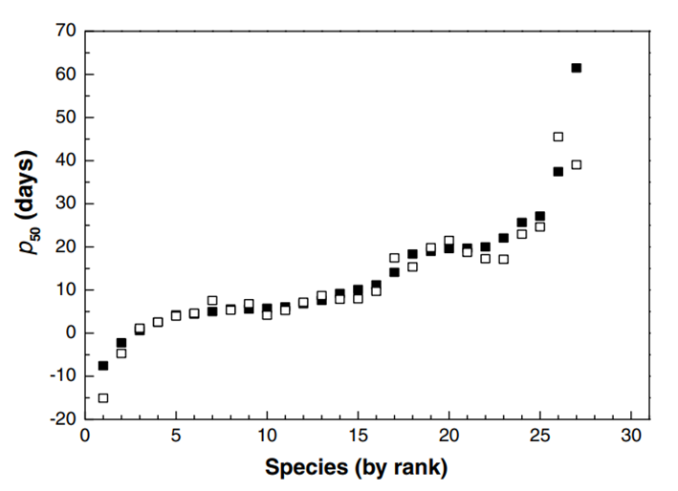

Like other germplasm forms also some seeds are intrinsically short lived, a trait associated with alpine habitats (Walters & Pence, 2021), so this reduced seed number protocol could be crucial for the conservation of these species.

This protocol allows to reduce the necessary seed from 450-500 to 150 but with many risks like the lack of points for probit analysis (and the consequent large standard error values) and the reduced accuracy and precision.

The seeds are placed over a super-saturated salt solution (Hay et al., 2008) that creates a moist environment where you can control the percentage of relative humidity. This method requires the presence of undissolved salt that goes into solution when water moves in and re-crystallise when water rehydrates the seeds or evaporates. Hay et al. (2008) described the use of solutions of Lithium Chloride of different concentrations to show how to adjust them (Fig. 2) without using different salts and to assess their stability. Such a reliable method allows to open hermetically sealed boxes to operate on the seeds with the assurance that the RH would be restabilised in few hours.

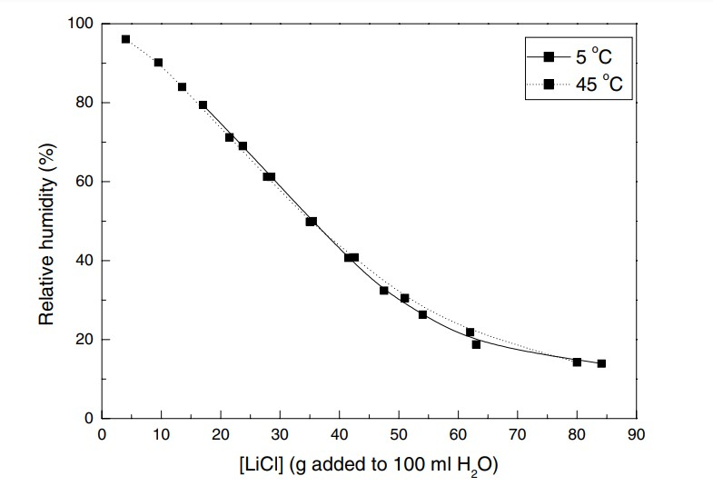

The seed viability is described by the equation *υ = Ki – (p/σ)*, “where *υ* is the viability after *p* years in storage, *σ* is the slope of the line and *Ki* is the initial viability of the seeds” (Solberg et al., 2020). Despite the large confidence intervals, the formula is still used, instead of other improved equations. The genetic conservation is now so important that it brought to the institution of more than 1750 seed banks (Solberg et al., 2020).

Germination is a fine-tuned process regulated by environmental stimuli like temperature and moisture (Bewley et al., 2013) which starts with the uptake of water. A representation of germination can be made through the course of water uptake so as the process is divided in phases (Nonogaki et al., 2010; Fig. 3):

* Rapid imbibition by the seed until complete hydration;
* Limited water uptake;
* Increase in water uptake.

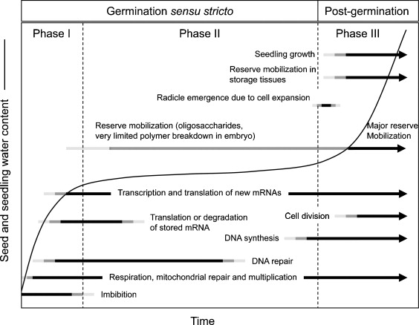

Fig. 3: Time course of germination and early seedling growth (Phase III) events (Nonogaki et al., 2010).

Some species develop seed dormancy which prevents the germination when the cues are not reliable, so these embryos won’t grow up, for example, in a relatively warm day in full winter (Baskin & Baskin, 2014). The variability in dormancy ensures the distribution in time of the emergences, the consequence is the better survival of the population in unpredictable conditions (Venable, 2007). The tuning can be pretty accurate since the cues range over from the daily alternation of temperatures (Thompson et al., 1977) to the need for light or darkness (Carta et al., 2017). Dormancy is traditionally ascribed to alpine species seeds, in that case is a physiological dormancy (Fernández‐Pascual et al., 2021), a type of dormancy that prevents germination when the seed has been dispersed since brief time (Meyer & Monsen, 1991). One of the requirements for the seeds to germinate can be to sense the winter temperatures as Söyrinki (1938) showed the necessity to simulate the snow stratification by storing them at winter temperatures to increase seed germination in most arctic-alpine species, in facts the species from the alpine grasslands seem to have the highest level of dormancy (Margreiter et al., 2020). Another important promoter of germination is the light, via phytochromes (Shinomura, 1997), that regulate the levels of bioactive GA and ABA (Seo et al., 2006), the germination capacity is indeed determined by the balance of the two antagonistic hormones (Seo et al., 2009): the GA is an inductor of germination, while ABA inhibits it.

Alpine plant diversity is particularly threatened by tourism and climate change, a problem of increasing importance (Ferrarini et al., 2008; Parolo & Rossi, 2008). To conserve and preserve this diversity *in situ* conservation as well as *ex situ* seed banks can help, primary by safeguard species from extinction and/or provide propagating material for habitat restoration. The main problem is the lack of knowledge about the seed life span, meaning how long will alpine seeds remain viable in storage, which is related to environmental factors and taxonomic group (Probert et al., 2009). Probert et al., 2009 proposed a model after the analysis of 195 species and the *p50* is a function of presence or absence of endosperm, mean annual temperature and mean annual rainfall. Despite a considerable variation in the model was not explained, it predicted the shorter life of seeds for species inhabiting cold and wet habitats, compared to those from warmer and drier place. Consistently, a few years later a study conducted in the European Alps highlighted that alpine species were shorter lived than closely related species from lower elevation and warmer climate (Mondoni et al., 2011); in particular, the seeds from lowlands showed a higher initial seed viability, slower deterioration rate or both, as compared to alpine seeds (Fig. 6), and this trend was significant both between and within species. More recent observations confirmed this trend also in other mountain chains (Seglias, 2022). Unlike the findings of Probert et al. (2009), the presence/absence of the endosperm did not affect seed longevity in alpine species, while it main drivers were mean total annual rainfall, rainfall during the reproductive period and mean annual temperature.

Despite being short-lived, seed longevity of alpine plants also varied significantly both across and within species, from 4.7 to 95.4 days in the time taken for viability to fall to 50% (Mondoni et al. 2011), suggesting that other factors, beyond macroclimate and taxonomy, could affect seed longevity. However, since then no further studies have been conducted to better investigate seed longevity drives in such threatened group of species.

As previous authors have shown (Mondoni et al., 2011, 2014; Probert et al., 2009; Seglias, 2022), seeds of alpine plants are short-lived in storage, but the longevity was variable both across alpine and lowland and within alpine species (i.e., seed from alpine species are shorter-lived but with a lot of variance; Mondoni et al., 2011). In this vein, considering the high topographic diversity of alpine landscape (Körner et al., 2011) and its related microclimatic variability, the possibility that microenvironmental conditions further drive seed longevity across alpine species cannot be ruled out.

Scherrer and Körner (2011) verified the topographic variability of the alpine terrains, which create many little thermal habitats and from which the vegetal species distribution is dependent, since the found species were ascribable to the “subalpine”, “alpine” and “nival” categories and, depending on the conditions of their microhabitats. The relation between seed longevity and microclimatic conditions is therefore plausible but still unknown. The aim of this dissertation is to investigate this relationship, through the collection of seed longevity data via accelerated ageing protocol (Davies et al., 2016). This ageing protocol allows to speed the seed ageing, thereby reducing the time of observation. In particular, we focused on two contrasting alpine microenvironments: the snowbed and fellfield. Alpine snowbed communities, develop in sites characterized by a very short snow-free period, high moisture with dense plant layer, accumulation of substantial amounts of snow for much of the year and, on average, low productivity (Björk & Molau, 2007). At the other end of the spectrum there are fellfield communities, characterised by patches exposed to freeze-thaw cycles and dry summer periods with more open vegetation (Block et al., 2009).

Based on these differences, we hypothesised that species from snowbed habitats have short-lived seeds in storage because of their lower temperatures, shorter growing season and higher humidity, while species from fellfields are longer-lived, being more adapted to a warmer and more heterogenous environment.

In addition to microhabitat differences the alpine belt is characterised by a large diversity of plants (Korner 2003), of which only a fraction can be considered alpine specialist (i.e., living only above the high elevation treeline), while several other can occur also at lower elevations and, therefore, at warmer climate (i.e., generalist species). We can expect that the former group will show short lived seed, compared to the latter.

In August and September 2021, we collected seeds from 25 co-occurring species in alpine grassland communities (Table 1), then stored at 22°C and 35% RH until the start of the aging protocol in January 2022. All species were classified according to their habitat distribution, specialist meaning strict alpine or not-specialist meaning generalist; and also, according to their microenvironment preference: fellfield, snowbed or neutral. Their microenvironment preference was based on DCA scores of 80 1 m2 botanical inventories conducted during 2019 and 2021 summer.

**3.3. Lab protocol**

The protocol was developed by Davies et al., 2016 to accelerate the ageing and simulate long periods of ageing; in this case it’s optimised for alpine seeds, less longevous. The initial RH value was 30-35% (Hygropalm 3 display unit; Rotronic Instrument UK Ltd, Crawley ,UK), so the seeds (200 seeds per species) were rehydrated (Cisteaceae needed a scarification with sand paper) to 47% RH at 20°C for 5 days in a non-saturated LiCl solution (Hay et al., 2008) in crystal vials and kept in a 300 x 300 x 130 mm sealed electric enclosure box (Ensto UK Ltd, Southampton, UK) before moving the vials into the ageing conditions. The ageing conditions consisted in a temperature of 45+/-2 °C, a RH of 60% and absence of light. A subsample of 42 seeds were withdrawn after 2, 10, 15 and 30 days and sowed in petri dishes 1% agar with 250 ml/L of GA3 (Kew Royal Botanic Garden Technical Information sheet_13a), in some species the amount of seeds for subsamples was reduced due to the lack of seeds. After the sowing, seeds were checked once a week during one month, in which the germination was scored removing the seedlings with a visible root (longer than 2,5 mm); after the end of each germination test the ungerminated seeds were cut-tested to confirm the state of the embyo visually. The petri dishes were held with a daily cycle of temperature and light:

* 12h at 22°C with light;
* 12h at 12°C without light.

**3.4. Statistics**

We first applied probit analysis using GenStat (Hay et al., 2014) to calculate *p50*, *Ki*, and slope (-1/*σ*) and Origin to draw seed survival curves using viability equation:

*v = Ki – (p/σ)*

where *v* is viability in NED (Normal equivalent deviates), *p* are the days of ageing, *Ki* is the initial viability, *σ* is the standard deviation of the distribution of deaths over time. Then the analysis of *p50, Ki,* and slope were conducted in R with a GLM, family specified as Gaussian, using as fixed predictors:

* species distribution;
* microhabitat preference.

Germination indices were also calculated in R with GerminaR (Lozano‐Isla et al., 2019) package and three of them were used as responsive variables:

* germination percentage (GRP);
* mean germination rate (MGR);
* synchronization index (SYN).

The three variables were analysed with MCMC-GLM models using MCMglmm package in R (Hadfield, 2010), including phylogeny and bedrock as random factor to consider the non-independence in the data (accessions with shared phylogeny). The phylogeny tree was created using *V.PhyloMaker* R package. The fixed predictors were:

* days in ageing conditions;
* species distribution;
* microhabitat preference
* interaction of them except the interaction between distribution and microhabitat preference.

The third analysis we performed was using raw data, where germination success or failure was considered as a binomial response variable (MCMC-GLM, multinomial2 family). The fixed predictors and the phylogeny tree were the same.

**4. RESULTS**

**4.1. Probit analysis**

Probit analysis was used to obtain p50, Ki and slope values. However, when tested in MCMC-GLMM models no significant differences were detected.

**4.2. R analysis**

All the species responded to the ageing protocol: the results show a decline in germination capacity, meaning that they lose viability with increasing ageing days. The sole species distribution (Habitat) had no significant impact on germination capacity (p=0,746; Fig. 8).

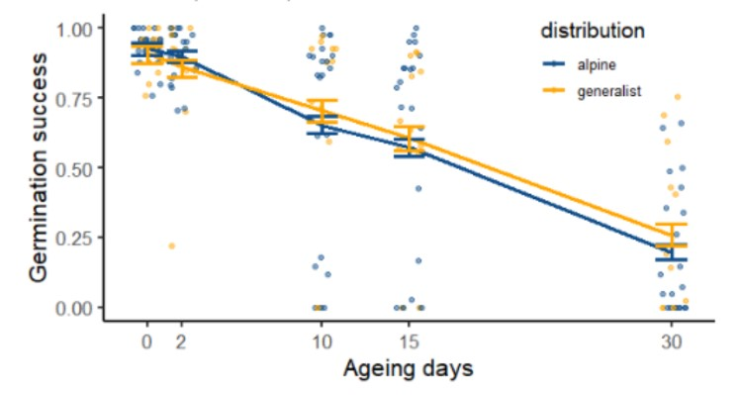

Fig.8: Germination success declines depending on the ageing days, but without differences depending on distribution. Point represents raw data, line average values and error bar represent 95% confidence interval; blue color for strict alpine species and yellow for generalist species.

Contrasting patterns emerge when comparing microhabitats species preferences: seeds from species preferring snowbeds areas lost viability at a faster rate through the ageing protocol than the species with fellfield preference or neutral (p=0,02; Fig. 9;).

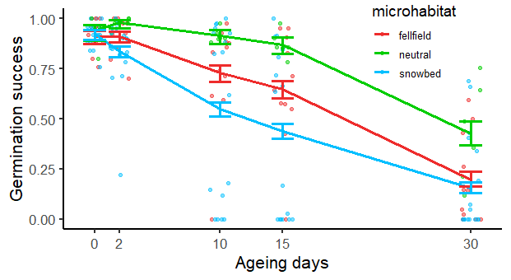

Fig. 9: Germination success declines for all species however for the ones with snowbed microhabitat prefence decreases significantly faster than in the other microhabitats. Points represent raw data, lines average values and error bar the 95% confidence interval; red for fellfield preference, blue for snowbed preference, green for neutral.

Differences become more significant (p<0,001) when considering both variables: species distribution (Habitat) and microhabitat preference: alpine species with preference for snowbeds areas were significantly more responsive to artificial ageing (Fig. 10). Another pattern we identified is that generalist species with no microhabitat preference (neutral) have a higher germination success through the whole ageing process.

The MCMC-GLM with (multinomial3 family) analysis reveals a significant fall in germination success due to the ageing protocol (p<0,0001; Table 3), but also due to the interaction between ageing and snowbed microenvironment (p=0,00556; Table 3). The artificial ageing protocol was effective on all the seeds, but primarily in species with snowbed preference, showing that the lower viability is related to a the different response to ageing. With this same model we were able to consider the phylogeny tree and bedrock variable. We found that the results are phylogenetically constrained (lambda=0,63), but bedrock didn’t impact the observed patterns.

|  |  |
| --- | --- |
| ***scale(ageing)*micro + scale(ageing)*habitat*** |  |
| Variables | p-value |
| intercept | 0,43911 |
| scale(ageing) | <1e-04 |
| microsnowbed | 0,05667 |
| microfellfield | 0,52156 |
| habitat generalist | 0,79378 |
| scale(ageing):microsnowbed | 0,00556 |
| scale(ageing):microfellfield | 0,13711 |
| scale(ageing):habitatgeneralist | 0,07067 |

Table 3: MCMC-GLM with germination raw data (multinomial2); the effect on snowbed species is almost significant.

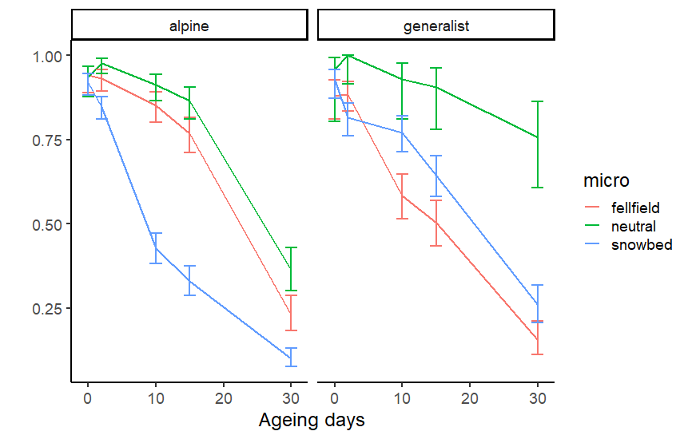

Fig. 10: Germination success curves along ageing days in different panels according to their habitat distribution (strict alpine and generalist); red for fellfield preference, blue for snowbed preference, green for neutral.

To notice that the initial germination success doesn’t depend on microhabitat preference, yet the response to ageing is affected.

Germination indices were calculated using GerminaR package in R (Lozano‐Isla et al., 2019).

GRP index (Germination percentage; Fig. 11a) was significantly influenced by artificial ageing (p<0,0001; Table 2), but also species with preference to snowbed microhabitat had significant differential response (p=0,016; Table 2), meaning that species responded differently depending on microenvironment. Mean germination rate and synchronization index were not affected by the microniche, but the mean germination rate decreased in response to the ageing (Fig. 11b).

|  |  |  |  |
| --- | --- | --- | --- |
| Variables | GRP | MGR | SYN |
| Intercept | p=0,00889 | p=0,804 | p=0,427 |
| Scale(Ageing) | p<1e-04 | p=0,894 | p=0,565 |
| Microsnowbed | p=0,016 | p=0,902 | p=0,892 |
| Microfellfield | p=0,2255 | p=0,955 | p=0,659 |
| Habitat Generalist | p=0,93956 | p=0,783 | p=0,344 |
| Scale(Ageing):Microsnowbed | p=0,0733 | p=0,928 | p=0,836 |
| Scale(Ageing):Microfellfield | p=0,018 | p=0,975 | p=0,56 |
| Scale(Ageing):Habitatgeneralist | p=0,05867 | p=0,974 | p=0,888 |

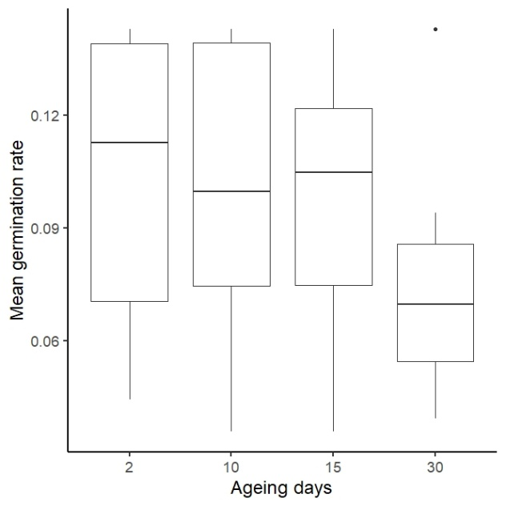Table 2: MCMC-GLM with germination indices (gaussian): GRP=germination percentage; MGR=mean germination rate; SYN=synchrony; indices from GerminR.

**a**

**b**

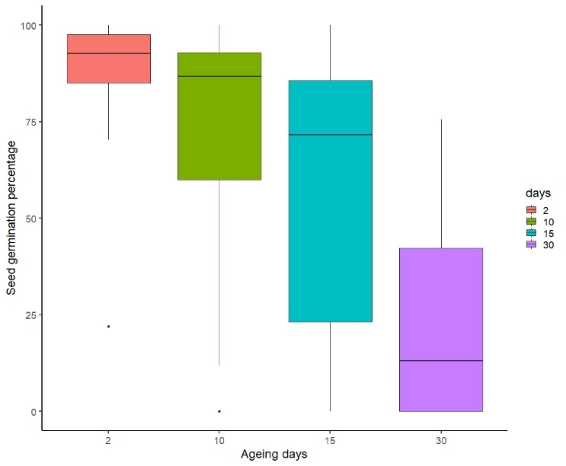

Fig. 11: a) Germination percentage (GRP)and b) Mean germination rate (MGR) trends in response to the days of ageing.

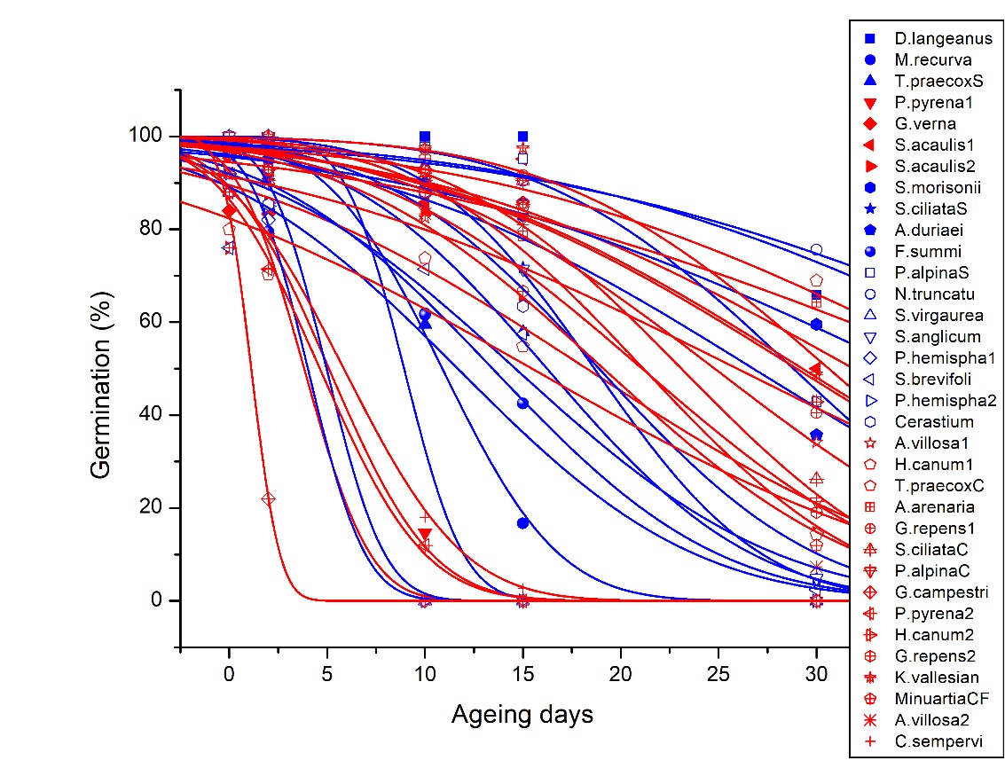

Fig. 12: Germination percentage depending on ageing days; curves divided by bedrock type: blue=calcareous bedrock; red=siliceous bedrock.

**4.3. Intra-specific differences**

Some entries belonged to the same species (Fig. 13) and some of them showed differences in germination loss response between the two different microhabitat preference.

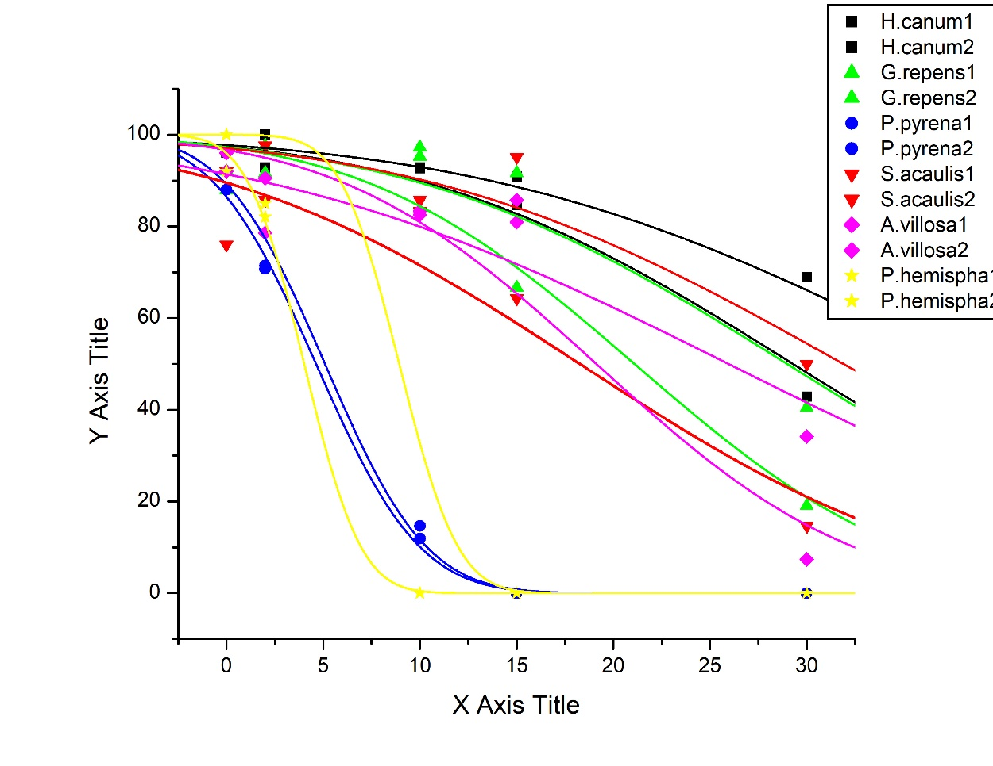

Fig. 13: y=Germination percentage; x=Days of ageing; Each colour represents a species.

The responses were different depending on the species considered: *Silene acaulis* was the most responsive to the ageing protocol, as we can see by the shift in the germination percentage (GRP) curve (Fig. 13), while *Pedicularis pirenaica* was the least affected, maybe the most phylogenetically constrained.

**5. DISCUSSION**

Understanding species differences in seed longevity is crucial to the effective management of seed collections, because it underpins the selection of viability test intervals and hence the strategies of regeneration or re-collection (Probert et al., 2009). Current studies have already shown significant variation in the longevity of seeds, which could be related to different factors, such as environmental stress (Walters & Pence, 2021), like the amount of ROS (Bailly, 2004), genetic factors (Mondoni et al., 2014), dormancy and endosperm presence (Tausch et al., 2019). A seed is a perfect organism to bank, because of its adaptation to stressful conditions (Walters & Pence, 2021), but the resistance in the time is variable (Mondoni et al., 2011; Probert et al., 2009; Walters et al., 2005): some patterns have been recognised, as the dependence on the phylogeny and the shorter life of the alpine seeds (Mondoni et al., 2011), but a big fraction of this variability is not yet explained. In fact, among the alpine species there’s much variability (Mondoni et al., 2014). An important source of loss of availability through time is the concentration of ROS (reactive oxygen species), augmented by high temperature, moisture and O2 (Bailly, 2004). These radicals are able to damage the macromolecules, among which the nuclear DNA, especially in combination with the loss of activity of the antioxidant enzymes, due to ageing. High seed water contents enable enzyme activity and metabolism, but the antioxidant and regeneration mechanisms are not sufficiently active, so ROS can accumulate (Bailly, 2004; Tausch et al., 2019) and this can explain the effectiveness of the ageing protocol.

The aim of the thesis is the investigation of the longevity variation, assuming a role of the microenvironment on the trait, following the known trend according to which seeds from colder environments are shorter-lived. The results presented here confirm that: seeds aged in identical conditions (45°C, 60% RH) have significant differences in longevity both between and within species, the estimates for p50 ranged between 1,12 and 44,62 ays. Interestingly, this variation was significantly different when species were grouped depending on their main microhabitat, especially when considering their geographical distribution. In particular, the R analysis reveals a bigger drop in germination percentage (GRP; p=0,016) and germination success (p=0,00556) of the seeds from species with snowbed preference, and the fall is further augmented when taking in consideration both the snowbed preference and the alpine distribution effects, while the bedrock did not have an impact. These results indicate that microenvironmental conditions (snowbed and fellfields species) and life-history (generalist and alpine specialist) may play a significant role as seed longevity drivers and contribute to explain the large variation of seed longevity found across alpine species. The results are consistent with the literature, since seeds from warmer/drier environments are known to be longer-lived (Probert et al., 2009; Walters et al., 2005). The causes are not clear, although this could depend on mass and elevation (Satyanti et al., 2018). The selective forces may be the length of growing season (Seglias, 2022): a shorter growing season needs a quicker maturation to be exploited; but also the need, for the species inhabiting drying climate, to survive for sufficient time in the dry state (Probert et al., 2009). Consistently Wang et al., (2009) highlighted that seeds from dryer environments are more resistant, maybe because of they have to persist longer in the soil before conditions became suitable for germination in arid zones. Other not known mechanisms could also result in shorter longevity in storage conditions. Also the phylogenetic signal is confirmed to be high (lambda=0,63), supporting previous results (Mondoni et al., 2011, 2014; Tausch et al., 2019) on the genetic dependence of seed resistance to aging. This results also highlight that microhabitats seems colonised by closely related species.

**6. CONCLUSIONS AND PERSPECTIVES**

We take advantage of a little fraction of plants, but this fraction provides essential ecological services (Smith et al., 2011). The importance of the conservation of these species brought to develop procedures to store the seeds, up to hundreds of years (Solberg et al., 2020), the ability to remain viable is highly variable. Alpine seeds in particular are very sensible to ageing (Mondoni et al., 2010), though the variability is, again, high.

Alpine environments are characterised by a certain grade of “roughness” (Körner et al., 2011), that creates different habitats in little spaces (Körner, 2004). These microhabitats develop their own microclimate that influences the time that seeds remain viable, according to our results seeds from species with snowbed microhabitat preference (environments with lengthy snow cover and high moisture) have a shorter seed lifespan, as verified through the ageing protocol developed by Davies et al., 2016. The R analysis showed contrasting patterns of loss of viability between snowbed and fellfield seeds, patterns that depend on the ageing time, thus is just the ageing resistance to be influenced by the climatic conditions of provenance.

The physiological causes are not clear: it’s possibly due to oxidation, aggregation of denatured proteins (Sano et al., 2016) and there are indication that lead to think to a strong genetic component (Rajjou et al., 2008). It is commonplace to think the evolution causes could follow the necessity, for the fellfield plants, to endure hotter periods. In this case a cue comes from Prieto-Dapena et al., 2006, which verified that the overexpression of small heat shock proteins genes results in an increase in seed longevity in a controlled deterioration test.

The susceptibility to higher temperature has conservation implications in climate warming conditions we are going through: the germination potential loss could be greater from year to year.

Future investigations are needed to find the physiological and evolutive causes of the relation between availability and microniche; the answers to these questions will be the key to the understanding of the phenomenon, thereafter to the development, or expansion, of mitigation proceedings. Surveys will be also important to determine the *in situ* meaning of these results, even a quantification of the germination loss through the years and, perhaps, the evidence of a spatial shift of the habitats.

The accelerated ageing protocol doesn’t provide a direct prediction of longevity under gene banking conditions (-20°C; Merritt et al., 2014), but it is useful as a comparative approach. These results lead to suggest that the snowbed and alpine specialist species should be tested more frequently than fellfield and generalist to monitor their viability in storage and highlight that species from other habitats, not tested here, may show different patterns. Considering the high species and habitat diversity found in the alpine belt (Körner et al., 2011), further studies are needed on other microhabitats (e.g. rock, debris, glacier foreland) for a better and more comprehensive understanding of the seed longevity patterns in these extreme environments.