Kailie’s super amazing and helpful swim tracking tutorial
Written 08/21/25

Part 1: Adjusting videos to work in TrackingGUI
- Open Fiji/ImageJ
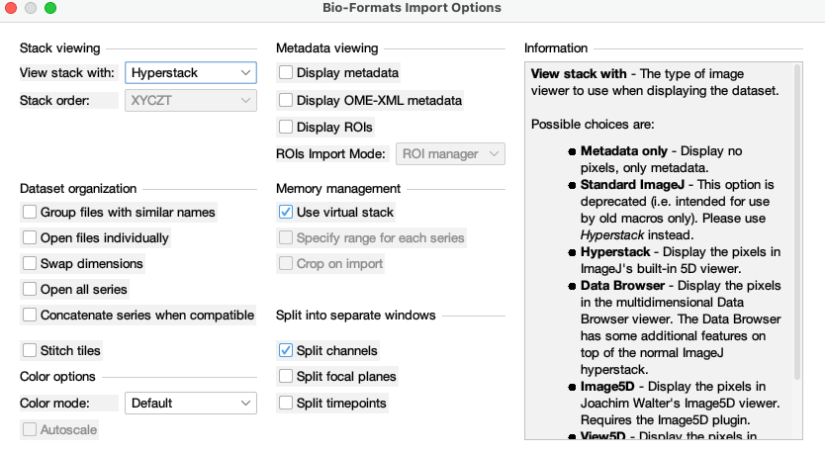
  - File -> open -> make sure to check “use virtual stack” to not overload your computer’s memory
- Image-> adjust -> brightness and contrast -> auto
  - This is so you can see what your cells look like.
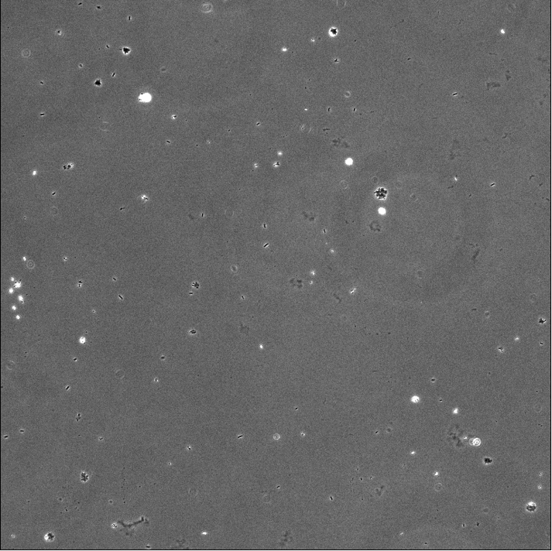
  - Image -> duplicate -> check duplicate stack, when finished duplicating a new stack will pop open and have the ending C=0-1
- Create a new folder for your edited images in whichever directory you prefer. I like to have them on my desktop. Make sure to name the file with the bacteria, strain and treatment!
- If your cells were imaged with fluorescence, skip to step 5.

  - If your cells were imaged without fluorescence (i.e., in phase), click Edit -> invert -> yes to all frames. Now your video should look like this:
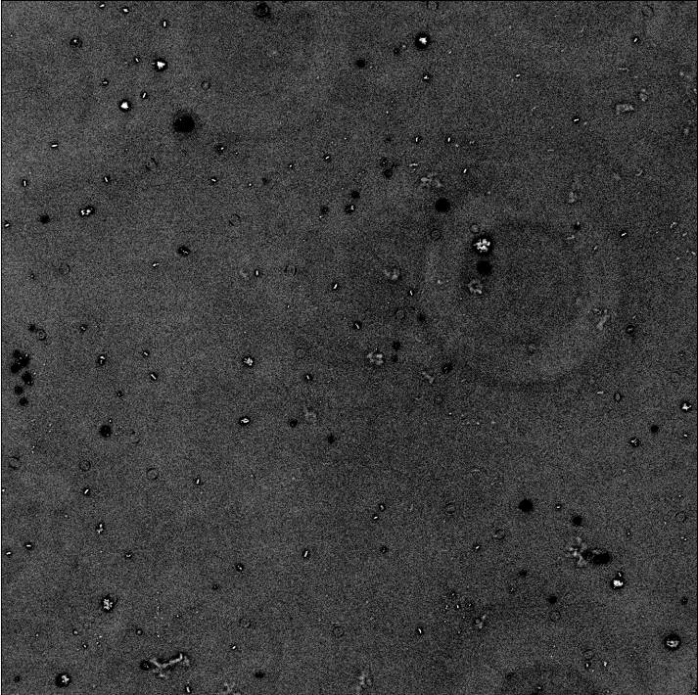
- Use the brightness & contrast sliders to make the cells visible with a dark background. I start by using the auto button and then pressing apply, then darkening the background from there by upping the minimum. Make sure to click apply, and you should have something like this:
  - File -> save as -> image sequence
  - Save to the pre-made folder from step d above, using a naming convention like “IR715 WT_”. MAKE SURE TO INCLUDE THE UNDERSCORE AT THE END OF THE NAME!
- Repeat for the rest of the frames in your video, changing the start at value to be the number after your last written file (i.e., ended at file_899, start at 900)

Part 2: TrackingGUI
- Open Matlab and run the command “TrackingGUI_rp” (no quotes)
- A pop-up window will open. Navigate to your folder where the image sequence is saved and click and open the first image in the sequence. Next, on the next pop-up window, open the last image in the sequence.
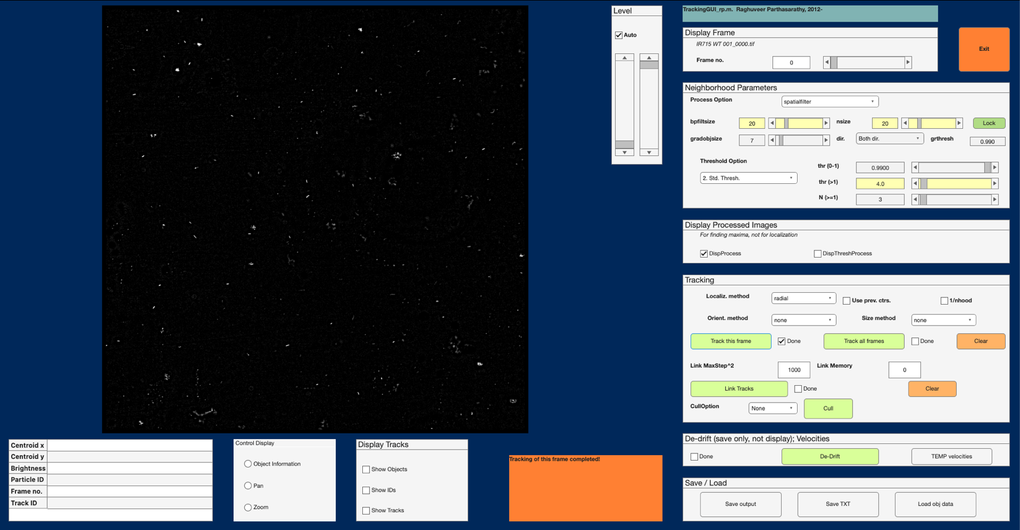
- A new GUI will open:
C
B
A
- Next set the parameters for the GUI to determine an object. I use:
  - bpfiltsize = 20
  - Threshold option 2 (Std. Thresh., from drop down menu)
  - thr (>1) = 4.0
- Next, click the “track this frame” button
  - Toggle, under display tracks the “show objs” box to see if the objects look correct.
    - If the program is highlighting more than half of objects that don’t seem to be cells, change your parameters and take note of them
- Hit “track all frames”
  - This while take a while, but a window with a progress bar will popup for you to look at
- Once are frames are tracked (should see a check in box next to “Track all frames” box), hit “Link Objs -> Tracks”
  - This should go fairly quickly!

- Next, we will cull the tracks to have a standard deviation of greater than 2 and a track length equal to or longer than 1 sec
  - Select Cull Option from drop down as “tracks” and press the cull button and hit no to de-drift
  - Select StdDev and input 2 as the min value, and leave infinite as the max value
    - Should take less than 5 minutes to complete, can close the figure window that comes up
  - Select Track length and for the min value, input the frame rate (the number of frames in your video/length of your video in seconds, usually for my videos it is 2671/30 so around 89)
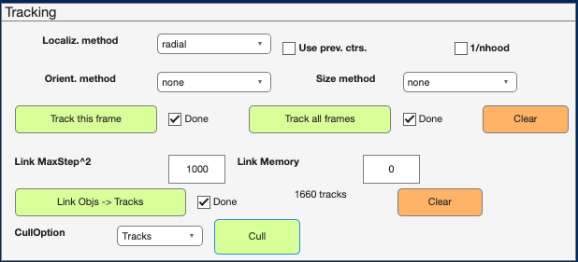
- After culling, you should see a track number above the cull button. Take note of this number in a separate note/spreadsheet/whatever!
- Click the “save output” button
  - Name it something you can distinguish easily, such as strain-treatment-replicate and don’t forget the .mat extensions (i.e. WTNone1.mat)
  - The orange box to the left of the save/load box will say “Done saving variables” when it has finished.
Part 3: Matlab Coding
- Load the file you just saved in to the command window with by double clicking on it or using the load command (looks like this: load("/Users/kailie/Desktop/WTNone1.mat")”
- Copy the following code into the command window and press enter to run it:
uniqueFrames=unique(objs_link(5,:));
objs_in_frame=zeros(size(uniqueFrames));
for j=1:length(uniqueFrames)
objs_in_frame(j)=sum(objs_link(5,:)==uniqueFrames(j));
end
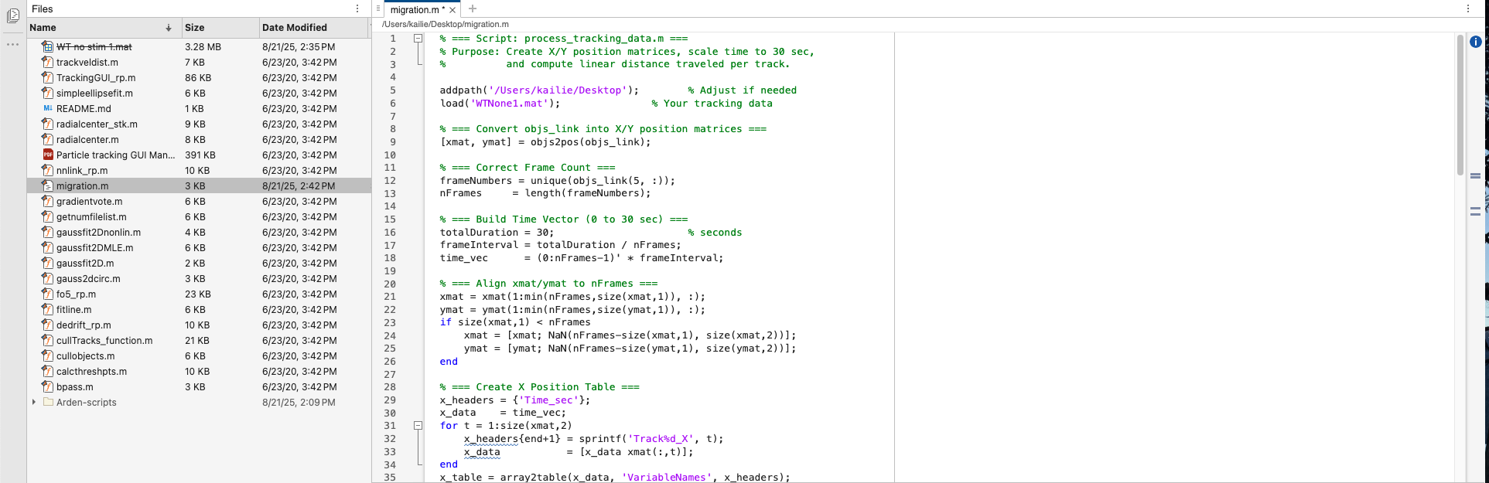
- Open up the migration.m in Matlab and change the path on line 5 (the location of your file, without quotes and the file, so something like \Users\kailie.franco\Desktop\) and load to the path where your file from TrackingGUI is saved on line 6 (the name of the file only, like WTNone1.mat):
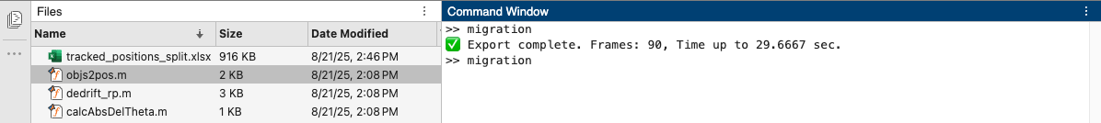
- Type “migration” in the command window, or press the run button. If the script works, it should look like following, and export a document called tracked_positions_split.xslx. You can change the name of this file by changing line 68 of the migration.m script.
  - If you didn’t rename the file, rename it to the strain-treatment-replicate.xslx (i.e. WTNone1.xslx)
  - Save both the .mat file and the .xslx file on the J-Drive under the following: "J:\Baylink-Lab\Kailie Franco\Year 4\Swim Tracking Files"

