**Business analytics exam – Clara Albert**

**Exercise 10**

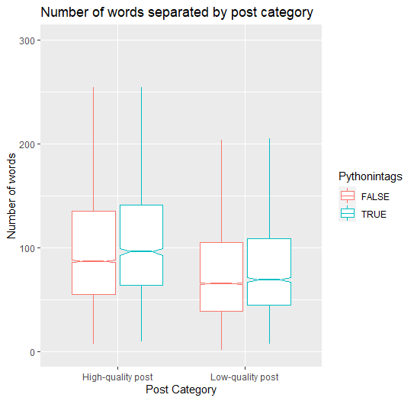

In the plot you can see he differences in the median values between the different groups. First of all, if the post category is high-quality the median value is higher than if is low-quality. So, with this result we can have an idea of how the number of words can affect the quality of the post. On the other hand, independent of the post category if python is found on the “Tags” of a post, the median of number of works is higher than if is not found.

If we see all the results alone, we can say that the number of words has an impact on the category of the post. We can’t conclude anything because only with plots we can’t say something for sure.