**MIP course - Ex1: part2**

Clara Herscu, id: 203319371

**Part a:**

Results:

In this part I will show for every test example the following information: BB, CC, and images of all stages of segmentation (Body, Lungs, and Lungs band).

1. BB: 126, CC: 187, images:

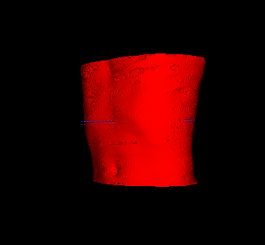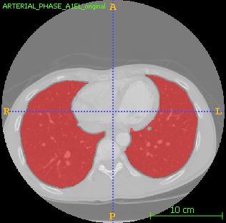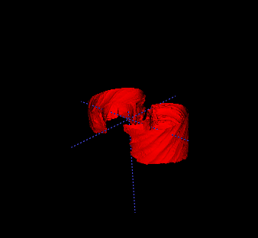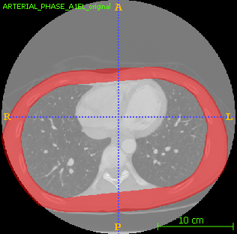

1. BB: 37, CC: 78, images:

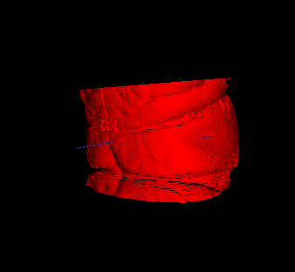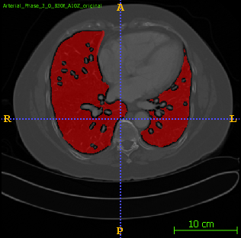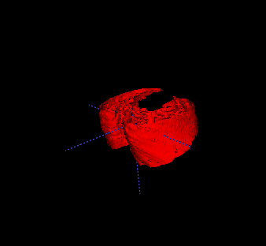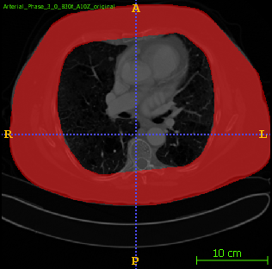

1. BB: 147, CC: 167, images:

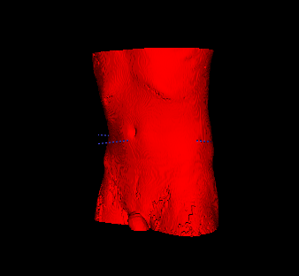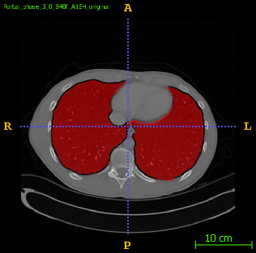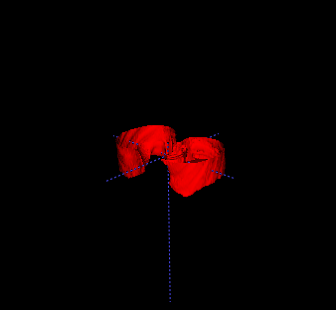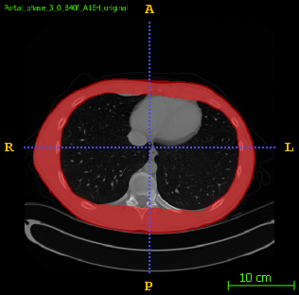

1. BB: 163, CC: 187, images:

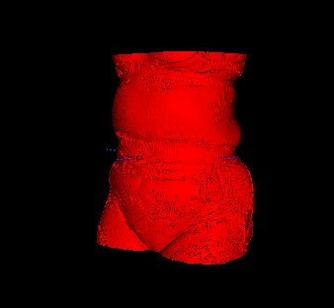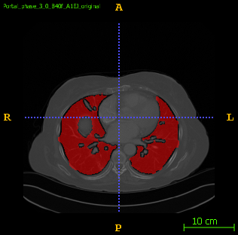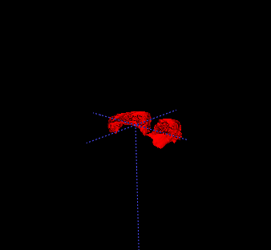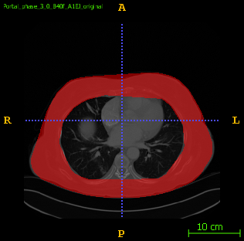

1. BB: 15, CC: 22, images:

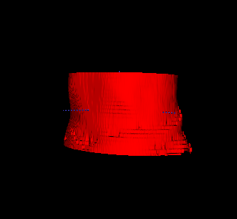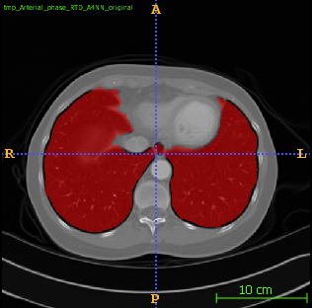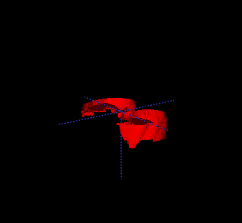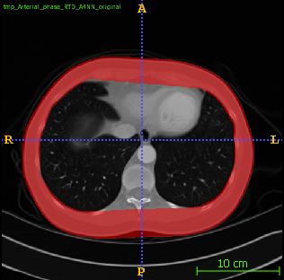

Remark: In some of the images, the lungs do not create two separate connected components. In these cases, the addition of the two greatest components resulted in segmentation of lungs and another body part (usually intestines). In order to avoid this, I first picked the biggest connected component, and then checked if its' width is at least 60% of the body's width. If it wasn't, I then added the following biggest component. This is based on an assumption that the lungs are necessarily as wide as 60% of the body.