**MIP course - Ex1: part2**

Clara Herscu, id: 203319371

**Results:**

In this part I will show for every test example the following information: BB, CC, and images of all stages of segmentation (Body, Lungs, Lungs band and entire ROI of spine and chest bones).

1. BB: 126, CC: 187, images:

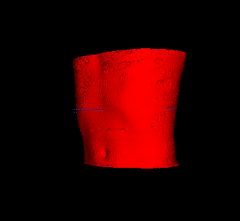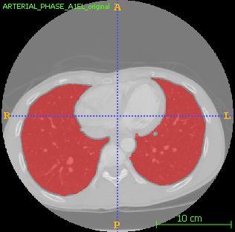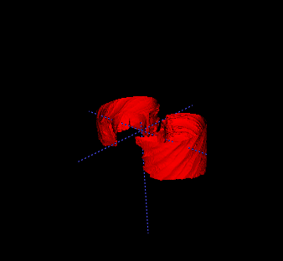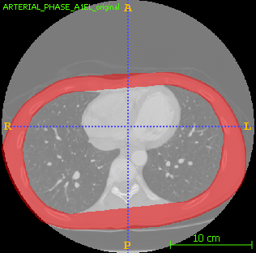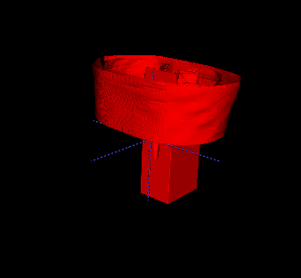

1. BB: 37, CC: 78, images:

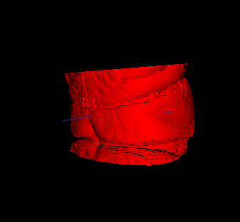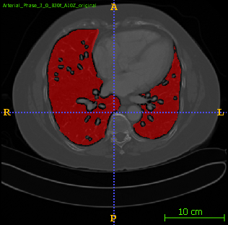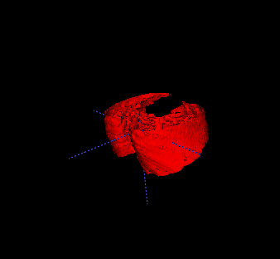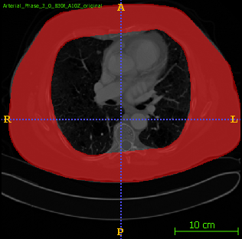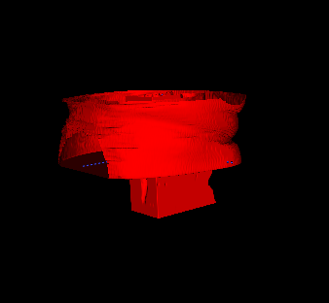

1. BB: 147, CC: 167, images:

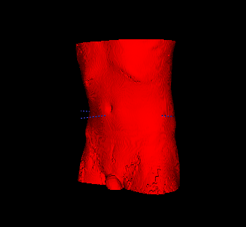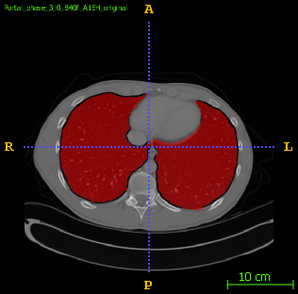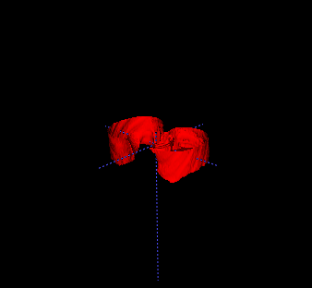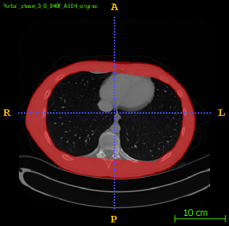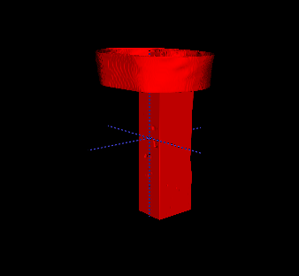

1. BB: 163, CC: 187, images:

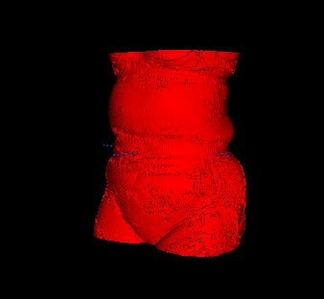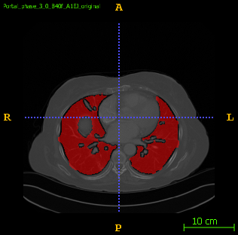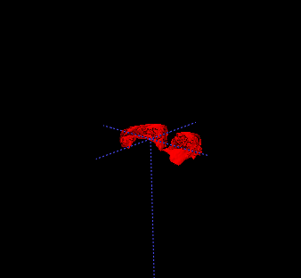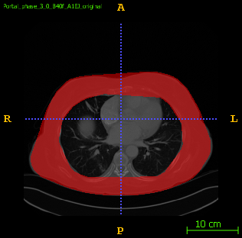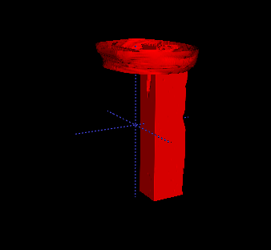

1. BB: 15, CC: 22, images:

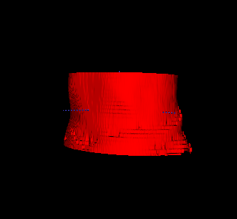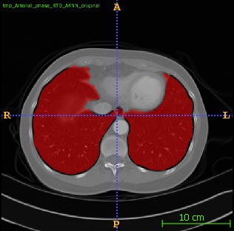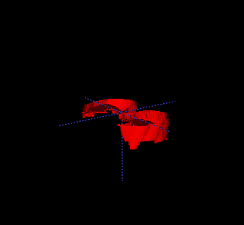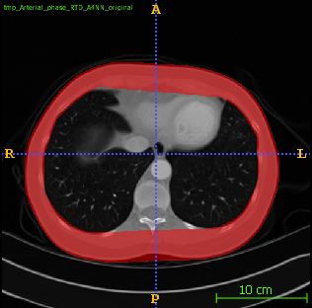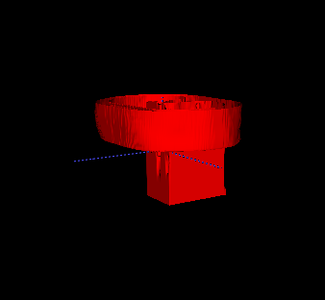

Remarks:

1. In some of the images, the lungs do not create two separate connected components. In these cases, the addition of the two greatest components resulted in segmentation of lungs and another body part (usually intestines). In order to avoid this, I first picked the biggest connected component, and then checked if its' width is at least 60% of the body's width. If it wasn't, I then added the following biggest component. This is based on an assumption that the lungs are necessarily at least as wide as 60% of the body.
2. In the ROI part, I took the lowest aorta location (aortaX, aortaY, aortaZ) and used it to locate the spine. I then defined the ROI to be a box along the whole z axis limited by aortaX-60 and aortaX + 60 to the left and right, and aortaY downwards. After this, I substracted the actual aorta from this box, and returned an intersection of this result with the body segmentation and then added the lung band.