**MIP course - Ex1: part3**

Clara Herscu, id: 203319371

Results:

**Part A:**

1. 10000100:

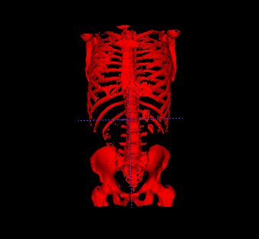

VOD: 64.5583

1. 10000104:

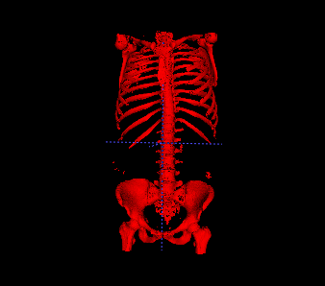

VOD: 56.6024

1. 10000105:

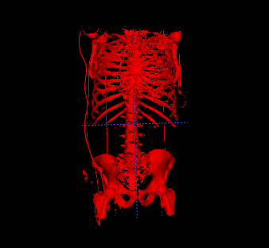

VOD: 46.1446

1. 10000106:

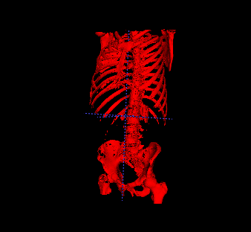

VOD: 75.6059

1. 10000108:

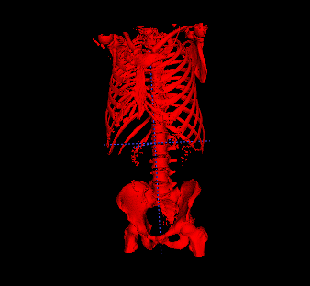

VOD: 33.0921

**Part B:**

1. ARTERIAL_PHASE_A1EL:

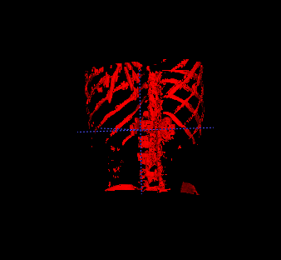

1. Arterial_Phase_3_0_B30f_A10Z:

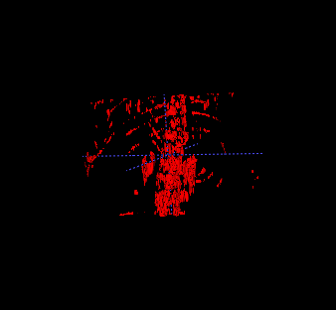

1. Portal_phase_3_0_B40f_A1EH:

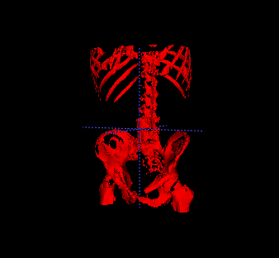

1. Portal_phase_3_0_B40f_A1EJ:

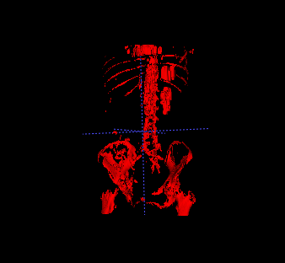

1. tmp_Arterial_phase_RTD_A4NN:

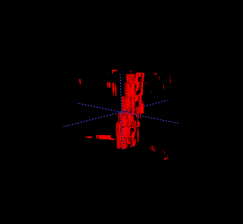

Remarks and explanations:

1. while segmenting the ribs area, I found that taking a mean value over the entire cube surrounding the seed is problematic – many times, the seeds were located well inside a rib, but were still very close to the edge and therefore in their closed cube, there were many voxels with much lower grey values. In order to avoid this bias, I used a threshold of 100 – I only calculate the mean and std over voxels with grey values greater than 100 because they are actually the only ones that could be relevant for the bones.
2. In the selection of seeds: I took all the voxels with grey values around (mean+std), and then selected 100 of them randomly. I did this selection for the spine and the ribs separately, so in total I got 200 seeds in the entire volume.