**MIP: Ex2 Part1**

Clara Herscu (login: clara.herscu; id:203319371)

1. Results:

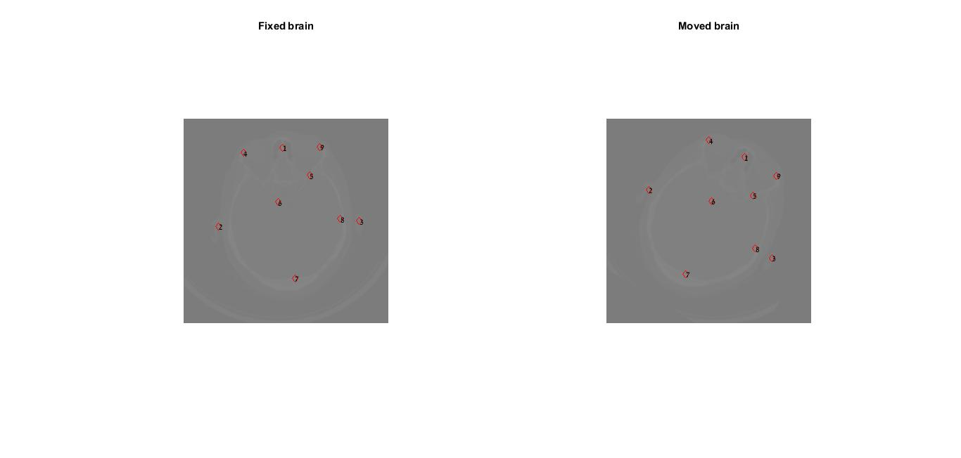

There are no visible wrong couplings in this sample.

1. I got the following rigid registration matrix:
$$\begin{matrix}0.8498 & 0.5271 & 0 \\ -0.5271 & 0.8498 & 0 \\ 174.1571 & -96.7364 & 1\end{matrix}$$

2. The distance in pixels is:

[0.8274, 0.0748, 4.5108, 1.3933, 1.7205, 1.0002, 0.9799, 2.1162, 0.7557]

(RMSE = 1.9134)

1. Result:

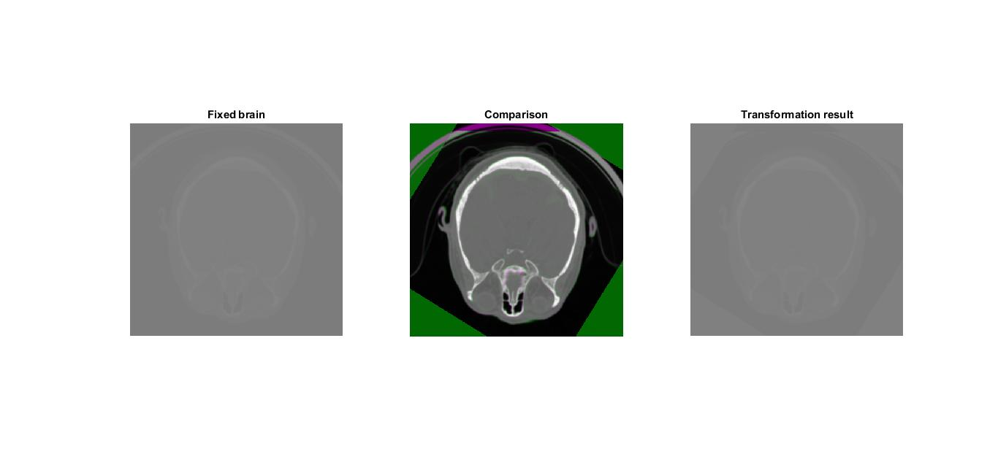

1. Results:

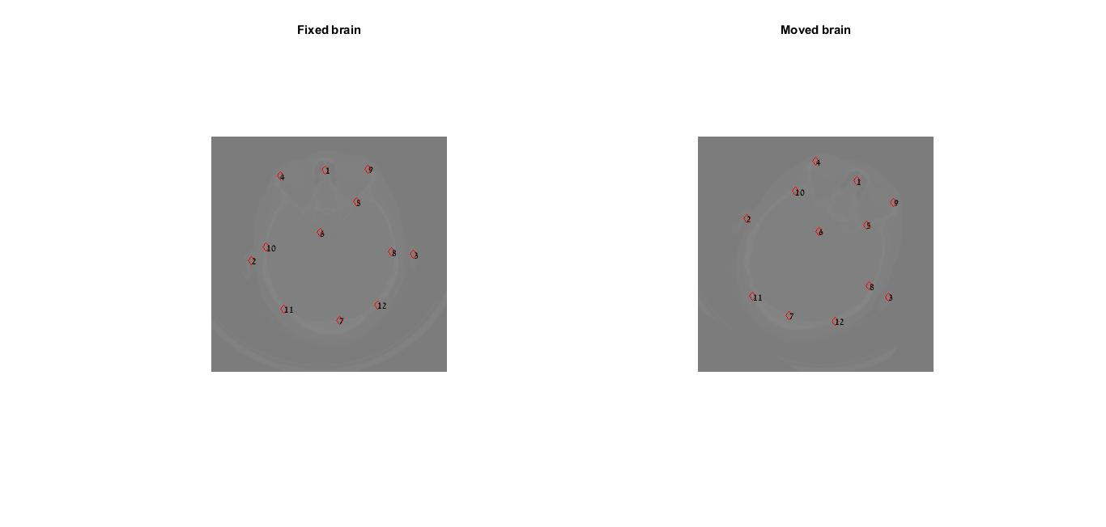

Here we do have outliers: {10, 11,12}

I got the following rigid registration matrix:

$$\begin{matrix}0.8480 & 0.5300 & 0 \\ -0.5300 & 0.8480 & 0 \\ 170.0854 & -101.6005 & 1\end{matrix}$$

The distance in pixels is:

[7.4508, 7.2853, 5.1906, 6.4522, 7.6625, 7.6862, 7.5153, 8.5978, 8.0666, 75.4758, 44.3636, 5.2930]

(RMSE = 27.2849)

And the result is:

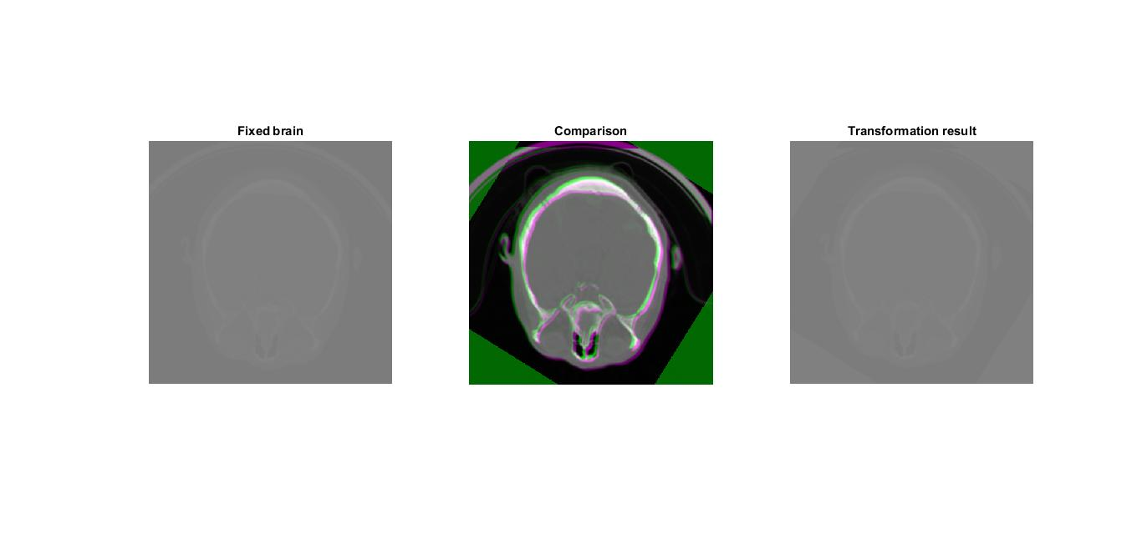

Why?