Hello, I would like to use optical encoder from old HP printer (It has 4 pins, and capacitor between pin 1 and 3. Part no. 09845 Agilent 58), and count steps with Arduino Mega.  
Can anyone help?  
Does anyone know how to connect this encoder to the Arduino, and some code?

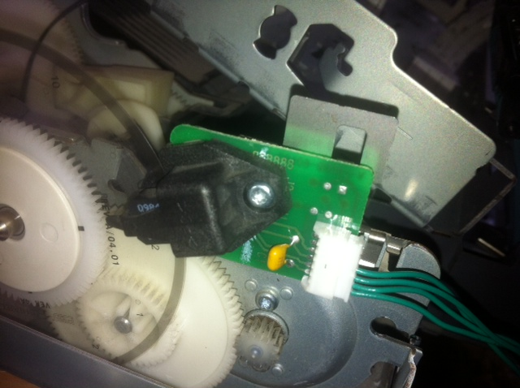

It looks like a rotory encoder. You have to work out what wires are 5V and ground then the other two are the quadrature index pulses.  
Code you can use is here:-  
<http://arduino.cc/playground/Main/RotaryEncoders>

<http://forum.arduino.cc/index.php?topic=92582.0>

/\* Read Quadrature Encoder

Connect Encoder to Pins encoder0PinA, encoder0PinB, and +5V.

Sketch by max wolf / www.meso.net

v. 0.1 - very basic functions - mw 20061220

\*/

int val;

int encoder0PinA = 3;

int encoder0PinB = 4;

int encoder0Pos = 0;

int encoder0PinALast = LOW;

int n = LOW;

void setup() {

pinMode (encoder0PinA, INPUT);

pinMode (encoder0PinB, INPUT);

Serial.begin (9600);

}

void loop() {

n = digitalRead(encoder0PinA);

if ((encoder0PinALast == LOW) && (n == HIGH)) {

if (digitalRead(encoder0PinB) == LOW) {

encoder0Pos--;

} else {

encoder0Pos++;

}

Serial.print (encoder0Pos);

Serial.print ("/");

}

encoder0PinALast = n;