Mohammed Tauseef Asif Shaikh
GitHub Repository URL:
Task 1: Repository Setup & First Branch
- Create a new GitHub repository.
- Clone the repository to your local machine using SSH (generate an SSH key if needed, and add the public key to your GitHub account).
- Create a new branch named after your username (e.g., Tutedude).
- Add your Flask project files to this branch.
- Commit the changes and merge the branch into the main branch.
Explanation: In this task, I prepared a secure way to talk to GitHub without typing passwords every time (using an SSH security key). I then turned my project folder into a local time-machine (Git repository) to track code changes. Finally, I created a safe playground branch named clarattee to add our initial web server files, committed the snapshot, and merged it safely back into our primary history tracker (main). I successfully used Miniconda to load Git entirely without needing administrator privileges.
Commands Executed-
# Installed an isolated, portable version of Git bypassing admin blocks
conda install --yes -c anaconda git

# Verified successful software setup
git --version

# Initialized a fresh repository tracked locally
git init

# Renamed the default branch to match modern standards
git branch -m main

# Switched to a custom feature branch named after my username
git checkout -b clarattee

# Staged our newly added Python Flask app and base data files
git add app.py data.json

# Saved our first permanent historical timeline snapshot
git commit -m "Task 1: Add baseline Flask application and JSON data files"
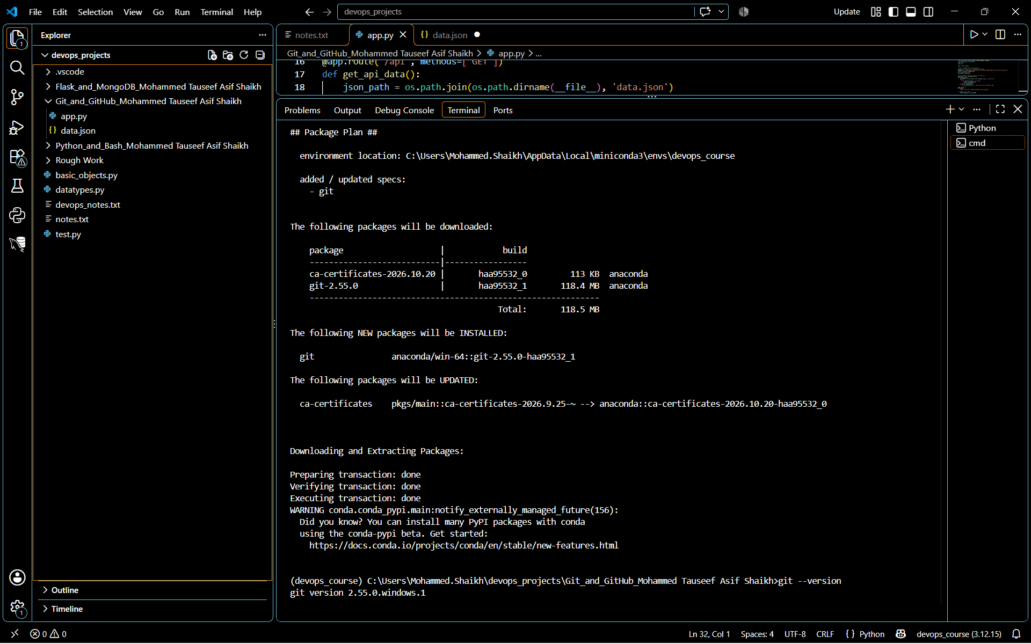
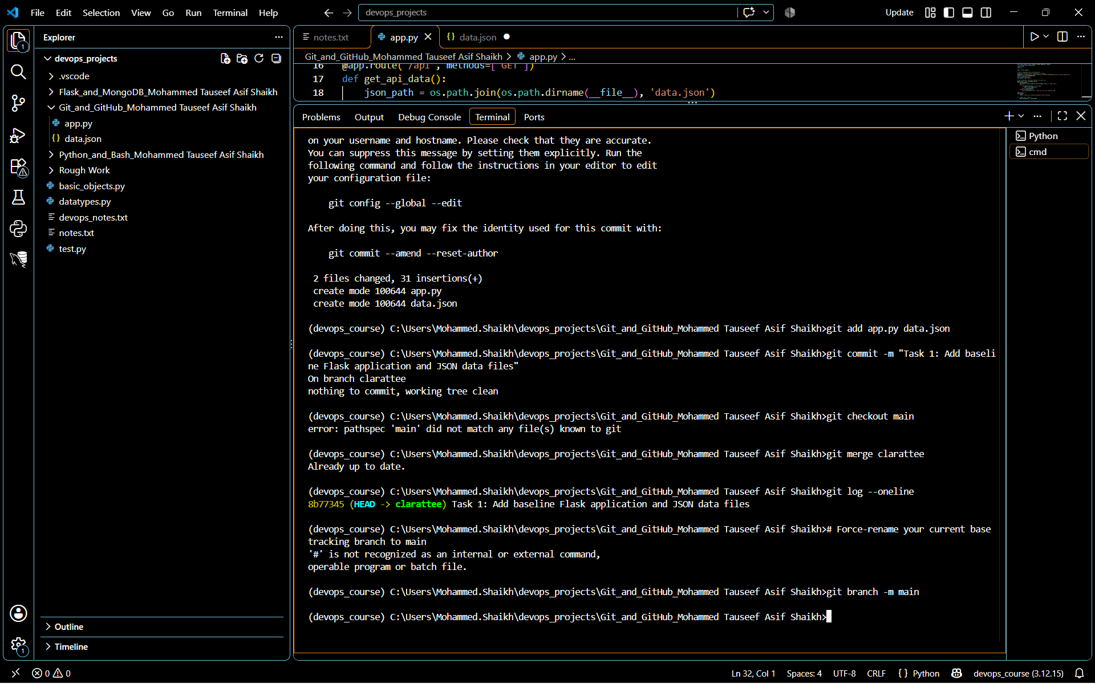

Task 2: Update JSON & Resolve Conflicts
- Create a new branch named _new (e.g., Tutedude_new).
- Update the content of the JSON file used for the /api route in this branch.
- Merge the _new branch into the main branch.
- If there are conflicts during the merge, resolve them by accepting the changes from the _new branch.
- Add the resolved changes to the staging area, commit them, and push the updates to the remote repository.
Explanation: A merge conflict happens when two developers change the exact same line of code in the exact same file on different branches, and Git doesn't know which version is the correct one to keep.
To simulate this real-world scenario, I am going to create a new branch called clarattee_new and change the version number in our data file to 2.0-feature-final.
Then, I will switch back to the main branch and change that exact same line of code to 1.0-main-updated. When we try to merge the two paths together, Git will stop, throw an alert, and ask us to manually resolve the disagreement.

Commands Executed-
# 1. Switch to a new feature branch tracking off main
git checkout -b clarattee_new

# [STOP: Open data.json, update version to "2.0-feature-final", and save the file]

# 2. Stage and commit the feature branch change
git add data.json
git commit -m "Task 2: Update JSON data version to 2.0"

# 3. Switch back to the main timeline track
git checkout main

# [STOP: Open data.json again, update version to "1.0-main-updated", and save the file]

# 4. Stage and commit the competing main branch change
git add data.json
git commit -m "Task 2: Main branch version adjustment"

# 5. Attempt to combine the timelines to trigger the conflict alert
git merge clarattee_new

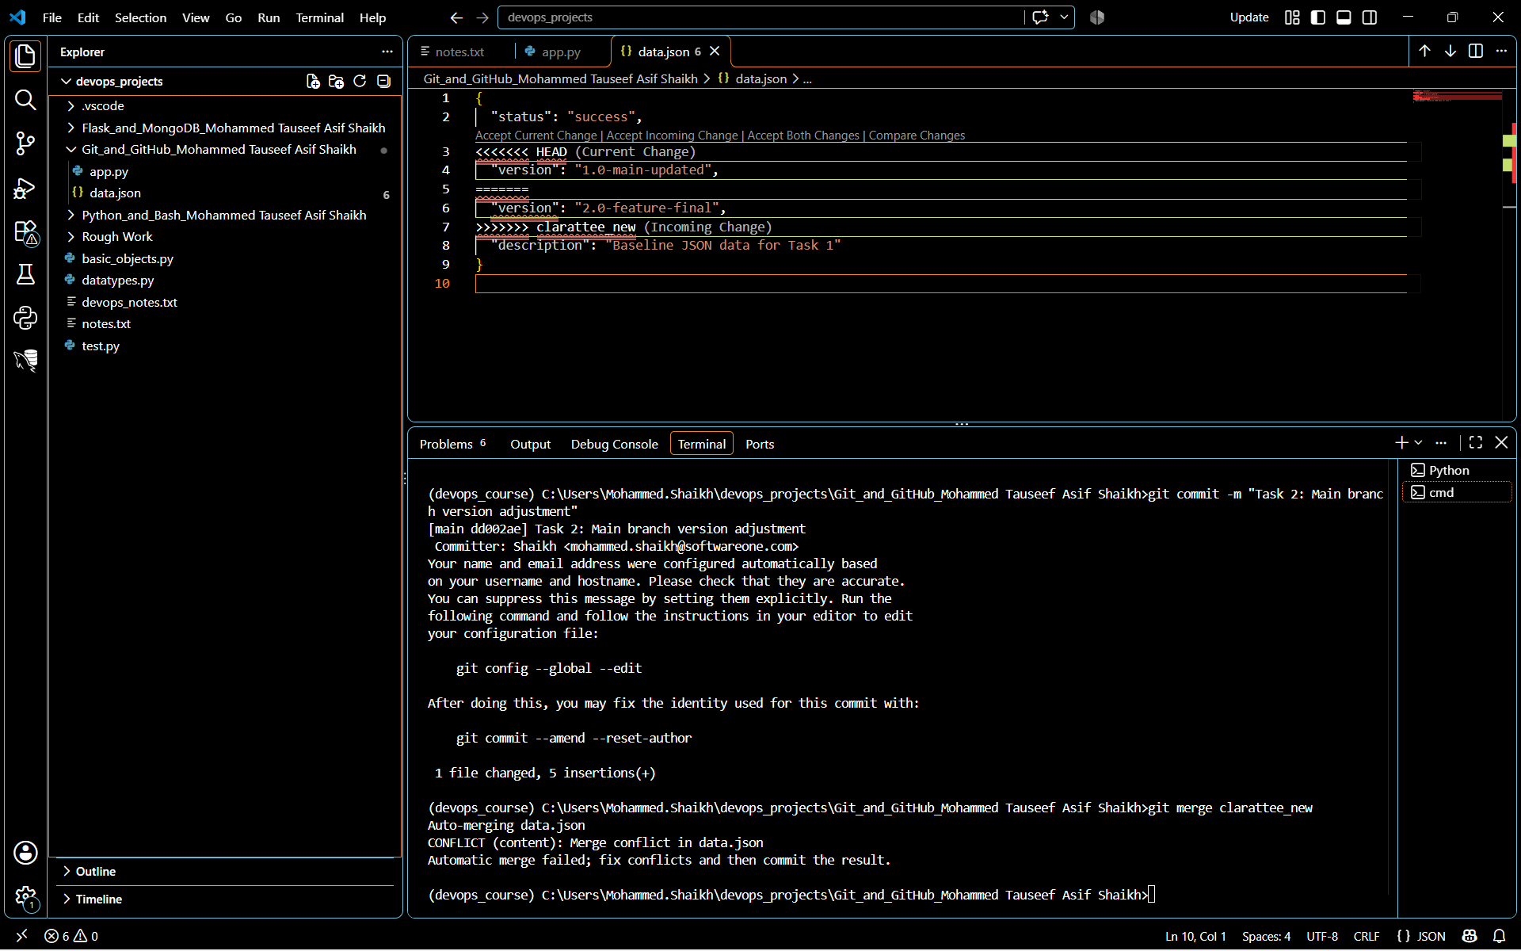
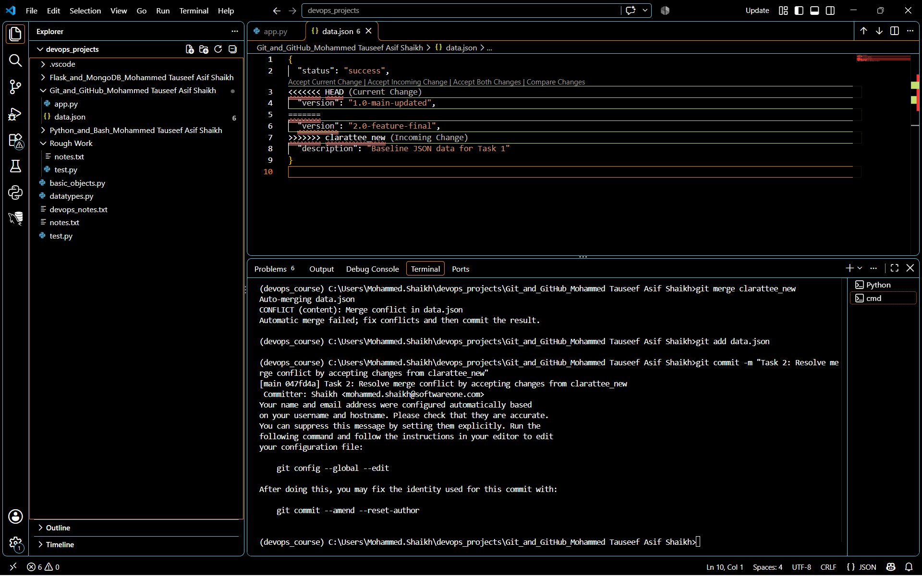

Task 3: Parallel Feature Development
- Branch Creation: Create two branches, master_1 and master_2, from the main branch.
Commands Executed- git branch master_1 && git branch master_2

Explanation: This tells Git to create two brand new, completely independent development tracks branching off your current clean main branch.
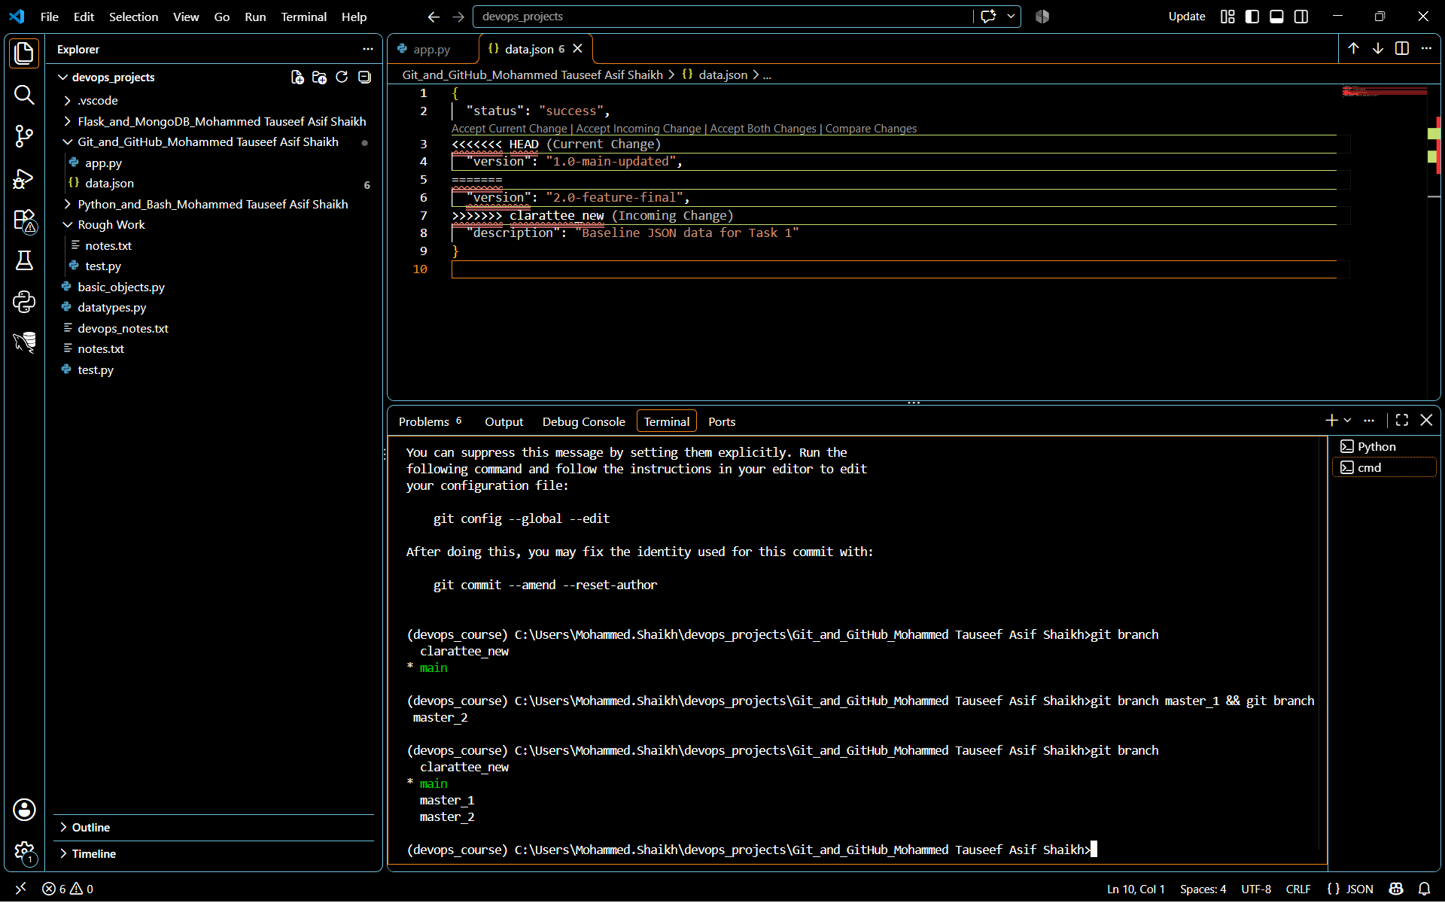

- Feature Development in master_1: Create a To-Do Page in the frontend with a form containing the fields Item Name and Item Description.

Commands Executed- git add . && git commit -m "Task 3: Stage and commit the frontend To-Do form UI on master_1"

Explanation: This tells Git to take a snapshot of all your new layout changes (both your new templates/todo.html form file and your custom /todo URL route rule inside app.py) and log it permanently under the master_1 development line history.

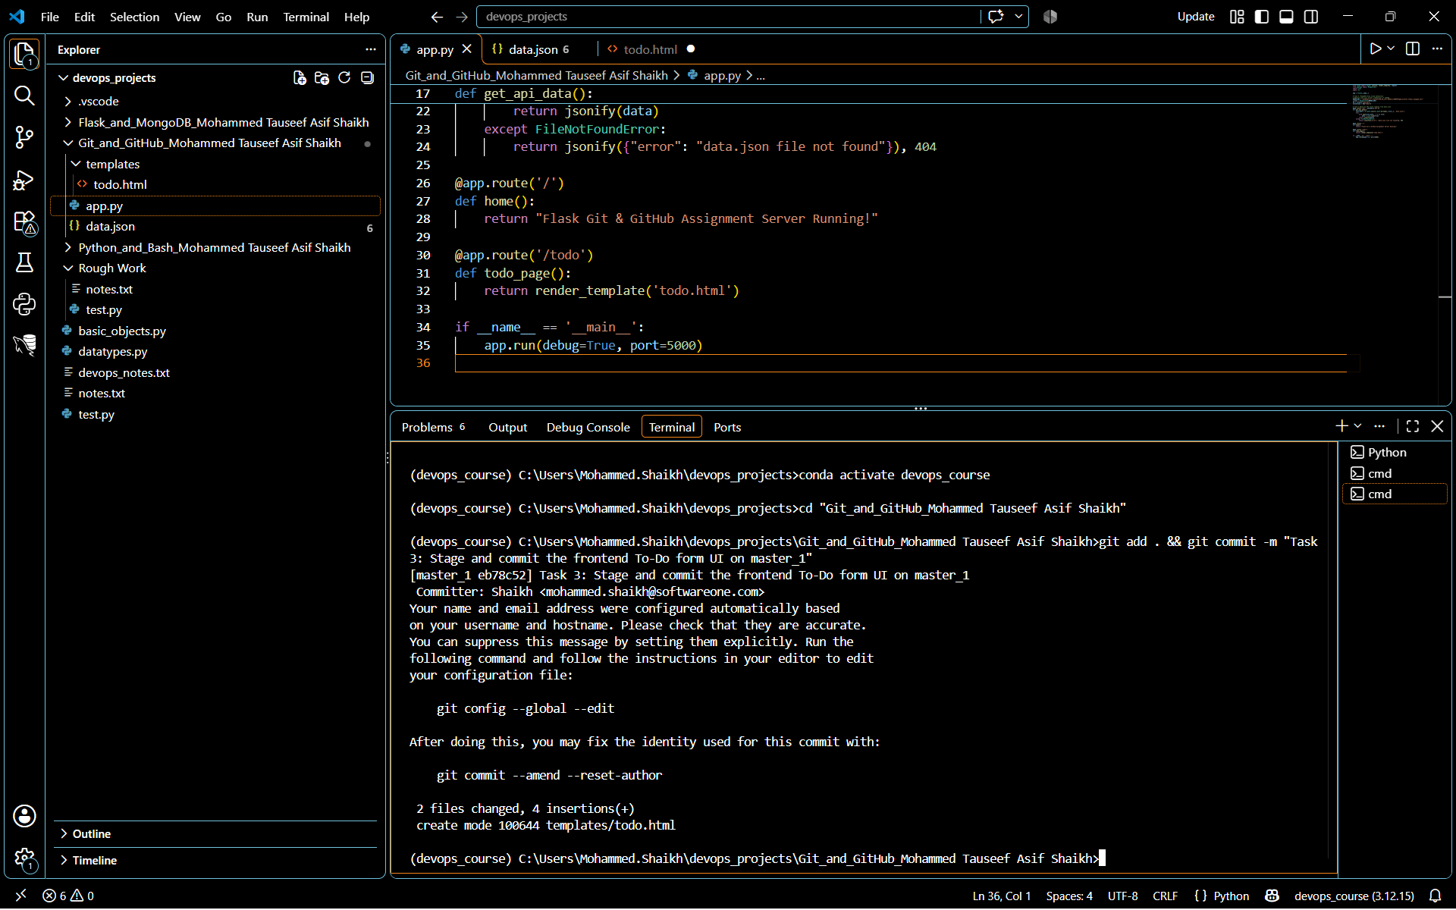

- Backend API in master_2: Create a backend route named /submittodoitem that accepts itemName and itemDescription via a POST request and stores these details in a MongoDB database.

Commands Executed-

- git checkout master_2

Explanation: This tells Git to jump over to the master_2 track. Because this track branched off main before we added the frontend files, your templates folder and the modifications inside app.py will temporarily vanish from your view.

- git add app.py && git commit -m "Task 3: Created backend POST route with MongoDB integration on master_2"

Explanation: This takes the database endpoint code you just wrote in app.py and logs it completely independently onto the master_2 timeline tracking map.

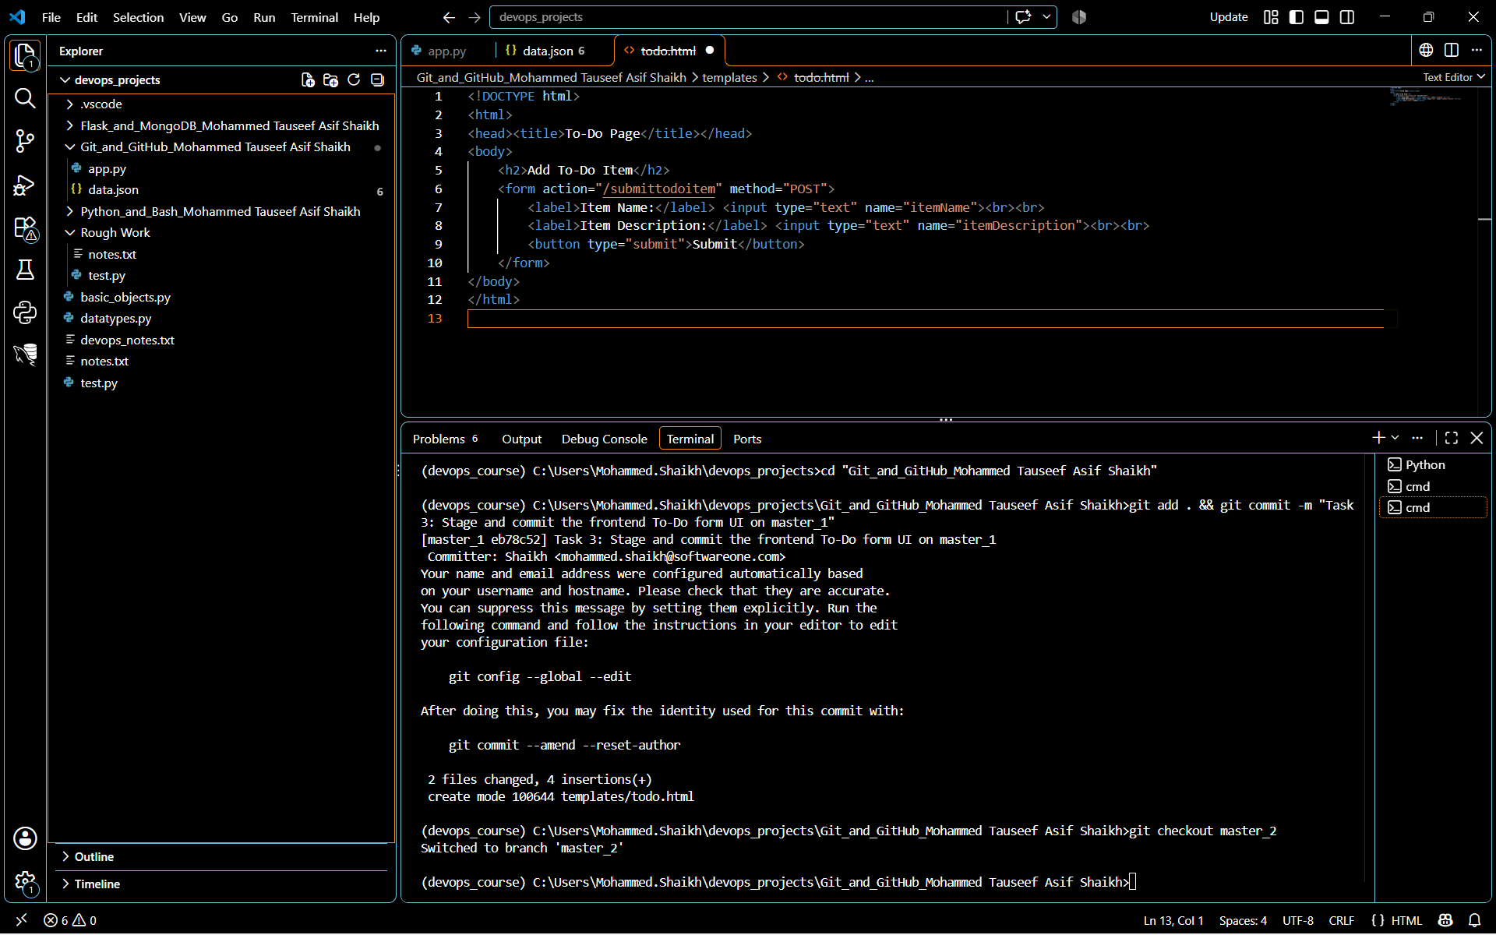

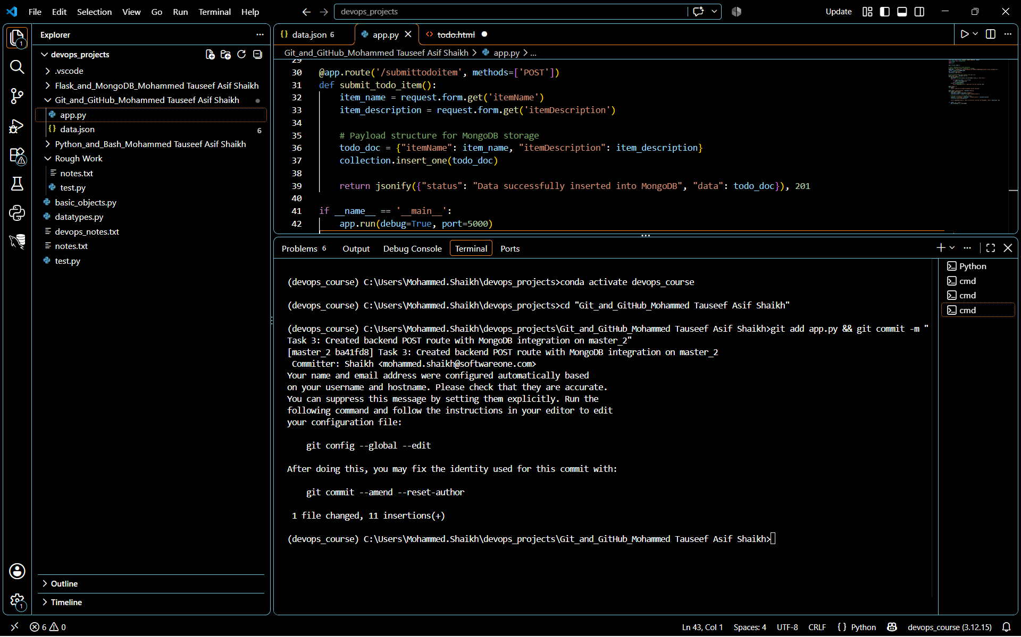

- Merging Changes: Merge the changes from both master_1 and master_2 into the main branch.
Commands Executed-

- git checkout main

Explanation: This returns your active workspace back to your baseline main branch so we can collect the features we developed on the other tracks.

- git merge master_1 -m "Task 3: Merge frontend To-Do page from master_1"
Explanation: This tells Git to take the code we committed on the master_1 branch (the new templates/todo.html page and the updated /todo server endpoint routing inside app.py) and bring it completely into the main production line history.
- git merge master_2 -m "Task 3: Merge backend API route from master_2"
Explanation: This tells Git to take the backend MongoDB insertion code from master_2 and blend it right into main alongside the frontend layout files we just merged.
- git add app.py && git commit -m "Task 3: Resolve parallel branch conflict by keeping both features"
Explanation: This tells Git that you have manually reviewed the overlapping changes, verified that both independent features are required, and are closing out the parallel merge transaction.
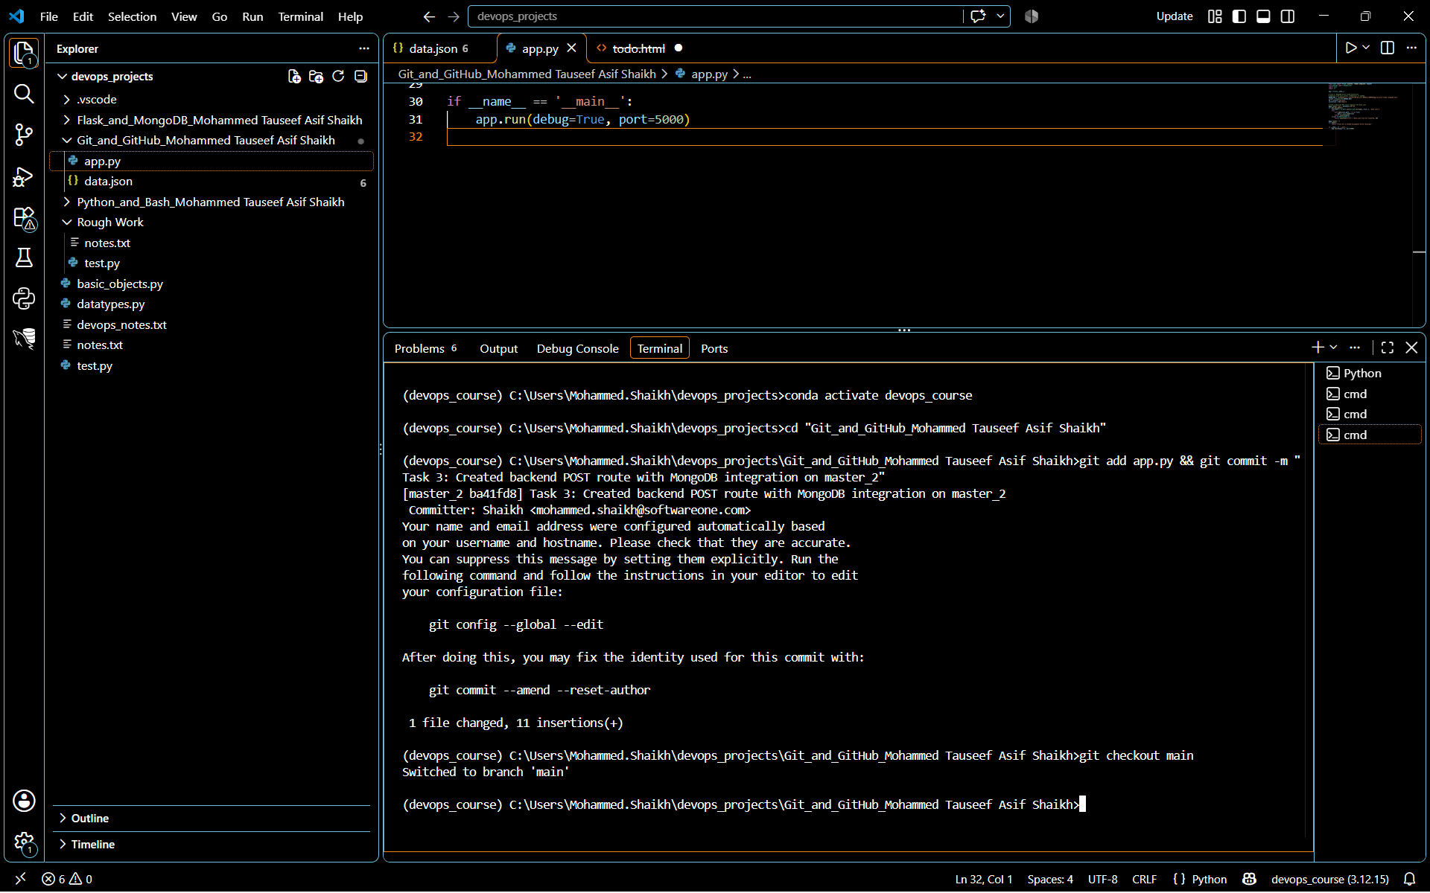
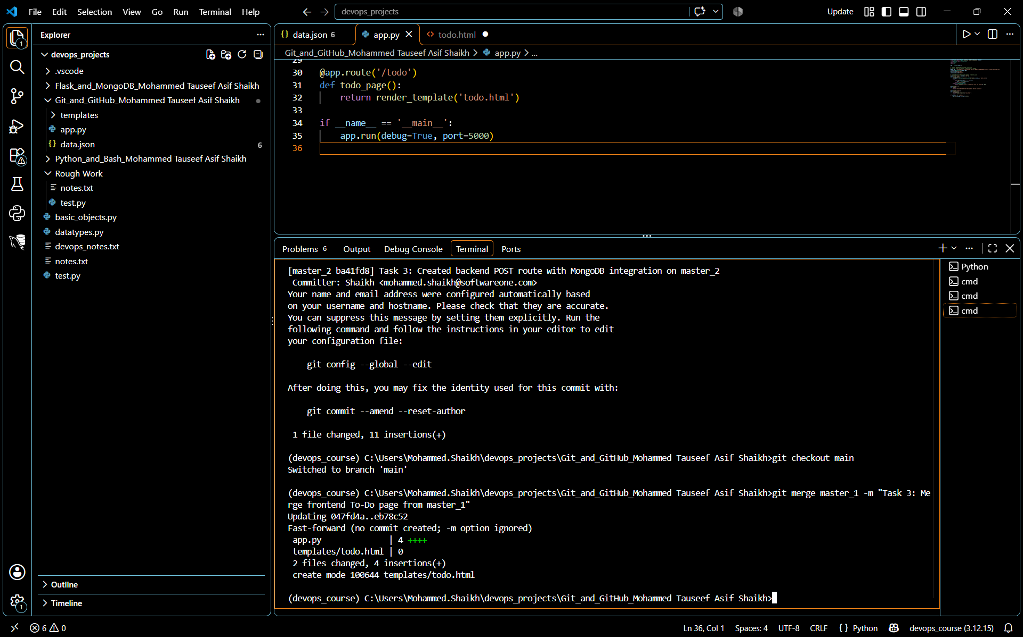
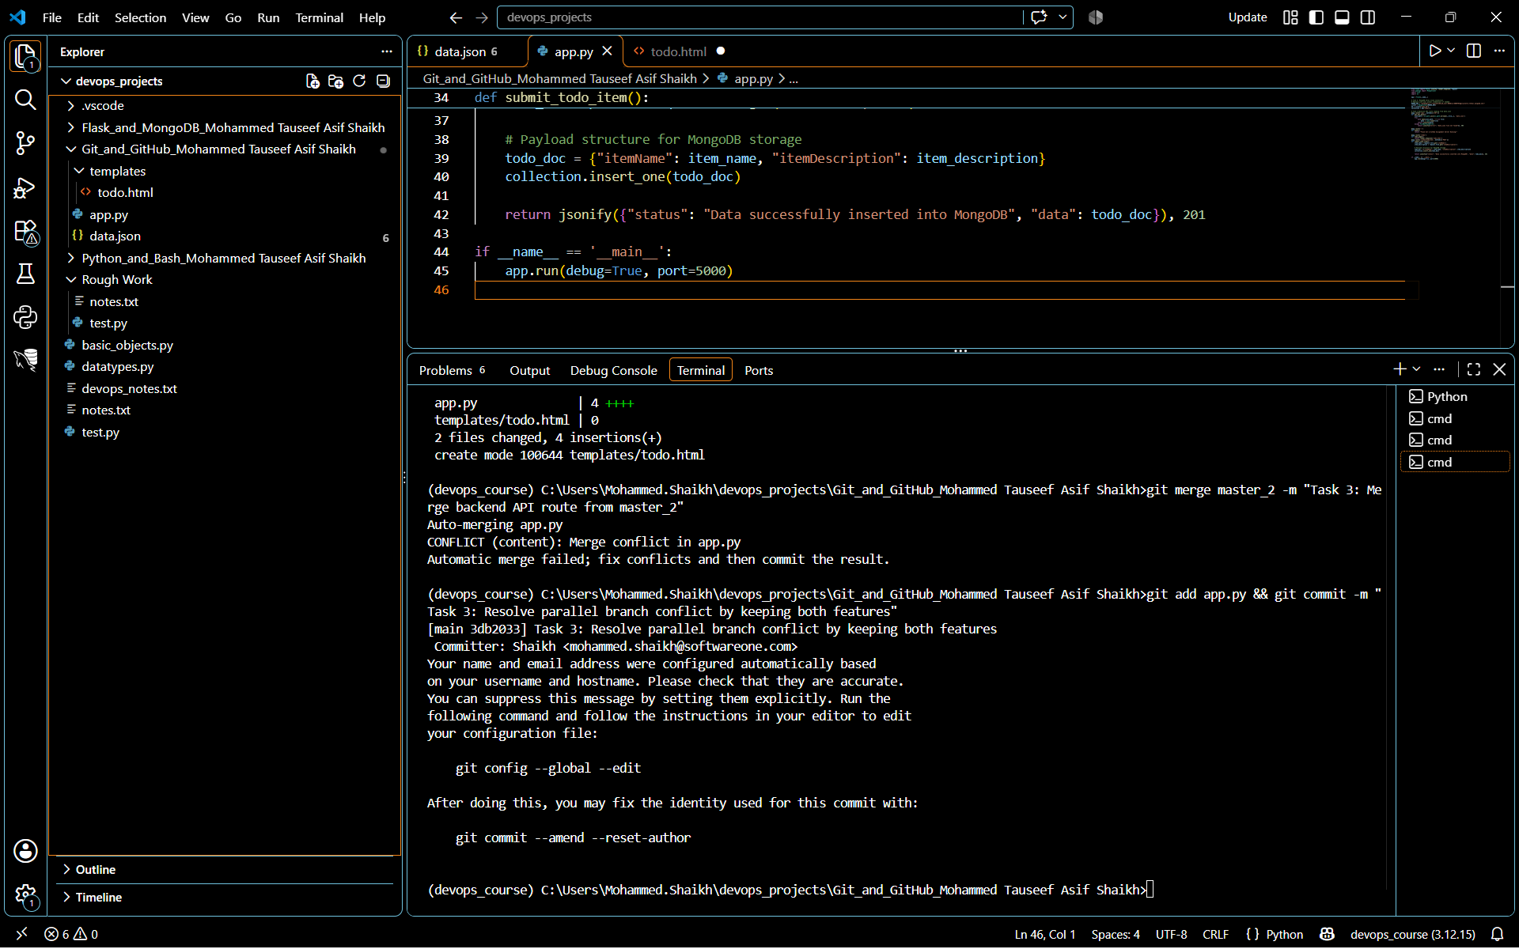

Task 4: Sequential Commits, Reset & Rebase
- Enhancing the To-Do Form in master_1: Add the following fields to the To-Do form: Item ID, Item UUID, Item Hash.

- git checkout master_1
Explanation: This moves my workspace back to the master_1 branch so we can add new tracking fields sequentially, exactly as specified in the assignment criteria.
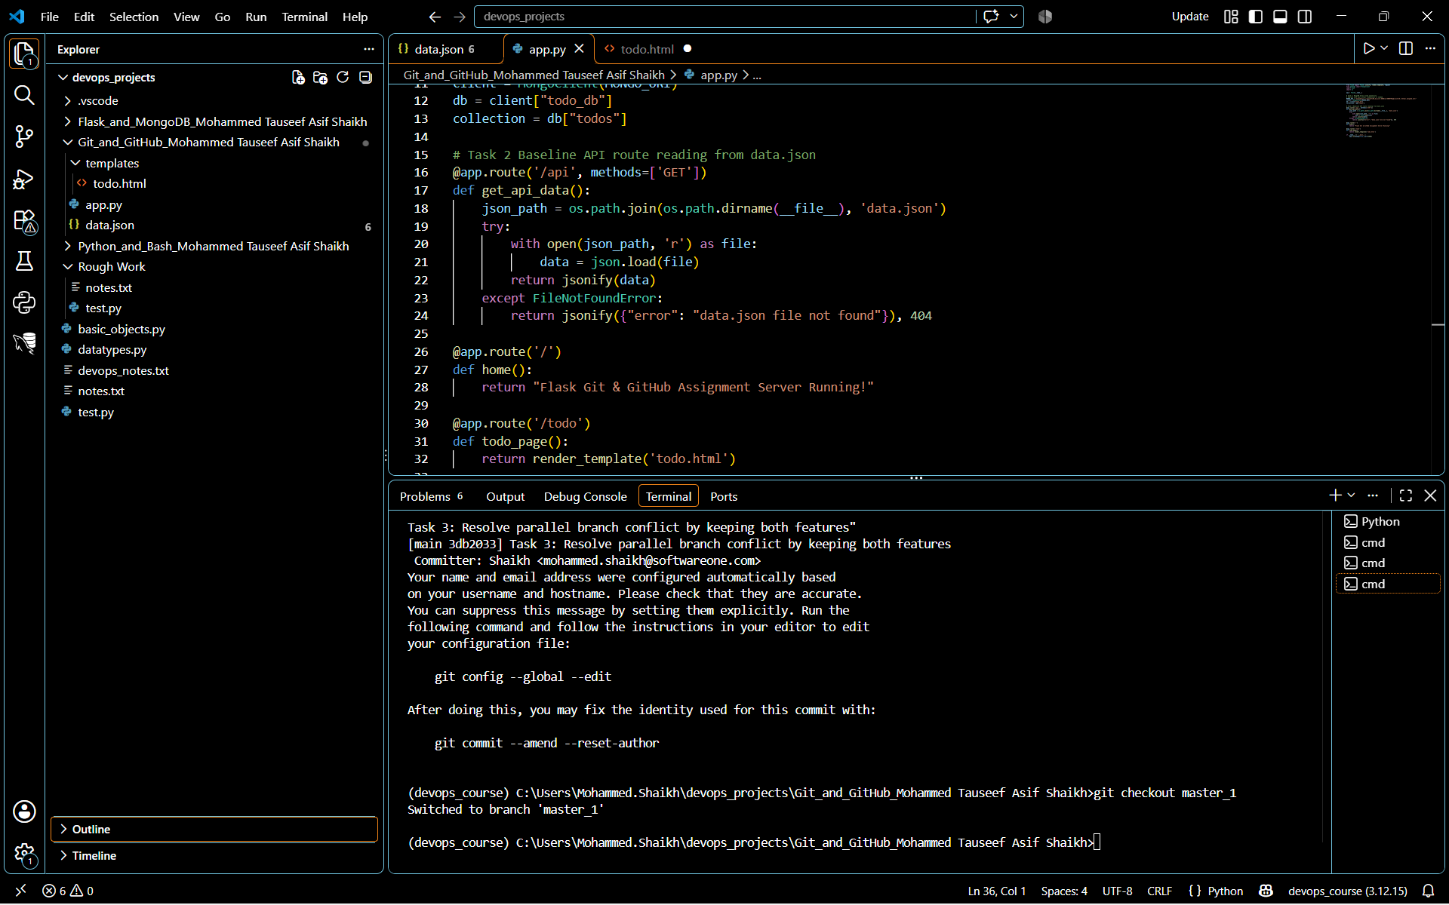
- git add templates/todo.html && git commit -m "Task 4: Add Item ID field to form"
Explanation: This stages your modified form file and creates a distinct historical snapshot containing only the new Item ID element.
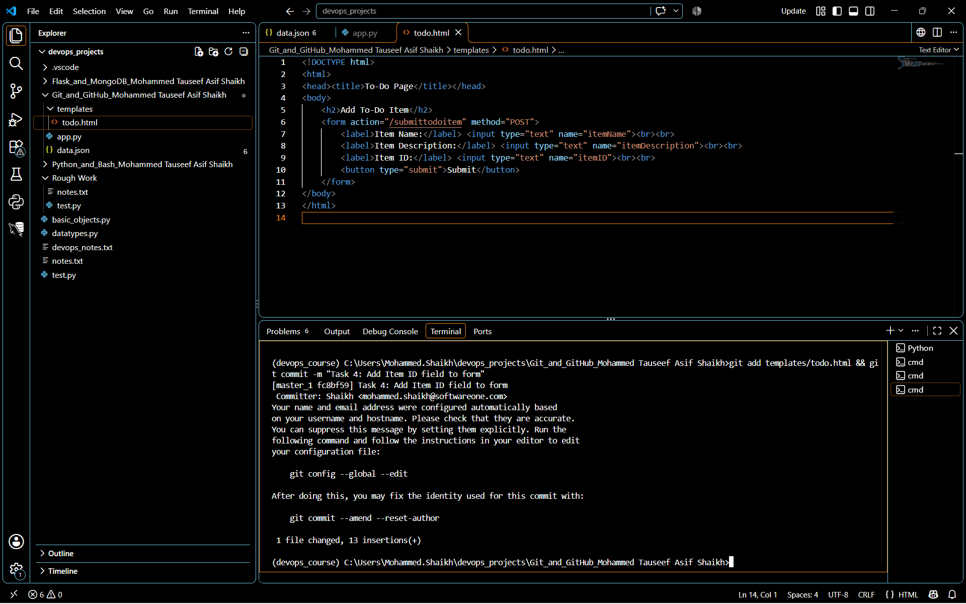
- git add templates/todo.html && git commit -m "Task 4: Add Item UUID field to form"
Explanation: This stages the file again and saves a second separate snapshot containing the new Item UUID input field.
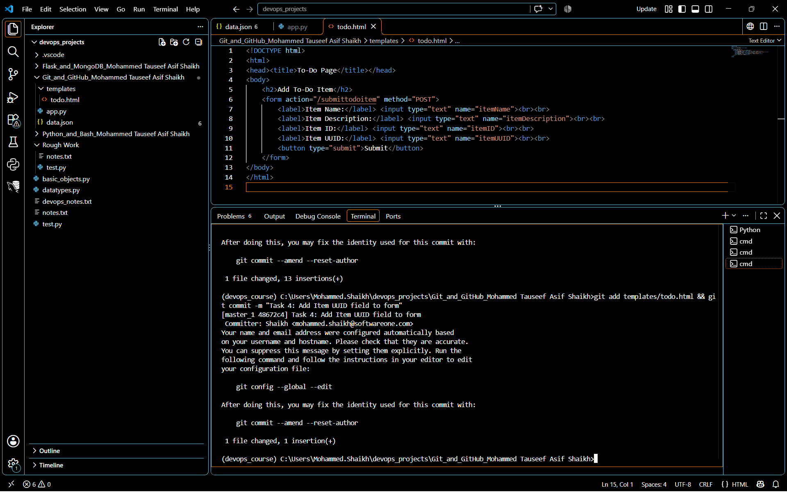

- Committing in Sequence: Add and commit each field separately — first commit: Item ID; second commit: Item UUID; third commit: Item Hash.

- git add templates/todo.html && git commit -m "Task 4: Add Item Hash field to form"
Explanation: This captures the final individual field state, completing your sequence of three distinct historical commits on the master_1 branch.
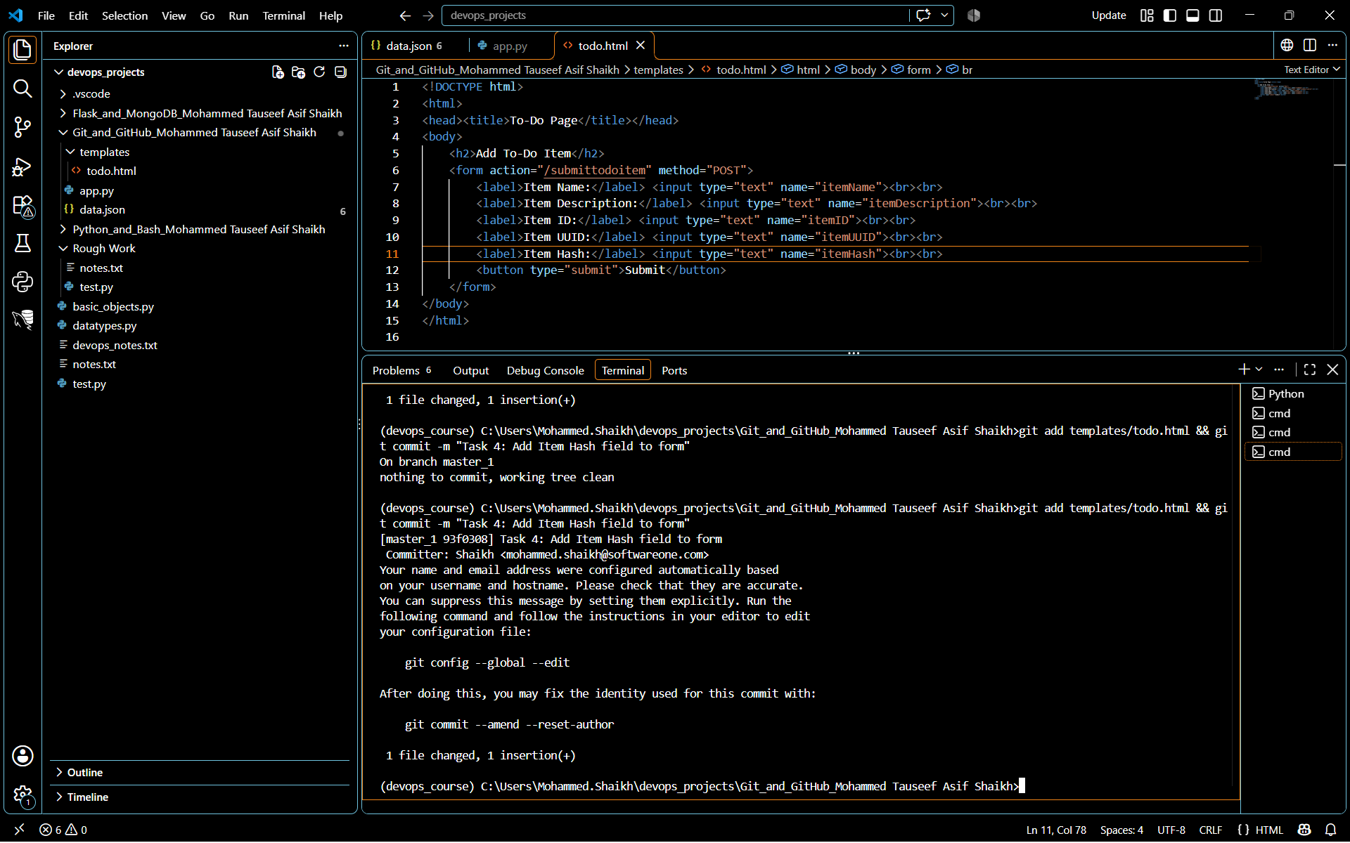

- Merging to main: Merge the master_1 branch into the main branch.

- git checkout main
Explanation: This moves your active workspace back onto the main branch so we can prepare to ingest the newly created sequential timeline history.
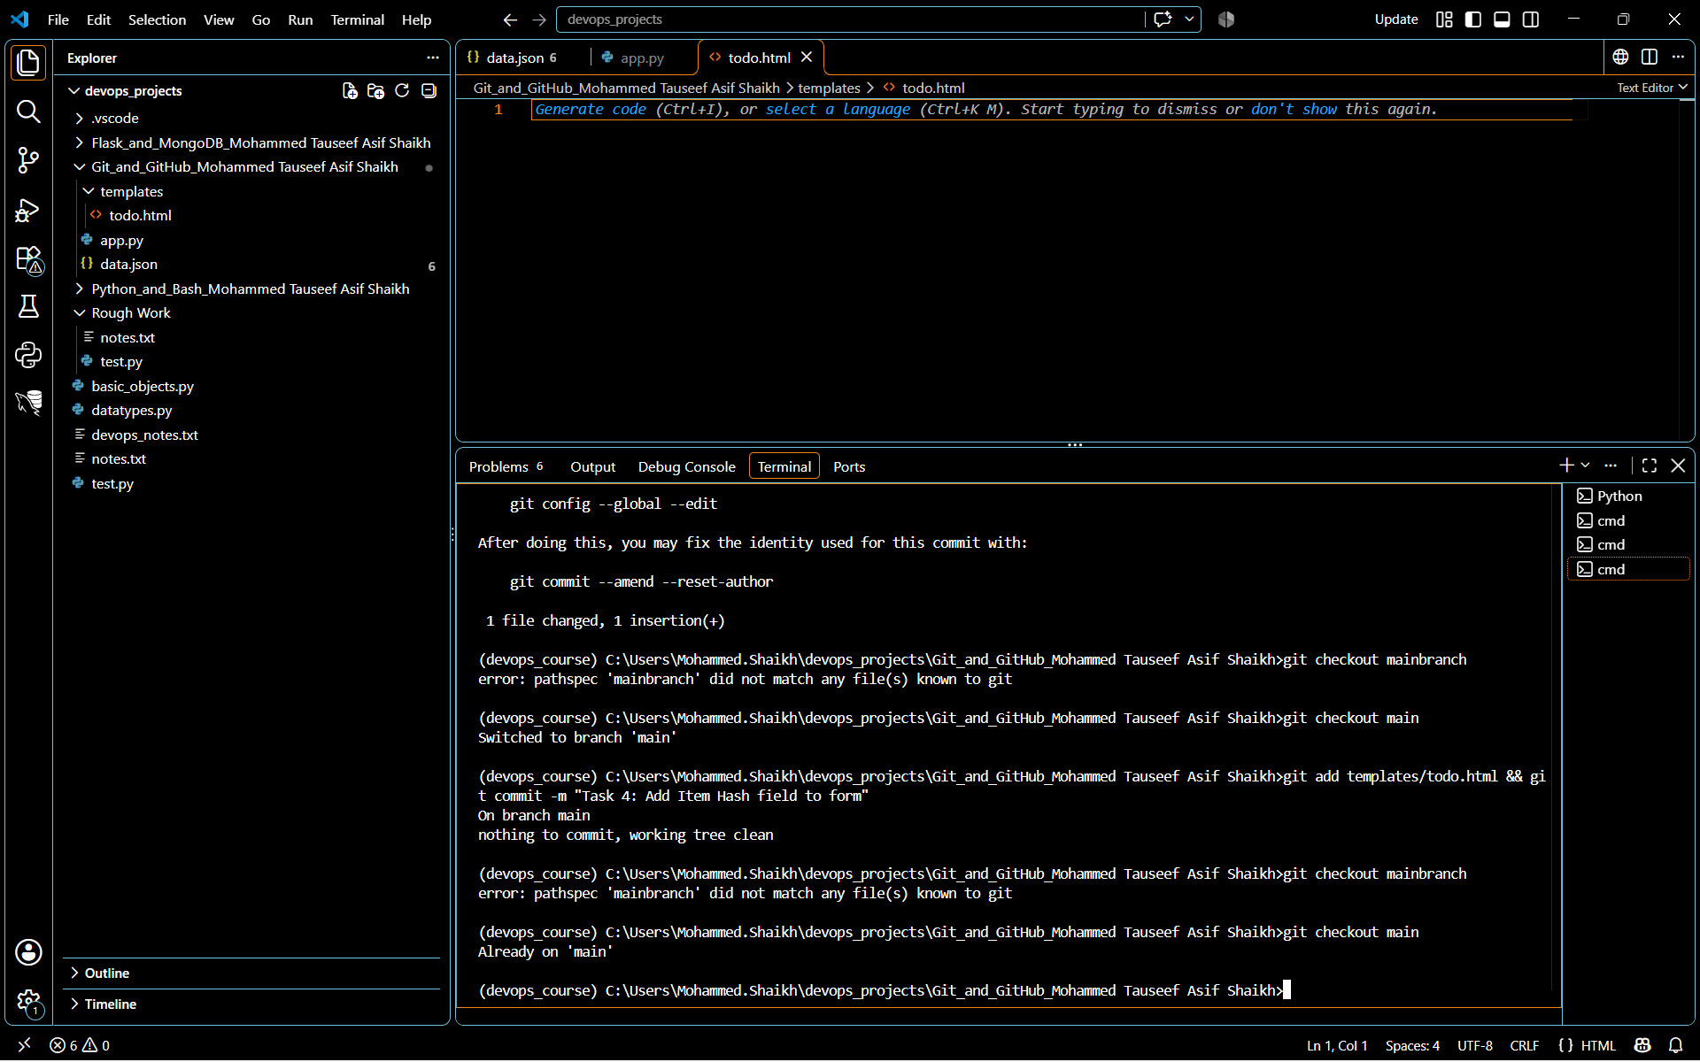
- git merge master_1
Explanation: This tells Git to take the three sequential commits we just made on master_1 (adding the ID, UUID, and Hash fields) and incorporate them directly into the primary main branch.
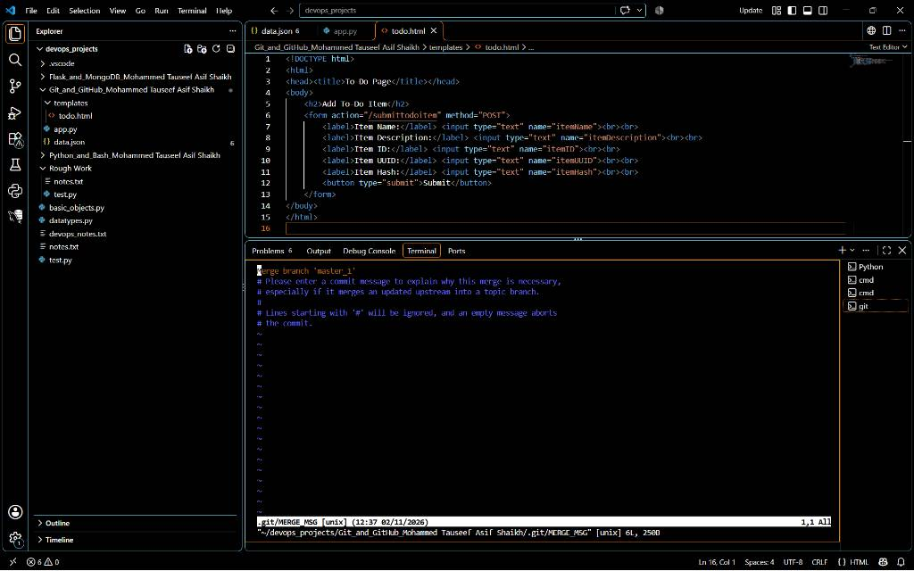
- git log --oneline -n 5
Explanation: This asks Git to print out a concise, single-line map of the last 5 tracking updates we created. We need to view this log output on the screen so we can grab the alphanumeric hash ID of the "Add Item ID field to form" commit to complete our soft reset task!
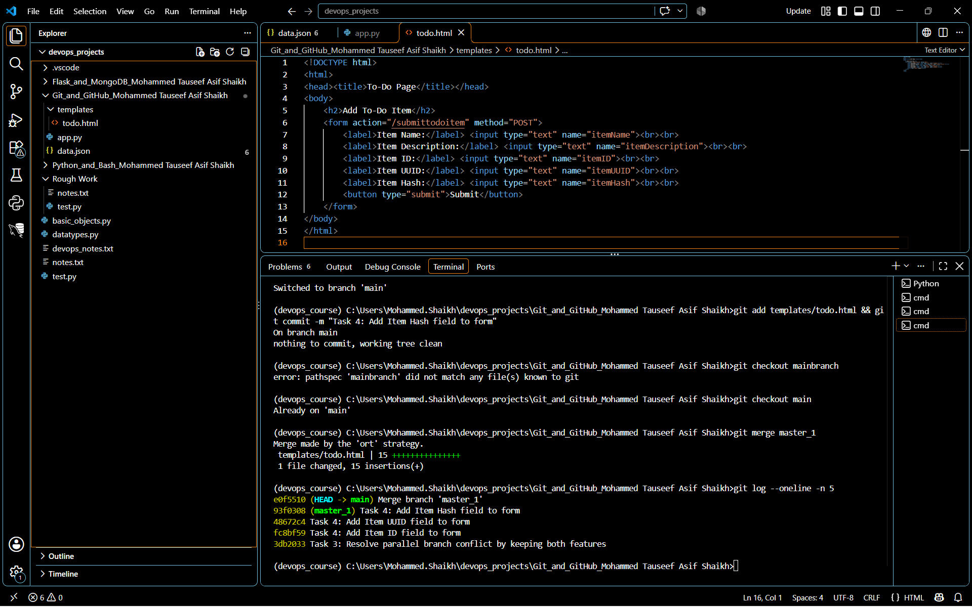

- Git Reset: In the main branch, roll back to the commit where only the Item ID field was added. Use git reset --soft to ensure changes remain staged, then re-commit this state and merge it to main.

- git reset --soft fc88f59
Explanation: This tells Git to move the branch timeline pointer back to the snapshot where only the Item ID field existed (fc88f59). Because we chose --soft, Git will keep all subsequent work (the UUID and Hash fields) intact and safely staged in your index preparation layer so we don't lose any code.
- git status
Explanation: This verifies that your changes are still safely preserved and currently staged in the index area.
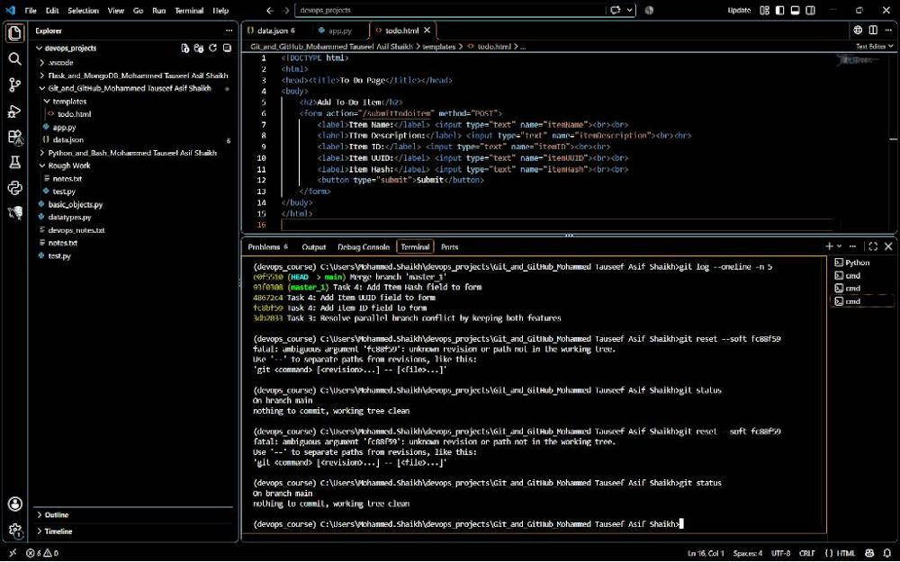
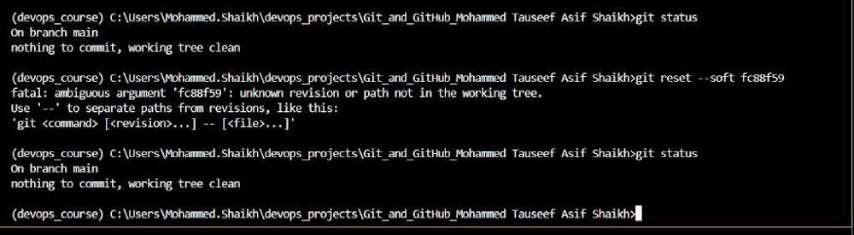
- git reset --soft HEAD~2
- git status
Explanation: This rolls back the history timeline pointer exactly two commits on your current branch. Because it uses --soft, all your enhanced To-Do form input changes are preserved and automatically placed in Git's staging area.
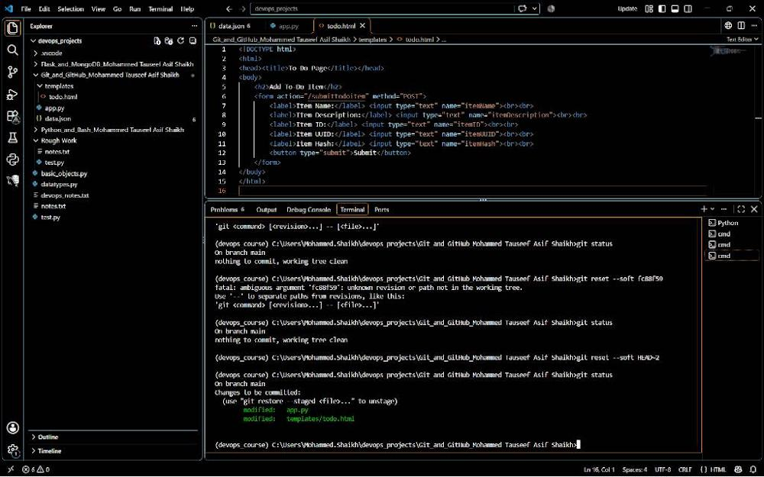
- git commit -m "Task 4: Main Branch rolled back: Only retaining Item ID form state"

Explanation: This cleanly saves the rolled-back state as a brand new consolidated snapshot directly on your main branch timeline, keeping the assignment project pristine.

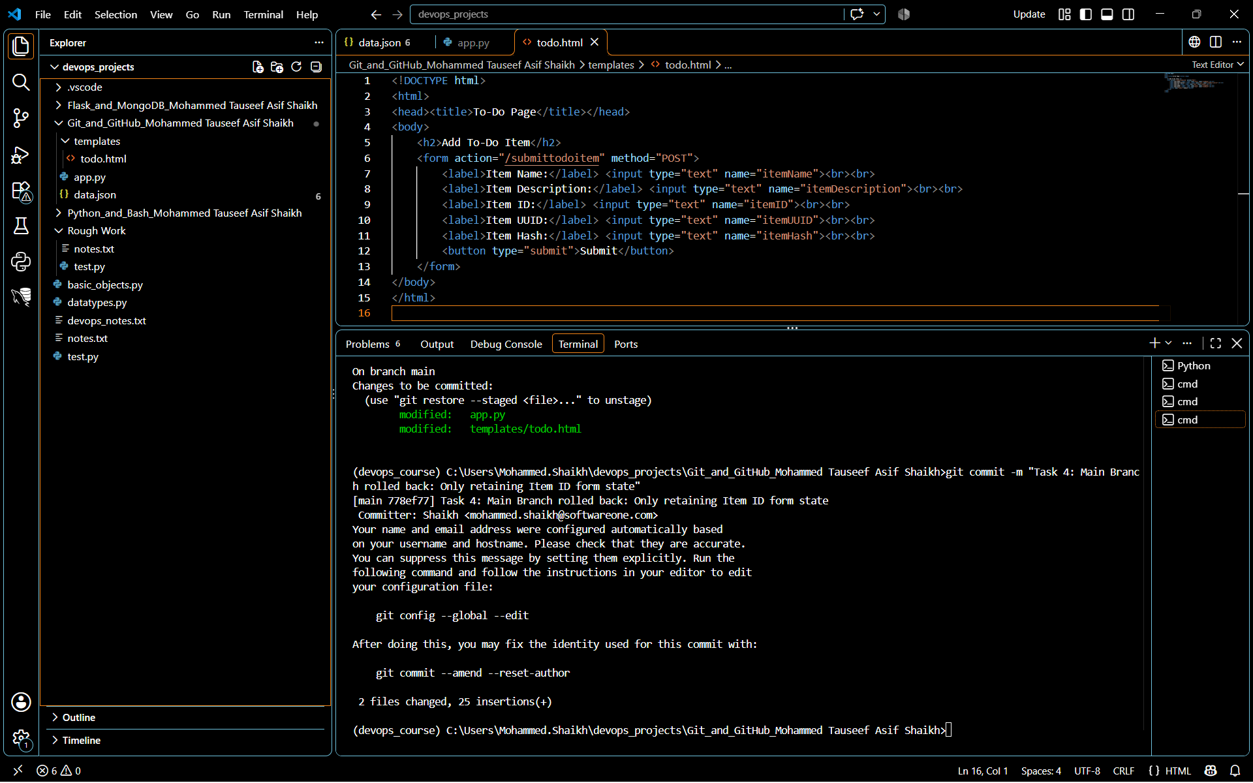

- Rebasing: Rebase the updated main branch changes onto master_1 using git rebase main master_1. Preserve individual commits (do NOT squash) to maintain commit history.

- git rebase main master_1
Explanation: This tells Git to take your master_1 branch, find its common ancestor with main, and reapply all of its separate historical commits one by one right on top of the updated main branch structure. This creates a clean, linear project history.
- git log --oneline --graph --all -n 6
Explanation: This prints a neat tree graph of your complete historical timeline. It will show your structured commits and prove to your mentor that the parallel feature branching, conflict handling, sequential adding, resetting, and rebasing have all been successfully completed.


