**Twitter Data Analysis Process**

**Report to Non-Technical Audience**

THE WHY? (Hypothesis Selection):

What you intend to investigate

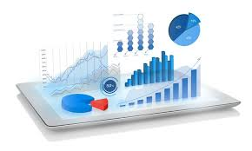

VISUALIZE

Get Data From Twitter by Filtering using the Hashtag valentines

(specify time and data size)



* Clean the data
* Drop Unwanted features
* Extract Features from others
* Redefine new dataset

