CEE6580

Spring 2018

HW #2 UPDATED

Due 3/6/2018

Can be done in groups up to 3 people or individually.

**Problem 1. (20 pts)**

One of the promising applications of Microbial Fuel Cells (MFCs) is in the treatment of Wastewater.

a) Calculate how much electricity (kW) could theoretically be generated by the Ithaca Area WWTP if they were to install MFCs for electricity generation to destroy influent BOD. Assume all the electrons in the WW organic matter could be harnessed (transferal of the eeqs from the WW organics through an MFC circuit to O2 to form H2O) and that EACH ELECTRON goes through a 1 Volt voltage drop in the MFC circuit. SHOW all Work.

NOTE:The Ithaca WWTP treats an average of 6.5 million gallons per day of wastewater. This WW corresponds to 7200 pounds (3273 kg) per day of BOD (biochemical oxygen demand). RECALL THAT ELECTRICAL POWER (WATTS) = I*V WHERE I is CURRENT with units of amps (1 amp = 1 COULOMBS PER SECOND)

***Current of electrons flowing through plant:***

***I = F*eeq/second***

***I=96400C/eeq *(7200 lbBOD/day) *(454 g/lb)*(day/86400 sec)*(1eeq/8g BOD)***

***I= 455,890 C/s (amps)***

***For an MFC assume direct electricity production***

***Assuming a maximum of 1 V drop in an MFC,***

***Pmax = 456 kW***

b) Why would this theoretical level never be reached? What are the potential drawbacks of applying MFCs to wastewater treatment?

***- Unproven technology***

***- expensive catalyst materials***

***- slower treatment efficiencies than activated sludge processes(less effective BOD treatment for same residence time)***

***-inefficiencies in system (e.g. losses in circuit/culture)***

**Problem 2 (20 points).**

For the salicylate monooxygenase (EC:1.14.13.1) of Pseudomanas sp. find its entry on the BRENDA enzyme database.

1. write out the full stoichiometry of the reaction it catalyzes with salicylate.

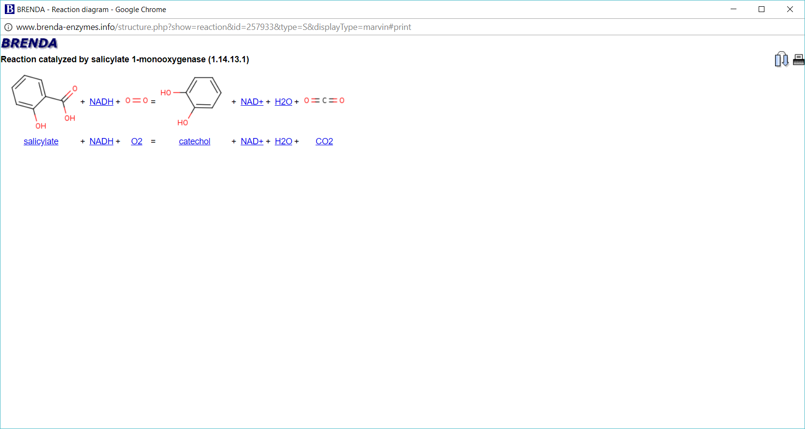

1. using parameters on the EC entry page write out a generalized kinetic rate expression for the disappearance of salicylic acid over time in a batch reactor in the presence of benzoate.

***NOTE benzoate is a competitive inhibitor of salicylate. kcat or turnover rate (moles/mole/sec) are alternates for the specific max transformation rate by the enzyme***



(c) when benzoate and salicylate are both present at 0.1μM, and NADH and O2 are both much greater than their respective Ks values, what is the specific salicylate utilization rate (micromoles/(L*time)? Assume a level of 50 nanomoles (nano = 10-9) of enzyme per L. (== 2.6 mg enz/L)

***The high concentrations of O2 and NADH relative to their respective Ks values, means the last two terms in the (b) eq’n are unity (=1).***

***Different acceptable answers depending on which parameters values were selected from the website. MAKE SURE TO LIST ACTUAL PAPERS WHERE PARAMETERS COME FROM.:***

***e.g.***

***Vmax = 5 umol/(min*mg enzyme) (Balashova et al., Biodegradation , 1999),***

***Km = 1.6 x10-6 M (Suzuki et al., J Biochem)***

***KI for benzoate= 3.1 x10-3 M (White-Stevens J Biol Chem, 1972)***



***Then using the enzyme concentration of 2.6 mg/L you get:***

***0.294*2.6 = 0.76 umole/(L*min)***

***If you chose Vmax = 0.58 umol/(min*mg enzyme) (Bushan et al AEM 2004 p4040); Ks= 1.6 x10-6 M (Suzuki et al., J Biochem), and KI = 3.1 x10-3 M (White-Stevens J Biol Chem, 1972)you get 0.03 umole/(min*mg)*2.6 mg Enzyme/L = 0.078 umole/(L*min)***

***If you chose to use the turnover number (units of moles S/(mole Enz*time)) other answers will result.E.g. for Pseudomoans sp:***

***Turnover = 0.00075/s (0.00075 mol S/(mol E*s)) (Huang, S.T.; Teng, C.J.; Lee, Y.H.; Wu, J.Y.; Wang, K.L.; Lin, C.M.; Anal. Chem. 82, 7329-7334 (2010)***

***Ks= 1.6 x10-6 M (Suzuki et al., J Biochem), and KI = 3.1 x10-3 M (White-Stevens J Biol Chem, 1972)you get***

***4.41x10-5 mole S/(moleEnz*s)*50x10-9moles enz/L***

***= 2.2 x10-13 moles/(L*s) = 1.32x10-11 moles/(L*min) = 1.32 x 10-5 umoles /(l*min)***

***Other answers may result if a student found different parameters***

**Problem 3 (20 pts)**

Bioenergetics of growth on naphthalene.

Naphthalene is the lightest of the polynuclear aromatic hydrocarbons (PAHs).

Using web and print resources,

a) Calculate how much free energy is theoretically available from the complete aerobic “mineralization” (i.e. oxidation completely to CO2) of one eeq of naphthalene with oxygen as the EA. (Hint: b/c naphthalene doesn’t appear in the Bioenergetics half rxn table, youll need to write out the balance redox reaction with O2 as the EA, then use free energies of formation of all products & reactants (available through the Knovel link at the website) to calculate ΔG0’r ). ΔG0’ of formation for O2 is zero, for water is (-237 kJ/mole) for naphthalene is (+223.6 kJ/mole) and for CO2 is (-394 kJ/mole).

***1 eeq of naphthalenes = 1/48 of a mole (4*n+b-2*c-d = 48 eeq per mole)***



***Therefore, the delG for the oxidataion of 1 eeq of naphthalene can theoretically generate is 106.4 kJ/eeq (=25.5 kcal/eeq).***

b) Using KEGG (<http://www.kegg.jp/kegg/kegg2.html>) or Metacyc (<https://metacyc.org/>) searches, find pathways that biodegrade naphthalene. Determine the fraction of the theoretical energy that actually gets captured in the form of ATP. Assume the pathway through catechol is used. Consider ATP produced by both substrate level phosphorylation and by oxidative phosphorylation (OP) via the electron transport chain. For each NADH, 3 ATP are produced via OP and for each FADH, 2 ATP are produced. (At biologically relevant concentrations of ATP, ADP and Phosphate, ΔG for the formation of ATP from ADP & Pi is +12.5 kcal/mole ATP – 52.5 kJ/mole ATP). Recall that for pyruvate (AND Acetyl-CoA) going through the TCA cycle, the TCA cycle released 3 CO2s (2 CO2), 4 NADH (3 NADH), 1 FADH (1 FADH), and one ATP equivalent (1 ATP) via substrate level phosphorylation.

***YOU MUST check each enzymatic step to account for small organic molecules (glyoxylate, pyruvate or acetylCoA, e.g) and NADH & ATP consumed or produced at the substrate level. Make sure you have all 10 carbons accounted for.***

***See below for pertinent pathways in the Naphthalene and Benzoate pathways from KEGG.***

***Net from naphthalene to catechol:  
“Upper pathway” from Napth to salicylic acid then to catechol: Naphthalene (10 Carbons) = catechol + pyruvate + CO2 (6 + 3 +1 =10 carbons)***

***From there two options exist for the lower pathway taking catechol.***

***Option A (“ortho” cleavage of catechol): For the lower pathway which takes catechol through cis-cis-muconate (starting with 1.13.11.1) the net lower pathway will be: acetyl CoA & 1 succinyl CoA (2 + 4 = 6 Carbons). You then follow succinyl CoA to pyruvate +CO2 (succinylCoA to succinate to fumarate to S-malate to oxaloacetate to Phosphoenol pyruvate to pyruvate). This has a net production of 1 NADH and 1 GTP (=ATP equivalent). The combined lower and upper pathways ultimately will produce:***

***2 CO2***

***1 NADH + 1 ATP (from succinylCoA to pyruvate)***

***2 pyruvate: 8 NADH, 2 ATP, 2 FADH2, 6 CO2***

***acetylCoA: 3 NADH, 1 ATP, 1 FADH2 2 CO2***

***Net: 12 N (=36 ATP); 3 F (6 ATP), 4 ATP = 46 moles ATP total per naphthalene x 12.5 kcal/mole ATP = 575 kcal/mole = 2406 kJ/mole or 50 kJ/eeq***

***Therefore the efficiency of capture is  
50/106.4 x100% = 47% efficiency***

***Option B (“meta” cleavage of catechol):. If choose 2-hydroxymuconate semialdehyde*** ***as the product of catechol (1.13.11.2) your net from the lower pathway will be: 1 acetaldehyde, 1 formate, and 1 pyruvate (2+1+3 = 6 carbons)***

***Acetaldehyde is converted to acetylCoA: 1 acetaldehyde = 1 acetylCoA + NADH.***

***Formate is converted to CO2 and 1 NADH***

***So the net production of the upper and lower pathway would be:***

***2 CO2***

***1 NADH (from acetaldehyde to acetylCoA)***

***1 NADH (from formate to CO2)***

***1 Acetyl CoA: 3 NADH, 1 ATP, 1 FADH2, 2 CO2***

***2 pyruvate: 8 NADH, 2 ATP, 2 FADH2, 6 CO2***

***Net: 13 N (= 39 ATP), 3 F (6 ATP), 3 ATP = 48 ATP***

***= 600 kcal/mole = 2510 kJ/mole = 52.3 kJ/eeq***

***Net: 52.3/106.4 x100% = 49 % efficiency***

c) How does this compare to the E=0.6 value used by McCarty (in the Gossett bioenergetics packet)

***In both cases it is lower than the assumed efficiency used by McCarty et al.***

**Problem 4 (20 pts)**

Exploring Reactor performance for TCE degradation in a CSTR. Let’s assume the following parameters apply to *Dehalococcoides* growing anaerobically on TCE.

K = 0.1 umole/L

qmax = 5.28x 10-9 umoles/cell/day

Y= 1.6 x 108 cells X/umole TCE

b= 0.05/d

V= 1 L

So = 200 umoles/L

Assume Monod kinetics apply, there is no other limiting substrate besides TCE, and that there is no biomass in the influent.

1. First let’s consider steady state operation predictions.
   1. What is the minimum θc (residence time) (and maximum Q in L/day) to avoid cell washout at this So?
   2. If you operate at twice this θc, what will be the steady state effluent concentrations of S and X?
   3. If you operate at 10 times this θc, what will be the effluent concentrations of S and X?



1. Using Stella or Excel to model X and S in this system during startup. Above we solved for the steady state concentrations of S and X under different θc. Now we will explore the dynamics of the effluent S & X during “startup” of a reactor.
   1. Assume an initial inoculum level in the bioreactor of X,initial = 1x106 cells /L and S,init = 200 umoles/L. Then run the model with Q =0.25 L/day with 200 umoles/L influent (as in part “a” above). Plot X and S over time. What are the steady state levels ultimately? How long did it take for the system to come to 95% of the steady state values for X & S?
   2. Chose one kinetic parameter (qmax, Y, b, K) to change the value of. Vary from the set values down to 20% (1/5th the value) and up to 500% (5x the value). What is the effect on steady state X & S? Present plots.
   3. Hand in your model electronically via Blackboard.

**Problem 5: (20 pts)**

a) Create an excel spreadsheet and plot ΔG versus electron acceptor concentration for the following respirations linked to glucose catabolism. Assume 25°C and the following concentrations of other chemical species: HCO3- = 70 mM; CO2 = 0.02 atm; glucose = 10 mM; Fe+2 = 0.1 mM; H+ = 1E-7 M (pH=7); N2 = 0.8 atm; H2S = HS- = 0.0001 mM.

|  |  |
| --- | --- |
| Electron Acceptor | Range of concentration to consider |
| O2 | 0.000002 atm – 0.2 atm |
| SO4-2 | 0.000001 M – 0.1 M |
| Fe+3 | 0.000001 M – 0.5 M |
| NO3- | 0.000001 M – 0.1 M |

b) If a growth media contains 10 mM glucose as the electron donor and the following mixture of Electron Acceptors, predict which type of organism has the thermodynamic advantage – aerobes, nitrate reducers, sulfate-reducers, or iron reducers.

|  |
| --- |
| O2 = 0.00005 atm |
| SO4-2 = 100 mM |
| Fe+3 = 1 mM |
| NO3- = 1 mM |

