CEE6580 HW4b: Comparative Genomics of Methanotrophic Bacteria.

Methanotrophs are organisms that can grow with methane as a sole carbon and energy source. Both aerobic and anaerobic methanotrophs exist though the aerobic types are the most widespread and well-studied. Reminder, there are a variety of methanotrophs now known, as summarized below.

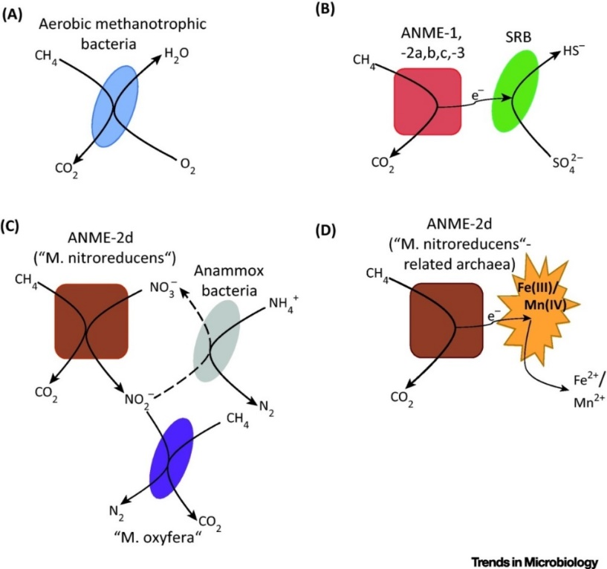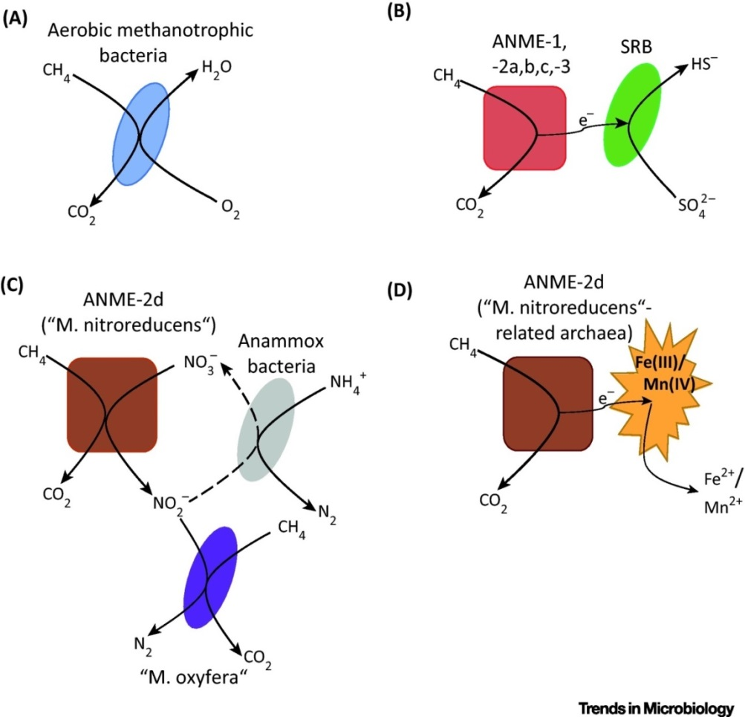

ANME: anaerobic methane-oxidizing archaea

SRB: sulfate-reducing bacteria

0.5 μm

(Dalton, 2005)

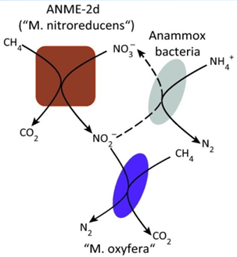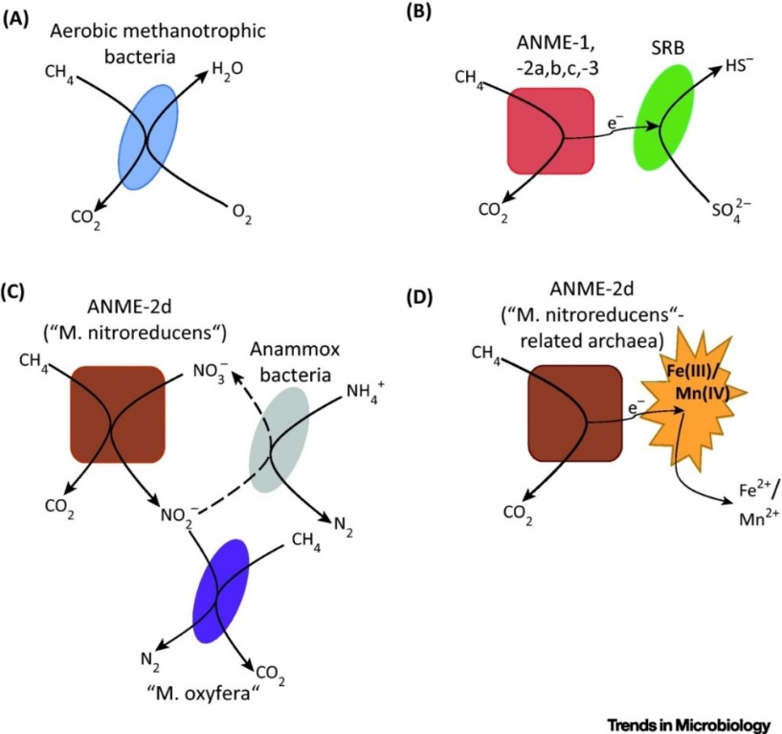

Bacterial types

Archaeal types

For this HW question we will focus on a particular genus of aerobic methanotrophs (*Methylocystis*). We will use resources at the Joint Genome Institute’s Integrated Microbial Genomes website: <https://img.jgi.doe.gov/cgi-bin/m/main.cgi>

1. (15 pts) Core genome determination. How many genes are conserved across the various *Methylocystis* genomes (this is defined as the “core genome” for the genus)? What approximate fraction of the whole genome is this?

For this analysis you will first collect all the Methylocystis genomes into a Genome Cart then go to Find Genes/Phylogenetic Profiler/Single Genes. Select one of the genomes in your cart and Add to the

1. (15 pts) *Methylocystis parvus* OBBP is a methanotroph with the ability to accumulate poly-hydroxybutyrate, or PHB, which is one of the polyhydroxyalkanoate (PHA) polymers. Do all members of the genus have this ability to produce PHB starting from acetyl-CoA (ie. They have all the enzymes needed to go from acetyl-CoA to PHB)? If not, which genes are missing from the current annotations? NOTE: the Polyhydroxybutyrate synthesis pathway is part of the KEGG pathway called “Butanoate metabolism” (under the larger category of Carbohydrate metabolism). NOTE there are different ways to approach this problem but I encourage starting with the pathway in strain OBBP and click on the specific enzymes in the pathway. This will take you to the info page for that specific gene in OBBP. Then scroll down and chose the option “[Show neighborhood regions with this gene's bidirectional best hits](https://img.jgi.doe.gov/cgi-bin/m/main.cgi?section=GeneNeighborhood&page=geneOrthologNeighborhood&gene_oid=2549982173&show_checkbox=1&cog_color=yes&use_bbh_lite=1)”

See following pages for hints/screenshots for analyses you can use in IMG

Some key screen shots from the website are provided below to help you navigate the resources you will need

First you will need to collect genomes of Methylocystis strains. One way to do that is by using the Genome Search tool at IMG:

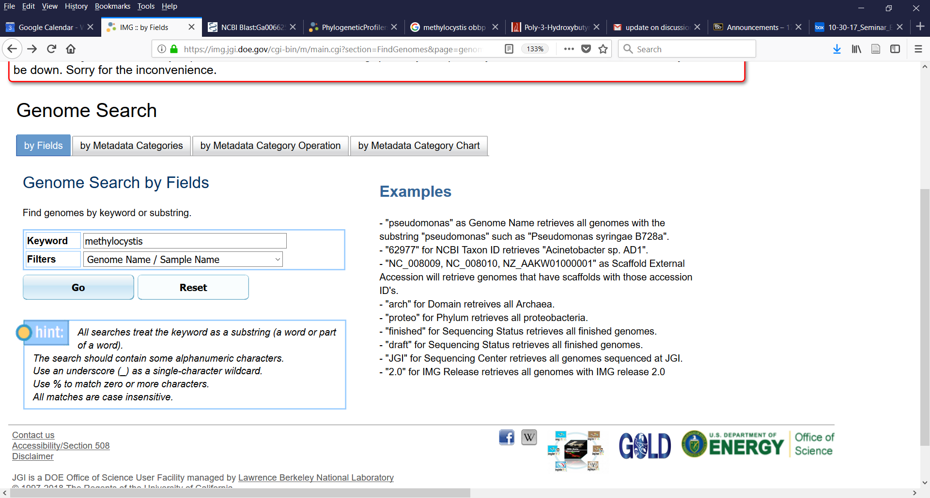

Select all the genomes you find and add them to your Genome cart.

To determine the core genome among all Methylocystis genomes go to the pull down tab “Find Genes” and chose Phylogenetic Profiler/Single Gene:

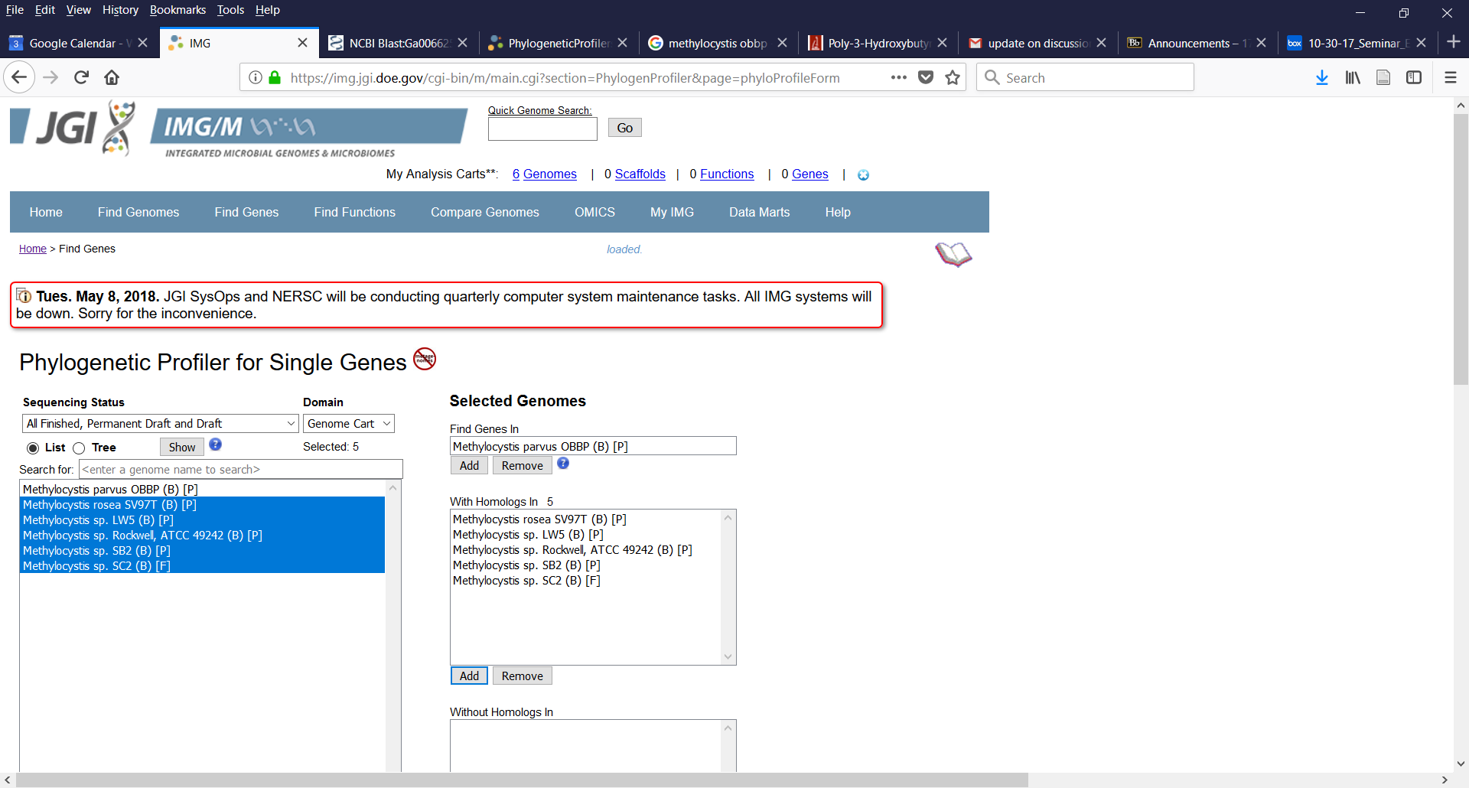

For the Polyhydroxybutyrate synthesis pathway it is part of the KEGG pathway “Butanoate metabolism”. The pathway elements found in *Methylocystis parvus* OBBP are shown here with the final enzyme in PHB synthesis highlighted:

