CEE6580
HW #4
Case study: Use of omics data to study PCE-dechlorinating enrichment cultures containing Dehalococcoides ethenogenes strain 195
(Individual or small group assignment)
Theme: working with Omics data

Part a (this document): Microarray data for Dehalococcoides genes’ expression analysis
Part b (for next week): Community rRNA high throughoutput sequencing data for the D2 community

Introduction to approach:

mRNA (messenger RNA) is the intermediate between the genes encoded on the genome and the proteins expressed within the cell. Therefore, they signal the initial investment a cell makes in order to produce a protein or regulatory response. The transcriptome is the collection of all mRNA expressed in a given organelle, cell, or tissue of interest. Therefore, microarray technology must be robust enough to capture a significant portion of these genes in order to fully characterize the transcriptome.

Microarray technology is a semi-quantitative experimental method to monitor the levels of thousands of RNA transcripts simultaneously, enabling the researcher to track the entire transcriptome of an organism. Microarrays are devices with probes that are complimentary to the target mRNAs of interest to a surface or bead. Thousands of these probes are laid out in grids, for example the data analyzed in this assignment had 8 separate arrays laid out on a single glass slide with each array containing 15,000 probe spots. The sample mRNA to be studied is reverse transcribed into cDNA and then labeled with a fluorescent dye, most commonly Cy3 or Cy5. In the hybridization step the cDNA binds by complementary base-pairing to the probe of interest – thereby binding it to the surface at the probe location. After a wash step to remove unbound cDNA, a specialized scanner then reads each probe spot on the microarray and records its fluorescence intensity.

For this worksheet, you will be working with two color microarray data. In this experimental setup, two separate samples are labeled with two distinct fluorescent dyes (for example, Sample A is labeled with Cy3 and Sample B is labeled with Cy5) and are hybridized with the same microarray. Therefore, the microarray scanner goes through and reads each probe spot twice, once for the Cy3 (red) and once for the Cy5 (green). Therefore, there is a red and green channel. Intensity in each channel is a measure of how much of that particular cDNA there was in the sample. If the levels of a particular mRNA are about the same, the red & green fluorescences will be about the same and the spot will appear yellow. A log ratio between the two signal intensities is often reported as an easy way to detect significant changes between the two samples. The log ratio is the Log(red channel/green channel). You can consider this a technical calculation of how “yellow” the spot really is. Perfectly yellow spots have a log ratio of zero ( a ratio of 1).

Worksheet:
Posted to the Blackboard site, you will find an Excel document () of data values from a microarray experiment. You will be analyzing data from two microarrays (out of dozens that were part of a larger dataset to be analyzed in part b of the HW#4).

Background:
Environmental engineers study strains Dehalococcoides because the microorganisms are able to reductively dehalogenate halogenated organic compounds. Halogenated organic compounds are common and persistent environmental pollutants. These compounds include (but are not limited to) tetrachloroethene (PCE), trichloroethene (TCE), vinyl chloride (VC), polychlorinated biphenyls (PCBs), and chlorophenols.

In the dataset you will work with, our lab was focused on discovering the differential expression of D. ethenogenes’ genes in response to the environment in controlled lab studies. One of the first environmental parameters we varied in our study was how the electron acceptor, donor, and supporting nutrients were fed to the mixed community microbial reactors. Interestingly most dechlorinating organisms grow better in mixed communities and even the bioaugmentation cultures sold for in situ bioremediation are natural enrichment cultures. The basic metabolic interactions among community members of the “D2 culture” we will deal in this HW with are shown in the Figure 1 below (excerpted from a textbook chapter by Richardson, Chapter 14 of “Organohalide Respiring Bacteria” 2016). For D. ethenogenes, the halogenated compounds serve as electron acceptors. The electron donor for D ethenogenes is hydrogen (H2). Hydrogen is not fed directly in this community however. Instead, butyrate is fed - which is fermented by some of the microbial community members into hydrogen and acetate (see Figure 1).
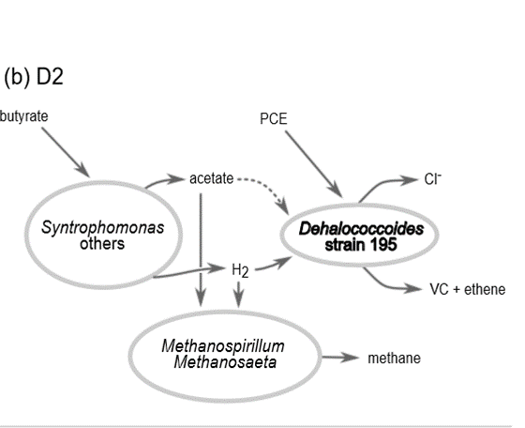
Figure 1. Metabolic interactions among various abundant microbes in the D2 dechlorinating enrichment (containing Dehalococcoides strain 195 as the sole dechlorinating organism). Note the key role of fermenters in providing 195 with both H2 and C source (acetate)

In CEE 6580 and other environmental engineering courses, you have learned about the differences between reactor designs. One of the first reactor differences that are emphasized is the distinction between a batch and continuous flow reactor. In relation to microbial cultures, batch studies are relatively easier to conduct as the researcher only needs to provide pulse inputs of the required nutrients. A batch system would be similar to having a localized point spill of TCE. However, batch reactors often do not reflect environmental settings. Most often D. ethenogenes is found in environments where a constant input of halogenated compounds is provided by a contaminant plume. Examples include contaminated groundwater and river sentiment. (See Figure 2 for a schematic of the differences between batch and continuously fed reactors).

(a)
(b)

Figure 2. Schematic comparison of the influent concentration of the substrates needed for metabolism for a (a) batch fed and (b) continuous fed reactor.

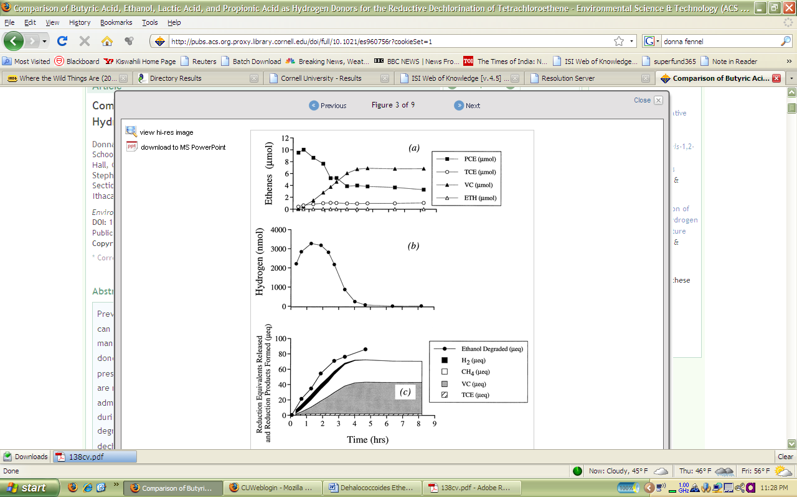

PCE, TCE, DCE
VC
ETH
Ethenes
Concentration
(a)

Hydrogen
Concentration

(b)
time
Figure 3. Time course plot of the chlorinated ethenes (a) and hydrogen (b) in the D2 mixed community culture containing Dehalococcoides ethenogenes after a batch (pulse) feed. (Fennell et al. 1997)
time
Figure 4. Hypothetical time course plot of the chlorinated ethenes (a) and hydrogen (b) in the D2 mixed community culture containing Dehalococcoides ethenogenes during s continuous feed. Similar to a chemostat.

The differences between these two regimes on a reaction product basis are displayed in Figure 3. and Figure 4. These graphs concern the dechlorination of PCE, which D. ethenogenes dechlorinates to TCE->DCE->VC and finally to ethene. Note that the hydrogen concentration in both Figure 2(b) and 4(b) increases at the very beginning. Take a moment to reason through the differences between the graphs.

In comparing the ethenes, PCE begins at a high level and is degraded away in the batch fed (Figure 3(a)) while it is almost nonexistent in the continuous fed (Figure 3(b)). The continuous fed culture utilizes the PCE at a very fast rate, allowing almost no buildup of the compound and low steady state levels of the compound.

The microarray data provided analyzes the gene expression differences between the batch fed and continuously fed system.

The first microarray is a control versus control experiment. The control in this case is a mixed community culture containing Dehalococcoides ethenogenes strain 195 sampled 6 hours after a batch feeding of PCE and butyrate (during active respiration).

The second microarray compares the control batch feed with the same culture supplied with a continuous feed of PCE and butyrate.

Working with the Data
The data is organized into DET probe numbers based on the location of each gene on the genome (e.d. DET0001 is the first gene in the genome). There is also a decoding key to provide more info on what each probe represents (see second worksheet in the Excel doc). The data sets represented are the processed fluorescence intensity (PFU), the log ratio between the red and green channels, and a p-value of an experimental fit already run on the data. The reason why the intensity is considered ‘processed’ is because it has been normalized across the array to correct for bad spots and also the background intensity was removed. The p-value is developed from a “fit” model that assumes no difference in expression level (=null hypothesis) and then rates the confidence (p-score) in that null hypothesis. A score of 0.05 or less represents a 95% confidence level that the null hypothesis can be rejected (i.e. there is differential expression). More stringent cutoffs can be placed – e.g for 99% or 99.9% confidence levels (p-scores of 0.01 and 0.001, respectively).

- 5 Points. For the PCE-Control Microarray, sort the data according to the PCE continuous feed sample (red channel). List the top ten unique probes (i.e. if the list appears as DET1, DET1, DET3, do not report the second DET1, we are looking for the top ten unique probes, so disregard multiple entries).

- 5 Points. For the PCE-Control Microarray, sort the data according to the Control (green) channel. List the top ten unique probes. Was there significant difference from the previous list? Speculate on what this means.

- 5 Points. For the PCE-Control Microarray, sort the data according to the Log Ratio between the two “channels”. List the top ten unique probes. What does this indicate relative to gene expression? Scroll down, you will see a negative set as well, what do these indicate? Note: Remember, LogRatio=Log(red channel/green channel). In this case it is in log10 base (sometimes people do work in log2 base, so be aware if you examine other datasets).

- 20 Points. Let’s compare the control array’s similarity to the PCE-control array. Plot the PCE-Control Green Channel versus Red Channel for all probes on a X-Y Scatter Plot and examine the slope and R2 of the line. Repeat the process for the Control Microarray.
  - Explain why the Control versus Control Microarray is more tightly linear than the PCE Continuous Feed versus Control Microarray.

- 20 points. Now, a convenient way to look at the data is a “volcano” plot. This plot will look at the log p value versus the log ratio value. Therefore, first transform the given p-value into a - Log P Value. Then, on the y-axis plot the –Log P value and on the x axis plot the LogRatio. You should get a graph that looks like molten lava spewing out of a volcano top. Do this for both of the data sets. Do the two graphs look different? Focus on data with a 99% confidence of differential expression (p ≤ 0.01)

- 10 Points. Now, Excel is not the smartest program in the world, but there are many ways to hack it in order to perform the tasks that you truly wish to do. You will notice a final tab in Excel labeled DET1-100 (a subset of the 1600 genes total in DET). We will construct a very basic heatmap with Excel for these data values. A heatmap is another way to visualize the differential expression of the data. Traditionally, the “cool” colors represent not very differentially expressed spots while the “warm” colors represent those differentially expressed. If you look online, you will discover many macros developed to build more complex heatmaps, but this time we will use the simple conditional formatting tab.
  - E.g 1. Go to Format > Conditional Formatting. Select “cell value” is “less then” 0.01. Assign a dark color. Do the same for 0.3 (roughly log(2)) but assign a lighter value. Now, for the final condition, assign the “cell value” to be “greater than” 0.3. Glance through the two columns.
  - E.g. 2. Select the excel cells with the data. Go to Format > Conditional Formatting. Select Color scales. This will set color of each cell based on where it is in the full range of values seen in the selected cells.
Does the PCE column have more extreme colors than the control? Does this analysis support your volcano plots, and X-Y plots previously generated?

- 20 points. Pick 3 genes which showed differential expression (P value <0.01 for the LogRatio values in PCE-control). Go to Integrated Microbial Genomes (IMG) and determine what functions the genes is annotated to have.
  - What type of evidence led to the particular annotation (what is the Gene Ontology)?
  - Which KEGG pathways are involved?
  - What other IMG genomes have similar homologs to the selected genes.

