Exam
April 30, 2013

CEE6580 Microbial Biodegradation and Biocatalysis Lab

Prof: Ruth Richardson

Name:___________________________________

Part I (55 pts): MC & Short answer
1-5 (15 pts):__________
6-11 (40 pts): _________

Part II (45 pts): Long answer:
Problem 1 (11 pts): _________
Problem 2 (10 pts): _________
Problem 3 (11 pts): _________
Problem 4 (13 pts): _________

TOTAL (100 pts) : _________

Part I. Multiple choice and Short Answer

Multiple Choice (3 pts each)

1. Which best describes what eeq, COD and coulombs all have in common: a) they all refer to an amount of energy that can be extracted from a waste; b) they all refer to a quantity of electrons; c) they are units of equal electrical charge; d) they are measures of bioavailability of electrons.

2. Which type of inhibition shows an increase in Km in response to increasing inhibitor concentrations: a) competitive; b) first-order; c) uncompetitive; d) none of the above.

3. The relationship between reaction mechanism and reaction summary is that: a) the mechanism is the rate limiting step in a summary; b) the mechanism is the list of specific reactions that, when added, result in the summary reaction stoichiometry; c) the kinetics are dictated by the summary reaction, not by the reaction mechanism; d) several summary reactions add to the reaction mechanism.

4. Which analytical method would give you the best idea of biomass (i.e. amount of organic carbon) in a mixed microbial culture (a) microarrays (b) ELISA assays (c) RT-PCR (d) COD assay.

5. Under identical pure culture conditions, two organisms can utilize a given substrate at the same rates (ie. the have the same values for qmax and Ks) yet they grow at very different specific growth rates. What is the most likely explanation: (a) they have different growth yields (Y); (b) the enzymes are only constitutively expressed in one organism (c) the organisms have different optimum growth temperature (d) none of the above.

Short answer (6 pts each unless noted)

6. (12 pts) Consider the following list of common molecular biology enzymes, reagents, and tools. Chose 4 of them and explain how they are used in techniques/assays discussed in the course:
- DNA ligase
- Restriction enzymes
- DNA polymerase (Taq polymerase)
- Reverse transcriptase.
- Primers
- Probes
- Reporter gene
- Reporter tag (fluorescent or enzymatic)
- Trypsin protease
- Gel electrophoresis
- Antibodies
- Plasmid

7. Describe 2 specific challenges each to successful application of:
a) bioremediation

b) biocatalysis/biosynthesis

8 Explain the general process of genome sequence assembly and annotation.

9. . Hybridization is a key concept for nucleic-acid based molecular methods. Describe the specific hybridization occurring in:
a. Microarrays

b. Reverse Transcription -PCR

10. (10 points). For each chemical below hypothesize what the first biodegradation step would be (2 pts each). Assume Aerobic conditions unless anaerobic conditions are specified. In each case which broad Enzyme Commission (EC) class the responsible enzyme would belong to (2 pts). Note, in some cases more than one answer may be correct.

a) TCE (trichloroethene) (Anaerobic)

b) MTBE: 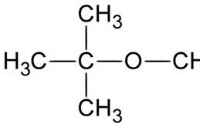

c) naphthalene

d) DDT 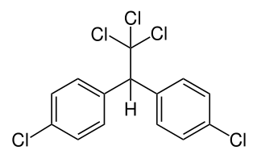

PART II Long answer

Problem 1 (11 points). Predicting Yields

Consider the following microbial physiologies:
i.an anaerobic chemolithoautotroph respiring H2S (to sulfate (SO₄⁻²)) using Nitrate (NO3-) as an electron acceptor. Assume NO₃- goes to N₂.
ii. an acetoclastic methanogen (a chemoorganoheterotroph that ferments acetic acid to CO₂ & CH₄).

a) (8 points) Calculate the theoretical Yields for the two organisms (units of g biomass/eeq Electron donor substrate). Show work for partial credit. Assume NH4 is available for biosynthesis needs.

b) (3 points) If a media contained 0.1 Molar each of H2S and acetate, what would be the total maximum amount of biomass generated per (g X/L) (for this question we’ll simplify some things: ignore kinetics, assume the nitrate is non-limiting, and assume that sufficient NH4 is available for biomass synthesis; also ignore corrections to ΔG^{0’} )

Problem 2 (10 points):

In this class we discussed several options for wastewater treatment. With respect to the fate of the BOD/COD, there are two general routes for conversion: anaerobic processes and aerobic processes.

- (4 points) For these two general cases give two processes/reactor types that we discussed in class that employ that route (i.e. 2 anaerobic processes and 2 aerobic processes)

- (6 points) what is the fate of the biodegradable COD in the wastewater in the two cases (anaerobic and aerobic). For the purposes of this question assume carbohydrate as a model organic compound in wastewater? In other words what is the summary reaction for what happens to the carbon and electrons from the carbohydrate?

Problem 3 (11 points):

Imagine the following reaction by which a transcriptional regulator protein (TRP) complexes with a co-repressor and undergoes a conformational change to form an active repressor complex:

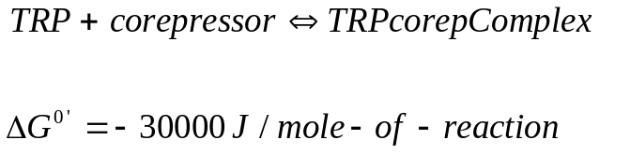

- (5 pts) Briefly describe (with a sketch) how the repressor/corepressor complex will affect gene expression (zooming in on the regions around the promoter).

- (2 pts) At what concentration of co-repressor will 99% of the TRP be in the active form for repression at equilibrium (i.e. the ratio of TRP-complex:TRP alone 100:1). Show all work

- (4 pts). Besides repressors, what are two other types of transcriptional regulators?

Problem 4. (13 points)
Assume the following for a CSTR bioreactor treating aminobenzoate (S):
Volume = 0.5 L
Q (flow) = 0.025 L/hr
q_{max}= 0.3 mg S/(mg X*hr)
Y = 0.3 mg X/mg S
So (influent S) = 300 mg/L
Xo (influent X) = 0 mg/L
b= 0.1/day (= 0.004/hr)
K (= Ks = Km; half saturation constant) = 1 mg/L

a) (8 pts) What are the steady state concentrations of S and X leaving the reactor?

b) (3 pts) In reality is it often difficult to precisely determine K and high levels of uncertainty exist in its estimated value. Imagine your kinetics experiments lead to a 95% confidence interval for K of 0.2 mg/L – 1.8 mg/L. What are the resulting 95% confidence intervals on the predicted steady state values of S and X?

c) (2 pts) How might this affect operating conditions if you are required to degrade aminobenzoate to EPA-approved levels (a general answer is sufficient here – no exact calculation is required)

