SOS Bioreactivity Supplement
clare f. mccann
2026-07-15
Table of contents

This notebook collects supplementary figures, tables, and the full sensitivity/robustness analyses that accompany sos-bioreactivity-analyses.qmd (the primary hypothesis-testing notebook) and sos-bioreactivity-reactivity-revised.qmd (the own-peak/trough sensitivity re-analysis).

Figure 1: Larger TAG Study Design
PLACEHOLDER

Figure 2: Raw Correlations Between Stress Markers
Circle size and color reflect correlation magnitude (red = negative, blue = positive); p-values are raw/uncorrected.
raw_biomarker_tp_cols <- c(
paste0("CRP_log_", 1:4),
paste0("IL10_log_", 1:4),
paste0("IL6_log_", 1:4),
paste0("TNFalpha_log_", 1:4),
paste0("DHEA_log_", 1:4),
paste0("Testosterone_log_", 1:4),
paste0("Cortisol_log_", 1:4)
)
raw_biomarker_tp_labels <- c(
paste0("CRP (T", 1:4, ")"),
paste0("IL-10 (T", 1:4, ")"),
paste0("IL-6 (T", 1:4, ")"),
paste0("TNF-α (T", 1:4, ")"),
paste0("DHEA (T", 1:4, ")"),
paste0("Testosterone (T", 1:4, ")"),
paste0("Cortisol (T", 1:4, ")")
)
raw_biomarker_tp_df <- sos_crp_wide |>
select(SampleID, all_of(paste0("CRP_log_", 1:4))) |>
full_join(sos_cytokines_wide |> select(SampleID, all_of(c(
paste0("IL10_log_", 1:4), paste0("IL6_log_", 1:4), paste0("TNFalpha_log_", 1:4)
))), by = "SampleID") |>
full_join(sos_hormones_wide |> select(SampleID, all_of(c(
paste0("DHEA_log_", 1:4), paste0("Testosterone_log_", 1:4), paste0("Cortisol_log_", 1:4)
))), by = "SampleID")
raw_hr_subj_cols <- c(
"resting_avg", "Task", "Self-Connected", "Self-Disconnected", "Other", "Fixation-Cross",
"selfconnected_subj_stress", "selfdisconnected_subj_stress", "other_subj_stress"
)
raw_hr_subj_labels <- c(
"HR: Resting (avg)", "HR: Task (overall)", "HR: Self-Connected", "HR: Self-Disconnected",
"HR: Other", "HR: Fixation-Cross",
"Subj Stress: Self-Connected", "Subj Stress: Self-Disconnected", "Subj Stress: Other"
)
raw_alltp_df <- raw_biomarker_tp_df |>
left_join(
hr_final_wide |> select(SampleID, resting_avg, Task, `Self-Connected`, `Self-Disconnected`, Other, `Fixation-Cross`),
by = "SampleID"
) |>
left_join(
sos_subj_stress |> select(SampleID, selfconnected_subj_stress, selfdisconnected_subj_stress, other_subj_stress),
by = "SampleID"
)
all_raw_tp_cols <- c(raw_biomarker_tp_cols, raw_hr_subj_cols)
all_raw_tp_labels <- c(raw_biomarker_tp_labels, raw_hr_subj_labels)
raw_alltp_mat <- raw_alltp_df |>
select(all_of(all_raw_tp_cols)) |>
setNames(all_raw_tp_labels) |>
as.matrix()
raw_alltp_rc <- rcorr(raw_alltp_mat)
plot_sig_corrplot(raw_alltp_rc$r, raw_alltp_rc$P, "Raw Biomarker Levels (T1-T4), HR & Subjective Stress",
tl.cex = 0.55, cl.ratio = 0.04, mar = c(0, 0, 2, 0))
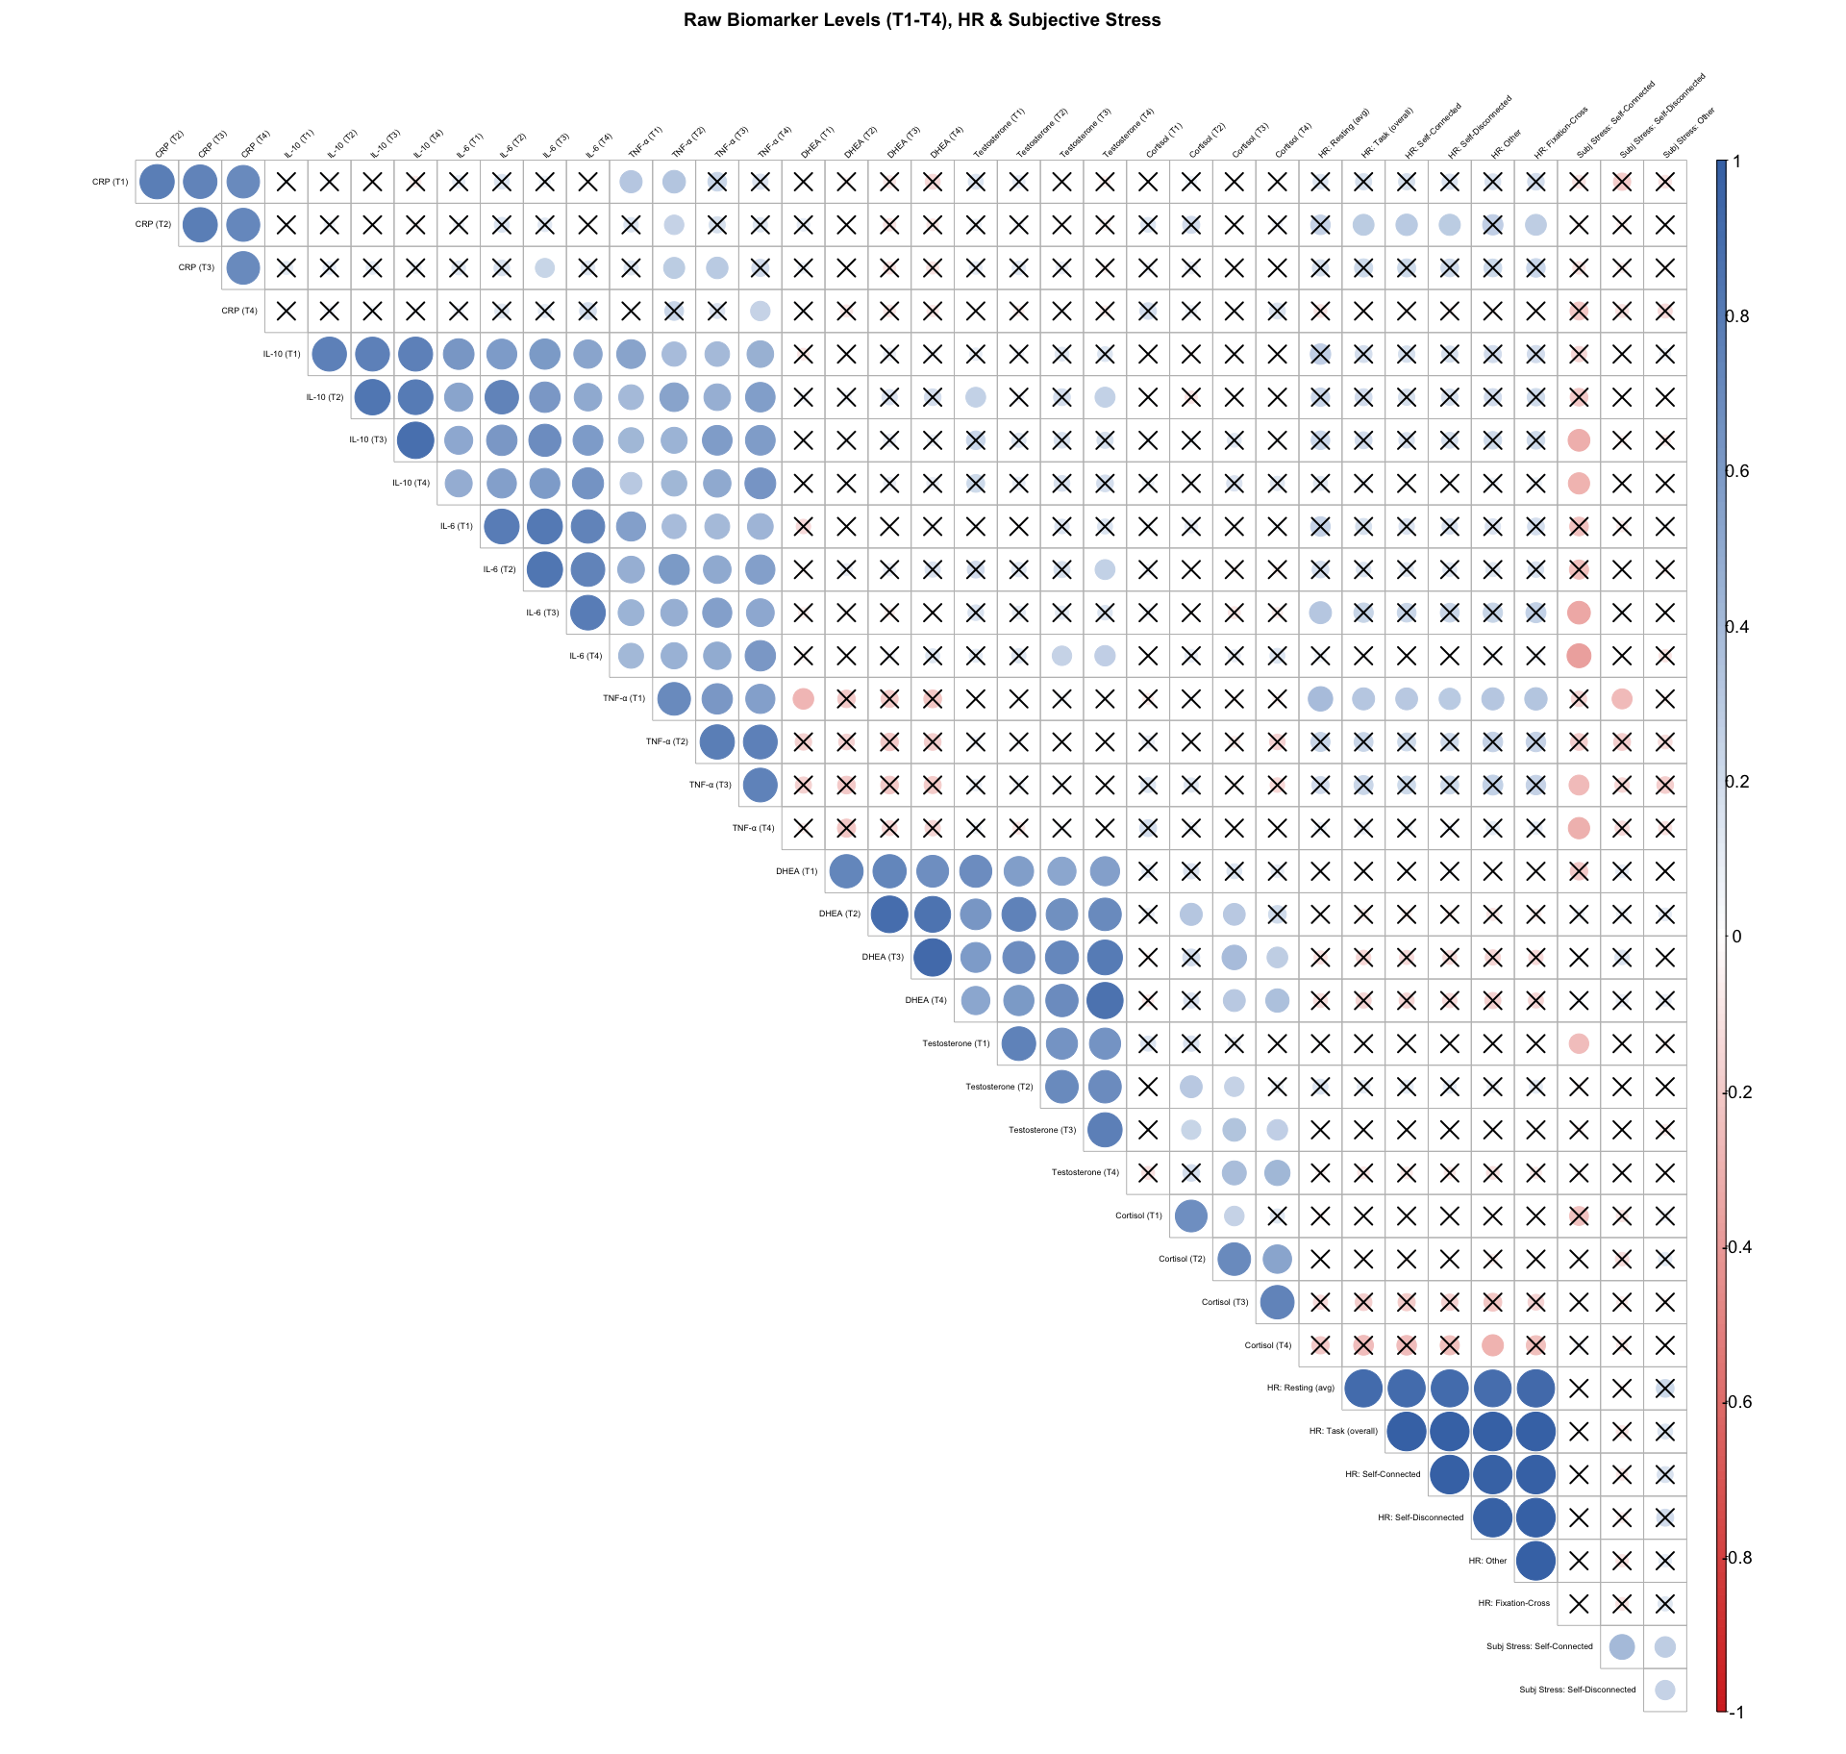

Peak Descriptives
Each participant’s peak is the higher of their T3 or T4 sample. See sos-bioreactivity-analyses.qmd (Hypothesis 1a continued) for the corresponding reactivity t-tests, and sos-bioreactivity-reactivity-revised.qmd for a sensitivity re-analysis using each participant’s own maximum/minimum across all four timepoints rather than restricting “peak” to T3/T4.

N Peaks at T3/T4: Full Sample
t3_vs_t4_tbl |>
select(biomarker, n_valid, n_peaked_T3, n_peaked_T4, n_tie) |>
kable(col.names = c("biomarker", "N (valid T3 & T4)", "Peaked at T3", "Peaked at T4", "Tied"),
caption = "Which timepoint (T3 or T4) had the higher value, all participants") |>
kable_styling(bootstrap_options = "hover", full_width = FALSE)
Which timepoint (T3 or T4) had the higher value, all participants
biomarker | N (valid T3 & T4) | Peaked at T3 | Peaked at T4 | Tied
CRP | 70 | 37 | 29 | 4
IL-10 | 71 | 37 | 30 | 4
IL-6 | 71 | 40 | 22 | 9
TNF-alpha | 71 | 46 | 24 | 1
DHEA | 67 | 24 | 43 | 0
Testosterone | 67 | 24 | 43 | 0
Cortisol | 67 | 33 | 34 | 0

N Peaks at T3/T4: Subsample (T3 or T4 Higher Than T1)
t3_vs_t4_tbl |>
select(biomarker, n_responders, n_resp_peaked_T3, n_resp_peaked_T4) |>
kable(col.names = c("biomarker", "N responders (peak > T1)", "...peaked at T3", "...peaked at T4"),
caption = "Among responders only (peak exceeds T1): which timepoint (T3 or T4) captured the peak") |>
kable_styling(bootstrap_options = "hover", full_width = FALSE)
Among responders only (peak exceeds T1): which timepoint (T3 or T4) captured the peak
biomarker | N responders (peak > T1) | …peaked at T3 | …peaked at T4
CRP | 40 | 22 | 18
IL-10 | 55 | 30 | 25
IL-6 | 44 | 27 | 16
TNF-alpha | 45 | 31 | 14
DHEA | 41 | 12 | 29
Testosterone | 33 | 11 | 22
Cortisol | 32 | 14 | 18

Marker Trends Overlaid on Actual Session Timing
Saliva samples were not collected at fixed clock times, so the plots elsewhere in this project that show trajectories across the ordinal T1–T4 sequence can obscure how each biomarker actually behaves relative to real elapsed time and to the scan/task/session milestones. This figure instead anchors every participant’s trajectory to their own actual, measured scan start time.
75 of 79 participants have a usable session anchor (0 anchored to SOS-task start instead of scan start, due to a missing scan start time; 4 excluded entirely for missing both).
Dashed vertical lines mark the mean (across participants) time of each session milestone, relative to each participant’s own anchor (0 = their own scan start, or SOS-task start for the few participants missing a scan start time). Thin gray lines are individual participants’ observed trajectories; the black line is a loess smooth across everyone, plotted against real elapsed time rather than the ordinal T1–T4 sequence.
ggplot(anchor_traj_data, aes(x = elapsed_min, y = value)) +
geom_vline(data = event_lines, aes(xintercept = x, color = event),
linetype = "dashed", linewidth = 0.6) +
geom_line(aes(group = SampleID), color = "gray70", alpha = 0.35, linewidth = 0.3) +
geom_point(color = "gray70", alpha = 0.35, size = 0.7) +
geom_smooth(method = "loess", formula = y ~ x, color = "black", fill = "gray40",
alpha = 0.2, linewidth = 1) +
scale_color_brewer(palette = "Dark2", name = "Session milestone (mean time)") +
facet_wrap(~biomarker, scales = "free_y", ncol = 4) +
labs(x = "Minutes since scan start (actual, anchored per participant)",
y = "Concentration (log-transformed)") +
theme_minimal() +
theme(legend.position = "bottom", strip.text = element_text(face = "bold"))
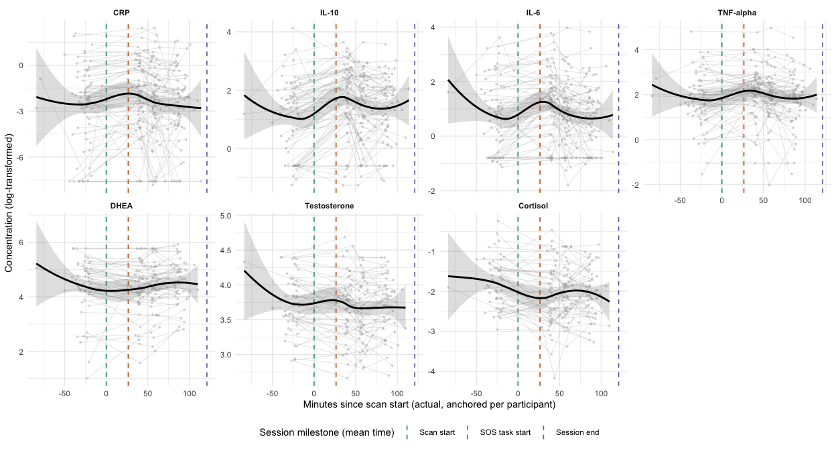
Note. T1 saliva samples were typically collected before the scan (negative values on the x-axis) as a pre-scan baseline. The loess bands flare out at the far left/right edges of each panel where data are sparse — treat the smooth as most reliable in the denser middle region, roughly spanning scan start through the SOS-task start.

Sensitivity Analyses
Full sensitivity and robustness analyses supporting the Hypothesis 1–3 results in sos-bioreactivity-analyses.qmd. Section 3a (Exclusionary) re-runs the primary analyses after excluding participants for illness, bleeding gums, or smoking. Section 3b (Adjusted) re-fits the primary models with physiological covariates entered directly. The Cross-Check subsection ties both sets of results together against the primary (unadjusted, full-sample) findings.

Exclusionary
Participants flagged here (illness, bleeding gums, smoking) are excluded in the analyses below.

Covariate Descriptives

Smokers
smoking |>
count(smokes) |>
mutate(smokes = if_else(smokes, "Yes", "No")) |>
kable(col.names = c("Smokes", "n"),
caption = "Smoking status at time of session") |>
kable_styling(bootstrap_options = "hover", full_width = FALSE)
Smoking status at time of session
Smokes | n
No | 65
Yes | 7

Oral Hygiene
oral_health |>
summarise(
`N participants` = as.character(n()),
`Gum soreness: mean (SD)` = paste0(
round(mean(gum_soreness, na.rm = TRUE), 1), " (",
round(sd(gum_soreness, na.rm = TRUE), 1), ")"
),
`Bleeding gums: n (%)` = paste0(
sum(bleeding_gums, na.rm = TRUE), " (",
round(mean(bleeding_gums, na.rm = TRUE) * 100, 1), "%)"
)
) |>
pivot_longer(everything(), names_to = "Item", values_to = "Value") |>
kable(caption = "Oral health descriptives") |>
kable_styling(bootstrap_options = "hover", full_width = FALSE)
Oral health descriptives
Item | Value
N participants | 72
Gum soreness: mean (SD) | 1.4 (0.7)
Bleeding gums: n (%) | 0 (0%)

Illness
illness |>
count(ill_yn) |>
mutate(ill_yn = if_else(ill_yn, "Yes", "No")) |>
kable(col.names = c("Ill in last 24 hrs", "n"),
caption = "Illness at time of session") |>
kable_styling(bootstrap_options = "hover", full_width = FALSE)
Illness at time of session
Ill in last 24 hrs | n
No | 68
Yes | 10
cat("N excluded for illness:", length(ill_ids), "\n")
N excluded for illness: 10
cat("SampleIDs:", paste(ill_ids, collapse = ", "), "\n")
SampleIDs: TAG045, TAG048, TAG207, TAG202, TAG304, TAG179, TAG122, TAG312, TAG314, TAG041

Medications
meds_wide |>
select(-SampleID) |>
summarise(across(everything(), \(x) sum(x, na.rm = TRUE))) |>
pivot_longer(everything(), names_to = "medication", values_to = "n_using") |>
filter(n_using > 0) |>
mutate(medication = str_remove(medication, "^flag_")) |>
arrange(desc(n_using)) |>
kable(col.names = c("Medication category", "n using"),
caption = "Medication use at SOS visit") |>
kable_styling(bootstrap_options = "hover", full_width = FALSE)
Medication use at SOS visit
Medication category | n using
allergy | 6
nsaid | 5
bc | 3
supplement | 3
ssri | 2
pain_other | 2
sleep | 2
dental | 2
inhaler | 1
antibiotic | 1
vaccine | 1
insulin | 1
migraine | 1

Illness Exclusion
Re-running peak vs. T1 t-tests and HR t-tests after excluding participants who were ill at the time of the session.
sens_peak_tests <- list(
crp = run_peak_test("crp_peak", "CRP_log_1", crp_wide_well),
il10 = run_peak_test("il10_peak", "IL10_log_1", cytokines_wide_well),
il6 = run_peak_test("il6_peak", "IL6_log_1", cytokines_wide_well),
tnfa = run_peak_test("tnfa_peak", "TNFalpha_log_1", cytokines_wide_well),
dhea = run_peak_test("dhea_peak", "DHEA_log_1", hormones_wide_well),
test = run_peak_test("test_peak", "Testosterone_log_1", hormones_wide_well),
cort = run_peak_test("cort_peak", "Cortisol_log_1", hormones_wide_well)
)
sens_pfdr <- setNames(
c(p.adjust(map_dbl(sens_peak_tests[1:4], \(t) t$p.value), method = "fdr"),
p.adjust(map_dbl(sens_peak_tests[5:7], \(t) t$p.value), method = "fdr")),
names(sens_peak_tests)
)
sens_peak_tests |>
map(broom::tidy) |>
list_rbind(names_to = "biomarker") |>
mutate(
biomarker = case_match(biomarker,
"crp" ~ "CRP", "il10" ~ "IL-10", "il6" ~ "IL-6", "tnfa" ~ "TNF-α",
"dhea" ~ "DHEA", "test" ~ "Testosterone", "cort" ~ "Cortisol"
),
p_fdr = round(unname(sens_pfdr), 4)
) |>
select(biomarker, estimate, statistic, parameter, p.value, p_fdr) |>
mutate(across(where(is.numeric), \(x) round(x, 3))) |>
mutate(p_fdr = cell_spec(p_fdr, bold = p_fdr < 0.05,
color = if_else(p_fdr < 0.05, "#2166ac", "black"))) |>
kable(col.names = c("biomarker", "Mean diff", "t", "df", "p (raw)", "p (FDR)"),
escape = FALSE,
caption = "Peak vs. T1 t-tests excluding ill participants") |>
kable_styling(bootstrap_options = "hover", full_width = FALSE)
Peak vs. T1 t-tests excluding ill participants
biomarker | Mean diff | t | df | p (raw) | p (FDR)
CRP | 0.602 | 2.471 | 59 | 0.008 | 0.008
IL-10 | 0.594 | 5.657 | 60 | 0.000 | 0
IL-6 | 0.304 | 3.176 | 60 | 0.001 | 0.002
TNF-α | 0.370 | 3.503 | 60 | 0.000 | 0.001
DHEA | 0.092 | 1.133 | 57 | 0.131 | 0.393
Testosterone | -0.003 | -0.073 | 57 | 0.529 | 0.793
Cortisol | -0.142 | -1.308 | 57 | 0.902 | 0.902

list(
"Task vs. Resting" = t.test(hr_all_wide_well$Task, hr_all_wide_well$resting_avg, alternative = "greater", paired = TRUE),
"Self-Connected vs. Fixation-Cross" = t.test(pull_hr_well("Self-Connected"), pull_hr_well("Fixation-Cross"), alternative = "greater", paired = TRUE),
"Self-Connected vs. Self-Disconnected" = t.test(pull_hr_well("Self-Connected"), pull_hr_well("Self-Disconnected"), alternative = "greater", paired = TRUE),
"Self-Connected vs. Other" = t.test(pull_hr_well("Self-Connected"), pull_hr_well("Other"), alternative = "greater", paired = TRUE)
) |>
map(broom::tidy) |>
list_rbind(names_to = "comparison") |>
select(comparison, estimate, statistic, parameter, p.value) |>
mutate(across(where(is.numeric), \(x) round(x, 3))) |>
mutate(p.value = cell_spec(p.value, bold = p.value < 0.05,
color = if_else(p.value < 0.05, "#2166ac", "black"))) |>
kable(col.names = c("Comparison", "Mean diff", "t", "df", "p"),
escape = FALSE,
caption = "HR paired t-tests excluding ill participants") |>
kable_styling(bootstrap_options = "hover", full_width = FALSE)
HR paired t-tests excluding ill participants
Comparison | Mean diff | t | df | p
Task vs. Resting | 3.981 | 6.833 | 40 | 0
Self-Connected vs. Fixation-Cross | 0.745 | 3.558 | 40 | 0
Self-Connected vs. Self-Disconnected | 0.423 | 2.180 | 40 | 0.018
Self-Connected vs. Other | 1.754 | 6.465 | 40 | 0

BMI × Biomarker Reactivity (Illness-Excluded)
For each biomarker reactivity score (peak − T1), we correlated BMI with the difference score in the illness-excluded sample, matching the bivariate-correlation approach used for the other covariate checks in this document.
immune_outcomes <- c("crp_difference", "il10_difference", "il6_difference", "tnfa_difference")
immune_labels <- c("ΔCRP", "ΔIL-10", "ΔIL-6", "ΔTNF-α")
hormone_outcomes <- c("dhea_difference", "test_difference", "cort_difference")
hormone_labels <- c("ΔDHEA", "ΔTestosterone", "ΔCortisol")
run_bmi_corr <- function(outcome, data) {
dat <- data |> select(all_of(outcome), BMI) |> na.omit()
cor.test(dat[[outcome]], dat$BMI)
}
immune_bmi_fits <- map(immune_outcomes, \(o) run_bmi_corr(o, cov_immune)) |> setNames(immune_labels)
hormone_bmi_fits <- map(hormone_outcomes, \(o) run_bmi_corr(o, cov_hormones)) |> setNames(hormone_labels)
immune_bmi_praw <- map_dbl(immune_bmi_fits, \(ct) ct$p.value)
hormone_bmi_praw <- map_dbl(hormone_bmi_fits, \(ct) ct$p.value)
immune_bmi_pfdr <- setNames(p.adjust(immune_bmi_praw, method = "fdr"), names(immune_bmi_praw))
hormone_bmi_pfdr <- setNames(p.adjust(hormone_bmi_praw, method = "fdr"), names(hormone_bmi_praw))
bind_rows(
tibble(Biomarker = immune_labels,
r = map_dbl(immune_bmi_fits, \(ct) unname(ct$estimate)),
p_raw = unname(immune_bmi_praw),
p_fdr = unname(immune_bmi_pfdr)),
tibble(Biomarker = hormone_labels,
r = map_dbl(hormone_bmi_fits, \(ct) unname(ct$estimate)),
p_raw = unname(hormone_bmi_praw),
p_fdr = unname(hormone_bmi_pfdr))
) |>
mutate(across(c(r, p_raw, p_fdr), \(x) round(x, 3))) |>
mutate(p_fdr = cell_spec(p_fdr, bold = p_fdr < 0.05,
color = if_else(p_fdr < 0.05, "#2166ac", "black"))) |>
kable(escape = FALSE,
col.names = c("Biomarker", "r", "p (raw)", "p (FDR)"),
caption = "BMI x biomarker reactivity correlations, illness-excluded (FDR within immune markers / hormones)") |>
kable_styling(bootstrap_options = "hover", full_width = FALSE)
BMI x biomarker reactivity correlations, illness-excluded (FDR within immune markers / hormones)
Biomarker | r | p (raw) | p (FDR)
ΔCRP | 0.124 | 0.341 | 0.511
ΔIL-10 | -0.130 | 0.318 | 0.511
ΔIL-6 | -0.002 | 0.988 | 0.988
ΔTNF-α | 0.114 | 0.383 | 0.511
ΔDHEA | -0.168 | 0.220 | 0.66
ΔTestosterone | -0.069 | 0.617 | 0.926
ΔCortisol | 0.001 | 0.995 | 0.995

Bleeding Gums & Smoking Exclusion
Re-running peak vs. T1 biomarker t-tests after excluding participants who reported bleeding gums OR who smoke, in addition to those who were ill.
N excluded (ill + bleeding + smoking): 15
IDs: TAG024, TAG041, TAG045, TAG048, TAG102, TAG122, TAG132, TAG179, TAG202, TAG205, TAG207, TAG303, TAG304, TAG312, TAG314
clean_peak_tests <- list(
crp = run_peak_test("crp_peak", "CRP_log_1", crp_wide_clean),
il10 = run_peak_test("il10_peak", "IL10_log_1", cytokines_wide_clean),
il6 = run_peak_test("il6_peak", "IL6_log_1", cytokines_wide_clean),
tnfa = run_peak_test("tnfa_peak", "TNFalpha_log_1", cytokines_wide_clean),
dhea = run_peak_test("dhea_peak", "DHEA_log_1", hormones_wide_clean),
test = run_peak_test("test_peak", "Testosterone_log_1", hormones_wide_clean),
cort = run_peak_test("cort_peak", "Cortisol_log_1", hormones_wide_clean)
)
clean_pfdr <- setNames(
c(p.adjust(map_dbl(clean_peak_tests[1:4], \(t) t$p.value), method = "fdr"),
p.adjust(map_dbl(clean_peak_tests[5:7], \(t) t$p.value), method = "fdr")),
names(clean_peak_tests)
)
clean_peak_tests |>
map(broom::tidy) |>
list_rbind(names_to = "biomarker") |>
mutate(
biomarker = case_match(biomarker,
"crp" ~ "CRP", "il10" ~ "IL-10", "il6" ~ "IL-6", "tnfa" ~ "TNF-α",
"dhea" ~ "DHEA", "test" ~ "Testosterone", "cort" ~ "Cortisol"
),
p_fdr = round(unname(clean_pfdr), 4)
) |>
select(biomarker, estimate, statistic, parameter, p.value, p_fdr) |>
mutate(across(where(is.numeric), \(x) round(x, 3))) |>
mutate(p_fdr = cell_spec(p_fdr, bold = p_fdr < 0.05,
color = if_else(p_fdr < 0.05, "#2166ac", "black"))) |>
kable(col.names = c("biomarker", "Mean diff", "t", "df", "p (raw)", "p (FDR)"),
escape = FALSE,
caption = "Peak vs. T1 t-tests: excluding ill, bleeding gums, and smokers") |>
kable_styling(bootstrap_options = "hover", full_width = FALSE)
Peak vs. T1 t-tests: excluding ill, bleeding gums, and smokers
biomarker | Mean diff | t | df | p (raw) | p (FDR)
CRP | 0.567 | 2.264 | 55 | 0.014 | 0.014
IL-10 | 0.599 | 5.332 | 56 | 0.000 | 0
IL-6 | 0.297 | 2.899 | 56 | 0.003 | 0.004
TNF-α | 0.370 | 3.295 | 56 | 0.001 | 0.002
DHEA | 0.093 | 1.076 | 53 | 0.143 | 0.43
Testosterone | -0.010 | -0.201 | 53 | 0.579 | 0.869
Cortisol | -0.177 | -1.549 | 53 | 0.936 | 0.936

Biomarker Trends: Illness, Bleeding Gums & Smoking Exclusion
Re-fitting the immune biomarker time-trend models (CRP, IL-10, IL-6, TNF-α) after excluding participants who were ill, reported bleeding gums, or smoke. Hormones are not re-run here since illness/bleeding gums/smoking are inflammation-specific confounds.
clean_model_comp_tbl <- imap_dfr(mlm_clean_list, function(res, name) {
tibble(
biomarker = name,
Model = c("Linear", "Quadratic"),
df = res$aic$df,
AIC = round(res$aic$AIC, 1),
BIC = round(res$bic$BIC, 1)
)
})
clean_best_rows <- clean_model_comp_tbl |>
group_by(biomarker) |>
mutate(is_best = AIC == min(AIC)) |>
ungroup() |>
pull(is_best)
clean_model_comp_tbl |>
kable(caption = "Model comparison: excluding ill, bleeding gums, and smokers") |>
kable_styling(bootstrap_options = "hover", full_width = FALSE) |>
row_spec(which(clean_best_rows), bold = TRUE, color = "#2166ac")
Model comparison: excluding ill, bleeding gums, and smokers
biomarker | Model | df | AIC | BIC
CRP | Linear | 6 | 931.0 | 951.8
CRP | Quadratic | 10 | 926.5 | 961.1
IL-10 | Linear | 6 | 615.7 | 636.5
IL-10 | Quadratic | 10 | 585.8 | 620.4
IL-6 | Linear | 6 | 610.6 | 631.4
IL-6 | Quadratic | 10 | 598.3 | 632.9
TNF-alpha | Linear | 6 | 586.2 | 607.0
TNF-alpha | Quadratic | 10 | 566.3 | 600.9
clean_fixed_effects <- imap_dfr(mlm_clean_list, function(res, name) {
broom.mixed::tidy(res$quadratic, effects = "fixed") |>
mutate(biomarker = name)
}) |>
group_by(term) |>
mutate(p_fdr = p.adjust(p.value, method = "fdr")) |>
ungroup()
iwalk(mlm_clean_list, function(res, name) {
cat("\n\n####", name, "\n\n")
tbl <- clean_fixed_effects |>
filter(biomarker == name) |>
select(term, estimate, std.error, statistic, df, p.value, p_fdr) |>
mutate(
across(c(estimate, std.error, statistic, df), \(x) round(x, 3)),
p.value = round(p.value, 4),
p_fdr = round(p_fdr, 4)
)
tbl |>
mutate(p_fdr = cell_spec(p_fdr, bold = !is.na(p_fdr) & p_fdr < 0.05,
color = if_else(!is.na(p_fdr) & p_fdr < 0.05, "#2166ac", "black"))) |>
kable(escape = FALSE,
col.names = c("Term", "b", "SE", "t", "df", "p (raw)", "p (FDR)"),
caption = paste(name, "quadratic fixed effects (excluding ill, bleeding gums, smokers)")) |>
kable_styling(bootstrap_options = "hover", full_width = FALSE) |>
print()
})

CRP
CRP quadratic fixed effects (excluding ill, bleeding gums, smokers)
Term | b | SE | t | df | p (raw) | p (FDR)
(Intercept) | -2.621 | 0.294 | -8.905 | 61.515 | 0.000 | 0
poly(Time, 2)1 | -1.067 | 1.428 | -0.747 | 59.537 | 0.458 | 0.6106
poly(Time, 2)2 | -2.387 | 1.106 | -2.158 | 112.944 | 0.033 | 0.033

IL-10
IL-10 quadratic fixed effects (excluding ill, bleeding gums, smokers)
Term | b | SE | t | df | p (raw) | p (FDR)
(Intercept) | 1.402 | 0.136 | 10.341 | 61.264 | 0.000 | 0
poly(Time, 2)1 | 1.210 | 0.671 | 1.804 | 62.848 | 0.076 | 0.3038
poly(Time, 2)2 | -3.159 | 0.566 | -5.581 | 91.533 | 0.000 | 0

IL-6
IL-6 quadratic fixed effects (excluding ill, bleeding gums, smokers)
Term | b | SE | t | df | p (raw) | p (FDR)
(Intercept) | 0.818 | 0.144 | 5.677 | 61.769 | 0.0000 | 0
poly(Time, 2)1 | -0.518 | 0.653 | -0.793 | 61.306 | 0.4310 | 0.6106
poly(Time, 2)2 | -2.063 | 0.580 | -3.555 | 88.220 | 0.0006 | 0.0008

TNF-alpha
TNF-alpha quadratic fixed effects (excluding ill, bleeding gums, smokers)
Term | b | SE | t | df | p (raw) | p (FDR)
(Intercept) | 1.956 | 0.116 | 16.836 | 59.025 | 0.0000 | 0
poly(Time, 2)1 | 0.142 | 0.739 | 0.191 | 58.328 | 0.8488 | 0.8488
poly(Time, 2)2 | -2.151 | 0.551 | -3.907 | 79.285 | 0.0002 | 0.0004

Reactivity Correlations: Illness, Bleeding Gums & Smoking Exclusion
Correlations between each of the 4 immune reactivity measures and all 13 reactivity measures (Hypothesis 1d), recomputed after excluding participants who were ill, reported bleeding gums, or smoke.
diff_matrix_clean <- all_difference |>
filter(!SampleID %in% excl_clean_ids) |>
select(-SampleID) |>
as.matrix()
colnames(diff_matrix_clean) <- c(
"ΔHR: Task vs. Rest", "ΔHR: SC vs. SD", "ΔHR: SC vs. Other", "ΔHR: SC vs. Fixation-Cross",
"ΔCRP", "ΔIL-10", "ΔIL-6", "ΔTNF-α", "ΔDHEA", "ΔTestosterone", "ΔCortisol",
"ΔSubj Stress: SC vs. SD", "ΔSubj Stress: SC vs. Other"
)
diff_rcorrs_clean <- rcorr(diff_matrix_clean)
immune_labels_clean <- c("ΔCRP", "ΔIL-10", "ΔIL-6", "ΔTNF-α")
all_reactivity_labels <- colnames(diff_matrix_clean)
hr_cols_clean <- all_reactivity_labels[1:4]
imm_cols_clean <- all_reactivity_labels[5:8]
horm_cols_clean <- all_reactivity_labels[9:11]
subj_cols_clean <- all_reactivity_labels[12:13]
raw_immune_clean_mat <- diff_rcorrs_clean$P[immune_labels_clean, all_reactivity_labels, drop = FALSE]
fdr_immune_clean_mat <- raw_immune_clean_mat
for (im in immune_labels_clean) {
for (cols in list(hr_cols_clean, imm_cols_clean, horm_cols_clean, subj_cols_clean)) {
fdr_immune_clean_mat[im, cols] <- p.adjust(raw_immune_clean_mat[im, cols], method = "fdr")
}
}
# The 4 immune measures appear both as rows and as part of the 13 columns, so
# this matrix contains true self-correlations (e.g. ΔCRP row x ΔCRP column:
# r = 1, p = NA from rcorr). corrplot cannot handle r non-NA / p NA at the
# same cell, so those self-correlation cells are blanked in r too.
r_immune_clean_mat <- diff_rcorrs_clean$r[immune_labels_clean, all_reactivity_labels, drop = FALSE]
self_pairs <- outer(immune_labels_clean, all_reactivity_labels, `==`)
r_immune_clean_mat[self_pairs] <- NA
plot_sig_corrplot(
r_immune_clean_mat,
fdr_immune_clean_mat,
type = "full", cl.ratio = 0.1, cl.cex = 1.1,
tl.cex = 0.98, mar = c(0, 0, 1, 5), diag = TRUE
)
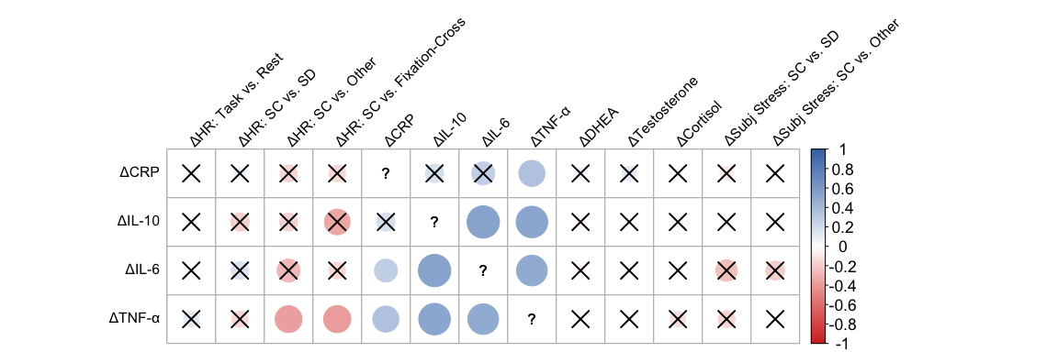
X marks indicate non-significant correlations after FDR correction (p_{FDR} ≥ .05). FDR applied separately for each immune reactivity measure, within each reactivity domain (matches the Hypothesis 1d FDR convention).

Puberty Correlations: Illness, Bleeding Gums & Smoking Exclusion
Correlations between pubertal status/timing (Hypothesis 2) and the 4 immune reactivity measures, recomputed after excluding participants who were ill, reported bleeding gums, or smoke.
timing_reactivity_clean <- timing_reactivity |>
filter(!SampleID %in% excl_clean_ids)
immune_reactivity_vars <- c("crp_difference", "il10_difference", "il6_difference", "tnfa_difference")
immune_reactivity_labels <- c("ΔCRP", "ΔIL-10", "ΔIL-6", "ΔTNF-α")
pub_immune_mat_clean <- timing_reactivity_clean |>
select(all_of(c(all_pub_vars, immune_reactivity_vars))) |>
as.matrix()
colnames(pub_immune_mat_clean) <- c(all_pub_labels, immune_reactivity_labels)
pub_immune_corrs_clean <- rcorr(pub_immune_mat_clean)
raw_pub_immune_clean <- pub_immune_corrs_clean$P[all_pub_labels, immune_reactivity_labels, drop = FALSE]
fdr_pub_immune_clean <- raw_pub_immune_clean
for (pv in all_pub_labels) {
fdr_pub_immune_clean[pv, ] <- p.adjust(raw_pub_immune_clean[pv, ], method = "fdr")
}
plot_sig_corrplot(
pub_immune_corrs_clean$r[all_pub_labels, immune_reactivity_labels, drop = FALSE],
fdr_pub_immune_clean,
type = "full", cl.ratio = 0.15, cl.cex = 1.1,
tl.cex = 1.0, mar = c(0, 0, 1, 4), diag = TRUE
)
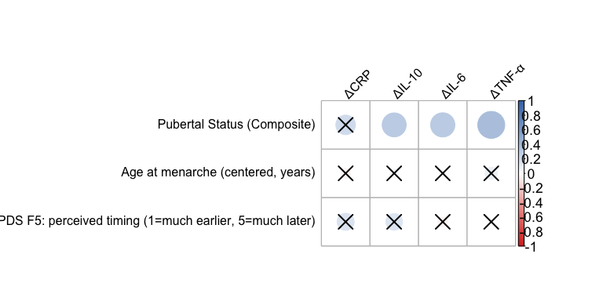
X marks indicate non-significant correlations after FDR correction (p_{FDR} ≥ .05). FDR applied separately for each puberty/timing variable, across the 4 immune reactivity outcomes.

Adjusted
Age, BMI, hours since waking, and (for CRP, DHEA, and Testosterone) flow rate are entered as covariates in the models below.

Covariate Descriptives

Sample Timing
i = immune-tube collection (paired with CRP/cytokine reactivity); h = hormone-tube collection (paired with hormone reactivity). The two are collected within the same minute for nearly everyone, so only modest differences are expected between them.
saliva_timing |>
select(starts_with("elapsed_")) |>
summarise(across(everything(), list(
Mean = \(x) round(mean(x, na.rm = TRUE), 1),
SD = \(x) round(sd(x, na.rm = TRUE), 1),
Min = \(x) round(min(x, na.rm = TRUE), 1),
Max = \(x) round(max(x, na.rm = TRUE), 1),
N = \(x) sum(!is.na(x))
))) |>
pivot_longer(everything(), names_to = c("variable", "stat"), names_sep = "_(?=[^_]+$)") |>
pivot_wider(names_from = stat, values_from = value) |>
mutate(variable = recode(variable,
elapsed_i_T2 = "T1 → T2 (immune tube)",
elapsed_i_T3 = "T1 → T3 (immune tube)",
elapsed_i_T4 = "T1 → T4 (immune tube)",
elapsed_h_T2 = "T1 → T2 (hormone tube)",
elapsed_h_T3 = "T1 → T3 (hormone tube)",
elapsed_h_T4 = "T1 → T4 (hormone tube)"
)) |>
kable(caption = "Actual elapsed time (minutes) between saliva collections") |>
kable_styling(bootstrap_options = "hover", full_width = FALSE)
Actual elapsed time (minutes) between saliva collections
variable | Mean | SD | Min | Max | N
T1 → T2 (immune tube) | 67.9 | 10.9 | 28 | 113 | 71
T1 → T3 (immune tube) | 86.4 | 10.0 | 72 | 128 | 72
T1 → T4 (immune tube) | 116.6 | 10.8 | 99 | 158 | 70
T1 → T2 (hormone tube) | 68.9 | 10.4 | 55 | 113 | 53
T1 → T3 (hormone tube) | 86.1 | 10.0 | 72 | 128 | 54
T1 → T4 (hormone tube) | 116.1 | 10.6 | 99 | 158 | 52

Flow Rate
Saliva flow rate (mL/min) at each timepoint, by tube type.
session_flow_raw |>
select(starts_with("flow_")) |>
summarise(across(everything(), list(
Mean = \(x) round(mean(x, na.rm = TRUE), 2),
SD = \(x) round(sd(x, na.rm = TRUE), 2),
Min = \(x) round(min(x, na.rm = TRUE), 2),
Max = \(x) round(max(x, na.rm = TRUE), 2),
N = \(x) sum(!is.na(x))
))) |>
pivot_longer(everything(), names_to = c("variable", "stat"), names_sep = "_(?=[^_]+$)") |>
pivot_wider(names_from = stat, values_from = value) |>
mutate(
tube = if_else(str_detect(variable, "flow_i_"), "Immune tube", "Hormone tube"),
Time = paste0("T", str_extract(variable, "\\d$"))
) |>
select(tube, Time, Mean, SD, Min, Max, N) |>
arrange(tube, Time) |>
kable(caption = "Saliva flow rate (mL/min) by timepoint and tube type") |>
kable_styling(bootstrap_options = "hover", full_width = FALSE)
Saliva flow rate (mL/min) by timepoint and tube type
tube | Time | Mean | SD | Min | Max | N
Hormone tube | T1 | 0.36 | 0.16 | 0.13 | 0.86 | 60
Hormone tube | T2 | 0.37 | 0.18 | 0.10 | 1.08 | 53
Hormone tube | T3 | 0.36 | 0.19 | 0.12 | 1.03 | 56
Hormone tube | T4 | 0.41 | 0.20 | 0.13 | 0.97 | 54
Immune tube | T1 | 0.36 | 0.18 | 0.09 | 1.06 | 77
Immune tube | T2 | 0.35 | 0.18 | 0.10 | 1.08 | 70
Immune tube | T3 | 0.35 | 0.18 | 0.10 | 1.03 | 73
Immune tube | T4 | 0.40 | 0.20 | 0.10 | 0.97 | 70

BMI
bmi |>
summarise(
n = sum(!is.na(BMI)),
Mean = round(mean(BMI, na.rm = TRUE), 2),
SD = round(sd(BMI, na.rm = TRUE), 2),
Min = round(min(BMI, na.rm = TRUE), 2),
Max = round(max(BMI, na.rm = TRUE), 2)
) |>
kable(caption = "BMI descriptives") |>
kable_styling(bootstrap_options = "hover", full_width = FALSE)
BMI descriptives
n | Mean | SD | Min | Max
70 | 23.04 | 5.29 | 14.94 | 42.09

Age
age_df |>
summarise(
n = sum(!is.na(age_at_session)),
Mean = round(mean(age_at_session, na.rm = TRUE), 2),
SD = round(sd(age_at_session, na.rm = TRUE), 2),
Min = round(min(age_at_session, na.rm = TRUE), 2),
Max = round(max(age_at_session, na.rm = TRUE), 2)
) |>
kable(caption = "Age at session (years)") |>
kable_styling(bootstrap_options = "hover", full_width = FALSE)
Age at session (years)
n | Mean | SD | Min | Max
75 | 13.8 | 1.06 | 11.94 | 15.98

Time Since Waking
Wake time was recorded as free text; times after 12:00 pm were treated as implausible and set to missing. Elapsed hours = time of T1 (immune tube) collection minus wake time.
wake_time |>
filter(!is.na(hours_since_wake)) |>
summarise(
n = n(),
Mean = round(mean(hours_since_wake), 1),
SD = round(sd(hours_since_wake), 1),
Min = round(min(hours_since_wake), 1),
Max = round(max(hours_since_wake), 1)
) |>
kable(caption = "Hours elapsed from waking to T1 sample collection") |>
kable_styling(bootstrap_options = "hover", full_width = FALSE)
Hours elapsed from waking to T1 sample collection
n | Mean | SD | Min | Max
45 | 6.1 | 1.7 | 2.5 | 10

Flow Rate, Age, BMI & Time-Since-Waking vs. Reactivity

Descriptives
covflow_react_join |>
select(all_of(covflow_vars)) |>
summarise(across(everything(), list(
Mean = \(x) round(mean(x, na.rm = TRUE), 2),
SD = \(x) round(sd(x, na.rm = TRUE), 2),
Min = \(x) round(min(x, na.rm = TRUE), 2),
Max = \(x) round(max(x, na.rm = TRUE), 2),
N = \(x) sum(!is.na(x))
))) |>
pivot_longer(everything(), names_to = c("variable", "stat"), names_sep = "_(?=[^_]+$)") |>
pivot_wider(names_from = stat, values_from = value) |>
mutate(variable = recode(variable, !!!setNames(covflow_labels, covflow_vars))) |>
kable(caption = "Physiological covariate descriptives (flow-rate deltas in mL/min; peak timepoint minus T1)") |>
kable_styling(bootstrap_options = "hover", full_width = FALSE)
Physiological covariate descriptives (flow-rate deltas in mL/min; peak timepoint minus T1)
variable | Mean | SD | Min | Max | N
Flow Rate Δ: CRP sample | 0.02 | 0.12 | -0.39 | 0.35 | 70
Flow Rate Δ: DHEA sample | 0.04 | 0.16 | -0.39 | 0.59 | 53
Flow Rate Δ: Testosterone sample | 0.03 | 0.18 | -0.42 | 0.59 | 53
Age at session (years) | 13.82 | 1.05 | 11.94 | 15.98 | 77
BMI | 23.36 | 5.73 | 14.94 | 42.09 | 70
Hours since waking | 6.12 | 1.65 | 2.55 | 10.03 | 43

Correlations: Physiological Covariates × All 13 Reactivity Outcomes
This uses the same bivariate-correlation approach as the primary reactivity-correlation analyses (Hypothesis 1d, Hypothesis 2). Columns are the same 13 reactivity outcomes used throughout (4 HR, 4 immune, 3 hormone, 2 subjective stress).
covflow_mat <- covflow_react_join |>
select(all_of(c(covflow_vars, reactivity_vars))) |>
as.matrix()
colnames(covflow_mat) <- c(covflow_labels, reactivity_labels)
covflow_corrs <- rcorr(covflow_mat)
raw_covflow_mat <- covflow_corrs$P[covflow_labels, reactivity_labels, drop = FALSE]
fdr_covflow_mat <- raw_covflow_mat
for (cv in covflow_labels) {
for (cols in list(hr_cols, imm_cols, horm_cols, subj_cols)) {
fdr_covflow_mat[cv, cols] <- p.adjust(raw_covflow_mat[cv, cols], method = "fdr")
}
}
r_covflow_mat <- covflow_corrs$r[covflow_labels, reactivity_labels, drop = FALSE]
# Mask flow-rate-difference rows against HR / subjective-stress columns
# (not a matched pairing; see note above). r and p must be blanked together
# — corrplot cannot handle a non-NA r paired with an NA p in the same cell.
r_covflow_mat[flow_covflow_labels, c(hr_cols, subj_cols)] <- NA
fdr_covflow_mat[flow_covflow_labels, c(hr_cols, subj_cols)] <- NA
plot_sig_corrplot(
r_covflow_mat,
fdr_covflow_mat,
type = "full", cl.ratio = 0.06, cl.cex = 1.1,
tl.cex = 0.95, mar = c(0, 0, 1, 6), diag = TRUE
)
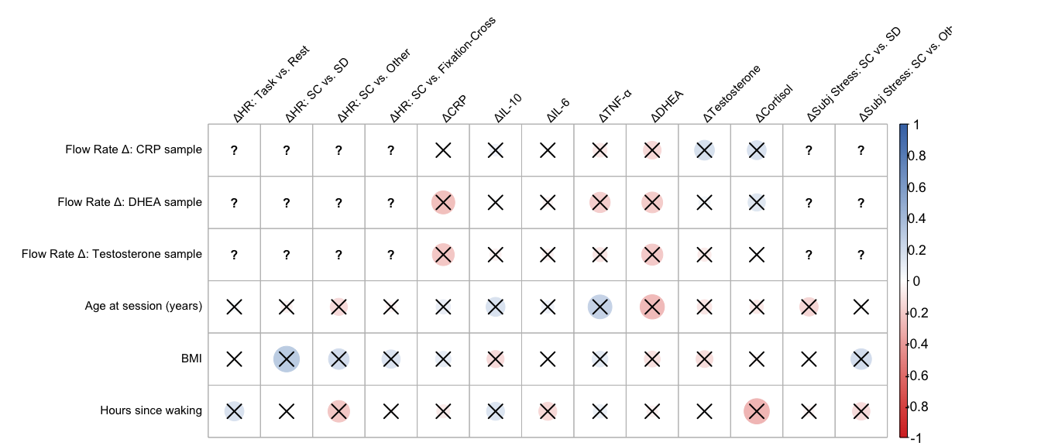
X marks indicate non-significant correlations after FDR correction (p_{FDR} ≥ .05). FDR applied separately for each covariate, within each reactivity domain (HR, immune, hormones, subjective stress). Blank cells for the flow-rate-difference rows against HR/subjective-stress columns indicate the pairing was not tested (see note above).

Correlation p-values: Physiological Covariates × All 13 Reactivity Outcomes
fdr_covflow_mat |>
as.data.frame() |>
mutate(across(everything(), \(x) {
sig <- !is.na(x) & x < 0.05
xlab <- if_else(is.na(x), "—", as.character(round(x, 4)))
cell_spec(xlab, bold = sig, color = if_else(sig, "#2166ac", "black"))
})) |>
kable(escape = FALSE,
caption = "FDR-adjusted p-values: physiological covariates × all reactivity outcomes (bold = p_FDR < .05; — = not tested)") |>
kable_styling(bootstrap_options = "hover")
FDR-adjusted p-values: physiological covariates × all reactivity outcomes (bold = p_FDR < .05; — = not tested)
 | ΔHR: Task vs. Rest | ΔHR: SC vs. SD | ΔHR: SC vs. Other | ΔHR: SC vs. Fixation-Cross | ΔCRP | ΔIL-10 | ΔIL-6 | ΔTNF-α | ΔDHEA | ΔTestosterone | ΔCortisol | ΔSubj Stress: SC vs. SD | ΔSubj Stress: SC vs. Other
Flow Rate Δ: CRP sample | — | — | — | — | 0.9677 | 0.9677 | 0.9677 | 0.9677 | 0.2545 | 0.2545 | 0.2545 | — | —
Flow Rate Δ: DHEA sample | — | — | — | — | 0.3441 | 0.8458 | 0.8458 | 0.3565 | 0.4911 | 0.6854 | 0.5043 | — | —
Flow Rate Δ: Testosterone sample | — | — | — | — | 0.4802 | 0.704 | 0.704 | 0.704 | 0.4419 | 0.8623 | 0.9232 | — | —
Age at session (years) | 0.8256 | 0.8256 | 0.8256 | 0.8256 | 0.5653 | 0.3566 | 0.5653 | 0.126 | 0.0907 | 0.5213 | 0.5213 | 0.4344 | 0.9472
BMI | 0.9988 | 0.1584 | 0.3827 | 0.4046 | 0.5126 | 0.5126 | 0.9098 | 0.5126 | 0.5588 | 0.5588 | 0.7718 | 0.9008 | 0.2684
Hours since waking | 0.683 | 0.9661 | 0.683 | 0.9661 | 0.6266 | 0.6266 | 0.6266 | 0.6266 | 0.8581 | 0.8581 | 0.2362 | 0.7699 | 0.7635
Results. Across the 60 physiological-covariate × reactivity-outcome pairs tested (flow-rate difference for CRP, DHEA, and Testosterone — the biomarkers expected to depend on saliva volume per unit time — each against all 7 biomarker reactivity outcomes; age, BMI, and hours since waking against all 13 reactivity outcomes; FDR-corrected separately for each covariate within each reactivity domain), 0 associations remained significant after correction: none survived FDR correction.

Covariate-Adjusted Biomarker Trends
Each biomarker’s time trend is re-fit with age, BMI, and hours since waking entered as fixed-effect covariates. Flow rate (time-varying, matched to the sample’s own timepoint) is included only for CRP, DHEA, and Testosterone, since these are the biomarkers whose concentrations are expected to depend on saliva volume per unit time.
covtrend_models <- list(
"CRP" = mlm_cov_crp, "IL-10" = mlm_cov_il10, "IL-6" = mlm_cov_il6, "TNF-α" = mlm_cov_tnfalpha,
"DHEA" = mlm_cov_dhea, "Testosterone" = mlm_cov_test, "Cortisol" = mlm_cov_cort
)
term_labels <- c(
"(Intercept)" = "Intercept",
"Time" = "Time",
"poly(Time, 2)1" = "Time (linear)",
"poly(Time, 2)2" = "Time (quadratic)",
"flow_rate" = "Flow rate (mL/min)",
"age_at_session" = "Age at session (years)",
"BMI" = "BMI",
"hours_since_wake" = "Hours since waking"
)
covtrend_group <- c(
"CRP" = "Immune", "IL-10" = "Immune", "IL-6" = "Immune", "TNF-α" = "Immune",
"DHEA" = "Hormones", "Testosterone" = "Hormones", "Cortisol" = "Hormones"
)
# FDR-corrected within term x group (immune markers / hormones), matching
# the primary quadratic model convention (Hypothesis 1a).
covtrend_all_fixed <- imap_dfr(covtrend_models, function(fit, nm) {
broom.mixed::tidy(fit, effects = "fixed") |> mutate(biomarker = nm)
}) |>
mutate(group = unname(covtrend_group[biomarker])) |>
group_by(term, group) |>
mutate(p_fdr = p.adjust(p.value, method = "fdr")) |>
ungroup()
for (nm in names(covtrend_models)) {
cat("\n\n####", nm, "\n\n")
covtrend_all_fixed |>
filter(biomarker == nm) |>
mutate(
term = recode(term, !!!term_labels),
across(c(estimate, std.error, statistic, df), \(x) round(x, 3)),
p.value = round(p.value, 4),
p_fdr = round(p_fdr, 4)
) |>
select(term, estimate, std.error, statistic, df, p.value, p_fdr) |>
mutate(p_fdr = cell_spec(p_fdr, bold = !is.na(p_fdr) & p_fdr < 0.05,
color = if_else(!is.na(p_fdr) & p_fdr < 0.05, "#2166ac", "black"))) |>
kable(escape = FALSE,
col.names = c("Term", "b", "SE", "t", "df", "p (raw)", "p (FDR)"),
caption = paste(nm, "trend model adjusted for flow rate, age, BMI, and hours since waking")) |>
kable_styling(bootstrap_options = "hover", full_width = FALSE) |>
print()
}

CRP
CRP trend model adjusted for flow rate, age, BMI, and hours since waking
Term | b | SE | t | df | p (raw) | p (FDR)
Intercept | -0.160 | 4.514 | -0.035 | 32.815 | 0.9720 | 0.972
Time (linear) | -1.716 | 1.874 | -0.916 | 61.207 | 0.3633 | 0.6209
Time (quadratic) | -3.007 | 2.137 | -1.407 | 37.599 | 0.1676 | 0.1676
Flow rate (mL/min) | 0.587 | 1.014 | 0.579 | 129.891 | 0.5636 | 0.5636
Age at session (years) | -0.675 | 0.319 | -2.114 | 31.576 | 0.0425 | 0.1702
BMI | 0.248 | 0.110 | 2.260 | 31.726 | 0.0308 | 0.1232
Hours since waking | 0.094 | 0.210 | 0.447 | 31.658 | 0.6581 | 0.6581

IL-10
IL-10 trend model adjusted for flow rate, age, BMI, and hours since waking
Term | b | SE | t | df | p (raw) | p (FDR)
Intercept | -0.902 | 2.419 | -0.373 | 33.026 | 0.7116 | 0.9488
Time (linear) | 1.550 | 0.764 | 2.029 | 48.573 | 0.0479 | 0.1917
Time (quadratic) | -3.215 | 0.738 | -4.354 | 52.761 | 0.0001 | 0.0002
Age at session (years) | 0.130 | 0.168 | 0.774 | 33.007 | 0.4442 | 0.4442
BMI | 0.004 | 0.056 | 0.080 | 33.007 | 0.9366 | 0.9366
Hours since waking | 0.093 | 0.109 | 0.854 | 33.007 | 0.3995 | 0.5327

IL-6
IL-6 trend model adjusted for flow rate, age, BMI, and hours since waking
Term | b | SE | t | df | p (raw) | p (FDR)
Intercept | 2.911 | 2.261 | 1.287 | 33.012 | 0.2069 | 0.8276
Time (linear) | -0.722 | 0.980 | -0.736 | 41.162 | 0.4657 | 0.6209
Time (quadratic) | -2.096 | 0.874 | -2.397 | 63.317 | 0.0195 | 0.026
Age at session (years) | -0.179 | 0.157 | -1.144 | 33.006 | 0.2607 | 0.4442
BMI | -0.005 | 0.052 | -0.088 | 33.006 | 0.9307 | 0.9366
Hours since waking | 0.102 | 0.102 | 1.002 | 33.006 | 0.3235 | 0.5327

TNF-α
TNF-α trend model adjusted for flow rate, age, BMI, and hours since waking
Term | b | SE | t | df | p (raw) | p (FDR)
Intercept | 1.398 | 1.787 | 0.783 | 33.018 | 0.4394 | 0.8789
Time (linear) | -0.118 | 1.046 | -0.113 | 36.002 | 0.9106 | 0.9106
Time (quadratic) | -2.630 | 0.837 | -3.141 | 36.001 | 0.0034 | 0.0067
Age at session (years) | -0.104 | 0.124 | -0.839 | 33.000 | 0.4075 | 0.4442
BMI | 0.048 | 0.041 | 1.149 | 33.000 | 0.2589 | 0.5178
Hours since waking | 0.147 | 0.080 | 1.835 | 33.000 | 0.0755 | 0.3018

DHEA
DHEA trend model adjusted for flow rate, age, BMI, and hours since waking
Term | b | SE | t | df | p (raw) | p (FDR)
Intercept | -5.113 | 1.978 | -2.585 | 18.362 | 0.0185 | 0.0277
Time (linear) | 1.624 | 1.456 | 1.115 | 20.580 | 0.2775 | 0.2775
Time (quadratic) | 1.151 | 1.021 | 1.127 | 22.053 | 0.2717 | 0.2717
Flow rate (mL/min) | 0.255 | 0.410 | 0.622 | 57.855 | 0.5362 | 0.5362
Age at session (years) | 0.509 | 0.127 | 4.016 | 17.982 | 0.0008 | 0.0024
BMI | 0.147 | 0.049 | 3.011 | 17.812 | 0.0076 | 0.0137
Hours since waking | -0.124 | 0.119 | -1.045 | 18.000 | 0.3098 | 0.6864

Testosterone
Testosterone trend model adjusted for flow rate, age, BMI, and hours since waking
Term | b | SE | t | df | p (raw) | p (FDR)
Intercept | 0.723 | 1.033 | 0.700 | 17.157 | 0.4934 | 0.4934
Time (linear) | -0.668 | 0.532 | -1.256 | 21.653 | 0.2224 | 0.2775
Time (quadratic) | 0.773 | 0.315 | 2.454 | 19.460 | 0.0237 | 0.0355
Flow rate (mL/min) | 0.124 | 0.162 | 0.762 | 45.509 | 0.4501 | 0.5362
Age at session (years) | 0.117 | 0.067 | 1.743 | 17.470 | 0.0989 | 0.1484
BMI | 0.075 | 0.026 | 2.948 | 16.732 | 0.0091 | 0.0137
Hours since waking | -0.048 | 0.063 | -0.759 | 17.789 | 0.4576 | 0.6864

Cortisol
Cortisol trend model adjusted for flow rate, age, BMI, and hours since waking
Term | b | SE | t | df | p (raw) | p (FDR)
Intercept | -4.353 | 1.091 | -3.989 | 34.133 | 0.0003 | 0.001
Time (linear) | -1.949 | 0.974 | -2.000 | 36.143 | 0.0531 | 0.1592
Time (quadratic) | 2.693 | 0.554 | 4.861 | 34.871 | 0.0000 | 0.0001
Age at session (years) | 0.095 | 0.075 | 1.271 | 33.130 | 0.2125 | 0.2125
BMI | 0.039 | 0.025 | 1.559 | 33.330 | 0.1285 | 0.1285
Hours since waking | 0.017 | 0.049 | 0.352 | 33.106 | 0.7267 | 0.7267
Results. After adjusting for age, BMI, hours since waking, and (for CRP, DHEA, and Testosterone) flow rate, the linear time term remained significant (FDR-corrected within immune markers and hormones separately) for 0 of 7 biomarkers (none), and the quadratic time term remained significant for 5 of 7 biomarkers (IL-10, IL-6, TNF-α, Testosterone, Cortisol). For comparison, the primary (unadjusted) analysis found the quadratic term significantly improved fit, FDR-corrected within immune markers and hormones separately, for 6 biomarkers (IL-10, IL-6, TNF-alpha, DHEA, Testosterone, Cortisol) (Hypothesis 1a); the improvement was not significant for CRP. 2 of 7 biomarkers also showed a significant adjusted intercept (i.e., a non-zero model-implied level at the reference timepoint after accounting for these covariates): DHEA, Cortisol. Among the covariates themselves, BMI was positively associated with DHEA, Testosterone; age at session was positively associated with DHEA (all FDR-corrected p < .05).

Cross-Check

Sensitivity Analysis Cross-Check
A single table summarising whether each biomarker’s reactivity result holds across all sensitivity analyses. Biomarker reactivity (peak − T1) is flagged as significant (✓) when p (FDR-corrected within immune / hormone family) < .05 for the primary and exclusion analyses. HR comparisons are flagged when the one-tailed paired t-test p < .05 (not FDR-corrected, matching the primary HR analysis, which is not part of a multi-test biomarker family). (BMI’s correlation with biomarker reactivity is reported separately above and is not folded into this consistency check, since it tests a different question — whether BMI relates to reactivity magnitude, not whether reactivity itself is significant.)
Biomarker reactivity: significance across all sensitivity analyses (* = p < .05)
Group | biomarker | Primary (FDR) | Ill excl (FDR) | Bleed+smoke excl (FDR) | Consistency
Immune | CRP | 0.034* | 0.008* | 0.014* | All sig
Immune | IL-10 | 0* | 0* | 0* | All sig
Immune | IL-6 | 0.002* | 0.002* | 0.004* | All sig
Immune | TNF-α | 0.001* | 0.001* | 0.002* | All sig
Hormones | DHEA | 0.048* | 0.393 | 0.43 | Mixed (1/3)
Hormones | Testosterone | 0.595 | 0.793 | 0.869 | All ns
Hormones | Cortisol | 0.858 | 0.902 | 0.936 | All ns

HR reactivity: significance across sensitivity analyses (✓ = p < .05)
Comparison | Primary | Ill excl | Consistency
Task vs. Resting | 0* | 0* | Both sig
Self-Connected vs. Fixation-Cross | 0.003* | 0* | Both sig
Self-Connected vs. Self-Disconnected | 0.017* | 0.018* | Both sig
Self-Connected vs. Other | 0* | 0* | Both sig
Results. Of the 7 biomarkers, 4 showed consistent significant reactivity across all three analyses (primary, illness-excluded, and bleed+smoke-excluded): CRP, IL-10, IL-6, TNF-α. 2 biomarkers were consistently non-significant across all analyses. 1 biomarker(s) showed mixed results across analyses: DHEA. Cells marked ✓ in blue indicate p < .05; orange “Mixed” entries indicate the biomarker changed significance status across the sensitivity conditions.

Quadratic Time Trend Cross-Check
The reactivity cross-check above tracks the peak-vs-T1 difference score; this companion table tracks robustness of the other primary finding from Hypothesis 1a — the quadratic time trend itself. A biomarker is flagged as significant (✓) when the FDR-corrected p-value for the quadratic time term is < .05: in the primary analysis (likelihood ratio test, quadratic vs. linear, FDR-corrected within immune markers and hormones separately), after excluding ill, bleeding-gum, and smoking participants (immune markers only — hormones were not re-run in that sensitivity check, so this cell is blank for hormones and the consistency denominator is 2 instead of 3), and in the covariate-adjusted trend model (adjusting for flow rate, age, BMI, and hours since waking; FDR-corrected within immune markers and hormones separately).
Quadratic time trend: significance across sensitivity analyses (* = p < .05)
Group | biomarker | Primary quadratic (FDR) | Ill+bleed+smoke excl quadratic (FDR) | Cov-adj quadratic (FDR) | Consistency
Immune | CRP | 0.557 | 0.033* | 0.168 | Mixed (1/3)
Immune | IL-10 | 0* | 0* | 0* | All sig
Immune | IL-6 | 0.003* | 0.001* | 0.026* | All sig
Immune | TNF-α | 0* | 0* | 0.007* | All sig
Hormones | DHEA | 0* | — | 0.272 | Mixed (1/2)
Hormones | Testosterone | 0.011* | — | 0.036* | All sig
Hormones | Cortisol | 0* | — | 0* | All sig
Results. Of the 7 biomarkers, 5 showed a consistently significant quadratic time trend across all available sensitivity analyses: IL-10, IL-6, TNF-α, Testosterone, Cortisol. 0 biomarkers were consistently non-significant. 2 biomarker(s) showed mixed results: CRP, DHEA. Note that immune markers are checked against 3 analyses and hormones against 2 (the illness/bleeding-gum/smoking exclusion was not re-run for hormones), so “All sig”/“All ns” denominators differ by biomarker group.

