**Exercise - Practice SAC 1a**

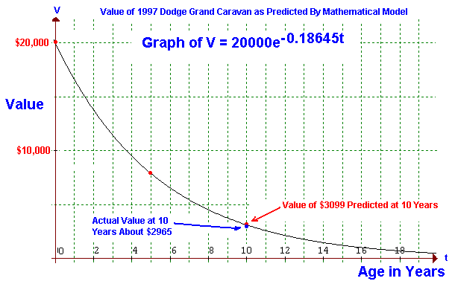

Create a software for a secondhand vehicle dealer to purchase a used Dodge Caravan based on the graph above. The calculation portion of the software should be in a function that accepts time in years. As seen in the graph, when new, the vehicle would cost $20000. After 10 years, it would be worth $3099. The function operates on the mathematical model above and returns the price of the vehicle to the dealer.

The dealer than either accepts or rejects the price. If the dealer accepts the price, the price is stored in a CSV file (first column). For each entry, a new row is used.

Explore how to find the total of the entire first column (all rows) of the CSV file. Modify your code so that the total is displayed when a button is pressed.