Habit Mastery League Project Proposal
Mobile App Development | Project One | October 17, 2026
Course section: ____________________ Team name: ____________________

Project summary
We propose Habit Mastery League, an offline Flutter app that helps students build personal habits through flexible weekly goals and a small progress garden. Users can track reading, sketching, organizing notes, or taking screen breaks without losing all visible progress after one missed day. The app emphasizes accurate, correctable history and clear weekly results.
Users will create habits, choose a weekly target from 1 to 7 days, record and correct dated check-ins, and see progress as both a number and a bundled plant illustration. A local Garden Guide will suggest a manageable target from recent history, explain its calculation, and allow the user to accept or ignore it. SQLite will store habits and check-ins; SharedPreferences will store settings. All app data and helper calculations remain on the device.

Team members and ownership
Member and student ID | Pathway | Primary responsibility
____________________ | ____________________ | UI, navigation, wireframes, accessibility, widget testing, and UI demonstration
____________________ | ____________________ | SQLite repositories, data integrity, Garden Guide, unit testing, and data/helper demonstration

The two team members will share integration testing, offline and restart verification on two devices or emulators, peer feedback, documentation, ClickUp coordination, and presentation preparation. Each member will review the other’s pull requests, maintain assigned tasks, contribute at least 20 meaningful commits, and explain their individual work in the presentation.

Repository and approval
Repository: https://github.com/clarenceli00/project01-MAD
The team will provide instructor access to the repository and use collaborator access for each member. Development will begin after instructor-team approval.
Proposal deadline: October 18, 2026 at 11:59 PM Eastern. Final deadline: October 28, 2026 at 11:59 PM Eastern.

Scope and local data design

Five screen roles
Screen | Planned behavior
1 Habit Garden | List habit tiles; filter by category; show distinct completed days, target, rate, and plant stage; open habit or add one.
2 Habit Editor | Create or edit title, category, start date, motivation, and weekly target with a labeled 1–7 slider.
3 Habit Detail | Inspect or edit a habit; start, check in, finish, or reset the weekly flow; open journal; confirm habit deletion.
4 History and Insights | Choose habit and week; create, read, edit, and delete check-ins using a form sheet; display weekly results and Garden Guide.
5 Settings | Persist default target and reduced-motion preference; use a labeled default-target slider.

Two related SQLite entities
Entity | Fields and constraints
Habit | id primary key; title nonblank; category nonblank; weeklyTarget integer 1–7; startedLocalDate YYYY-MM-DD; motivation text; cycleWeekStart and cycleStatus for the saved workflow.
CheckIn | id primary key; habitId foreign key; localDate YYYY-MM-DD; note text. UNIQUE(habitId, localDate) enforces one check-in per habit per day.

Habit CRUD appears in the garden, editor, and detail screen. CheckIn CRUD appears in the detail quick-add and journal form sheet. Parameterized queries and transactions protect saves. Enable SQLite foreign keys. Confirmed habit deletion cascades to its check-ins; the dialog states the number of records that will be removed.

Architecture and Flutter evidence
Use screen widgets → controllers or state holders → repository → SQLite or preferences. Keep weekly calculations and Garden Guide in pure Dart functions. Reusable HabitTile and ProgressLabel are StatelessWidgets; editor forms, date selection, and cycle controls use StatefulWidgets. Dispose controllers and check widget lifecycle before updating UI after asynchronous operations.
Use save, check-in, edit, delete, finish, and reset buttons with labels and confirmation where needed. A history swipe gesture opens edit actions; every gesture also has a visible Edit or Delete button. Disable pending save actions to prevent repeated writes, and refresh all affected views after successful changes.

Progress rules and Garden Guide

Weekly progress and integrity
A local calendar week runs Monday through Sunday, using date-only values and an injected local today value for tests. Check-ins retain their selected calendar date when the device time zone changes; no UTC conversion changes a saved date. The active week follows the current device local calendar.
For a selected week, completedDays is the number of distinct valid check-in dates for that habit within that week. Display completedDays / weeklyTarget and the uncapped percentage. Plant illustrations use min(completedDays / weeklyTarget, 1), so extra days remain visible numerically. Current targets apply to displayed weeks; prior target versions are not stored. Label past-week rates as measured against the current target.
Reject future start dates, future check-ins, and check-ins before the habit start date. Block a start-date edit that would invalidate existing check-ins until those entries are corrected or deleted. Duplicate creation or editing onto an occupied date shows a helpful message and leaves totals unchanged. Example: target 4 with two distinct dates is 50%; a duplicate stays 50%; deleting one date gives 25%, including after offline restart.

Saved weekly workflow
Start sets the current week to Active; check-in updates progress; Finish marks the flow Finished and offers history review. Reset confirms a return to Ready for the current week and clears only workflow state. It retains all saved check-ins and their calculated progress. Reopening restores the saved state; a new week begins Ready without modifying previous history.

Garden Guide local smart helper
Owner: the team member responsible for the data layer and helper. Garden Guide will suggest a practical weekly target based on the user’s recent routine. The card will identify its method as a history-based rule and show the calculation without confidence scores.
Inputs: CheckIn.localDate, Habit.startedLocalDate, and Habit.weeklyTarget. Count distinct days per week, in days/week, for the latest three whole completed eligible local calendar weeks. Include zero-count weeks; exclude the current week and any partial starting week. A week is eligible only if its Monday is on or after the habit start date.
Method: average the three counts, round halves up, and clamp to 1–7. Counts 2, 3, 4 suggest 3 days/week. Fewer than three eligible weeks shows “Not enough history” and retains the user’s target. Reject malformed inputs and counts outside 0–7. Compute from existing rows; add no helper entity.
Explanation: show the three week ranges, counts, and calculation. Apply copies the suggestion into an editable target field; a separate Save confirms the change. Keep my target dismisses it. Existing check-in rows remain intact.

Evaluation and acceptance plan

Helper baseline and critical thinking
Baseline: always suggest the current user-set weekly target. Compare it with Garden Guide against distinct completion days in the following completed week. Report absolute error in days/week for each method and mean absolute error across valid cases; this measures agreement with later activity, not whether the suggestion caused improvement.
Alternative considered: use the median of the same three weeks to reduce the effect of an unusually busy week. We propose the mean because it is simple to explain and uses all observations. A zero week is retained as recorded inactivity, although missing logging may look identical. This limitation will be disclosed rather than guessed away.
Case type | Fixture and expected outcome
Normal | Weeks 2, 3, 4 → suggestion 3; following week 2 → helper error 1. Baseline target 4 → error 2.
No data | Only two eligible completed weeks → Not enough history; target unchanged. A new habit follows the same fallback.
Invalid | Input count −1 or 8 → validation error and no suggestion; duplicate dates in raw history count once.
Boundary | 0, 0, 0 → clamp to 1; 7, 7, 7 → 7. A Sunday/Monday boundary and partial starting week must select the correct rows.
Counterexample | 0, 0, 7 → mean suggests 2; median suggests 1. If next week is 7 and current target 7, baseline error 0 and helper error 5. Record that recent change can defeat the mean.

Evaluation will use a controlled date and clearly labeled fictional histories. AI_FEATURE.md will record actual outputs, explanation, override behavior, and any revision or retained limitation. Graduate evaluation will additionally use at least five held-out valid cases, separate from tuning cases, with both methods evaluated on the same inputs and outcomes.

Core acceptance tests
Habit CRUD: create a valid habit; restart and find it; edit its target; cancel deletion without changes; confirm deletion and verify child rows are removed. CheckIn CRUD: add, inspect, edit note/date, and delete; verify the garden and history update together.
Validation and failures: reject blank title, target outside 1–7, future dates, pre-start dates, duplicate inserts, and duplicate date edits. Simulate a failed write: show an error, preserve form input, and do not display false progress. Empty garden and empty journal show a clear add action.
Reliability and accessibility: run in airplane mode; restart after saves and workflow transitions; verify settings persist. Test two devices/emulators with different screen sizes and enlarged text. Check readable labels, touch controls, non-color numeric progress, reduced motion, and safe back navigation.
Peer revision: ask a peer to create a habit, correct a mistaken date, and find the weekly rate. Record completion, confusion, and comments; revise labels or layout and repeat the affected task.

Wireframes for habits and activity
Low-fidelity layouts show the five unique screen roles. Form sheets and confirmation dialogs are overlays within these roles. Values and dates are illustrative.
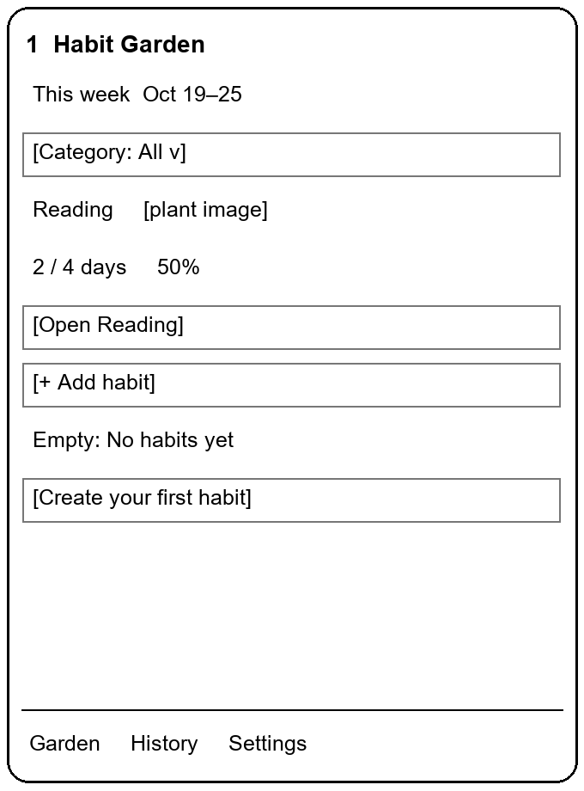 | 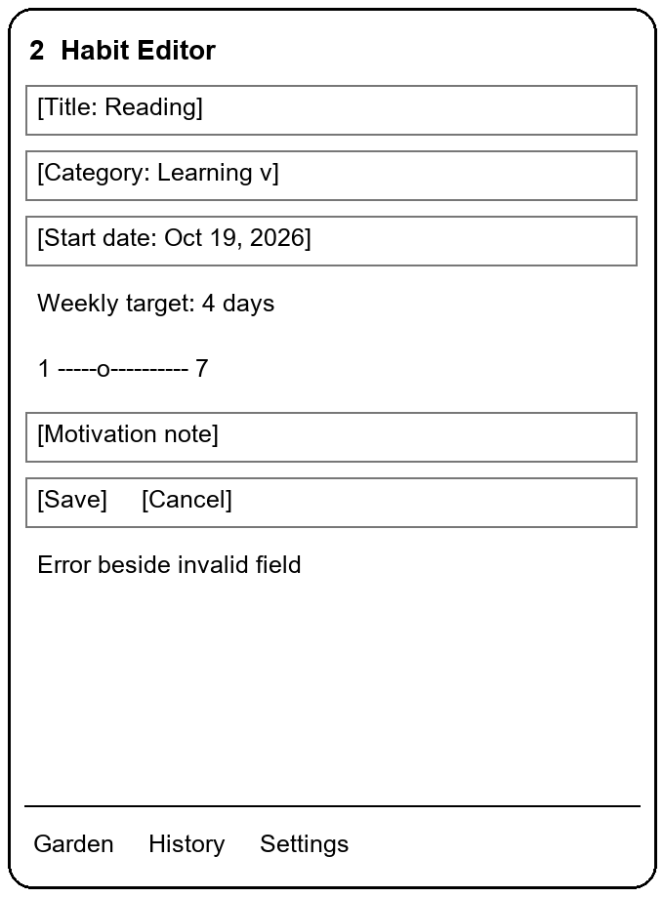 | 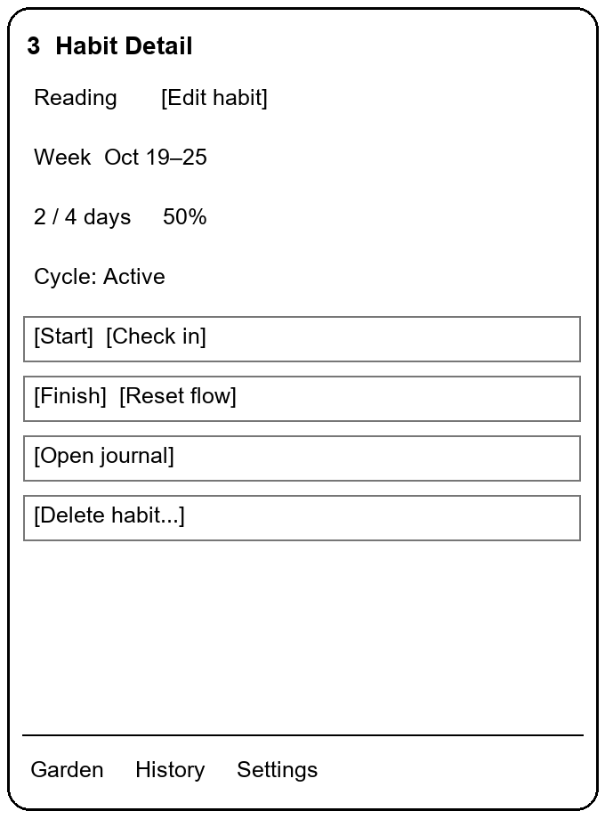

Navigation and CRUD flow
1 Garden → Add habit → 2 Editor → Save → 1 Garden. Tap a tile → 3 Detail → Edit habit → 2 Editor → Save → 3 Detail. Cancel or Back returns without saving. Detail → Delete habit → confirm cascade → Garden.
3 Detail → Check in → date and note form sheet → Save → refreshed Detail. Duplicate date → inline feedback → choose another date or open the existing record. Start, Finish, and Reset change the saved weekly workflow; Reset explicitly says saved check-ins will remain.

Interaction and feedback
The garden uses reusable plant tiles with explicit numbers. The editor validates title, category, start date, and target before saving. The detail screen displays the active week and workflow status. Buttons show loading during writes. A failed save preserves the typed input and offers retry.

Wireframes for history and settings
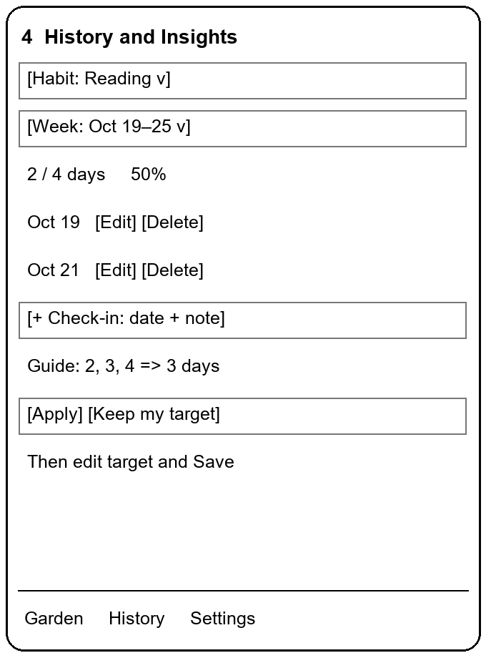 | 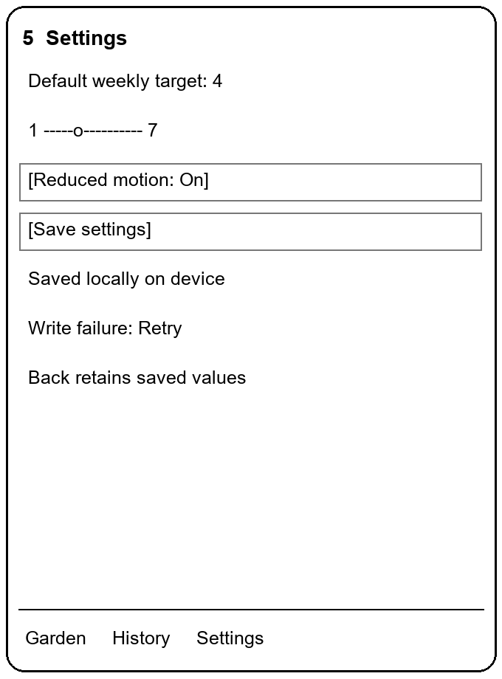

Check-in correction and helper flow
3 Detail → Open journal → 4 History, already filtered to the habit. History → Add or Edit → date and note sheet → Save → refreshed history and garden. Delete → confirm → remove one row and refresh. Swipe opens edit actions; visible buttons provide the same actions.
History → Garden Guide Apply → editable habit target → Save confirms. Keep my target leaves the goal unchanged. No-data or invalid history displays feedback instead of a suggestion. Changing week filters both the journal and the numeric aggregate; the helper clearly labels its separate three-week input period.

Persistent settings and design iteration
Any bottom tab → 5 Settings. Default target affects newly created habits only. Save persists both preferences, shows confirmation, and reports write failure if needed. Reduced motion replaces transitions with static plant stages.
Peer review will assess label clarity and correction paths before implementation. Testing will include enlarged text on both devices and checks for clipping and crowded controls. Before-and-after images and peer observations will be retained with the relevant ClickUp task.

Execution schedule and ClickUp plan

Coordination workflow
ClickUp board URL: ____________________. The team will use the free plan for project coordination. The Kanban workflow will be Backlog → Ready → In Progress → Review and Test → Done. WIP limits will be one In Progress task per person and two tasks total in Review and Test. Each task will record an owner, due date, pathway, acceptance criteria, evidence, and related pull request.
A task will be Done when its acceptance criteria pass, review is complete, evidence is attached, and the change is merged. Coordination evidence will include a readable planning snapshot dated October 18, 2026 and dated progress records throughout the project.
Date in 2026 | Work and completion evidence
Oct 17–18 | Proposal planning, team ownership, repository access, wireframes, and coordination evidence. Proposal milestone: October 18 at 11:59 PM Eastern. Development follows instructor-team approval.
After approval to Oct 21 | Create the five screens and navigation. Deliver one working slice: create a validated habit, save locally, display it, and reload after restart. Oct 21 is the UI/navigation checkpoint.
Oct 22–24 | Finish both entities’ CRUD, duplicate/date guards, cycle controls, filters, progress, and settings. Add Garden Guide with explanation, override, and case fixtures. Oct 24 is the core-functionality checkpoint.
Oct 25–26 | Run integrity, failure, offline/restart, accessibility, and two-device checks. Complete peer revision, helper evaluation, AI_FEATURE.md, and any graduate requirements.
Oct 27 | Tested APK, README, evidence, and presentation preparation. The 10–15 balanced curated questions will include I1/I2/D1/D2/R4. The questions-only Word document will precede recording of the 20–25 minute team presentation.
Oct 28 | Final project delivery and individual submissions by October 28 at 11:59 PM Eastern.

Practical task acceptance criteria
Data acceptance criteria include blocking duplicate date creation and edits, reproducing the 50% → 25% correction example after restart, and applying the documented cascade policy. Helper acceptance criteria include all five case types, explanation, override, and offline no-data feedback. UI acceptance criteria include access to all five screen roles with readable enlarged text.

Implementation scope by pathway

Undergraduate and graduate coverage
Undergraduate scope includes the complete core described in the preceding sections and the required local helper. Graduate scope includes the same core and every extension below. Individual responsibilities will follow each member’s pathway.
Graduate requirement | Planned implementation and owner
Advanced shared state | Provider, Riverpod, or BLoC for reactive habits, check-ins, loading/error/success, persistence, and cleanup. Owner: ____________________.
Architecture | Separate UI/domain/data with repository boundaries and dependency injection; document dependency direction, rationale, and trade-off. Owner: ____________________.
Testing | At least 10 meaningful unit tests plus widget/integration tests and a coverage report; cover dates, duplicates, rates, persistence, transitions, and helper behavior. Owner: ____________________.
Advanced features | Background weekly summaries, local reminders with permission/failure feedback, local file export, and custom plant animation with implicit and explicit animation plus reduced motion. Owner: ____________________.
Helper evaluation | At least five held-out valid comparison cases separate from tuning; report both methods’ metrics, errors, limitations, and offline tests. Owner: ____________________.
Graduate Q and A | Include a selection from each group A3/A4/A5, D3/D4, and T3/T4/T5 within the same 10–15 total questions. Each graduate explains individual code/test evidence. Owner: ____________________.

