MM (Music Maker)
A Local-First Hip-Hop Music Production Platform — Architecture & Design
Author: Clarence Stephen • May 2026 • Portfolio overview

Reviewer note
About this document. MM is a proprietary system I'm building with a co-founder. The codebase, model weights, and step-by-step roadmap stay private. This document is a portfolio overview at architecture-and-design altitude.
What's covered: the system's positioning, the three pipelines it supports, the GPU strategy, and the wedge. What's omitted: implementation details, API surfaces, database schemas, and the strategic roadmap.
Published under CC BY-NC 4.0 alongside my other documentation samples at github.com/clarencestephen/MM-Documentation-Samples. The MM source itself is not public.

1. Summary
MM is the system I'm building for AI-native Hip-Hop music production. It runs entirely on the user's own machine, makes zero external API calls, and is genre-focused rather than general-purpose. The wedge is editability and voice identity, not generic text-to-song generation.
Six things to know:
- Local-first by design. Every component runs on the user's hardware. No cloud TTS, no metered API calls, no subscription dependencies on a third party.
- Genre-focused. Optimized for Hip-Hop, Melodic Rap, R&B, and Lo-fi. Other genres may work; they are not the design target.
- Three pipelines: Create (lyrics + beat → vocal → mix), Transform (source → separate → rewrite → overlay), and Identity (clone a voice once, reuse across songs).
- Dual-GPU architecture, with workload split by audio domain. GPU 0 handles voice and language; GPU 1 handles separation and alignment. A single GPU also works.
- The wedge is editability and identity. Section-level regeneration and a reusable artist voice are the two features generic text-to-song products struggle to deliver.
- Designed to run on a single workstation. VPS deployment is a possible future option for sharing or collaboration, not the primary form factor.

2. Architecture
Inputs flow through a thin API layer into a job queue. Workers are typed by GPU because the two main workload classes — voice / language model on one side, audio separation and alignment on the other — have different memory and throughput profiles and run concurrently on a real song. The CPU handles orchestration, mixing, and export. Outputs are WAV, MP3, and stems-as-ZIP.
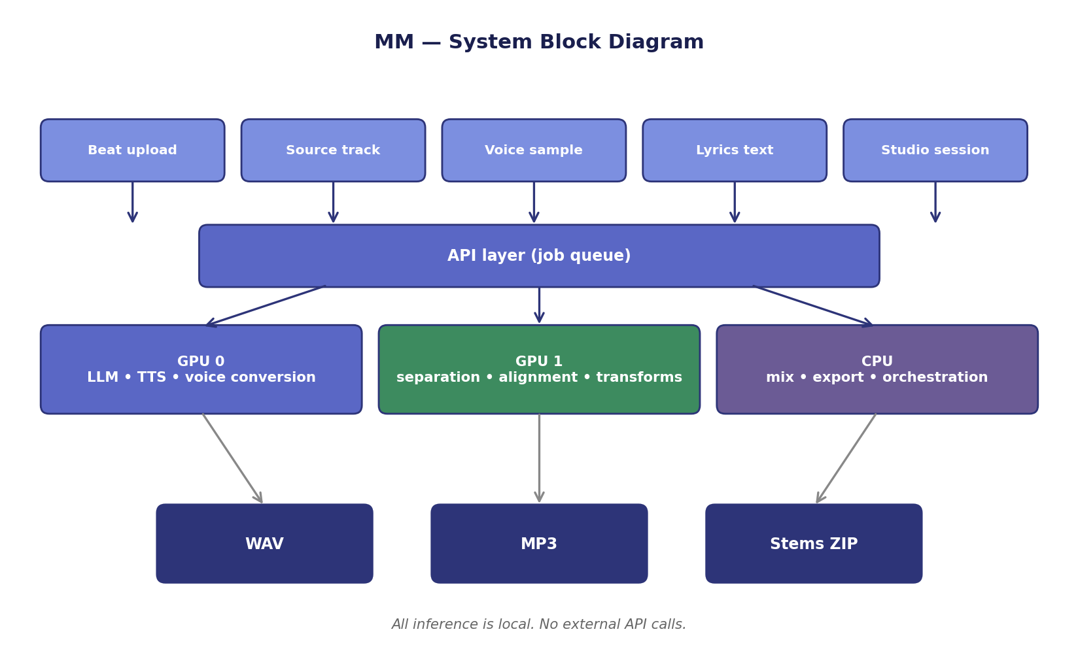
Figure 1. System block diagram. Inputs at the top; outputs at the bottom; GPU-typed workers in between. Implementation, service files, and API endpoints are intentionally not shown.
The diagram is at block altitude on purpose. The implementation is the moat. Section §7 names what is intentionally not in this document.

3. The three pipelines
MM is structured around three distinct creative workflows. They share the same infrastructure but solve different problems.

3.1 Create
Stage | What it does
Input | Beat audio file plus lyrics text. Lyrics can be user-written or LLM-generated from a prompt.
Stages | Prompt parsing → optional lyric refinement → vocal generation → mix against the beat.
Output | Full song WAV at draft quality (fast iteration) or render quality (clean export).

Create is the simplest pipeline and the daily driver. The interesting parts are the draft / render split (so users can iterate without paying for full re-renders) and section-level regeneration (re-do one verse without touching the rest).

3.2 Transform
Stage | What it does
Input | An existing source song.
Stages | Stem separation → lyrics alignment → parody or section rewrite → new vocal generation → overlay onto the instrumental → mix.
Output | Transformed song with new vocals over the original instrumental.

Transform is the path I expect creators to use most for parody, remix, and reinterpretation. The hard part is the alignment: vocals have to land on the right beats and breath gaps. The pipeline caches separated stems and transcripts because they are expensive to compute and identical across many edits of the same source.

3.3 Identity
Stage | What it does
Input | A short voice sample from the user.
Stages | Voice cloning → persona creation → reuse across future songs.
Output | A reusable voice identity that the Create and Transform pipelines can call as a parameter.

Identity is the moat. Generic text-to-song products generate a generic voice. MM lets a creator build their own artist voice once and apply it consistently across every song they make. Cross-song persona consistency is harder than it sounds, and the next major build phase is dedicated to it.

4. GPU strategy
Two GPUs are not a hard requirement, but they are the recommended setup. The reason is concurrency: voice and audio-separation workloads do not compete cleanly for the same memory or throughput, so running them on separate cards halves the wall-clock time on real songs. Single-GPU users get the same outputs, just slower.
Device | Workload | Why this device
GPU 0 | LLM, vocal generation, voice conversion | Sequence models with small per-step compute and large memory residency. Fits well alongside the LLM.
GPU 1 | Source separation, lyrics alignment, audio transforms | Heavier per-step compute with shorter context. Different memory access pattern than GPU 0; runs concurrently without stepping on it.
CPU | API server, mixing, export, orchestration | Bookkeeping and audio file assembly. None of it benefits from GPU.

5. Genre focus and the wedge
MM is not trying to be all music. Hip-Hop, Melodic Rap, R&B, and Lo-fi are first-class. Other genres may work, but they are not the design target. The narrowing is deliberate: a focused product can ship features that a horizontal one cannot.

5.1 Why narrowing helps
- Phrasing models trained on rap cadences perform better than general lyric models on rap.
- Voice characteristics matter more than melodic range for the target genres, which lines up with MM's TTS-first stack.
- Production conventions (e.g. how vocals sit in a beat, where ad-libs land) are tighter in these genres, which makes mix automation tractable.

5.2 The three differentiators
- Editability. Section-level regeneration. The user can re-do one verse without re-rendering the whole song. Most generative music products treat the song as an indivisible blob; MM treats it as a structured project.
- Transformation. Take any source track and rewrite over it. The Transform pipeline turns the existing audio into raw material rather than treating every output as text-to-song from scratch.
- Identity. Clone a voice once; reuse across songs. The same artist persona can show up across an entire body of work. This is the feature I expect to be the durable advantage.

6. Why local-first
Local-first is a stance, not a feature. Four reasons it shapes the entire stack:
- Privacy. Source tracks and voice samples never leave the machine. For users uploading their own voice or unreleased work, that matters.
- Cost. No per-generation API spend, no metered TTS. Once the workstation exists, generation is effectively free at the margin.
- Latency. No round-trip to a cloud service. Section-level regeneration is interactive only when the round-trip is sub-second, and a cloud architecture cannot meet that consistently.
- Customization. Models are inspectable and swappable. A user can substitute a different voice-cloning model or lyric LLM if they prefer. A cloud product cannot offer that.

7. What's not in this document
This is a portfolio overview, not a product spec. The following are intentionally excluded:
- The implementation. Service decomposition, queue topology, schemas, file layouts, API endpoints, configuration.
- Specific model weights, fine-tuning approach, and the voice-conversion architecture that is the core of the Identity pipeline.
- The strategic roadmap and step-by-step build order.
- Pricing, tier structure, and business-model details.
- UI / UX specifics beyond the pipeline-level description.
The moat is in those details. The architecture description in §2–§4 is portable. The implementation is not.

8. Provenance & license
Authored by Clarence Stephen. Published under Creative Commons Attribution-NonCommercial 4.0 International (CC BY-NC 4.0). Companion repository: github.com/clarencestephen/MM-Documentation-Samples. The MM source itself is private and not published.

