# Component Registry, Browser and Editor Reference Manual

### Introduction

The Component Registry has the following features:

1) Register and store CMDI Components/Profiles.

2) Enable a user to browse the registered Components/Profiles.

3) Enable a user to edit and create Components/Profiles.

For more information on CMDI, visit <http://www.clarin.eu/cmdi>.

### Component Registry

The start screen of the Component Registry application shows the Component Browser. From here you can access the other main functionalities: edit and import. The sections in this document describe each of these functionalities, starting with the Component Browser.

### Component Browser

In the Component Browser (see Figure 1) there is a choice of two **tabs**: "Profiles" and "Components". Clicking on either of them allows you to view all the registered Profiles or Components in a list. Next to these two tabs, there is a **select box**. This box allows you to switch between public space and user space. The public space shows all published profiles/components by all users. The user space shows all profiles/components that are located in your own workspace. The user space items are not published.

On the far right, there is a **filter** input field. Here you can type a term to quickly filter out all non-matching items.

If you **select an item** in the browser list, the panel below the list fills up with info about the selected Profile/Component. It allows for a default "view" and an xml view. The **default view** is an interactive view where you can click open reference components to explore the full structure of a profile/component. The **xml view** shows the actual xml of a Profile/Component. The **comments tab** provides a place for discussion by allowing authenticated users to post a comment on a specific Profile/Component or to see what others have written.

When you **right click on an item** in the list or on the info pane you are given some options. You can download the Profile/Component as an xml representation or get the corresponding xsd of that xml representation. Other tools can use the downloaded xml or xsd, CLARIN supported tools will integrate with the registry automatically so you won’t have to download anything yourself. Arbil (see <http://www.clarin.eu/cmdi>) can for instance be used to edit metadata based on the xsd’s generated by the profiles.

On the top left, there are three **buttons**: “Create new”, “Edit (as new)” and “Import”. The first button brings you to the editor (see the section “Component Editor”) so that you can start creating a new profile/component in your workspace. The second button will only be enabled if an item in the list is selected; then clicking the button will open the selected item in the editor, depending on the active space either as a copy (public space) or the item itself (in the workspace). Both actions require you to authenticate if you’re not yet logged in. The final button will bring you to the import form (see the section “Import”).

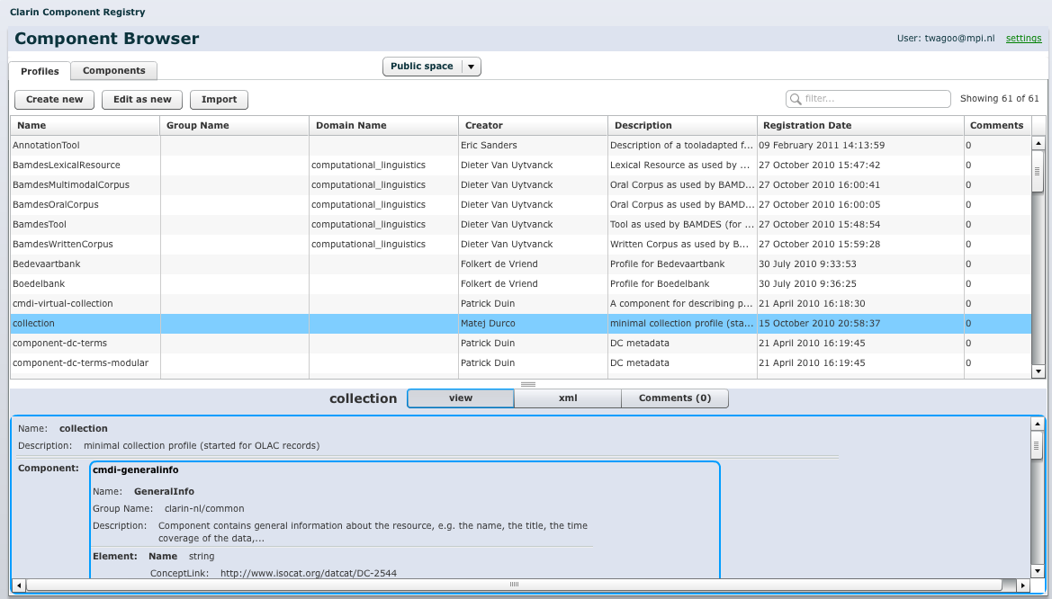

Figure 1. Browse Screen

### Component Editor

The "Component Editor" view (see Figure 2) allows you to create a new Profile/Component or edit an already existing Profile/Component. The view offers four buttons:

* “save”: submits the Profile/Component and overwrites an existing Profile/Component in your private workspace, or will create a new one if a previous version of it did not exist already.
* “save as new”: always creates a new Profile/Component in private workspace.
* “publish in public space”: tries to submit you Profile/Component to the public space.
* “cancel”: returns to the Component Browser discarding any changes (you will need to confirm this if there are unsaved changes).

“Save” and “publish” always validate the created Profile/Component. When successful the "Browse" view will show with the newly added item highlighted. If shown in the browse overview it means that the Profile/Component is registered. If the action was unsuccessful, an error message will be displayed and the Profile/Component is not registered. The created Profile/Component is validated against the xsd schema: http://www.clarin.eu/cmd/general-component-schema.xsd.

A Profile or Component can be made public if:

* It is valid (e.g. all fields are filled in correctly).
* It contains already public components.

Below the buttons the view is split in two parts: an editing pane with below it an editing palette. The palette can be used to drag items onto the editing pane. You can select an already existing component from the list. When you drag an item over the editing pane it will highlight to show where you are allowed to drop the item. When dropping an existing component a reference to that component is created and can be viewed. The editing pane has green “+component”, “+element”, “+attribute” buttons that can be clicked to add new components, elements or attributes to the pane. Newly created fields can then be edited. You can reorder the elements and components with the little up and down arrows.

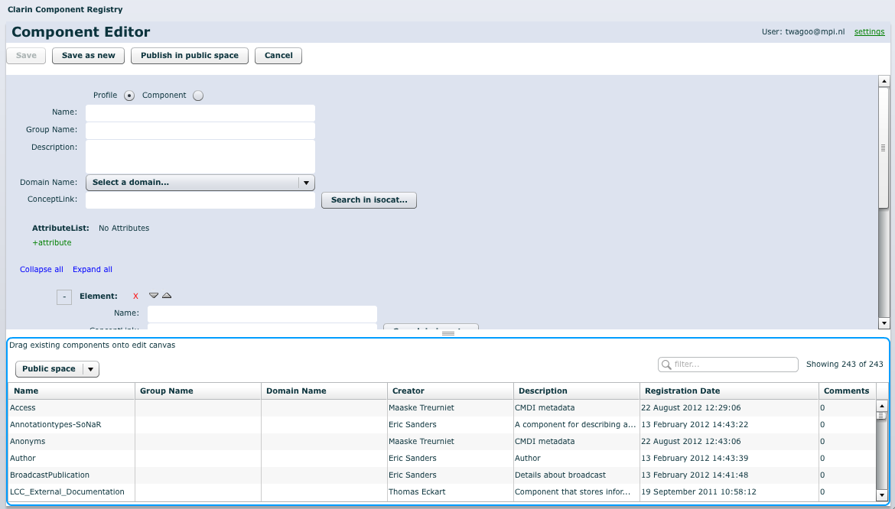

Figure 2. Edit Screen

The form sections for individual elements and components can be collapsed and expanded so as to hide or show specific sections using the -/+ button next to each section. These actions will not affect the actual specification, but is only intended to ease navigation within the editor. Collapsed components and elements can still be moved or deleted, but their input fields will be hidden; instead all values will be displayed on a single line. Before the first element in the editor there are action links to collapse or hide all elements and components in the editor.

When new items are added it should be fairly straightforward to fill in the fields. The fields that need to be filled in depend on the type of item (see Figure 3). Three fields are a bit more complicated: ConceptLink (for Component/Element), DisplayPriority (for Element) and Type (for Element/Attribute).

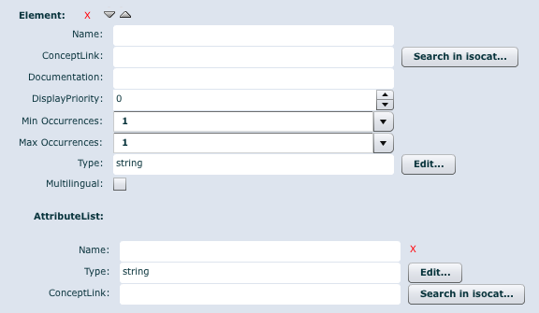

Figure 3. Element and attribute editing

### ConceptLink

A conceptlink can be added by clicking on the button next to the field this pops-up a search box (see Figure 4) to search for concepts in the Isocat concept registry. Select one and press ‘Ok’ to use the selected concept for the field.

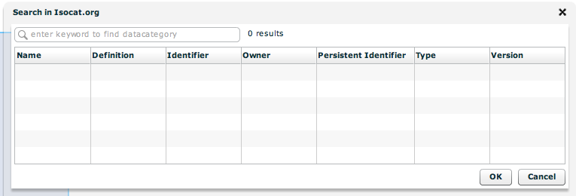

Figure 4. Isocat Search popup

#### DisplayPriority

The “display priority” is a number that is used in determining the *display value* for the containing component in clients and viewers. They will use the value of the field with the highest display priority that has an actual value (e.g. for an Actor component this could be the Name field).

By default, the display priority will be set to 0 for fields, which indicates that the concerning field is not taken into account when determining the display value. However, **at least one field** should have a positive number larger than 0. Among the fields that have a value above 0, **lower numbers indicate higher priority**.

#### Type

The “type” field can be edited by clicking the button next to it. This pops-up a window (see Figure 5) forcing you to choose between three different types by selecting a tab: Type (primitive type), Controlled Vocabulary or Pattern. Primitive type is used when the type of the field must be for example type "string" or "boolean". You can also create a vocabulary of allowed values for this particular field. Thirdly can also choose to specify a regular expression pattern to allow only values that match the pattern.

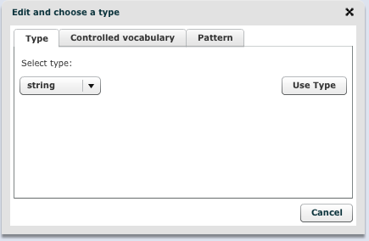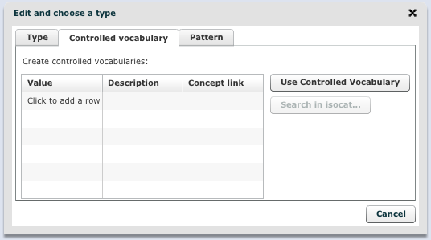

Figure 5. Edit and choose type popup: type and controlled vocabulary

### Import

In the Component Browser, clicking the “Import” button will open the import screen (see Figure 6). Importing allows you to register components and profiles as xml files. Select an XML file that represents a profile or a component from your file system and fill in the fields or keep the values that automatically get loaded from the file. When “Submit” is pressed an attempt is made (just like the "Save" button from the Edit view) to store the component. To go back to the browser without importing anything, press the “Close” button.

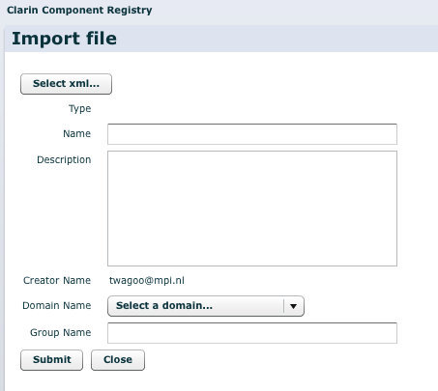

Figure 6. Import screen

### Other features

It is possible to create a reference link (bookmark) to a public component or profile that starts up the Component Registry with the browse view and the given component or profile selected. This is done with the URL: http://catalog.clarin.eu/ds/ComponentRegistry/?item=<id>

For example to open the Registry on component with id clarin.eu:cr1:c_1271859438180, the url becomes: http://catalog.clarin.eu/ds/ComponentRegistry/?item=clarin.eu:cr1:c_1271859438180

The id of a component can be seen in the xml of the browse view.

### Known Issues

* There currently is now way of logging out of the Component Registry other than ending the browser session