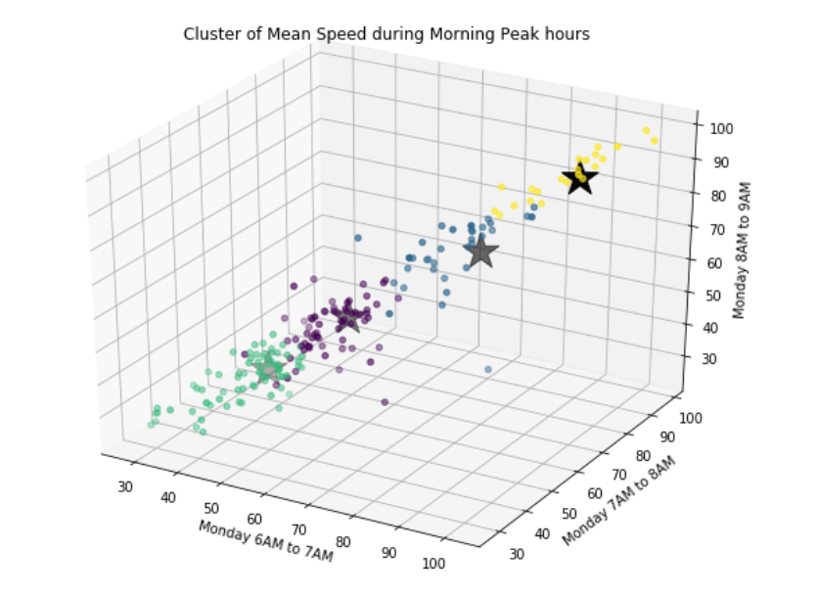

Figure 1:1 Cluster of Mean Speeds during Morning peak hours

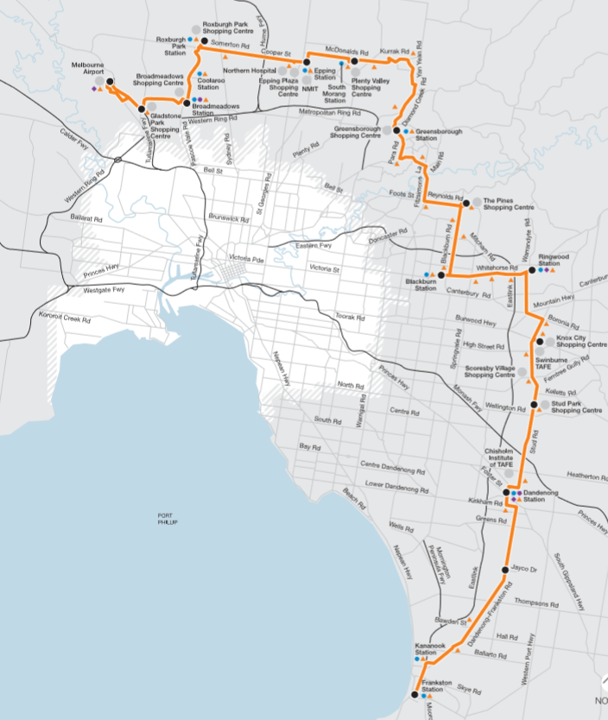

Figure 1:2 Route map of the bus towards the Airport

The following visuals show with the red marks where the mean speed is below the speed limits on Mondays

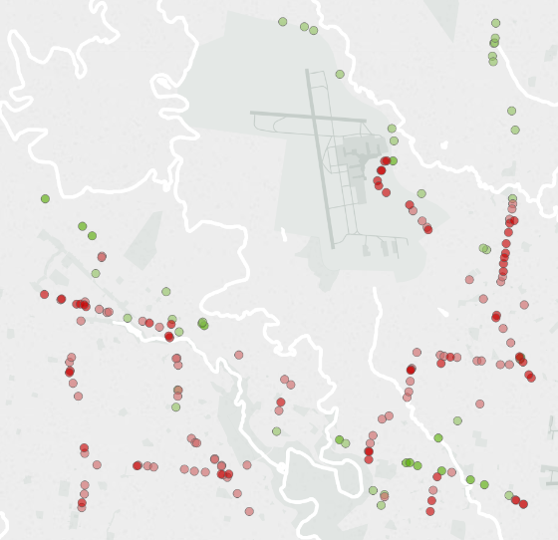 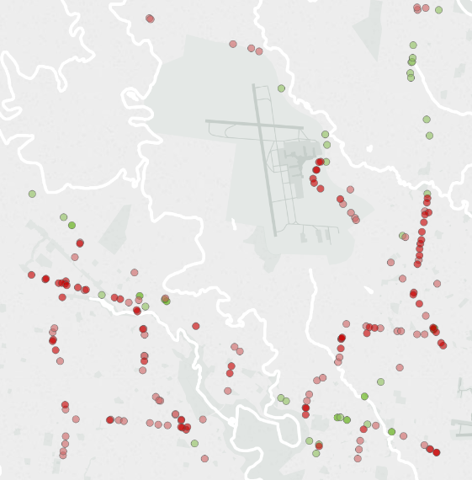 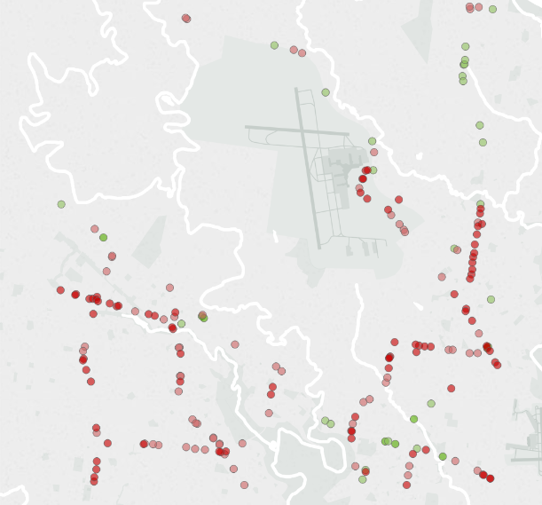

Fig 1.3 : Traffic location (6AM-7AM) Fig 1.4 : Traffic locations (7AM-8AM) Fig 1.4 : Traffic locations (8AM- 9AM)

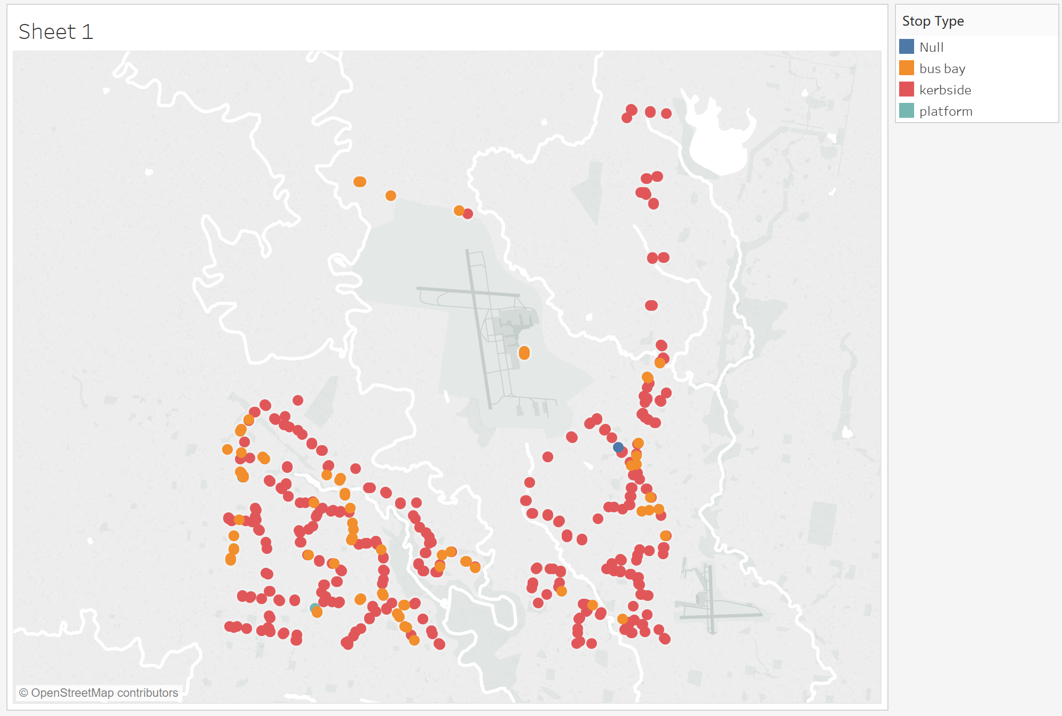

Figure 1.5 : Public Transport type around Tullamarine Airport area

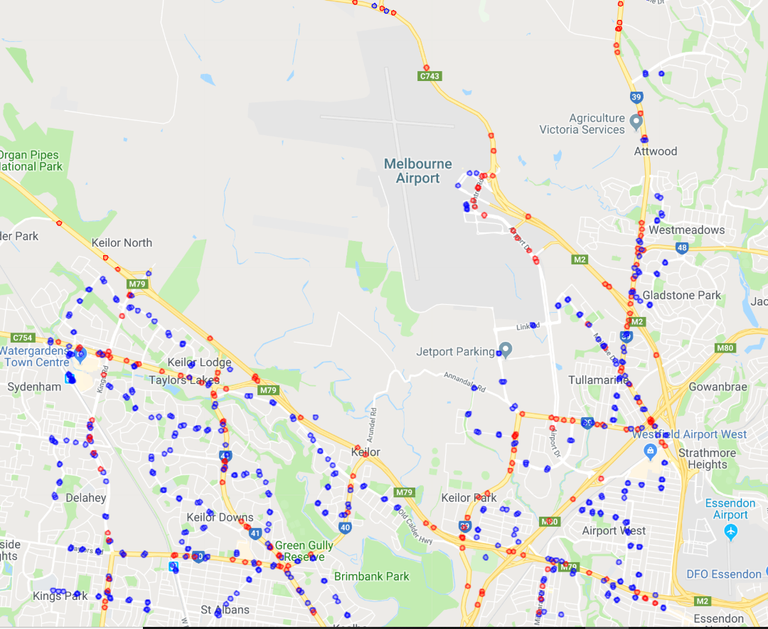

Stop locations

Speed capture locations

Figure 1.5 : Map of Stop locations and Speed camera locations