https://docs.spring.io/spring-security/site/docs/5.3.5.BUILD-SNAPSHOT/reference/html5/#servlet-authentication

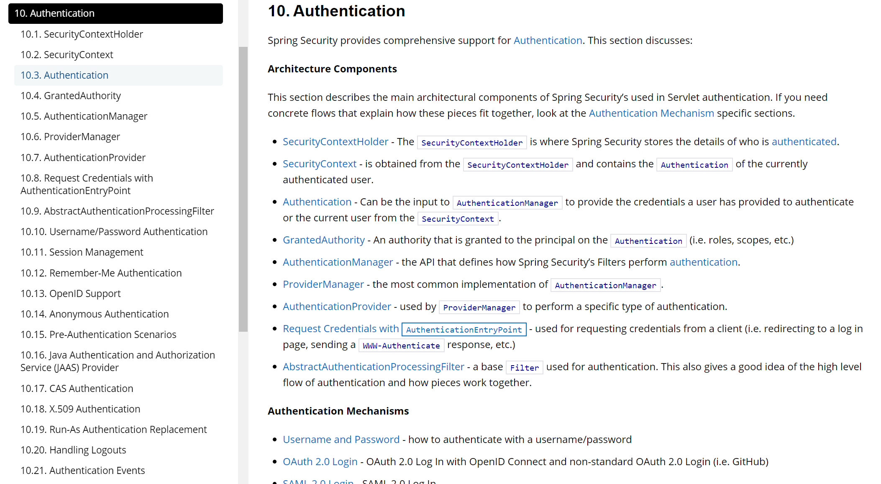

屏蔽不适用默认的账号分配
@SpringBootApplication(exclude = SecurityAutoConfiguration.class)
或@EnableAutoConfiguration(exclude = {
org.springframework.boot.autoconfigure.security.servlet.SecurityAutoConfiguration.class
})
public class Actviti7DemoApplication {
private Logger logger = LoggerFactory.getLogger(Actviti7DemoApplication.class);

public static void main(String[] args) {
SpringApplication.run(Actviti7DemoApplication.class, args);
}

@Bean
public Connector testConnector() {
return integrationContext -> {
logger.info("以前叫代理，现在叫连接器被调用啦~~");
return integrationContext;
};
}
}

Username/Password Authentication
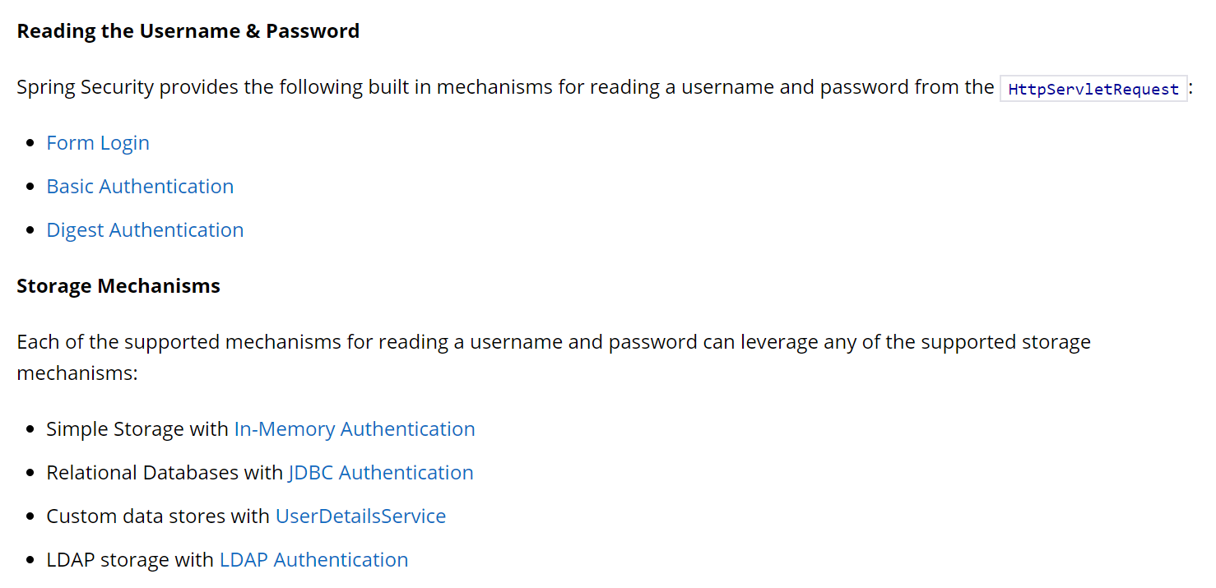

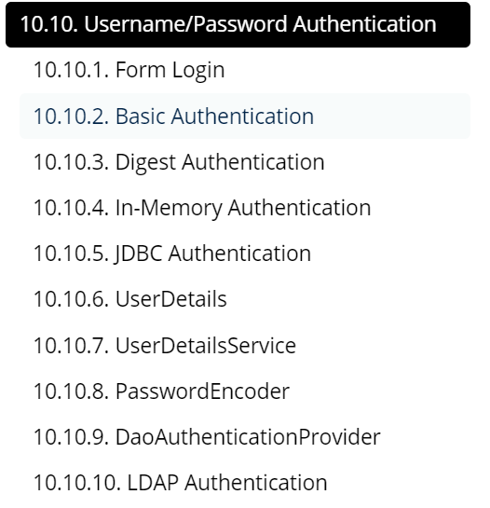

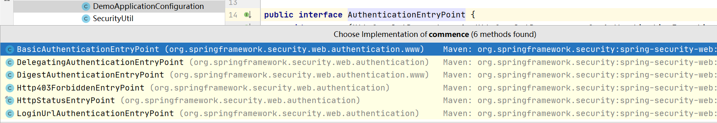
how form based log in works within Spring Security.
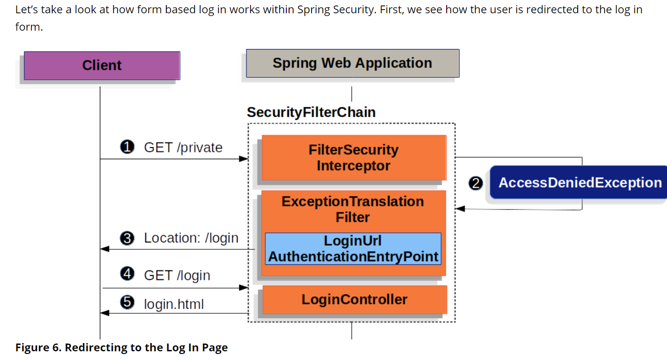
定制登录页面:
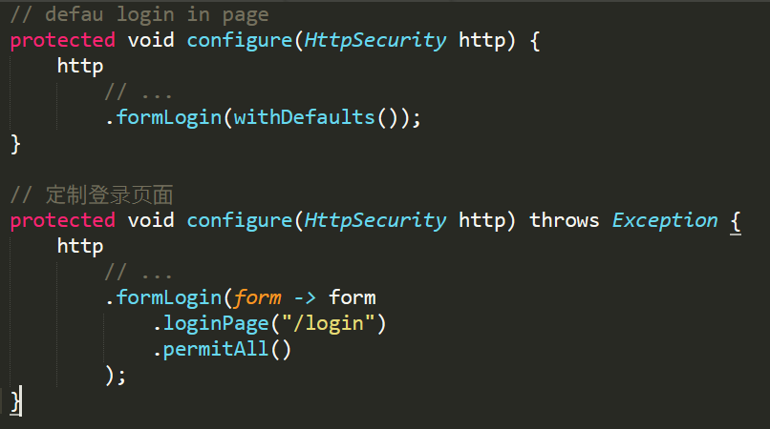

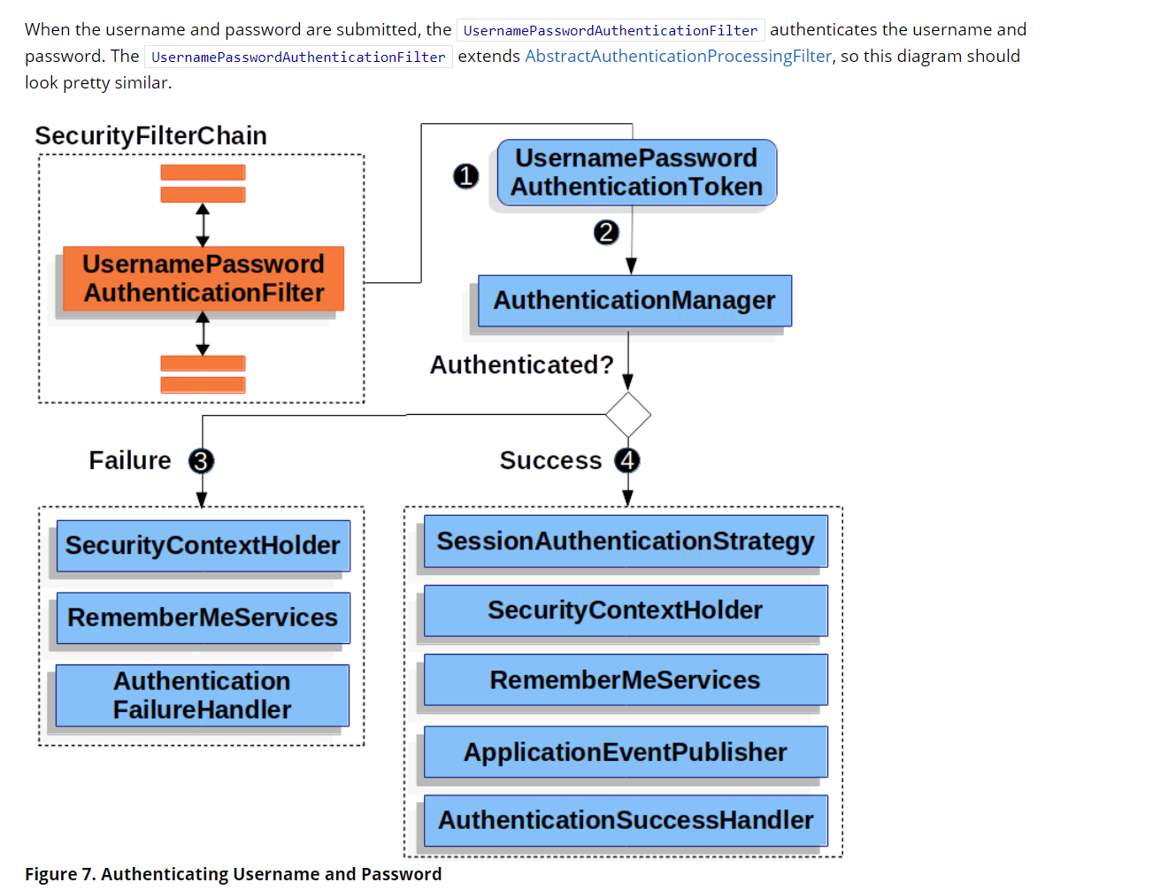

how HTTP Basic Authentication works
