## 安装

Windows下：[https://github.com/tporadowski/redis/releases](https://github.com/tporadowski/redis/releases" \t "https://www.runoob.com/redis/_blank)

不同操作系统：参考 <https://www.runoob.com/redis/redis-install.html>

## 启动

redis-server.exe redis.windows.conf

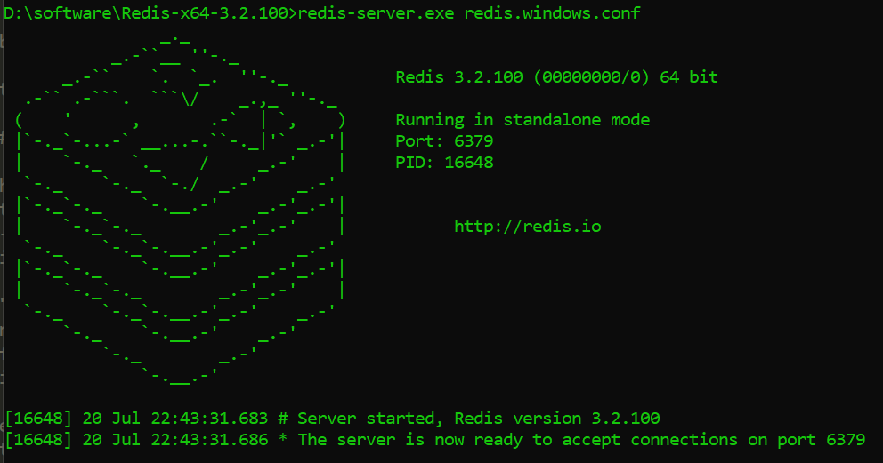

**Test**

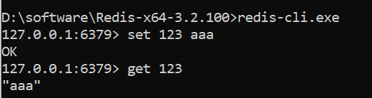

## 配置参数

*# By default, if no "bind" configuration directive is specified, Redis listens*

*# for connections from all the network interfaces available on the server.*

*# 绑定多个bind 192.168.1.100 10.0.0.1*

**bind 127.0.0.1**

*# Protected mode is a layer of security protection, in order to avoid that*

*# Redis instances left open on the internet are accessed and exploited.*

**protected-mode yes**

*# Accept connections on the specified port,*

*# If port 0 is specified Redis will not listen on a TCP socket*

**port 6379**

*# TCP listen() backlog.*

*#*

*# In high requests-per-second environments you need an high backlog in order*

*# to avoid slow clients connections issues. Note that the Linux kernel*

*# will silently truncate it to the value of /proc/sys/net/core/somaxconn so*

*# make sure to raise both the value of somaxconn and tcp_max_syn_backlog*

*# in order to get the desired effect.*

**tcp-backlog 511**

*# Close the connection after a client is idle for N seconds (0 to disable)*

**timeout 0**

# TCP listen() backlog.

**tcp-backlog 511**

*# Close the connection after a client is idle for N seconds (0 to disable)*

**timeout 0**

*# TCP keepalive.*

*#*

*# If non-zero, use SO_KEEPALIVE to send TCP ACKs to clients in absence*

**tcp-keepalive 0**

*# Specify the server verbosity level.*

*# This can be one of:*

*# debug (a lot of information, useful for development/testing)*

*# verbose (many rarely useful info, but not a mess like the debug level)*

*# notice (moderately verbose, what you want in production probably)*

*# warning (only very important / critical messages are logged)*

**loglevel notice**

*# Specify the log file name. Also 'stdout' can be used to force*

*# Redis to log on the standard output.*

**logfile ""**

*#* Set the number of databases. *The default database is DB 0, you can select*

*# a different one on a per-connection basis using SELECT <dbid> where*

*# dbid is a number between 0 and 'databases'-1*

**databases 16**

*# Save the DB on disk:*

**# save <seconds> <changes>**

save 900 1

save 300 10

save 60 10000

*# By default Redis will stop accepting writes if RDB snapshots are enabled*

*# (at least one save point) and the latest background save failed.*

**stop-writes-on-bgsave-error yes**

*# Compress string objects using LZF when dump .rdb databases?*

*# For default that's set to 'yes' as it's almost always a win.*

*# If you want to save some CPU in the saving child set it to 'no' but*

*# the dataset will likely be bigger if you have compressible values or keys.*

**rdbcompression yes**

*# Since version 5 of RDB a CRC64 checksum is placed at the end of the file.*

*# This makes the format more resistant to corruption but there is a performance*

*# hit to pay (around 10%) when saving and loading RDB files, so you can disable it*

*# for maximum performances.*

*#*

*# RDB files created with checksum disabled have a checksum of zero that will*

*# tell the loading code to skip the check.*

**rdbchecksum yes**

*# The filename where to dump the DB*

**dbfilename dump.rdb**

*# The working directory.*

*#*

*# The DB will be written inside this directory, with the filename specified*

*# above using the 'dbfilename' configuration directive.*

*#*

*# The Append Only File will also be created inside this directory.*

*#*

*# Note that you must specify a directory here, not a file name.*

**dir ./**

**########################### REPLICATION Master-Slave ############################**

Redis replication is asynchronous

Redis slaves are able to perform a partial resynchronization with the master if the replication link is lost for a relatively small amount of time.

Replication is automatic and does not need user intervention.

**# slaveof <masterip> <masterport>**

*# If the master is password protected (using the "requirepass" configuration*

*# directive below)*

**# masterauth <master-password>**

*# When a slave loses its connection with the master, or when the replication*

*# is still in progress, the slave can act in two different ways:*

*#*

*# 1) if slave-serve-stale-data is set to 'yes' (the default) the slave will*

*# still reply to client requests, possibly with out of date data, or the*

*# data set may just be empty if this is the first synchronization.*

*#*

*# 2) if slave-serve-stale-data is set to 'no' the slave will reply with*

*# an error "SYNC with master in progress" to all the kind of commands*

*# but to INFO and SLAVEOF.*

*#*

**slave-serve-stale-data yes**

*# You can configure a slave instance to accept writes or not.*

**slave-read-only yes**

**repl-diskless-sync no**

*# When diskless replication is enabled, it is possible to configure the delay*

*# the server waits in order to spawn the child that transfers the RDB via socket*

*# to the slaves.*

**repl-diskless-sync-delay 5**

*# Disable TCP_NODELAY on the slave socket after SYNC?*

**repl-disable-tcp-nodelay no**

**当master停止工作时，决定哪个slave提升为master**

*# The slave priority is an integer number published by Redis in the INFO output.*

*# It is used by Redis Sentinel in order to select a slave to promote into a*

*# master if the master is no longer working correctly.*

**slave-priority 100**

**################################## SECURITY ###################################**

*# Require clients to issue AUTH <PASSWORD> before processing any other*

*# commands.*

**requirepass foobared**

**################################### LIMITS ####################################**

**# 不配置时默认32个连接数**

**maxclients 10000**