**Project #1 - Converging Diverging Nozzles**

*Group 6 - May 3rd, 2018*

*Dr. Willet - Tacoma Community College - Numerical Methods - Spring ‘18*

*Created By: My Nguyen & Clarisa Leu-Rodriguez*

**Purpose:**

The purpose of this project is to analyze the MATLAB root finding methods discussed in class considering the isentropic converging diverging nozzle equation.

**Background Information:**

About The de Laval Nozzle Design:

Accelerating a liquid or gas to high velocities is the central issue for many different types of industrial applications. The basic tool for accelerating a gas is a de Laval nozzle, named after its inventor Gustaf de Laval. It is essentially a cylindrical pipe that necks down in the middle forming an hourglass shape. The pressure and velocity of the entering gas needs to be enough (though still subsonic) and the constriction small enough for the gas to reach the speed of sound at the choke point or throat. If this happens, as the gas leaves the throat it expands and accelerates to supersonic speeds.

**The de Laval Nozzle Design**

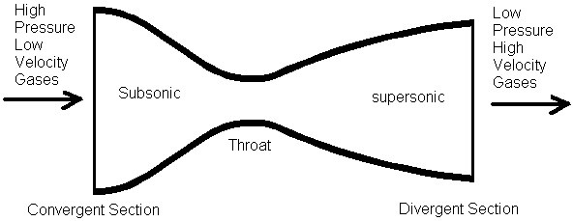

Rockets, scramjets, and ramjets all use nozzles to accelerate hot exhaust to produce thrust as described by Newton’s third law of motion; for every action there is an equal and opposing action. The amount of thrust produced by the engine is dependent on the mass flow rate through the engine, the exit velocity of the flow, and the pressure at the exit of the engine. The value of these three flow variables are all determined by the nozzle design.

A nozzle is essentially a specially shaped tube through which hot gases flow. In a convergent-divergent, or CD, nozzle, the hot exhaust leaves the combustion chamber and converges down to the throat of the nozzle which has the minimum area. The throat size is chosen to choke the flow and set the mass flow rate through the system. The flow in the throat is sonic which means the Mach number is equal to one in the throat. Downstream of the throat, the geometry diverges, and the flow is isentropically expanded to a supersonic Mach number that depends on the area ratio of the exit to the throat. If the flow is subsonic then the Mach Number is less than 1. For a supersonic flow, the Mach number is greater than 1.

About the Relevant Equation:

$$Â=\frac{1}{M}[(\frac{2}{k+1})(1+\frac{k-1}{2}M^{2})]^{\frac{k+1}{2(k-1)}}$$

In this equation, M is the Mach number, Â is the normalized area of the nozzle, and k is the specific heat ratio of the gas. In this project, we will analyze values of k=1.285 ($CO_{2})$, 1.400 (Air), and 1.667 (Noble Gases).

**Problem Description:**

For each value of Â, there are two values of M, one being subsonic (before entering the throat of the nozzle) and one supersonic (after the throat). In this project, we will produce graphs using MATLAB scripts and functions. Our graphs will show how the Mach number M (on the y axis) varies with a normalized area Â (on the x axis) for all three types of gases: carbon dioxide, air, and noble gases. We will analyze the equation using an open method and a bracketing method and compare the two separate run times for the two separate approaches. Also, we will determine run time for the two separate methods and determine which one is more efficient and how to improve the efficiency of each approach.

**Results:**

For the modified secant method and bisection method, both approaches produced the same graph of the normalized area Â vs the Mach number M of the nozzle:

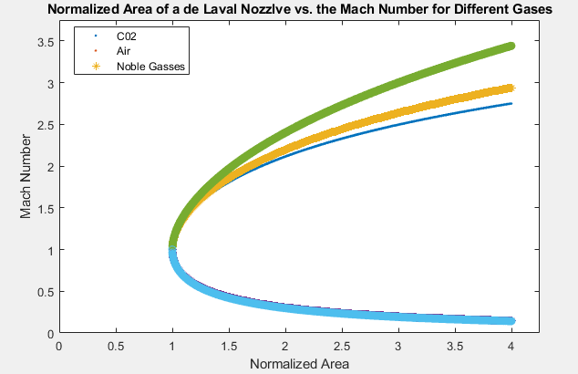

**Discussion:**

Run-Time:

We used the modified secant method and the bisection method to find the different Mach numbers for each value of Â over the interval from Â=1 to Â=4 with a step size of 0.001. We timed how long it took to perform this computation for all three gases. The run time for the modified secant method on My’s computer was on average about: 0.350801 seconds. The run time for the bisection method on My’s computer was on average about: 0.254984 seconds.

Open-Iterative Method - Modified Secant:

In the modified secant method, to return both roots we had to alter our initial guess. The modified secant method wrote in class inputs an initial guess, error tolerance, and maximum number of iterations. To obtain the subsonic Mach numbers, our initial guess was 10-6 or *delta* based on previous discussions in class. To obtain the supersonic Mach numbers, our initial guess had to be greater than 1 but less than 4, based on analysis of the graph we obtained from Mathematica. Our initial guess to obtain the supersonic Mach numbers was 4. Initially, we had an initial guess of 5000 for the supersonic value which caused the run-time to drastically increase. Choosing an initial guess close to the value we were expecting noticeably improved the runtime of our program. Therefore, we varied our initial guesses for each M value appropriately.

We choose 50 for the maximum number of iterations, if the algorithm didn’t find the root after 50 iterations we could stop. We also chose our error to be about 0.001 for more accurate results. With these set parameters for the modified secant method, we had no convergence issues. However, we had convergence issues when we chose negative initial guesses and the run time increased drastically with larger intervals and a larger number of subdivisions.

To check our results, we did some research about the Mach number and what it means in terms of the speed of sound. The Mach number in the supersonic case is about 1.3 - 5, and in subsonic case is less than 0.8. Base on this information, we were able to check if our outputs were on the right track or not as we were expecting two M values within these ranges.

Bracketing Method - Bisection Method:

With this method, we needed to alter the interval [a,b] where we could expect the root to be found, the number of subdivisions, and the desired absolute error based on the class code. We also had to choose values of a and b such that there was a sign-change. To obtain the supersonic Mach number, we called bisection on the interval from 1 to 4 for supersonic case, and from 0 to 1 for subsonic. After trial and error, to improve the run time we chose 2 as the number of subdivisions with an absolute error of 0.001. To improve the run time, the number of subdivisions and length of the interval needs to be minimized.

Bracketing Method vs. Modified Secant Method:

Depending on what intervals we started with, or how close to a root we started with, the bisection method might converge in few iterations. By doing this project, we could say that the average rate of convergence issues of the bisection method is much smaller than the secant method. We checked different values for the intervals and the subdivision of both supersonic and subsonic cases including the big interval with very small number of subdivision, the rate of convergence issues of bisection method is still very small.

For bisection, usually what we expect is that it will converge slower than the modified secant method. However, we noticed that when we called bisection with a very small number of subintervals it performed faster than the modified secant method.

**Conclusion:**

In conclusion, the secant method has bigger rate of convergence issues. It’s harder to find the initial guess, error, and iterations appropriately. The script gave error method whenever the inputs were not appropriately. On the contrary, finding the inputs for bisection method is easier, less rate of convergence issues. According to our script, the bisection method run faster than the modified secant method.

The most challenging part of this project was trying to improve the run time of both root finding methods in MATLAB. The most interesting part of this project was learning about the CD nozzle design. The method that seemed to work better in practice was the bisection routine however that was only due to us improving the efficiency by varying the inputs. In most cases we’ve discussed in class though, the modified secant method should have a better runtime and converge faster.

**References:**

<https://en.wikipedia.org/wiki/Isentropic_nozzle_flow>

<https://en.wikipedia.org/wiki/Mach_number>

<https://en.wikiversity.org/wiki/The_bisection_method>

<https://www.grc.nasa.gov/www/k-12/airplane/nozzled.html>