**Introduction:**

The purpose of this project is to analyze *Arrhenius’* equations considering the two variations of least squares regression discussed in class, linear and nonlinear. Our aim is to model a set of given data and develop two different models for the data and analyze which model fits the data best.

We developed a MATLAB script that executed general least squares regression using a nonlinear and a linearized method which compiled and graphed various experimental data points for the given temperature and reaction rate values associated with the chemical equation: $O+H2→OH+H.$ By computing the correlation coefficients, we determined which of the two models would be a better method to use for future projects based on how well the two models fit the data.

**Relevant Equations & General Approach:**

The relationship between the temperature and reaction rate values are represented by the two Arrhenius equations below:

$k=Ae^{-\frac{E}{RT_{a}}}$ and $k=AT_{a}^{b}e^{-\frac{E}{RT_{a}}}$

*k* = reaction rate

*A* = frequency factor

*E* = activation energy

*R* = ideal gas constant (8.314)

$T_{a}$ = temperature (Kelvin)

*b* = constant

*Arrhenius’* equations both compute the reaction rate of a chemical reaction. For the modified equation (equation 2), it makes explicit the temperature dependence of the pre-exponential factor ($T_{a}^{b}$). The original equation (equation 1) is the modified *Arrhenius* equation corresponding with *b=0.* This temperature dependency term of the exponential factor is to give a better fit to an experimental observation, but it is more frequently common to leave out this term for calculations in Chemistry.

With the first equation, we computed the specific values of *A* and *E* that would represent best fit for the experimental data based on the model. This equation is easily linearizable, therefore we used a linear model for the first equation. For the second equation, we computed different values of *A*, *E*, and *b* which would also create the best fit model for the same data. For this equation we used a nonlinear method of general squares regression.

**Linear Method:**

For the first equation, $k=Ae^{-\frac{E}{RT_{a}}}$, we used the linearized method by taking the logarithm on both sides as follows:

$$\log\left(k\right)=\left(-\frac{E}{RT}\right)+log⁡(A)$$

Then we compared this to the slope-intercept form: $y=mx+b$ where $y$ represents $\log\left(k\right)$, $m$ represents the slope $-\frac{E}{R}$, $x$ represents $\frac{1}{T}$, and $b$ represents $\log\left(A\right).$ A general outline for this linearized method algorithm we used is shown below:

- Set the new values of T and k based on the logarithm

- Find the average mean values, slope, and y-intercept to find values for A and E

- Compute the correlation coefficient

- Create a regression model for this data based on the formulas discussed in class.

**Nonlinear Method:**

For the nonlinear method of least squares regression, we used a built in MATLAB method, *fminsearch(),* using the nonlinear model**: $k=AT_{a}^{b}e^{-\frac{E}{RT_{a}}}$**  to find the best fit coefficients *A, E,* and *b*. To use *fminsearch(),* we first had to define a separate function file (*nonlinmodel.m*) to define the model we wanted. *fminsearch()* is a nonlinear programming solver built into MATLAB which finds the common root for a system of nonlinear equations (for example, two partial derivatives). *fminsearch()* speeds up the numerical process of finding the best fit coefficients of the nonlinear model based on the given data which can also be found using the Newton-Raphson method. To call *fminsearch*(), we had to pass in an array of initial guess for which the min may exist based on our unknown coefficients, a set of options, and our data. Our initial guesses for which the minimum of our model may exist were [1,1,1] based on the unknown coefficients. We noticed that increasing our initial guesses to [2,2,2] decreased the correlation coefficient of the model versus the actual & inputting zero or negative values computed a correlation of 0%. Therefore, we left our initial guesses at [1,1,1].

**Results:**

|  |  |  |  |  |
| --- | --- | --- | --- | --- |
|  | **Frequency Factor (A)** | **Activation Energy (E)** | **Constant (b)** | **Correlation Coefficient** |
| **Linear** | 3.82*10^14 | 6.1644e+04 | N/A | 0.990425 |
| **Nonlinear** | 198.6294 | 1.3154*10^4 | 3.3329 | 0.986024 |

**Graphs:**  
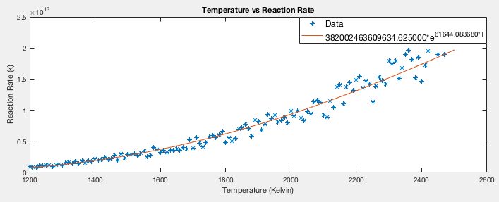

The graph above shows the results from the linearized model & the given data.

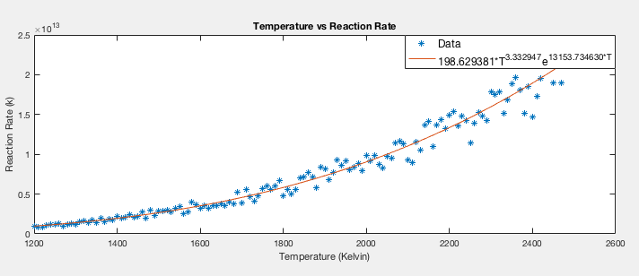

The graph above shows the results from the nonlinear model & the given data.

Based on analysis of the two graphs, they correspond with what we expected based on *Arrehenuis’* equations. The higher the temperature, the faster the chemical reaction. Both models correlate strongly with the data and we were pleased with our results.

**Conclusion:**

In conclusion, based on our results, the linear model we produced fit the data best based on having larger correlation coefficient of 0.990425 compared to the nonlinear model which had a correlation coefficient of 0.986024. Both the models produced modeled the given data well in our opinions, as both had large correlation coefficients. We expected the nonlinear model to fit the data better as it had an extra term for the temperature dependence of the pre-exponential factor, but our results were the opposite and the linear model was the better fit of the two.

The most interesting part of this project in our opinion was learning about the *Arrhenius’* equations and modeling the given data using general squares regression in MATLAB. We also thought it was interesting learning more MATLAB functions and getting more experience using these functions.