Setting up a fixed IP address for an Oracle Virtual Box

To enable the lamp-ng Virtual Box to connect to your local network, you need to use a “bridged network adapter”.

You can set this from the Vitual Box menu:

Machine / Settings

Select Network in the left bar and set:

Attached to: Bridged Adapter

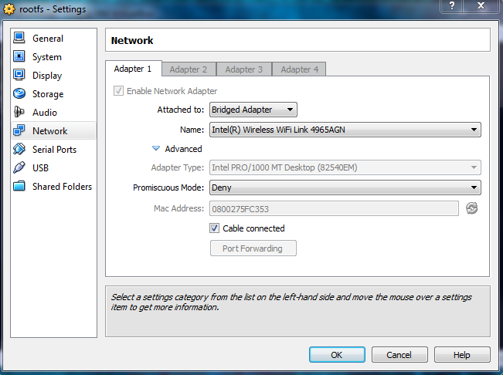

If your Virtual Box was running already, you’ll need to re-start it so a local IP address is issued. To re-start the Virtual Box, enter the command below:

shutdown –r now

Once the Virtual Box has finished booting up, enter the following commands to fix the Virtual Box’s IP address to 192.168.0.90.

cd

. setnetwork.sh

If you prefer to use a different IP address, after running the script edit the interfaces file configuration:

vi /etc/network/interfaces

Then replace the IP for a suitable one and then re-start the linux networking:

/etc/init.d/networking/restart