|  |  |
| --- | --- |
| **Onsite Case** | Description: LogoBINUS-University |
| WDH1S2 |
| **Periode Berlaku** Semester Genap 2020/2021  ***Valid on*** *Even Year 2020/2021* | **Software Laboratory Center**  **Assistant Recruitment 21-2** |

## Materi

*Material*

* Introduction to HTML
* HTML Tags
* Link
* Image
* Text Styling
* Line
* List
* Form & Form Components
* Design using Basic CSS (inline CSS)

## Soal

*Case*

**Kenshoo**

**Kenshoo** is the only technology platform for brands looking to plan, activate and measure effective marketing across ALL of the most-engaging digital channels. You as a website developer, are asked to make a website for Kenshoo that looks like the figure below.

1. **Request a Demo Page**

* **Header**

The header consists of Kenshoo’s logo, **unclickable** navigation that **changes color** when it is **hovered**, and a “Request a Demo” button that redirect to its page. The header will **stick to the top of the page** even if the page is scrolled.



Figure 1. Header

* **Footer**

The footer consists of navigation link and the brief information about Kenshoo. The **social media** navigation is **clickable** andwill redirect user to other page. The other navigation that is **not clickable** can **change** **color** when it is **hovered**.

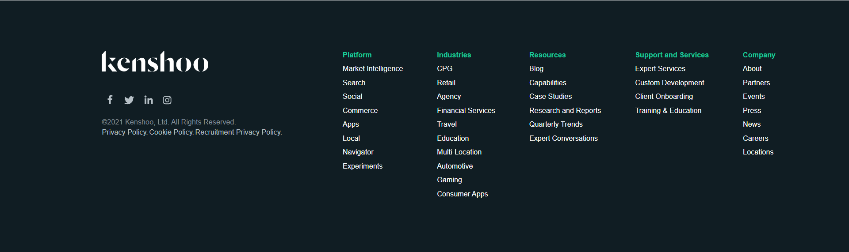

Figure 2. Footer

* **Main Section**

The main section of this page consists of **form section** and **video section**.

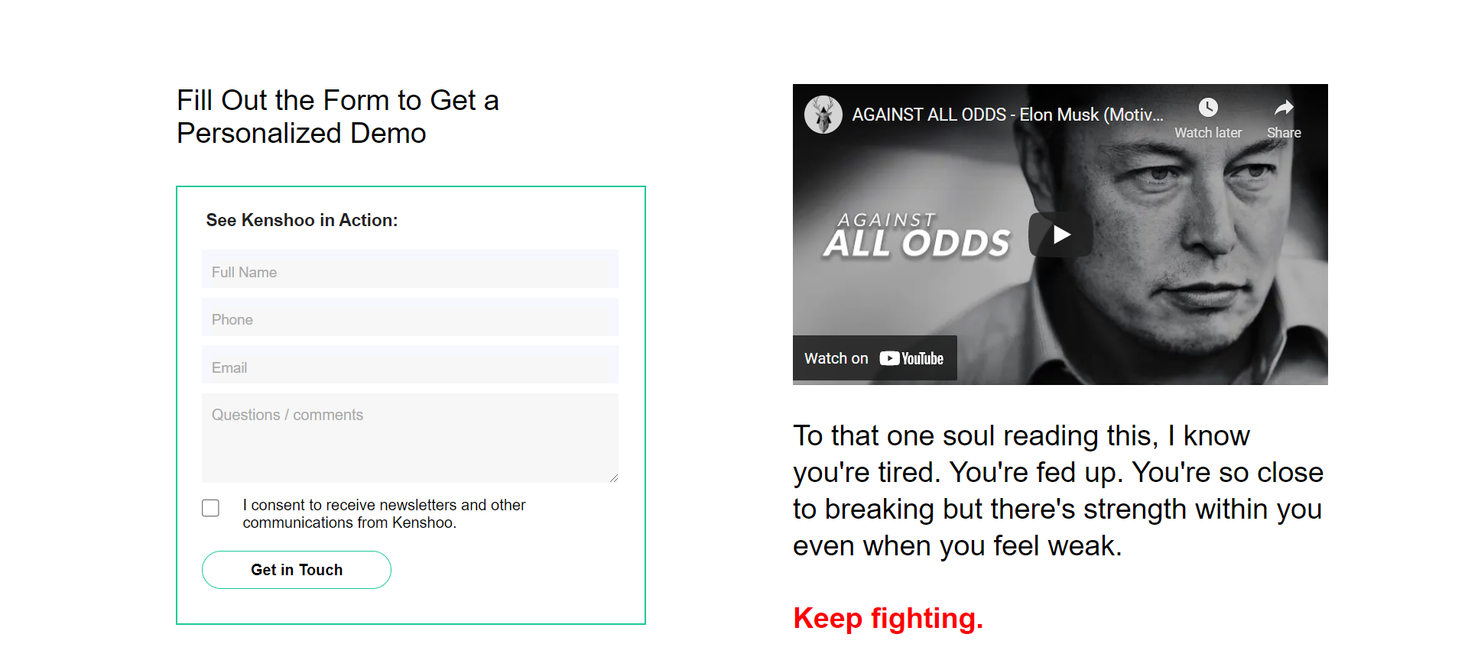

Figure 3. Main Section

* **Form Section**

The form consists of a button and fields that user **must be filled** in order to be redirect to the **Home Page**. Also **Validate** that email fields must be filled in **email format**. After user has filled all of the fields needed and clicked on the “**Get in Touch**” button, **redirect** user to the **Home Page**.

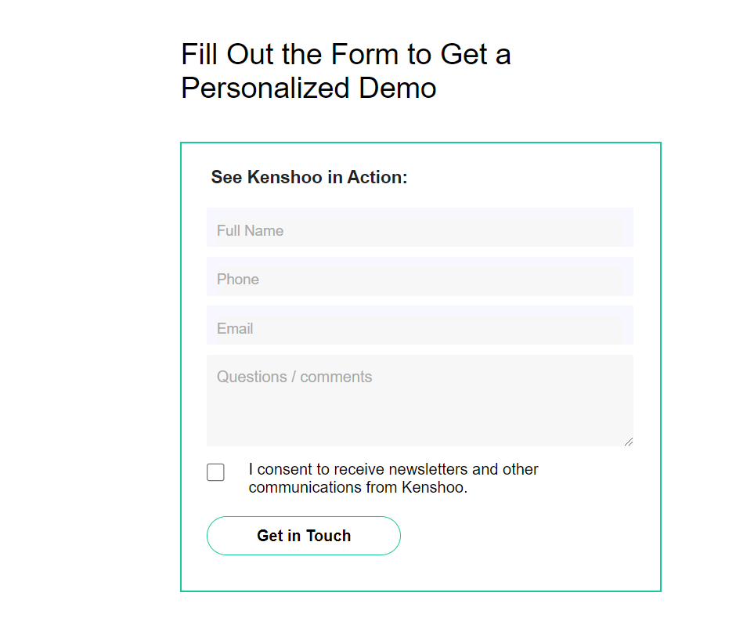

Figure 4. Form Section

* **Video Section**

This section consists of a **video** that has been **published on Youtube**. Use the video directly from **Youtube** and display it on this section. Then, display the **quotes** below the video.

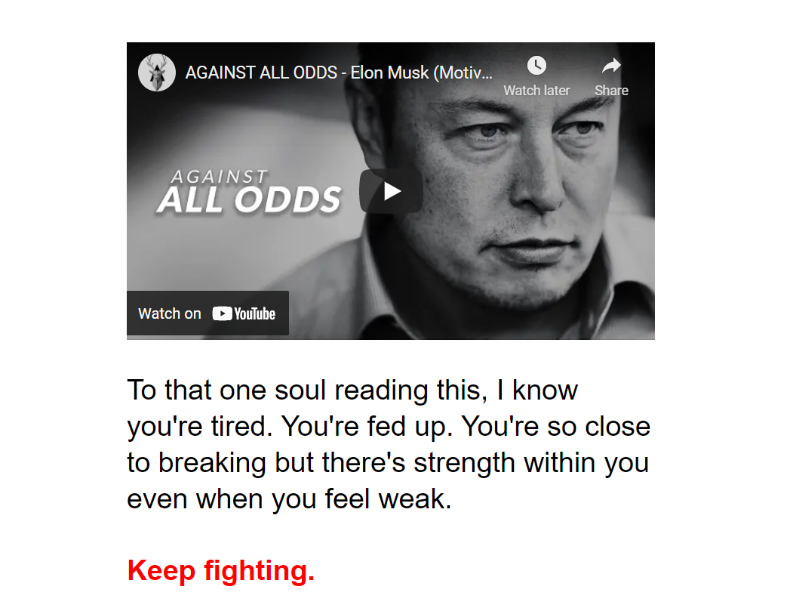

Figure 5. Video Section

1. **Home Page**

* **Header**

The header consists of Kenshoo’s logo and **unclickable** navigations that **changes color** when it is **hovered**). The header will **stick to the top of the page** even if the page is scrolled.



Figure 6. Header

* **Footer**

The footer consists of navigation link and the brief information about Kenshoo. The **social media** navigation is **clickable** andwill redirect user to other page. The other navigation that is **not clickable** can **change color** when it is **hovered**.

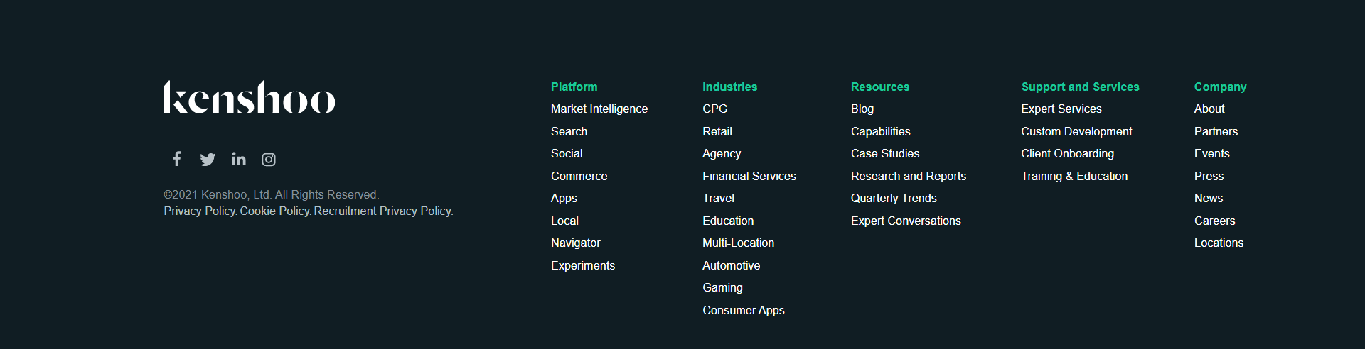

Figure 7. Footer

* **Main Section**

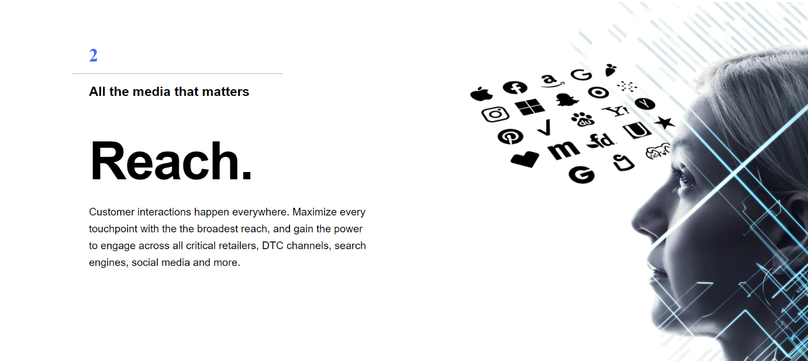The section consists of the Kenshoo’s news. **Redirect** user to **next section** if “**Explore**” is clicked. Give **scroll animation** between each section when it is **scrolled**.

Figure 8. Main Section

## Komponen

*Components*

|  |  |  |
| --- | --- | --- |
| Components | Criteria | Percentage |
| Others | Header | **28%** |
| Footer | **12%** |
| Home Page | Main Section | **17%** |
| About Us Page | Form Section | **32%** |
| Video Section | **11%** |

## Notes

* You can use all display include **flex**
* **Do not use table to do layouting**
* For the guide of **flex** display, you can use this website “**https://flexbox.help/**”

**Please run the EXE file to see the sample program.**