Appendix D
User Manual
For the Farm Owner
The farm owner has full access. The owner can do everything a Record Keeper can (see For Record Keepers) and, in addition, manages user accounts and the farm profile, and is the only user who can delete records.
1. Signing In
1.1 Open a web browser and go to the farm's website. Click “Sign in” at the upper-right corner of the page.
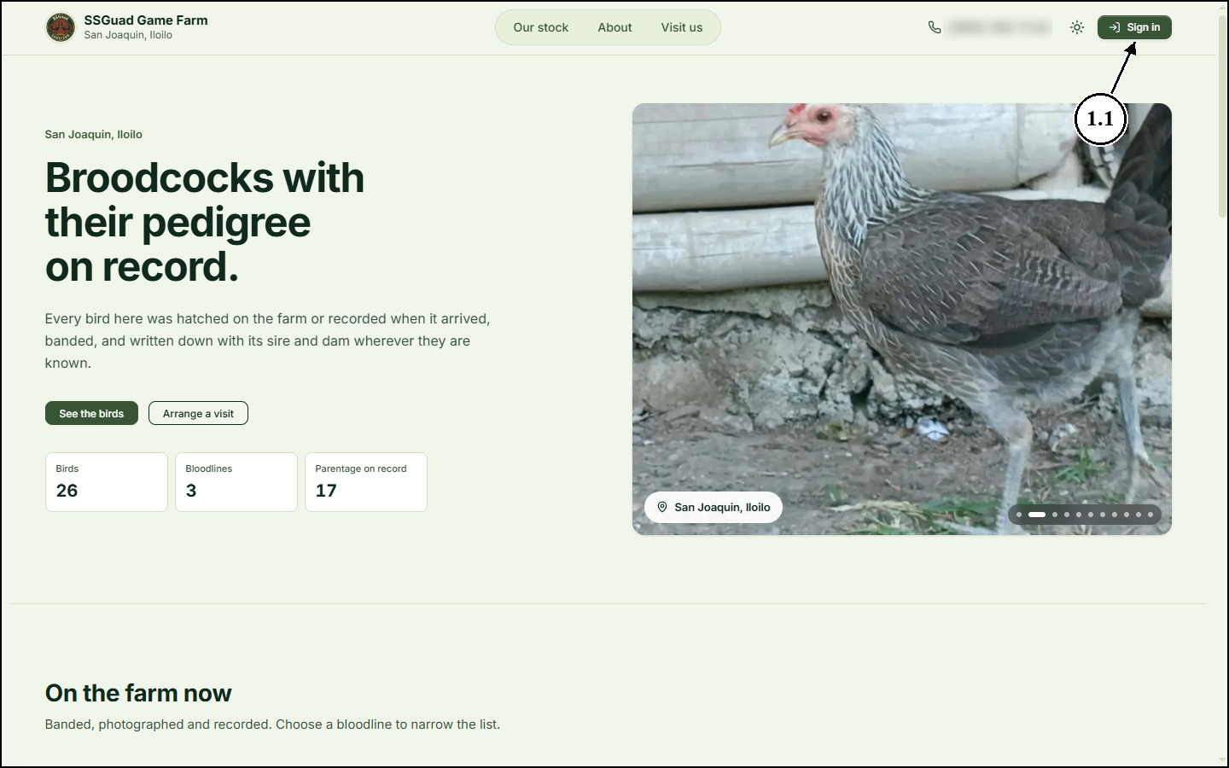
1.2 Enter the email address and password of your account.
1.3 Click “Sign in”. If you forget your password, click “Forgot password?” and follow the link that is sent to your email.
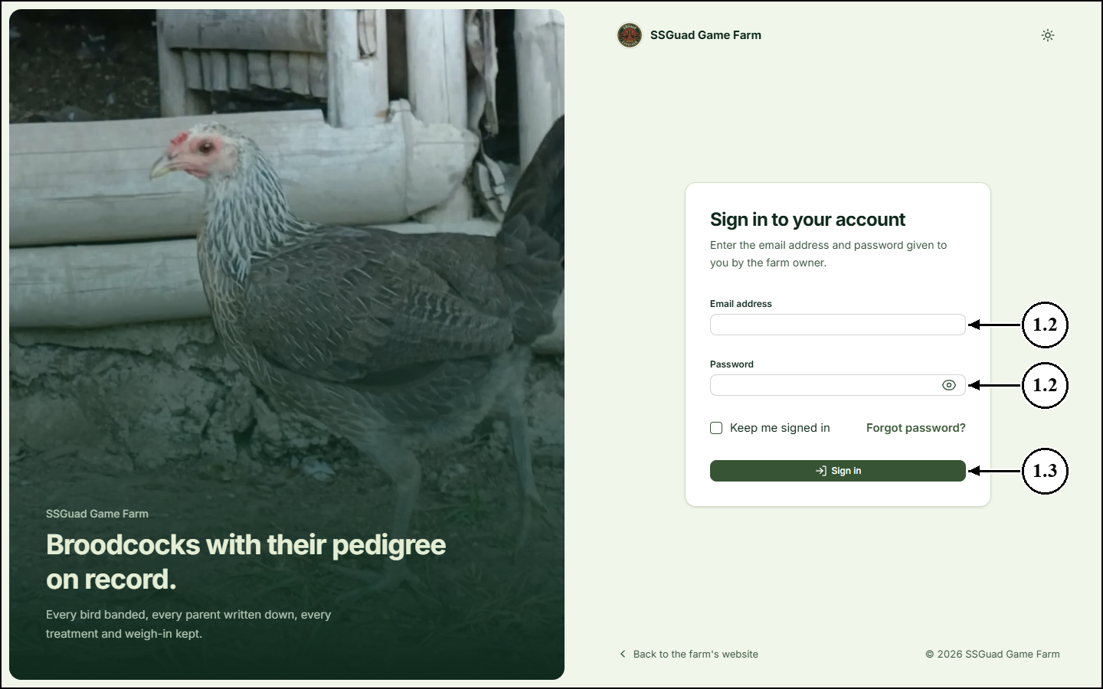
2. Using the Dashboard
2.1 After signing in, you are taken to the Dashboard. The owner’s sidebar has an Admin section with two extra pages: Users and Farm Profile.
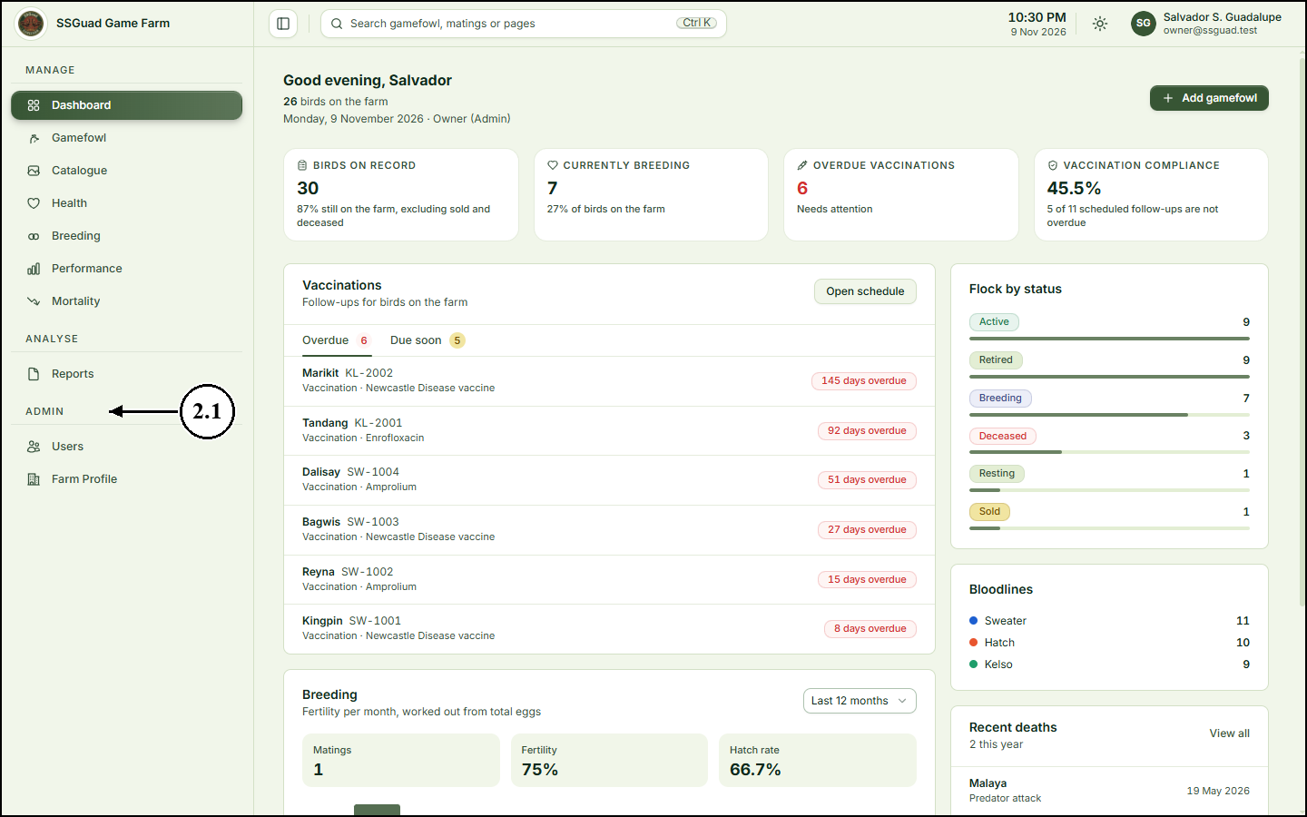
3. Adding a User Account
3.1 On the sidebar, click “Users”. The page lists every account with its role, position, contact number and status.
3.2 Click “Add User”.
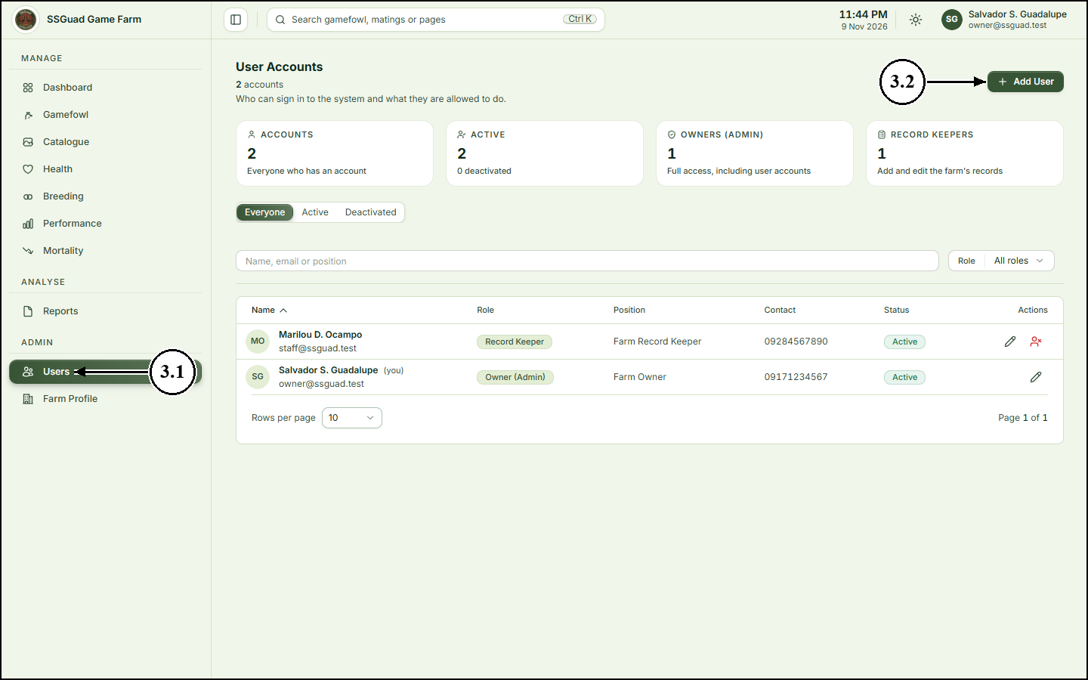
3.3 Enter the person’s full name and email address. They will use this email address to sign in. Add their contact number, position and address if you have them.
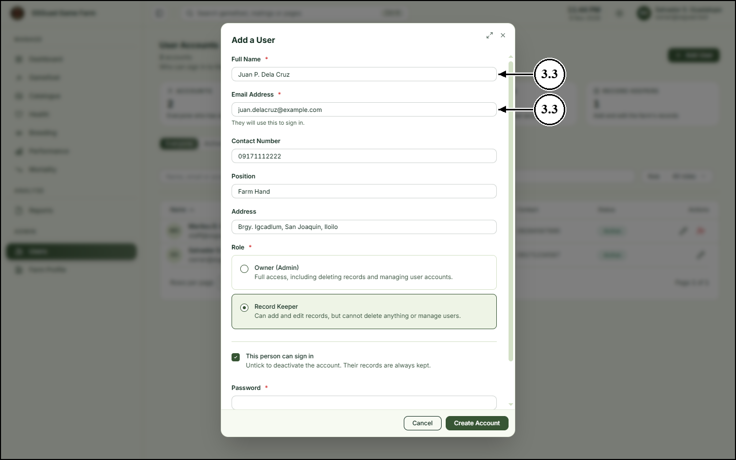
3.4 Choose the person’s role: Owner (Admin) or Record Keeper. The description under each role says what that person will be allowed to do. Only the farm’s own people have accounts; customers and other visitors use the public website without signing in.
3.5 Leave “This person can sign in” ticked so the account can be used straight away.
3.6 Enter a password for the account, then enter it again under Confirm Password.
3.7 Click “Create Account”.
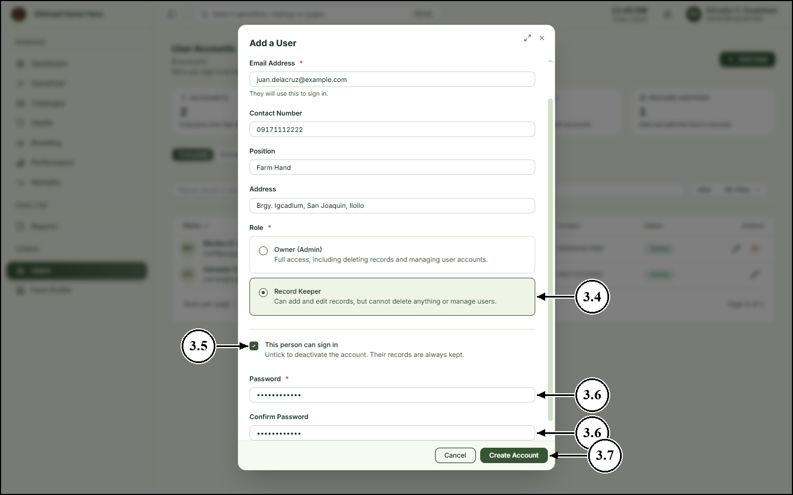
3.8 The new account appears in the list. To change someone’s details or role later, click the edit (pencil) icon at the end of their row.
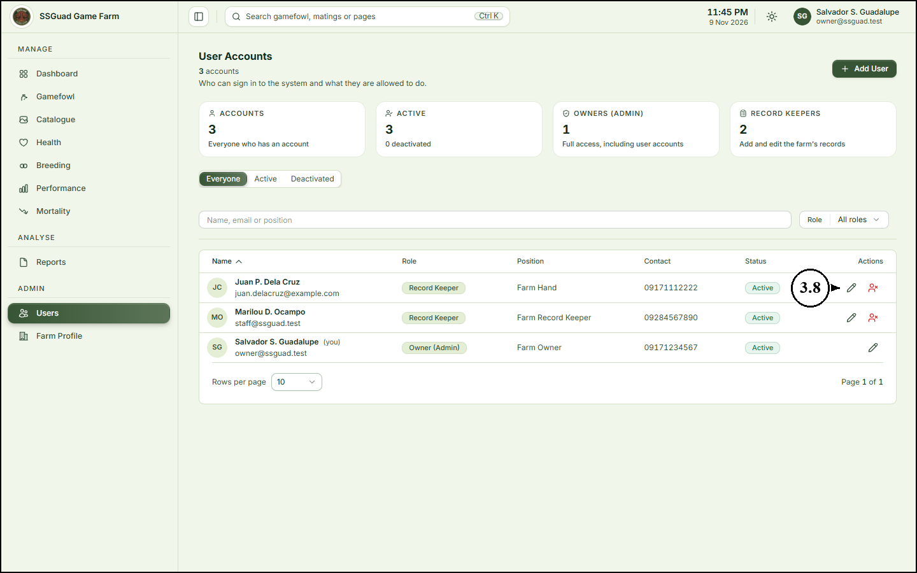
4. Deactivating or Reactivating an Account
4.1 To stop someone from signing in, click the deactivate icon at the end of their row.
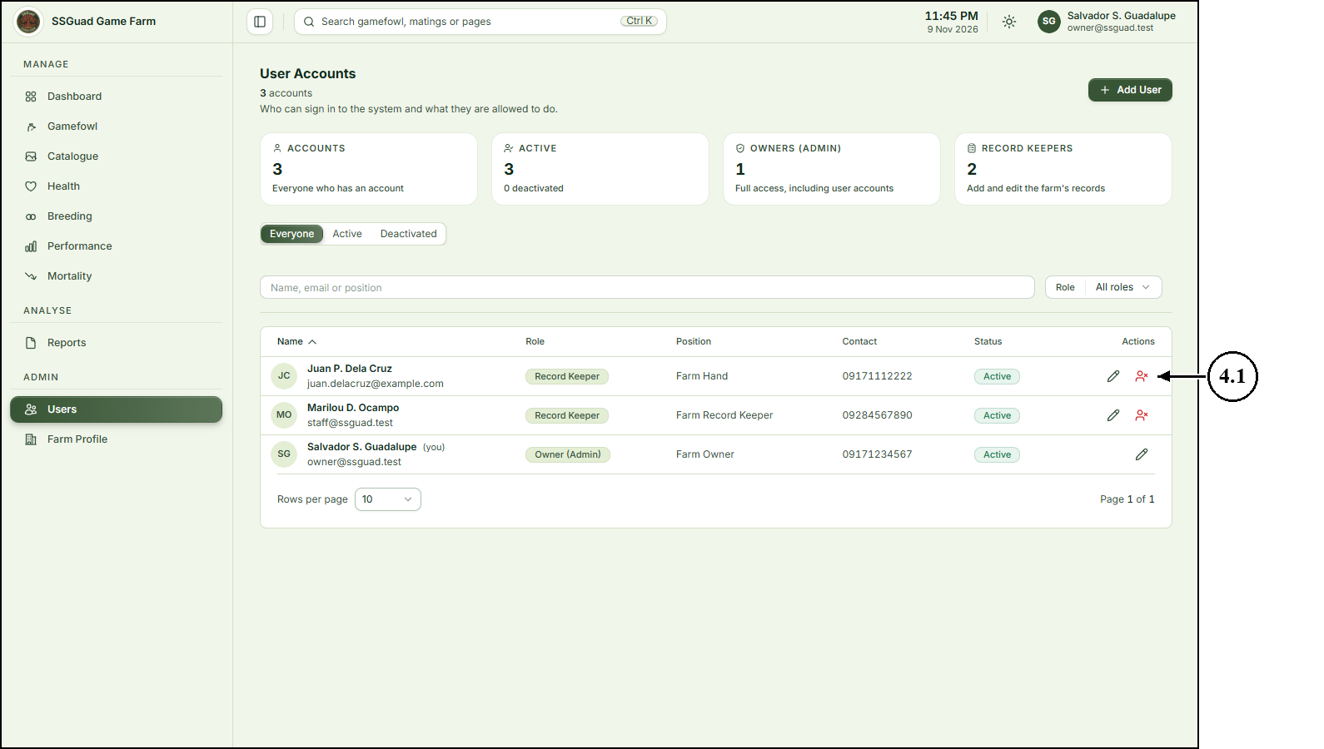
4.2 Read the message, then click “Yes, deactivate” to confirm. The person is signed out at once; everything they have recorded is kept.
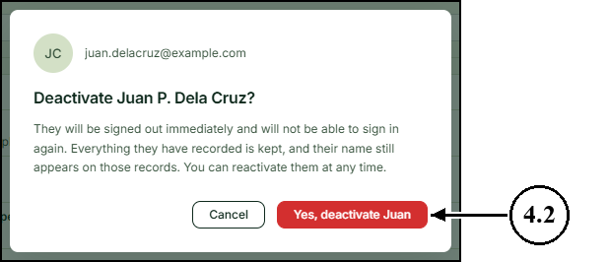
4.3 The account’s status changes to Deactivated.
4.4 To let the person sign in again, click the reactivate icon at the end of their row.
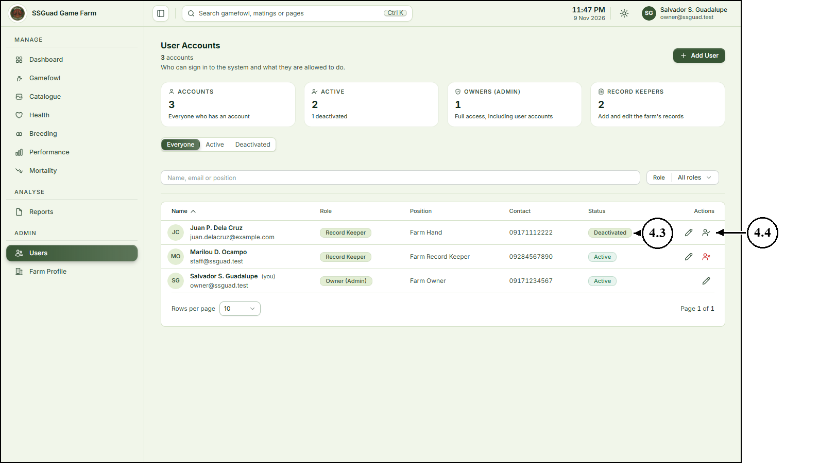
4.5 Click “Yes, reactivate” to confirm. The person can sign in again with their existing password.
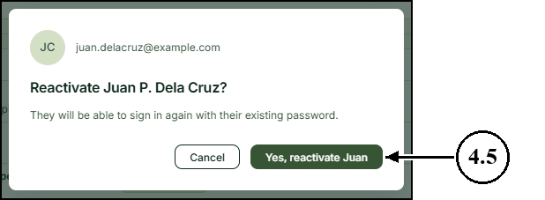
5. Updating the Farm Profile
5.1 On the sidebar, click “Farm Profile”.
5.2 Edit the farm’s name, phone number, email address, location, visiting hours or note to visitors. The preview on the right shows how the public pages will display them.
5.3 Click “Save Changes”. The changes appear on the public pages straight away.
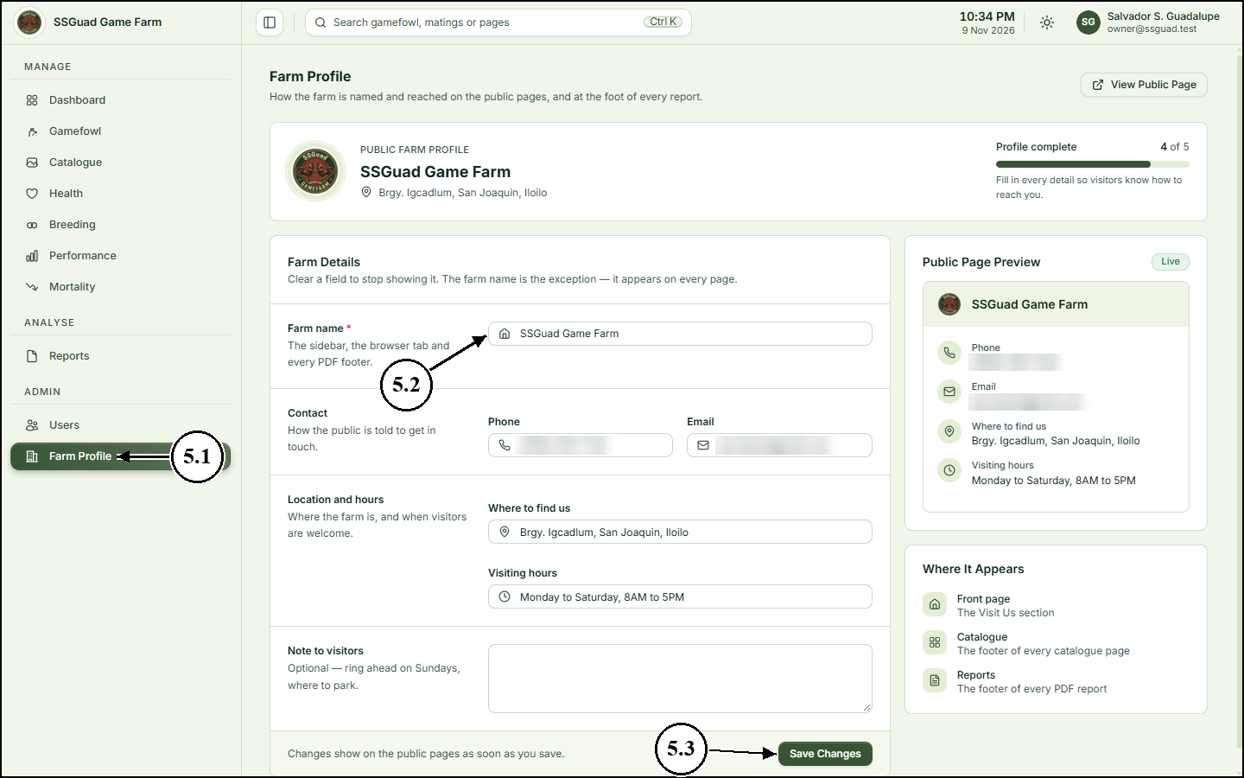
6. Deleting a Record
6.1 Open the list that holds the record. For example, on the sidebar, click “Gamefowl”.
6.2 Click the delete (trash) icon at the end of the record’s row. Only the owner sees this icon.
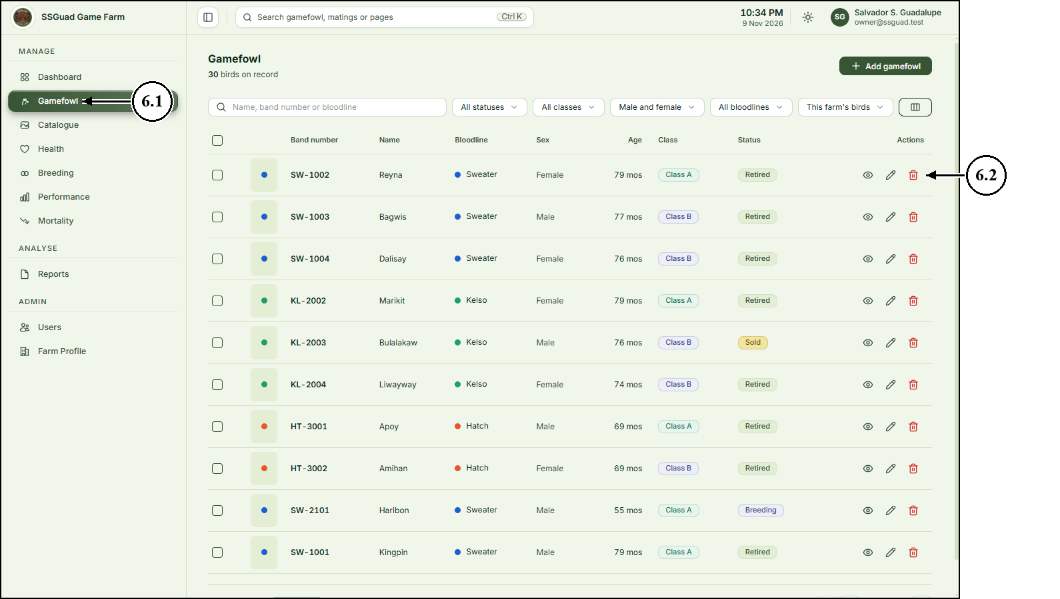
6.3 Read the message, then click “Yes, delete this bird” to confirm. The bird’s health, breeding and performance history is kept, and the deletion is recorded in the activity log.
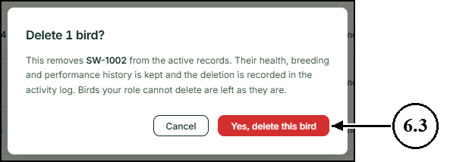
For Record Keepers
Record Keepers are the farm staff who keep the records. They can add and edit records, but cannot delete anything or manage user accounts.
1. Signing In
1.1 Go to the farm's website and click “Sign in”. Enter the email address and password of the account the farm owner created for you.
1.2 Click “Sign in”.
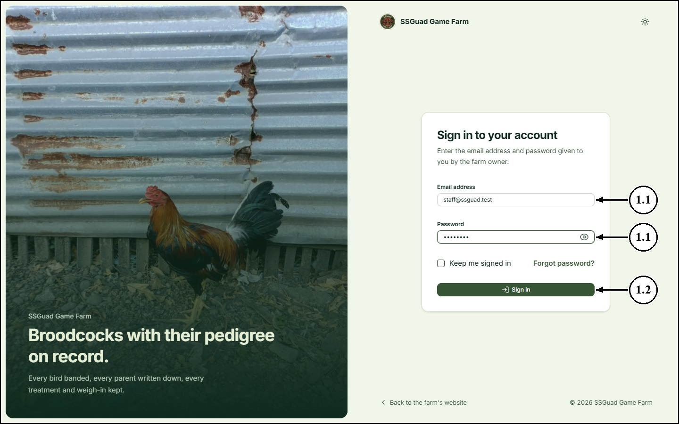
2. Using the Dashboard
2.1 After signing in, you are taken to the Dashboard. The figures at the top show the birds on record, how many are breeding, how many vaccinations are overdue and the vaccination compliance rate.
2.2 The Vaccinations panel lists the birds whose follow-up doses are overdue or due soon. Click “Open schedule” to see all of them.
2.3 Use the sidebar on the left to move between pages.
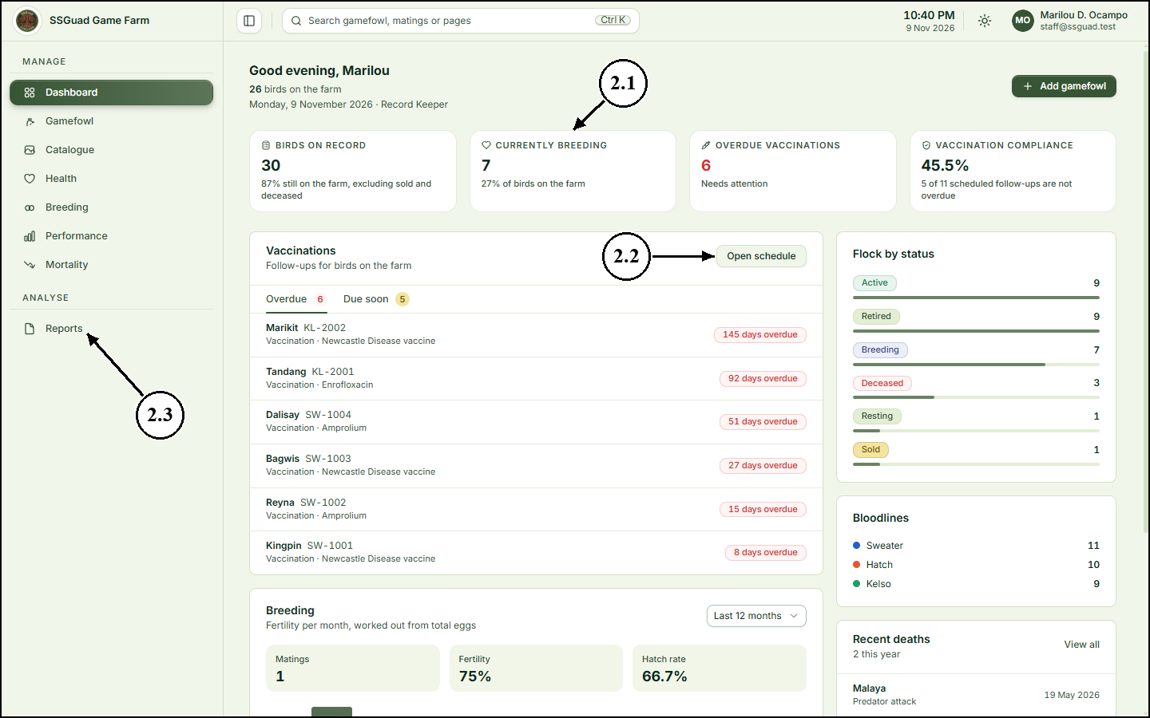
3. Searching for a Bird or Mating
3.1 Click the search box at the top of any page, or press Ctrl+K.
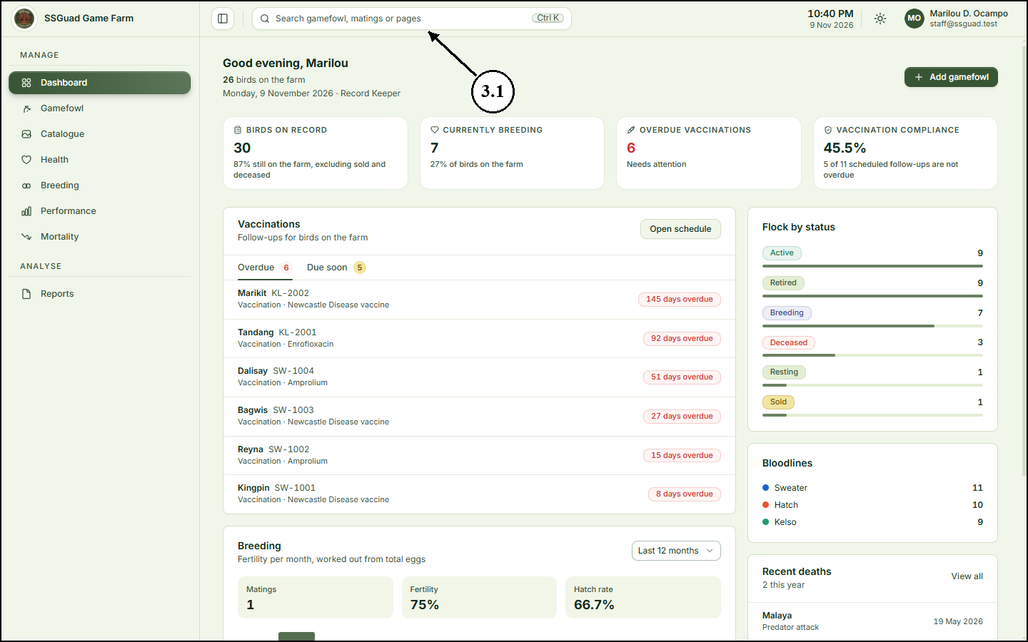
3.2 Type a name or band number.
3.3 Click a result to open it.
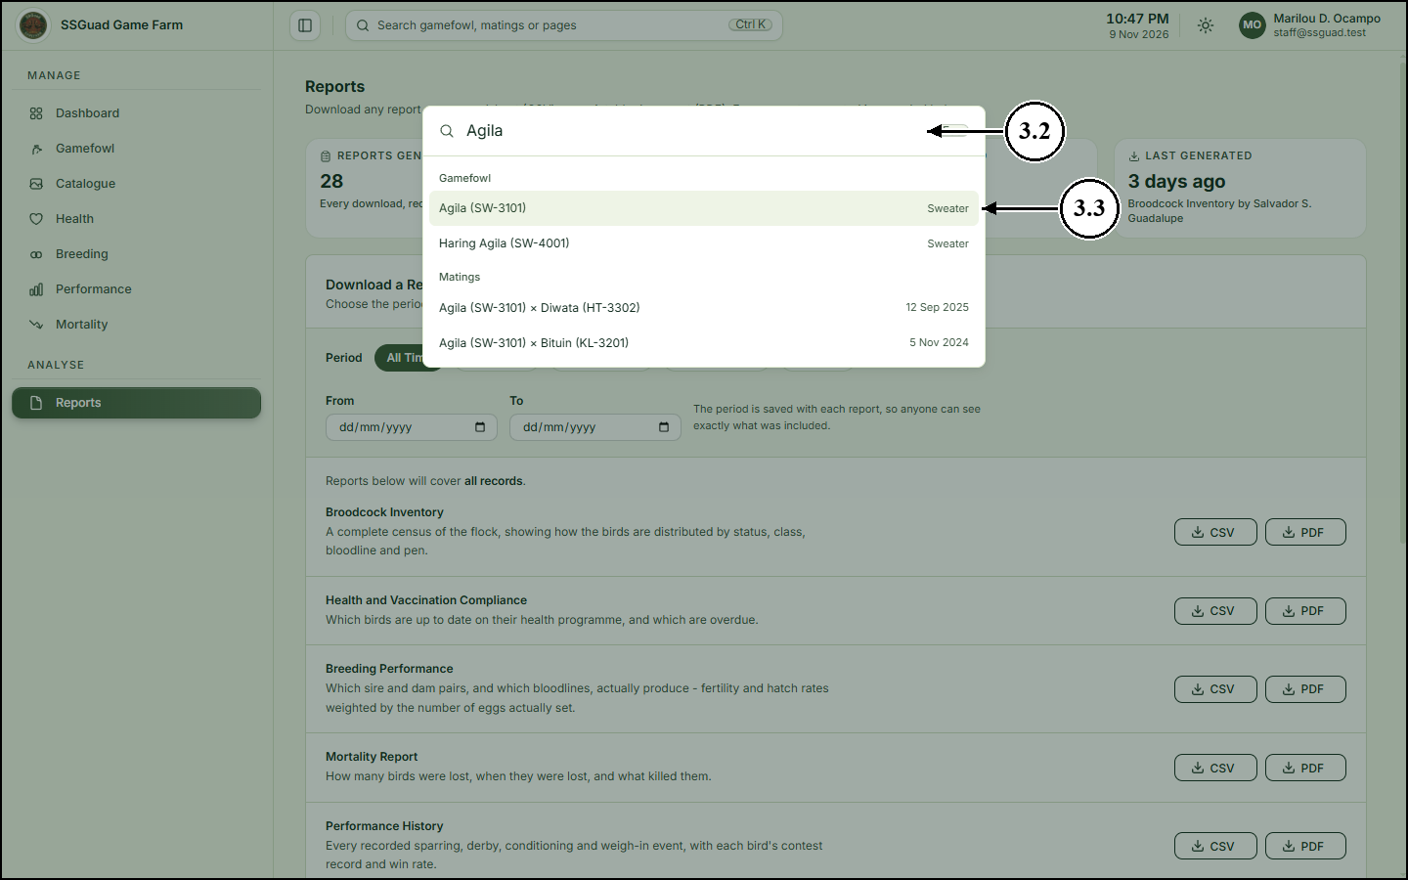
4. Managing Gamefowl Records
4.1 On the sidebar, click “Gamefowl”. The list shows every bird with its band number, bloodline, sex, age, class and status.
4.2 To find a bird, type its name, band number or bloodline in the search box. The lists beside it filter by status, class, sex, bloodline and ownership.
4.3 Click “Add gamefowl” to register a new bird.
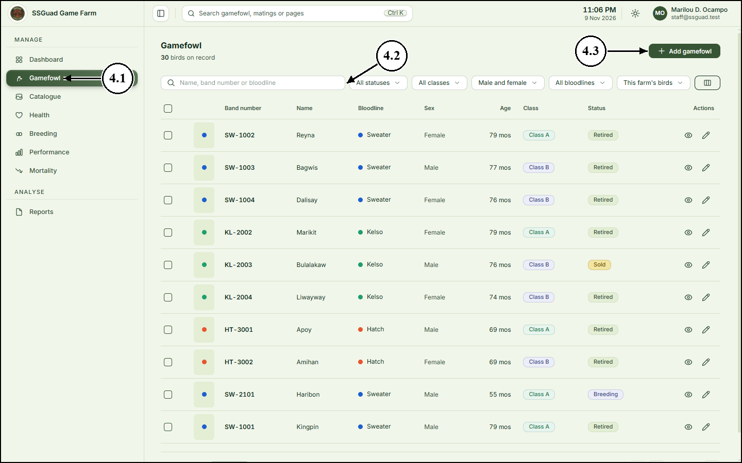
4.4 Enter the bird’s name, band number and bloodline, and choose its sex, class and status.
4.5 Choose the bird’s sire (father) and dam (mother). If a parent is not one of the farm’s birds, choose “Someone else’s bird” at the end of the list and type its name.
4.6 Enter the date the bird was hatched.
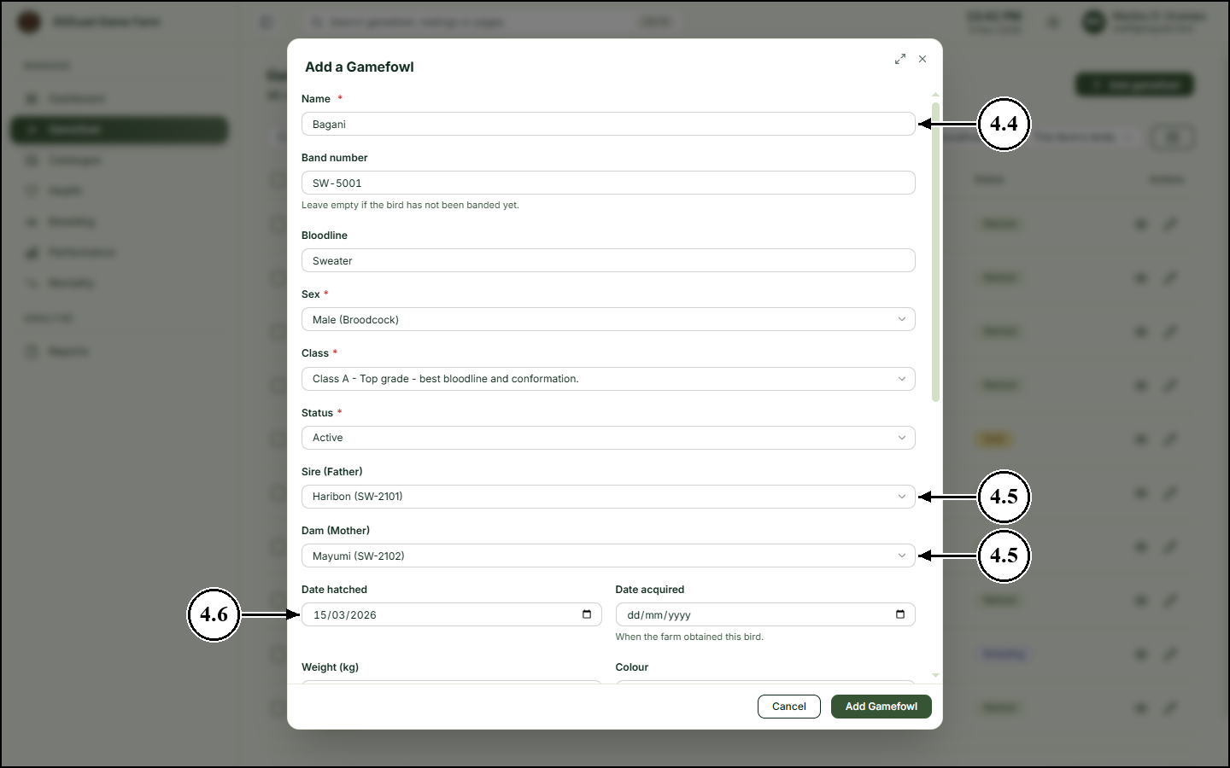
4.7 Scroll down to record the weight, colour, comb type, leg colour and any distinguishing marks. Tick “This bird is for sale” to show the bird as available in the catalogue.
4.8 Click the upload area to add photos of the bird.
4.9 Click “Add Gamefowl” to save the record.
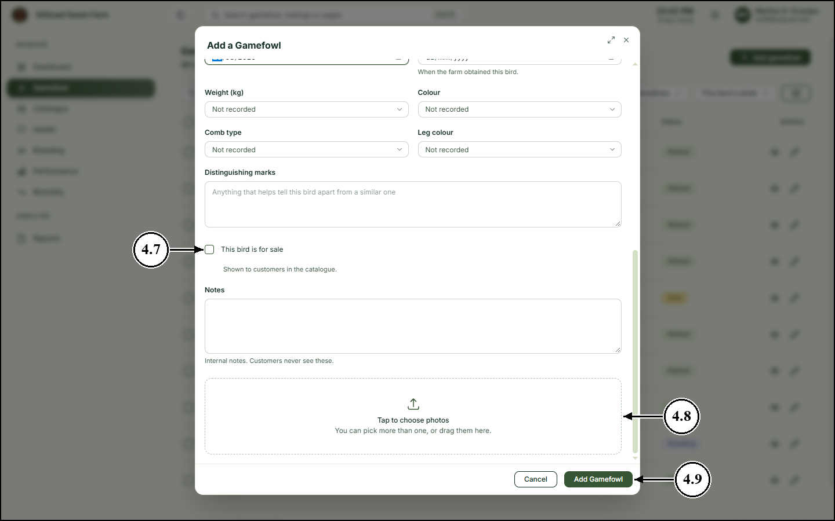
4.10 To open a bird’s page, click the view (eye) icon at the end of its row.
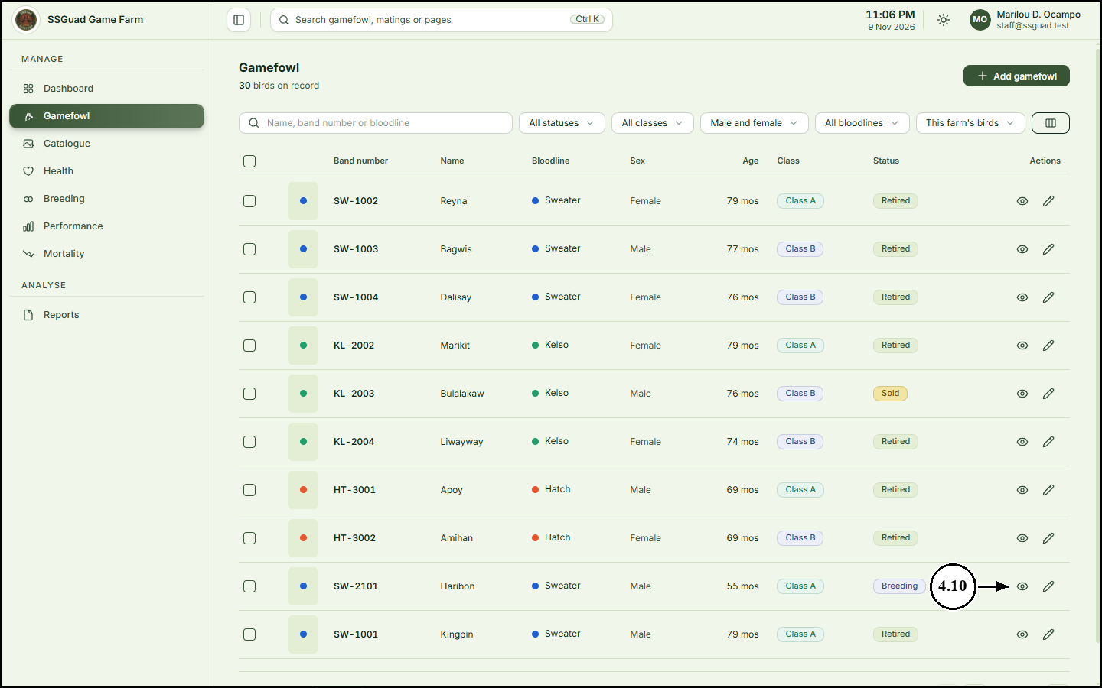
4.11 Click “Edit Bird” to change the bird’s details.
4.12 Click “Add Photos” to upload pictures of the bird.
4.13 Click the tabs to see the bird’s pedigree, details, photos, health, performance and offspring.
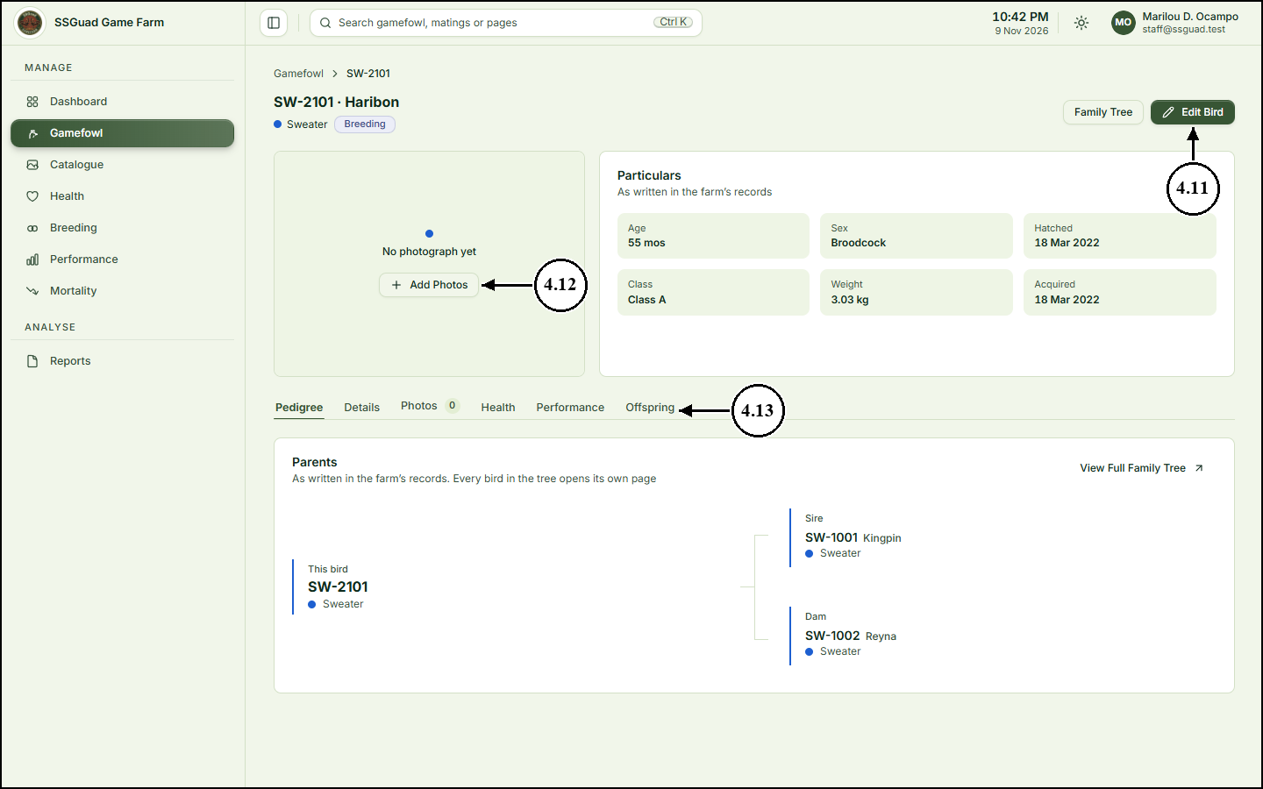
5. Recording Health Care
5.1 On the sidebar, click “Health”. The list shows every vaccination, medication, deworming, treatment and check-up.
5.2 Click “Add Health Record”.
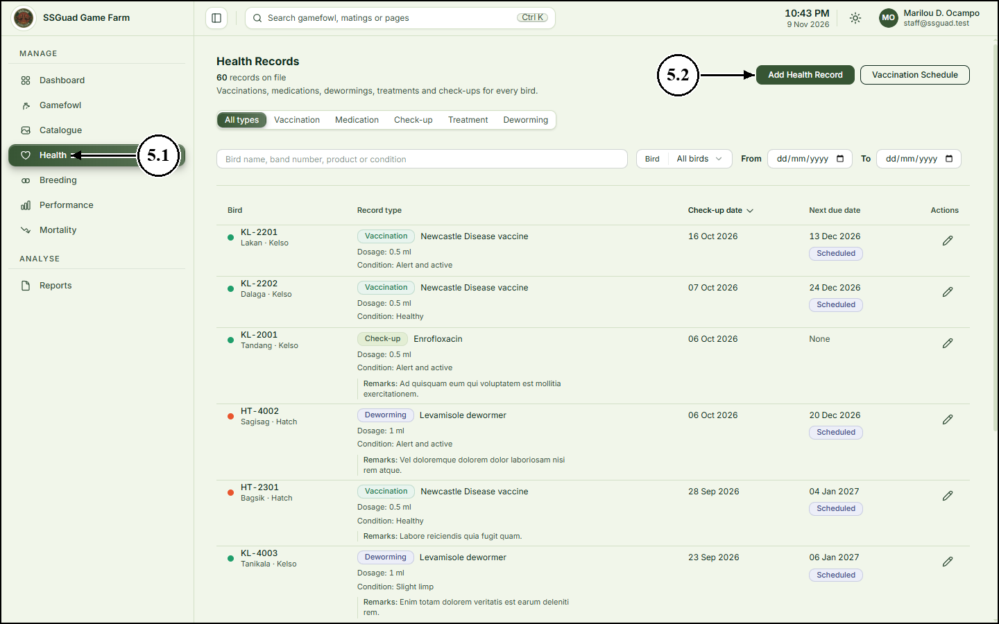
5.3 Choose the bird.
5.4 Choose the record type and the product used.
5.5 Enter the dosage and choose how the bird was on the day.
5.6 Enter the check-up date. If another dose is needed, enter the next due date.
5.7 Click “Save Health Record”.
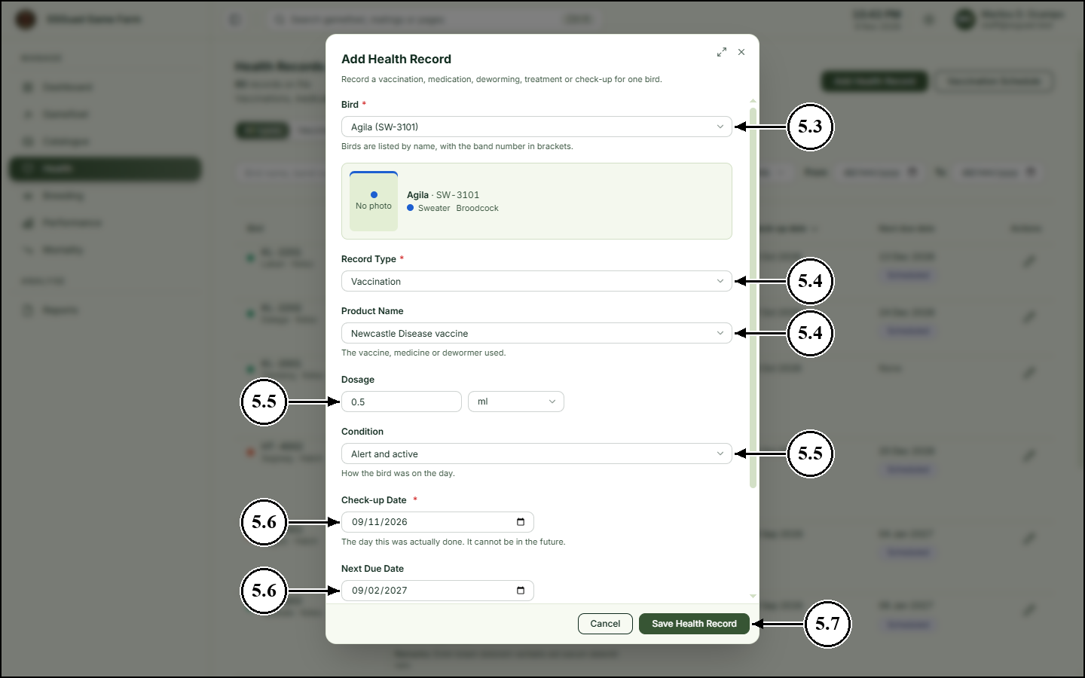
5.8 To see which birds are due or overdue for a dose, click “Vaccination Schedule” on the Health page.
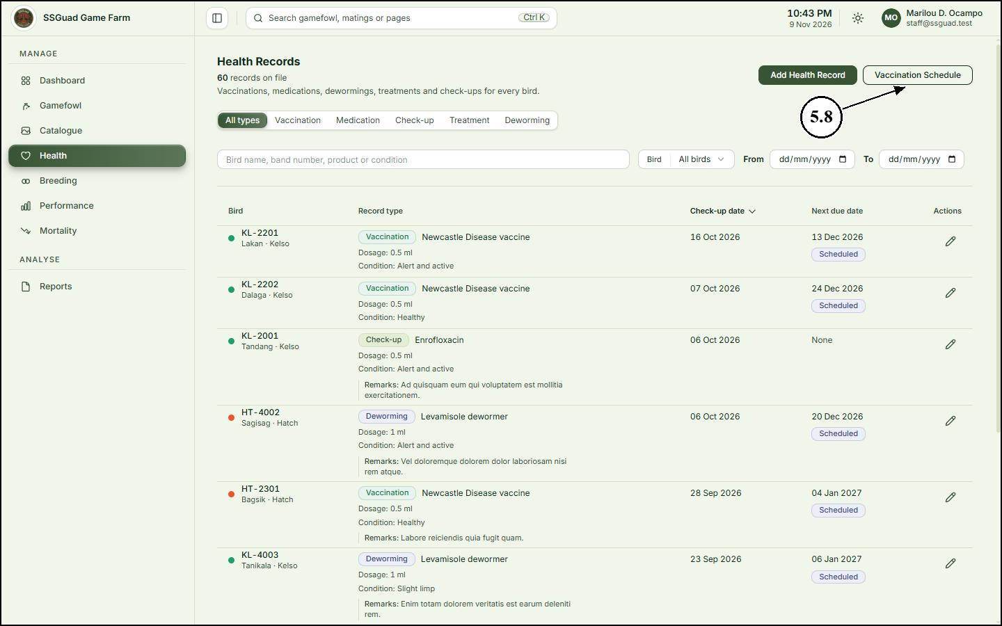
5.9 Overdue follow-ups are listed first. Click “Record Follow-up” beside a bird to record its next dose.
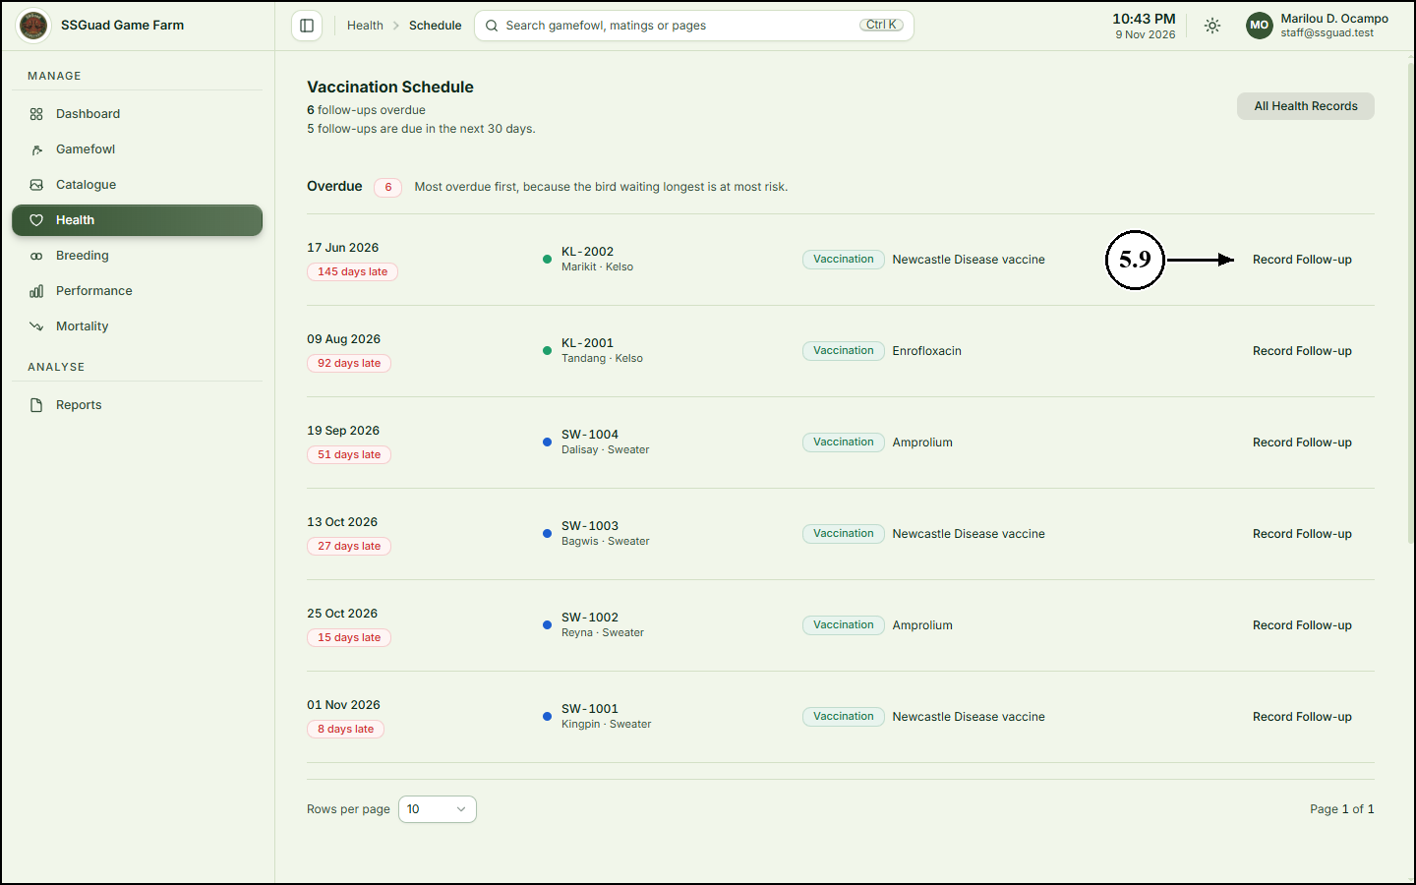
6. Recording Matings and Hatches
6.1 On the sidebar, click “Breeding”. The figures at the top show the eggs set and the fertility and hatch rates, which are worked out from the egg numbers.
6.2 Click “Record a Mating”.
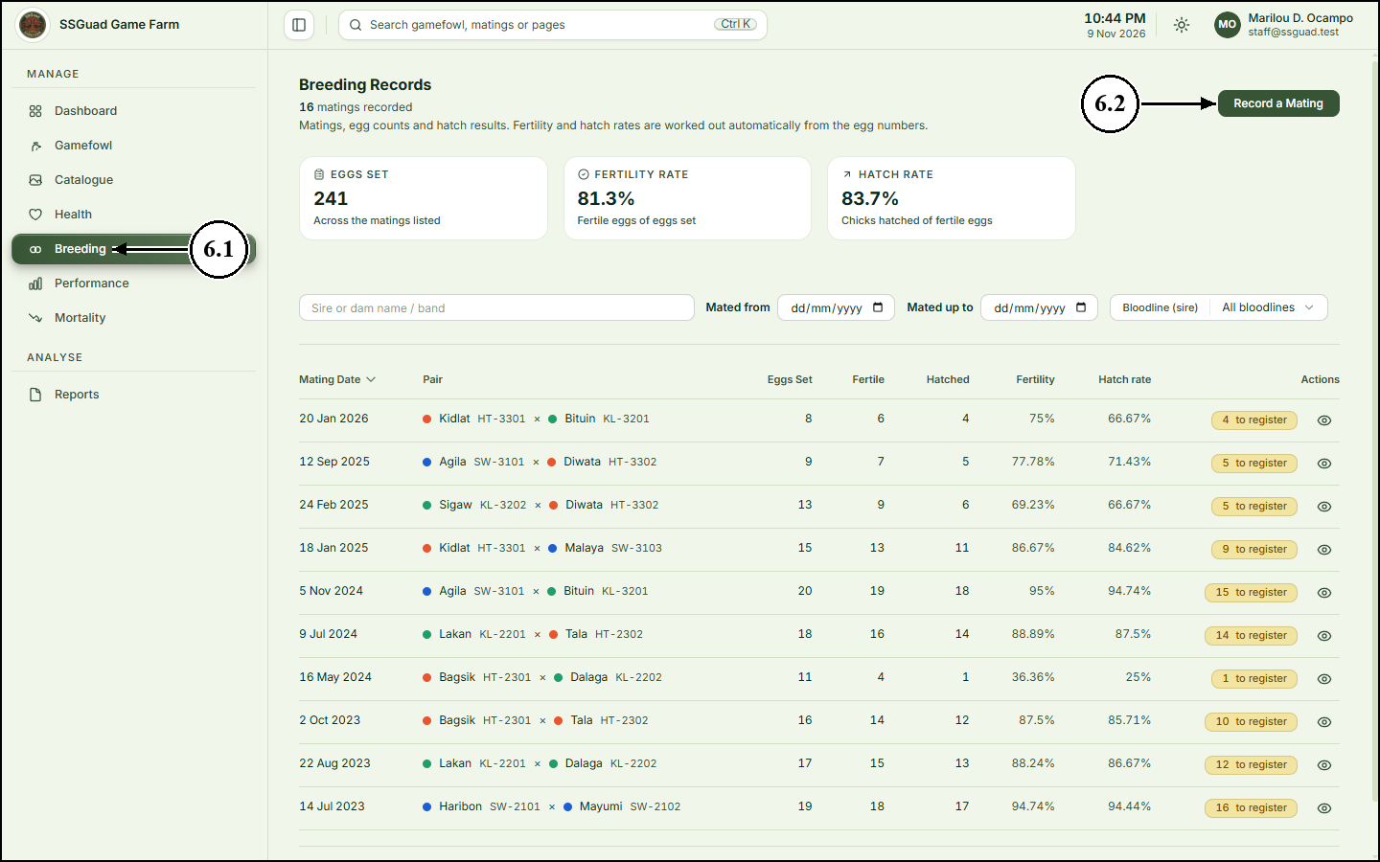
6.3 Choose the sire (father) and the dam (mother).
6.4 Enter the mating date.
6.5 Enter the number of eggs set, fertile eggs and eggs hatched.
6.6 Click “Save Breeding Record”.
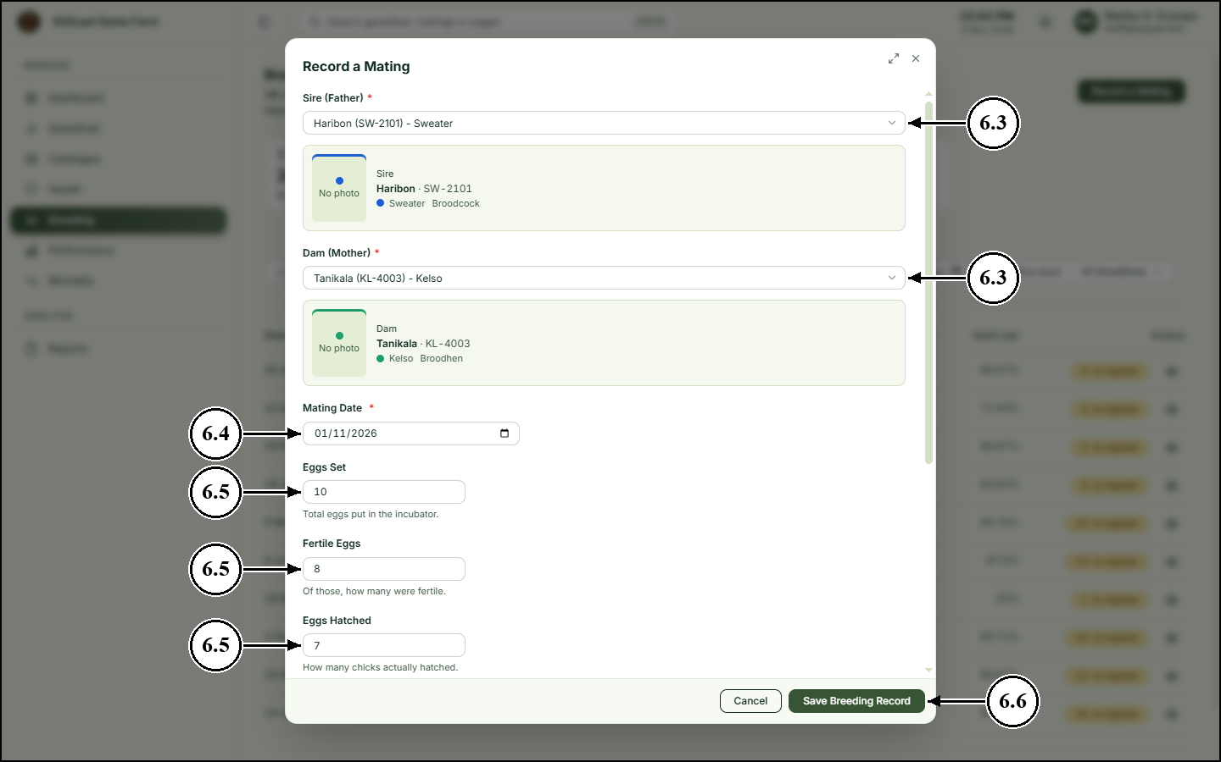
6.7 To open a mating, click the view (eye) icon at the end of its row.
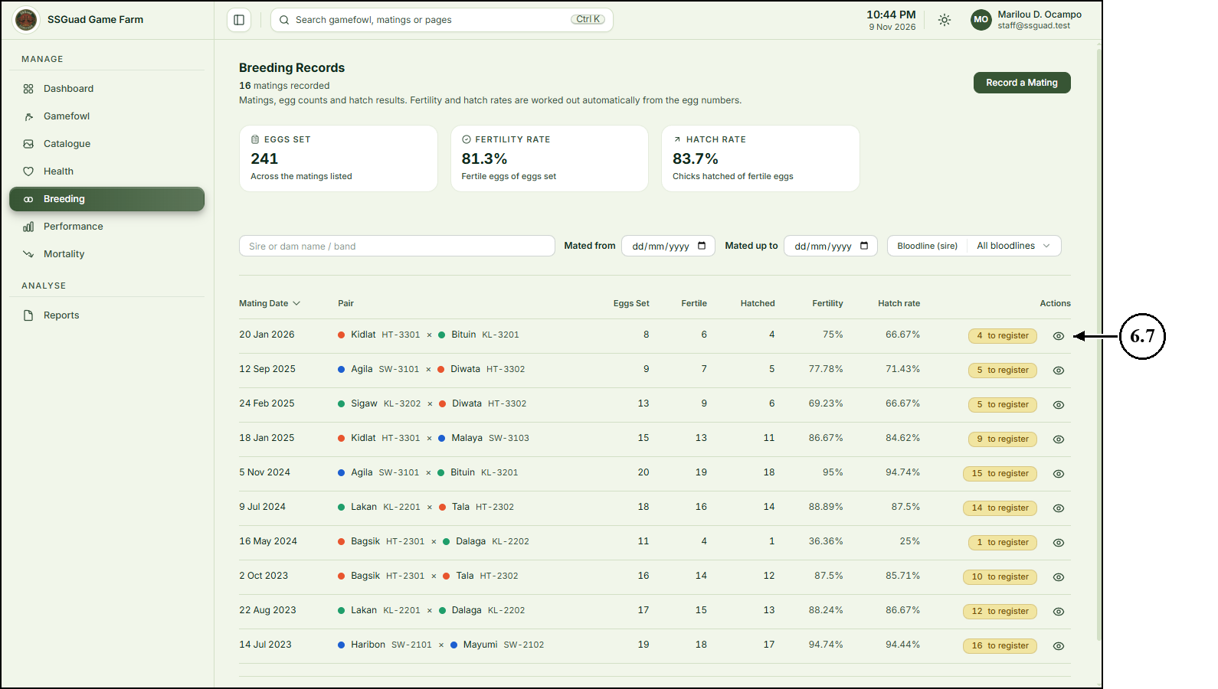
6.8 The mating record shows the egg results and rates. When chicks have hatched, click “Register chicks” to add them as bird records.
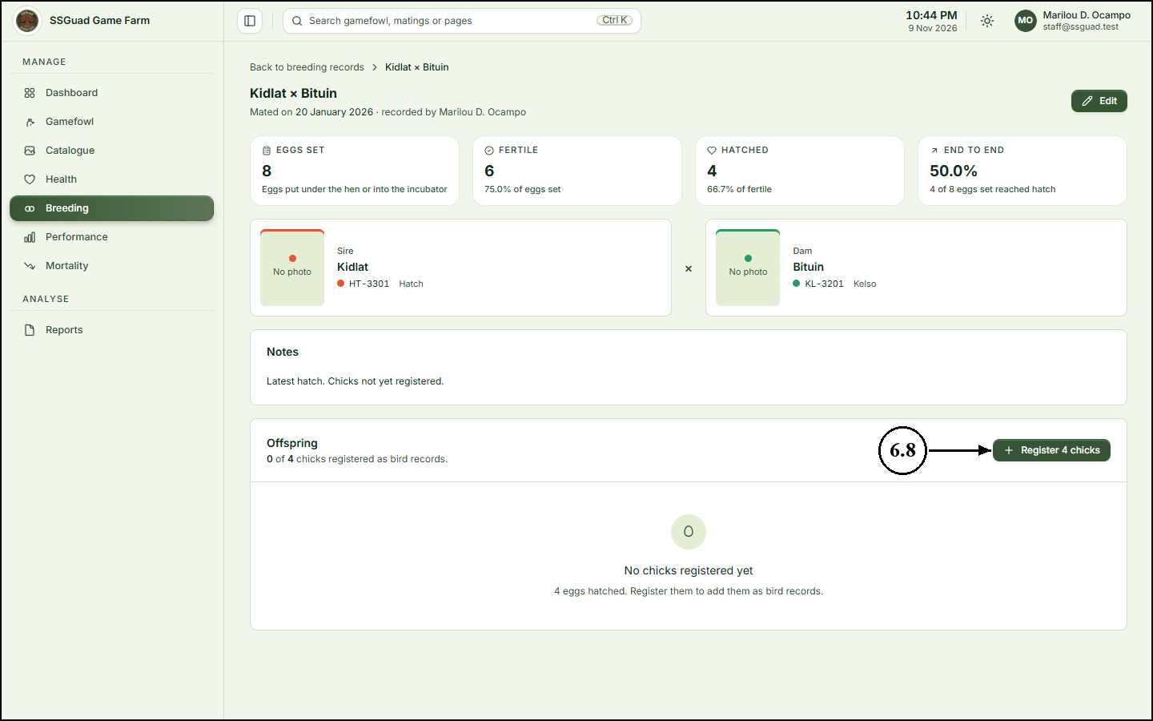
6.9 Enter how many chicks to register, their sex, the date they hatched and their pen.
6.10 Click “Register chicks”. Each chick is added with this sire and dam, so it appears in the family tree straight away. You can name and band each chick later.
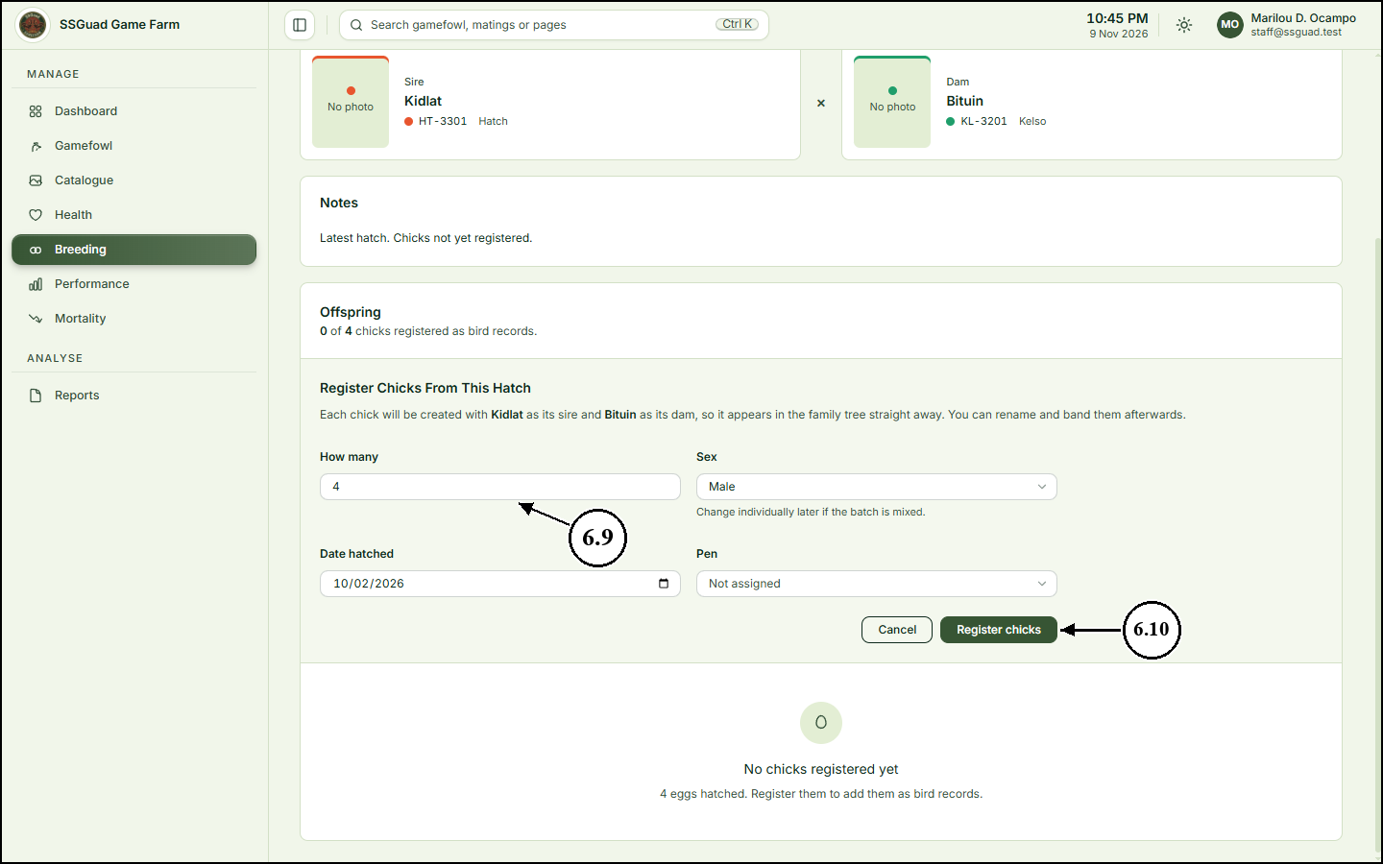
7. Recording Performance
7.1 On the sidebar, click “Performance”.
7.2 Click “Add Performance Record”.
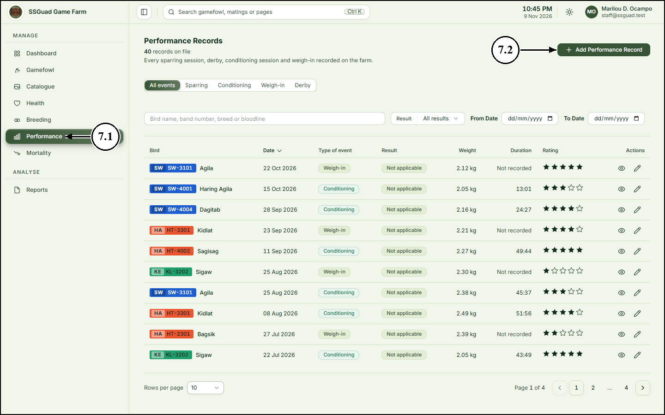
7.3 Choose the bird and enter the date of the event.
7.4 Choose the type of event (sparring, conditioning, weigh-in or derby) and the result.
7.5 Enter the bird’s weight and how long the session lasted.
7.6 Click the stars to rate the bird’s showing.
7.7 Click “Save Performance Record”.
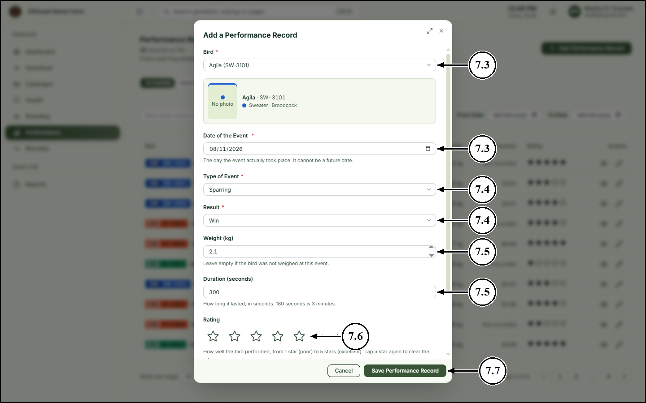
8. Recording a Death
8.1 On the sidebar, click “Mortality”.
8.2 Click “Record a Death”.
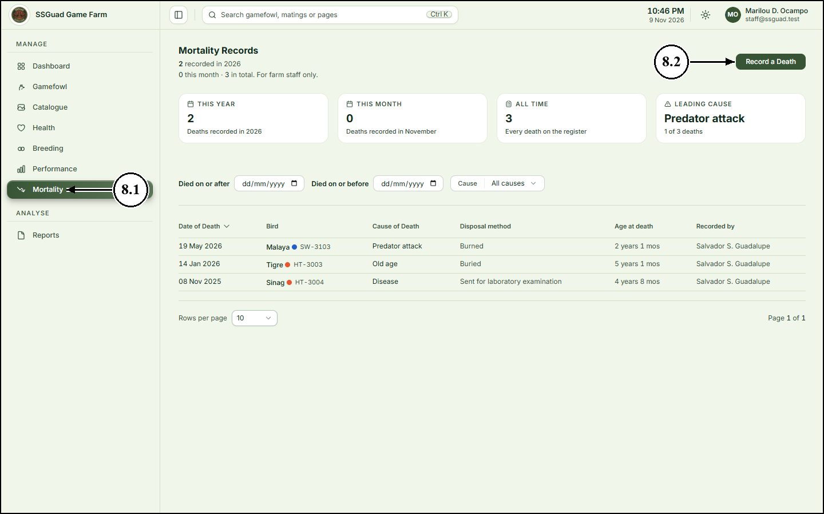
8.3 To shorten the list of birds, type part of the bird’s name under “Find the Bird”.
8.4 Choose the bird under “Which Bird Died?”.
8.5 Enter the date of death, the cause of death and how the bird was disposed of.
8.6 Click “Record This Death”. The bird’s status changes to Deceased.
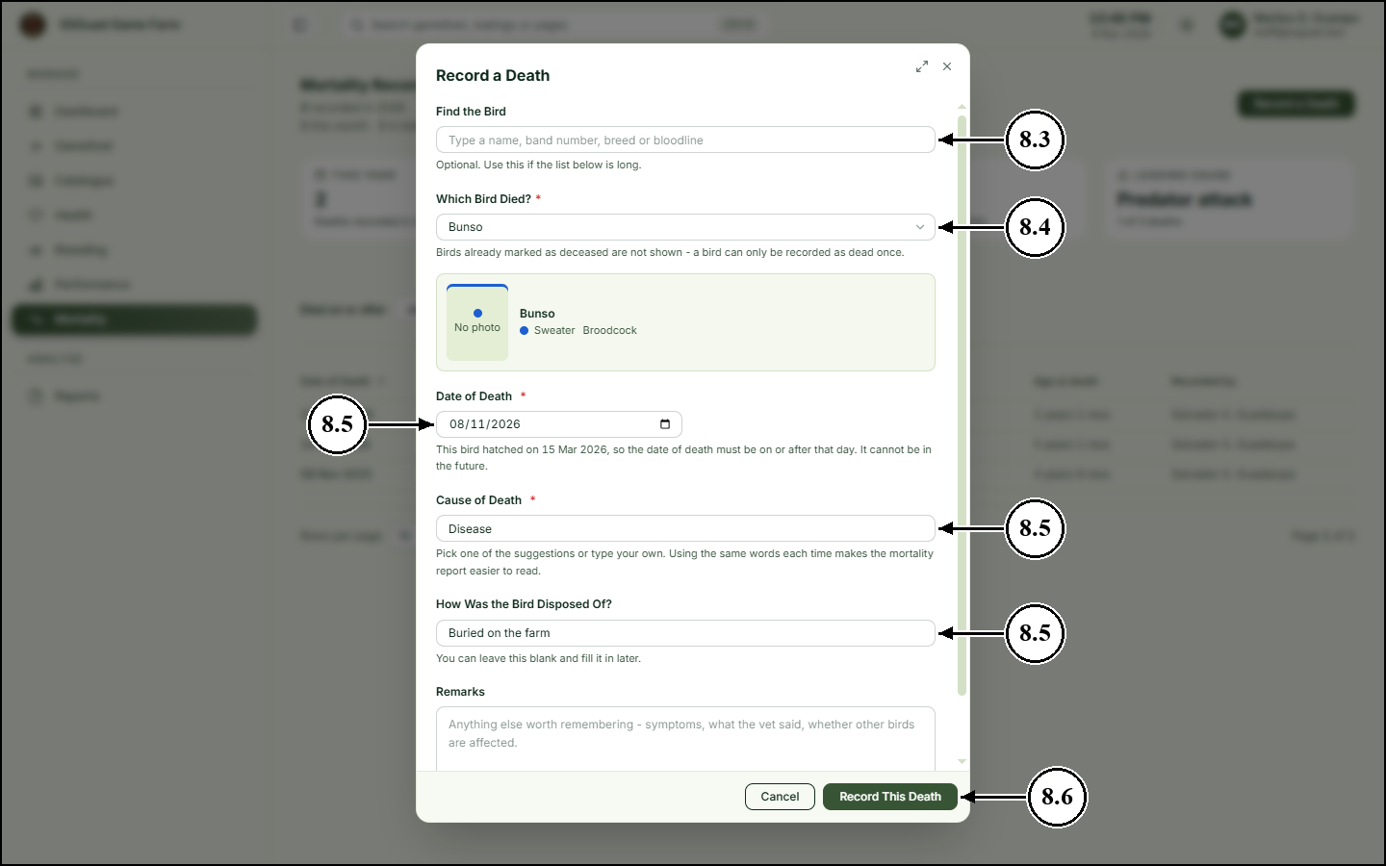
9. Generating Reports
9.1 On the sidebar, click “Reports”.
9.2 Choose the period the report should cover, for example “This Year”.
9.3 Click “PDF” beside a report to download a printable copy.
9.4 To open the report in a spreadsheet instead, click “CSV”.
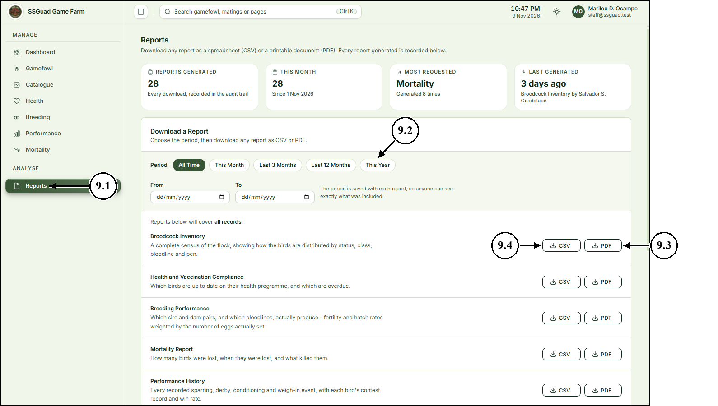
9.5 The report opens as a PDF, ready to print or save. The footer shows when it was generated and by whom.
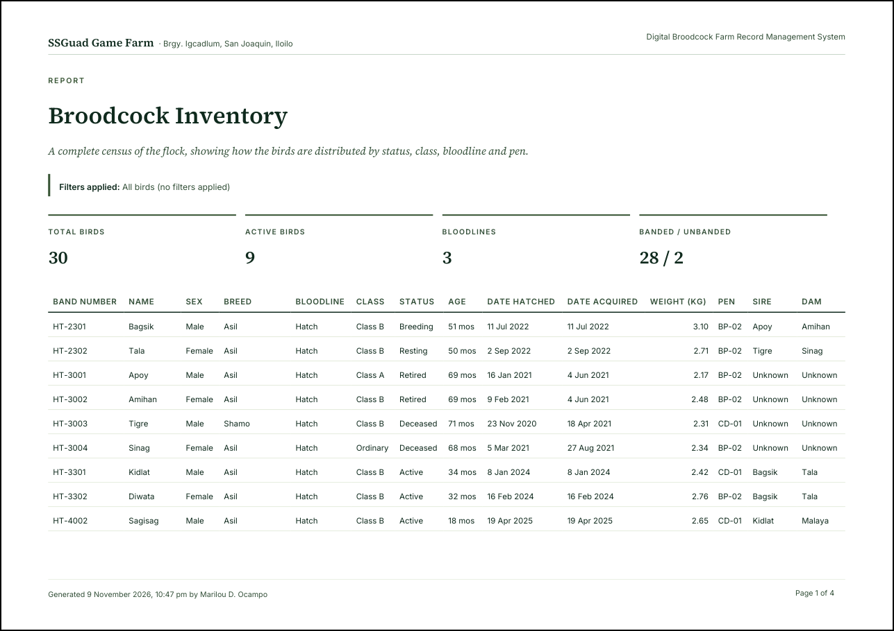
10. Updating Your Profile
10.1 Click your name at the upper-right corner of the page.
10.2 Click “My profile”.
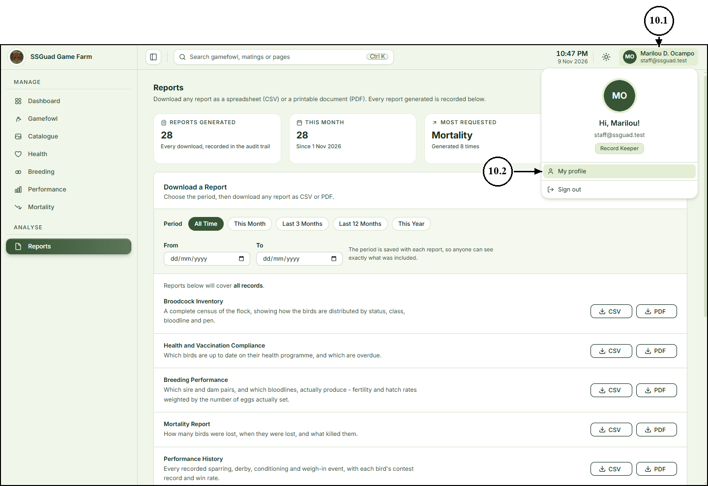
10.3 Edit your name, contact number, position or address.
10.4 Click “Save Changes”.
10.5 To change your password, enter your current password, then the new password twice.
10.6 Click “Change Password”.
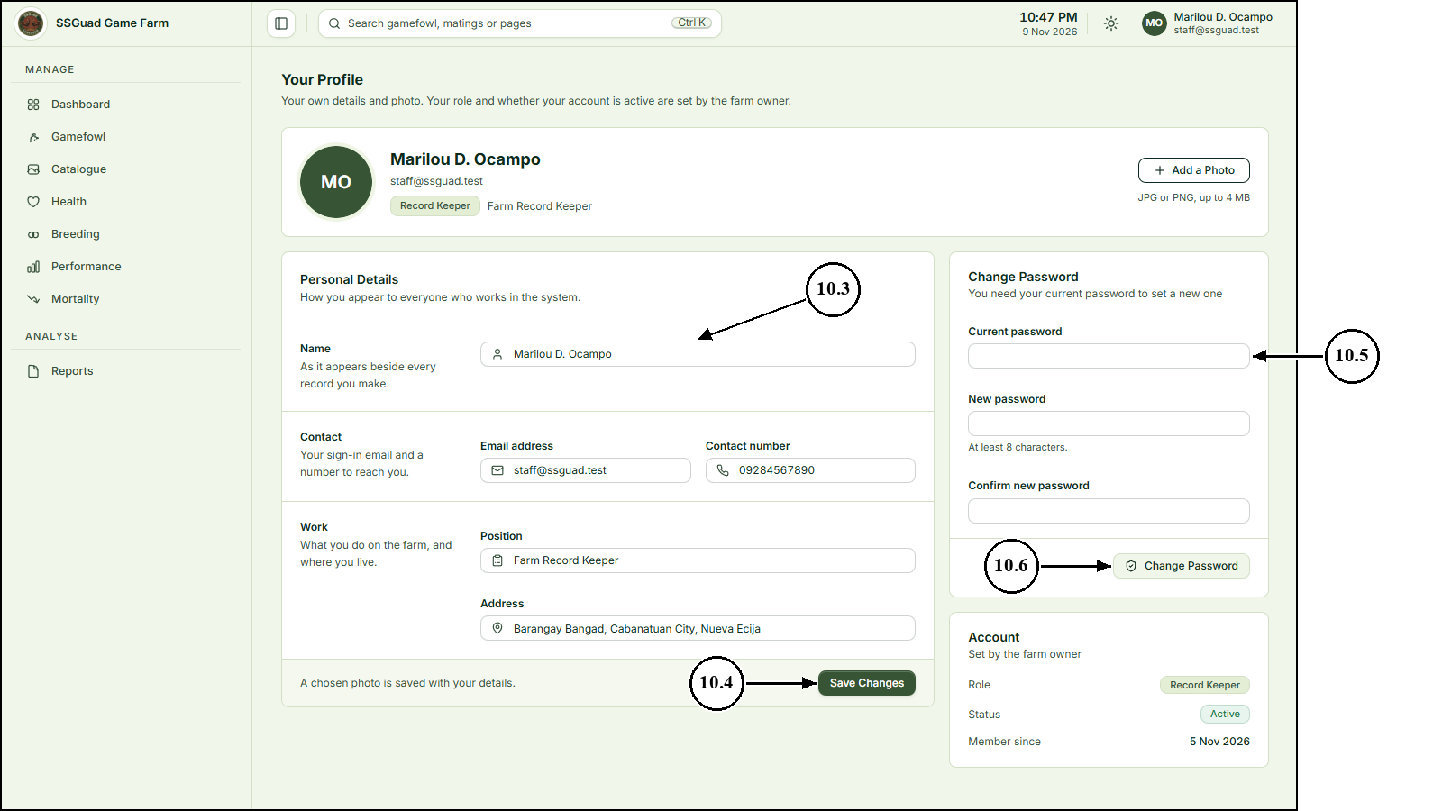
11. Signing Out
11.1 Click your name at the upper-right corner of the page.
11.2 Click “Sign out”.
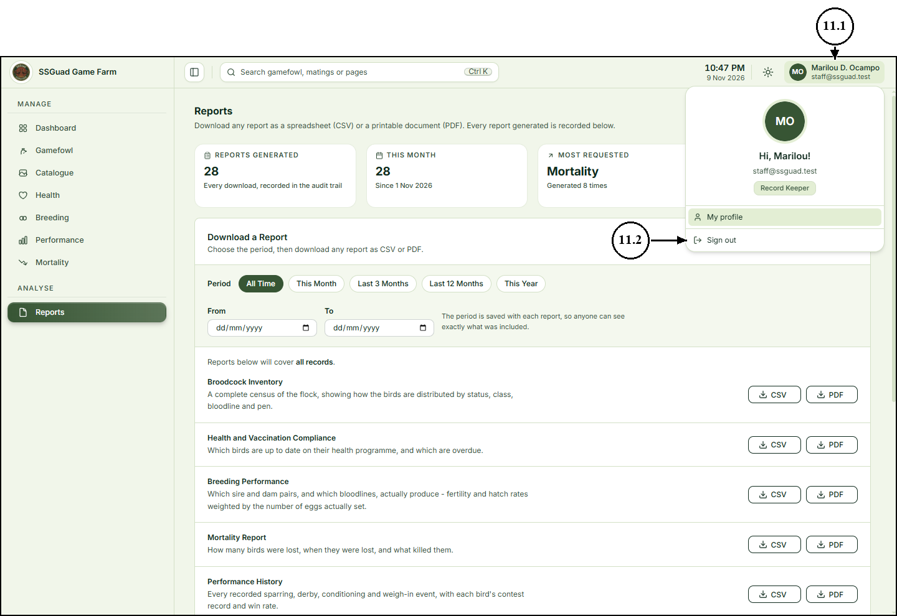
For Public Visitors
Anyone can view the farm’s public website, its catalogue and each bird’s page. No account is needed and there is nothing to sign in to: accounts are only for the farm owner and the record keepers. Prospective buyers browse the same way as any other visitor.
1. Opening the Farm Website
1.1 Open a web browser and go to the farm's website. The home page introduces the farm and shows how many birds, bloodlines and recorded parentages it keeps.
1.2 On the top menu, click “Our stock” to see the birds on the farm.
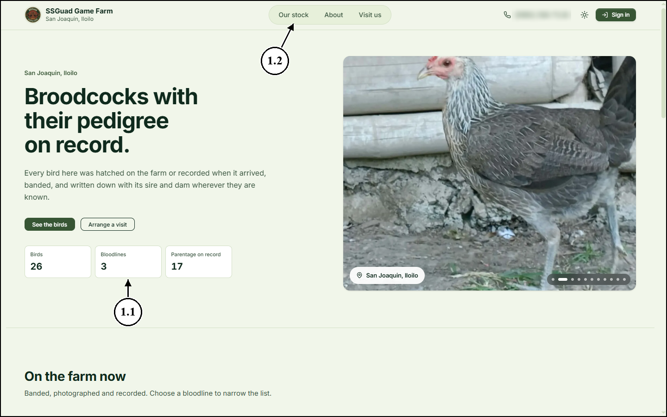
2. Browsing the Catalogue
2.1 Type a name, band number or bloodline in the search box to find a bird.
2.2 Choose a bloodline from the Bloodline list to show only that bloodline.
2.3 Tick “Available birds only” to show only the birds that are for sale.
2.4 Click a bird’s card to open its page.
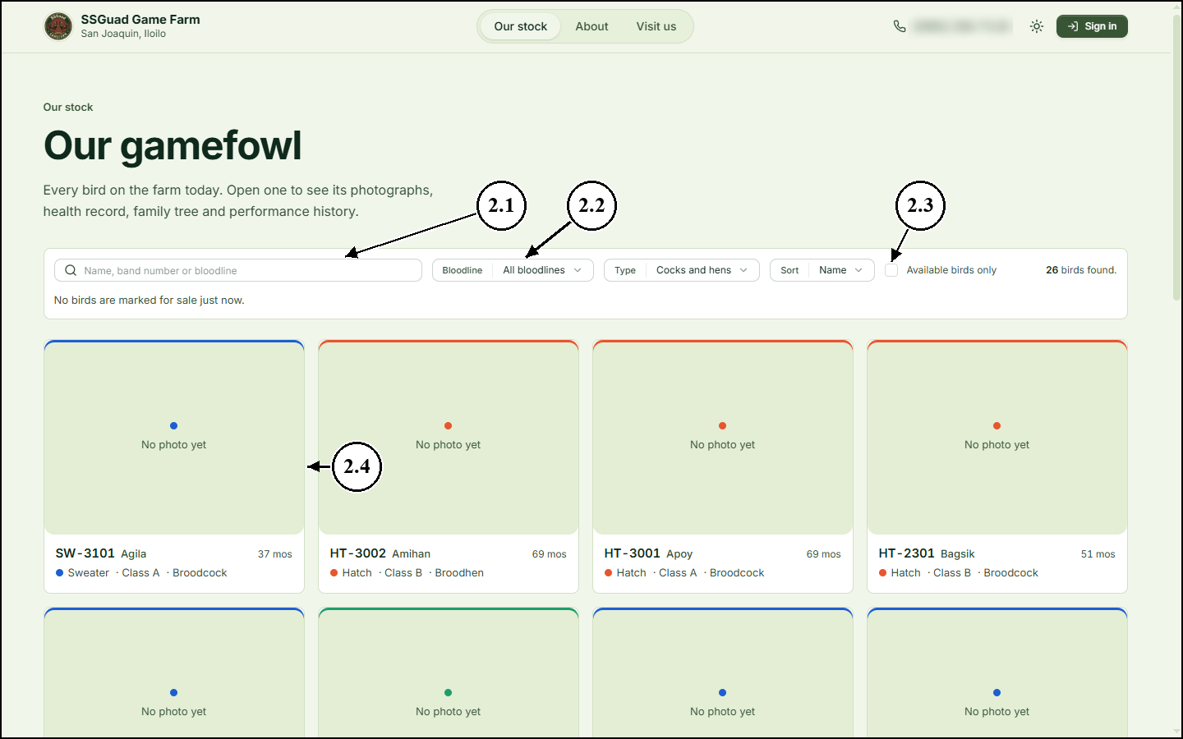
3. Viewing a Bird’s Page
3.1 The bird’s page shows its photo and particulars: age, sex, date hatched, class, weight and date acquired.
3.2 Click the “Health” tab to see the bird’s vaccinations, medications and check-ups.
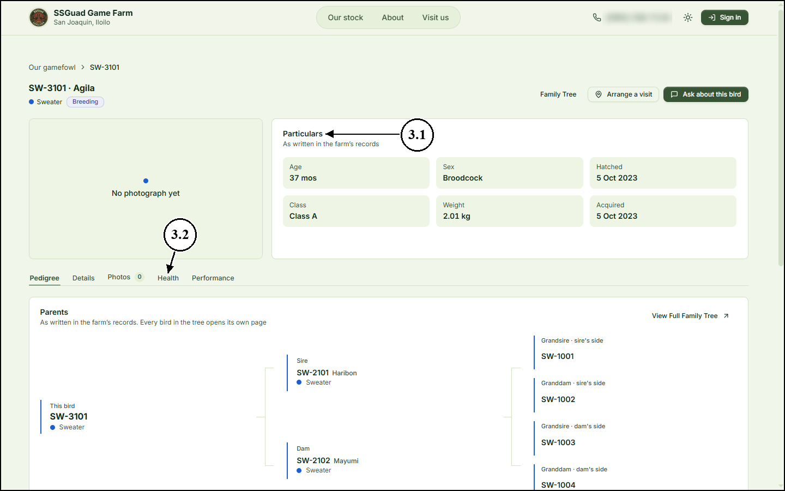
3.3 The Health History lists each treatment, newest first, with its dosage and the next date it is due.
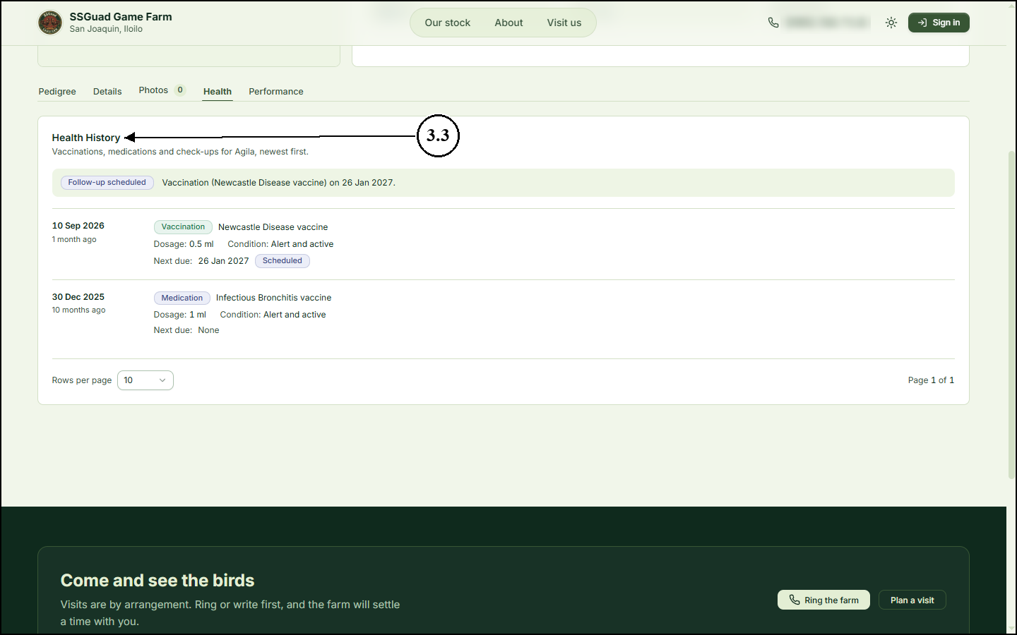
4. Viewing the Family Tree
4.1 On the bird’s page, click “Family Tree”.
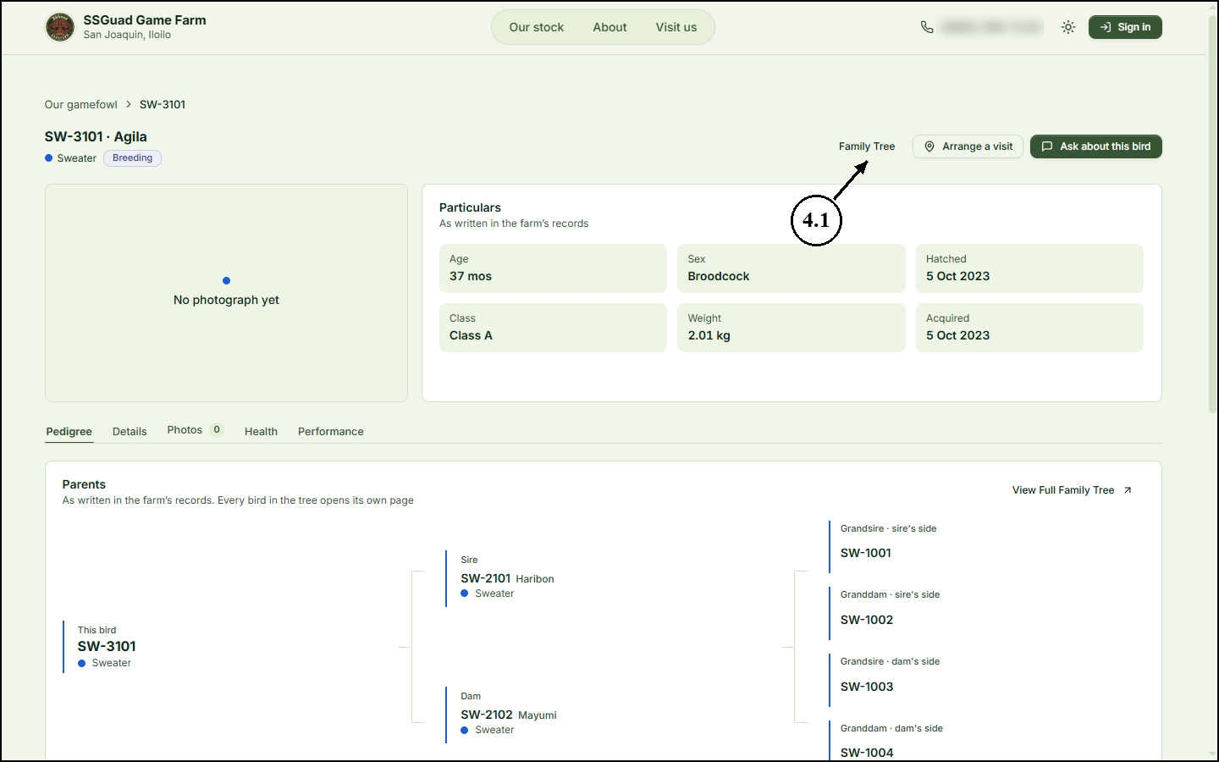
4.2 The bird is at the bottom, its sire (father) on the left and its dam (mother) on the right, with their parents above them. The bar at the top shows how much of the pedigree is recorded.
4.3 Click “View Bird” to return to the bird’s page.
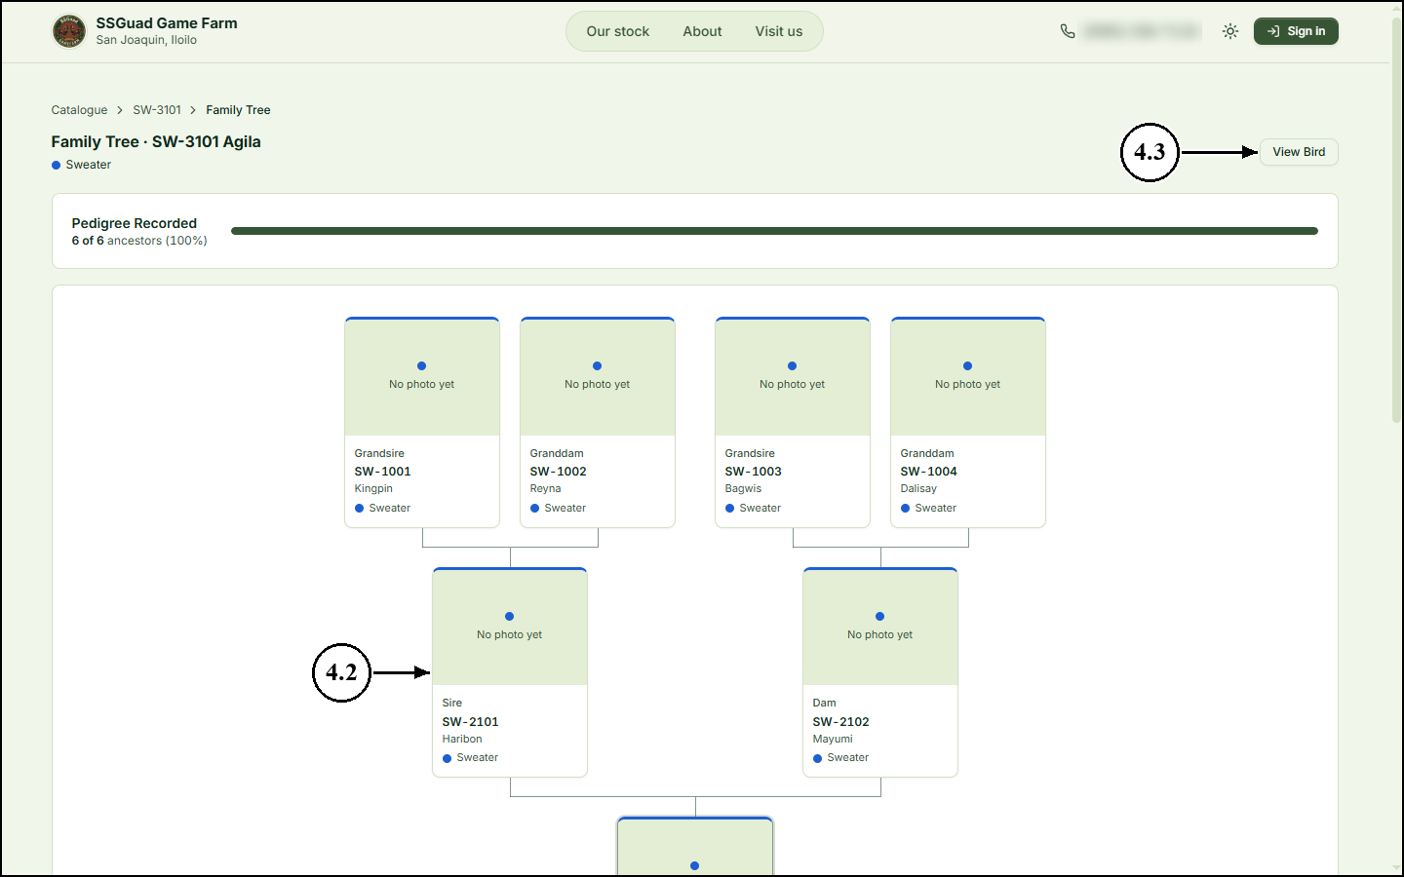
5. Arranging a Visit
5.1 On the top menu, click “Visit us”.
5.2 The page lists the farm’s address and visiting hours. Visits are by arrangement: click “Ring the farm” or “Send an email” to agree on a day and time.


