Study
Ok

Hazard characterization
The first step to build an adaptation strategy is to identify hazard conditions in the project area, in relation to a range of climate variables and natural hazards. This has to be done both for the baseline/observed climate and for the predicted future climate in the study area.
Climate variables and hazards related to baseline/observed climate, can be modeled by processing historical datasets. First, the relevant climate variables are selected and serve as a base to derive climate indices necessary for the hazard analysis. For each climate-related hazard one or more relevant indices, such as probability of occurrence, exceedances over threshold values, are identified. The indices are calculated for a defined climatic period and climate variables can be combined with other parameters to evaluate characteristics of more complex natural hazards, such as landslides or floods. Given a defined hazard scale, the hazard conditions in the project area can be quantified.
In dealing with Climate Change conditions, it is essential to determine for each climate variable or hazard considered how it may evolve in the future, by examining the outputs of climate models. Uncertainty in climate model projections should be acknowledged and recorded by presenting a summary of climate model outputs using appropriate downscaled data.
Therefore, hazard analysis focuses on three main characteristics: intensity, frequency, and size or location of the natural hazard.
- Intensity is the observed or potential magnitude of a given natural hazard.
- Frequency relates to how often a natural hazard of a particular intensity is likely to occur, or has occurred, in a given location. This probability is often expressed in return periods.
- Location refers to the affected geographical area. Considering that both the intensity of an event may be influence the evolution of a climatic episode in nearby areas, and that the modification of elements such as drainage or land use conditions in the project area may also modify the intensity of threats from adjacent areas, a careful analysis must be performed for the actual area to be considered in any project.
Considering the long-term scale, the relevant information is climate data provided at decadal scales. This kind of approach is aimed to providing support to bidding companies and infrastructure designers (most elements of the road infrastructure have a design life of more than 30 years).

Exposure evaluation
Once the hazard characterization in the project area has been assessed, the next step is to evaluate exposure to climate hazards of the elements at risk considered.
The elements at risk refer to the different single elements of the infrastructure. Due to the existence of a very high number of elements in a road infrastructure that need to be analysed, a typology of potential types of elements at risk has been defined, taking into account the list of potential elements at risk and hazards proposed in a previous work performed by CEDEX (“Climate Change Vulnerability and Risk Assessment Methodology for Road Projects”).
Identifying the elements at risk together with the potential hazards that can affect them, is needed in the assessment of the impacts of Climate Change in road infrastructure.
Finally, attention has to be paid to the traffic flow in the case of transport infrastructure. A problem in a road element will probably also affect traffic flow and this must be accounted for.
The analysis tool offers the possibility to select which are the components of the road that are likely to be affected by climate hazards in order to obtain results of impact and vulnerability.
The elements at risk (in relation to the potential hazards) so far considered in the system are listed below:
- Landslide and erosion and falling of slopes;
- Structural movements in structure due to the presence of water;
- Insufficient capacity of the drainage works due to heavy rain;
- Insufficiency of channeling capacity due to heavy rains;
- Insufficiency of bearing capacity due to the presence of water in the pavement;
- Pavement rutting as a result of high temperature;
- Insufficient road surface drainage capacity as a consequence of heavy rain;
- Effect of snow in a section on the road traffic;
- Effect of ice in a section on the road traffic;
- Effect of snowdrifts in a section on the road traffic;
- Effect of wildfires in a section on the road traffic;
- Effect of fog in a section on the road traffic.

Vulnerability analysis
The vulnerability is defined as the probability that an element at risk experiences a level of damage, according to a predefined damage scale, as a consequence of a hazard event of a given intensity.
In the case of the transport infrastructure, it is not possible to define vulnerability classes because there is a wide variety of typologies for each element at risk. Also, it is not possible to define vulnerability functions because a lot of statistical data is needed in order to define these functions and this data is not available. Several studies have been carried out in the past trying to appraise these vulnerability functions but, at the time of writing, no valid functions have resulted.
Therefore, the methodology adopted proposes to assess the vulnerability by means of expert judgment. This means that for each element at risk identified, a technician will assess the level of damage (impact) as a consequence of a hazard event of the expected intensity according to climate change (in the horizon year) with a given probability.
Table: Scale for Assessing the Probability of Hazards affecting the project.
1 Rare | 2 Unlikely | 3 Possible | 4 Likely | 5 Almost Certain
Highly unlikely to occur. | Unlikely to occur. | Incidents have occurred in similar sites. | Incident is likely to occur. | Incident is very likely to occur.
Table: Scale for Assessing the Severity of Hazards affecting the project.
1 Insignificant | 2 Reduced | 3 Moderate | 4 Remarkable | 5 Important
Minimal impact with no special needs for adaptation. | The impact resolution is compatible with routine maintenance actions. | Modest and very localized repairs and/or replacements are required. | The effect on the integrity of the element is remarkable. Its repair requires a punctual rehabilitation/reconstruction of the element. | The effect on the integrity of the element can be total. Its repair requires a generalized rehabilitation/reconstruction of the element.

Risk and impact assessment
For each element at risk, the risk will be assessed on the basis of a double perspective: (1) the integrity of the element and (2) conditions of circulation; except for those hazards that affect only traffic conditions and not the infrastructure itself (such as water on the pavement that might cause aquaplaning but will not affect the road materials nor the bearing capacity.)
Probability represents how likely the identified climate hazards are to occur within a given timescale (i.e. rare, unlikely, possible, likely, almost certain). The severity accounts for the consequence of the hazardous event occurring in terms of the intensity over time. The level of risk is calculated by combining the possible level of affectation with the probability of occurrence of that type of event.
As previously stated, this analysis will be carried out by an expert using information provided.
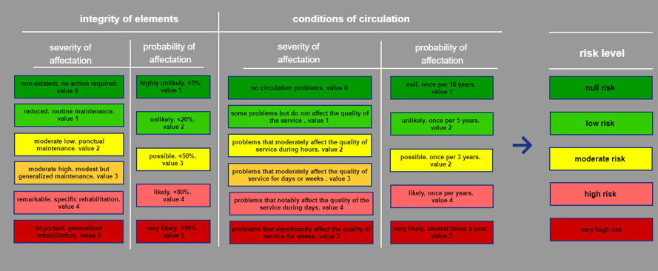

Figure: Risk levels.
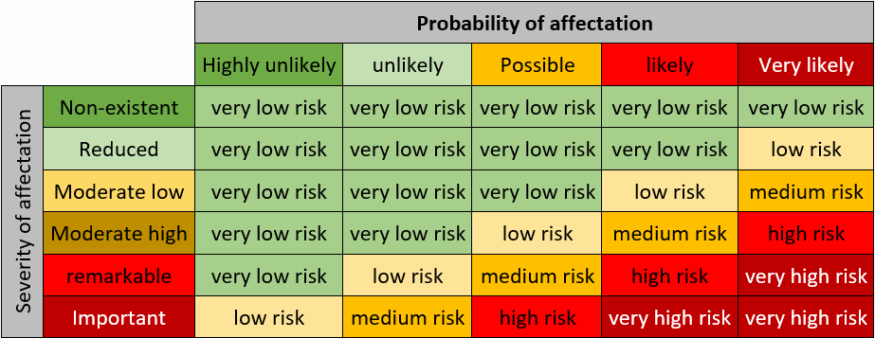
Figure: Risk levels matrix.

Identify adaptation options step
Adaptation options in the transport sector may generally be divided into engineering (structural) options and non-engineering options. “Not to act”, or to “maintain a business as usual approach” (“do nothing” option) should also be retained as a possible option. In a number of circumstances, findings from the impact, vulnerability, and adaptation assessments may indicate that doing nothing (no climate proofing) is the best course of action.
Also, it has to be defined the level of risk that can be assumed. It will depend on the criticality of the infrastructure. It is assumed that the level of risk related to road elements should not be higher than medium and the level of risk associated to traffic conditions should remain low.
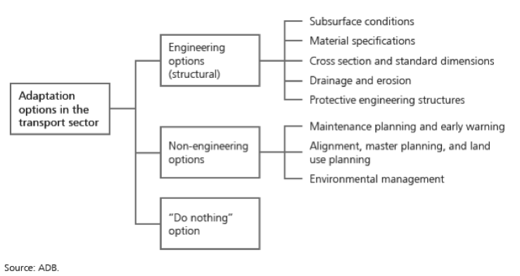
Figure: Nature of adaptation options in the transport sector. Source: ADB.

